Commentary on a visual source: ground plan of Poblet Monastery
(a)
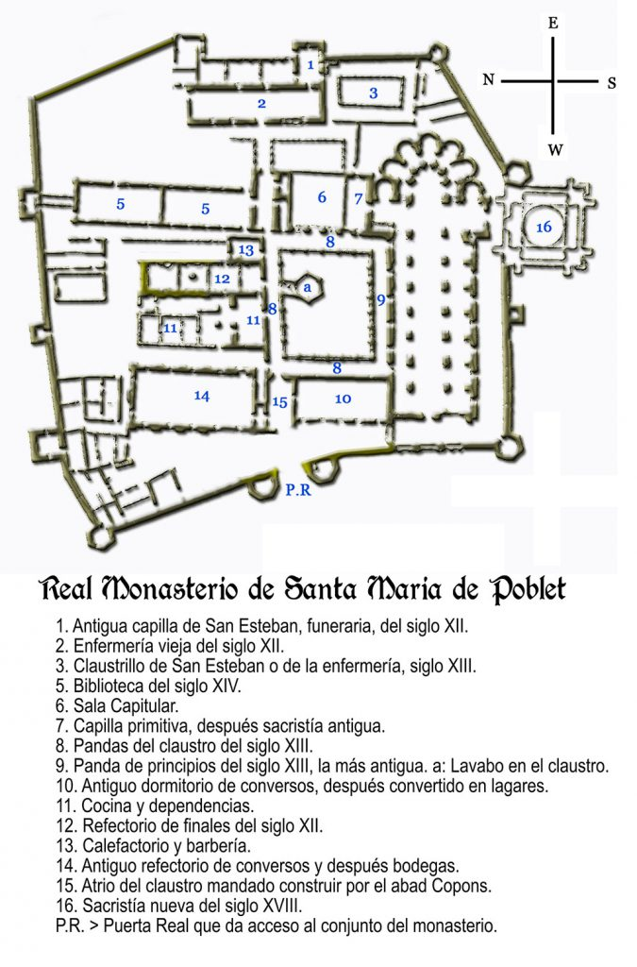
The source is (a) a ground plan of part of Poblet monastery, more formally the Reial Monestir de Santa Maria de Poblet, in north-eastern Spain. The monastery is in the province of Tarragona in Catalunya, just to the north of the Prades mountains.
The plan covers the central zone (of three) of the complex. It was produced by Domènech I Montaner in 1916, when the monastery was not occupied, and shows the state of the complex before restoration work began.
The second image (b) is a larger scale and more recent plan of the monastic church which offers a more detailed picture.
Poblet was established in the context of the Reconquista, the long struggle between the Christian kingdoms of the north of the Iberian Peninsula and the successor states to the Muslim Emirate of Córdoba in the south. Count Ramon Berenguer IV of Barcelona conquered the region of Lleida and Tortosa in his campaign of 1148-49. The monastery of Poblet was founded in this newly conquered territory on lands provided by the Count in 1150 to consolidate the Christian hold on the area.
The new monastery site was actually occupied about 1160 by monks sent from Fontfroide. It was in the affiliation of Clairvaux via Grande Selve. It was occupied until 1835, when it was included in the general dissolution of the Spanish monasteries. However, the buildings were not demolished. Restoration work began in 1930 and in 1940 the site was re-occupied by a Cistercian monastic community, initially from Italy, which is still active there today.
Ramon Berenguer married Petronilla of Aragon and their son was Alfonso I of Aragon. Poblet was therefore a royal foundation and remained closely linked to the ruling families of Aragon and then Spain. Since the monastery was occupied continuously for about 675 years it is unsurprising that the buildings that make up the complex today have been subject to significant changes in form and use. They can conveniently be considered under two categories: the essentially religious and the secular. The first category can be compared directly with their equivalents in other Cistercian monasteries; the second are exceptional and probably unique. The church, though clearly religious in its primary function, has elements which are not typical. The two categories are discussed separately, starting with the conventional religious elements.
It has been helpful to compare the ground plans of a northern group – Tintern, Fountains, Fontenay and Strata Florida and a Catalan group – Santes Creus, Villabona de les Monjes and Poblet itself.
The church dominates the southern section of the complex. Entirely conventionally, the main axis runs almost due east to west. The basic structure is standard, with apse, transepts and nave with north and south aisles. There is a Galilee porch at the west end. However, comparison with the other monasteries highlights a number of points of interest.
The apse is very short. The choir monks would presumably have used the crossing and if necessary the east end of the nave and the lay-brothers the west end. This configuration is shared with the other two Catalan monastic churches but differs from the northern group, where there is a choir or presbytery. This appears to be a regional preference. Functionally they would be equivalent, with a screen in the nave to separate the choir monks from the conversi. There is, however, no indication of this screen on the plan.
In addition, the apse is surrounded by an ambulatory with five chapels. This is exceptional since it occurs only in Poblet of the seven monasteries and contrasts with the square east end found in many Cistercian churches. It is also unusual that the south aisle has seven chapels; and there is one chapel in each of the north and south transepts. This number of chapels suggests that the number of ordained monks needing to celebrate the mass regularly was quite large at some point in the later history of the monastery.
On the north and south sides of the crossing there are sepulchres. While the tombs of patrons are not uncommon in Cistercian churches, these are particularly significant. They commemorate the burials of several kings of Aragon from the 12th to the 15th century, since the church at Poblet was a Royal Pantheon.
The night stair to the monks’ dormitory is at the point where the north aisle meets the north transept. This was a practical requirement, since the cloister together with the associated buildings lies on the north side of the church, rather than the south. This is unusual but not unique – the cloister at Tintern is also to the north of the church.
Going round the cloister anti-clockwise from the north transept are the normal functional spaces. Beside the east range there is a small former chapel, later used as the sacristy until the 18th century. Next there is the chapter house; then the stairs from the north end of the monks’ dormitory leading into the cloister. The monks’ dormitory itself is above the sacristy and chapel. On the north-east corner of the cloister is the locutorium or parlour. Sticking out to the north, away from the cloister, is the former monks’ room, now the library.
The north range has the calefactorium, the monks’ refectory and the kitchen. Opposite the monks’ refectory is the fountain, protruding into the cloister. Its function and location are normal but it is an exceptionally large and elaborate structure.
The original lay brothers’ dormitory is on the east range of the cloister. The lay brothers’ refectory stretches out to the north away from the cloister. It is noticeably larger than the monks’ refectory giving some indication of the relative numbers of monks and conversi at the time of construction. The same is true of the dormitories. Later the lay brothers’ dormitory and refectory were converted into a winery and wine cellar with smaller accommodation for the remaining lay brothers built in the north-east corner of the innermost enclosure.
There are other structures outside the core complex. The infirmary and an early chapel are in a smaller, separate group of buildings on the eastern edge of the complex together with two small cloisters. The monks’ and lay brothers’ cemeteries are to the south-east and south respectively of the church, inside the wall.
While these facilities are typical of any Cistercian monastery there are others which are anything but conventional. The original foundation was situated on newly conquered borderlands beside Moorish territory. However, the site was also close to the border with the rival Christian kingdom of Castilla. The monastic complex is surrounded by three walls, of which only the innermost is shown on the ground plan. In the 14th century, war with Castilla led to the fortification of the monastic complex. The ground plan shows the tall and thick wall around it, defended by towers, some square and some polygonal, and the massive towers of the Portal Reial (Royal Gate) which was the only access to the central complex.
In addition to the defensive constructions, parts of the complex were converted for use as a royal palace. These include dependencies for the royal chambers just behind the infirmary and work on the former lay brothers’ dormitory. In the days of Stephen Harding the right of the patron of Cîteaux to hold court in the monastery was refused. It is striking that this principle was essentially abandoned at Poblet.
Finally, an elaborate new sacristy was built in the 18th century to the south of the south transept, penetrating the 14th century wall. Although a sacristy is a common feature of most churches, this one hardly conforms to the early Cistercian architectural principles of simplicity and austerity. Indeed it seems quite superfluous.
More generally, it is difficult to see how this monastic environment, certainly from the 14th century onwards, could conform to the Cistercian ideal of residing in the desert, “a place of horror and vast solitude”. It was indeed established in an abandoned, unsettled frontier zone. However, by the 14th century the area was no longer wild and the military and royal presence in the monastery must have made it hard to sustain even a psychological sense of desolation.
Since the plan is limited to the central zone there are important facilities it does not show. These include the porter’s lodge, accommodation for guests and workshops (a forge) or a mill. There was space for these things in the outer zones.
Nevertheless it is possible to see in the earlier buildings most of the basic elements of a Cistercian monastery. The complex as a whole was a carefully worked out arrangement of spaces which facilitated compliance with the Rule of Saint Benedict. While the rule specified what the monks should be doing at almost every moment of the day, every day of the year, the monastery provided appropriate spaces for each activity arranged to simplify as far as possible the movement between them in accordance with that routine. Indeed, not only was it a tool to aid compliance, it was an instrument to enforce compliance. There was not only no time, there was also nowhere, to do anything which was not compliant with the rule.
Overall, the examination of these two plans shows that Poblet shared the common features of a Cistercian monastery but that there were later additions that reflected both the changes in monastic practices and the requirements of the local political and military situation.

General references
i Montaner, Lluis Domènech. Poblet N°12. Hijos de J.Thomas. 1916.
Saloustros, Savvas. Structural analysis of the church of the Poblet monastery. Diss. Universitat Politècnica de Catalunya. Escola Tècnica Superior d'Enginyers de Camins, Canals i Ports de Barcelona. Departament d'Enginyeria de la Construcció, 2013.
Burton, Janet. Life in a Medieval Cistercian Monastery. Strata Florida Books, Volume 4. 2023.
Burton, Janet E., and Julie Kerr. The Cistercians in the Middle Ages. Vol. 4. Boydell Press, 2011.
Mallarach, Josep M. "Poblet Monastery cloister garden on the Al-Andalus border: aims and meaning of the restoration work." 2014.
McCrank, Lawrence J. "The Frontier of the Spanish Reconquest and the Land Acquisitions of the Cistercians of Poblet, 1150-1276." Essays in History 15 (1971).
Bruun, Mette Birkedal, ed. The Cambridge companion to the Cistercian order. Cambridge University Press, 2013.

I Montaner, Lluis Domènech. Poblet N°12. Hijos de J.Thomas. 1916
Saloustros, Savvas. Structural analysis of the church of the Poblet monastery. Diss. Universitat Politècnica de Catalunya. Escola Tècnica Superior d'Enginyers de Camins, Canals i Ports de Barcelona. Departament d'Enginyeria de la Construcció, 2013 (Advanced Masters in Structural Analysis of Monuments and Historical Constructions (SAMHC)), 2013.

