Student Name: Gabriella Nichelle Smith
P Number: 1901111
Program of Study: Computer Games Design
Module: M4X01560

Tasks in the order I received them:
Task One: Semiotic Analysis (Ryan Task) = 504
Task Two: Manifesto (Julia Task) = 571
Task Three: (Jon Task) = 521

Task One: Semiotic Analysis (Ryan’s task)
Once we start to grow and learn we are growing with the knowledge of ‘the way we see things is affected by what we know or what we believe in’ (Berger J., 1972). It allows every one of us the meaning behind the photographic message. The rain can mean misery and dark times/ days whereas the sunshine can mean a good day and there is hope ahead after the storm. But, despite what we think what they are they can still change the meanings (polysemous), the rain would be a good sign if a person lived in extreme heat conditions such as, the desert, the rain would change how it was seen from being a bad thing to an amazing feeling, the rain would be seen as freedom.
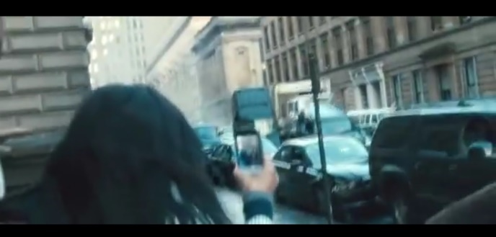

World War Z Movie, Philadelphia Scene, 2013

When deconstructing this image, you can see a person who’s a girl because of her long hair cascading over her shoulders, holding her phone up recording the massive truck shoving the other cars aside. This shows no one helping people finding a way to help stop this terroristic event, but recording it instead, shows this isn’t a community of people who want to put they’re lives on the line to help. Recently there was “an attack on one of the London bridges where a man has stabbed two people and some people helped restrain the attacker and assist the injured individuals” (BBC News, 1st December 2019) this event alone proves that there are a small amount of people out there who do want to help with massive attacks. “the brave individuals who put their own lives at risk to selflessly help and protect other” (The Queen, 1st December 2019).
Within the frame we also see metonym of the tall buildings which can identify which country and guess what the city within the country could be, in this picture the buildings show that the scene is constructed around a United States country and the most likely cities it would be based in would be: San Francisco, Philadelphia, NYC. These buildings also denote that it’s day time the way that the light is reflecting from the buildings but, it also connotes that it’s a wet day because, the reflection of the sunlight isn’t very bright in the reflections. This is also backed up by the glossy ground and the way it’s reflecting the light which shows that’s it’s been raining for a while before this act of terrorism occurs.
This frame also places the truck pushing through the middle isle of one-way traffic and the phone within the centre of the frame to show that is what the audience must focus on these objects connote once again the lack of community to help the people who are getting injured by this vehicle.

A basic knowledge of semiotics can provide guidance to the audience even during a movie it can help the audience to understand the emotions during the scene and how it’s contrasts with the world in which we live in.

Bibliography
Berger J. (1972) Ways of Seeing. London, Penguin.
BBC News and The Queen (Autor of Article not Stated), (1st December 2019), ‘London Bridge attack: ‘Amazing heroes’ praised’, [BBC News Report]. DOI 1. Available at: https://www.bbc.co.uk/news/uk-england-london-50608315 (Accessed on: 10th December 2019.)

Task Two: Manifesto (Julia’s task)
- The game world is a chance to escape.
- Reality is trapped with politics and economic growth.
- Games gives a chance to move with multiple functionality.
- You can be whoever you want to be without discrimination.
- A bond with family, friends as well as meeting new people.
- A choice to create your own person.
- Adventure to new places without having to worry about money, jobs, work.
- Be your own hero or villain.

Key Words and Images
Virtual World
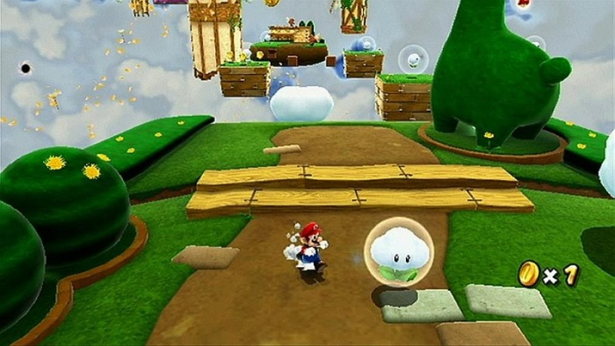

Super Mario Galaxy 2, May 2010

- Games gives a chance to move with multiple functionality.
Games made by companies such as ‘Nintendo’ uses ‘new functionality as a game such as Super Mario Galaxy develops when another game is made, wide range motion controls which would get more enjoyment from players’ (Miyamoto and NintenDaaNC, 2010) positive emotions that come from the games would block out reality struggles, they allow a person to forget all the struggles they would be going through, as well as a break from exams and studies. The game world is an amazing experience to try new tricks and moves that makes a person free. When performing a trick, they can go wrong but, it can also make players laugh at how they failed but, still looking cool when doing the trick, it gives the game more enjoyable when playing it. The audio in the games also reflects each different world which is also what makes it unique as well as hearing some similar music in previous games. ‘Super Mario Galaxy 2 has a level that resembles another level in a different game Super Mario 64 or a sequel to the original level’ (Chuggaaconroy, 2019) This gives a sense of familiarity to players who’ve played the previous games.

Key Word and Image:
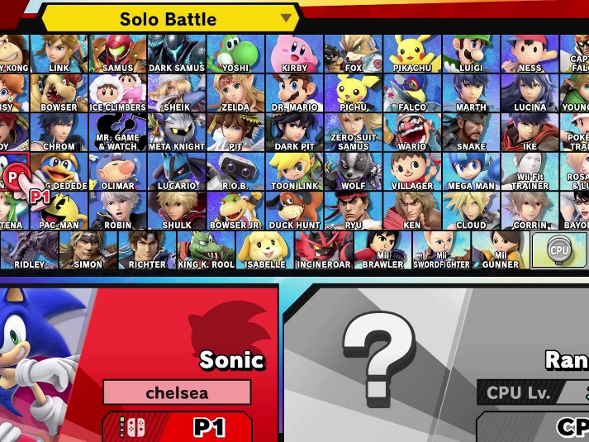
Avatar

Super Smash Bros Ultimate, December 2018
- Be your own hero or villain.
As world known es have developed people can now be the villain instead of the hero, this is what really inspires people and capture interests, after all this makes games more interesting because, not everyone wants to be the good guy or girl. Features such as these, can make a player connect with the emotions that a villain would feel and make them understand people such as terrorists in the world so they can understand them better. Being a hero or villain also gives more story/ adventure choices when you want to pick which path a player wants to go down with a game such as ‘Legend of Zelda Hylule warriors legends, the games narrative allows the player to play as both hero and villain as part of the main story and side story of the narrative/ timeline in the game’ (S.Prell, 2014) when players want to play a game one hundred percent they must change they’re way of playing if they’re going to play a villain instead of the hero for some of the levels.

Key Word and Image:
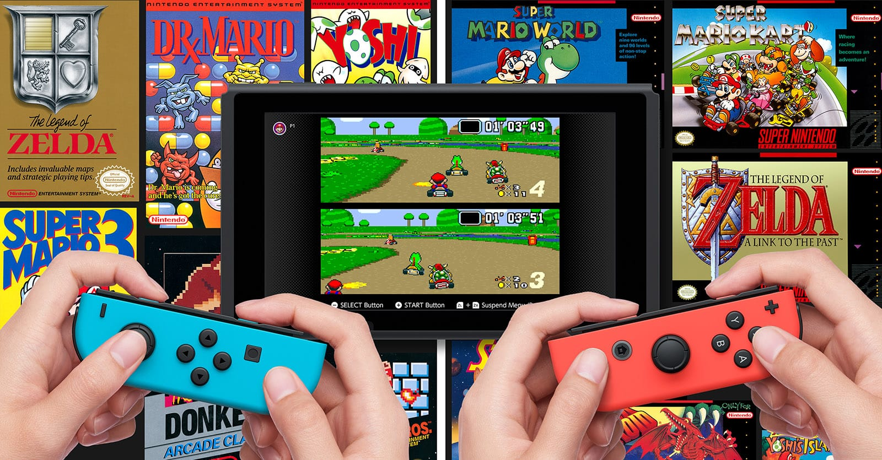
Community

Nintendo Switch Online, 2017
- A bond with family, friends as well as meeting new people.
Gaming consoles now allow people to come together as a community when players play online as well as playing with multiplayer with friends and family. It’s these consoles that allow a person to connect to the community of gamers like themselves and make new friends from around the world. Some of the games are also suited for an older target audience such as ‘Wii sports allows one to four people to play a range of five different sports allowing family to bond, competition and most importantly have fun’ (avenger00000, 2008). This is what keeps families together, children from the age of three up play games and want to have fun then grow apart as they get attached to consoles, by bringing games out that adults and children alike can play keeps the family close and attached to each other.

Bibliography:
Miyamoto and NintenDaaNC, (2010), ‘[NC UK] Miyamoto on Super Mario Galaxy 2’ [video]. Available at: https://www.youtube.com/watch?v=StxbKV095qs (Accessed on: 20th December 2019)
Chuggaaconroy, (2019), ‘Super Mario Galaxy 2- Episode 30: King of Throwbacks’ [video]. Available at: https://www.youtube.com/watch?v=X3EQiEDnWIo&list=PL_sYhAj0WXROScbAOakRhAsINVoa9sSmh&index=30 (Accessed on: 26 November 2019.)
S.Prell, (2014), Zelda villain Ganondorf playable in Hyrule Warriors.. Available at: https://www.engadget.com/2014/08/05/zelda-villain-ganondorf-playable-in-hyrule-warriors/?guccounter=1&guce_referrer=aHR0cHM6Ly93d3cuZ29vZ2xlLmNvbS8&guce_referrer_sig=AQAAANLDvZBd4Tm6owSTmZ0Cedlu4jc00L7HYakK4TkmLd9gxUE-y2S_v7dB_E__5dTjAaIWq9osKcuxc3sRn2omCSGooYPOaA_Hep5EWHBY4XEF5VckFGIghXCfgG7Iox7BOEqPsQ6E4ankkd_HQmCqr4fcAGjs6zPSh1jVEMojX9Q- (Accessed on: 2nd January 2020)
avenger00000, (2008), ‘nintendo wii commercial compilation’, [video]. Available at: https://www.youtube.com/watch?v=xc_EeTtOtwM (Accessed on 22 December 2019.)

Task Three: (Jon’s task)
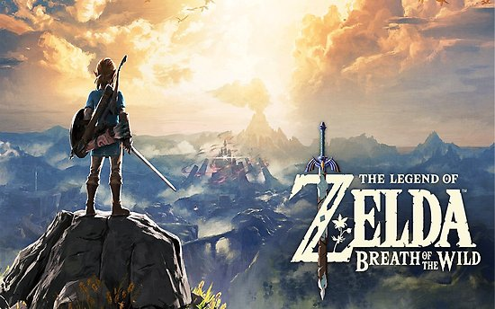

A reflection of ‘the hero with a thousand faces’ (Campbell Joseph, 1990). A hearo is a normal person in an ordinary and uneventful world and where the ‘hearos are considered odd by those who possess an ability or characteristic which makes them feel out of place’.
To represent this type of character, this is an advert for ‘The Legend of Zelda Breath of the Wild’. This represents ‘the call to adventure’ (Campbell Joseph) theory, in order for a hero ‘to begin their journey they must be called away from the ordinary world.’ This is what the image is doing to the viewers it’s drawing them into the vast world that they/ the hero is about to explore the type of landscape one would never find in the real world due to the economy/ society, conflict and wars, ‘fantastic quests don’t happen in everyday life’ (Campbell Joseph), which is what makes this virtual environment and nature have an impact on the audience.

This advert influences how big the adventure was going to be because, there are a vast number of areas and environments to explore and experience thanks to ‘accepting the call’ (Campbell Joseph) they can have a choice of where to go next. The artwork was from an advert back when it was going to be released in 2017 and it stood out and caught the eye of the people because, it was going to be the next biggest Zelda game ever for the new Nintendo Wii U and Switch consoles. The adverts were placed in gaming shop windows such as ‘Game’ and had huge social media adverts on ‘YouTube’, there were Facebook pages and groups, this really stood at because, the game was aimed a young teenage audience who are known to be on social media all the time. This work had an impact on me because, looking at it made me feel like I was standing on top of this virtual world right beside the for whom would be my guide around the environment of my own heroic journey.
The sword design had an impact on me left me breathless with the way the light is shining through the shadow of the figure. This object shows the impact of the world because, it was brighter and more powerful than the hero.
Breath of the Wild was given a ‘Golden Joysticks Award’ once released in 2017 (BBC Newsbeat, 2017) which proves how big of a quest this proved to be for a player and the in-game heroic journey is for people to escape to. This game wished for the character Link/ the players character to ‘know that has multiple options and actions he could take and the player can think for themselves what choices you want to make so you can be more connected with Link’ (ZackScottGames, 2017) this feature is important because, as you look at the image you are the person who makes the choice to peruse this quest/ heroic journey and they should feel an emotional connection with the character they are playing as to allow the game to identify where your choices would ultimately lead to.

Bibliography
Campbell Joseph, (1990), ‘THE HERO’S JOURNEY’, [PDF File]. Available at: http://mythologyteacher.com/documents/TheHeroJourney.pdf (Accessed on: 20/12/2019)

No name provided on article/ newsbeat, (2017), ‘The Legend of Zelda: Breath of the Wild named the ultimate game at the Golden Joystickes’, [news article]. Available at: http://www.bbc.co.uk/newsbeat/article/42027185/the-legend-of-zelda-breath-of-the-wild-named-ultimate-game-at-the-golden-joysticks (Accessed on: 20/12/2019)

Aonuma Eiji, Miyamoto Shigeru and ZackScottGames, (2017), Interview with Shigeru Miyamoto and Eiji Aonuma! The Legend of Zelda: Breath of the Wild! [video]. Available at: https://www.youtube.com/watch?v=-qH7DvSBlwk (Accessed on: 20/12/2019.)

