Reflecting on the Competence of Entrepreneurs using Entrecomp, AI and Narratives People Know and Love

Abstract
In the evolving landscape of education, where generative artificial intelligence (AI) is making significant inroads, the confluence of celebrated storytelling and entrepreneurship education presents a transformative pedagogical approach. This paper delves into the potential of harnessing narratives from a spectrum of celebrated texts, from Tolkien's Middle-Earth to the adventures of Winnie the Pooh and the galactic battles of Star Wars, as foundational pillars to impart the competencies of the EntreComp framework. By drawing upon the rich production values and cultural resonance of these stories, educators can craft engaging lessons that not only resonate with students but also align with key entrepreneurial competencies. Central to this approach is the role of AI, exemplified by tools like GPT, Claude and Bard which facilitate the creation of content, exercises, and reflective prompts that are both contextually relevant to the narrative and pedagogically sound. This paper unveils a novel methodology, intertwining the magic of storytelling with the rigor of entrepreneurship education, leveraging AI's capabilities to create a dynamic, interactive, and deeply reflective learning environment.
Keywords
Entrepreneurship Education | Generative Artificial Intelligence | Storytelling in Education | EntreComp Framework| Reflective Learning | GPT in Education

Contents
Introduction 2
The Power of Storytelling in Entrepreneurship Education 3
The Reflecting on Stories 4
The EntreComp Framework and Storytelling Reflections 5
The Role of AI in Bridging Storytelling and Entrepreneurship Education 7
Practical Implementation 8
Step 1: Identifying a Resonant Narrative 8
Step 2: Generating a Narrative Summary with GPT 8
Step 3: Ask GPT to Identify Competencies within the Storyline 8
Step 4: Crafting Analogies Along the EntreComp Framework 9
Step 5: Engaging in Reflective Exploration 10
Reflection and the Power of AI 12
The Ethics of AI in Entrepreneurial Education: An Educator's Perspective 13
Conclusion 14
References 15

Introduction
Historically, stories have played a pivotal role in education, offering a rich tapestry of experiences, lessons, and insights that resonate deeply with learners. People instinctively make sense of the world by using “story”. It seems we “live inside” great stories where we find ourselves walking in the character’s shoes or feeling emotionally connected (Moon, 2010).
Storytelling is a device that humans use to communicate ideas translating experiences that can be consumed publicly. (Bruner 1986; Miller and Pennycuff 2008) argue that it has been an intrinsic part of human culture passing knowledge across generations.
Instead of just emphasising theoretical knowledge, stories underscore the significance of practical application of skills and real-world performance (Bridges, 1996; Mulder, 2012; Vitello et Al, 2021)
Along with psychosocial attributes like beliefs and values, competence is defined as the aptitude to merge and employ knowledge, skills seen in stories with a view to ensuring consistent achievements within a given area (Vitello et Al, 2021).
In the contemporary enterprise education, the EntreComp framework emerges as a comprehensive tool to foster entrepreneurial competencies, emphasising the importance of competences that entrepreneur’s “do” such as spotting opportunities, mobilizing resources, and working with others (European Commission, 2016).
The allure of using popular narratives in teaching entrepreneurial competence, lies in their universality and their ability to captivate audiences. When juxtaposed with the competencies outlined in the EntreComp framework, these narratives become potent tools for teaching complex entrepreneurial concepts.
For instance, Frodo Baggins' journey in Tolkien's Middle-earth can illuminate the competency of "Mobilizing Resources," offering insights into leadership, resource mobilization, and team dynamics. Such an approach not only makes learning engaging but also contextualizes abstract concepts, making them more relatable and understandable for students.
However, the process of integrating these narratives with the EntreComp framework in educational curricula presents challenges. It requires a deep understanding of both the narrative and the educational objectives, and a creative approach to bridge the two. This is where advancements in artificial intelligence, particularly generative models like GPT, come into play. These AI models can assist educators in crafting lessons, activities, and reflections based on popular narratives while aligning them with the competencies of the EntreComp framework.
Moreover, the use of AI in this context is not just a mere technological addition; it represents a paradigm shift in how education can be delivered. As highlighted by Bell and Bell (2023), the integration of generative artificial intelligence into education can facilitate personalized learning experiences, providing answers, feedback, and outputs tailored to the needs of individual students. This personalization, when combined with the structured approach of the EntreComp framework, offers a promising avenue for a more enriched, engaging, and effective entrepreneurial education.
In this paper, we delve deeper into the confluence of popular narratives, the EntreComp framework, and artificial intelligence. We explore the potential of this triad, the challenges it presents, and the opportunities it offers for a more holistic, engaging, and effective educational experience.

The Power of Storytelling in Entrepreneurship Education
Storytelling, an age-old practice, has been instrumental in transmitting knowledge, values, and cultural norms across generations. Historically, stories have been the primary medium through which societies have communicated their histories, lessons, and moral values. In the realm of education, especially in the context of entrepreneurship, stories, particularly those deeply embedded in popular culture, can serve as powerful tools to elucidate complex concepts, making them more relatable and comprehensible to students.
Jarrett (2019) emphasizes the significance of storytelling in the development of human knowledge and understanding and further argues storytelling is synonymous with the social construct we call learning. However, in educational settings, particularly tertiary education, storytelling often faces challenges, some educators perceive a lack of personal creativity; or struggle to find suitable stories; some site reluctance on pedagogical grounds. Miller and Pennycuff (2008) posit that such hurdles should be overcome due to the increased engagement using storytelling is one that can engage and motivate even the most reluctant learners.
The use of popular narratives, such as those seen in popular movies, books, and television, provides a rich tapestry of characters, events, and moral dilemmas that can be mapped onto the entrepreneurial journey and described in Entrecomp Framework (European Commission, 2016). These narratives, familiar to many, can be dissected to extract lessons on leadership, decision-making, resource allocation, team dynamics, and more. Such an approach not only makes the learning process more engaging but also provides context, making abstract entrepreneurial concepts more tangible. Moon (2010) argues that “it often seems that we need story more than we need ‘truth’ – often when ‘truth’ is not entertaining to us.
The integration of AI, like GPT, into this pedagogical approach further amplifies its effectiveness. As Bell et al. (2022) highlighted, the incorporation of AI tools in entrepreneurship education can foster a more interactive and dynamic learning environment. AI can assist in customizing narratives, generating relevant content, making the learning experience more personalized and responsive.
Moon (2010) offers insights into the multifaceted nature of storytelling, suggesting various media that can carry a story, including written word, graphic representation and music. In the context of entrepreneurship education, leveraging these diverse modes can stimulate student engagement and knowledge generation.
Furthermore, the act of storytelling, as described by McDrury and Alterio (2002), enables individuals to personally reflect on aspects of the story worlds the characters inhabit aiding understanding. In the entrepreneurial context, stories can provide insights into the personal and professional challenges entrepreneurs face, their decision-making processes, their failures and successes, and the lessons they glean from their experiences.
When effectively integrated into entrepreneurship education, stories can bridge the gap between theoretical knowledge and practical understanding. By drawing on popular narratives and leveraging the capabilities of AI, educators can create a dynamic, engaging, and context-rich learning environment that resonates with students, preparing them for the multifaceted challenges of the entrepreneurial world.

The Reflecting on Stories
In the discourse on competencies, particularly those delineated in the EntreComp framework, Polanyi (1967) posits the notion of "tacit knowledge." This form of knowledge is characterized by its intuitive nature, yet its articulation and transfer remain elusive. Such competencies, deeply ingrained and often enacted without conscious thought, resist facile dissemination.
Eraut (1994) further nuances this discussion by differentiating between practical and theoretical knowledge. He contends that while practical knowledge, akin to the competencies in EntreComp, is inextricably tethered to its context, theoretical knowledge ostensibly transcends contextual boundaries. However, Eraut challenges this dichotomy, suggesting that for theoretical knowledge to attain profound significance, it necessitates active engagement and reinterpretation by the learner.
This dichotomy between perceived competence and actual practice is further elucidated by Argyris and Schön (1974). They introduce the conceptual distinction between "espoused theory" – a practitioner's articulated beliefs about their competence – and "theories in use" – the actual practices manifested in real-world scenarios. This disparity, often latent, underscores the complexities inherent in competency-based education and practice.
Schön (1983) advocates for reflection as a potent tool to bridge this chasm. He underscores the transformative potential of reflection in transmuting "knowing-in-action" into "knowledge-in-action." By discerning and addressing the incongruences between "theories in use" and "espoused theories," reflective practices can foster a more authentic and integrated understanding of competencies.
While the literature offers limited explicit definitions of reflection, the perspective of Boud, Keogh, and Walker (1985) resonates profoundly. They define reflection within the learning paradigm as "a generic term for those intellectual and affective activities in which individuals engage to explore their experiences, leading to novel understandings and appreciations." Such reflective engagements can be catalysed by analysing popular narratives, especially those already embedded within the students' cognitive landscapes.

The EntreComp Framework and Storytelling Reflections
The EntreComp Framework, developed by the European Commission, is a comprehensive tool designed to foster entrepreneurial competencies (European Commission, 2016). It encompasses and defines a set of 15 competencies, grouped into three areas: Ideas and Opportunities, Resources, and Into Action. Each competency is crucial for entrepreneurial success, and when combined with the power of storytelling, they can be made more relatable and comprehensible.
Ideas and Opportunities:
- Spotting Opportunities: Recognizing value-creating opportunities in one's socio-economic environment.
  - Example: In "Alice in Wonderland," Alice spots the White Rabbit and decides to follow him, leading her to the magical world of Wonderland.
- Creativity: Developing creative and purposeful ideas.
  - Example: In "Peter Pan," Neverland is a realm where imagination reigns supreme, and the Lost Boys continuously come up with creative games and adventures.
- Vision: Imagining the future.
  - Example: In "The Avengers," Tony Stark/Iron Man envisions a world protected by a team of superheroes, leading to the formation of the Avengers.
- Ethical and Sustainable Thinking: Assessing consequences and impact of ideas and actions.
  - Example: In "Frozen," Elsa realizes the consequences of her powers and isolates herself to protect others.
Resources:
- Self-awareness and Self-efficacy: Believing in oneself and keeping motivated.
  - Example: In "Winnie the Pooh," despite his occasional self-doubt, Pooh often finds inner strength and confidence to help his friends.
- Mobilizing Resources: Gathering and managing the necessary resources to pursue opportunities.
  - Example: In "Robin Hood," Robin mobilizes the resources of the Merry Men to redistribute wealth and challenge the oppressive regime.
- Financial and Economic Literacy: Understanding economic and financial concepts.
  - Example: In "Star Trek," the Federation's understanding of a post-scarcity economy, where resources are abundant and money is obsolete, showcases a unique perspective on economic concepts.
- Mobilizing Others: Inspiring and persuading others to join one's cause or venture.
  - Example: In "Jungle Book," Mowgli leverages the unique skills of his animal friends, like Baloo's strength and Bagheera's wisdom, to navigate the challenges of the jungle.
Into Action:
- Taking the Initiative: Taking action to turn ideas into action.
  - Example: In "Toy Story," Woody takes the initiative to rescue Buzz from Sid's house, showcasing the importance of proactive action.
- Planning and Management: Prioritizing, organizing, and following up.
  - Example: In "Harry Potter," Hermione Granger's meticulous planning aids Harry and Ron in their various quests.
- Coping with Uncertainty, Ambiguity, and Risk: Making decisions under uncertain conditions.
  - Example: In "Star Wars," Rey takes the initiative to find Luke Skywalker and learn the ways of the Force, showcasing the ability to act under uncertainty.
- Learning through Experience: Learning by doing and reflecting on experiences.
  - Example: In "Alice in Wonderland," Alice's encounters with various whimsical characters and her navigation through Wonderland's challenges lead to personal growth and self-awareness.

The Role of AI in Bridging Storytelling and Entrepreneurship Education
The integration of Artificial Intelligence (AI) into the educational landscape has ushered in a new era of possibilities, particularly in the realm of entrepreneurship education. As elucidated by (Mollick & Mollick, 2023), AI can be harnessed to implement evidence-based teaching strategies that might otherwise be challenging due to time and resource constraints.
In the context of entrepreneurship education, the fusion of storytelling with pedagogical objectives can be significantly enhanced by AI. Traditional methods of weaving storytelling into education often demand intensive manual effort, with educators meticulously crafting exercises and narratives. AI, especially Large Language Models (LLMs) like GPT-3, presents a paradigm shift, offering scalability and the ability to generate content rapidly (Mollick & Mollick, 2022).
These LLMs, trained on vast datasets encompassing diverse genres and styles, have the prowess to generate compelling narratives when aptly prompted. Their training enables them to understand the nuances of information structuring, narrative development, and thematic execution. While they operate within their training boundaries, their potential for creative thought is noteworthy. They can draw connections between disparate ideas, suggest analogies, and even craft fictional scenarios.
Harnessing this creativity can lead to the production of narratives that align with both popular stories and specific competencies within the EntreComp framework. For instance, when briefed about a competency such as "Spotting Opportunities," AI can craft a narrative set in the world of "Alice in Wonderland" or "Star Trek," enhancing the relatability and engagement of the learning experience.
The benefits of integrating AI into entrepreneurship education are manifold:
- Enhanced Engagement: Drawing from popular narratives, AI can create content that resonates with students, making lessons more engaging and memorable.
- Diverse Learning Materials: The vast array of stories within AI's reach ensures diverse content, catering to varied student preferences.
- Efficiency: The automation of content generation by AI allows educators to concentrate on other pivotal aspects of teaching, such as fostering discussions and offering personalized guidance.
- Consistency: AI ensures alignment of content with the competencies of the EntreComp framework, maintaining pedagogical consistency across various narratives and exercises.
Moreover, as highlighted by Mollick & Mollick (2023), AI can act as a "force multiplier" for educators, enabling them to implement challenging but well-proven pedagogical strategies. By generating multiple explanations from varied perspectives, AI can assist instructors in deconstructing their knowledge, making it more accessible to students. This aligns with the notion that for clear and logical explanations to be provided to novices, experts must deconstruct their knowledge (Ericsson & Pool, 2016).
While AI holds immense promise in revolutionizing entrepreneurship education, it is imperative to approach its integration with caution and thoughtfulness. As the field of AI continues to evolve, it presents both opportunities and challenges, necessitating ongoing research and dialogue among educators, researchers, and technologists.

Practical Implementation
As Mollick & Mollick (2023) emphasize, the use of AI, particularly in the realm of education, can be transformative when applied judiciously. Here's a step-by-step guide to implementing this approach:

Step 1: Identifying a Resonant Narrative
Before delving into AI-generated content, it's pivotal to identify a narrative that resonates with the student cohort. This narrative should be one that students recall with ease, ensuring that the subsequent lessons built around it are both engaging and relatable. For instance, if a cohort has a shared appreciation for "Star Wars," it becomes an ideal narrative backdrop.

Step 2: Generating a Narrative Summary with GPT
Once the narrative is chosen, educators can use GPT to generate a concise summary or overview. This serves as a refresher, ensuring all students have a shared understanding of the narrative's key events and themes.
Example Prompt: "Provide a brief summary of the 'Star Wars' original trilogy, highlighting the main events and characters."
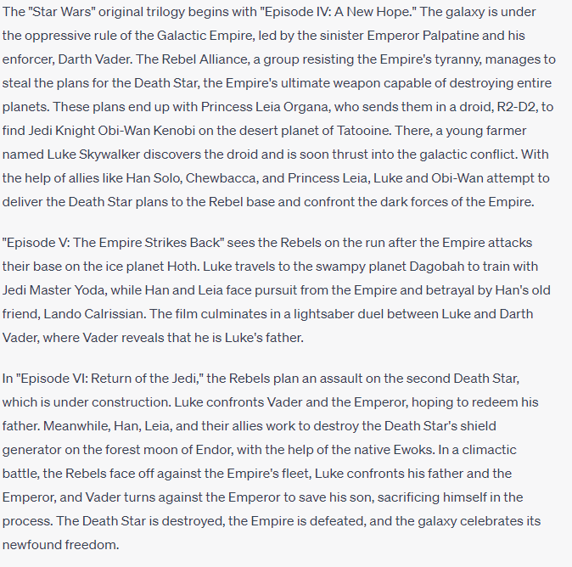
Figure 1 GPT 4 responds to prompt to provide a brief summary of Star Wars

Step 3: Ask GPT to Identify Competencies within the Storyline
Prompt GPT with a question like: "Which entrepreneurship competencies from the EntreComp framework are evident in the Star Wars original trilogy?" This will generate a list of competencies that the storyline naturally illuminates.
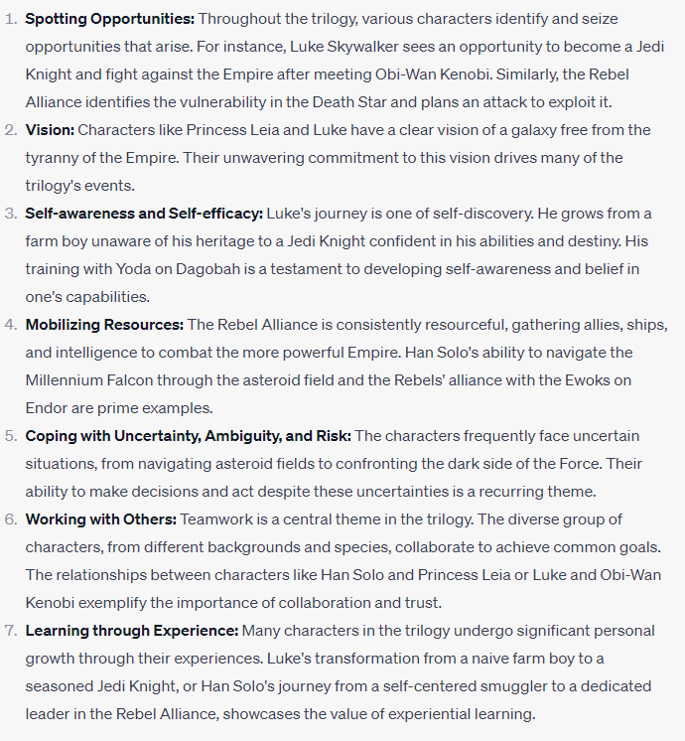
Figure 2 GPT Responds to prompt: Which entrepreneurship competencies from the EntreComp framework are evident in the Star Wars?

Step 4: Crafting Analogies Along the EntreComp Framework
With the narrative foundation set, educators can now utilize GPT to craft analogies that align with the EntreComp competencies. These analogies serve to bridge the gap between the narrative and the competency, making abstract concepts more tangible.
Example Prompt:
"Draw an analogy between Luke Skywalker's journey in 'Star Wars' and the EntreComp competency of 'Spotting Opportunities.”
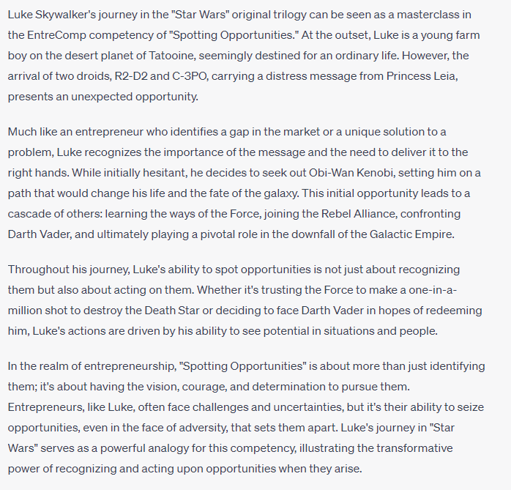
Figure 3GPT responds to prompt: Draw an analogy between Luke Skywalker's journey in 'Star Wars' and the EntreComp competency of 'Spotting Opportunities

Step 5: Engaging in Reflective Exploration
After establishing the analogy between the narrative and the EntreComp competency, the next phase involves guiding students into introspection. This is achieved by presenting reflective questions tailored to the competency, encouraging students to connect the narrative to their own experiences and deepen their understanding.
Example Prompt:
"Based on the analogy between Luke Skywalker's journey and the 'Spotting Opportunities' competency, provide reflective questions that encourage students to examine their own experiences with recognizing and acting on opportunities."
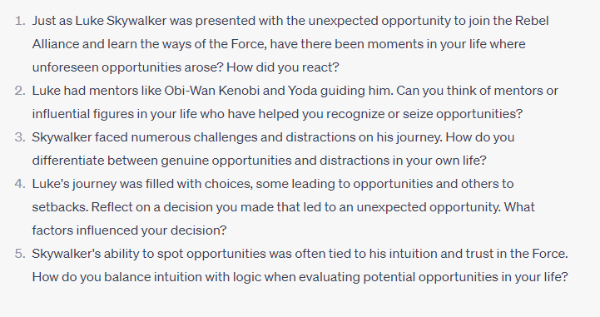
Figure 4 GPT Responds to Prompt: Based on the analogy between Luke Skywalker's journey and the 'Spotting Opportunities' competency, provide reflective questions that encourage students to examine their own experiences with recognizing and acting on opportunities
These questions are designed to help students draw parallels between Luke's journey and their own experiences, fostering a deeper understanding of the 'Spotting Opportunities' competency.
Relevance: By starting with a narrative familiar to students, the lessons inherently become more relevant and engaging (Mollick & Mollick, 2023).
Depth of Understanding: Analogies, as Mollick & Mollick (2023) highlight in their meta-referencing of prior educational studies, serve as powerful tools to deepen understanding, allowing students to grasp complex concepts through familiar narratives.
Flexibility: The use of AI offers educators the flexibility to craft content that aligns with varied narratives and competencies, ensuring lessons remain fresh and diverse.
Interactivity: AI-generated narratives can be used as starting points for discussions, debates, and reflections, fostering a more interactive and dynamic learning environment.

Reflection and the Power of AI
Reflection stands as a cornerstone in the learning process, allowing learners to introspect, analyse, and derive deeper meanings from their experiences. As highlighted by Boud, Keogh, and Walker (1985) and other scholars, reflection transforms mere information into knowledge, bridging the gap between theoretical understanding and practical application. The process of reflection is not just about looking back but also about fostering forward-thinking, enabling learners to anticipate and prepare for future challenges.
The integration of Artificial Intelligence (AI) into the reflection process offers a transformative approach to enhancing this critical aspect of learning. Here's how AI can bolster the reflection process:
Personalized Feedback: AI can analyse a student's inputs, assignments, or responses and provide tailored feedback. This feedback can highlight areas of strength, pinpoint areas needing improvement, and suggest resources or strategies to address those areas.
Prompts for Deeper Thinking: AI can generate reflective questions or prompts based on the content learned. For instance, after a lesson on entrepreneurship competencies, AI might ask, "How do you see the 'Spotting Opportunities' competency playing out in your personal experiences?"
Tools for Self-Assessment: AI can provide tools that allow students to assess their understanding and skills. By comparing their self-assessments with AI-generated assessments, students can gain insights into their perceptions versus their actual performance.
Integration of Storytelling: As discussed in the works of scholars like Jarett, storytelling can be a powerful pedagogical tool that while viewed as as problematic due to lecturers’ limited creativity, can be overcome with the clever use of AI. AI can weave narratives that resonate with students, making the reflection process more relatable and engaging. For instance, drawing parallels between a popular narrative like 'Star Wars' and entrepreneurship competencies can provide a familiar context for students to reflect upon.
Meta-Reflection: AI can assist students in reflecting on their reflection process. By analysing patterns in a student's reflective practices over time, AI can provide insights into how their reflection skills are evolving and suggest ways to enhance them.
Incorporating AI into the reflection process aligns with the sentiments of scholars like Eraut, Schon, and Boud, emphasizing the significance of transforming knowing-in-action to knowledge-in-action. By facilitating deeper introspection and bridging the gap between theoretical knowledge and its practical application, AI becomes an invaluable ally in the journey of lifelong learning.

The Ethics of AI in Entrepreneurial Education: An Educator's Perspective
The integration of Artificial Intelligence (AI) into entrepreneurial education is not merely a technological advancement but an ethical endeavour. As educators harness the capabilities of AI, they shoulder the responsibility of ensuring that its application aligns with the principles of fairness, transparency, and respect for individual rights. An approach such as this highlights ethical considerations that must be considered before working.
- Balancing Technology with Human Interaction: While AI can streamline many educational processes, educators must remember the irreplaceable value of human touch. AI should complement, not replace, the personal guidance, feedback, and mentorship that educators provide.
- Bias and Fairness: AI models, reflecting the biases in their training data, can inadvertently perpetuate societal stereotypes. Educators must be discerning in their use of AI, ensuring that the feedback and content generated do not reinforce biases. Continuous evaluation and awareness of potential pitfalls are crucial.
- Authenticity of Content: As educators use AI to craft narratives or examples, they must ensure clarity about the origins of such content. Students should be made aware of the distinction between AI-generated narratives and human-authored ones, especially when these narratives are used as teaching tools.
For educators, the integration of AI into entrepreneurial education is a journey filled with promise but also laden with ethical considerations. The onus is on educators to navigate this landscape judiciously, ensuring that while they harness the efficiencies and innovations AI offers, they remain steadfast in their commitment to fairness, transparency, and the holistic well-being of their students. The goal is to use AI as a tool that amplifies the educator's capabilities, not one that diminishes the human essence of teaching and learning.

Conclusion
In the evolving landscape of education, the confluence of celebrated narratives, the EntreComp framework, and artificial intelligence presents a transformative pedagogical approach. The power of storytelling, deeply rooted in human culture, offers a rich tapestry of experiences that resonate with learners, making abstract entrepreneurial competencies tangible and relatable. As Bruner (1986) and Moon (2010) have emphasized, stories allow us to understand the world, communicate ideas, and translate experiences into public discourse.
The EntreComp framework, developed by the European Commission, provides a structured approach to fostering entrepreneurial competencies, emphasizing the importance of competences that entrepreneurs "do" (European Commission, 2016). By aligning these competencies with popular narratives, educators can craft lessons that not only engage students but also deepen their understanding of entrepreneurial concepts.
Central to this approach is the role of artificial intelligence, particularly generative models like GPT. As highlighted throughout this paper, AI offers unprecedented scalability, efficiency, and creativity in content generation. It acts as a bridge, seamlessly integrating storytelling with pedagogical objectives and enhancing both the delivery and reception of content.
Moreover, the integration of AI into this pedagogical approach offers the promise of personalization, interactivity, and deeper reflection. As Mollick & Mollick (2023) and Bell & Bell (2023) have noted, AI can act as a "force multiplier" for educators, enabling them to implement challenging but well-proven pedagogical strategies and facilitate reflective learning.
In conclusion, the synergy of storytelling, the EntreComp framework, and AI offers a promising avenue for a more enriched, engaging, and effective entrepreneurial education. By harnessing the magic of celebrated narratives and leveraging AI's capabilities, educators can create a dynamic, interactive, and deeply reflective learning environment that prepares students for the challenges and opportunities of the entrepreneurial world.

References
- Argyris C., Schön. D.. 1974. Theory in Practice: Increasing Professional Effectiveness.
- Bell, R., & Bell, H. (2023). Entrepreneurship education in the era of generative artificial intelligence.
- Boud, D., Keogh, R., & Walker, D. (1985). Promoting Reflection in Learning: A Model. Reflection: Turning Reflection into Learning. London: Routledge.
- Bridges, D. (1996). Competence‐based education and training: progress or villainy? Journal of Philosophy of Education, 30(3), 361-376
- Bruner J (1986) Acts of meaning, Cambridge, MA: Harvard University Press.
- Eraut, M. (1994). Developing Professional Knowledge and Competence. London: Falmer Press.
- Ericsson, K. A., & Pool, R. (2016). Peak: Secrets from the new science of expertise. Houghton Mifflin Harcourt.
- European Commission. (2016). EntreComp: The Entrepreneurship Competence Framework.
- Jarrett, K. (2019). Developing the art of storytelling as a pedagogical tool for academics. In Navigating with Practical Wisdom: Articles from the 2018 University of Brighton Learning and Teaching Conference. Brighton, UK.
- McDrury, J., & Alterio, M. (2002). Learning through storytelling in higher education. London: Kogan Page Limited.
- Mollick, E.R. and Mollick, L. (2023). Using AI to Implement Effective Teaching Strategies in Classrooms: Five Strategies, Including Prompts. SSRN Electronic Journal. doi:https://doi.org/10.2139/ssrn.4391243.
- Mulder, M. (2012). Competence-based education and training. The Journal of Agricultural Education and Extension, 18(3), 305-314.
- Miller S and Pennycuff L (2008) ‘The Power of Story: Using Storytelling to Improve Literacy Learning’. Journal of Cross-Disciplinary Perspectives in Education, vol. 1, no.1, pp. 36-43.
- Moon, J. (2010). Using story in higher education and professional development. New York: Routledge.
- Polanyi, M. (1967) The Tacit Dimension, Routledge and Kegan Paul, London U.K.
- Schon, D. (1983) The reflective practitioner. Temple Smith, London.
- Vitello, S., Greatorex, J., & Shaw, S. 2021. What is competence? A shared interpretation of competence to support teaching, learning and assessment. Cambridge University Press & Assessment

