  Conference of Parties Education & Youth | Abstract  A critique on youth involvement and the delivery of Education for Sustainable Development  Alison Maher (2205763)  MSc Environmental Conservation and Management

Table of Contents
Introduction 3
Agenda 21 and the formation of COP 4
Youth have a voice 5
Education for sustainable development 7
COP 28 and beyond 11
Conclusion 12
References 13
Appendix 1 – Student Led Seminar 17
Cop 27 – Education and Youth 17
Appendix 2 – Post-Seminar Summary Sheet 18
Cop 27 – Education and Youth 18
Appendix 3 – Sustainable Development Goal 4 infographic 21
Appendix 4 – SDG 4 Quality Education 22

Introduction

This report aims to determine to what extent COP conferences have addressed the subject of Education and youth. Looking at research, policy and legislation and discussions from a student-led seminar conclusions will be drawn as to how effective these conferences have been. Particularly in increasing youth involvement in these conferences and progress on Education for sustainable development and how realistic it is that the 2030 Sustainable Development Goal 4, quality education, will be realised.

Conference of the Parties (COP) have, to a certain degree, engaged with the topic of education and youth since their inception. However, the extent and complexity of these discussions have varied considerably over the years. Bold statements have been made and policies and legislation enacted. Nevertheless, when critically assessing any success, questions remain as to the accomplishments to date and what the future prospects are for youth and their education. It has been suggested that education is paramount towards achieving sustainability. Solutions posited from the realms of economics, politics, and technology alone are insufficient. A profound transformation in our cognitive paradigms and behaviour is necessary to transition towards a sustainable future (Bokova 2015).
Education for Sustainable Development is crucial for preparing future generations with the necessary understanding and abilities to lessen, adapt to, and ultimately reverse the impacts of climate change. However, pupils must also be taught critical thinking abilities, the science behind climate change, and ethical frameworks for implementing sustainable development (Yadav 2023).

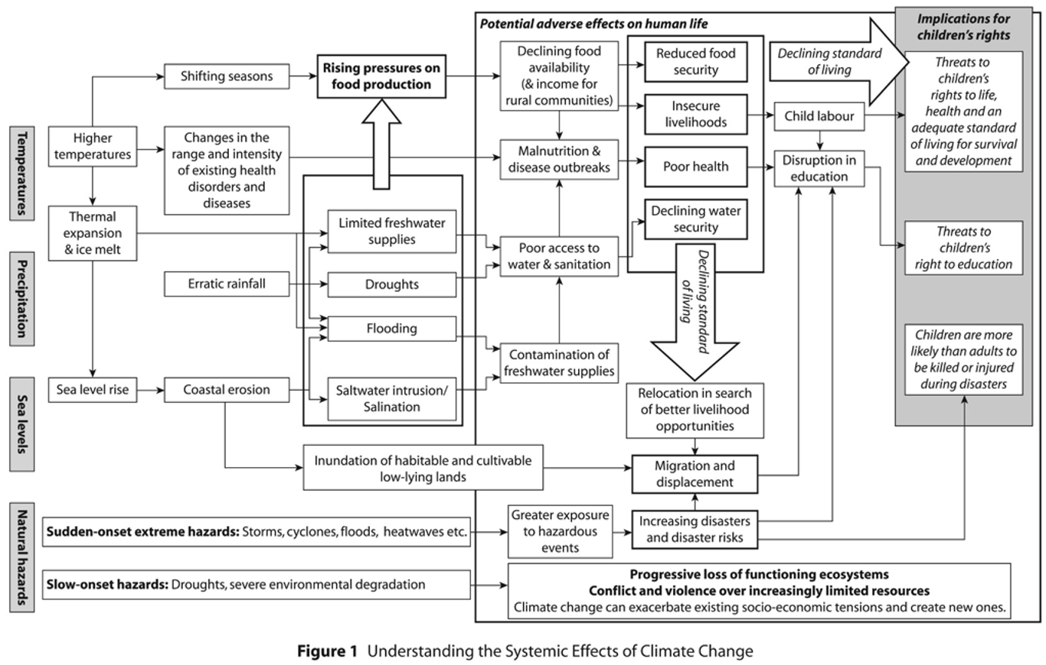
In their pivotal work, Mochizuki and Bryan (2015) delve into the intricate relationship between climate change and its far-reaching implications for children’s rights and education. This critical analysis sheds light on the systemic effects that reverberate across societies, transcending geographical boundaries and generations. Children, born into this evolving reality, face a lifetime shaped by climate-induced disruptions. These disruptions can be slight and seemingly insignificant or conversely, disastrous. They exacerbate existing vulnerabilities, potentially reversing hard-won gains in child survival and well-being. Ecosystems shift, extreme weather events intensify, and resources dwindle, children bear the brunt. Their access to education, health, and safety becomes increasingly tenuous. The flowchart below illustrates how climate-induced disruptions such as increased temperature, higher precipitation, sea level rise and natural disasters will almost always have a negative impact on children, their health and their
Figure 1 Understanding the Systemic Effects of Climate Change (Mochizuki & Bryan, 2015)

Agenda 21 and the formation of COP

The chronological figure presented below delineates pivotal milestones that have profoundly influenced the evolution of Education and Youth at COP conferences, ultimately establishing their prominent role as climate activists and leaders.
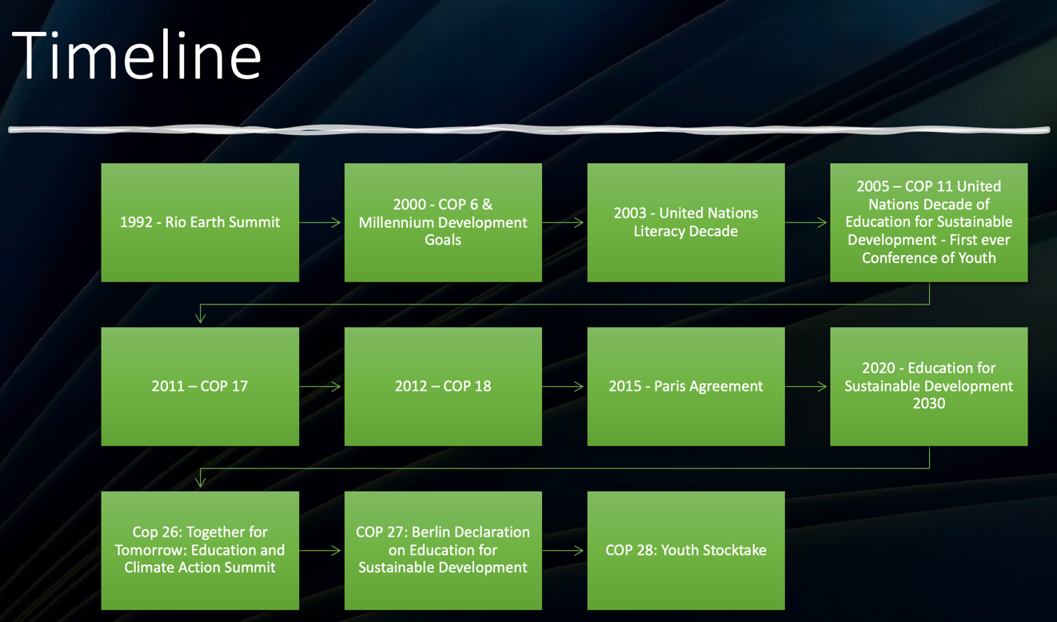
Figure 2 Timeline of key dates for Education and Youth at COP

The Earth Summit held in Rio de Janeiro in 1992 culminated in the formulation of Agenda 21, a comprehensive plan of action for global leaders to pursue sustainable development. Chapter 25, titled ‘Children and Youth in Sustainable Development’, acknowledges the pivotal role of young individuals and emphasises the necessity of their active participation at all levels, including decision-making processes, in environmental conservation. It further mandates that by the year 2000, each nation should ensure that at least half of its youth population has access to secondary education (United Nations, 1992).

Agenda 21 is an ambitious action plan, which could be perceived as being inherently susceptible to failure due to its lofty objectives that are non-binding which has meant that implementation has varied across different regions and governments (Stakeholder Forum for a Sustainable Future, 2011). Nevertheless, it is plausible to suggest that it laid the groundwork for establishing the blueprint for Education for Sustainable Development, and perhaps will facilitate the attainment of the Sustainable Development Goals (SDGs) by 2030.

Youth have a voice

The first instance where young people had a notable contribution at COP conferences was in COP 6 in The Hague. Here two youth delegates reported on the outcomes of their previous week’s Youth Conference which was attended by 118 young people from 61 countries. They stressed the importance of youth representation calling for a regular World Youth Meeting on Climate Change (Convention on Biological Diversity, 2002). This was also the year that the Millennium Development Goals, of which “Achieve universal primary education” declared that by 2015 children will be able to complete a full course of primary education and have access to all levels of education, regardless of gender. At the World Education Forum the international community affirmed its commitment to achieving Education for All (EFA) by 2015 through the adoption of the Dakar Framework for Action. This Framework focuses on six EFA goals, the last goal being to improve all aspects of quality education, but it mainly focusses on inequalities amongst women and girls, and indigenous groups with little focus on the environment.

At COP 8 youth delegates presented the Children’s Charter to President Baalu, it detailed their concerns for greenhouse gasses, rising sea levels and threats to biodiversity. (International Institute for Sustainable Development 2002). The presence of young people at these conferences up till now could be seen as tokenistic in nature with little commitment to listen and action what they were calling for. It wasn’t until 2005 that both Education and Youth were prominent subjects at COP where the first Conference of Youth took place and the discussions and outputs of these fed into the main COP discussions. This was also the year that the United Nations Decade of Education for Sustainable Development (2005-2014) was officially launched.

A significant advance in progress happened during COP 17 where Anjali Appadurai, a member of the Youth Delegation, gave a concise speech highlighting the UNFCCC negotiations’ inability to effectively address climate change stating that young people have been given a voice at these conferences and yet their interests are not being addressed (Appadurai, A. 2021). It could be argued that this speech was the catalyst to further, more impactful appearances at COP. The following year at Doha, Qatar approximately 800 people marched in what is thought to be the country's first demonstration. Of these people around 100 were members of the Arab youth climate movement who called for their Arab leaders to take the lead in the climate talks about to convene (Vidal, J. 2012).

With this increase in young inspirational speakers, COP 21 in Paris, saw various Youth-led side events, workshops, and activities taking place including Intergenerational Inquiry sessions. For the next three COP conferences these ‘side events’ remained completely separate and seemed to just be a token gesture towards young people and their involvement in COP. By 2018 frustrations due to inaction were building, which led to Greta Thunberg delivering a powerful speech at COP 25 urging world leaders to take urgent action on climate change (Carrington, D. 2018). Spurred on by Thunberg’s Fridays for Future protests COP 26 in Glasgow saw thousands of protestors take to the streets to protest against inaction on climate change (Quiñones, L. 2021). This conference also saw the plenary Together for Tomorrow: Education and Climate Action Summit, this was the first gathering of Environment and Education ministers together at an international level. This event was also notable for the Youth for Climate movement as it saw the launch of their Youth4Climate Manifesto. It brings together the ideas and concerns of young climate leaders, categorising them into the following themes: Youth Driving Ambition, Sustainable Recovery, Non-State Actors' Engagement and Climate Conscious Society (Giulia. 2022).

Education for sustainable development

The Greening Education Partnership is a worldwide effort that adopts a holistic system-wide strategy to assist nations in addressing the climate crisis. It recognises the pivotal role of education in achieving sustainable development. This partnership serves as a collaborative platform for governments Non-governmental organizations, civil society, youth, academia, and the private sector. The Greening Education Partnership strives to implement robust, synchronised, and comprehensive measures. Its ultimate goal is to equip every learner with the necessary knowledge, skills, values, and attitudes to effectively address climate change and promote sustainable development. It aims to achieve this through its four pillars of transformative education:
• Greening Schools: Implementing sustainable practices within educational institutions.
• Greening Curriculum: Integrating climate change education across subjects.
• Greening Teacher Training and Education Systems’ Capacities: Enhancing educators’ readiness to teach climate-related topics.
• Greening Communities: Engaging local communities in climate action.
(UNESCO, 2022). Eco-Schools, a worldwide educational initiative, actively involves 19.5 million children across more than 70 countries. This program offers a comprehensive seven-step framework, motivating students to proactively engage with environmental challenges. By fostering youth participation, Eco-Schools cultivates a profound sense of responsibility toward the planet’s well-being. Schools participating in this initiative undertake a diverse range of activities, including waste reduction, energy conservation, and biodiversity projects. Through the implementation of sustainable practices, students acquire valuable skills while contributing to a more ecologically conscious future. As discussed in the student-led seminar (see appendix 2) the implementation of this programme across the whole school can be inconsistent and not wholly embraced by all teachers and pupils.

The 2002 World Summit on Sustainable Development (Johannesburg Summit) the UN General Assembly declared the period between 2005 and 2014 as the United Nations Decade of Education for Sustainable Development and designated UNESCO as the lead agency. This decade helped pave the way towards Article 12 of the 2015 Paris Agreement. Article 12 states that all measures should be taken to enhance climate change education, training, public awareness, public participation and public access to information (UNCCC, 2015). Although increased media coverage during COP 21 in Paris helped close the knowledge gap on climate change, the overall knowledge on this subject area was limited and verified that the most effective way of closing this knowledge gap is through education (De Silva-Schmidt et al. 2022). Selin (2016) states that Incorporating real-world application of engaging in COP 21 helped students achieve a variety of learning goals relevant to multidisciplinary sustainability education and this active learning improves pupil engagement. Similarly, Menzie-Ballantyne and Ham (2021) discovered that the School Strike 4 Climate protests enrich the curriculum and offer chances for interdisciplinary learning and a profound conceptual grasp of global citizenship and sustainable development. The rallies contributed to a deeper understanding of these important topics.

Ramírez et al. (2023) agree that integrating ESD into curriculums supports various SDG’s as outlined in the UN Agenda 2030. This integrated approach fosters environmental consciousness, critical thinking and informed decision making, however when it comes to the actual integration into curriculums there is a distinct disparity across the globe. Figures 3 and 4 below highlight the disparity between the extent to which global citizenship education and education for sustainable development are mainstreamed into policies and subsequently the mainstreaming of global citizenship and sustainable development into curricula (Our World in Data team, 2023).
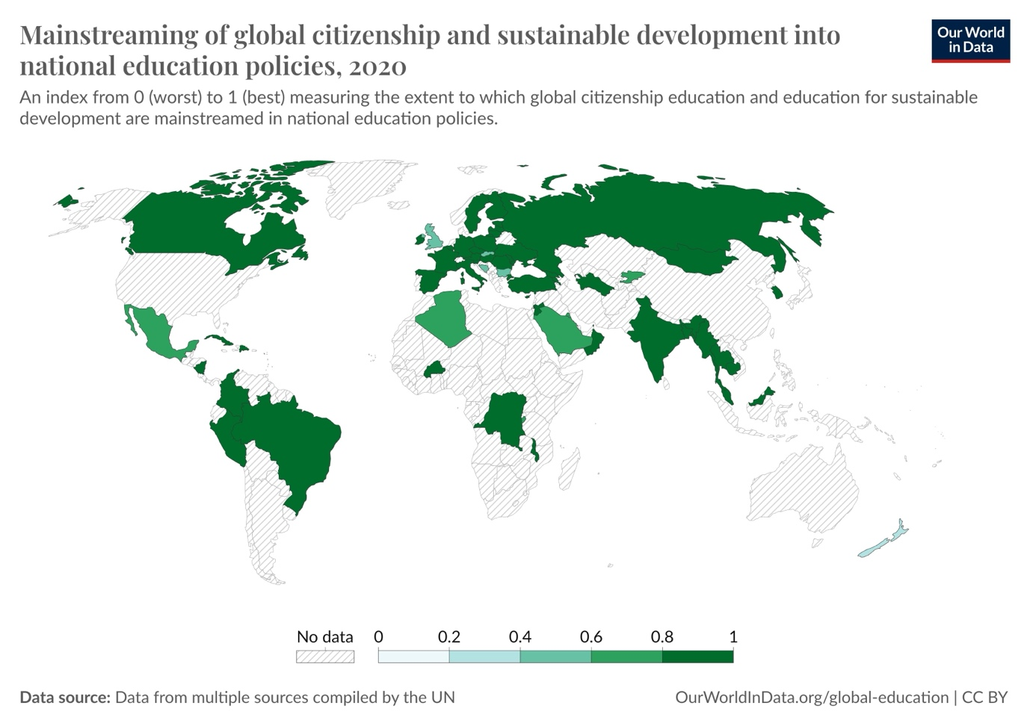
Figure 3 Mainstreaming Sustainable Development into National Education Policies
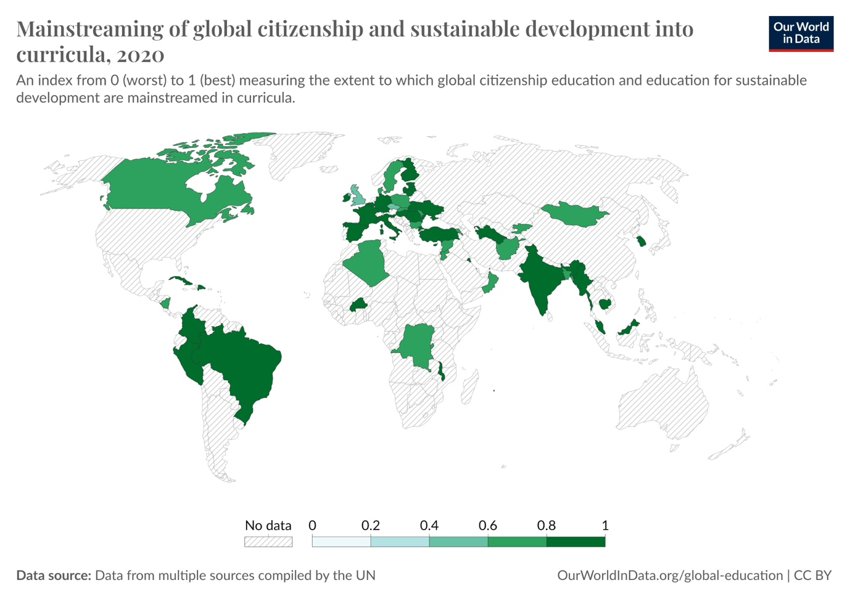
Figure 4 Mainstreaming Sustainable Development into Curricula
A rigorous worldwide social science study by Brunold and Ohlmeier (2022) assessed the effectiveness of the implementation of the UN Decade for Education and found that the goals outlined within the DESD have not been sufficiently entrenched on an international or regional scale in certain instances. Also they contend that the success of the DESD hinges upon the inclusion of Civic (Citizenship) Education as a fundamental prerequisite. To address this, they advocate for the implementation of long-term, structurally embedded strategies that fully integrate Civic Education into educational curricula. Importantly, these strategies should emphasise the significance of Civic Education by incorporating concepts related to good governance and democracy.

Similarly Mochinzuki & Bryan (2015) adopt a similar perspective asserting that the education sector does not explicitly prioritise climate change education in vital strategy documents like Article 6 of the United Nations Framework Convention on Climate Change (UNFCCC). They hypothesise that the climate crisis necessitates a robust educational paradigm that actively engages learners in comprehending the scientific, technical, behavioural, ethical, effective, and pragmatic dimensions of climate change. While pedagogical interventions are frequently posited as the solution to climate change, there is still uncertainty of how this should be delivered so that it is most effective and results in positive action. Vaughter (2016) & Olsson (2022) posit the solution could be placed in action competence. Imparting knowledge about climate change alone and expecting positive action as a result is foolish, knowledge without action is meaningless. Action competence is fundamental so that positive attitudes and behaviours foster direct positive societal action, resulting in sustained tangible climate positive action and social justice. It is recommended that learning environments are established that create foundations for action competence to grow and flourish, certain policies and practices act as barriers to positive climate action and even go as far as to contradict the knowledge that is being taught in climate change education. This was also echoed from the personal experiences discussed in the student-led seminar. Vaughter (2016) & Olsson (2022) further state that action competence should take into account the uniqueness of each school, culture and society. Through this understanding, action competence has the potential to flourish.
Pupils should be part of school decision-making processes when it comes to how they should respond to the issues of climate change. This involvement is instrumental in fostering students’ action competence, it empowers them and allows them to realise the gravity of being the custodians of the globe. Cincera & Krajhanzl (2013); Ahmad et al. (2023) echo that pupils involvement in the Eco-Schools programme allows them to play and active role in the schools decision-making when it came to positive climate action, giving them recognition that they are not passive recipients of knowledge but active participants in shaping their educational environment. Lee et al. (2015) Found that education level and beliefs about the causes of climate change are effective predictors of climate change awareness. Although this research is nearly ten years old, it still holds relevance to the current status quo as Flynn et al. (2021) echo these findings in their study, the largest ever on public opinion on climate change.

In the 2016 International Conference on Education as a Driver for Sustainable Development Goals, it was underscored that the progression towards sustainable development should not be viewed solely through the conventional economic lens. Instead, it necessitates the incorporation of three pivotal domains: environmental, social, and economic. However, the core of the problem ultimately resides in behaviour change amongst citizens across the globe and characteristics such as respect, empathy, enthusiasm, dedication and compassion are essential for fostering a conducive environment for the educational shift towards sustainability. (International Conference on Education as a Driver for Sustainable Development Goals 2016).

It would be fair to say that the UNESCO Global Action Programme (GAP) encountered challenges in fully realising its objectives. Consequently, an extension was implemented by the formulation of a strategic roadmap. This extension specifically targeted the attainment of Goal 4 of the Sustainable Development Goals, which pertains to quality education. ESD for 2030, building upon the foundation laid by the GAP, seeks to reorient and fortify educational systems and practices to actively support sustainable development across all domains. Notably, ESD for 2030 places heightened emphasis on education's pivotal role in advancing the broader SDGs. Subsequently, the Berlin Declaration, issued in 2021, underscores the critical importance of Education for Sustainable Development. It calls for concerted efforts to seamlessly integrate sustainability principles into education at all levels, equipping students with the requisite knowledge, skills, values, and attitudes necessary for meaningful contributions to sustainable development

COP 28 and beyond

COP conferences have progressively acknowledged the significance of youth participation in its deliberations. YOUNGO, the official youth constituency of the United Nations Framework Convention on Climate Change, established in 2009, champions the integration of young individuals in climate change initiatives. Representatives from YOUNGO deliver formal declarations and contribute to the negotiations. Notably, it was during COP28 in Dubai that the inaugural Youth Stocktake was convened, assembling youth leaders and climate activists to deliberate on youth policy proposals. It culminated in the 2023 Global Youth Statement a consolidated list of policy demands from over 700,000 young people in over 150 countries. This marked a significant milestone in the recognition and inclusion of youth voices in climate change discourse and policy-making (YOUNGO, 2023). Moreover, the Greening Education Partnership established the first historical Greening Education Hub, featuring over 200 sessions organised to promote concrete actions and solutions through education (United Nations, 2023).

Gey et al. 2022 argue that in order for ESD to be most impactful, students should be involved in the assessment and evaluation of their own learning. But indicators need to be established in order to monitor and evaluate the implementation of ESD and how far we are from achieving the 2030 goal. Günther et al. (2022) Developed an Outcome Indicator Test to assess the implementation of ESD among students in Germany which highlighted the knowledge and attitudes of individual learners as a key indicator when measuring the success of SDG 4.7. Zdravkova (2023) also highlights the importance of working at a micro level, focussing on personalised learning to foster sustainable development among students that then permeates through to the mezzo level and eventually the macro levels of policy and governments.
Kopnina’s (2020) critical analysis of the Education for Sustainable Development goals shines a light of the disparity between sustainable development and the persistent drive for economic growth. She justifiably states that there lies contradiction within the SDG’s and that in order for ESD to succeed a system that is far more eco-centric and educates with both indigenous knowledge and scientific knowledge rather than an economy-centred anthropocentric system.

Conclusion

It could be concluded that quality education for sustainable development is some way off from achieving the 2030 goal; however, some significant progress has been made.
There is hope emanating from Wales where the Wellbeing of Future generation Act localises the global UN targets into seven well-being goals and provides a legally-binding common purpose for national and local government, health boards and other specified public bodies
Furthermore the new Welsh Curriculum, Implemented in 2022, sets out a new way of learning for all aged 3-16. It focusses on four purposes one being to help foster ethical, informed citizens who: Show their commitment to the sustainability of the planet and are ready to be citizens of Wales and the world.

Quality education for sustainable development could be achieved through a systematic universal curriculum that is entirely transparent in its delivery, reporting and evaluation. As highlighted in the student led seminar in order for progress to be made, there should be a standardised approach to how countries report on implementing Sustainable Development Goal 4 to allow for more transparency and have it embedded within the political agenda.
However, it must be developed with local priorities in mind but have a global perspective in its delivery and impact. A robust teacher training framework will help create a workforce that is fully equipped to deliver ESD.

The engagement of young people in Conference of the Parties conferences has witnessed notable advancements, albeit primarily in recent years. However, a comprehensive integration of the youth agenda within these critical global gatherings remains an ongoing imperative. The above analysis has delved into the evolving landscape of youth involvement in COP conferences, emphasising key milestones and persistent challenges.
Over the years, COP conferences have accommodated youth participation through parallel side events. These ancillary sessions provided a platform for young voices to express their perspectives on sustainable development. However, despite these efforts, the youth agenda remained somewhat peripheral, lacking a central stage for meaningful dialogue and influence.
A pivotal turning point occurred at COP 28, where young delegates finally ascended to a more prominent position. Their concerns, aspirations, and demands found resonance on a real pedestal. This elevation allowed youth representatives to articulate their vision for a sustainable future, transcending mere tokenism. While COP 28 marked progress, sustained youth engagement remains elusive. Further efforts are essential to fully integrate the youth agenda into the core fabric of COP conferences. The empowerment of young leaders is integral to the global pursuit of a more equitable and sustainable world.

References

Ahmad, N., Toro-Troconis, M., Ibahrine, M., Armour, R., Tait, V., Reedy, K., Malevicius, R., Dale, V., Tasler, N., & Inzolia, Y. (2023). CoDesignS Education for Sustainable Development: A Framework for Embedding Education for Sustainable Development in Curriculum Design. Sustainability, 15(23), 16460. https://doi.org/10.3390/su152316460

Appadurai, A. (2021). Lookback: Anjali Appadurai Speaks for ‘Silent Majority’ at COP 17. [Online]. The Energy Mix. Last Updated: March 1, 2021. Available at: https://www.theenergymix.com/lookback-anjali-appadurai-speaks-for-silent-majority-at-cop-17/ [Accessed 27 April 2024]

Brunold, A., & Ohlmeier, B. (2022). Civic Education for Sustainable Development of UNESCO – Decade 2005–2014. Discourse and Communication for Sustainable Education, 13(2), 79–90. https://doi.org/10.2478/dcse-2022-0020

Carrington, D. (2018). 'Our leaders are like children,' school strike founder tells climate summit. The Guardian. [Online]. Tue 4 Dec 2018. Available at https://www.theguardian.com/environment/2018/dec/04/leaders-like-children-school-strike-founder-greta-thunberg-tells-un- [Accessed 15 March 2024].

Cincera, J., & Krajhanzl, J. (2013). Eco-Schools: what factors influence pupils’ action competence for pro-environmental behaviour? Journal of Cleaner Production, 61, 117–121. https://doi.org/10.1016/j.jclepro.2013.06.030

Convention on Biological Diversity. (2002). THE YOUTH DECLARATION TO THE CONVENTION ON BIOLOGICAL DIVERSITY, THE HAGUE, NETHERLANDS. [Online]. Global Youth Biodiversity Network. Last Updated: 18th April 2002. Available at: https://www.gybn.org/_files/ugd/0d4e2d_5a5fc42ed3344ed6b09cba95bc912f22.pdf [Accessed 15th March 2024].

De Silva-Schmidt, F., Brüggemann, M., Hoppe, I., & Arlt, D. (2022). Learning about climate politics during COP 21: Explaining a diminishing knowledge gap. Public Understanding of Science, 31(5), 617–633. https://doi.org/10.1177/09636625211068635

Education Cannot Wait (September 2023) Alarming New Global Estimates: 222 Million Crisis-Affected Children and Adolescents are Now in Need of Education Support, Available at: https://www.educationcannotwait.org/sites/default/files/2022-06/ecw_222million_study_advocacypaper.pdf (Accessed: 11 December 2023).

Flynn, C., Yamasumi, E., Fisher, S., Snow, D., Grant, Z., Kirby, M. Browning, P.,
Rommerskirchen, M., & Russell, I. (2021) Peoples’ Climate Vote, United Nations Development Programme.

Foundation for Environmental Education. (2023). ECO-SCHOOLS AS A WHOLE SCHOOL APPROACH. [Online]. Eco-Schools. Available at: https://static1.squarespace.com/static/550aa28ae4b0f34c8f787b74/t/657717e0f3cee14f13da573f/170230371 [Accessed 7th April 2024].

Gey, N., Pellaud, F., Blandenier, G., Lepareur, C., Massiot, P., Shankland, R., & Gay, P. (2022). Assessment of cross-cutting competences in education for sustainable development. Environmental Education Research, 29(5), 766–782. https://doi.org/10.1080/13504622.2022.2136362

Giulia. (2022). Youth4Climate Manifesto. [Online]. Youth4Climate. Last Updated: 8 August 2022. Available at: https://community.youth4climate.info/topic/youth4climate-manifesto [Accessed 15th March 2024].

Günther, J., Overbeck, A. K., Muster, S., Tempel, B. J., Schaal, S., Schaal, S., Kühner, E., & Otto, S. (2022). Outcome indicator development: Defining education for sustainable development outcomes for the individual level and connecting them to the SDGs. Global Environmental Change, 74, 102526. https://doi.org/10.1016/j.gloenvcha.2022.102526

International Conference on Education as a Driver for Sustainable Development Goals. (2016). Journal of Education for Sustainable Development, 10(2), 214–218. https://doi.org/10.1177/0973408216661813
International institute for sustainable development, (2002). summary of the eighth conference of the parties to the un framework convention on climate change: 23 October – 1 November 2002. IISD.

Irina Bokova. (2015). Why education is the key to sustainable development. [Online]. World Economic Forum. Last Updated: 19th May. Available at: https://www.weforum.org/agenda/2015/05/why-education-is-the-key-to-sustainable-development/ [Accessed 23 April 2024].

Kopnina, H. (2020). Education for the future? Critical evaluation of education for sustainable development goals. The Journal of Environmental Education, 51(4), 280–291. https://doi.org/10.1080/00958964.2019.1710444

Lee, T. M., Markowitz, E. M., Howe, P. D., Ko, C.-Y., & Leiserowitz, A. A. (2015). Predictors of public climate change awareness and risk perception around the world. Nature Climate Change, 5(11), 1014–1020. https://doi.org/10.1038/nclimate2728

Menzie-Ballantyne, K., & Ham, M. (2021). School Strike 4 Climate: the intersection of education for sustainable development, education for global citizenship and the Australian Curriculum. Australian Journal of Environmental Education, 38(1), 85–95. https://doi.org/10.1017/aee.2021.14

Mochizuki, Y., & Bryan, A. (2015). Climate Change Education in the Context of Education for Sustainable Development: Rationale and Principles. Journal of Education for Sustainable Development, 9(1), 4–26. https://doi.org/10.1177/0973408215569109

Olsson, D., Gericke, N., & Boeve-de Pauw, J. (2022). The effectiveness of education for sustainable development revisited – a longitudinal study on secondary students’ action competence for sustainability. Environmental Education Research, 28(3), 405–429. https://doi.org/10.1080/13504622.2022.2033170

Our World Data Team. (2023). Mainstreaming Sustainable Development into National Education Policies. [Online]. Our World Data. Available at https://ourworldindata.org/sdgs/quality-education. [ Accessed on 15th November 2023 ].

Our World Data Team. (2023). Mainstreaming Sustainable Development into Curricula. [Online]. Our World Data. Available at https://ourworldindata.org/sdgs/quality-education. [Accessed on 15th November 2023 ].

Police, Crime, Sentencing and Courts Act 2022. Available at: https://www.gov.uk/government/publications/public-order-bill-overarching-documents/public-order-bill-factsheet (Accessed 11 December 2023).

Quiñones, L. (2021). COP26: Thousands of young people take over Glasgow streets demanding climate action. [Online]. United Nations. Last Updated: 5 November 2021. Available at: https://news.un.org/en/story/2021/11/1105042 [Accessed 5th April 2024].

Ramírez Suárez, V., Acosta-Castellanos, P. M., Castro Ortegon, Y. A., & Queiruga-Dios, A. (2023). Current State of Environmental Education and Education for Sustainable Development in Primary and Secondary (K-12) Schools in Boyacá, Colombia. Sustainability, 15(13), 10139. https://doi.org/10.3390/su151310139

Selin, N. E. (2016). Teaching and Learning from Environmental Summits: COP 21 and Beyond. Global Environmental Politics, 16(3), 31–40. https://doi.org/10.1162/glep_a_00364
Stakeholder Forum for a Sustainable Future, 2011. Review of implementation of Agenda 21 and the Rio Principles . United Nations.
The Guardian (2023) How will recent and future legislation affect the right to protest in the UK?, Available at: https://www.theguardian.com/world/2023/nov/13/how-will-recent-and-future-legislation-affect-the-right-to-protest-in-the-uk (Accessed: 11 December 2023).

UNCCC (2015) Paris Agreement Available at: https://unfccc.int/files/meetings/paris_nov_2015/application/pdf/paris_agreement_english_.pdf [Accessed: 11 December 2023]

UNESCO. (2022). Greening Education Partnership. [Online]. UNESCO. Available at: https://www.unesco.org/en/sustainable-development/education/greening-future [Accessed 15th March 2023].

United Nations (1992) Agenda 21 Available at: https://sustainabledevelopment.un.org/content/documents/Agenda21.pdf [ Accessed on 15th November 2023 ].

United Nations. (2023). COP28 hosts first ever Youth Stocktake with YOUNGO. [Online]. COP 28. Last Updated: 8 December 2023. Available at: https://www.cop28.com/en/news/2023/12/COP28-hosts-first-ever-Youth-Stocktake-with-YOUNGO [Accessed 27 April 2024].

Vaughter, P. (2016). Climate Change Education: From Critical Thinking to Critical Action. https://f55146caed8a556d1b4344a3e60314a0.r2.cloudflarestorage.com/scholarcy-library--ingestion--production/885af19e-2f1b-4112-95cf-8aab71e6671c/UNUIAS_PB_4.pdf?X-Amz-Expires=3600&X-Amz-Date=20240420T125136Z&X-Amz-Algorithm=AWS4-HMAC-SHA256&X-Amz-Credential=201ed02fc7ecca88dc772b53fdcdc8ff%252F20240420%252Fauto%252Fs3%252Faws4_request&X-Amz-SignedHeaders=host&X-Amz-Signature=68f1db3e5012e4850a91a5cf22e55c82b65627b27466e6f6689eacdb9c6261c2

Vidal, J. (2012). Doha climate conference diary: Qatar's first environmental march. The Guardian. [Online]. Mon 3 Dec 2012. Available at https://www.theguardian.com/environment/blog/2012/dec/03/doha-climate-conference-diary [Accessed 5th April 2024].

Vidal, J. (2015). The young climate campaigners to watch before the UN's Paris summit. The Guardian. [Online]. Wed 10 Jun 2015. Available at https://www.theguardian.com/environment/2015/jun/10/young-climate-campaigners-paris-cop21 [Accessed 5th April 2024].

Yadav, S. (2023). Promoting Environmental Sustainability Among Students and Citizens for a Sustainable Future. In Advances in Educational Marketing, Administration, and Leadership (pp. 187–211). IGI Global. https://doi.org/10.4018/978-1-6684-9099-0.ch009

YOUNGO, (2023) Global Youth Statement, Available at: https://static1.squarespace.com/static/64e71b1580e9dc25aacc828d/t/6556a53d18157b2d49e1ae91/1700177231473/Global+Youth+Statement+Condensed+Demands [Accessed 15th March 2024].

Zdravkova, K. (2023). Personalized Education for Sustainable Development. Sustainability, 15(8), 6901. https://doi.org/10.3390/su15086901

Appendix 1 – Student Led Seminar

Cop 27 – Education and Youth

Cop 27 could be considered one of the most significant gatherings since Paris 2015. Cop 27 saw G77 + China agree to provide financial reparations in the form of a ‘loss and damage’ fund for developing countries (mainly the global south) to help these nations recover from the damage and economic losses as a result of the ongoing impacts of climate change. Although this is a significant step forward, Cop 27 did not end with a commitment to phase out fossil fuels. Many people remain dubious as to whether this loss and damage fund will materialise into anything, especially as no legal action can be taken against countries that don’t contribute. Although much attention was paid to the specifics of the ‘loss and damage’ fund throughout the conference, education also took a significant step forward. For the first time, education had a dedicated platform for voicing their demands for quality climate change education for all.

The Covid 19 pandemic saw the largest disruption to the education system in history. More than 90% of children worldwide were negatively impacted, with girls and young women being disproportionately affected.

Youth movements have become more and more prominent and vocal in recent years in advocating for action on climate change. From the Fridays for Future movement to the Youth Climate Movement, young people are actively working towards making quality education for sustainable development accessible to all worldwide.

This seminar will use available information from the Sustainable Development Goals (specifically SDG 4), Non-Governmental Organisations and national legislation to explore and possibly find answers to the questions below.

Who – Should be included? What age range?
What – What should Education for Sustainable Development look like in practice?
When – The SDGs are time-sensitive, with a target to achieve all of them by 2030. Is this a realistic timeframe?
Why – Why is education so important? Are there other more important issues that should be addressed first?
How – How could Education for Sustainable Development be delivered? Locally, nationally and globally? How far away are we from success?

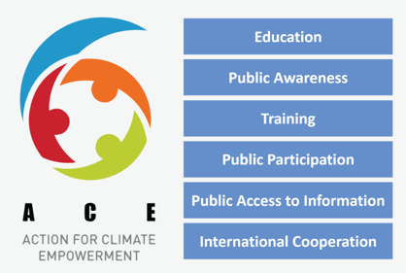

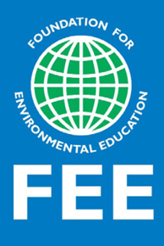


Appendix 2 – Post-Seminar Summary Sheet

Cop 27 – Education and Youth

A short presentation was delivered to students outlining the extent to which Education and Youth has been discussed at COP conferences over the years and what milestones have been achieved to date. A brief overview of Sustainable Development Goal 4 (Quality Education) started a group discussion summarised below.

Who – Should be included? What age range?
The group's consensus is that Education for Sustainable Development (ESD) involves mainly children of primary age, with more emphasis on Eco-School schemes and the importance of outdoor learning and forest school schemes. There is significantly less emphasis on this when pupils are secondary school age and even more so at college or university. At the university level, there are conservation societies, but these are mainly voluntary; there could be some scope for this to be more embedded into university life, perhaps something more mandatory. A possible solution could be implementing this holistically through other subjects across the universities. Certain subjects, such as law, have no connection to the issue of climate or environment unless a specific topic in case law includes it. With the older students, there could be more opportunities to get more involved. Educational trips, students could make more valuable contributions to making a difference environmentally. However, there are potentially some issues around people gathering in groups. Recent changes in the law have made it difficult for people to demonstrate or protest against climate issues (Police, Crime, Sentencing and Courts Act 2023; The Guardian, 2023).
Teaching ESD should be incentivised to be seen as a prestigious profession but accessible to all communities and people with diverse backgrounds and demographics. Projects should be nationally and locally significant; people are more inclined to become involved in projects that are local to them and that directly benefit the local community. A whole school, whole community approach would ensure greater ‘buy-in’ from a broader range of stakeholders by finding out what the pupils and community have in common and how this can be used to drive education for ESD.

What – What should Education for Sustainable Development look like in practice?
Every teacher should be climate literate from the beginning so that climate change and ESD can be taught across all subjects; the new Welsh Curriculum does support this to a certain extent. However, this will only be realised once fully embedded over time. Educators must share the same standpoint on ESD; there cannot be any disparity between a teacher's knowledge and the collective drive to teach this subject. Some teachers have been known to be dismissive and hold the “it doesn’t matter anyway” opinion. This can create confusion among pupils and potentially reverse the excellent work that other teachers have invested in them.
Teaching pupils more about the “real world” could help pupils to recognise the importance of ESD. History lessons about the Tudors and Stuarts and the Industrial Revolution are important. Still, such lessons could also include how the behaviours of this time have led to the climate issues we are experiencing today. In addition, pupils could explore how climate change has developed over the years, helping them to find possible solutions to this crisis.
However, making what is taught relevant to the age group is essential—being mindful of not focusing too much on the negative aspects and being aware of climate anxiety. It is important not to instil fear in them but to inspire them to take action and make them aware that there is a time element to this and action needs to be taken sooner rather than later.

When – The SDGs are time-sensitive, with a target to achieve all of them by 2030. Is this a realistic timeframe?
Although progress has been made since 1992, it seems unrealistic that quality ESD will be achieved by 2030. With the right policies and political support, it is possible to accomplish this, but at a later date. It could be that certain things are prioritised over others. Decisions may have to be made as to what is more important. Is it policies or implementation of an ESD curriculum? This, however, should not distract us from the task at hand, and all efforts, no matter how small, should be made to achieve this goal, no matter how unlikely it may seem. Each small step is still progress. For progress to be made, there should be a standardised approach to how countries report on implementing Sustainable Development Goal 4 to allow for more transparency and have it embedded within the political agenda.

Why – Why is education so important? Are there other more important issues that should be addressed first?
Increasing awareness of climate change through education helps to challenge people's perceptions, ideas and inaccuracies. Having COP 28 held in the UAE has its discrepancies, but it could be seen as shining a spotlight onto a place that historically has not had quality universal education for all and in an area of considerable investments in the exploration of oil.
Evidence has shown that through education, people's opinions have changed, even since the 1990s. The increase in knowledge has led to many taking action on climate change, from ‘Just stop oil’ to the ‘Fridays for Future’ movements. Without education on climate change, perhaps there would not be so many successful activist groups. However, some countries have other far more critical issues that must be resolved first, such as war or famine, leaving many without an education. (Education Cannot Wait, 2023)

How – How could Education for Sustainable Development be delivered? Locally, nationally and globally? How far away are we from success?
Although the group did not get around to answering these questions directly, the discussion outlined above did go some way to finding possible answers to these questions. It could be concluded that quality education for sustainable development is some way off from achieving the 2030 goal; however, some significant progress has been made. This could be achieved through a systematic universal curriculum that is entirely transparent in its delivery, reporting and evaluation. It must be developed with local priorities in mind but have a global perspective in its delivery and impact. A robust teacher training framework will help create a workforce that is fully equipped to deliver ESD.

References
Education Cannot Wait (September 2023) Alarming New Global Estimates: 222 Million Crisis-Affected Children and Adolescents are Now in Need of Education Support, Available at: https://www.educationcannotwait.org/sites/default/files/2022-06/ecw_222million_study_advocacypaper.pdf (Accessed: 11 December 2023).

The Guardian (2023) How will recent and future legislation affect the right to protest in the UK?, Available at: https://www.theguardian.com/world/2023/nov/13/how-will-recent-and-future-legislation-affect-the-right-to-protest-in-the-uk (Accessed: 11 December 2023).

Police, Crime, Sentencing and Courts Act 2022. Available at: https://www.gov.uk/government/publications/public-order-bill-overarching-documents/public-order-bill-factsheet (Accessed 11 December 2023).

Appendix 3 – Sustainable Development Goal 4 infographic

Appendix 4 – SDG 4 Quality Education

