University Of Wales
Trinity Saint David

MSc Property and Facilities Management

Strategic Property, Finance and Procurement

Lecturer: Deborah Hughes Created By: Allyn Pritchard
Submission Deadline: 10th January 2023 Student No.: 1101011

Contents
1.0 Introduction 4
2.0 UWTSD Project 4
2.1 Project Overview 4
2.2 Procurement Routes 5
2.2.1 Traditional 5
2.2.2 Design & Build 6
2.2.3 Management 7
2.2.4 Collaboration 7
2.3 Tender Process 8
2.4 Contract Types 9
2.5 Recommendations 10
3.0 Asset Portfolio 11
3.1 Asset Portfolio Overview 11
3.1.1 Meyler House 12
3.1.2 Kensington Court 13
3.1.3 De Clare Court 14
3.1.4 Johnston Stores 15
3.1.5 Upper Market Street 16
3.1.6 Rhiannon House Shop & Flats 17
3.1.7 Hanover Court 18
3.1.8 Caldey Court 19
3.2 Asset Appraisals 20
3.3 Property Improvements 20
3.4 Procurement, Tender & Contract Recommendations 21
4.0 Conclusion 22
5.0 References 22
6.0 Bibliography 25
7.0 List of Figures 28
8.0 Appendixes 29
8.1 Appendix 1 29
8.2 Appendix 2 30
8.3 Appendix 3 31
8.4 Appendix 4 32
8.5 Appendix 5 33
8.6 Appendix 6 35
8.7 Appendix 7 36
8.8 Appendix 8 37
8.9 Appendix 9 39
8.10 Appendix 10 40
8.11 Appendix 11 41
8.12 Appendix 12 45
8.13 Appendix 13 46
8.14 Appendix 14 47
8.15 Appendix 15 48
8.16 Appendix 16 49
8.17 Appendix 17 50
8.18 Appendix 18 51
8.19 Appendix 19 52
8.20 Appendix 20 53
8.21 Appendix 21 54
8.22 Appendix 22 55
8.23 Appendix 23 56
8.24 Appendix 24 57
8.25 Appendix 25 58

Introduction
This report will look at two scenarios, the first scenario will look at advising UWTSD senior management team on the possible procurement route, tender process and contract options for a new construction project which will be aimed at new and innovative start-up companies (Please see Appendix 1 for an outline of the proposed project). This section of the report will outline the optimal route to secure the project and given the nature of any major construction project external expertise will be required at some point either during the procurement stage or the construction phase, no one organisation is capable of undertaking all these processes (Booth, 2010).The second scenario will look at an asset portfolio of eight properties that are owned and managed by a social housing provider. This section of the report will focus on providing a potential cost/benefit analysis of the properties and look at various data sets to determine the future viability of the properties. Given the nature of the social housing sector collaboration and social inclusion will be key to delivering value-based outcomes in not only the housing sector but in procurement (Martin Haranb, 2011). The report will also focus in on one of the properties to select the best procurement process, tendering choice, and contract to alter one of the buildings to make it DDA compliant (Please see Appendix 2 for full assumptions on the asset portfolio).

UWTSD Project

Project Overview
The project will be managed at high level by the UWTSD inhouse facilities and management team which has limited scope to be hands on during all phases of the construction project, the team also has limited experience of delivering construction projects on this scale and with such complexity. This report will now look at possible procurement, tender and contract options which would be most suited to the construction project at the SA1 campus. By ensuring the UWTSD adopts the most suitable form of procurement for this project it will help with innovation, quality and the use of technology which will only enhance the final product (Carlos Mena, 2014). The key strategic decisions will need to be based on tried and tested formulas and concepts which will aid UWTSD in the successful completion of this project, the Iron Triangle (Cost, Time & Quality) (Aqua Group, 1999) is one of these concepts and will be used as a key metric to help guide the outcome of the report (Caccamese, 2012).
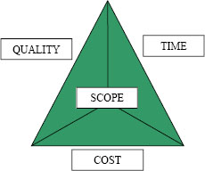

Fig. 1

Procurement Routes
There are four procurement routes open to UWTSD for this construction project and the report will look at these three to ascertain the best route, correct selection of procurement route is key as this usually dictates if the project is design led (Traditional), supplier led (Design & Build), project co-ordinator led (Management) (TOOKEY, et al., 2001) or collaboration. The report will now look in detail at the following procurement routes.
- Traditional
- Design & Build
- Management
- Collaboration

Traditional
The traditional procurement route is the main type of procurement route for the construction industry and combined with incentivisation has provided beneficial outcomes for both client and contractor (Oyegoke, et al., 2009). Traditional procurement route is a sequential process in which process steps are completed consecutively and the client engages with external consultants to prepare a design against a set brief and also prepare a project budget, tender documentation is also drafted during the early point of this process.
Traditional procurement has a range of advantages as it can be utilised by both and experienced or inexperienced client. For a full list of advantages, disadvantages and when it would apply, please see Appendix 3, some of the key advantages are as follows.
- Scheme is fully or partially designed (depending on tender approach one or two staged tender)
- Tender submissions are comparable
- Early commitment to maximum price and provide cost certainty around variations
- Build quality standards are easily controlled
- Clients have options for one or two staged tender process which could allow for more collaboration
- Easily adaptable off the shelf contracts available for use
The disadvantage of the traditional route is a long procurement time and longer construction phase due to its sequential process. There is an argument that due to the contiguous nature of traditional procurement and the possible dispute of design alterations late on in the construction phase that this slows this route to the point where the validity of the route is questioned (Kong & Gray, 2012).

Design & Build
Design and build procurement routes are being adopted more regularly within the construction industry but require a clear and defined scope from the client and the emphasis is on the contractor to be responsible for the design and construction of the project (Lam, et al., 2004). For a full list of advantages, disadvantages and when it would apply, please see Appendix 4, some of the key advantages are as follows.
- The majority of risk is transferred to the contractor
- Commitment to fixed/max price early on in process
- Client does not have to undertake full design on basic project scope, saving time, money, and effort initially
- The design is undertaken by construction experts who will find ways to value engineer all aspects of the project
- Variety of designs are undertaken during the process by several contractors, so the client has the option to choose the optimal design
Disadvantages of the route are the client will pay a premium for the risk that the contractor is taking onboard, and the contractor will only seek to meet the minimum requirements of the design brief and that the design liability will only be limited. This route will also increase costs across the board as they will be undertaking lots of the elements themselves. Utilising this procurement route could hinder collaboration between all parties including consultants, architects, sub-contractors, etc and this could have an impacts on innovation on the project (Rahola & Straub, 2013).

Management
This route is split into two sub routes which are Management Contract and Construction Management, these can provide a time and project speed advantage as processes are non-sequential, this allows the client or management agent/contractor to tender smaller works packages out before full drawings and specifications are completed. It draws many similarities with design and build but does place a greater emphasis on the client in term of overall project control (Oyegoke, et al., 2009). For a full list of advantages, disadvantages and when it would apply, please see Appendix 5, some of the key advantages are as follows.
- Works packages can overlap design and save construction time
- Collaborative way of working
- Flexibility around design but design completed in stages as per works packages
Disadvantages of the route are that cost certainty is unknown until the last works package is let, not a favourable route for an unexperienced client given the amount of works packages that could be involved in a major construction project.

Collaboration
This route provides the opportunities for innovation and usually creates the best value for money in terms of overall outcomes for the client. This route requires the client to collaborate with a nominated contractor early on, this is useful as it eliminates waste and duplication on both the client and contractor sides of the project. This method of procurement is a route that is utilised less often than others but does create the best results. For a full description, please see Appendix 6.

Tender Process
The purpose of undertaking any tender exercise is to achieve two purposes, one, select a suitable contractor and two, obtain a price within a suitable timeframe (Murdock & Hughes, 2008). Tendering is a critical stage where the client and potentially other parties would produce several documents in preparation for tender, these would include.
- Drawings
- Technical Specifications
- Performance Specifications
- Bill of Quantities
- Schedule of Rates
Full details of each one of the above documents can be found in Appendix 7.

Depending on the detail of the documents in appendix 7, the complexity of the project and other deliverables this would help indicate what tender route would be most applicable for UWTSD. Cost is a key deciding factor, but it is now an accepted fact you should not appoint a contractor exclusively on cost alone and that a certain level of quality assurance is needed, and this should be incorporated into the tender itself (Murdock & Hughes, 2008).
The seven routes of tender that the project could use are as follows.
- Open Tendering
- Selective Tendering
- Negotiated Tendering
- Framework Tendering
- Single-Stage and Two-Stage Tendering
- Public Procurement (OJEU)
Please see appendix 8 for an in-depth description of each route
Each tender route has its merits in isolation, but negotiation does play a key part in the entire process, negotiation & collaboration when implemented correctly can have benefits for both client and supplier. The construction industry seems to unintentionally avoid collaboration and partnership working as both parties feel that they will lose an element of control, but this way of working does benefit both parties and the overall construction project (Plane & Green, 2012).
The construction project that UWTSD want to undertake is going to need to fit the skill set that it has available internally in both procurement and construction phases, UWTSD have an inhouse facilities/construction team which can undertake the management part of the design required but would need external consultants to support in other aspects. Currently UWTSD do a significant number of open tenders which are available to all contractors/suppliers to tender for online via Sell2Wales, this is shown in appendix 9 and this does evidence that UWTSD does have the capability to undertake any route, but resource will need to be planned out accordingly. Regardless of what tender route is chosen, ensuring that the tender documents are clear and accurate is critical to ensuring comparative tender returns, substandard tender documents could lead to inaccurate estimates, higher costs within bids and potential claims and disputes during the construction phase (Laryea, 2011).

Contract Types
Choosing the right contract type is hugely important but usually selecting the right form of contract is dictated by the procurement route which is chosen (Lupton & Stellakis, 2019) and no particular form of contract is perfect for specific project types (Abed, et al., 2018). So, the types of contract that are available to UWTSD for this project they are as follows.
- Fixed Price Contracts
- Cost Reimbursable
- Measured Contracts

(Please see appendix 10 for an in-depth analysis of each type of contract)
Within the construction industry there are an array of contract forms to choose from and they have different applications, with varying degrees of complexity making some difficult to interpret without some level of legal understanding and some are less adversarial than others (Murdock & Hughes, 2008). The main forms of contracts are as follows.
- JCT (Joint Contracts Tribunal)
- NEC4
- FIDIC (International Federation of Consulting Engineers)
- ICC/ICE (Association for Consultancy and Engineering and Civil Engineering Contractors Association)
- CIOB (Chartered Institute of Building)
- RIBA (Royal Institute of British Architects)
Please see appendix 11 for an in-depth analysis of the first 3 types, others are available but for the purpose of this report these will not be looked at, but they will be referenced only.
Given the complexity of the project and the inhouse UWTSD team availability selecting a contract which is clear, non-adversarial and promotes collaboration will be fundamental if the project is to succeed.

Recommendations
Looking at the project as a whole and given its potential complex build requirements and the demand on resource in terms of time from staff at UWTSD, this report will use tried and tested methods when selecting what procurement route, tender process, and contract to use for the project. Within Appendix 12, the report utilises the Skidmore and Marsden Strengths and weakness of Procurement Routes (Roy Morledge, 2021) table in which helps guide clients to choosing a procurement route. As you can see based on the requirements set out in appendix 12, design and build is the more favourable option closely followed by collaboration. This form of procurement will allow for a commitment of a fixed price early on, with the contractor taking onboard the majority of the risk involved. When it comes to the tender process given that UWTSD have vast amounts of experience within public sector tendering (as per appendix 9). It is recommended that the tender process should be an open tender, by undertaking the open tender process the university can maximise their input early on to ensure all requirements are clearly set out within the tender documents. This process will also allow for maximum competition amongst potential bidders ensuring the cost is competitive, also the process would possibly be subject to public sector procurement rules (dependent upon funding for the project) and must be advertised on open tender platforms like the Official Journal of the EU (OJEU, 2021). Looking at the contract options and the nature of the works being undertaken, only two contract options really stand out NEC4 and JCT. Both contract types have their merits, but the NEC would be more suitable given its non-adversarial nature, clarity and flexibility coupled with a design and build procurement route, these are also some of the reasons the NEC contract forms were recommended in “Constructing the Team the Latham Report” in which Sir Michael Latham recommended NEC should be adopted more widely (Latham, 1994) . In terms of the specific NEC4 contract which should be used appendix 13 shows a JCT contract selection flowchart which can be used as a guide only but looking at this in conjunction with the NEC documents it is recommended that the NEC4 Design Build and Operate Contract be used given that its designed for design and build projects (NEC, 2021). The recommendation given for this construction project are amongst the most popular within the construction industry it also highlights the lack of choice for major constructions projects and/or the lack of suitable skilled professionals employed within organisation to undertake other options/routes (NBS, 2018) .

Asset Portfolio

Asset Portfolio Overview
ateb housing are a traditional registered social landlord within Pembrokeshire west Wales, and has a property stock of 3118, ranging from traditional general needs properties to commercially operated premises (please see Appendix 14 for stock count and locations). Within ateb’s property stock, eight properties have been identified that need assessing to ascertain whether or not these properties are viable for the future (Welsh Government, 2022) and if not, what will be the most beneficial outcome for the organisation in relation to these buildings. Further details regarding the eight properties can be found in appendix 2.

Meyler House
Meyler House is ateb’s current corporate office, which is situated in the middle of Haverfordwest and constructed in 1972, Pre covid the building was at 100% capacity with over 150 people based at the offices. Post covid the building is being used in a hot desk set up with around 250 employees working in a hybrid fashion. The building is split over two floors with a commercial EPC rating of ‘E’, is freehold and the major building components are in overall poor condition. Meyler House has a current total capital component replacement cost of £314,500.00, all of the major components will need replacement within the next 10 years. Please see appendix 15 for the full component list of Meyler House that was generated from ateb’s asset management system Lifespan.

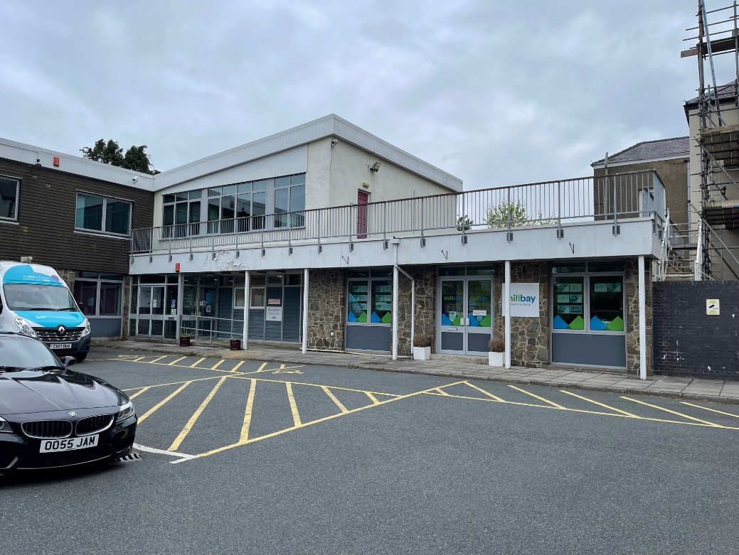

Fig. 2

Kensington Court
Kensington Court is a 52-bed extra care setting situated on the outskirts of Haverfordwest. The building was constructed in 2011, is staffed 365 days of the year by ateb staff and is a freehold build with a current commercial EPC rating of ‘C’. The building is split over 5 floors and houses a commercial kitchen, dining area, hairdressers, and communal laundry facilities. Kensington Court has a current total capital component replacement cost of £739,700.00 and overall, the building is in excellent condition. Please see appendix 16 for the full component list of Kensington Court that was generated from ateb’s asset management system Lifespan.



Fig. 3

De Clare Court
De Clare Court is a 36-bed extra care setting situated in Milford Haven. The building was constructed in 2009, is staffed 365 days of the year by ateb staff and is a freehold build with a current commercial EPC rating of ‘C’. The building is split over 4 floors and houses a commercial kitchen, dining area, staff meeting rooms and communal laundry facilities. De Clare Court has a current total capital component replacement cost of £659,300.00 and overall, the building is in excellent condition. Please see appendix 17 for the full component list of Kensington Court that was generated from ateb’s asset management system Lifespan.



Fig. 4

Johnston Stores
Johnston Stores is an estimated 320m² storage facility that is used by ateb’s in-house trades team to store building materials and tools. The building is leased for a modest fee of £408.00 per calendar month from a local landowner, the lease itself is on a rolling 12-month contract which provides no certainty as the landowner could decide not to renew the lease at any time. Given the nature of the building it does not have nor require a commercial EPC. ateb have no responsibility for the building components as the lease agreement states that all repairs and servicing will be carried out by the building owner but it is ateb’s responsibility to report all defects in a prompt manner. The building is in extremely poor condition and given ateb’s growth over the last decade, the organisation has now outgrown the facility.

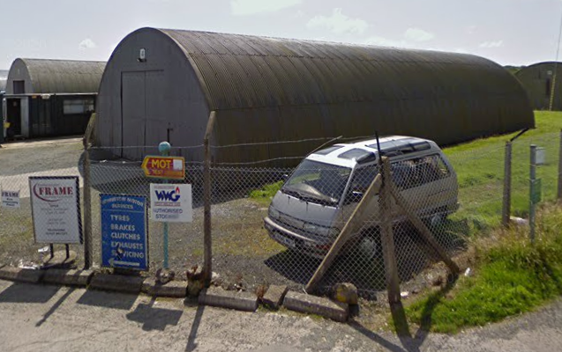

Fig. 5

Upper Market Street
Upper Market Street is a block of 6 renovated flats within the centre of Haverfordwest, the building was constructed in the late 1900’s and is freehold, it sits within a conservation area and is a listed building the current domestic EPC rating of all the Flats is ‘F’. The building is split over 3 floors and houses 6 1 bed flats. Upper Market Street has a current total capital component replacement cost of £150,100.00 (communal and all flats) and overall, the building is in poor condition. Please see appendix 18 for the full component list of Upper Market Street that was generated from ateb’s asset management system Lifespan.

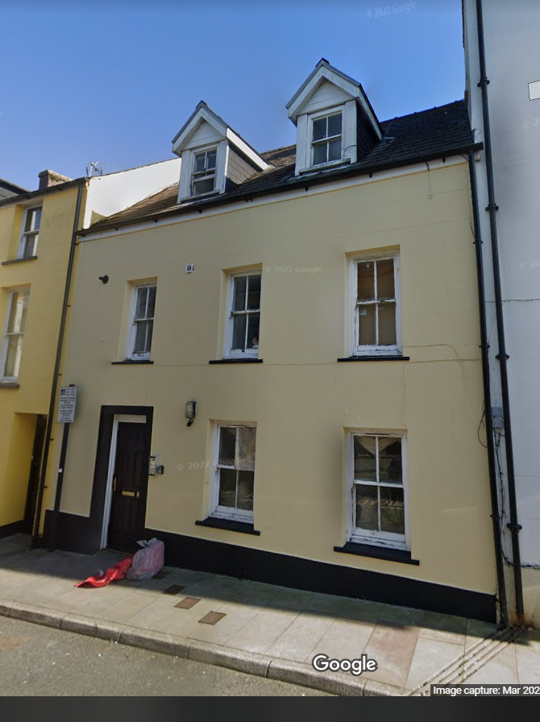

Fig. 6

Rhiannon House Shop & Flats
Rhiannon House shop and flats are a block of 6 renovated flats and a leased shop within the centre of Pembroke Dock, the building was constructed in the late 1900’s and is freehold, it sits within a conservation area and the current domestic EPC rating of all the Flats is ‘E’. The building is split over 3 floors and houses 6 2/3 bed flats. The shop of the ground floor is leased out to a local hairdressers who have full responsibility of the shop’s landlord compliance and maintenance of building components within the ground floor. Rhiannon House has a current total capital component replacement cost of £230,600.00 (communal and all flats) and overall, the building is in poor condition. Please see appendix 19 for the full component list of Rhiannon House that was generated from ateb’s asset management system Lifespan.



Fig. 7

Hanover Court
Hanover Court is a block of 38 flats in Tenby, the building was constructed in 1984 and is leased from Coastal Housing who are another registered social landlord based in Swansea, ateb have signed a fully managed lease for 100 years (89 years left). The property sits within a conservation area the current domestic EPC rating of all the Flats is ‘D’. The building is split over 4 floors and houses 38 2-3 bed flats. Hanover Court has a current total capital component replacement cost of £752,800.00 (communal and all flats) and overall, the building is in good condition. Please see appendix 20 for the full component list of Hanover Court that was generated from ateb’s asset management system Lifespan.



Fig. 8

Caldey Court
Caldey Court is a purpose-built block of flats on the outskirts of Haverfordwest, the building was constructed in 1991 and is freehold, and the current domestic EPC rating of all the Flats is ‘D’. The building is split over 3 floors and houses 6 3 bed flats. Caldey Court has a current total capital component replacement cost of £143,300.00 (communal and all flats) and overall, the building is in good condition. Please see appendix 21 for the full component list of Rhiannon House that was generated from ateb’s asset management system Lifespan.



Fig. 9

Asset Appraisals
When looking at asset appraisals we need to first understand what ateb’s key strategic requirements are around their property stock, Appendix 22 sets out 15 critical business requirements and what they mean to the organisation, these requirements go beyond the bricks and mortar and look at social and economic impacts (Stewart, 2019). These 15 critical business requirements have been applied to known data sets set out within this report and other business factors, within Appendix 23 an asset appraisal has been undertaken which sets out what properties are to be disposed and what properties are to be retained within the stock.
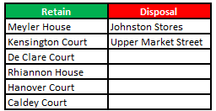

Fig. 10
The above table summarises what properties are to be retained and what properties are to be disposed of using the property appraisal matrix in appendix 23. Both Johnston Stores and Upper Market Street have be chosen for disposal, this is mainly based on their current properties condition, capital component replacement costs/component life cycles and limiting conditions around properties being in a conservation area and needing listed building consent.

Property Improvements
Hanover Court produced an asset appraisal score of 3060 and is identified as a property that is key within ateb’s property stock, the only negative is that the property is leased from coastal housing for a further 89 years. Given the age, location and customer type housed within the site it would be advantageous for the site to be upgraded to further comply with the Equalities Act 2010 (The Disability Discrimination Act 1995 was superseded by the Equalities Act 2010) (Uk Goverement, 2022). Please see appendix 24 for all recommended upgrade works.

Procurement, Tender & Contract Recommendations
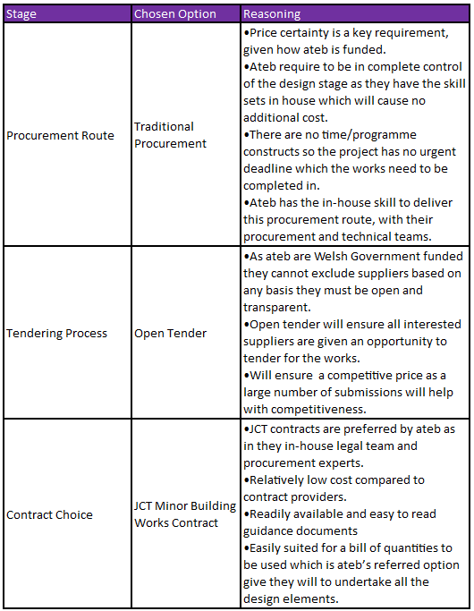
Looking at the package of works required within appendix 24, and the estimated budget of £78,700.00, this would be over ateb’s public sector threshold of £25,000.00 (ateb are a publicly funded housing group which is not for profit). so, the works will have to go to public tender and ateb publicises all tenders on ‘Sell2wales’ and they have an experienced procurement team to undertake this process (please see appendix 25 for further details). Given ateb’s track record of undertaking open tenders and status as a not-for-profit organisation which is publicly funded the preferred options would be as follows.

Fig. 11

Conclusion
Looking at the first scenario which is the UWTSD innovative construction project, there are several methods of procurement, tender and contract all of which have their own merits but looking at the wider construction sector both traditional and design & build are the most frequent used procurement routes, open tenders being the most used tender process and JCT being the number one contract type used (NBS, 2018). This is in stark contrast with the more advantageous and outcome-based options like collaboration and NEC4 contracts (Latham, 1994), what is key is to ensure that you have the correct technical competency and sufficient time to be able to deploy any of the methods/options (Oyegoke, et al., 2009). Now looking at the asset portfolio, the eight properties that the report examined had a vast array of asset data which was key to making the correct strategic decision for the housing provider. By ensuring that the key corporate, social, economic fundamentals of the housing provider were used when undertaking the property appraisals, it ensures that the right properties are kept within the housing stock based upon the organisation top priorities. The housing provider is governed by stricter procurement regulations than more commercial organisations, but this is an advantage not only to the client but the contractor and end user because decision will not solely be made upon what is more commercially advantageous but other factors including technical & social factors.

References
Abed, M., Alhalaq, K., Tayeh, B. A. & Abed, M., 2018. SELECTING THE APPROPRIATE CONSTRUCTION CONTRACT TYPE BY USING THE ANALYTICAL HIERARCHY PROCESS APPROACH. International Journal of Construction Project Management, 10(2), pp. 137-154.
Aqua Group, 1999. Tenders and Contracts for Building. 3rd ed. London : Blackwell Science.
Ashworth, A., 2012. Contractual Procedures in the construction industry. 6th ed. London: Routledge.
ateb Group, 2022. ateb. [Online]
Available at: https://www.atebgroup.co.uk/
[Accessed 22 December 2022].
Booth, C., 2010. Strategic procurement organizing suppliers ans supply chains for competitive advantage. 1st ed. London : Kogan Page .
Caccamese, A. &. B. D., 2012. Beyond the iron triangle: year zero. Marsailles, Project Management Institute.
Carlos Mena, R. v. H. M. C., 2014. Leading Procurement Strategy. 1st ed. London: Kogan Page Limited.
Designing Buildings, 2021. Designing Buildings. [Online]
Available at: https://www.designingbuildings.co.uk/wiki/Tender_processes_for_construction_contracts
[Accessed 12 December 2022].
Designing Buildings, 2021. Designing Buildings. [Online]
Available at: https://www.designingbuildings.co.uk/wiki/Collaborative_procurement_in_the_construction_industry
[Accessed 14 December 2022].
El Sawalhi, N. &. A. O., 2017. Multi-Attribute Utility Theory for Selecting an Appropriate Procurement Method in the Construction Projects. Journal of Construction in Developing Countries, Volume 22, p. 75–96.
JCT, 2021. JCT. [Online]
Available at: https://www.jctltd.co.uk/category/contract-families
[Accessed 12 December 2022].
JCT, 2022. Deciding on the appropriate JCT contrtact 2016 - updated 2022. London: JCT.
Kong, A. & Gray, J., 2012. Traditional Procurement is too Slow. Construction economics and building, 6(1), pp. 51-62.
Lam, E. W. M., Chan, A. P. C. & Chan, D. W. M., 2004. Benchmarking design-build procurement systems in construction. Benchmarking : an international journal, 11(3), pp. 287-302.
Laryea, S., 2011. Quality of tender documents: case studies from the UK. Construction management and economics, 29(3), p. 275–286.
Latham, M., 1994. Joint Review of Procurement and Contractual Arrangements, London : Crown .
Latham, S. M., 1994. Constructing the Team , London : Crown .
Lupton, S. & Stellakis, M., 2019. Which Contract? Choosing the appropriate building contract. 4th ed. London: RIBA Publishing.
Martin Haranb, G. N. A. A. S. M. a. J. B., 2011. The performance of UK regeneration property within a mixed. Journal of Property Research, Volume 28, pp. 75-95.
Murdock, J. & Hughes, W., 2008. Construction Contracts. 4th ed. London: Taylor & Francis.
NBS, 2018. National Construction Contracts and Law Report 2018, London : RIBA.
NEC, 2021. NEC. [Online]
Available at: https://www.neccontract.com/getmedia/aa22a130-1e62-4364-b741-fa6bc613747a/NEC4-The-Next-Generation-White-Paper.pdf
[Accessed 22 December 2022].
NEC, 2021. NEC. [Online]
Available at: https://www.neccontract.com/products/contracts
[Accessed 12 December 2022].
OJEU, 2021. OJEU. [Online]
Available at: https://www.ojeu.eu/
[Accessed 22 December 2022].
Oyegoke, A. S. et al., 2009. Construction project procurement routes: an in-depth critique. International journal of managing projects in business, 2(3), pp. 338-354.
Plane, C. V. & Green, A. N., 2012. Buyer-supplier collaboration: the aim of FM procurement?. Facilities, 30(3), pp. 152-163.
Rahola, T. B. S. & Straub, A., 2013. Project delivery methods in European social housing energy renovations. Property management, 31(3), pp. 216-232.
Roy Morledge, A. J. S. S. Y. A., 2021. Building Procurement. 3rd ed. Oxford: Wiley.
Sell2Wales, 2022. Sell2Wales. [Online]
Available at: https://www.sell2wales.gov.wales/search/search_mainpage.aspx?results=true
[Accessed 11 December 2022].
Sell2Wales, 2022. Sell2Wales. [Online]
Available at: https://www.sell2wales.gov.wales/search/search_mainpage.aspx?results=true
[Accessed 22 December 2022].
Stewart, J. I., 2019. Real Estate Appraisal in a Nutshell. 2nd ed. London : University of Toronto Press.
TOOKEY, J. E., MURRAY, M., HARDCASTLE, C. & LANGFORD, D., 2001. Construction procurement routes: re-defining the contours of construction procurement. Engineering, construction, and architectural management, 8(1), pp. 20-30.
Uk Goverement, 2022. GOV.UK. [Online]
Available at: https://www.gov.uk/definition-of-disability-under-equality-act-2010
[Accessed 22 December 2022].
Welsh Government, 2022. The Welsh Housing Quality Standard 2023 Draft for Consultation , Cardiff: Crown .

Bibliography
Abed, M., Alhalaq, K., Tayeh, B. A. & Abed, M., 2018. SELECTING THE APPROPRIATE CONSTRUCTION CONTRACT TYPE BY USING THE ANALYTICAL HIERARCHY PROCESS APPROACH. International Journal of Construction Project Management, 10(2), pp. 137-154.
Aqua Group, 1999. Tenders and Contracts for Building. 3rd ed. London : Blackwell Science.
Ashworth, A., 2012. Contractual Procedures in the construction industry. 6th ed. London: Routledge.
ateb Group, 2022. ateb. [Online]
Available at: https://www.atebgroup.co.uk/
[Accessed 22 December 2022].
Baily, P., 2008. Procurement principles and management. 10th ed. London : Chartered Institute of Purchasing & Supply.
Baker, T., 2003. The design/build disadvantage. Heating/Piping/Air Conditioning Engineering, 75(2), pp. 64-64.
Baldiri Salcedo Rahola, T., Straub, A. & Sayce, S., 2013. Project delivery methods in European social housing energy renovations. Property management, 31(3), pp. 216-232.
Booth, C., 2010. Strategic procurement organizing suppliers ans supply chains for competitive advantage. 1st ed. London : Kogan Page .
Caccamese, A. &. B. D., 2012. Beyond the iron triangle: year zero. Marsailles, Project Management Institute.
Carlos Mena, R. v. H. M. C., 2014. Leading Procurement Strategy. 1st ed. London: Kogan Page Limited.
Designing Buildings, 2021. Designing Buildings. [Online]
Available at: https://www.designingbuildings.co.uk/wiki/Tender_processes_for_construction_contracts
[Accessed 12 December 2022].
Designing Buildings, 2021. Designing Buildings. [Online]
Available at: https://www.designingbuildings.co.uk/wiki/Collaborative_procurement_in_the_construction_industry
[Accessed 14 December 2022].
El Sawalhi, N. &. A. O., 2017. Multi-Attribute Utility Theory for Selecting an Appropriate Procurement Method in the Construction Projects. Journal of Construction in Developing Countries, Volume 22, p. 75–96.
El-Haram, M. A. & Agapiou, A., 2002. The role of the facility manager in new procurement routes. Journal of Quality in Maintenance Engineering , 8(2), pp. 124-134.
JCT, 2021. JCT. [Online]
Available at: https://www.jctltd.co.uk/category/contract-families
[Accessed 12 December 2022].
JCT, 2022. Deciding on the appropriate JCT contrtact 2016 - updated 2022. London: JCT.
Kong, A. & Gray, J., 2012. Traditional Procurement is too Slow. Construction economics and building, 6(1), pp. 51-62.
Lam, E. W. M., Chan, A. P. C. & Chan, D. W. M., 2004. Benchmarking design-build procurement systems in construction. Benchmarking : an international journal, 11(3), pp. 287-302.
Laryea, S., 2011. Quality of tender documents: case studies from the UK. Construction management and economics, 29(3), p. 275–286.
Latham, M., 1994. Joint Review of Procurement and Contractual Arrangements, London : Crown .
Latham, S. M., 1994. Constructing the Team , London : Crown .
Lupton, S. & Stellakis, M., 2019. Which Contract? Choosing the appropriate building contract. 4th ed. London: RIBA Publishing.
Martin Haranb, G. N. A. A. S. M. a. J. B., 2011. The performance of UK regeneration property within a mixed. Journal of Property Research, Volume 28, pp. 75-95.
McIntyre, J. C., Constable, M. D. & Barlow, F. K., 2015. Property and prejudice: How racial attitudes and social-evaluative concerns shape property appraisals. European journal of social psychology, 45(6), pp. 716-727.
Murdock, J. & Hughes, W., 2008. Construction Contracts. 4th ed. London: Taylor & Francis.
NBS, 2018. National Construction Contracts and Law Report 2018, London : RIBA.
NEC, 2021. NEC. [Online]
Available at: https://www.neccontract.com/getmedia/aa22a130-1e62-4364-b741-fa6bc613747a/NEC4-The-Next-Generation-White-Paper.pdf
[Accessed 22 December 2022].
NEC, 2021. NEC. [Online]
Available at: https://www.neccontract.com/products/contracts
[Accessed 12 December 2022].
OJEU, 2021. OJEU. [Online]
Available at: https://www.ojeu.eu/
[Accessed 22 December 2022].
Oyegoke, A. S. et al., 2009. Construction project procurement routes: an in-depth critique. International journal of managing projects in business, 2(3), pp. 338-354.
Plane, C. V. & Green, A. N., 2012. Buyer-supplier collaboration: the aim of FM procurement?. Facilities, 30(3), pp. 152-163.
Plane, C. V. & Green, A. N., 2012. Buyer-supplier collaboration: the aim of FM procurement?. Facilities , 30(3/4), pp. 152-163.
Rahola, T. B. S. & Straub, A., 2013. Project delivery methods in European social housing energy renovations. Property management, 31(3), pp. 216-232.
Roy Morledge, A. J. S. S. Y. A., 2021. Building Procurement. 3rd ed. Oxford: Wiley.
Sell2Wales, 2022. Sell2Wales. [Online]
Available at: https://www.sell2wales.gov.wales/search/search_mainpage.aspx?results=true
[Accessed 11 December 2022].
Sell2Wales, 2022. Sell2Wales. [Online]
Available at: https://www.sell2wales.gov.wales/search/search_mainpage.aspx?results=true
[Accessed 22 December 2022].
Stewart, J. I., 2019. Real Estate Appraisal in a Nutshell. 2nd ed. London : University of Toronto Press.
TOOKEY, J. E., MURRAY, M., HARDCASTLE, C. & LANGFORD, D., 2001. Construction procurement routes: re-defining the contours of construction procurement. Engineering, construction, and architectural management, 8(1), pp. 20-30.
Uk Goverement, 2022. GOV.UK. [Online]
Available at: https://www.gov.uk/definition-of-disability-under-equality-act-2010
[Accessed 22 December 2022].
Weddell, B., 2006. Choosing the right NEC contract. 1st ed. London : Thomas telford Publishing .
Welsh Government, 2017. gov.wales. [Online]
Available at: https://www.gov.wales/building-regulations-guidance-part-m-access-and-use-buildings
[Accessed 22 December 2022].
Welsh Government, 2022. The Welsh Housing Quality Standard 2023 Draft for Consultation , Cardiff: Crown .

List of Figures
Figure 1 - Iron Triangle Pg. 5
Figure 2 - Meyler House Pg. 12
Figure 3 - Kensington Court Pg. 13
Figure 4 - De Clare Court Pg. 14
Figure 5 - Johnston Stores Pg. 15
Figure 6 - Upper Market Street Pg. 16
Figure 7 - Rhiannon House Shop & Flats Pg. 17
Figure 8 - Hanover Court Pg. 18
Figure 9 - Caldey Court Pg. 19
Figure 10 - Retain/Disposal Table Pg. 20
Figure 11 - Procurement, Tender & Contract Table Pg. 21

Appendixes

Appendix 1
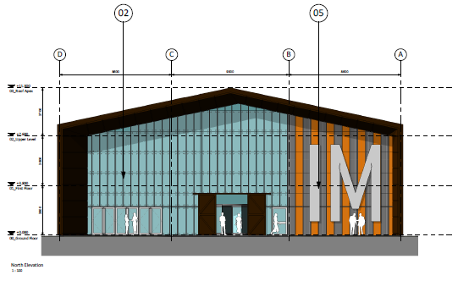
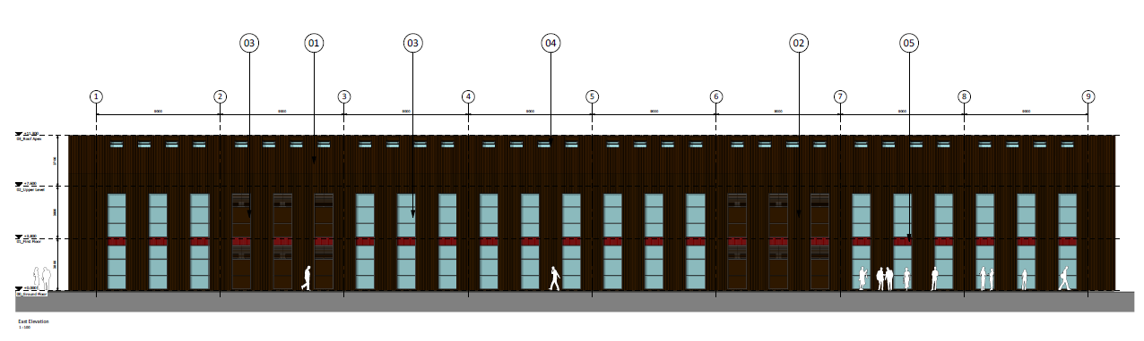
Below are the initial concept drawings for the new SA1 building which will be used by new innovative start-up companies.

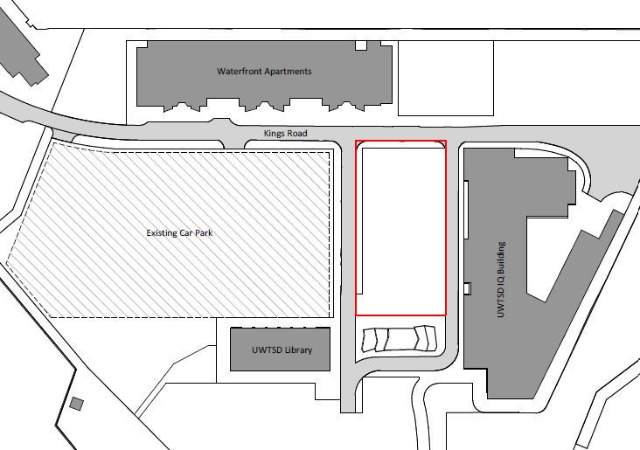

Appendix 2

Below is the asset portfolio that will be utilised throughout this report, this data is headline data only and any detailed data will be referenced separately.
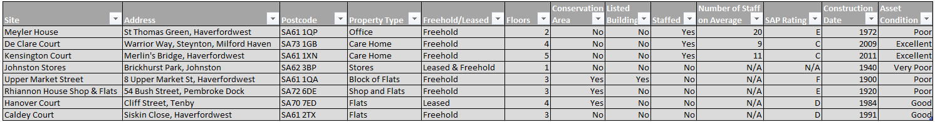

Appendix 3
Below looks at the traditional procurement route and the advantages, disadvantages and when it would apply.

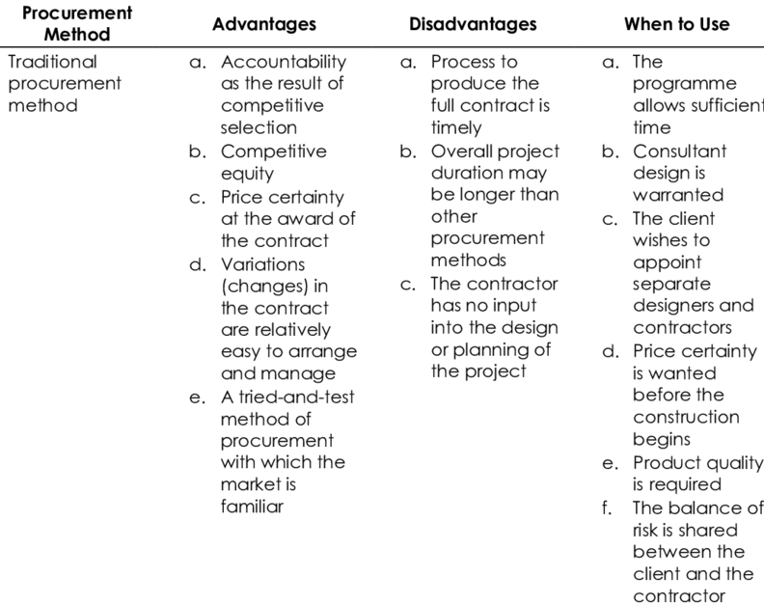

(El Sawalhi, 2017)

Appendix 4
Below looks at the design and build procurement route and the advantages, disadvantages and when it would apply.
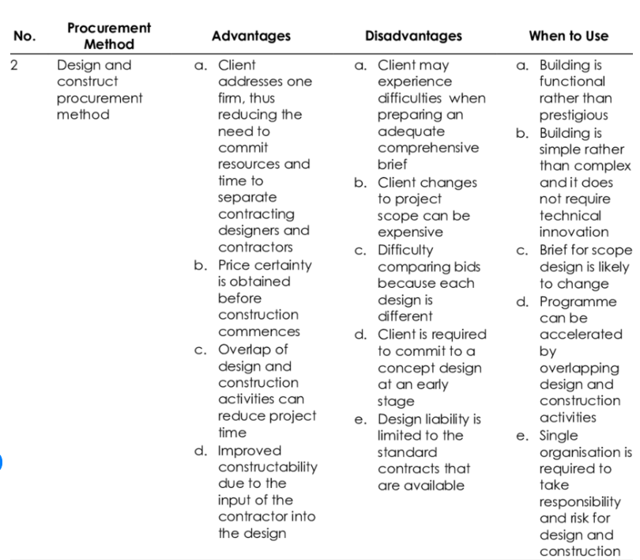

(El Sawalhi, 2017)

Appendix 5
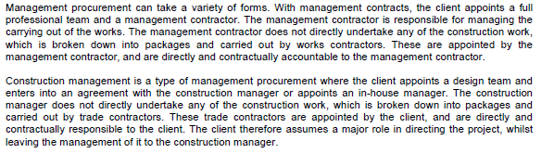
Below looks at the two sub sections within management.
(JCT, 2022)

Below looks at the management procurement route and the advantages, disadvantages and when it would apply.

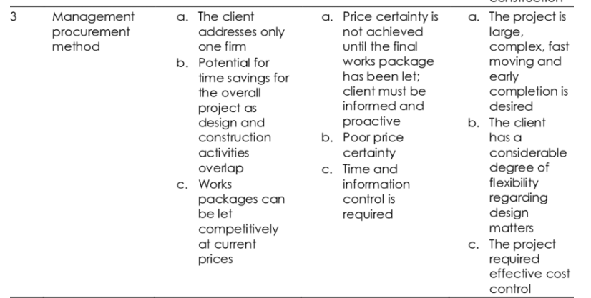

(El Sawalhi, 2017)

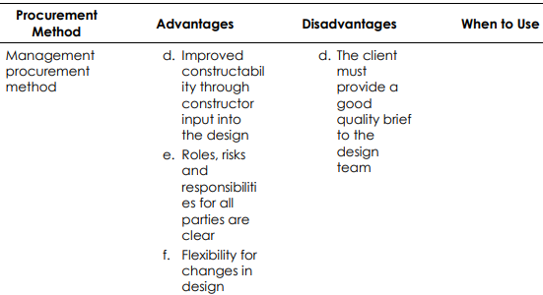

(El Sawalhi, 2017)

Appendix 6
Below looks at the collaboration as a procurement route.

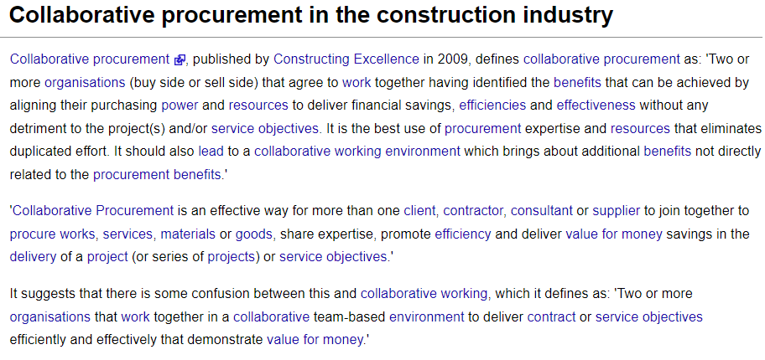
(Designing Buildings, 2021)

Appendix 7
Below are full descriptions of all documentation that could be used within a tender process

Drawings - drawing are produced to illustrate the client’s requirements; these draws will allow quantity surveyors and cost estimators to prepare a cost plan. Drawings my be done via external consultants on the client side or on the supplier side depending on what procurement is chosen. Early planning is key with any project and accurate and confirmed drawing will ensure disputes and claims are kept to a minimum during construction phase.

Technical/Normal Specifications - A specification used without a bill of quantities, would be used as a working/management document which would set out exactly what works the contractor would undertake and how. It will form part of the tender acceptance and will need to stand up legally without any ambiguity.

Performance Specifications - A specification that can be used on any job regardless of size or complexity and should be in addition to a bill or quantities, schedule of rates and drawings. A performance specification specifies the performance of a particular section of the project or main components (e.g., boiler/electrical system). It will include basic measurements and expectations set again the project or best practice.

Bill of Quantities - Within this document the client or consultant acting on the client’s behalf would have quantified and measures all components. Standardize the procedure used by contractors submitting bids to create a definite price for the work to be done. Gives the contractors the same information for a fair and accurate way to quote the project and allows the contract administrator or quantity surveyor to verify that each contractor has submitted genuine bids that are in accordance with the tender information and offer the client value for their money.

Schedule of Rates – This is a tabulated works order descriptions that sets out a fixed amount for a set quantity and the measurement of the task takes place after the works have been completed. This is more suited to maintenance and/or FM works.

(Aqua Group, 1999) (Ashworth, 2012)

Appendix 8
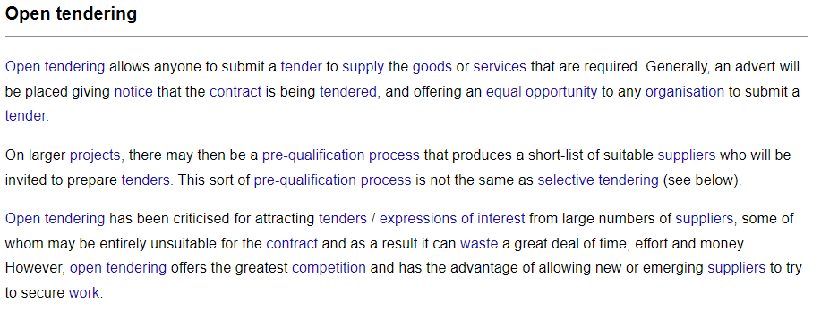
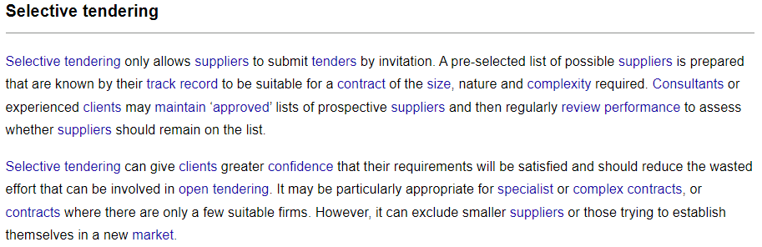
The seven routes of tender that the project could use are as follows.
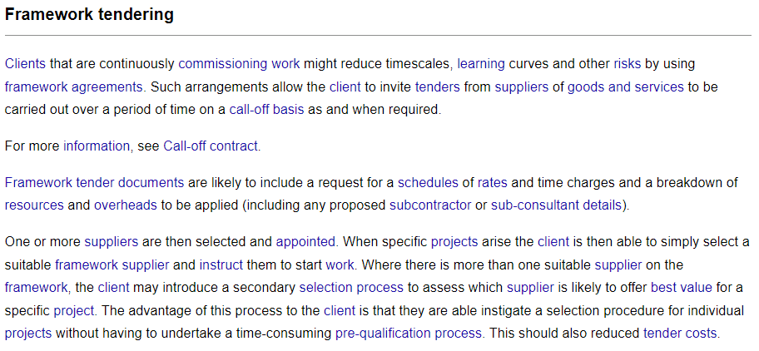
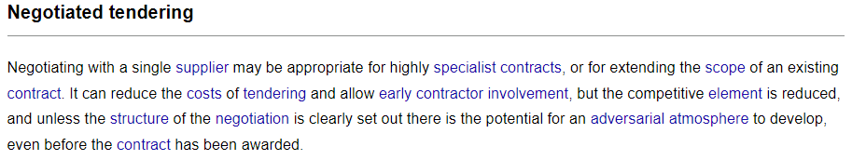
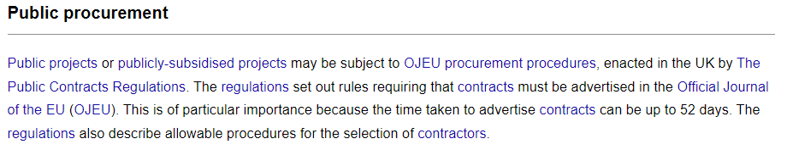
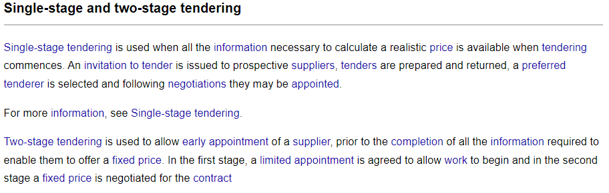

(Designing Buildings, 2021)

Appendix 9
Below are screen shots of Sell2Wales website which is a free online tendering portal provided by the Welsh Government for both public and private sector tenders. Currently UWTSD undertake a significant number of open tenders.
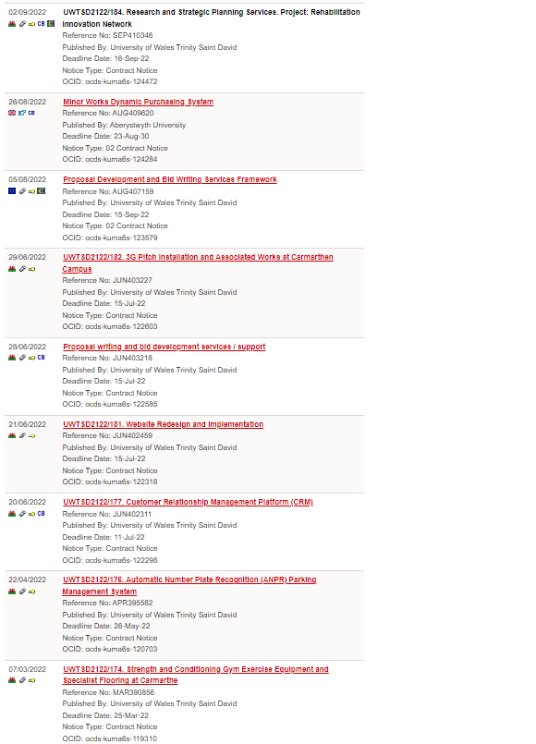
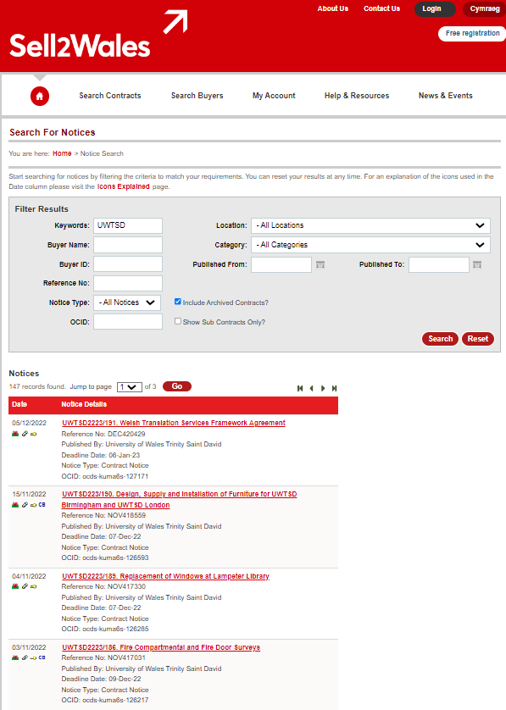

(Sell2Wales, 2022)

Appendix 10
Below are descriptions of the types of contract are available.

Fixed Price Contracts - fixed price agreed before works have commenced, if cost does exceed original submitted cost, then the contractor will need to absorb these additional costs not the client. The contractor could benefit from savings from the project if the circumstance allows due to value engineering of the project while on site. Variations can be achieved via instruction from project coordinator or client consultant and provisional sums could be included for works that are not yet defined within the project.

Cost Reimbursable - cost reimbursable contract or cost plus, is a high-risk form of contracting as the final cost of the project is not known and is usual avoided for this reason, but during covid 19 it has come in use more due to the uncertainly in the markets and cost of materials. In this form of contract, the contractor is reimbursed for the cost the incur on the project this works would be used in instances of emergency works/repairs or could be used to emergency situation where contracts are but in place for health and safety reasons. Example of this contract is NEC4

Measured Contracts – Cost reimbursable contractors are usually used for minor work/maintenance/FM works and are genially undertaken by a singular contractor and a schedule of rate (SORs) are typically used on this form of contract. Final costs are not known until works have been completed and are normally based on a re-measurement of the works undertaken. This form of contract does allow for a quick start on site, but this inevitably comes with risk associated with cost.

(Aqua Group, 1999) (Ashworth, 2012) (Murdock & Hughes, 2008)

Appendix 11
Below are descriptions of the forms of contract are available.

JCT - Joint Contracts Tribunal contracts are intended for large scale construction and maintenance projects for both public and private sectors, the contract types allow for either a bill of quantities to be used or not and allows for sub-contractor contractor nominating. All JCT contracts include optional provision for collaboration within the contract, but JCT contractor are written in a way which it makes it difficult for the layperson to understand and this does often require a legal contracts expert to brought in to help (Lupton & Stellakis, 2019).
JCT have an array of contracts which are widely used within the construction sector, below are the main contracts which are applicable to construction and maintenance.
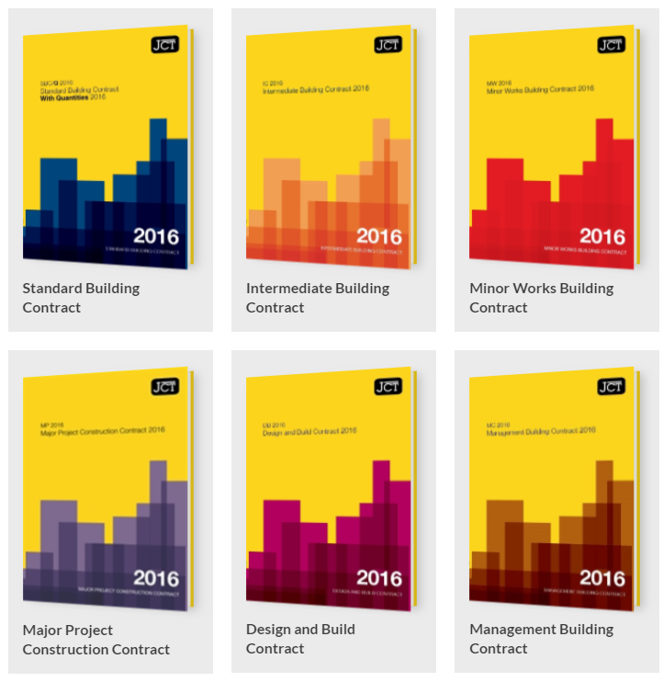

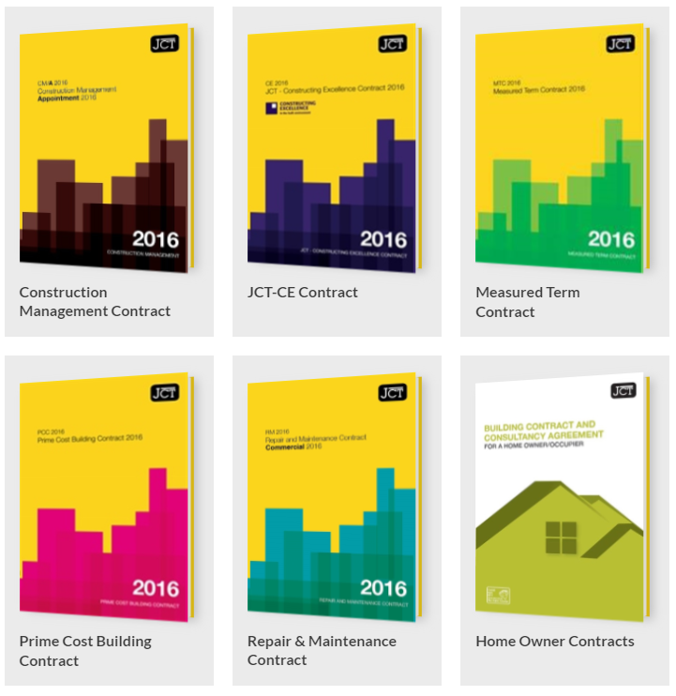

(JCT, 2021)

NEC - NEC4 contracts have a three key benefits,
- Flexibility – an all-purpose document suitable for traditional, design & build or management contracts and be used for engineering and constructions works across the UK and oversees.
- Clarity – the forms are clear, the document using plain English and easily understandable by the layperson which is likely to lead to fewer disputes and challenges.
- Good Management on the part of all parties – aim to put an end to adversarial works within projects.
The NEC form of contracts was recommended to the UK government to be adopted to all government contracts by the Latham Report (Lupton & Stellakis, 2019) (Latham, 1994).

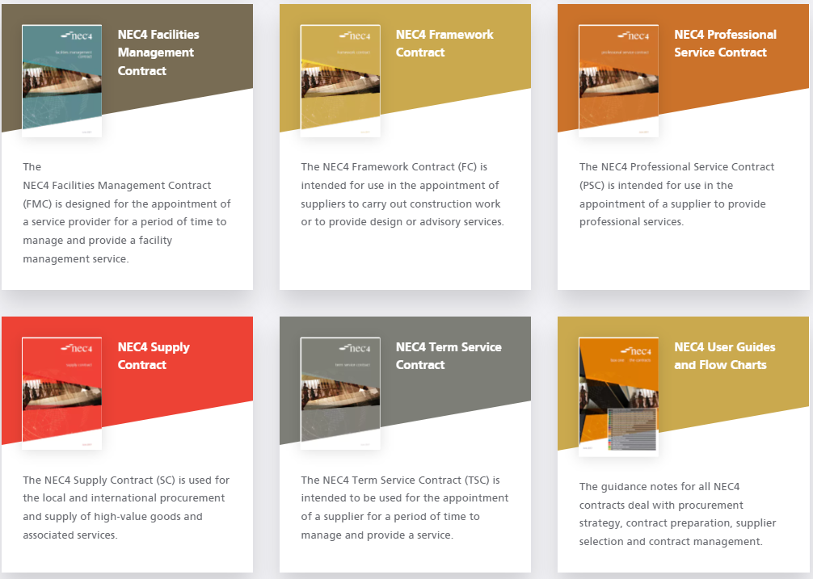
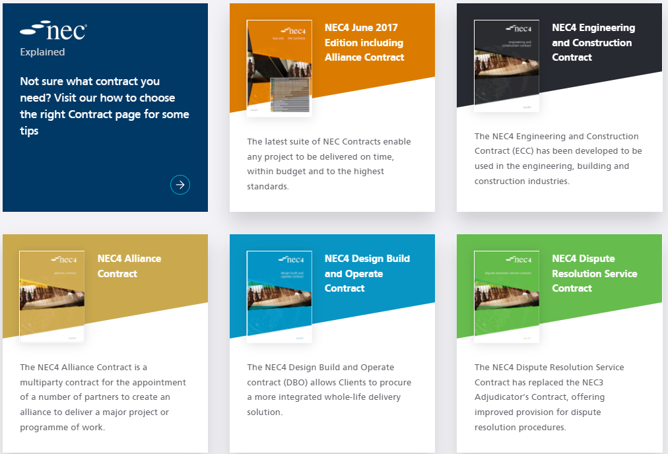
NEC have an array of contracts which are widely used within the construction sector, below are the main contracts which are applicable to construction and maintenance.
(NEC, 2021)
FIDIC – The International Federation of Consulting Engineers (FIDIC) contracts are intended to be used where the client, contractor and/or or parties are in different countries and in countries where no suitable contracts for the works intended exist. The contracts are split up into 3 separate forms.
FIDIC Red Book – Conditions of Contract for Construction
FIDIC Yellow Book – Conditions of Contract for Plant and Design & Build
FIDIC Silver Book – Condition of Contract for EPC/Turnkey Projects
FIDIC contracts are the most widely used international for of contracts for infrastructure projects that involves multinational companies (Lupton & Stellakis, 2019).

Other forms of contract which are to be noted are
- ICC – Infrastructure Conditions of Contracts
- CIOB – Chartered Institute of Building
- RIBA – Royal Institute of British Architects

Appendix 12
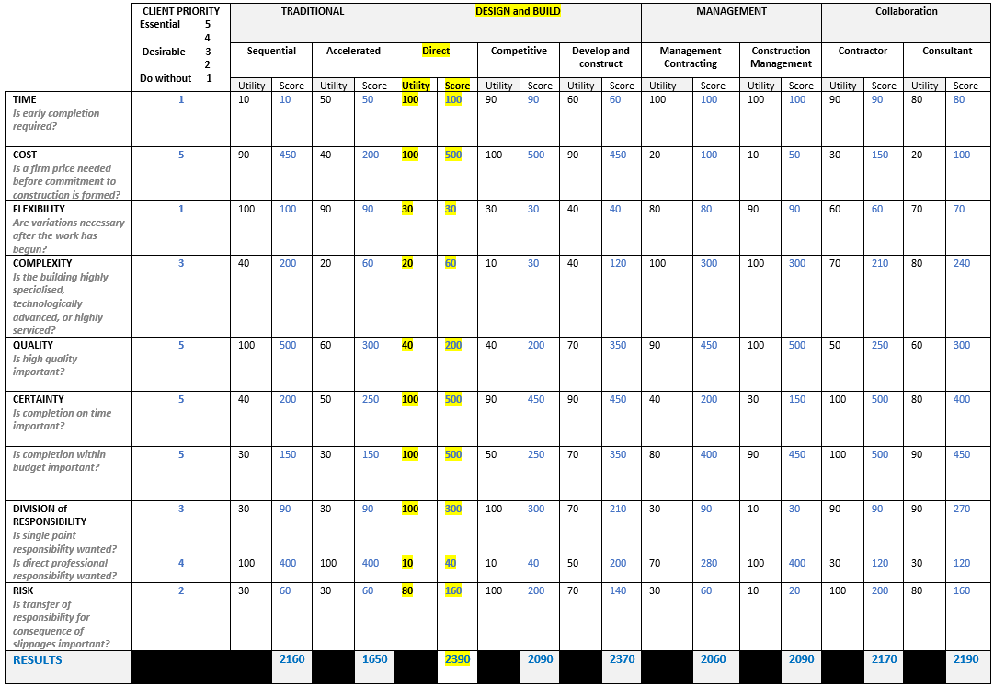
Below is the Skidmore and Marsden Strengths and weakness of Procurement Routes table which I have used to help guide the decide of what procurement route to take. (Roy Morledge, 2021)

Appendix 13
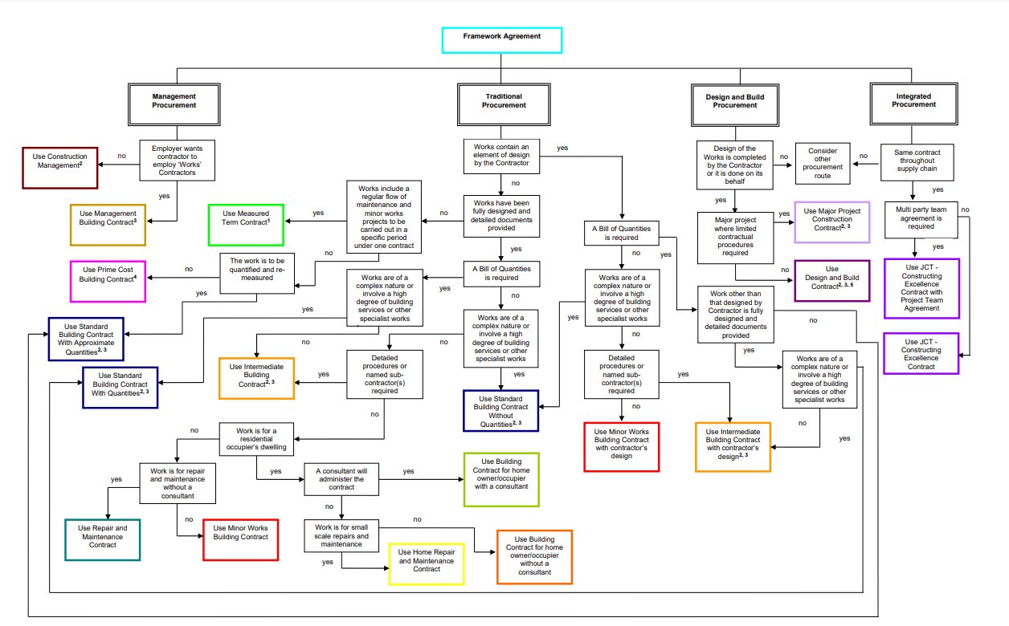
Below is the JCT main contract selection flow chart (JCT, 2022)

Appendix 14
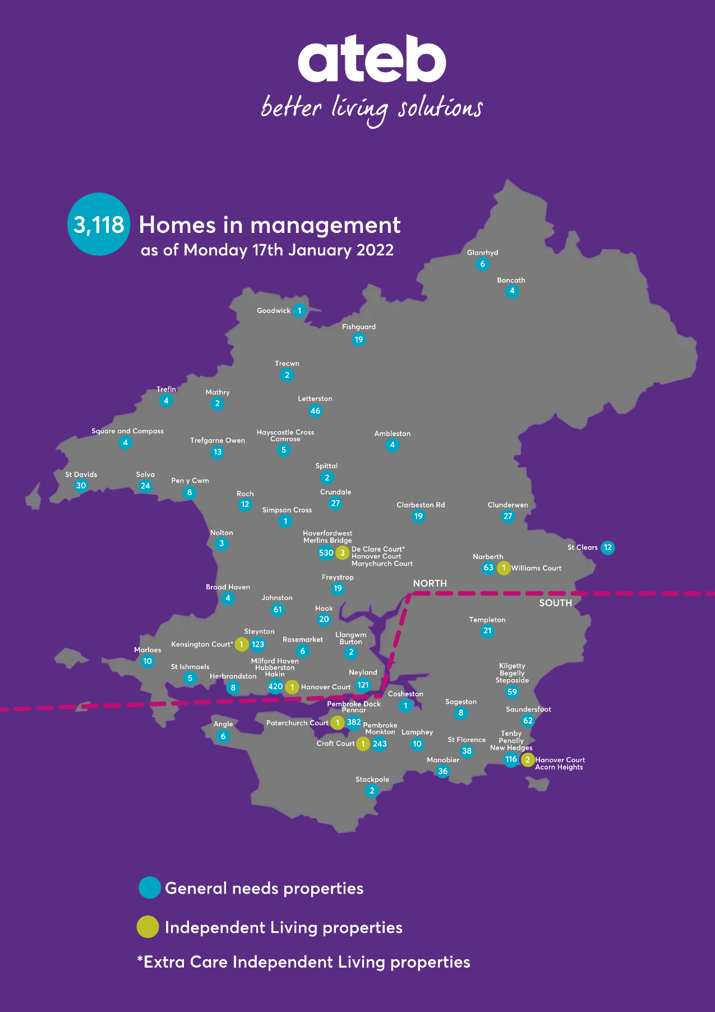
Below is the ateb housing property count and their geographical location (ateb Group, 2022).

Appendix 15
Below is a component list of Meyler House that was generated from ateb’s asset management system Lifespan.

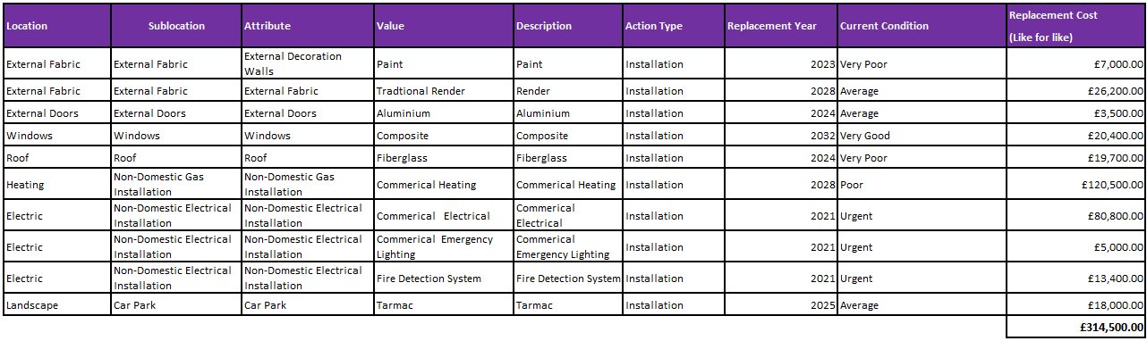

Appendix 16
Below is a component list of Kensington Court that was generated from ateb’s asset management system Lifespan.
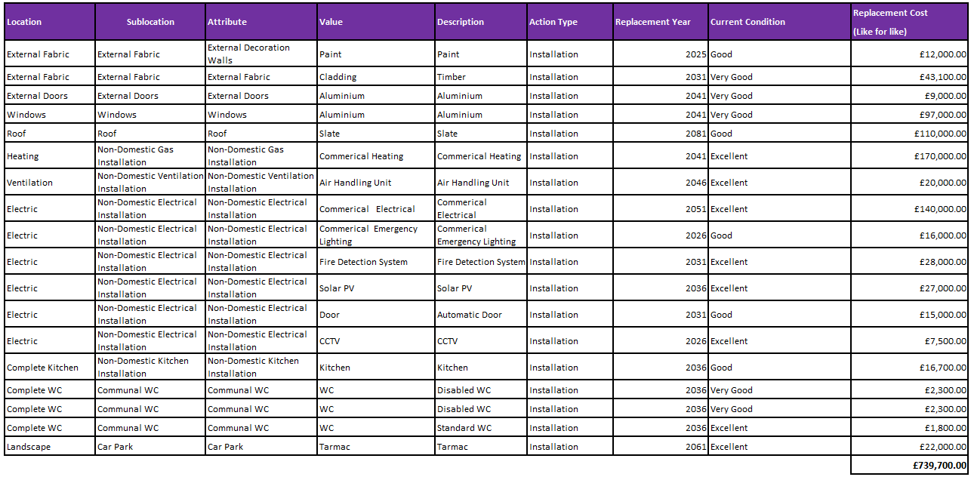

Appendix 17
Below is a component list of De Clare Court that was generated from ateb’s asset management system Lifespan.
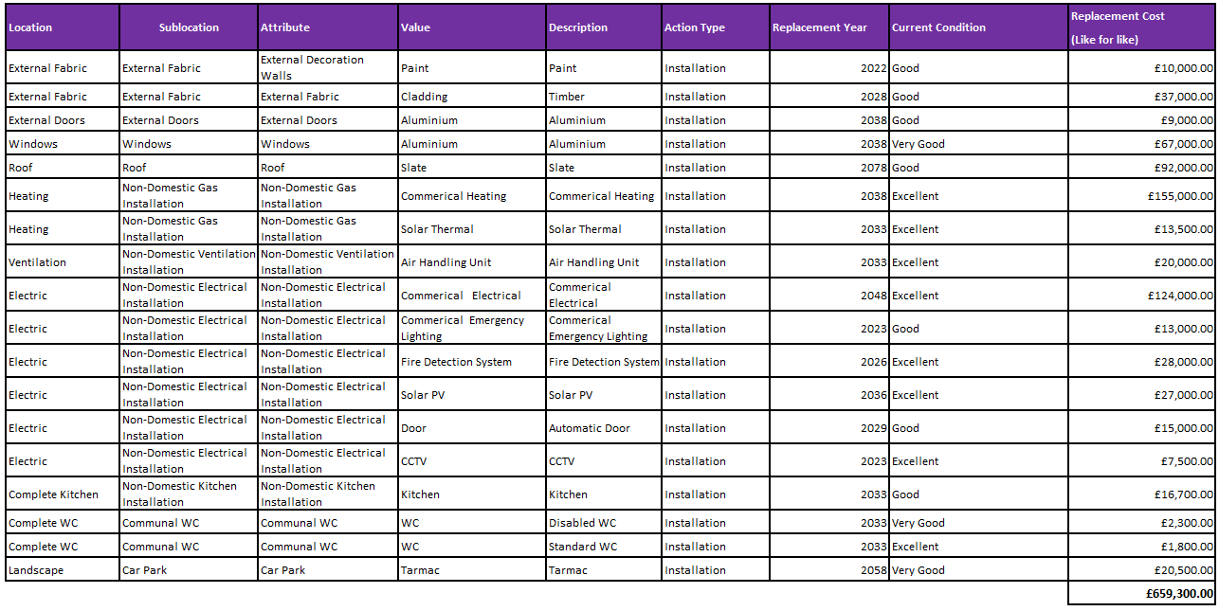

Appendix 18
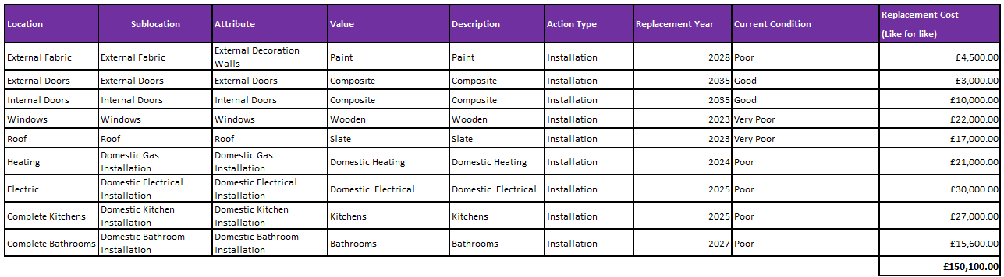
Below is a component list of Upper Market Street that was generated from ateb’s asset management system Lifespan.

Appendix 19
Below is a component list of Rhiannon House that was generated from ateb’s asset management system Lifespan.
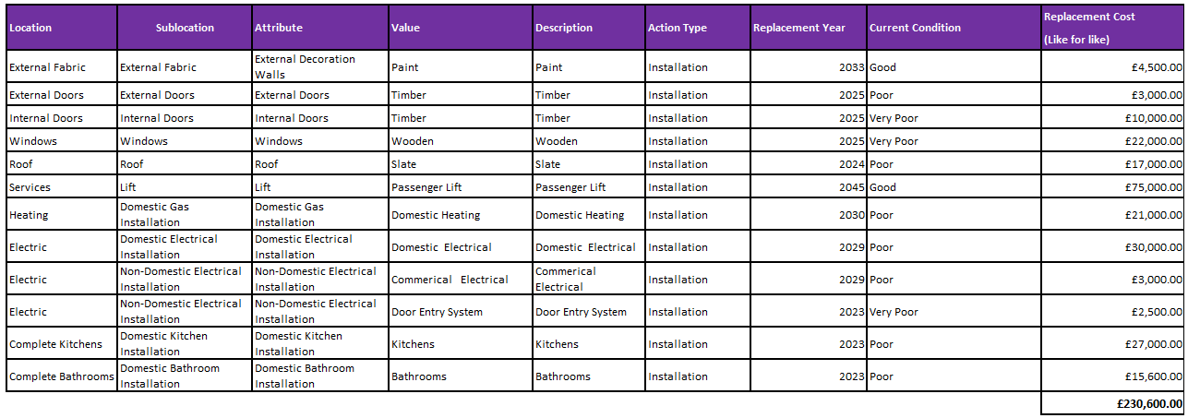

Appendix 20
Below is a component list of Hanover Court that was generated from ateb’s asset management system Lifespan.
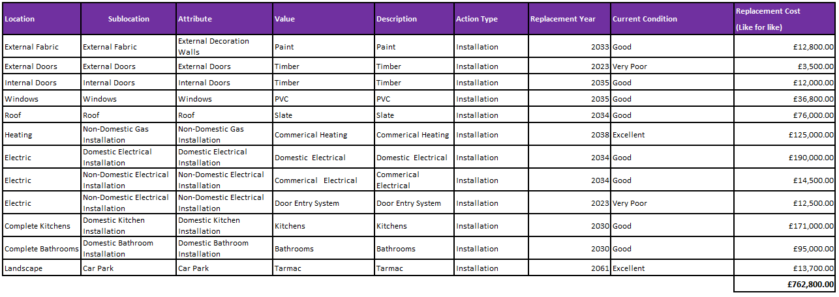

Appendix 21
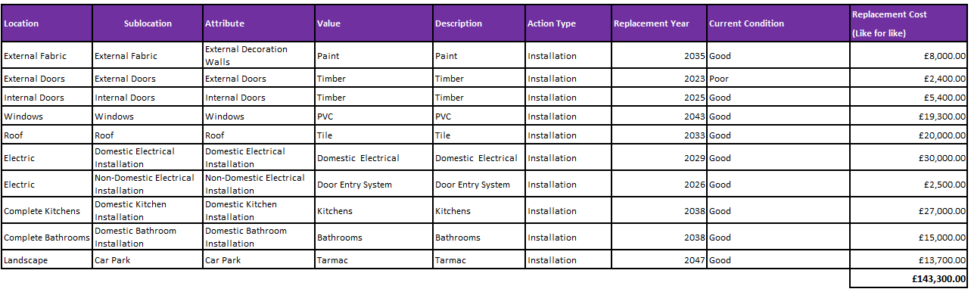
Below is a component list of Caldey Court that was generated from ateb’s asset management system Lifespan.

Appendix 22
Below sets out a list of 15 business critical requirements that are in rank order or importance to ateb as an organisation.

- Location – Properties must be in situated within areas that people want to live, they also must be in the areas with the most housing need.
- Component Data Condition - Information from ateb asset management system and overall component life cycle and cost impact.
- Property Age – When the property was first constructed, this would impact repairs, planned and compliance works budgets.
- Corporate identity - Does the property fit ateb corporate style and its intended target audience.
- Corporate Objectives – Does the property deliver housing in the areas and to the people that need it most.
- Net Zero Pathway – Does the property have a cost-effective pathway to net zero, what it cost to implement property improves to get the maximum desired effect.
- Freehold/Leased – Is the property Freehold or is it leased from another organisation, currently ateb favour freehold and are trying to move away from new leased properties.
- Energy Efficiency – Is the property in its current state energy efficient.
- Climate – What sort of climate is the property situated in, costal, rural, urban, etc.
- Utilities – Are the utilities to the property suitable for the property and the customer that live within.
- Growth - Does this property sit within ateb growth strategy (does the site allow for expansion, is the site situated in a desirable area, etc).
- Legislation – what legislation applies to the site and what effects this has on maintenance budgets.
- Skill Set – What skill sets are required to keep these properties in good working order and what housing skills are needed to help with customers.
- Transport – What is the current transport like in the area (Roads, Rail, public transport, etc).

Appendix 23
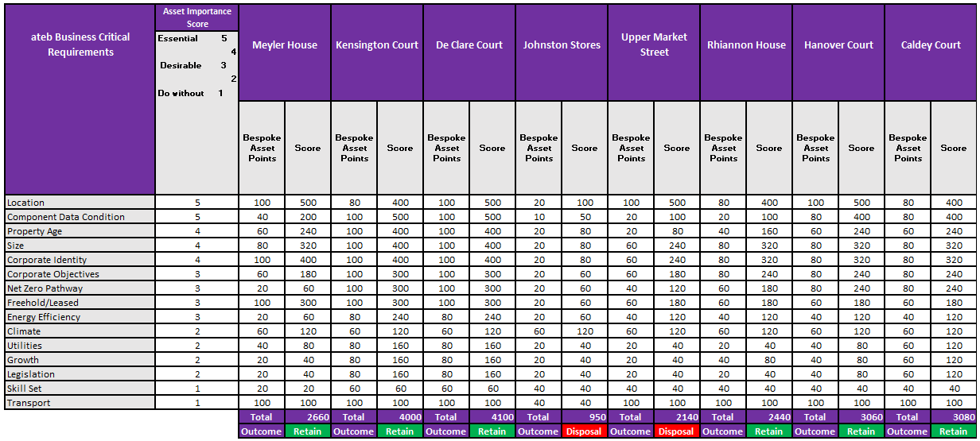
Below is the asset appraisal for the 8 sites that have been scrutinised within the report.

Appendix 24
For Hanover Court to further comply with the Equalities Act 2010, it is suggested that a passenger lift to be installed within the building itself, the building has several spiral staircases which not all are deemed essential for fire safety. So it is recommended hat one of these stairwell be transformed in a small passenger lift, by installing this lift it will help the organisation comply with the Equalities Act 2010 but to achieve this ateb will need to follow Approved Document M.
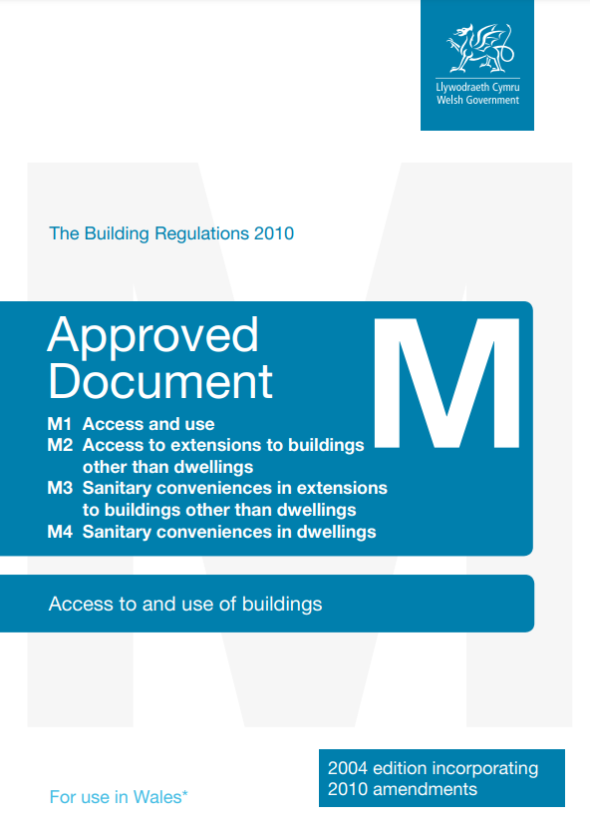

(Welsh Government, 2017)

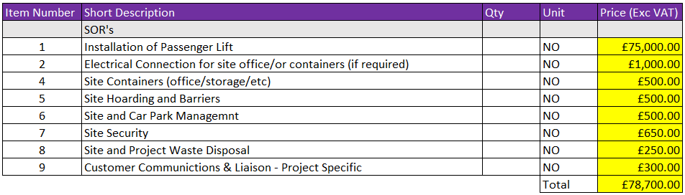
Below sets out the schedule of rates for the project and the budgeted amount of £78,700.00, this figure is based on bases from ateb’s asset management system lifespan.

Appendix 25
Below are recent contract award notices which ateb have undertaken an open tender to procure a variety of services.
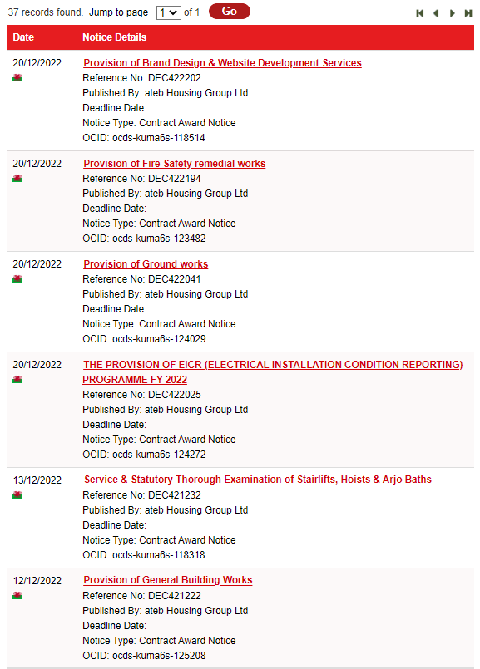

(Sell2Wales, 2022)

