Kate Scale

1909165

Design Craft 2019

Ways of thinking ADAD4018

Manifesto 513 words

Reflective writing 492 words

Observational writing 525 words

Kate Scale
1909165
Design Craft
2019-2020
Module ‘Ways of Thinking’ ADAD4018

Task One: Manifesto (Julia and Gwen)

The ability to produce a product out of something that has been disregarded and classed as rubbish
and recycling it into something of interest.

A determination to produce a professional product which is pleasing to, firstly, my critical eye.

Expressing myself through design and stepping into the unknown.

Imagining the unimaginable and pushing boundaries to achieve.

Making mistakes and breaking rules. There is no right or wrong in the creative world.

The use of colour is essential in my work, producing more emotion and feeling.

Our countryside, environment and nature constantly inspire and amaze me and add ideas and passion to my work.

Being random and never going with the first idea.

Recycling
My use of recycled and disregarded material is so important to my creative practice. Giving something another use or home in our wasteful society produces an appealing result.
Recycling is such a prominent goal in so many households and our country is striving to reduce, reuse and recycle.

‘You maybe referred to as a consumer but there is very little that you actually consume – some food, some liquids… Everything else is designed to throw away when you have finished with it. But where is away?’ (2008 Braungart and McDonough)

This is so thought provoking and reiterates the importance of my journey to reuse neglected objects which maybe a challenge in our ‘perfect world’. Its rubbish to many but to me it’s a way of being creative and creating art from something unconventional.
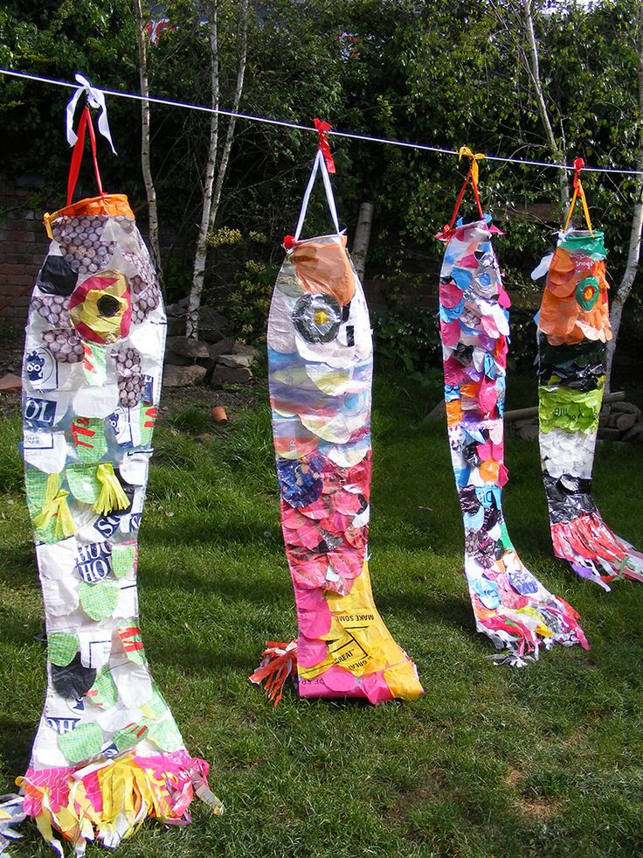 (Pinterest, 2019)

Making Mistakes
This is such an important part of my exploration. The sketchbook I use is a diary or entry into a
whole new world of ideas and thoughts. Creative ideas are often started from the smallest of
scribbles. Edward Hill states that ‘the scribblings of any….. child clearly indicates how thoroughly
immersed he is… there must be some quantity of magic in this alone’ (The language of drawing
1966). I agree that time must be spent experimenting, deep thinking and wisely repeating the same
Action until perfection is established.

It certainly is about working things out with your utmost imagination, never giving up and trying with
all your perseverance to succeed. We, as creators, do not tend to follow the trodden path, we
observe and push through barricades until we find that moment of genius. This is in line with
Melanie Rothschild’s view, ‘of all places, art is a spot where mistakes should be considered honoured
guests’ (2014 Rothschild)

Imagination
Being creative ignites our constant imagination and deep thoughts. Imagination influences our
Intentions and dreams and re-creates our lives and well being.

How terribly dull and impossible life would be without imagination. Inside our heads, stories are
told, shapes and patterns are formed, colours are united and above all happiness is created.

From primitive times we, as humans, have always used our imagination to progress. Experimenting and questioning.

Albert Einstein said ‘Imagination is more important than knowledge… imagination embraces the
entire whole’ (goodreads.com). It is part of the way we are assembled, and we must continue to push out ideas whether they excite us or not.

References

Braungart, M. and McDonough, W. (2008). Cradle to cradle. p.loc 350 Kindle edition.
Goodreads.com. (2019). A quote by Albert Einstein. [online] Available at: https://www.goodreads.com/quotes/556030-imagination-is-more-important-than-knowledge-for-knowledge-is-limited [Accessed 30 Dec. 2019].

Hill, e. (1966). the language of drawing. new jersey.

Pinterest. (2019). Recycled plastic bag wind sock art project,art in schools | Plastic art, Plastic bag crafts, Recycled plastic bags. [online] Available at: https://www.pinterest.nz/pin/727120302307466833/ [Accessed 30 Dec. 2019].

Rothschild, M. (2014). The art of mistakes. Cincinnati: North Light Books/F+W Media.

Task 2: Reflective writing (Jon)
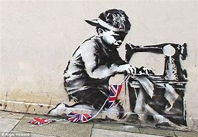

Photo from the Daily Mail (2013)

The art I chose to study is ‘Slave Labour’ by Banksy. Banksy is an anonymous English Graffiti artist, film director and, known by himself as a vandal, who covers numerous topics such as anti-war, greed, despair and political arguments. Despite being one of the most famous street artists in the world, he has never revealed his identity. You cannot help admiring the fact that he controls his own story.

The picture sometimes known as ’Bunting Boy’ is a 48 x 59-inch piece of a young boy bent over an old sewing machine, sewing Union Jack bunting. It is a black and white spray paint image on concrete, with red, white and blue sprayed bunting. Banksy produced this on the side of a Poundland shop, using distinct stencil technique, the same year as Queen Elizabeth celebrated her Diamond Jubilee. Stencilling is quick and allows the artist to paint quickly and protect their anonymity.

The piece appears bold and striking and initially makes you feel curiosity and sorrow. This may be due to the positioning of the child who portrays exhaustion and sadness. This is a contrast to the bright colours of the Union Jack bunting which could be used to portray the message that whilst so many people are rejoicing a wonderful and momentous occasion for our beloved Queen, others are suffering at our unbeknown expense. Jonathan Jones states that ‘the very lack of art in his work is what makes it popular’ and ‘real art’ is ‘complex… and often difficult’ (2017). I disagree with this view as art is subjective to the individual, and although Banksy’s technique may be considered somewhat simplistic in this piece, it conveys a hard-hitting message of child labour.

Banksy’s work is admired by many and his graffiti style is often adopted by others. After all, graffiti has been around since the Stone age where drawings were sketched on the walls of caves. However, this often results in public property being vandalised and tarnished. Cooper & Chalfant highlight this in ‘subway art’ where they depict how the police department in New York lost control over the subways and trainlines and were unable to prevent graffiti forming (1984). I think that what distinguishes Banksy’s art from other graffiti which becomes a meaningless blur, is the popularity is receives from the media and travelling speech, particularly among the younger generation. Ruskin supports this as he stated that “the opinions formed on right grounds by those few who are…competent judges… communicate themselves gradually from mind to mind, descending lower as they extend wider’’ (2009).

Overall, I am an admirer of Banksy’s work which awakes the soul and teaches us to envisage the big picture. You cannot help but respond to his humour, quick thinking and anonymity and as Banksy himself says ‘people either love me, hate me or don’t really care’ (2005). Whether I will be saying the same and still seeing Banksy’s work in ten years’ time is somewhat debateable.

References
Banksy (2005). Banksy Wall and Piece. London: Century, The Random House.

Cooper, M. and Chalfant, H. (1984). Subway Art. London: Thames & Hudson Ltd.

Jones, J. (2017). Britain’s best-loved artwork is a Banksy. That’s proof of our stupidity | Jonathan Jones. [online] the Guardian. Available at: https://www.theguardian.com/commentisfree/2017/jul/26/britain-artwork-banksy-art-girl-with-balloon

Ruskin, J. (2009). Modern painters. Charleston, N.C.: Nabu Press.

Webb, S. (2013). Banksy's 'Slave Labour' mural taken from wall and put on U.S. art auction website for £450,000. [online] Mail Online. Available at: https://www.dailymail.co.uk/news/article-2280431/Banksy-Slave-Labour-mural-torn-London-wall-US-art-auction-website-450k.html

Task 3: Observational writing (Ryan)
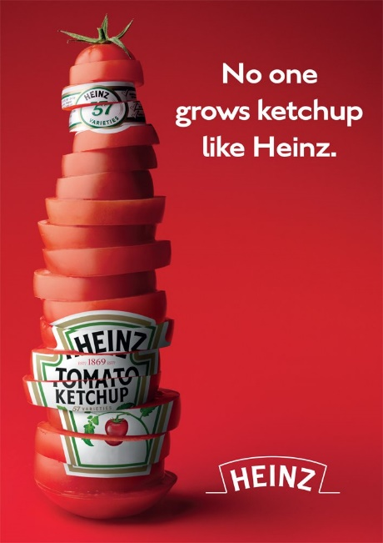

Image from World Branding Awards (2019)
The advertisement I have chosen is from Heinz and is promoting their tomato ketchup. It consists of an image, a brand logo and a short piece of text. Heinz is a well-known household brand established in 1869 which is recognisable and trustworthy. It is important for the modern consumer to know where their products originate from and freshness is a number one selling point which Heinz understands and portrays in this advert.

The image used in the advertisement is of a freshly sliced tomato in the shape of a Heinz ketchup bottle which has been put together using digital photo manipulation. According to Kress & Leeuwen, ‘the more a picture can create an illusion of touch and taste and smell, the higher its modality’ (2006). This advert successfully does this as it appeals to the viewers senses and implies that Heinz tomato ketchup is made from freshly produced ingredients. This message is also reinforced through the uneven slices of tomato, suggesting that the ingredients are natural and not artificially perfect. This point may not immediately be clear to the viewer but the image encourages them to think about it for longer which is beneficial for Heinz as ‘the interaction created by the need for the viewer to work it out means that there is a greater pay off, or sense of reward when the puzzle is solved’ (Burtenshaw, Mahon and Barfoot, 2011).

The colour scheme for the advert is predominantly red. This makes the piece striking and eye-catching. Many food brands use this colour as it suggests ripeness and a readiness to eat (Kramer, 2019) which is what Heinz is portraying with its tomatoes. Common connotations with red include energy and strength which create an excitement towards the product. This colour is also suggested to stimulate appetite and influence customers metabolism (Singh, 2006) which is relevant for the product. The accompanying colour white, is often associated with freshness and purity which is a significant factor for the consumer when deciding which product to buy. The two colours produce an enticing combination bold and attracts the viewers’ attention.

The text on the advert reads; ‘No one grows ketchup like Heinz.’. The word ‘grows’ implies that the tomatoes are grown by specialist Heinz farmers, and assures the customer that Heinz know where their ingredients are from because this is important to many people. This word also accompanies the message which the image portrays, which is that the product is natural and carefully made, rather than being artificially produced. The fact that the text is a short sentence holds the viewers attention as ‘clarity and simplicity often make a message more powerful’ (Burtenshaw, Mahon and Barfoot, 2011). The brand name Heinz is included four times in the advert. This reinforces the fact that it is a recognisable and well-established brand.
Advertising is a fascinating subject to study and I believe Heinz have made a good attempt to sell a ‘healthy’ product when we know that ketchup has a high sugar content. A lot of consumers would conveniently think that its part of a healthier life style plan and be tempted by its apparent freshness.

References:
Awards.brandingforum.org. (2019). World Branding Awards. [online] Available at: https://awards.brandingforum.org/wp-content/uploads/2015/02/Heinz-European-ad.jpg [Accessed 16 Dec. 2019].

Burtenshaw, K., Mahon, N. and Barfoot, C. (2011). The fundamentals of creative advertising. Lausanne: AVA Pub. SA, p.97.

Kramer, L. (2019). How to use colors in marketing and advertising - 99designs. [online] 99designs. Available at: https://99designs.co.uk/blog/tips/colors-marketing-advertising/ [Accessed 16 Dec. 2019].

Kress, G. and Van Leeuwen, T. (2006). Reading images. Geelong, Vic.: Deakin University, p.164.

Singh, S. (2006). Impact of colour on marketing. Management Decision, 44(6), pp.783-789.

