Supporting document
Authors
Ellis-Anthony Willis - Each Part of the process was done collaboratively.
Owen Gittos – Each Part of the process was done collaboratively.

Overview
We are tackling mental health and personal growth; these topics encompass what people are feeling and how they interact with themselves and others. More and more people struggle with poor mental health, so we think its important that there is a document that allows people to grow and become better.
Design thinking is a process that is used to find a solution through a process. One step leads to another. It applies to many different industries and is used to do market research or to create a product or an app or a camp or anything.
We would use design thinking to test and reevaluate or solution, constantly making updates and changes to the solution.

What is the assignment? – Our Assignment is to ‘Use Design Thinking to Create Possible Solutions’
What problem we are tackling and what do we hope to accomplish? – solution will solve
The problem we have

Firstly what is design thinking? (look on moodle for definition and references) how will we use design thinking? (Design thinking phases)
- Talk about design thinking as a journey and a process
- When is design thinking used? – Its used to follow a process to find a potential solution
How we used design thinking?
- Talk about the process of what we did:
  - Persona research – why we did our respective personas
Starting point – we identified a person for me it was, highschooler, I then identified some challenges she faced, Owen was also doing the same thing, we then cross examined what his persons challenges were with my persons.
Each had different personas with different challenges.

    - Ellis Persona findings – she was anxious about doing things badly, she was worried about being wrong and judged by other people(social settings). She is capable physically, a good map reader, friendly and creative. She wants to do more climbing and be more confident in herself. (from my solution I hope she gets more confidence in herself and more self-aware.
    - She thinks it would be scary, she would be judged and climbing is cool. She says she doesn’t want to do it, she doesn’t give a reason why. She likely feels scared anxious and judged. She doesn’t participate fully and doesn’t want to engage fully.
    - Owens Persona Findings – Being anxious about going to university as well as making new friends and trying something new. Having a lack of confidence and motivation. Not being comfortable in their own skin.
  - Comparison – identifying wicked problems
  - Mindmap / what interacts with our wicked problem
  - Come to an agreement on what challenge we were going to focus on
  - Did research on solutions to the contemporary challenge
  - Prototype options
  - Prototype research and feedback
  - New prototype iterations
What’s good about our prototype?
- Interaction
- Intuitive
- Inviting
- Tackles many problems in a non invasive way
- Anonomus

- Lots of topics
What the assignment is – Solve a contemporary challenge – What we did
Starting point – we identified a person for me it was, highschooler, I then identified some challenges she faced, Owen was also doing the same thing, we then cross examined what his persons challenges were with my persons.
Each had different personas with different challenges.
Agreed on some links – mental health and personal growth by making a mind map on everything that effects those or links to those things.
So, to come to an agreement on what we were going to focus on we researched what the most important problems were in society and also decide what was most important to us as a group.
What’s important to us? Overcoming bad mental health and boundaries put on ourselves.
We then brainstormed ideas for a solution on the contemporary challenge we chose.
Came up with a GUIDE TO CONQUERING YOURSELF.
We asked ourselves how we could make it accessible and usable to everyone.
We did research into different apps and websites with a similar ideas and decided what worked and what didn’t.
Then came to a conclusion our idea and how it can be better then the others out there.

We came up with Prototypes – came up with different prototypes and looked at the pros and cons of each.
We then showed our prototype to people and got feedback then made new iterations of the prototype making the improvements from the feedback.
Our prototype is not yet finished, with more time and more resources this is how it would work.

Presentation slides
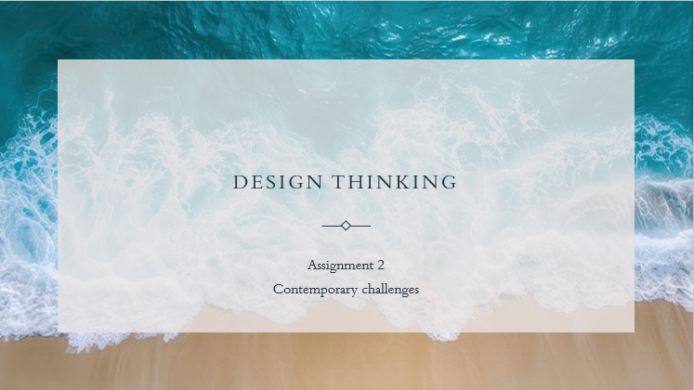Owen
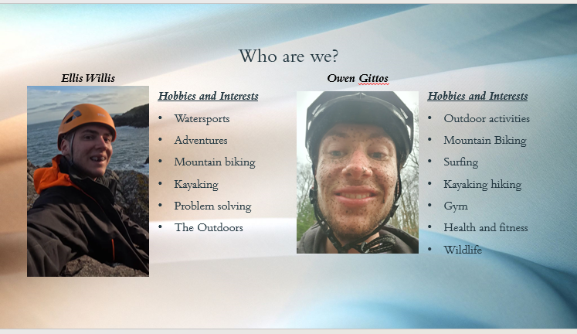
Ellis & Owen
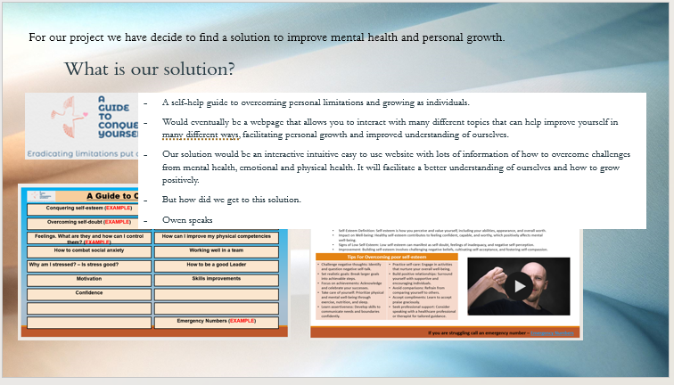
Ellis
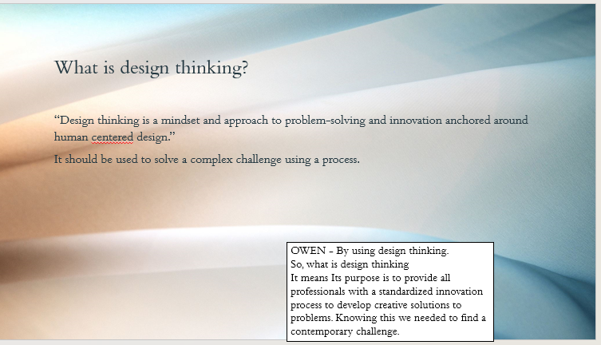Owen
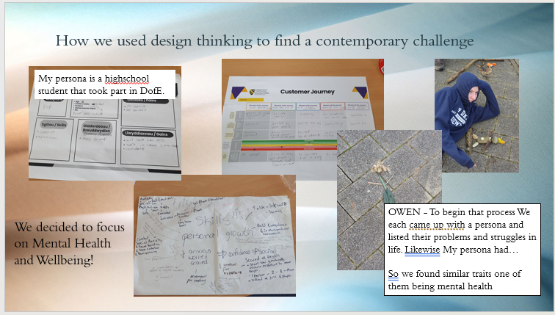
Ellis & Owen
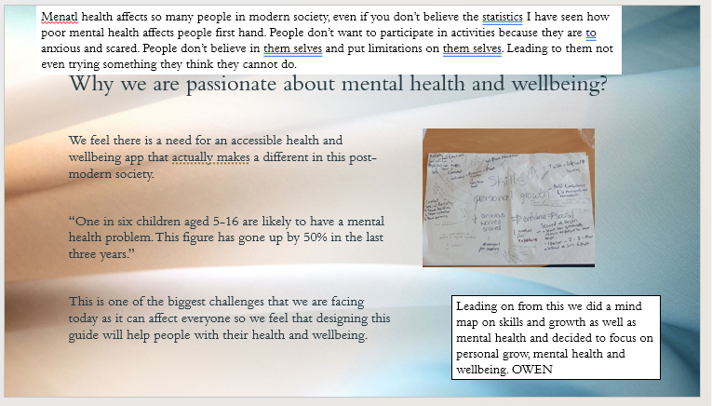
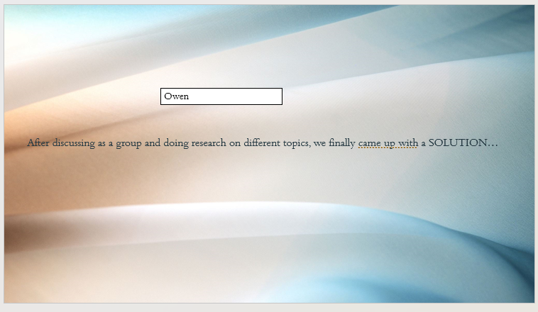
Owen
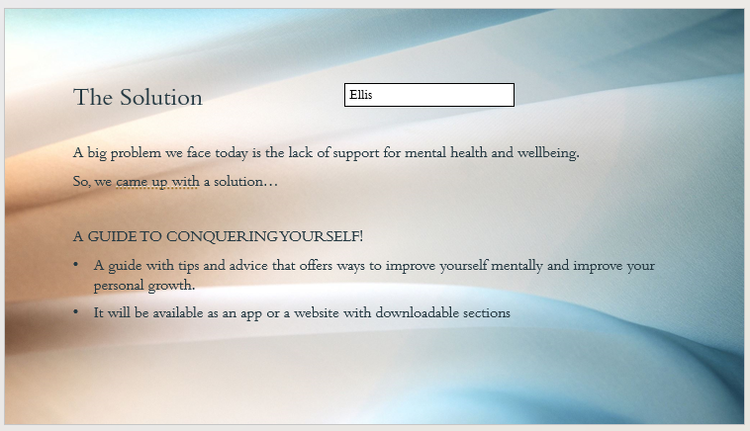
Ellis
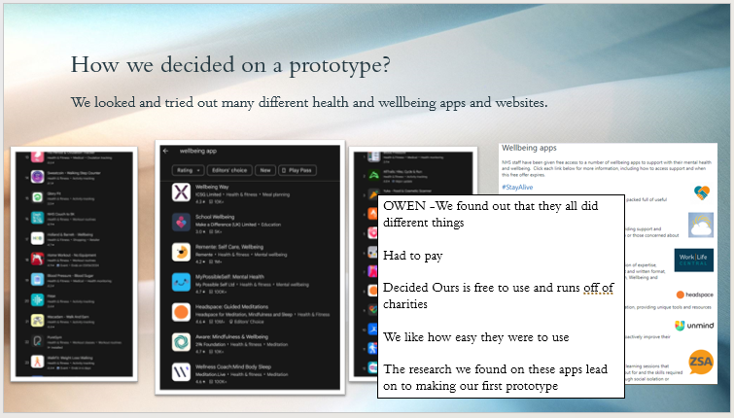
Owen
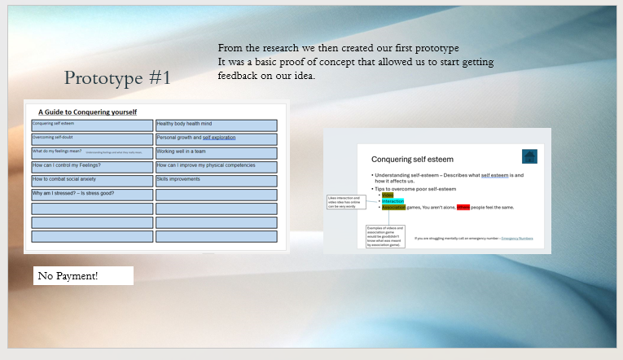
Ellis
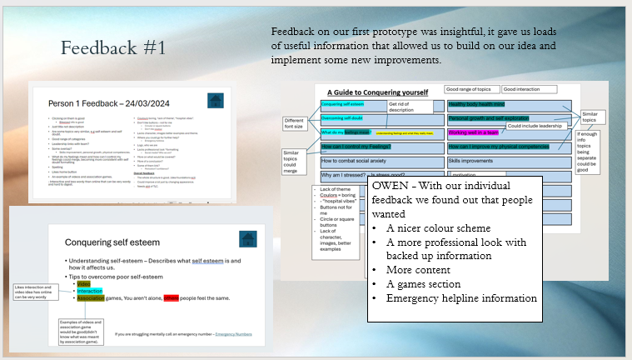
Ellis & Owen
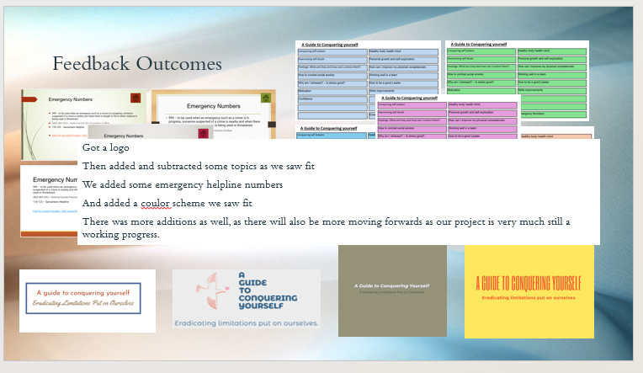
Ellis
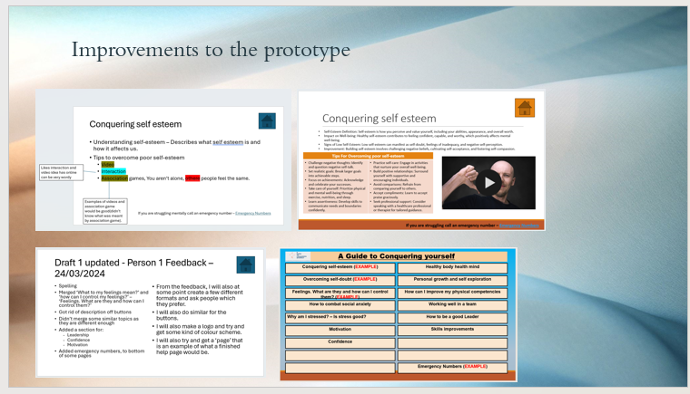
Ellis
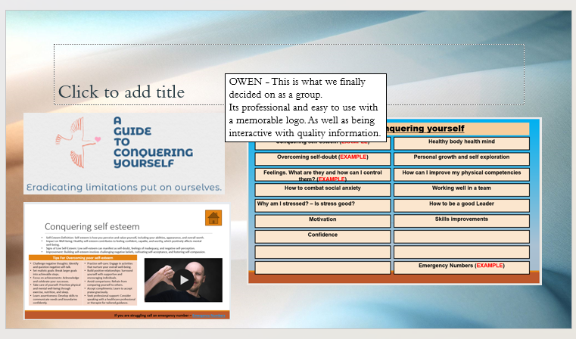
Owen
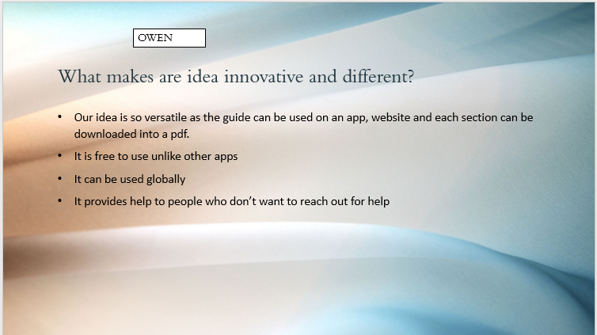
Owen
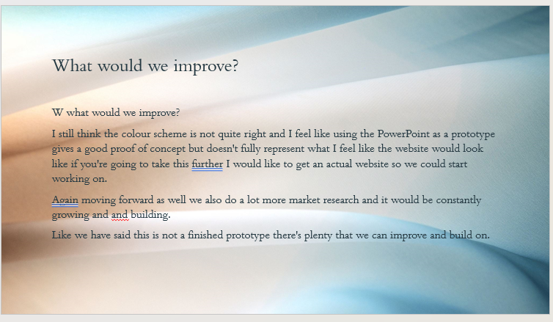
Ellis
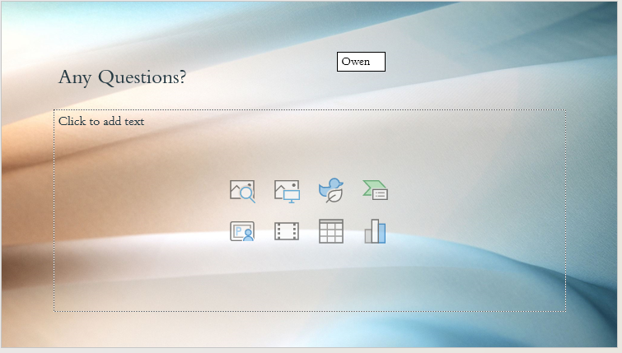
Owen
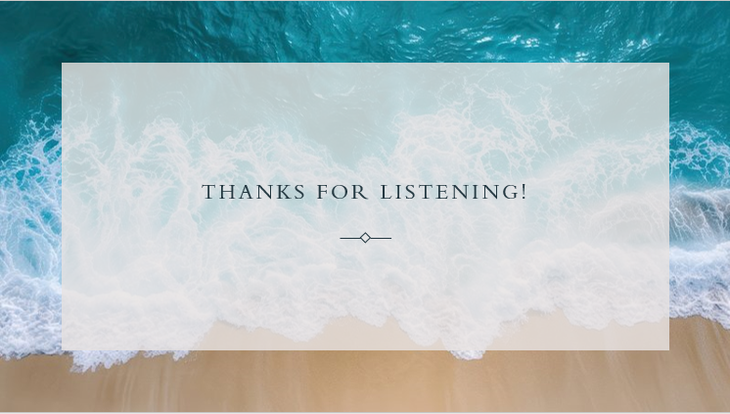

References
Han (2022) WHAT IS DESIGN THINKING & WHY IS IT IMPORTANT? Available at: https://online.hbs.edu/blog/post/what-is-design-thinking https://www.actionforchildren.org.uk/blog/is-youth-mental-health-getting-better-or. (Accessed on: April).

Action for Children (2024) Is youth mental health getting better or worse? Available at: worse/#:~:text=One%20in%20six%20children%20aged,six%20to%20one%20in%20four. (Accessed on: April).

Cogen (2023) 30 wellbeing apps to transform your health, from diet and fitness to sleep and stress. Available at: https://inews.co.uk/inews-lifestyle/wellbeing-apps-transform-health-diet-fitness-sleep-stress-2480225. (Accessed on: April).

NHS (2024) Wellbeing apps. Available at: https://www.england.nhs.uk/supporting-our-nhs-people/support-now/wellbeing-apps/. (Accessed on: April).

