Strategic management
A report
On
LC Furnture & Flooring
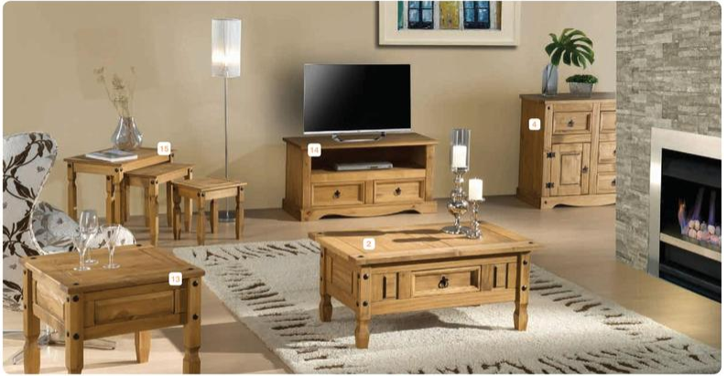

Student Name: Irene Muabana Kauzeni
Lecturer: Dr Rexon Nting

Table of Contents
Strategic management 1
Introduction 3
Strategic Direction of LC Furniture & Flooring 3
Strategic direction of LC Furniture & Flooring at a business unit 3
Strategic direction of LC furniture & Flooring in a corporate level 4
LC Furniture & Flooring’s Internal Environment Analysis 5
LC Furniture & Flooring’s VRIO analysis 5
LC Furniture & Flooring’s SWOT analysis 6
LC Furniture & Flooring’s TWOS Matrix 6
LC Furniture & Flooring’s External Environment Analysis 8
LC Furniture & Flooring’s PESTLE analysis 8
LC Furniture & Flooring’s Porter’s five force analysis 9
LC Furniture & Flooring’s Stakeholder analysis 10
Power-Interest Matrix 10
Stakeholder Management 11
LC Furniture & Flooring’s new strategy for sustainable growth 12
Business-Level Strategy: Bowman’s Strategy Clock 12
Corporate Level Strategy: Ansoff Matrix 13
LC Furniture & Flooring’s Strategic Evaluation 14
Conclusion and Recommendation 16
Conclusion 16
Recommendation 16
References 18

Introduction
LC Furniture & Flooring has four chain shops out of one is located in Hertfordshire. Naz Miah is the manager of LC Furniture. On 20th August 2019, Guardian interviewed Naz Miah, who said that after the announcement of the UK referendum to leave the EU in 2016, his company experienced a decline in sales. Amid growing uncertainty of Brexit, LC furniture started to recover the loss of declining in sales, but the no-deal Brexit would undergo another fall of his business (The Guardian, 2019). LC furniture imports most of the beds sold to customers from Germany. In this setting, Naz Miha predicted that the implementation of Brexit would contribute to a disastrous performance at LC furniture. These observations highlight the significance of the current report.
The report will contribute to providing an understanding about core aspects of strategic management for SMEs with reference to relevant theory and models.

Strategic Direction of LC Furniture & Flooring
Strategy is defined as building defenses against possible market and industry competition to accomplish specific organizational goals and objectives (David & David, 2019). This means that strategy contributes to confronting the challenges of industry competition, which is defined by five forces, according to Porter’s five force model. Most notably, direct rival competition, buyer power, supplier power, entrants, and substitute items intensify competition among market players (Ansoff et al., 2018). Hence, business firms develop and implement strategy to gain a strong position amid acute market competition.

Strategic direction of LC Furniture & Flooring at a business unit
Strategy at a business unit is defined as company’s approach to conducting functional activities in line with business strategy (Hitt et al., 2012). This indicates that there is a positive correlation between business strategy and corporate strategy (Hesterly & Barney, 2010). Porter’s generic strategy, as suggested by David & David (2019), is a theoretical framework of understand how a company designs and implements its business strategy. The model says that differentiation, cost leadership, and focus are three important strategic direction often employed by business to accomplish business objectives.
LC Furniture & Flooring is a small and medium enterprise (SMEs), which aims to gain profitability, and sustainability at the same time. The company has own manufacturing team as well as connection with Germany manufacturers (LC F&F, 2019). According to Naz Miah, the manager of LC furniture and flooring, the company tries to sell quality products at a reasonable price compared to its competitors. Why a firm adopts cost leadership strategy has been illustrated by Wheelen & Hunger (2011). The authors noted that cost leadership strategy increases the sales and profitability of a company only when it has strong ability to reduce operating cost. In response, LC furniture and flooring has developed a top team who have talent and skill to increase productivity as a mean of generating high productivity at less input (Hitt et al., 2012). Conversely, the cost leadership strategy does not work if firms fail to utilize organizational resources and capabilities according to resource based view theory of competitive advantage.
However, the company is working to prove itself as a differentiator from its competitors. More specifically, the company intends to utilize its design power and the quality of furniture to be different. The strength of differentiation strategy is that it helps build a strong brand image and trust, which in turn influence customers to go repeat purchase decision (LC F&F, 2019). Lack of top team, top manpower, and top management may disrupt the effectiveness of differentiation strategy.

Strategic direction of LC furniture & Flooring in a corporate level
Corporate level strategy is defined as long term direction of a company to attain its goals and objectives (Ansoff et al., 2018). Alternatively, corporate level strategy directs a firm where it intends to go (David & David, 2019). According to Ansoff Matrix, product development strategy, market development strategy, diversification, and market penetration strategy are key strategic considerations of a business at a corporate level.
Product development strategy is defined as a long term direction of a business to launch innovative and unique products in the market in order to be distinct and different from competitors (Ansoff et al., 2018). As a part of product development strategy, LC furniture regularly offers new and unique design bed, table, wardrobes and other furniture (LC F&F, 2019). The company collects furniture from German manufacturers (LC F&F, 2019). An advantage of product development strategy is that it helps retain and attract customers (Hesterly & Berney, 2011). The disadvantage is that customers don’t intend to purchase products with similar functions, and thus, the launch of product without considering customer demand may cause negative result.
Apart from product development strategy, market development is a key to expand company growth. For example; LC furniture has now four chain shops in the UK. In future, the company will enter in other parts in the UK (LC F&F, 2019). Lack of capital, manpower, and management efficiency, companies often face challenge to implement market penetration strategy and diversification strategy (The Guardian, 2019).

LC Furniture & Flooring’s Internal Environment Analysis

LC Furniture & Flooring’s VRIO analysis
The internal resources and competences analysis tool, VRIO analysis enables a business to measure the ability and competences of its resources to generate competitive advantage (Rothaermel, 2017). Therefore, the report conducts the VRIO analysis for measuring the strengths of the internal resources of LC Furniture & Flooring to generate a competitive advantage.
Table 1 VRIO analysis
Factors | Valuable | Rare | Inimitable | Organize | Competitive advantage
Passion and dedication of Naz Miah, the manager of LC furniture and flooring | Yes | Yes | Yes | Yes | Generates a competitive advantage
Extensive leadership and management of the owner-manager | Yes | Yes | Yes | Yes | Generates competitive advantage
Four chain shops | Yes | No | No | Yes | Not competitive advantage
Employees with skills and experiences | Yes | Yes | Yes | Yes | Generates competitive advantage
Own manufacturing team | Yes | No | Yes | Yes | Generates partial competitive advantage
Outsourcing and reliable supplier relationship | Yes | No | No | Yes | Not competitive advantage

According to the VRIO analysis, the leadership and management capabilities, and passion and dedication of owner-manager, and the skills and experiences of employees of LC Furniture & Flooring offer a competitive advantage. Hanson et al., (2016) argued that the resources of an organization, which consider as valuable, inimitable, rare, and organize, offer a competitive advantage. In addition, Jenkins & Williamson (2015) depicted that if the organizational resources fail to cover any of one element of the VRIO analysis tool, it will fail to generate a competitive advantage for the firm. For example; the chain shop of the LC Furniture & Flooring is an important resource but not rare and inimitable because the competitors of the company have also own outlets.

LC Furniture & Flooring’s SWOT analysis
SWOT analysis defines as the internal and external business analysis framework that facilitates to measure the strengths, opportunities, threats, and weaknesses of a business through a single outline (Hesterly & Barney, 2010).
Table 2SWOT analysis
Strengths  - Leadership and management capabilities of owner-manager (LC F&F, 2019).  - Skills and experiences of employees  - Own manufacturing team  - Strong brand image  - High quality of products  - Strong supply chain and outsourcing management | Weaknesses  - Only four chain shops in the UK.  - Depended on limited supplier  - Collecting materials form only EU countries  - Failing to fully satisfy stakeholders
Opportunities  - Developing new products and addressing customer new demand  - Business expansion over the UK and outside the UK  - Gaining a competitive position in the market by offering quality products (David & David, 2019). | Threats  - Possibility of materials shortage due to depending on limited suppliers  - The increasing cost of tax and duty of importing due to Brexit (The Guardian, 2019)  - Increasing operation cost due to increasing national wage rate

LC Furniture & Flooring’s TWOS Matrix
TWOS matrix refers to the strategic tool, used to develop a strategic way for overcoming the external threats and internal weaknesses by harnessing opportunities and strengths of LC Furniture and Flooring (Hitt et al., 2012).
Table 3 TWOS Matrix
Internal and external elements | Strengths (S)  - Leadership and management capabilities  - Employees’ skills and experiences.  - Own manufacturing team  - Strong brand image ((LC F&F, 2019).  - High quality of products  - Strong supply chain and outsourcing. | Weaknesses (W)  - Only four chain shops in the UK.  - Depended on limited supplier  - Collecting materials form only EU countries  - Failing to fully satisfy stakeholders
Opportunities (O)  - Developing new products and addressing customer new demand  - Business expansion over the UK and outside the UK  - Gaining competitive position in the marketplace. | S-O strategy  - Developing new product by employing strong supplier and outsourcing capabilities.  - Extensive management and leadership allows to expand the business. | W-O strategy  - Increasing number of chain shops by employing employee’s skills and experiences.  - Effectively manage stakeholders and gaining competitive position.
Threats (T)  - Possibility of materials shortage due to depending on limited suppliers  - Increasing cost of tax and duty of importing due to Brexit (The Guardian, 2019)  - Increasing operation cost due to increasing national wage rate (BBC, 2019) | S-T strategy  - Developing strong supply chain management to address material shortage.  - Strengthening in-house manufacturing team to reduce impost tax and duty. | W-T strategy  - In-store management for reducing operation cost.  - Finding alternative sources for collecting materials and outsourcing

LC Furniture & Flooring’s External Environment Analysis

LC Furniture & Flooring’s PESTLE analysis
The PESTLE analysis aims to notify the external opportunities and threats in the UK furniture and flooring industry.
Table 4 PESTLE analysis
Factors | Justification
Political | According to Rothaermel (2017), business, regardless of size, culture, operation, and industry, directly or indirectly affected by the political decision of a country. For example; the “no-deal Brexit” will directly influence the business sectors in the UK for operating business functions with EU countries, because it will increase the tax and duty of importing and materials and products (The Guardian, 2019). However, as the LC Furniture & Flooring collects materials from the EU suppliers, the Brexit will impose threats on the company by increasing tax and duty.
Economic | The economic indicators of a country more especially, national wages rate, GDP growth, inflation and exchange rate, the business rate may positively or negatively influence a business (Wheelen & Hunger, 2011). For example; BBC (2019) reported that the minimum wage rate in the UK will increase by 6.2% (£8.72) for people aged 25 and above from next April, and increasing wage rate by 1.4% (BBC, 2019). This means that the increased wage rate and business rate increase the operation cost of LC Furniture & Flooring because the company needs to pay extra wages and property costs.
Social | The retail survey by Deloitte (2019) found that British customers want to buy sustainable and quality products, more especially to purchase home accessories. This means that the LC Furniture & Flooring has opportunities to increase sales volume as well as profitability by offering sustainable and quality products.
Technological | The research report by Mintel (2019) showed that technological advancement creates revolutionary change in business more especially the retail sector. For example; the invention of robotic arms, the business automation system and the internet of thinking create opportunities for business in terms of managing and handling supply chain and warehouse, taking the quick and right decision, and business promotion.
Legal | Business refers to doing legal activities for gaining profitability and sustainability (David & David, 2019). This definition states the business should maintain legal rules and policies. Therefore, in order to operate legally business in the UK, the LC Furniture & Flooring needs to comply with national laws, act, and policies in the UK such as employment act, health and safety act, emission policy, equality act, industry competition policy etc, otherwise, the firm faces legal barriers (Mintel, 2019).
Environmental | In terms of gaining sustainability and developing a strong brand image, LC Furniture & Flooring must be complied with the environmental legislation in the UK such as new emission law. The fact is the British customers accept those brand which produces low emission, consume renewable energy, and offers sustainable products (Deloitte, 2019). Therefore, the furniture and flooring company needs to produce sustainable and environmentally friendly products.

LC Furniture & Flooring’s Porter’s five force analysis
The industry attractiveness and finding root of profitability tool, the Porter’s five forces model contributes to confronting the challenges of industry competition (Jenkins & Williamson, 2015)
Table 5 Porter’s five force analysis
Forces | Level of threat | Justification | Action to be needed by the LC Furniture & Flooring
Threat of entrants | Moderate to high | The Furniture market value in the UK is accounted for 86239 million US dollars and more than 8000 businesses (Statista, 2020). This means that high industry profitability may attract new entrepreneurs to entry in this industry, that’s why the threat of new entry is high. | To gain customer loyalty and trust by offering a sustainable and quality products.
Buyer power | High | The buyer power in the furniture industry in the UK is high due to the low switching cost and availability of brands because the industry comprises more than 8000 businesses (Statista, 2019). Rothaermel (2017) reported that low switching costs and availability of brands increasing buyer power due to getting available alternatives. | Need to maximize customer satisfaction and brand image by ensuring product quality.
Suppliers power | High | According to LC F&F (2019), the company collects materials from limited EU suppliers. Therefore, the supplier power of the company is high. The fact is that when a company depends on the limited suppliers, the suppliers get a competitive advantage by providing low-quality materials with high cost (Hanson et al., 2016). | To find out alternative suppliers' sources.
Threat of substitute | Moderate to high | The threats of substitutes in industry measures by the number of businesses that offer similar functional products (David & David, 2019). Therefore, producer of pretax, fabric bedding, steel and aluminum furniture producer are the direct substitute for LC F&F. | To executive top knows-marketing and offer better customer services.
Rivalry competition | High | As the furniture industry in the UK comprises of more than 8000 furniture manufacturers (Statista, 2019), the competition level for LC company is high. | To present itself as a different competitor in the marketplace with high quality and durable products at fair price.

LC Furniture & Flooring’s Stakeholder analysis

Power-Interest Matrix
Stakeholder defines as the group of individuals and organizations who directly or indirectly affected or being affected by the operation of a business (Mionoja, 2012). However, the “power-interest matrix”, developed by Mendelow’s facilitates to manage organizational stakeholders by prioritizing their power as well as interest (Ackermann & Eden, 2011). However, the following stakeholder matrix shows the key stakeholders of the LC Furniture & Flooring.
Table 6 Power-Interest Matrix
 | High interest | Low interest
High power | Owner-manager of the company  Organizational employees  Suppliers  Strategic partner of outsourcing | Customers  Government  Industry policymakers  Direct competitors
Low power | Middle man  Labor union  Material collectors  Transportation authority | Indirect competitors  Third-party organization  Media  NGOs and others.

Stakeholder Management
Stakeholder management is the most complex task of a business, a business comprises of several internal and external stakeholders, and therefore, the firm needs to manage them effectively and satisfy their requirements fully (Clifton & Amran, 2011). Freeman stakeholder theory suggests that businesses should satisfy their stakeholders by prioritizing their key requirements, interest, and influencing power (Minoja, 2012). Therefore, the LC Furniture and Flooring Company could have employed Mendelow’s stakeholder matrix for managing and satisfying its stakeholders. The key advantage of using the stakeholder matrix is that it helps the LC company to identify its stakeholders easily and manage them according to their influencing power and interest.
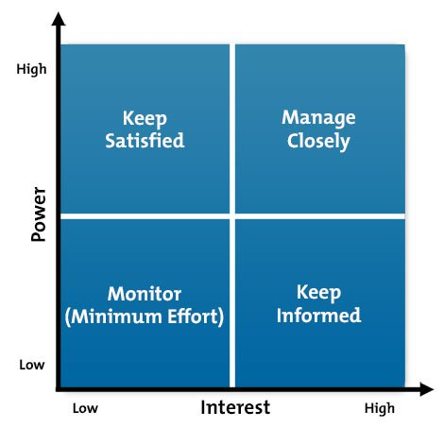
Figure 1 Stakeholder power interest matrix (Source: Clifton & Amran, 2011).
The matrix categorizes the stakeholders of LC Furniture and Flooring into four different branches, including “high power-high interest, high power-low interest, high interest-low power, and low interest-low power” (Ackermann & Eden, 2011).
According to the matrix, owner-manager of the company, employees, suppliers, and strategic partners of outsourcing are that stakeholder, of LC Furniture and Flooring, who have both high power and interest. So, the company should keep satisfied them at first (Stead & Stead, 2014). In addition, the high power but low-interest stakeholders are including customers, Government, industry policymakers, and direct competitors, who have the ability to create barriers on LC business through imposing legal ways and increasing competition (Clifton & Amran, 2011). So, LC furniture and flooring should closely manage them. On the other hand, the company can manage the stakeholders by giving minimum efforts who have low power and low interest. To do this, the company should monitor and keep inform them only (Ackermann & Eden, 2011).

LC Furniture & Flooring’s new strategy for sustainable growth

Business-Level Strategy: Bowman’s Strategy Clock
As the earlier section, it stated that the company’s business-level strategy is an approach of doing the financial operations in the market place for achieving a competitive position. This means that the business level strategy of a company is directly linked with strategic business objectives and mission statements. According to Wheelen & Hunger (2011), the company sets its business strategy in order to successfully achieve its business objectives and business mission. Therefore, it could be stated that there is a close correlation between the company’s business strategy and business mission. However, the key strategic mission of the LC Furniture and Flooring is to gain a sustainable position in the market by offering the quality products with fair prices toward customers (LC F&F, 2019).
Bowman’s Strategy Clock, the strategic tool which is employed by a business to develop its business-level strategy. Actually, the Bowman’s Strategy Clock is the extended version of Porter’s generic strategy (Rothaermel, 2017). However, Bowman’s Strategy Clock suggests that an organization can adopt any of one strategy among eight different strategies for developing a business strategy that demonstrates the below figure.
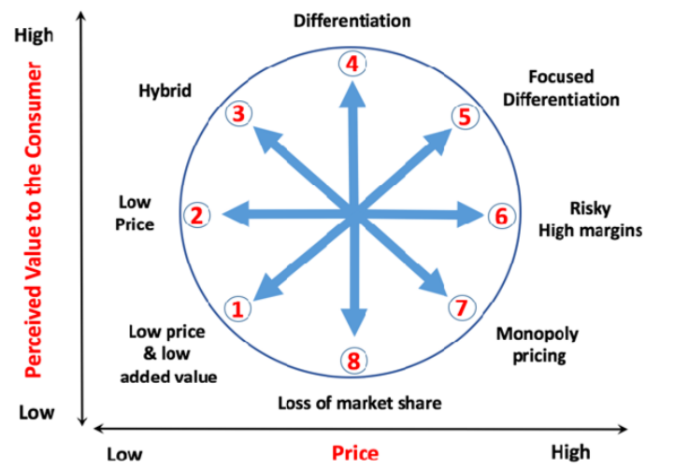
Figure 2 Bowman’s Strategy Clock (Source: Tassabehji & Isherwood, 2014).
According to Hanson et al., (2016), a company should consider organizational strengths, size, resources, and capabilities to develop business strategy. However, LC Furniture & Flooring is a small and medium enterprise (SMEs), which aims to gain profitability, and sustainability at the same time. According to Naz Miah, the manager of LC furniture and flooring, the company tries to sell quality products at a reasonable price compared to its competitors, and therefore the company develops its own manufacturing team as well as a connection with Germany manufacturers (LC F&F, 2019).
However, as the company aims to gain profitability, and sustainability, while at the same time wants to offer quality products at a fair price, it should adopt the hybrid strategy, according to Bowman’s Strategy Clock (Desai, 2019). The reason for adopting hybrid strategy is that it facilitates the company to offers products at a reasonable price compared to its competitors, while at the same time contributes to maintaining a standard quality of the products (Eyvrigh, 2016). Therefore, this argument is directly supported by the key aim of the LC Furniture and flooring.
The company could have employed others strategies to show the Bowman’s Strategy Clock such as differentiation, risky high margin, monopoly pricing, or differentiation focus strategy, but the strategies not fit for the LC furniture and flooring. The reason is that Tassabehji & Isherwood (2014) depicted that organization is required to gain high capital with large customers profile, internet resources and capability to develop high-quality products and strong brand image to adopt differentiation or other next strategies suggested the Bowman’s Strategy Clock. However, in line with the strategic mission and aim of the LC Furniture and Flooring, the company should employ hybrid strategy for gaining sustainable growth in the future.

Corporate Level Strategy: Ansoff Matrix
The business firms are more likely to devises their corporate-level strategy to a sustainable position in the industry, because, the corporate level strategy is directly linked with business mission and vision (Johnson, 2016). As the mission of the LC Furniture & Flooring is to offer new and quality products for the customers at a fair price, and vision is to gain a sustainable position in the marketplace, the company should employ product development strategy, represented by Ansoff matrix (Ansoff et al., 2018). The key reason is that as a small business, it is not easy to expand the business for the new market, and therefore, the product development strategy offers benefits of the company to increase customer volume by offering new products (Rothaermel, 2017).
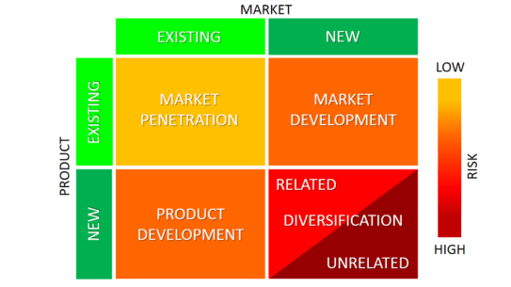
Figure 3 Ansoff matrix (Source: Jenkins & Williamson, 2015).
Further, the LC Furniture & Flooring would employ market development and diversification strategy, but it does not support its business size and capital structure. Jenkins & Williamson (2015) argued that a company can adopt a market development strategy to expand business in the new market and diversification strategy by offering high-quality products at a high price. For example; the company has only four chain shops (LC L&F, 2019). This means that the company has a lack of financial and non-financial resources, and therefore, the market development would not the best strategy. In addition, the mission of the company is to offer a quality products with a fair price. So, the diversification strategy and market penetration strategy will not support the mission of the company, because, it is required to offer high-quality products with a high price in diversification strategy and offer a quality product with low price at penetration strategy (XWheelen & Hunger, 2011).

LC Furniture & Flooring’s Strategic Evaluation
Strategic evaluation refers to critically evaluating the organizational resources and capabilities, competencies of owner-manager, possible strategic opportunities and developing the ways of confronting external threats as well as internal weakness (David & David, 2019). According to the LC F&F (2019), the company aims to gain a sustainable position in the market and profitability at the same time, by offering quality products at a reasonable price. To do this, the company should gain customer trust and loyalty, and increasing internal resources and capabilities. According to Rothaermel (2017), in order to increase customer trust and loyalty, LC Furniture and Flooring needs to develop new products with an attractive designs that ensure durability. In addition, as a small enterprise, the owner-manager of LC Furniture and flooring has passion and dedication that facilitates to develop a strategic vision. Further, the company has own manufacturing team and strategic partnership with Germany suppliers that facilitate to develop new products (LC F&F, 2019).
The external analysis shows that the political issues such as Brexit impose threats on the company by increasing tax and duty, economic factors more especially increasing business rate by 1.4% and wage rate by 6.2% (BBC, 2019) directly impact on organizational profitability, because it increases the operation and administration cost. In this situation, the company is required to retain customer confident by employing strategic pricing policy and finding a sustainable suppliers with relatively low cost (Hanson et al., 2016). On the other hand, social and technological factors create opportunities for the company. For example; the company has opportunities to gain customer trust and loyalty by offering sustainable, durable and quality products because British customer wants to buy sustainable and durable products for their home appliances (Deloitte, 2019). Similarly, the company can gain competitive advantage and economies of scale by employing technological advantage. For example; Mintel (2019) found that the UK furniture companies gain a technological advantage by using robotic arms for moving heavy wait products and material, and different designing and cutting technology for developing the new and attractive design for furniture and flooring.
Further, the five forces analysis shows that the UK furniture and flooring industry comprises high supplier and buyer power, industry profitability and attractiveness with moderate to high new entry threat, extensive competition and the threat of substitute. Therefore, the company can overcome the threats by offering a new products, gaining customer trust, finding low-cost outsourcing and supplier's sources, and increasing brand image through offering quality products and ensuring durability (Stead & Stead, 2014).

Conclusion and Recommendation

Conclusion
Business firms develop and implement a strategy to gain a strong position amid acute market competition. The report aimed to understand about core aspects of strategic management for SMEs more especially the LC Furniture and Flooring with reference to relevant theory and models. The report identified that the PESTLE analysis shows both opportunity and threats for the company such as political and economic factors impose threats by increasing Brexit uncertainty, and business rate and national wage, whereas the social and technological factors, creates opportunities for developing new products and using robotic arms and designing and cutting technology. The five forces analysis showed that the UK furniture and flooring industry comprises high supplier and buyer power, industry profitability and attractiveness with moderate to high new entry threat, extensive competition and the threat of substitute. Further, it was found that the passion and dedication, and leadership and management of owner-manager, employee skills, and own manufacturing team of the LC furniture and flooring allowed competitive advantage, according to VRIO analysis. The study conducted STWO analysis and TWOS Matrix analysis to measure the opportunities, strengths, threats and weaknesses and develop a strategic way of managing threats and weaknesses by harnessing opportunities and strengths. Furthermore, it examined that the hybrid strategy according to the Bowman’s Strategy Clock, and product development strategy according to the Ansoff matrix facilitated the company to gain sustainable growth.

Recommendation
Drawing upon the external and internal analysis of FC Furniture and Flooring, the study provides the following recommendations so that the company can gain competitive and sustainable growth.
New product development- the PESTLE analysis more especially the social factor indicates that the British customer wants to buy quality and durable products with attractive designs for their home accessories (Deloitte, 2019). Therefore, the LC Furniture and Flooring Company should adopt to develop a new product with standard quality, attractive design and durable features for addressing customers’ demand.
Adopting a hybrid strategy- According to Naz Miah, the manager of LC furniture and flooring, the company tries to sell quality products at a reasonable price compared to its competitors. Therefore, the company should adopt a hybrid strategy, according to the Bowman’s Strategy Clock (Desai, 2019). The reason for adopting hybrid strategy is that it facilitates the company to offers products at a reasonable price compared to its competitors, while at the same time contributes to maintaining a standard quality of the products (Eyvrigh, 2016).
Finding alternative sources pf suppliers- According to The Guardian (2019), the no-deal Brexit imposes extensive challenges on the business of LC Furniture and Flooring by increasing tax and duty. For example; at present, the company outsources from Germany manufacture and collect materials from the EU, therefore, after implementing Brexit, the company pays extra tax on importing furniture from Germany (The Guardian, 2019). In this situation, the company should find alternative sources of a supplier outside Germany as well as the EU.

References
Ackermann, F., & Eden, C. (2011) Strategic management of stakeholders: Theory and practice. Long range planning, 44(3), 179-196.
Ansoff, H. I., Kipley, D., Lewis, A. O., Helm-Stevens, R., & Ansoff, R. (2018) Implanting strategic management. Springer.
BBC. (2019) National living wage to rise by 6.2% in April. [Online] Available at> https://www.bbc.com/news/business-50947097 [Accessed: 4th January 2020].
Clifton, D., & Amran, A. (2011) The stakeholder approach: A sustainability perspective. Journal of Business Ethics, 98(1), 121-136.
David, F. R., & David, F. R. (2019) Strategic management: A competitive advantage approach, concepts and cases. Pearson.
Deloitte. (2019) Retail Trends 2019. [Online] Available at> https://www2.deloitte.com/uk/en/pages/consumer-business/articles/retail-trends.html [Accessed: 27th December 2019].
Desai, C. (2019) Strategy and Strategic Management. In Management for Scientists (pp. 65-84). Emerald Publishing Limited.
Eyvrigh, G. M. (2016) A review of marketing strategies. Kuwait Chapter of Arabian Journal of Business and Management Review, 33(3492), 1-7.
Hanson, D., Hitt, M. A., Ireland, R. D., & Hoskisson, R. E. (2016) Strategic management: Competitiveness and globalisation. Cengage AU.
Hesterly, W., & Barney, J. (2010) Strategic management and competitive advantage. Upper Saddle River, NJ.
Hitt, M. A., Ireland, R. D., & Hoskisson, R. E. (2012) Strategic management cases: competitiveness and globalization. Cengage Learning.
Jenkins, W., & Williamson, D. (2015) Strategic management and business analysis. Routledge.
Johnson, G. (2016) Exploring strategy: text and cases. Pearson Education.
LC F&F. (2019) LC Furniture & Flooring. [Online] Available at> http://www.lcfurnitureandflooring.co.uk/living-and-dining.html [Accessed: 3rd January 2020].
Minoja, M. (2012) Stakeholder management theory, firm strategy, and ambidexterity. Journal of Business Ethics, 109(1), 67-82.
Mintel. (2019) Furniture Retailing - UK - July 2019. [Online] Available at> https://reports.mintel.com/display/920360/ [Accessed: 24th December 2019].
Rothaermel, F. T. (2017) Strategic management. New York, NY: McGraw-Hill Education.
Statista. (2019) Furniture industry in the UK. [Online] Available at> https://www.statista.com/outlook/17000000/156/furniture/united-kingdom [Accessed: 23th December 2019].
Stead, J. G., & Stead, W. E. (2014). Sustainable strategic management. Routledge.
Tassabehji, R., & Isherwood, A. (2014) Management use of strategic tools for innovating during turbulent times. Strategic Change, 23(1‐2), 63-80.
The Guardian. (2019) We need to survive’: Stevenage’s small business owners reveal Brexit fears. [Online] Available at> https://www.theguardian.com/uk-news/2019/aug/20/stevenage-small-business-owners-brexit-no-deal [Accessed: 20th December 2019].
Wheelen, T. L., & Hunger, J. D. (2011) Concepts in strategic management and business policy. Pearson Education India.

