

Report submitted
as part of the requirements for
ACCA7026 Module
Artificial Intelligence

by
Kaicheng Li (2106269)

Supervisor: Assoc. Dr Mohamed Bennasar

January 2022

ABSTRACT
The MNIST handwritten digit dataset is a dataset commonly used in machine learning algorithm research. This report mainly researches and studies the implementation of handwritten digit recognition.
Firstly, by learning the basic principles of SVM and KNN algorithms and how they work, we understand how the algorithms are implemented. Then, the recognition of handwritten digits from the MNIST dataset was implemented on MATLAB. For the SVM algorithm, by adjusting the parameter C kernel type and gamma g, find the parameter combination that makes the model test accuracy higher to determine the model. For the KNN algorithm, the parameter K, that is, the number of neighbors, is mainly adjusted, and the parameter K that makes the model test accuracy higher is found to determine the model.
The parameters of the model are determined by conducting training experiments using part of the dataset. Based on the model with better performance in the preliminary experiments, all the data of the MNIST dataset are used for model testing. We use the confusion matrix and accuracy as evaluation indicators to evaluate the performance of the model. We get the values ​​of accuracy, precision, specificity, sensitivity, recall and F-score of the two algorithmic models.
The results show that the test accuracy of the SVM algorithm is 98.2%, which is slightly higher than that of the KNN algorithm, which is 96.90%. But overall, the KNN algorithm also showed good performance in this task.
Key Words： MNIST handwritten digit recognition; SVM; KNN ; confusion matrix

CONTENTS

1. INTRODUCTION 1
1.1. Handwritten Digit Recognition 1
1.2. MNIST Dataset 1
2. METHODOLOGY 2
2.1. SVM 2
2.2. KNN 2
3. DESIGN AND IMPLEMENTATION 4
3.1. MNIST Handwritten Digits Recognition Based On SVM 4
3.2. MNIST Handwritten Digits Recognition Based On KNN 7
4. RESULTS AND DISCUSSION 8
4.1. Model Performance Evaluation Metric 8
4.2. The result of MNIST handwritten digits recognition based on SVM. 10
4.3. The result of MNIST handwritten digits recognition based on KNN. 12
4.4. Results And Discussion 13
5. CONCLUSIONS 15
REFERENCE 16
APPENDIX： PROGRAMMING CODE 17

- INTRODUCTION
  - Handwritten Digit Recognition
With the development of economy and society, handwritten digit recognition has been widely used in many fields. Handwritten digit recognition is to recognize handwritten digits and classify them into 10 categories.
The handwritten digit recognition based on artificial intelligence technology has gone through three important stages: the first stage is to use traditional classifiers represented by support vector machines (SVM) for recognition; the second stage is to establish a convolutional neural network (CNN) In the third stage, a hybrid classification model represented by the combination of convolutional neural network and support vector machine (CNN+SVM) was established.
We want to try multiple solutions for a given problem and evaluate the solutions. We want to try different settings for the machine learning algorithm to get the best performance and compare the results^{[6]}. You will need to evaluate the performance of the trained model using different metrics, such as confusion matrix and classification accuracy.
  - MNIST Dataset
The MNIST dataset consists of 70,000 images of handwritten digits (60,000 training and 10,000 testing). It is a great database for learners and researchers, both in preprocessing and formatting spend the least amount of effort. Many methods have been tested on this training and test set^{[2]}.
- METHODOLOGY
  - SVM
The SVM^{[5]} is a linear classifier defined in the feature space to maximize the classification interval, and its goal is to find the optimal classification surface that can achieve the above requirements. The goal of SVM is to find a hyperplane, using two classes of data as far away from the hyperplane as possible, so that it can classify new data more accurately, even if the classifier is more robust, as shown in Fig 1.
The Support Vectors are the points closest to the separating hyperplane. Finding the maximum interval is to find the distance that maximizes the support vector to the separating hyperplane, and under this condition, find the separating hyperplane
In the case of nonlinearity, it can be transformed into a linear problem in a high-dimensional space, and then the optimal classification surface can be found. However, this conversion and solution are usually complicated and not easy to implement, so a very important concept kernel function is introduced into SVM. The kernel function can map the sample space to a high-dimensional space without increasing the computational complexity. With the addition of kernel functions, support vector machines eventually tend to be perfect.
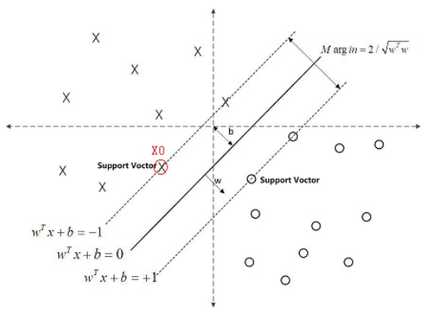
Fig.1 Support Vector
  - KNN
The KNN^{[4][7]} algorithm is a classification algorithm in machine learning, and its working mechanism is relatively simple: given a sample set, also called a sample training set, and know the corresponding relationship between the data in the sample data set and the classification to which it belongs. The K-nearest neighbor learning algorithm is a classification algorithm in machine learning, and its working mechanism is relatively simple: given a sample set, also called a sample training set, and know the corresponding relationship between the data in the sample data set and the classification to which it belongs.
- General steps of the KNN algorithm
(1) Obtain the training data set and extract its features.
(2) A part of the dataset is used as training data, and the other part is used as test data for verification.
(3) Select a K value and use the cross-validation method, that is, use the training set and the validation set to select the optimal K value.
(4) Calculate the K sample instances that are closest to the K value.
(5) Judging the accuracy by the test sample set.
(6) Modify the K value, skip to step (3), and select a more accurate K value
- Choice of K value
If a smaller value of K is selected, the training instance set will become smaller, the approximate error of training will become smaller, and the training data can be effective only when the training data is similar to the new input data. When the value of K decreases, it is easy to be affected by outliers, and the problem of overfitting is more likely to occur. If a larger K value is selected, the training instance will become larger, and the training approximation error will also become larger. If the training data is not related to the newly input new data, different effects will occur, and the problem of sample balance is prone to occur, making the model becomes simple, and there is an underfitting problem. Therefore, in general, the data is divided into training set and test set to select the optimal K value.
- DESIGN AND IMPLEMENTATION
In this chapter, after clarifying the model design process, data set, the software and the toolboxs, the realization process of the algorithm is analyzed. Finally, we will get a model with determined parameters.
- Model Design Process
In this work, we use SVM and KNN machine learning algorithms and artificial neural networks for handwritten digit recognition. Take the number recognition accuracy rate (that is, the classification accuracy rate) as the evaluation index, and try to set different parameters to make the model get the best performance. In this way, we have obtained models with good performance of each machine learning algorithm.
On this basis, we will evaluate the performance of several models in the next step.
- Dataset
Use the MNIST dataset
Download the data and load the data set into the workspace, the total size is 55.7 MB. We need to have a scrip to load the image data to a matrix of dimensions (60000+1000) by 784. The models we designed use them for model training and model testing.
- The softwares we use are as follows:
MATLAB Requirement:
We need to have the following MATLAB toolboxes installed on the machine:
- LIBSVM Toolbox.
- Statistics and Machine Learning Toolbox.
- Image Processing Toolbox.
- Optimization Toolbox.
- Computer Vision Toolbox.
- Bioinformatics Toolbox.
Python Requirement:
We need to have the following Python toolboxes installed on the machine:
- Pandas Toolbox.
- Numpy Toolbox.
- Tensorflow Toolbox.
- Sklearn Toolbox.
- Seaborn Toolbox.

  - MNIST Handwritten Digits Recognition Based On SVM
In this section, we use the SVM machine learning algorithm for experiments.
- Step 1: Data preprocessing
Read the file, import the data and use the ‘processMNISTdata’ function for data processing to get the image data ‘x_train’ and the corresponding label ‘y_train’ used for training. The data types are both arrays.
- Step 2: Model construction (use training data for model training)
Use the data in the 60000 sets of training data sets, and use the SVM function of the LIBSVM toolbox to train the model.
Among them, the initial settings of several hyperparameters are as follows:
- type of SVM: 0-SVC(multi-class classification)
- kernel type^{[1][2]}: 2–radial basis function
- the parameter C of C-SVC: 1.2
- probability estimates: whether to train a SVC model for probability estimates (default 0)
- quiet mode (no outputs)
- -g gamma : gamma g in kernel function
- Step 3: Model performance evaluation (use test data for model testing)
For the data in the 10,000 test data set, similar to the training data set, the data types of the tested image data ‘x_test’ and the corresponding label ‘y_test’ are both arrays. Use the model built in step 2 for testing. We can get the prediction label corresponding to the test data and the prediction accuracy of the model on the test set.
Further, we use the predicted label of the model on the test set to calculate the confusion matrix, and we can also draw the ROC curve corresponding to the model.
- Step 4: Change the parameters to choose more suitable parameters
With the initial setting of the above hyperparameters, we can basically implement the training and testing of the SNM model. On this basis, we can observe the performance of the model by changing the hyperparameters to different values. This can help us choose the hyperparameters that make the model perform best and save the model.
In this work, the changed hyperparameters are mainly kernel type and the parameter C of C-SVC. Here, only the accuracy rate is the observed evaluation index. We observe the impact of different hyperparameters on accuracy.
In particular, because it takes a long time to train the model with 60,000 sets of training data sets, 2,000 sets of training data are used in order to adjust the hyperparameters.
First fix the parameter C of C-SVC to 1.2, set the kernel type and gamma g respectively.
- 0 – linear.
- 1 – polynomial.
- 2 – radial basis function.
- 3 – sigmoid.
- 4-precomputed kernel (kernel values ​​in training_instance_matrix).
We can get the accuracy of the model as shown in the table 1.

Table 1
parameter C | kernel type | gamma g | test accuracy
1.2 | linear | 0.0001 | 89.85%
1.2 | linear | 0.000001 | 89.85%
1.2 | linear | 0.00000001 | 89.85%
1.2 | polynomial | 0.01 | 92.35%
1.2 | polynomial | 0.0001 | 92.35%
1.2 | polynomial | 0.000001 | 92.35%
1.2 | polynomial | 0.0000000001 | 51.56%
1.2 | radial basis function | 0.01 | 10.28%
1.2 | radial basis function | 0.0001 | 10.28%
1.2 | radial basis function | 0.000001 | 92.51%
1.2 | radial basis function | 0.0000000001 | 54.48%
1.2 | sigmoid | 0.01 | 11.35%
1.2 | sigmoid | 0.0001 | 11.37%
1.2 | sigmoid | 0.000001 | 37.22%
1.2 | sigmoid | 0.00000001 | 84.99%
1.2 | sigmoid | 0.0000000001 | 54.46%

Then fix the kernel_type to 2-radial basis function, and set the parameter C of C-SVC to 0.1, 1.2 and 10. The accuracy of the model on the test set can be obtained as shown in the following table.
Table 2
kernel_type | parameter C | test accuracy
radial basis function  gamma g  0.000001 | 0.1 | 63.93%
radial basis function  gamma g  0.000001 | 1.2 | 92.51%
radial basis function  gamma g  0.000001 | 10 | 92.56%
radial basis function  gamma g  0.000001 | 20 | 92.56%
radial basis function  gamma g  0.000001 | 100 | 92.56%
- Step 5: Determine the parameters
Through the different settings of the above parameters, we select the parameters that make the model performance better to save. Therefore, the final selected parameters of the SVM model are:
- type of SVM: 0-SVC(multi-class classification).
- Kernel type: 2–radial basis function.
- the parameter C of C-SVC: 10
- probability estimates: whether to train a SVC model for probability estimates (default 0).
- quiet mode (no outputs).
- gamma g: 0.000001

  - MNIST Handwritten Digits Recognition Based On KNN
In this section, we use the KNN machine learning algorithm for experiments.
- Step 1: Data preprocessing
Read the file, import the data and the training data ‘x_train’ and the corresponding label ‘y_train’.
- Step 2: Model construction (use training data for model training)
Use the data in 60,000 training data sets to train the model. The initial settings of the hyperparameters are as follows:
Neighbor Numbers K: 10
- Step 3: Model performance evaluation (use test data for model testing)
For the data in the 10,000 test data sets, similar to the training data set, the test image data ‘x_test’ and the corresponding label ‘y_test’ are included. Use the model built in step 2 for testing. We can get the prediction label corresponding to the test data and the prediction accuracy of the model on the test set.
- Step 4: Change the parameters to choose more suitable parameters
With the initial setting of the above hyperparameters, we can basically implement the training and testing of the KNN model. On this basis, we can observe the performance of the model by changing the hyperparameters to different values. This can help us choose the hyperparameters that make the model perform best and save the model.
In this work, the changed hyperparameter is K. Here, only the accuracy rate is the observed evaluation index. We observe the impact of different hyperparameters on accuracy. Set K respectively 7, 10, 17, 20.
The accuracy of the model on the test set can be obtained as shown in table 3.
Table 3
hyperparameter K | test accuracy
7 | 96.90%
10 | 96.70%
17 | 96.30%
20 | 96.24%
- Step 5: Determine the parameters
Through the different settings of the above parameters, we select the parameters that make the model performance better to save. Therefore, the final hyperparameter K selected by the KNN model is 7.

- RESULTS AND DISCUSSION
In this chapter, we will analyze the performance of different algorithm models to recognize numbers. Use the data in the 60000 sets of training data sets to train the model. Use the data in the 10000 sets of test data sets to train the model.
In Chapter 4, the parameters of the SVM and KNN models have been determined, so we use the parameters to determine the trained model, and use the confusion matrix and accuracy as evaluation indicators to evaluate the performance of the model.
By comparing the evaluation index values of different models, we can discuss and analyze the differences in the usability and performance of different algorithms.
  - Model Performance Evaluation Metric
In this work, the test data set is used to test the algorithm model that has been trained with the training data set. We can get the accuracy of the model recognition test handwritten digit data set. Further, we use the predicted label of the model on the test set to calculate the confusion matrix, and we can also draw the ROC curve corresponding to the model.
Confusion matrix: The confusion matrix is a display table of the corresponding statistics of the true labels of the data and the predicted labels of the model. Through the confusion matrix, we can finally calculate the evaluation index values of accuracy, precision, sensitivity(recall), specificity, and F-score.
TP (ture positives) indicates the number of samples that are actually predicted to be positive.
TN (ture negatives) indicates the number of samples that are actually predicted to be negative classes
FP (false positives) indicates the number of samples that are actually predicted to be positive.
FN (false negatives) indicates the number of samples that are predicted to be negative classes from samples that are actually positive classes
Confusion matrix | Predicted Positive | Predicted Negative
Actual Positive | TP | FN
Actual Negative | FP | TN

The following are the concepts and basic principles of these evaluation indicators.
- Accuracy
Accuracy represents the proportion of accurate prediction samples in all samples, and the accuracy rate can be used to judge the overall classification accuracy of the specified model.
$$Accuracy=\frac{TP+TN}{TP+FP+TN+FN}$$
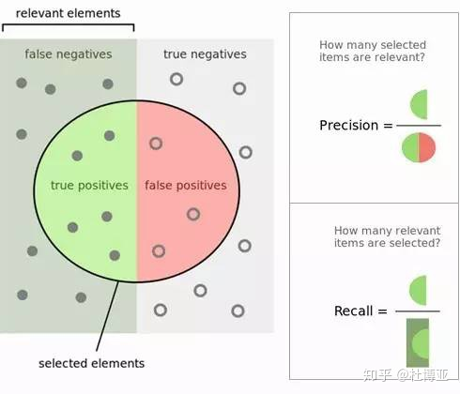
- Precision
Precision, also known as precision, indicates the proportion of true positive samples in the predicted positive samples. It indicates the probability (proportion) of samples that are actually positive among all predicted positive samples, that is, the accuracy of the prediction for the positive class.
$$precision=\frac{TP}{TP+FP}$$
- Sensitivity（Recall）
Sensitivity (Recall) represents the probability (proportion) of the actual positive samples being predicted as positive samples. It represents the proportion of all positive samples that are paired, and measures the classifier's ability to identify positive samples. The recall rate is also called the recall rate. For the original sample, it represents the proportion of accurate samples predicted by all positive samples.
$$Recall=\frac{TP}{TP+FN}$$
- Specificity
Specificity represents the proportion of all negative examples that are paired, and measures the classifier's ability to identify negative examples.
$$Specificity=\frac{TN}{TN+FP}$$
- F-score
F-score is a measure of test accuracy. It is an indicator designed to comprehensively consider the precision rate and the recall rate and to find a balance between the two. When the F-score is high, it can indicate that the test method is more effective.
$$F-score=2*\frac{Recall*Precision}{Recall+Precision}$$
- ROC curve
The ROC curve and AUC are indicators for evaluating the pros and cons of the binary model as a whole, where AUC is the area between the ROC curve and the horizontal axis. Compared with other evaluation indicators, the ROC curve has a certain stability. ROC curve and AUC are important evaluation indicators.
AUC = 0.5: Indicates that the model is as good as chance. AUC < 0.5: The discriminative ability of the model is no different from random guessing. AUC > 0.5: the model is better.
  - The result of MNIST handwritten digits recognition based on SVM.
- Accuracy
The recognition accuracy of the model on the test data set：
Table 4
kernel type | parameter C | gamma g | test accuracy
radial basis function | 10 | 0.000001 | 98.2%
- Corresponding ROC curve
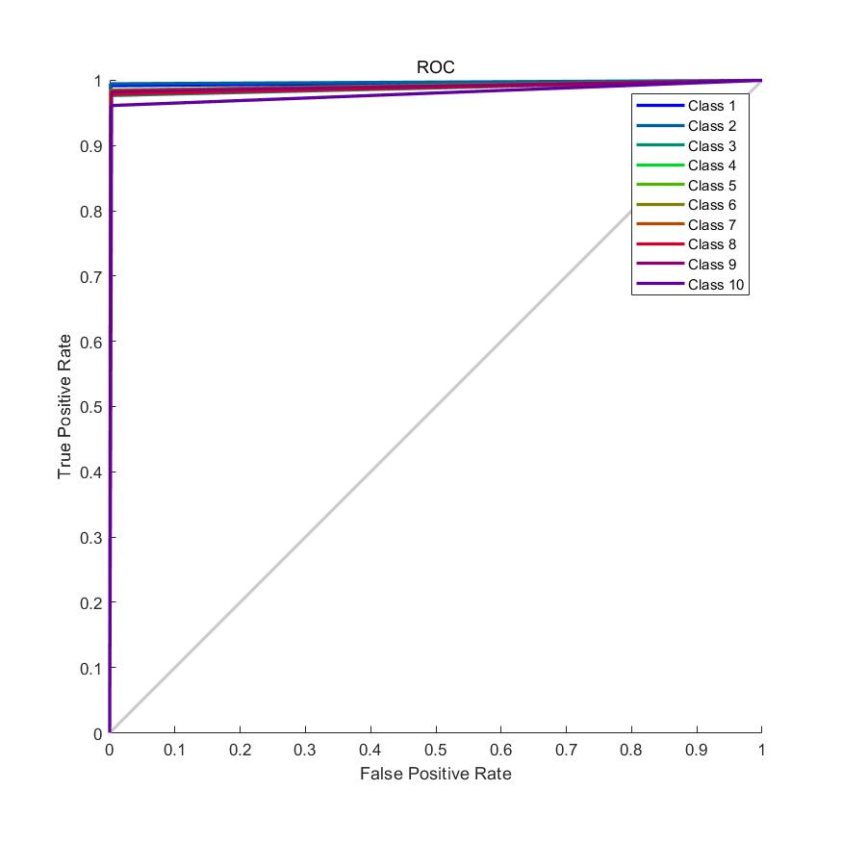
- Confusion Matrix
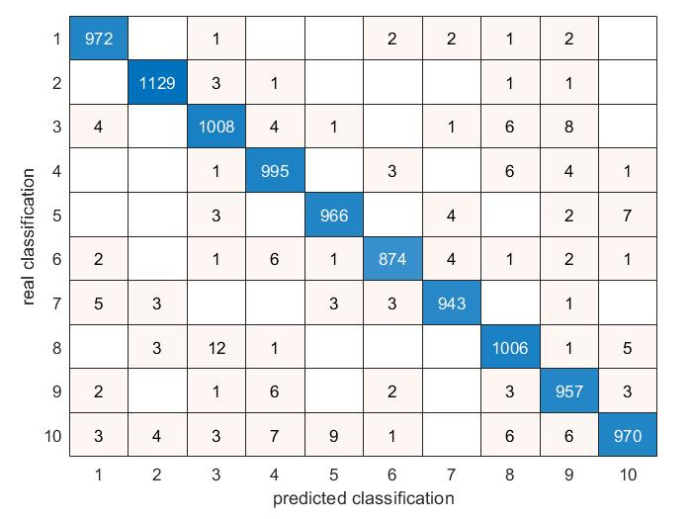
Through the confusion matrix, we can finally calculate the evaluation index values of accuracy, precision, specificity, sensitivity, recall and F-score.
- Accuracy
(972+1129+1008+995+966+874+943+1006+957+970)/10000 = 98.2%
We take class 1 as an example and calculate TP、TN、FP and FN from the confusion matrix as shown in table 5.
Table 5
Class 1 | Predicted Positive | Predicted Negative
Actual Positive | TP=972 | FN=8
Actual Negative | FP=16 | TN=9004
- Precision
$$precision=\frac{TP}{TP+FP}=98.38\%$$
- Sensitivity（Recall）
$$Recall=\frac{TP}{TP+FN}=99.18\%$$
- Specificity
$$Specificity=\frac{TN}{TN+FP}=99.82\%$$
- F-score
$$F-score=2*\frac{Recall*Precision}{Recall+Precision}=0.9878$$

  - The result of MNIST handwritten digits recognition based on KNN.
- Accuracy
The recognition accuracy of the model on the test data set：96.90%
- Corresponding ROC curve
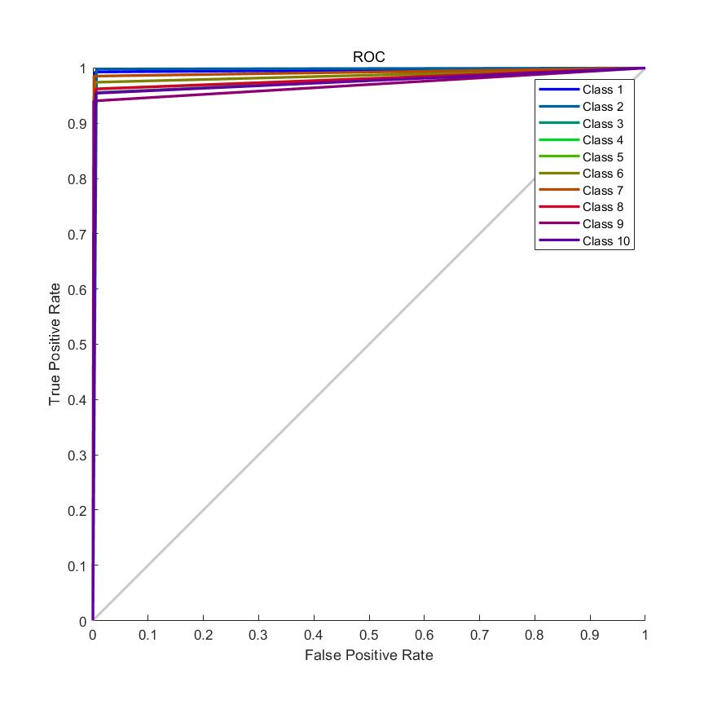
- Confusion Matrix
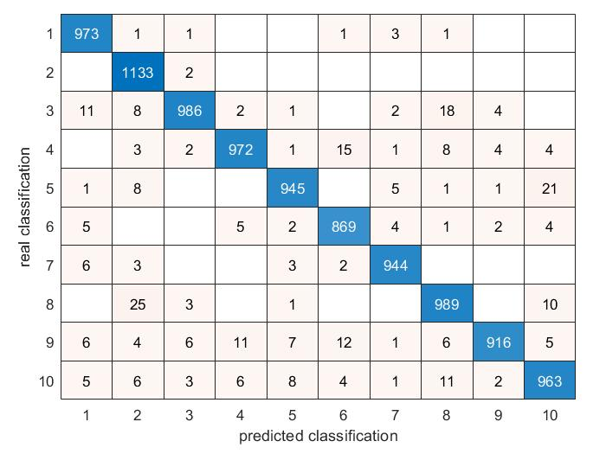
Through the confusion matrix, we can finally calculate the evaluation index values of accuracy, precision, specificity, sensitivity, recall and F-score.
- Accuracy
(972+1129+1008+995+966+874+943+1006+957+970)/10000 = 98.2%
We take class 1 as an example and calculate TP、TN、FP and FN from the confusion matrix as shown in the following table.
Table 6
Class 1 | Predicted Positive | Predicted Negative
Actual Positive | TP=973 | FN=7
Actual Negative | FP=34 | TN=8986
- Precision
$$precision=\frac{TP}{TP+FP}=98.38\%$$
- Sensitivity（Recall）
$$Recall=\frac{TP}{TP+FN}=99.29\%$$
- Specificity
$$Specificity=\frac{TN}{TN+FP}=99.62\%$$
- F-score
$$F-score=2*\frac{Recall*Precision}{Recall+Precision}=0.9883$$
  - Results And Discussion
As shown in the following table, table 7 lists each evaluation index of different algorithms.
Table 7
Performance Metrics | SVM | KNN
Accuracy | 98.2% | 96.90%
Precision | $$98.38\%$$ | $$98.38\%$$
Sensitivity（Recall） | $$99.18\%$$ | $$99.29\%$$
Specificity | $$99.82\%$$ | $$99.62\%$$
F-score | $$0.9878$$ | $$0.9883$$
We can see from Table 7 that the accuracy of the model based on the SVM algorithm is higher than that of the model based on the KNN algorithm. That is to say, to obtain a relatively high accuracy rate, we consider using the SVM model first. These model performance evaluation metrics including precision, sensitivity(recall), specificity, and F-score are cocmparable, that is, the two models are close in these performance evaluations.
- CONCLUSIONS
MNIST handwritten digital data set is a commonly used machine learning algorithm to study the data set. This report focuses on the implementation of writing number recognition for research and study.
By learning the basic principle of SVM and KNN algorithm and how to work, understand the algorithm implementation method. Then, handwritten digit recognition of MNIST dataset is realized on MATLAB. For SVM algorithm, the parameter C kernel type and Gamma g are adjusted to find the parameter combination that makes the model test with high accuracy, so as to determine the model. For KNN algorithm, the parameter K, namely the number of neighbors, is mainly adjusted to find the parameter K that makes the model test with high accuracy, so as to determine the model. Parameters of the model are determined by training experiments with some data sets.
Based on the model with good preliminary experimental performance, the model was tested with all the data of MNIST dataset. We use the confusion matrix and accuracy as evaluation indicators to evaluate the performance of the model. We obtained the values of accuracy, precision, specificity, sensitivity, recall and F-score of the two model. The results show that the test accuracy of SVM algorithm is 98.2%, slightly higher than KNN algorithm 96.90%. But in general, KNN algorithm also performs well in this task. We take class 1 as an example to analyze the specific performance indicators of the classification model, and it can be seen that the recognition performance of positive and negative cases is good. The precision, recall and Specificity of the two models were all above 90%. Their F-scores were above 0.98.
Whether there is a better parameter selection for the performance of rough parameter tuning of the model in the above report needs further study. On this basis, there are other algorithms worth studying and implementing.

REFERENCE
- Cortes C, Vapnik V. Support-Vector Networks[J]. Machine Learning, 1995, 20(3):273-297.
- Scholkopf, Bernhard, Sung, et al. Comparing support vector machines with Gaussian kernels to. [J]. IEEE Transactions on Signal Processing, 1997.
- L. Deng, "The MNIST Database of Handwritten Digit Images for Machine Learning Research [Best of the Web]," in IEEE Signal Processing Magazine, vol. 29, no. 6, pp. 141-142, Nov. 2012, doi: 10.1109/MSP.2012.2211477.
- 马玉贤,郭秀娟.基于K近邻算法识别手写数字[J].吉林建筑大学学报,2021,38(06):84-86.
- 张来君.基于SVM的手写数字识别[J].电子技术与软件工程,2021(23):166-167.
- Q. Xu and S. Geng, "A Fast SVM Classification Learning Algorithm Used to Large Training Set," 2012 Second International Conference on Intelligent System Design and Engineering Application, 2012, pp. 15-19, doi: 10.1109/ISdea.2012.469.
- Hao Z, Berg A C , Maire M , et al. SVM-KNN: Discriminative Nearest Neighbor Classification for Visual Category Recognition[C]// 2006 IEEE Computer Society Conference on Computer Vision and Pattern Recognition (CVPR'06). IEEE, 2006.

APPENDIX： PROGRAMMING CODE
SVM - PROGRAMMING CODE
%读取文件
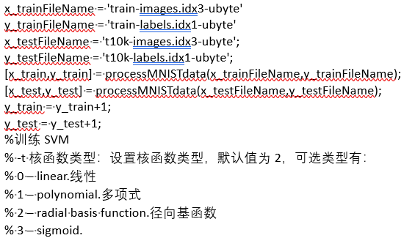
libsvm_options = '-s 0 -t 2 -c 1.2 -b 1 -q';
model = svmtrain(y_train(1:60000,:), x_train(1:60000,:), libsvm_options)
[predicted_labels, accuracy, prob_estimates] = svmpredict(y_test, x_test, model, '-b 1');
figure()
cm = confusionchart(y_test,predicted_labels);
cm.InnerPosition = [0.10 0.12 0.85 0.85];
xlabel("predicted classification")
ylabel("real classification")
y_pred_onehot = oneHot(predicted_labels,10);
y_test_onehot = oneHot(y_test,10);
figure()
plotroc(y_test_onehot,y_pred_onehot)

KNN - PROGRAMMING CODE
%训练KNN
mdl = ClassificationKNN.fit(x_train(1:60000,:),y_train(1:60000,:),'NumNeighbors',7)
predicted_labels2 = predict(mdl,x_test);
acc_knn = length(find(predicted_labels2==y_test))/length(y_test)
figure()
cm2 = confusionchart(y_test,predicted_labels2);
cm2.InnerPosition = [0.10 0.12 0.85 0.85];
xlabel("predicted classification")
ylabel("real classification")
y_pred_onehot2 = oneHot(predicted_labels2,10);
y_test_onehot2 = oneHot(y_test,10);
figure()
plotroc(y_test_onehot2,y_pred_onehot2)

FUNCTION PROCESSMNISTDATA CODE
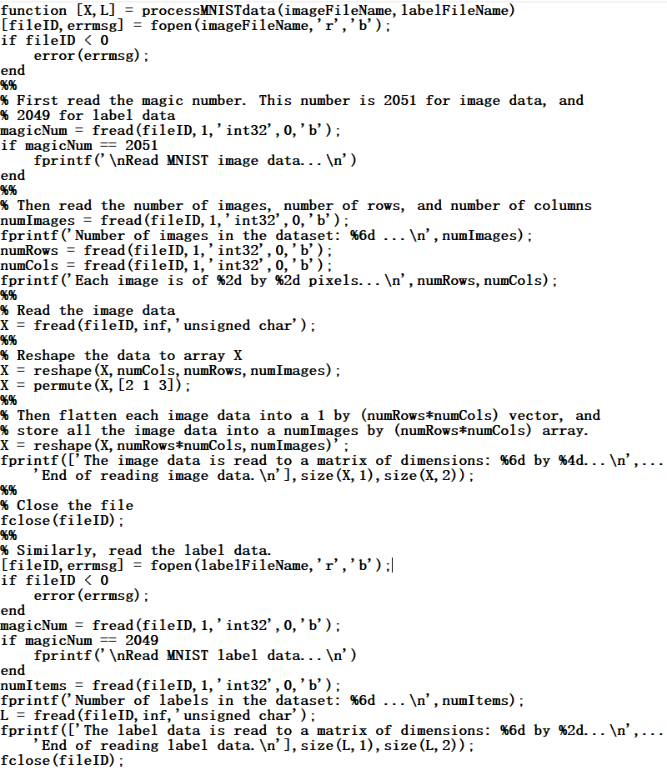
FUNCTION ONEHOT CODE


