Swansea Business School

An Introduction to Microsoft Word 2007:
Citations & Reference list/ Bibliography

Karen Jones

Introduction:
In any academic document it is vital to reference the sources that have been used in the main body of the text. A vast number of references styles exist for the multitude of research disciplines. This document aims to show how to use the Citation and Reference features available in Microsoft Word.

Creating the text to reference:
Either:
- Go to the Dissertation module on Blackboard and copy the text shown below (in the course documents folder ‘Referencing using MS Word: text for activity’. Or,

- Create a new Word document and enter the text as shown below:
Abstract
In this paper we describe the design and implementation of a Windows service based software agent toolset to classify student programmers. The graphical element of the toolset presents lecturers with the complexity level at which a student programmer is operating at. With an accurate complexity level it is possible to place appropriate learning resources to challenge the more advanced student and also to support the less advanced.
Keywords
Automatic Classification, .NET Windows Services, Software Agent

Introduction
To make student programmers more productive and technically competent requires both education and experience. To identify the training requirement necessitates detailed knowledge of the students’ skill set and the program code they currently use in order to generate complexity data. Over time, student programmers will create and develop many software solutions. Generating the programming complexity data from these solutions requires a significant amount of storage that ideally is saved within a relational database environment. The saved data is rich with hidden information, and with the right transformations and tools, can be used to classify student programmers. Thus, the people who most require support can be identified. There are several classification schemes reported in the literature. The classification process carried out by Govindarajulu involved the use of on-line questionnaires. This process is superior to that of paper-based questionnaires in that the data received is in a machine readable format and immediately available for analysis. The process takes time out of the end users normal schedule and questions can be misinterpreted. A superior approach is to gather the data automatically via software agent based toolkit. This creates an accurate picture of the end user and with data gathered on a continuous basis enables many snap-shots of the data to be captured. Multiple snap-shots over time gives the opportunity to measure the progress a student programmer has achieved. It is proposed to create a set of levels that programmers can work towards to gain a classification of their work. These classifications will be arrived at by analysing the user’s source code over a period of time and checking that code for features for each level of classification.

Agent Based Windows Service
An agent based on the concept of a Windows service has been explored by [5-9]. Windows services enable developers to create long-running executable processes that run an application in the background. The services can be automatically started when the operating system loads into memory, but can also be paused and restarted manually, either using the Microsoft Management Console (MMC) utility, or a third party utility. The authors have used this concept in the construction of the data gathering system that is configured to start automatically at user log-on to continuously monitor and analyse the code generated by student programmers.
A Windows Service is designed to not require user intervention and to run unattended and autonomously. To run a Windows service it must first be installed on the host machine and then the service will be started as a process when the computer boots up. Visual Studio ships components to install service applications as this type of application by itself is not capable of being installed.
After installers are added to the application, the next step is to create a setup project that will install the compiled project files and run the installers needed to install the service. In order to create a complete setup project, the service project’s output must be added to the setup project and then a custom action must be added to have the service installed.
The second sentence in the introduction needs to be referenced to its source to meet with academic convention.

- Place the cursor immediately before the full stop of the second sentence leaving a single space after the word data.
- Select the References tab.

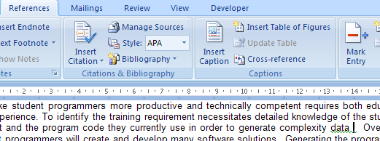

- From the Citations and Bibliography section, click the  button.
- Next click the Add New Source option.



- On the Create Source form fill in the details of the publication as shown below:
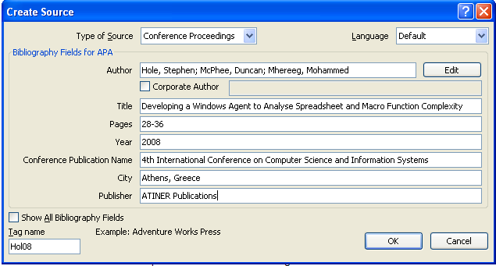

- The document will now show in the text the appropriate reference.

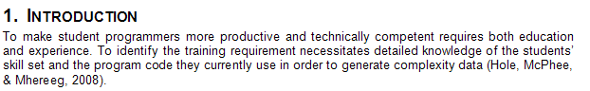

- At the end of the document create a page break.
- At the top of the final page add the heading References.
- Select the References tab.
- From the Citation and Bibliography section click on the button and Insert Bibliography.

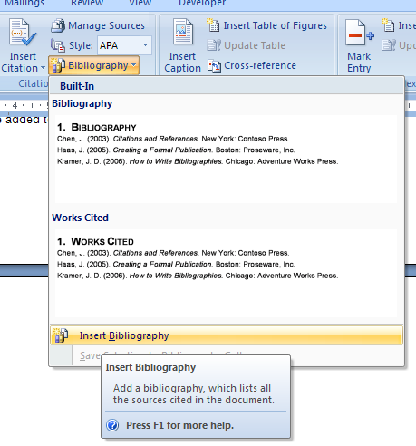
- The Reference section of the document now appears as below:
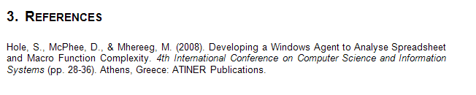
- The text below shows the references required in the academic paper and points 13-17 show the details of the source articles

Introduction
To make student programmers more productive and technically competent requires both education and experience. To identify the training requirement necessitates detailed knowledge of the students’ skill set and the program code they currently use in order to generate complexity data (Hole, McPhee, & Mhereeg, 2008).
Over time, student programmers will create and develop many software solutions. Generating the programming complexity data from these solutions requires a significant amount of storage that ideally is saved within a relational database environment. The saved data is rich with hidden information, and with the right transformations and tools, can be used to classify student programmers. Thus, the people who most require support can be identified. There are several classification schemes reported in the literature (Rockart & Flannery, 1983) (Cotterman & Kumar, 1989). The classification process carried out by Govindarajulu involved the use of on-line questionnaires (Govindarajulu, 2003). This process is superior to that of paper-based questionnaires in that the data received is in a machine readable format and immediately available for analysis. The process takes time out of the end users normal schedule and questions can be misinterpreted. A superior approach is to gather the data automatically via software agent based toolkit. This creates an accurate picture of the end user and with data gathered on a continuous basis enables many snap-shots of the data to be captured. Multiple snap-shots over time gives the opportunity to measure the progress a student programmer has achieved. It is proposed to create a set of levels that programmers can work towards to gain a classification of their work. These classifications will be arrived at by analysing the user’s source code over a period of time and checking that code for features for each level of classification.

Agent Based Windows Service
An agent based on the concept of a Windows service has been explored by (Hole & McPhee, Constructing an Agent to Facilitate Automatic Collection of End-User Data, 2006) (Hole & McPhee, Constructing an Agent to Facilitate the Automatic Collection of End-User Desk-Top Data, 2006). Windows services enable developers to create long-running executable processes that run an

- Reference 2 is show below:
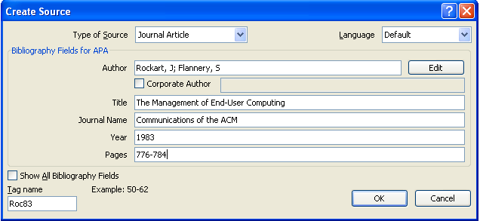
- Reference 3 is shown below:
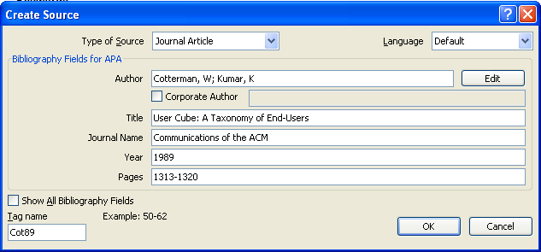
- Reference 4 is shown below:
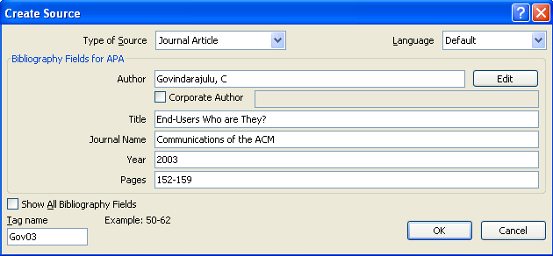

- Reference 5 is shown below:
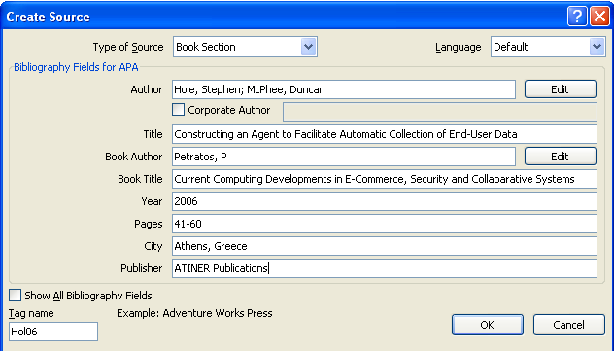
- Reference 6 is shown below:
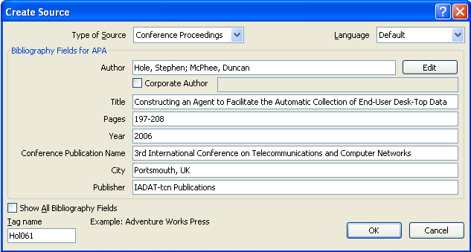
- To update the Reference section of the document Right click on the existing entry in the bibliography and then select Update. The result is shown below:
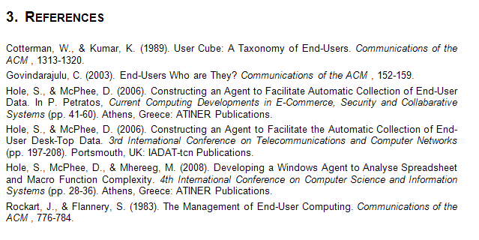
- On the Citations and Bibliography section of the References tab it is possible to change the style of the references.



