
Assignment 2:
Operating Systems
CertHE Computing Skills for the Workplace

Computer Architecture and Operating Systems ACCA4022_LON
Dr Redhwan Al-Amri (Lecturer)
University of Wales Trinity Saint David
(London Campus)
Student Name:
Student Number:
Group: 01
Date:

Table of Contents
Introduction 1
1. Key functions of general Operating Systems 1
1.1 Process and Processor Management 1
1.2 Memory Management 2
1.3 File System Management 2
1.4 Security and Protection 3
References 4

Introduction
Operating systems act as a barrier between software applications and hardware, and their design influences the effectiveness, reliability and security of computing resources used by competing workloads [1]. This report critically analyses process management, memory management, file systems and security in Windows and Linux and compares the design trade-offs. The rest of this document uses the command line tools and scripts on both platforms to show how these functions are observed, managed and automated in practice. Current textbooks and vendor documentation are used to make each judgement and to relate the theory with the observed behaviour of the system [1]. These perspectives highlight the fact that these two are not the best design and that administrators need to grasp the mechanisms behind these two.

1. Key functions of general Operating Systems
General-purpose operating systems have one kernel responsibility, and that is to arbitrate limited resources, but in different ways in Windows and Linux [1].

1.1 Process and Processor Management
Windows assigns a thread priority class and a round-robin time slice; a poorly assigned high priority may cause lower threads to be starved of time [2]. This predictability works well with interactive desktops, but puts the burden on the administrator to watch and change priorities in the Task Manager (see Figure 1). Manual tuning is very powerful but also dangerous, as priorities may be set incorrectly, which would affect the overall responsiveness of the system [2]. Instead, Linux uses a fair share scheduler that is optimised for throughput, which perhaps is appropriate for mixed workloads on servers; the downside is that it requires more administration knowledge to tune [1]. The two options demonstrate that scheduled policy is indicative of purpose and neither can be evaluated as better without taking into account workload.
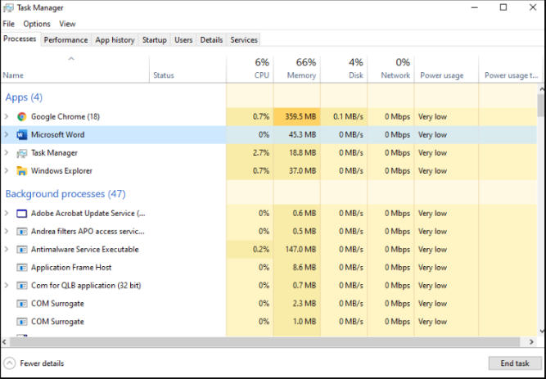

1.2 Memory Management
Both systems allocate a private virtual address space to each process; that keeps faults isolated to prevent conflict and enables efficient sharing of limited physical memory. Of course, paging to disk extends capacity, but too much swapping will cause performance to drop dramatically, so it is important to keep tabs on the memory pressure, rather than just increase the size of the swap space [3]. Linux uses optimistic memory overcommit to increase utilisation, but with heavy usage may trigger the out-of-memory killer [1]. Windows exposes this via the Performance tab and the Resource Monitor output, while the Linux administrator would usually check the output of free and vmstat, as shown in Figure 2. The graphical route is easier to use; the command line route is easier to automate and is the key when operating with numerous servers.
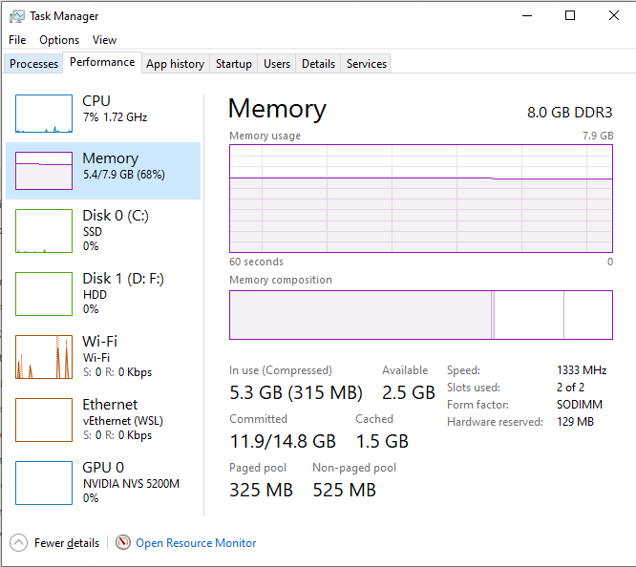

1.3 File System Management
NTFS is more resilient than FAT32 to system crashes, with journaling and per-file permissions and encryption [4]. Linux commonly uses ext4, which also journals metadata and scales well, although its permission model is simpler than Windows access control lists [1]. For the typical general-purpose system, the compromise of journaling is that it sacrifices write performance for quicker recovery after a power failure [1] [4]. Ownership and permissions are displayed by both Windows File Explorer and the ls command in Linux, as shown in Figure 3, which is beneficial for auditing and troubleshooting. Thus, when deciding on the file system, one should consider the recovery time, options of security and compatibility, and not take it for granted [4].
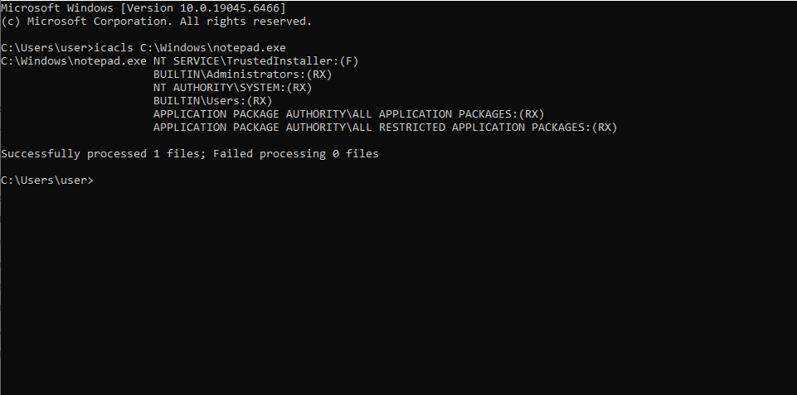

1.4 Security and Protection
The security of Windows is about access tokens and security descriptors: All processes receive the identity and privileges of the user that launched them [5]. Discretionary access control lists (DACLs) allow individual users and groups to be granted or denied access, providing a finer level of granularity than the traditional Linux owner, group and other model [1] [5]. In both cases, however, finer granularity leads to more complicated configurations, and misconfigured permissions are a frequent path for privilege escalation [1][5]. Least privilege administration is therefore key to a successful defence, and is enforced by the User Account Control prompt and the Linux sudo command [5].

References
[1] A. S. Tanenbaum and H. Bos, Modern Operating Systems, 5th ed. Hoboken, NJ, USA: Pearson, 2022. [Online]. Available: https://www.pearson.com/en-us/subject-catalog/p/modern-operating-systems/P200000003295.
[2] Microsoft, “Scheduling priorities,” Microsoft Learn. Accessed: Oct. 16, 2026. [Online]. Available: https://learn.microsoft.com/en-us/windows/win32/procthread/scheduling-priorities.
[3] The Linux Kernel Organisation, "Concepts overview," The Linux Kernel Documentation. Accessed: Oct. 16, 2026. [Online]. Available: https://docs.kernel.org/admin-guide/mm/concepts.html.
[4] Microsoft, “Filesystem functionality comparison,” Microsoft Learn. Accessed: Oct. 16, 2026. [Online]. Available: https://learn.microsoft.com/en-us/windows/win32/fileio/filesystem-functionality-comparison.
[5] Microsoft, “Access control components,” Microsoft Learn. Accessed: Oct. 16, 2026. [Online]. Available: https://learn.microsoft.com/en-us/windows/win32/secauthz/access-control-components.

