A Handbook for Early Years Practitioners:
Supporting Successful Transitions

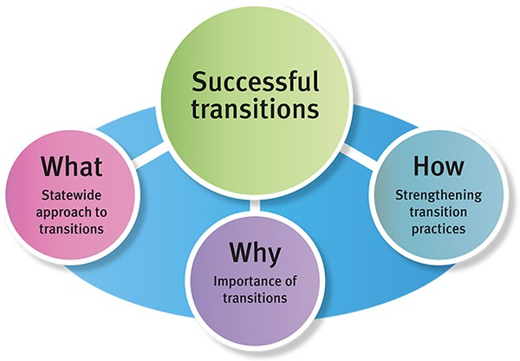

(Source: Queensland Government, 2019)

Alison Goodridge 2008453

Human Development: EAEE4003/C
Contents

Title Page Number
Introduction 3
How to use this Handbook 4
Needs of the Child 6
Role of the Adult 8
Partnerships 10
Intervention - Play 12
Outcomes 13
Reference List

Introduction
Children will undergo many transitions throughout their lives. According to Oxford Learning Dictionary (2020) a transition is “the process or a period of changing from one state or condition to another”. For young children transitions can include events which happen daily, for example changing which room they are in, being taken to a grandparent’s home or going to a medical appointment. They can also include major milestone events such as starting a new school or progressing into the next school year. This is supported by Tower Hamlets Council (no date).
Early Years Matters (2020) suggests that transitions will be so frequent that most care givers and other adults will consider them a normal part of the child’s life. As such they could expect the child to take such changes in their stride. However, as stated by Early Years (2020) “transitions are milestone events for children and have a definite effect on their development”.
Changes are often challenging and need to be planned for. Children need to be prepared and supported. This view is supported by Maureen Lunt (2017). Therefore, it is imperative for Early Years Practitioners to provide a stable and successful transition period for the child when they begin attending this setting. Guidance on how to achieve this shall be provided in this handbook.

How to use this Handbook
The main aim of this handbook is to provide information and advice to Early Years Practitioners who are working in the Nursery class of which the children are transitioning into. This information will assist the practitioner with providing a smooth and successful transition process. According to Lodge (2020) this is crucial to ensure that the child flourishes in their new environment.
Many of the children will have already attended a pre-school setting where they were cared for without a parent or guardian. According to Kirklees Council (2019) a pre-school can be described as any setting where education and care is being provided for a child during the term before they start school. An example of this could be a creche or playgroup. However, a number of children may never have been in a Early Years setting before. In this case there may be further barriers which inhibit the transition process, namely family beliefs and cultural differences. This view is supported by Brooker (2008, p.73).
As well as this, the practitioner must consider the individual needs of each child. Urie Bronfenbrenner’s Ecological Systems Theory shows us the importance of working together to provide a conducive environment, as suggested by Gilstrap (2020). Some children may have additional learning needs or a disability. In this instance there may be a wider network of people involved in the transition as detailed by The Council for Disabled Children (2015) “the period of planning and preparation is likely to involve the SENCO as well as the allocated key person and, for some children, the involvement a wider range of professionals”. Also, it must be considered that some children are ‘looked-after’ and therefore the agencies involved become greater again, as suggested by the website Achievement for All (no date).
This handbook will enable the Early Years Practitioner to better understand the role of the adult in the transitioning process. The adult is a key aspect in all areas of a child’s development. This is illustrated by Lev Vygotsky’s theory The Zone of Proximal Development as written by McLeod (2020). However, it is especially important during a period of change or transition. As Belfast Education and Library Board (2011. p.148) states
Research and practice has further identified that it is essential that everyone in this process has an understanding of their key role and how this relates to the child’s own experiences, capabilities and individual needs up to and beyond this point.
This explains how important your role as a practitioner as well as your relationship with the child is for the process of successful transition.
Next how to use play as an intervention will be discussed. This method is easily achievable and involves the child, the staff, the parents or guardians and any other relevant professionals. The intervention will help aid the transition process and ensure it is positive with a successful outcome. The intervention will be centered on the child and have a holistic approach that ensures all aspects of their care are met whilst providing a continuity of experience. This is suggested by Oxfordshire County Council (2017).
Lastly, this handbook will explain the outcomes which could be expected when the Early Years Practitioner follows the guidance contained within it. Lunt (2020) states that successful transition helps children to feel secure and provides a link between this unfamiliar new setting and the existing assurance of the current one. However, at times these transitions may fail. This handbook will also focus on illustrating the warning signs of this.
By following these guidelines, the Early Years Practitioner will not only provide the best possible transition process for each child, but they will aid their professional practice and enrich the setting.

The Needs of the Child
Each child is unique. This means that they develop at their own pace within their own limitations. Their development is continuous and complex, involving many areas all of which are equal in importance. This view is supported by Every Child Matters (2007). A theory studied by Jean Jacques Rousseau suggests that education should follow a child’s natural growth using each child’s specific needs (Aubrey and Riley, 2019). Consequentially, their individual needs must be considered to help promote a successful transition into the setting.
Each child must feel welcomed into the setting regardless of their background. As stated by the Welsh Government (2015b), they deserve to feel comfortable and valued as well as safe and cared for. No bias should be placed on the child for their religious and cultural beliefs and it is imperative that the needs these create are accommodated for. The Children’s Commissioner for Wales (2018) outlines that a child who learns in a setting which respects this will experience an inclusive, positive and caring environment. As such this will enable them to feel comfortable and magnify their feeling of value to us. This is also supported by the United Nations Rights of the Child, Article 14 – Your Right to Follow Your Own Religion.
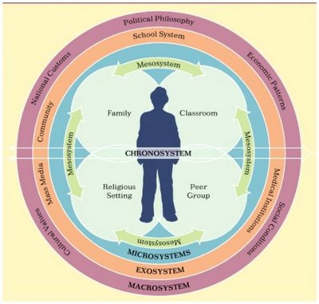
As Urie Bronfenbrenner highlights, the child is at the centre of the setting. When transitioning into a new setting, the Early Years Practitioners become part of the child’s micro-system. Therefore, they must build a good relationship with the child, especially during the initial process when the child is likely to experience separation anxiety when leaving their parents or guardians. This bond will give the child a solid base from where they feel comfortable enough to explore the setting and get involved with activities. This is underpinned by a holistic approach, considering the child’s whole needs and helping them and their family to feel included and valued as soon as possible. If the child can see that their parents or guardians have a good relationship with the practitioner, they are more likely to settle and engage with the activities. As Mackay et al. (2010) state, ‘regarding effects of quality parental interaction and academic achievement’.
(Source: Hubbli, no date).
The child needs to be part of a well organised, high quality setting with rich and stimulating experiences, as explained by Welsh Government (2015a). This approach can also be drawn from the theories of Montessori and Froebel. According to Tovey (2020), Froebel placed great importance on children needing to feel independent and autonomous and this could be gained from providing rich provision. As Montessori Northwest (no date) states, Montessori settings include a wide variety of resources which support every aspect of children’s development and create a match with their natural interests.
A rich and varied setting with a variety of play experiences also benefits the child’s brain development because play strengthens the pathways in the brain as children can act out and practice what they have already learnt through this. This view is supported by Harvard University (2020).

The Role of the Adult
Early Years Practitioners have a key role in the development of children. As shown in brain development studies, the period before a child turns three is the time where the brain develops most significantly. Therefore, upon starting at the setting, the practitioner must build on this as the child’s brain still has much plasticity. This view is supported by Harvard University (2020).
Serve and return is a fundamental part of this. As stated by Harvard University (2020), brain architecture is shaped when the practitioner responds appropriately to the child’s communication cues because it develops myelinization. As this shows the relationship between the child and the Early Years Practitioner is extremely important, especially so if the child has not got a close bond with their parents or guardians.
As Exploring Your Mind (2020) explains, attachment can be assessed by looking at the relationship between the child and their primary care-giver. With avoidant attachment the child believes that their needs will not be met because they seem withdrawn and quiet. Their care-giver is usually distant, disengaged and neglectful. When there is an ambivalent attachment the child shows signs of being anxious or angry and insecure, whilst the care-giver is usually inconsistent in their responses, meaning the child cannot rely on their needs being met. Lastly, in highly unusual and extreme situations such as substance abuse, the child and the care-giver can vary between the spectrums of depressive, angry or passive, unresponsive and confused. Because of this the child is confused and has no strategies to enable their needs to be met.
The Early Years Practitioner can be the consistent person in the child’s life which will create a positive secondary attachment figure. This is important for a successful transition because this relationship will give the child the confidence to explore from a secure base. This is supported by Maslow’s Hierarchy of Needs where it is seen that the basic physiological needs of the child must be satisfied before a child can develop further and reach self – actualization (Learning Theories, 2020).
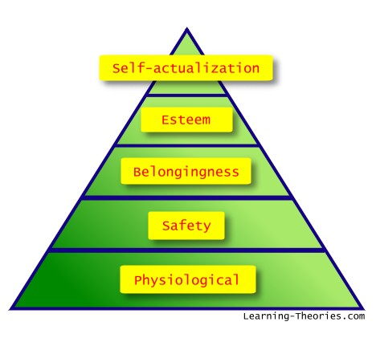(Source: Learning Theories, 2020).

However, all influences throughout the child’s life must be included in the child’s period of transition. Some are obvious, for example the parents or guardians and the child’s peers and siblings. Others may be a result of the child’s specific needs, such as a health professional who is an expert if the child has a disability. All of these are interconnected. Urie Bronfenbrenner’s Ecological Theory shows this and proves that it is important that the Early Years Practitioner realises that they have become part of the child’s microsystem, and as such are a significant influence on their development.
The child needs a consistent person in the setting who they can rely on for comfort, guidance and care. This is supported by John Bowlby’s Attachment Theory where, according to Cherry (2020), this significant attachment figure provides the base from which the child can explore. In relation to transitions, the Early Years Practitioner acts as the base and the new setting is where the child will explore.

Partnerships
According to Kirklees Council (2019) there are a wide range of people involved with the child when they start school. From the Ecological Theory of Urie Bronfenbrenner, we know that is imperative that all these people work together because it will provide a conducive environment which will aid a successful transition.
As an Early Years Practitioner, it is important not to lose sight that the parents or guardians are the experts on their child. As DES (1990) state, ‘Parents are their children's first and most important educators and should therefore be involved in their early years learning experiences’. Therefore, everything should be done in partnership with them. Developing a good relationship with the parents or guardians will aid this successful partnership.
Good communication is key to building this relationship. Inclusion can be fostered if the practitioner is fluid and responsive to the needs of the child and their family offering support when it is required. One option is to provide an ‘open door’ policy at the setting meaning that the parent or guardian can contact the setting at any time to ask any questions or queries about their child (Schärer, 2018).
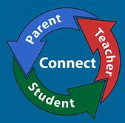
(Source: St Josephs R.C. School, 2020)
According to Tower Hamlets, when the partnership between parents or guardians and the Early Years Practitioner is secure, it fosters an atmosphere of mutual respect. This helps the child to feel safe and confident throughout the transition process. As parents and guardians are the most knowledgeable about their children, this partnership allows for the practitioner to share in this knowledge and become aware of any specific issues relating to the transition. The parents or guardians and the practitioner can then work together to overcome any issues and plan and support the successful transition into the setting.
There is the possibility that there will be many other agencies involved with the child. These could stem from an additional need or a medical problem and, in that instance, would include medical professionals. To facilitate a successful transition and ensure that the child’s whole needs are met, the Early Years Practioner must also ensure inclusion of these. As Early Years Matters (2020) states,
Practitioners working in partnership across services can provide professional support and guidance to one another and to parents either by signposting information or by being more directly involved – everybody’s contribution will make a difference to children’s learning and development.

Intervention - Play
Play is a developmental skill which supports transition and is innate in children. The importance of it can be seen in The Welsh Assembly Government’s Play Policy (2002) who state, ‘It is the very freedom and child centredness of play that makes it such an effective and comprehensive learning process.’ As children play their brains develop, their muscles grow stronger, they develop good social and life skills and it benefits their emotional and behavioral skills. As Sutton Smith (1997) states, ‘play is the lense through which children experience their world and the world of others’.
The significance of play as an intervention for a successful transition can be seen when one looks particularly at the emotional, behavioral and social benefits. When children play it creates joy which releases endorphins that improve their mood. Children can test things out in play without suffering any consequence. This increases their calmness, resilience, adaptability and their ability to deal with change. It also reduces the child’s feeling of being nervous, anxious or scared in the new setting. All these points are supported by Singer, Golinkoff and Hirsh-Pasek (2006, p.255-260).
As Harvard University (2020) directs, another significance the ability of play holds is to increase positive attachment between the child and the practitioner because it creates options and choices and models relationships based on inclusion. It invites an interaction between the Early Years Practitioner and the child which is natural to them.
When using play as an intervention, the practitioner should focus on the particular likes and dislikes of the child to ensure that they want to participate. When observing the child, particular repeated patterns of behaviour known as schemas, will indicate a natural part of the child’s development. If these are engaged with child will gain more from their play. As Flying Start (no date) states,
if as practitioners we support children’s schematic play patterns we can build on individual children’s interests, therefore taking part in powerful learning opportunities through sustained shared learning experiences.
Play underpins the creation of a positive attachment with the Early Years Practitioner. This is supported by the psychologist John Bowlby whose theory is based upon attachment theory. According to Bowlby the child will feel happy, secure and have the ability to explore if the care-giver is responsive and sensitive to the child’s needs and consistent in this response (Cherry, 2020).

Outcomes
Ultimately the desired outcome that all involved parties aspire to is that the transition process is successful, and the child settles well into the new setting. This positive experience will mean that children have the confidence to tackle future transitions because they have confidence and trust in their support network. This is supported by Queensland Government (2020).
Indications that the interventions have worked, and the transition has been successful include observing the child to be happy, strong and competent in the setting and tackling new experiences confidently (Kienig and Margetts, 2013). However, the practitioner must remain mindful that a successful transition can be harder to achieve for a number of children. This is evident in the fact that children develop at different rates, although there can be other underlying issues.
To conclude whether the transition has been successful many methods can be utilised. The Early Years Practitioner can ask the opinion of their parents or guardians; observe the child’s behaviour in the setting and look for behavioural changes. However, the most important method would be to include the voice of the child. As UNCRE Article 12 states,
Parties shall assure to the child who is capable of forming his or her own views the right to express those views freely in all matters affecting the child, the views of the child being given due weight in accordance with the age and maturity of the child.
According to Oxfordshire County Council (2017), continual evaluation of the child’s progress within the transition period is essential to understand if the transition is successful. If the child continues to display adverse behaviour which does not follow the expected outcomes, then further advice can be sought from the relevant professionals and support can be put into place for both the child and the parents.
Children are experts in their own lives and have the capacity to act upon their world. This is called agency. If their perspectives are listened to, not only will the practitioner understand whether the transition has been successful but can also improve the quality of the provision in the setting (Australian Children’s Education and Care Quality Authority, 2018).

