AI Declaration
AI Tool (with URL) | Date used | Why did you use this tool | Example prompt(s)
https://www.grammarly.com | 15/01/2026 | Check my work | Please check the following text for readability, grammar and syntax.
Https://perplexity.com | 19/01/2026 | Help with structuring a portfolio | Can you advise me on how to structure a report for an experiment?
https://scispace.com | 15/02/2026 | Aids in research | Can you help me find relevant scientific research papers on VO2 max performance and Wingate peak power output?
https://www.litmaps.com | 17/02/2026 | Aid in research | You give this 1 paper, and it finds relevant research papers on that subject in a mind map.

Experiment Portfolio
This portfolio will present 3 independent experiments in Sports and Exercise Physiology, providing objective data on an athlete's physical capacity, information for training prescriptions, support for monitoring performance adaptations, and support for clinical decisions in health and rehabilitation settings (McGuigan, 2017; Winter et al., 2022). The importance of assessing the aerobic and anaerobic energy systems in athletes stems from the repeated high-intensity efforts underpinned by the phosphocreatine (ATP-PC) and glycolytic energy systems, while aerobic capacity supports recovery and sustained performance (Bodganis et al., 1996; Bassett & Howley, 2000). Having a better understanding of an athlete's strengths and weaknesses allows coaches to make more targeted training programmes and track adaptations more clearly (McGuigan, 2017; Weakley et al., 2019).

Experiment 1 studies whether the Keiser Leg Power Test (KLPT) (Keiser Air300 Leg Press, Keiser, Fresno, USA) Peak Power Output (PPO) can predict the PPO during the Wingate Anaerobic Test (WAnT) (Monark Ergomedic 894E, Monark, Vansbro, Sweden). These both examine concurrent validity between two anaerobic power assessments (reference). Experiment 2 examines the relationship between the WAnT Total Power Drop (TPD) and the VO2 Max Test, testing whether a greater power drop is associated with lower aerobic capacity (Bar-Or, 1987; Calbet et al., 2003). Experiment 3 studies whether the KLPT and Counter movement Jump Peak Power Output (CMJPPO) test can predict a 10s sprint performance, exploring the neuromuscular foundations of explosive athletic actions (Wisloff et al., 2004; Komi, 2003).

Experiment 1 KLPT - WAnT

Method
In this experiment, there is a 5-minute RAMP warm-up (Winter et al., 2022), followed by a KLPT (Keiser Air300 Leg Press, Keiser, Fresno, USA), then 5 minutes of rest, and finally a WAnT (Monark Ergomedic 894E, Monark, Vansbro, Sweden). During data collection, my role is to ensure participants adhere to the protocol timings, provide standardised verbal encouragement during maximal efforts, and monitor comfort and safety throughout testing (McGuigan, 2017).

Results
Figure 1A: Pearson’s correlation coefficients for KPPO and WAnT PPO (SPSS v31, 2026)
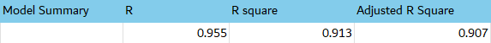

Figure 1B: Scatter graph showing the relationship between the KPPO (W) and the WAnT PPO (W), with linear regression line (R² = 0.913)
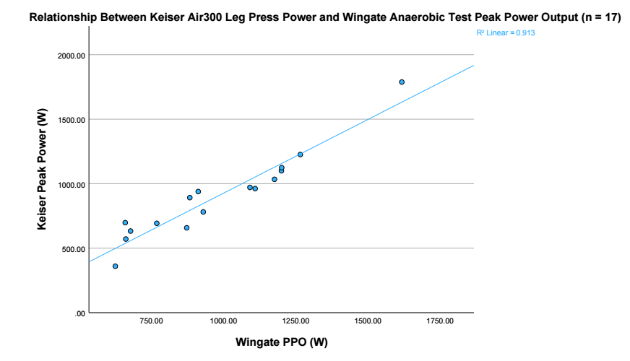

Interpretation
A strong positive correlation between the KPPO (Keiser Air300 Leg Press, Keiser, Fresno, USA) and the WAnT PPO (Monark Ergomedic 894E, Lab Equipment Ref. 7)(r = 0.955), with regression analysis showing that KPPO explained 91.3% of the variance in WAnT PPO (R² = 0.913) (Winter et al., 2022; Bar-Or, 1987), This indicates an exceptional validity between the KLPT and WAnT, suggesting that these two anaerobic tests measure similar underlying physiological capabilities, specifically the glycotic energy system and ATP-PC and the recruitment of type II muscle fibres during short maximal efforts (Wilmore & Costill, 2004; McArdle, Katch and Katch, 2010). The strong correlation indicates that, in this sample, the higher the Leg press peak power, the greater the peak power output on the WAnT, supporting the use of the KLPT as a practical alternative for anaerobic power.

Reflection
Several factors potentially affected measurement accuracy. Participants completed each test only once and received no familiarisation, which can prevent true maximal performance (Hopkins, 2000; Morrow et al., 2015). Pre-test conditions, such as diet and prior exercise, were not standardised, which can increase individual variability in power output (Burke and Deakin, 2015). The small sample size also limits statistical power and raises the potential for disproportionate results and influence from individual outcomes (Cogen, 1992; Morrow et al., 2015). Despite these limitations, the strong association between the 2 tests suggests that the KLPT can be used in applied settings to measure anaerobic power where the WAnT is less practical (McGuigan, 2017; Winter et al., 2022).

Experiment 2 WAnT Power drop - VO₂ Max Absolute vs Relative

Method
This experiment examines whether WAnT TPD is associated with aerobic capacity. A standardised 5-minute RAMP Warm-up is complete (Winter et al., 2022), then an incremental VO2 Max test on a Wattbike Atom (Wattbike Pro, Wattbike, Nottingham, UK) is performed using the inbuilt VO₂ Max Test Procedure. Following a 72-hour washout period, a WAnT is completed. My role in data collection is to set up and calibrate the tests, administer them, and collect all data per participant, per standard guidelines (McGuigan, 2017; Winter et al., 2022).

Results
Figure 2A: Correlation coefficients for WAnT TPD with absolute VO₂ Mx (L/Min) and relative VO₂ between absolute and relative values
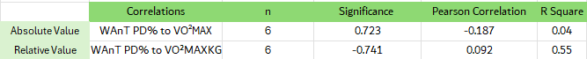

Figure 2B: Regression output for WAnT TPD predicting relative VO₂ max (ml/kg/Min). 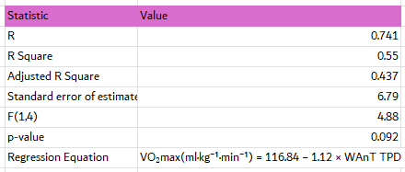

Figure 2C: Scatter Plot showing the relationship between WAnT TPD (%) and relative VO₂ max (ml/Kg/min), with linear regression line (R² = 0.550).
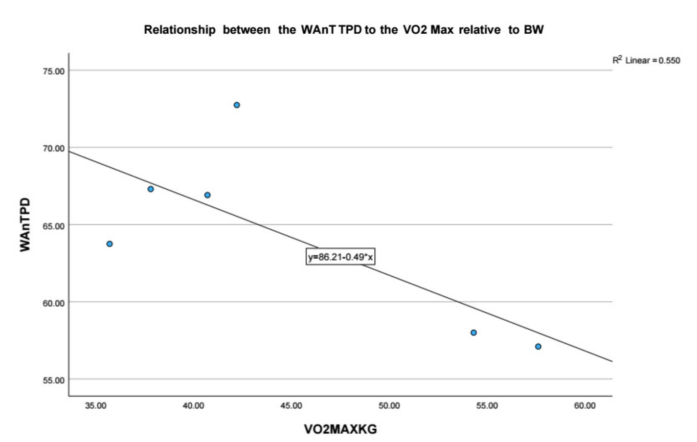

Figure 2C: Scatter Plot showing the relationship between WAnT TPD (%) and absoluteVO₂ max (L/min), with linear regression line (R² = 0.035).
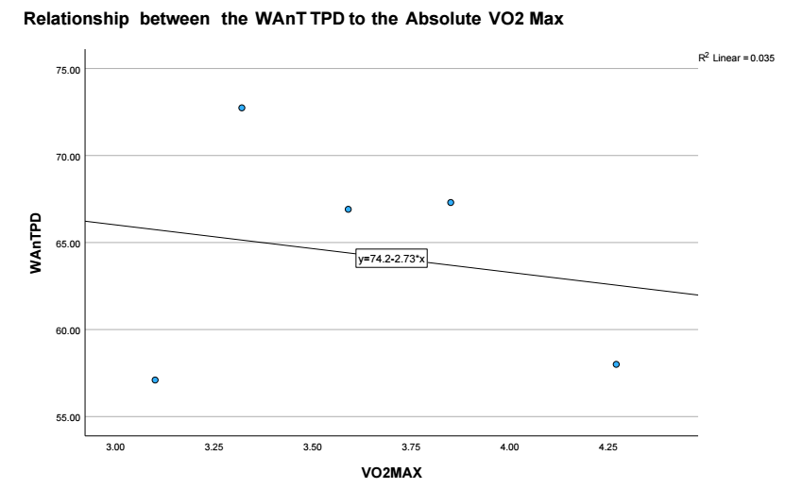
Scatterplot showing the relationship between WAnT TPD (%) and absolute VO₂ max (ml/kg/min), with linear regression line. R² = 0.035.

Interpretation
In the results, a negative correlation value of r = -0.741 is observed for the relative VO₂ Max-to-Wingate power drop values, compared with r = -0.187 for absolute VO₂ Max-to-Wingate power drop values. This suggests that, in this sample, athletes who exhibit a higher VO2 Max relative to body mass tend to show a lower percentage power drop during the Wingate test. In the regression model for relative VO₂ max, it was proposed that WAnT TDP accounted for 55% of the variance in VO2 Max (R² = 0.55); however, the difference was not statistically significant (p = 0.092), largely due to the small sample size (Cohen, 1992). Physiologically, the greater the percentage power drop across the WAnT, the more limited the capacity of the oxidative pathways to support ATP resynthesis upon the depletion of Phosphocreatine and glycolytic by-products accumulate (Bogdanis et al., 1996; Fitts, 1994). Athletes with a lower relative VO₂ Max are likely to rely heavily on anaerobic glycolysis during high-intensity exercise, consequently fatiguing more quickly and causing a greater power drop. On the contrary, athletes with a higher relative VO₂ Max can contribute more aerobic energy even during a predominantly anaerobic task, slowing metabolite accumulation and preserving power output (McGuigan, 2017; Winter et al., 2022). In this data set, Athlete H had the highest VO2 max and TPD (57.1%), whereas Athlete K had a lower VO2 max relative to body mass and a TPD of 67.3%, demonstrating this pattern at the individual level.

Reflection
In this experiment, external influences could have affected the results. Only six participants completed both the Wingate and VO2 max tests, substantially reducing the statistical power and making it difficult to discover significant effects when correlations are large (Cohen, 1992; Morrow et al., 2015). Familiarisation with VO2 Max testing procedures was not completed, which can lead to underestimation of true maximal values and increased between-subject variability, particularly in less-trained individuals (Poole and Jones, 2017). Another area for improvement is the testing order, prior activity and motivation during the days, as this can influence the degree of fatigue expressed on the WAnT and the attainment of a true VO₂ Max.
The findings from these results can impact real-world performance as a metric for coaching, promoting a better balance between aerobic fitness and anaerobic fatigue resistance, and increasing the use of more targeted programmes and monitoring adaptations over time (McGuigan, 2017; Winter et al., 2022).

Experiment 3 – KLPT, CMJ – 10m Sprint

Method
This cross-sectional study investigated whether KLPT PPO and CMJ PPO could predict 10m sprint performance in 14 participants. Following a standardised 5-minute RAMP warm-up (Winter et al., 2022), a KLPT (Keiser Air300 Leg Press, Keiser, Fresno, USA) is performed, followed by a CMJ on a force platform (Kistler BioWare). Following this 3 10m sprint through light gates (South Fort Street, Draper, USA), the fastest time is recorded. My role in the data collection is overseeing the tests and ensuring standardisation across participants (McGuigna, 2017).

Results
Figure 3A: Correlation matrix showing relationships between CMJ height, CMJPPO, KPPO and 10 m Sprint time
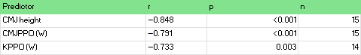

Figure 3B: Regression model summary of CMJ height, CMJPPO and KPPO predicting 10 m sprint time.
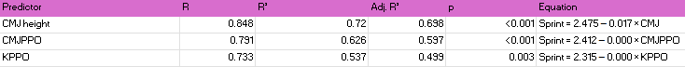

Figure 3C: Scatterplot showing the relationship between CMJ height (cm) and Sprint Speed (s), with linear regression line. R² = -0.720.
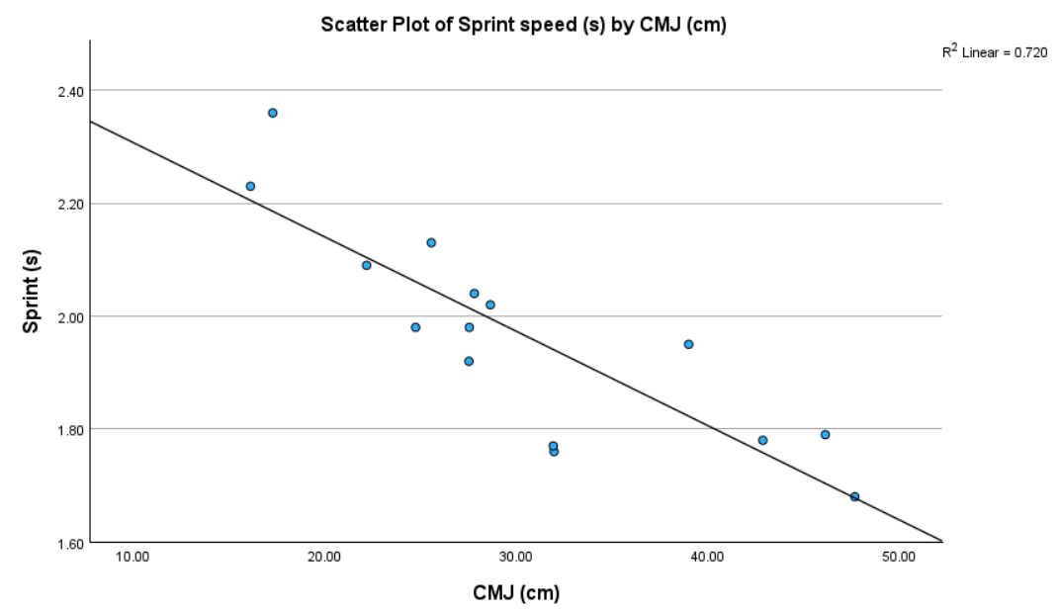

Figure 3D: Scatterplot showing the relationship between CMJ PPO (W) and sprint speed (s) with linear regression line. R² = -0.626.
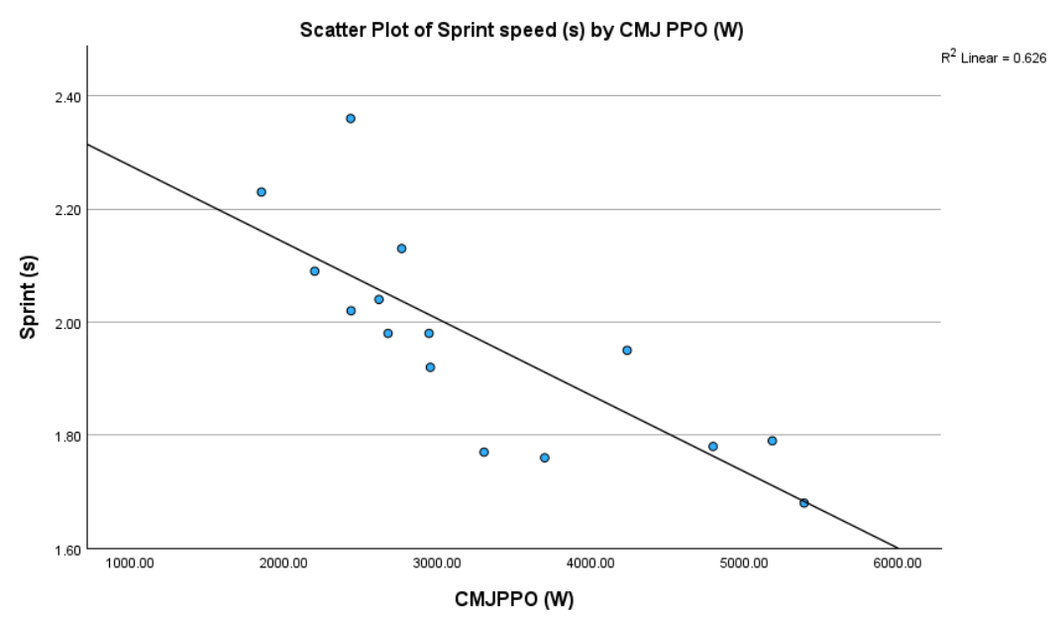

Figure 3E: Scatterplot showing the relationship between KPPO (W) and Sprint speed (s), with linear regression line. R² = -0.537.
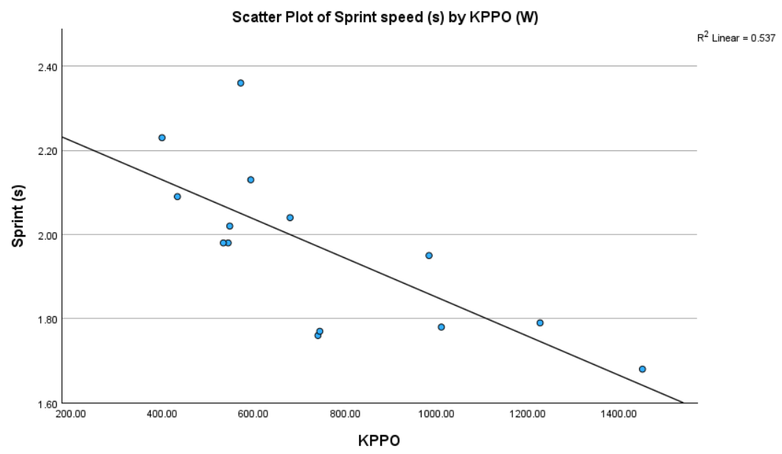

Interpretation
All three power measures were statistically significant and negatively correlated with the 10m sprint time. The CMJ height exhibited the strongest single predictor, with an r value of -0.848 and an R2 value of 0.720, followed by the CMJ PPO, with an r value of -0.791 and an R2 value of 0.626, and the KPPO third, with an r value of -0.733 and an R2 value of 0.537. This indicates that athletes who produce more power outputs record faster sprint times. These findings reflect the shared neuromuscular basis of sprinting, jumping, and explosive leg power, specifically the recruitment of type II muscle fibres and the high rates of force production through the ATP-PC system (Komi, 2003; Wisloff et al., 2004). The CMJ height may have emerged as the best predictor because it closely replicates the stretch-shortening mechanics and vertical force required during sprint acceleration, whereas KPPO is performed more contraindicated on a machine (Haff and Dumke, 2012; Maulder and Cronin, 2005).

Reflection
Several factors can influence the accuracy and reliability of these results. All of these tests were completed on the same day, introducing fatigue as a prominent factor, especially in sprint trials completed after multiple maximal efforts (McGuigan, 2017). The small sample size (n = 14) further limits statistical power and increases the likelihood that individual performances will influence the results (Cohen, 1992; Morrow et al., 2015). Despite these limitations, the strong correlations between CMJ height and KLPT can serve as practical field measures of neuromuscular qualities underpinning short-distance sprinting, thereby allowing coaches to track athletes' explosive power in regular assessments (McGuigan, 2017; Wisloff et al., 2004).

Conclusion
Across the three mini-experiments, a consistent theme emerged: performance on one aerobic or explosive power test strongly correlated with performance on the associated assessments, reflecting the shared physiological underpinnings of neuromuscular and anaerobic capacity. In the first experiment, there is excellent validity between the KLPT and the WAnT, with r = 0.955 and R² = 0.913, confirming that both tests assess similar phosphocreatine system capacity and type II muscle fibre recruitment. The paired-samples analysis revealed a significant decline in peak power in the WAnT (mean difference = 238 W; Cohen’s d = 2.404), highlighting the acute metabolic cost of maximal anaerobic exercise. The second experiment extended this by examining whether WAnT power drop percentage could predict aerobic capacity, and found a large but nonsignificant negative correlation with relative VO2 Max (r =- 0.741). This suggests a potential link between anaerobic fatigue and aerobic fitness, but warrants further experimentation with a larger sample to confirm it. The third experiment demonstrated that all tests (CMJ height, CMJPPO, and KLPT PPO) can predict 10M sprint performance, with CMJ height showing the greatest predictive power (R2 = 0.720), reinforcing the role of rate of force development in sprint acceleration.

Over the course of these three mini-experiments, my ability to design physiological tests has improved by streamlining testing procedures and allocating dedicated time slots for each participant, thereby improving adherence to the method. I have become more aware of the importance of controlling variables like rest intervals and testing order, which has improved the quality of my test designs. In conducting the tests, I have gained greater confidence in the collection and write-up of data from previous experiments, which, in turn, has improved the reliability of the results and reduced the standard deviation. My role in the data collection has shifted from simply following the protocol to actively monitoring and motivating participants throughout the experiments. My ability to interpret physiological data has also progressed substantially; previously, I would use only average values for analysis, but I can now use both average and mean values, along with standard deviation, to interpret the results more effectively. Previously, I focused mainly on whether the results were ‘significant’, but now I also consider why they are significant and what underlying physiological mechanisms may underlie them. This experience has highlighted specific areas I still need to improve, including pre-test conditions, such as controlling diet and hydration prior to testing. I would also increase the sample size for testing, which would improve the reliability and generalisability of the results. I would report confidence intervals for data analysis and effect sizes alongside p-values, and avoid overly complex models when the sample size is small.
References:
Bar-Or, O. (1987). 'The Wingate anaerobic test: an update on methodology, reliability and validity', Sports Medicine, 4(6), pp. 381–394.
Bassett, D.R. and Howley, E.T. (2000). 'Limiting factors for maximum oxygen uptake and determinants of endurance performance', Medicine & Science in Sports & Exercise, 32(1), pp. 70–84.
Bogdanis, G.C., Nevill, M.E., Boobis, L.H. and Lakomy, H.K.A. (1996). 'Contribution of phosphocreatine and aerobic metabolism to energy supply during repeated sprint exercise', Journal of Applied Physiology, 80(3), pp. 876–884.
Burke, L.M. and Deakin, V. (2015). Clinical Sports Nutrition. 5th edn. Sydney: McGraw-Hill.
Calbet, J.A.L., De Paz, J.A., Garatachea, N., Cabeza de Vaca, S. and Chavarren, J. (2003). 'Anaerobic energy provision does not limit Wingate exercise performance in endurance-trained cyclists', Journal of Applied Physiology, 94(2), pp. 668–676.
Cohen, J. (1992). 'A power primer', Psychological Bulletin, 112(1), pp. 155–159.
Fitts, R.H. (1994). 'Cellular mechanisms of muscle fatigue', Physiological Reviews, 74(1), pp. 49–94.
Haff, G.G. and Dumke, C. (2012). Laboratory Manual for Exercise Physiology. Champaign, IL: Human Kinetics.
Hopkins, W.G. (2000). 'Measures of reliability in sports medicine and science', Sports Medicine, 30(1), pp. 1–15.
Komi, P.V. (2003). Strength and Power in Sport. 2nd edn. Oxford: Blackwell Science.
Maulder, P. and Cronin, J. (2005). 'Horizontal and vertical jump assessment: reliability, symmetry, discriminative and predictive ability', Physical Therapy in Sport, 6(2), pp. 74–82.
McArdle, W.D., Katch, F.I. and Katch, V.L. (2010). Exercise Physiology: Nutrition, Energy, and Human Performance. 7th edn. Baltimore: Lippincott Williams & Wilkins.
McGuigan, M. (2017). Monitoring Training and Performance in Athletes. Champaign, IL: Human Kinetics.
Morrow, J.R., Mood, D.P., Disch, J.G. and Kang, M. (2015). Measurement and Evaluation in Human Performance. 5th edn. Champaign, IL: Human Kinetics.
Poole, D.C. and Jones, A.M. (2017). 'Measurement of the maximum oxygen uptake (VO₂max): VO₂peak is no longer acceptable', Journal of Applied Physiology, 122(4), pp. 997–1002.
Weakley, J., Till, K., Read, D.B., Roe, G., Darrall-Jones, J., Phibbs, P. and Jones, B. (2019) 'The effects of traditional, superset, and tri-set resistance training structures on perceived intensity and physiological and performance variables', Journal of Strength and Conditioning Research, 33(5), pp. 1232–1242.
Wilmore, J.H. and Costill, D.L. (2004). Physiology of Sport and Exercise. 3rd edn. Champaign, IL: Human Kinetics.
Winter, E.M., Jones, A.M., Davison, R.C.R., Bromley, P.D. and Mercer, T.H. (2022). Sport and Exercise Physiology Testing Guidelines: Volume I – Sport Testing. 2nd edn. London: Routledge.
Wisløff, U., Castagna, C., Helgerud, J., Jones, R. and Hoff, J. (2004). 'Strong correlation of maximal squat strength with sprint performance and vertical jump height in elite soccer players', British Journal of Sports Medicine, 38(3), pp. 285–288

Appendices:
Figure 1: Raw data table from testing. (Experiment 1)
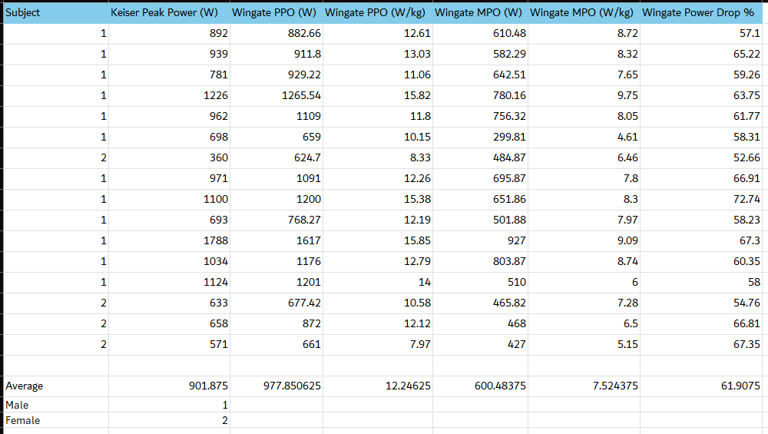
Raw data table showing results from KLPT and WAnT, Names removed and Gender labelled for anonymity.
Figure 2: Raw data table from WAnT Test. (Experiment 2)
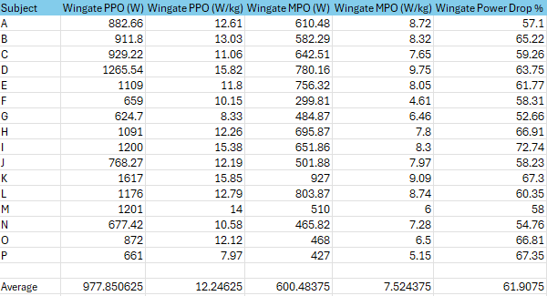
Raw data table showing WAnT Results matching the Subject letter

Figure 3: Raw Data from VO₂ Max test (Experiment 2)
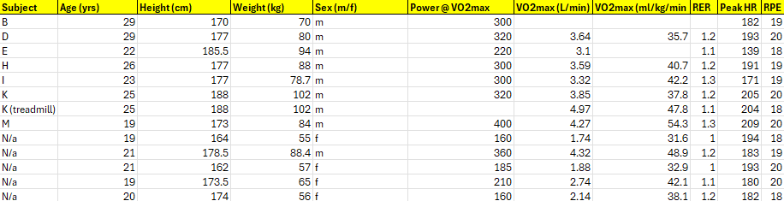
Raw Data table showing VO₂ Max test, subjects labelled and outliers from WAnT N/a

Figure 4: Raw data combining complete results from both tests. (Experiment 2)
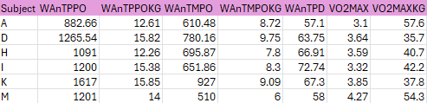
Raw data combining all results and matching to the subject

Figure 5: Raw data from KLPT, CMJ, 10m Sprint. (Experiment 3)


