Roots Without Trees: Culture and Identity in an Industrial Landscape (Mid Cornwall in the Nineteenth Century).
MA Celtic Studies
Sian Esther Powell
Professor Jane Cartwright


Master’s Degrees by Examination and Dissertation
Declaration Form
1. This work has not previously been accepted in substance for any degree and is not being concurrently submitted in candidature for any degree.
Name..…….………………………………………………………………………...
Date ………………………………………………………………………………...

2. This dissertation is being submitted in partial fulfilment of the requirements for the degree of ………………………………………………………………..................................
Name… …Sian Esther Powell………………………………………………………………………….
Date …………30/09/2020…………………………………………….…………..…………...

3. This dissertation is the result of my own independent work/investigation, except where otherwise stated.
Other sources are acknowledged by footnotes giving explicit references.
A bibliography is appended.
Name…………Sian Esther Powell…: ……………………………………………….……………….
Date: …………………30/09/2020…………………………………...……………………….

4. I hereby give consent for my dissertation, if accepted, to be available for photocopying, inter- library loan, and for deposit in the University’s digital repository
Name…………Sian Esther Powell…………………………………………………………………….
Date…………………………30/09/2020……………………….……………………………..
Supervisor’s Declaration.
I am satisfied that this work is the result of the student’s own efforts.
Signed: …………………………………………………………………………...
Date: …………………………………………………………………………..

Contents
Abstract …………………………………………………………………………….5
Introduction 6
- Background and methodology
Chapter 1: Landscape and Cornish identities ………………………………………..11
- Landscape and identity
- Dual Cornish identities
Chapter 2: Mid-Cornwall in the nineteenth century …………………………………28
- People of the clay country
- Religious life
- Industry and working life
- Social life
Chapter 3: Growth and decline (2000 words) …………………………………………56
- St Austell
- Ports
- Decline
Conclusion……………………………………………………………………………..62
References………………………………………………………………………………64

Acknowledgements:
Thank you to Wheal Martyn Clay Works and Rescorla Centre for the use of photographs within this these.

Abstract
This thesis seeks to analyse the social, cultural and industrial life of Mid-Cornwall, with particular focus on an area known colloquially as ‘’clay country’’ and the people that lived there in the latter half of the nineteenth century and the beginning of the twentieth century (1850-1925). One of the aims of this research was to explore the concept of various Cornish identities during this time period and within this area of Cornwall by looking at community life, religious life, home life and work life. Another aim of this thesis became clear much later in my research with the exploration of the idea that Cornwall was in a state of industrial, social and cultural decline from 1850 onwards. This assertion has been made by many authors and historians but when exploring ‘’Clay Country’’, with its connections to the largest mining industry in Cornwall (china clay mining), it became apparent that this was an idea worth challenging and exploring from another perspective. There appeared to be a distinct lack of contemporary sources exploring these social and cultural concepts specifically relating to Mid-Cornwall so the thesis often relies on contemporary primary sources from clay country authors as well as self-published accounts of growing up in the area and newspaper articles to explore the mind set of nineteenth century mid-Cornish people. Photographs are also used to explore community life. The secondary sources used explore various retroactive perspectives on Cornish identities and industrial history as well as more general books on Cornish history and achievements. This thesis also seeks to briefly touch upon the idea of industrial landscapes as an ‘’attack’’ or “scar” on the landscape and whether that is a belief shared by locals and academics alike.

Introduction
The idea of a Cornish identity is still something of great relevance in the more national conversations happening in contemporary Britain. The Cornish were only awarded national minority status in 2014 and the idea of Cornwall as a nation and a people separate to England and the English is still one very much culturally relevant.
This thesis seeks to use the research on mid-Cornwall’s community life, work life in the china clay industry, and religious life, amongst other things, to highlight the unique and strong identity of the population. In this sense it will be used to perhaps challenge the idea that Cornwall during the nineteenth century was in a total decline, stagnation or “great paralysis.”
Although the bulk of this thesis focuses on researching the latter half of the nineteenth century and the early twentieth century in Mid Cornwall’s Clay Country, there is still value in briefly analysing the more general position of Cornwall in the nineteenth century and the kinds of huge industrial, social, economic and cultural changes it was undergoing.
This thesis will use the work of prominent historians in the field of Cornish studies and related as a springboard in which to research and explore late nineteenth century and early twentieth century sources.
There are two ways in which to challenge the assertion made by many Cornish historians such as Deacon and Payton that Cornwall was in a kind of stagnation during this period. These are as follows; to use the strong community village life of the clay country populations to explore the idea of a social and cultural decline and to use the china clay mining industry to explore the idea that Cornwall was undergoing an economic and industrial decline. For the former, the focus will be drawn on religious life, specifically that of Methodism as well as a range of social activities and cultural customs. For the latter, the industry itself will be explored in terms of its significance to Cornwall and in a wider sense to the United Kingdom as well as an exploration of the many ways in which St Austell and surrounding areas including the ports and harbours that exported clay were changed forever.
There will be other tangential observations made on industries that were adjacent to or directly related to the china clay industry such as cooperages and Charlestown foundry. There will also be an exploration of the ways in which the major town of St Austell within mid-Cornwall expanded and changed during this period.
This thesis initially seeks to briefly explore the ideas of landscape and Cornish identity in order to provide a more complete image of and context for the communities of clay country and the china clay mining industry which will make up the bulk of the thesis before attempting to answer the question as to whether Cornwall in the nineteenth century was undergoing vast industrial and social decline.
The exploration of Cornishness and Cornish identities as relating to the landscape will incorporate the research of academics writing specifically about the clay country as well as offering some of the personal thoughts and feelings of Cornish people on the clay country landscapes. The more general look at different types of Cornish identities will draw heavily from the established work of prominent Cornish historians such as Bernard Deacon (insert dates of work) who have extensively covered this subject.
The portion of this thesis dedicated to studying the clay country communities will predominantly be made up of primary sources from people who grew up in these communities. This is with the belief that these personal recollections of village life, with their observations on religious life, family routines and neighbours will offer a credible look at the latter half of the nineteenth century and the first half of the twentieth century in Cornwall.
The use of images reflecting the contemporary time period will help to paint a credible view of the activities and community events involving dance, song and music within these communities.
The exploration of the china clay mining industry will predominantly use books related to the history of the subject as well as some contemporary (nineteenth century and early twentieth century) newspaper articles to paint an accurate representation of the industry’s influence in Cornwall. There will also be an inclusion of the 1913 China Clay Strike as a hugely significant social and industrial event in Cornish history and as a way to investigate change happening in Mid-Cornwall at the time.
There will be various usages of the terms “clay country”, “mid cornwall”, “clay landscapes” and “central cornwall” where one is more relevant to use over the others, for example the covering of any portion of mid-Cornwall that is not specifically recognised as being part of the clay country itself. Although, it can be argued that nearly the entirety of Mid Cornwall was altered and changed by the china clay mining industry during this period.
By exploring a very specific period and location within Cornwall that has often been neglected and overlooked, there is a chance this thesis may be able to bridge some of the gaps in understanding concerning Cornwall and the Cornish.
The first chapter seeks to set the context for the clay country and to introduce ideas of landscape and identity as related to Cornwall through the use of historians offering a broad range of subjects relating to Cornish landscapes and identity. It also explores the the complex ways in which local people viewed this heavily industrialised landscape that they grew up within. This chapter will also look at the idea of a dual Cornish identity, its emphasis on industrialisation will help to explore the subject of social, cultural and industrial decline later on in the thesis. This chapter primarily relies on the hypothesis and observations of established historians within the field of Cornish Studies most predominantly the assertions made by Bernard Deacon who is arguably one of the current experts in analysing Cornish identity having written extensively on the subject.
The second chapter will take a look at mid-Cornwall during the nineteenth century by exploring the childhood recollections of Salome Hocking, Dolly Warne and June Trethewey in an attempt to analyse a credible representation of life in the clay country during the latter half of the nineteenth century and the first half of the twentieth century. There will also be a reliance on the use of contemporary images which will help to better paint a picture of community life during this period. There is also some reference to newspaper clippings from the first half of the nineteenth century to help create a more complete look at nineteenth century Cornwall.
This chapter will look at the people of the clay country, religious life, working life and social life to attempt to create a complete picture of the communities during this period. This is in order to challenge the assertion that Cornwall was in a cultural and social decline but also to attempt to offer some research into an area of Cornwall that is often neglected, by academics and tourists alike.
The third chapter will seek to highlight the ways in which St Austell and its surrounding ports has expanded during the nineteenth century in order to challenge the idea of a Cornwall in mass industrial and social decline. The sources will be made up primarily of history books and photographic collections of the local regions.
The conclusion will seek to tie together the observations of culturally and socially rich clay country life and mass expansion in Mid Cornwall in order to perhaps challenge the assertion that Cornwall in the nineteenth century was undergoing a “Great Paralysis”.

Chapter 1: Cornish landscapes and Identity
Clay country
The “clay country” is an understood local term for the area of Mid-Cornwall that has been irrevocably altered and sculpted by the China clay mining industry.
It is a term that is so widely used in the locality that it is hard to determine when the first usage of it began. For the purpose of this thesis the term will be used to discuss the communities of mid Cornwall that existed alongside the industry. To name a few of these villages; St Dennis, Bugle, Foxhole, and St Stephen were among the more prominent. Writing in 1824, Samuel Drew offers that: “the only articles for which the parish of St Stephens is at present rendered remarkable, are its china clay and its china stone”. The identity of the clay country villages quickly became intrinsically linked to the industry.
These villages were heavily expanded during the 19th and 20th centuries to house the growing number of china clay workers and their families. In much the same way that coal villages evolved in South Wales. Kent explores this with a passing comment when describing the life of Joseph Hocking, a prominent clay country author “There he was stationed at Pontypool, in the Newport circuit, where the mining-Methodist and nonconformist culture existed in a similar way to that of Cornwall.”
The china clay mining industry began at the tail end of the eighteenth century, rose in prominence during the nineteenth century and arguably peaked in the twentieth century.
However, “clay country” is also a term that has been widely accepted and used by Cornish historians and academics such as Bernard Deacon and Alan M Kent, the latter of which was born there. Although, the exact specifications and boundaries may appear arbitrary and may even differ between people, it is understood to encapsulate the entirety of china clay mining land as well as the villages that developed around the old pits and workings. It must be noted that these communities during the nineteenth century would not have used the term “clay country” themselves although the proximity to the workings and the easily observable pits and sky tips meant that they were almost engulfed by the industrial landscape.
Grego, in his Clay Country chapter, notes that there “are few places or areas in the United Kingdom whose identities – right down to their very names – are based on the industry that takes (or took) place there.” Grego lists the few examples of this such as the Black Country in the Midlands and Steel City otherwise known as Sheffield. These are well known colloquialisms and exist outside of their own regional localities as prominent industrialised landscapes within an established “English” and “British” context. Grego concedes that the clay country is not as comparable in this sense, by offering that clay country is little known to those outside of Cornwall and indeed, those outside of mid-Cornwall who have no choice but to be faced with it. He goes on to use language that is very loaded, alluding to scars and damage and violence and human greed which is arguably the standard for how the clay landscapes of Mid-Cornwall are predominantly described. This type of language is prominent and almost ubiquitously used whenever anyone analyses or explores the clay country.
This sentiment that clay country is little known and often forgotten despite its powerful visible presence is echoed by Fogg who writes in “Cornwall’s China Clay Country” that this is a landscape may not last forever and offers the observation that unlike the atmospheric moors, romantic coasts and the far West of Cornwall, the clay country is relatively neglected by tourists. This concept of temporality is not new when exploring the china clay country, indeed it is the aim by Imerys the prominent china clay company in Cornwall, to “re-green” the area and many of the former waste tips that dot the landscape are now covered in gorse, bracken and heather. The technique of hydro-seeing by Imerys sought to change the previously alien and decidedly science fiction looking landscape into something that closer resembled the moorland and fields that once existed there. This type of action goes towards appealing to those who would insist on viewing the clay country as irrevocable change to the mid Cornwall landscape and even in extreme cases a symbol of destruction, violence and death.
Indeed, Laviolette (2003) uses the clay country of Mid-Cornwall in small part as a back drop when exploring the concept of ‘’landscaping death’’ and Cornish identity as one relying on the concept of deathliness. He posits that “this malleable environment of mining illustrates my overall argument about the symbolic forms of death and resurgence in Cornwall.”
Turner asserts that particular industries such as tin mining and china clay extraction lead to significant changes that “still provide the dominant character of the modern landscape”. This could not be truer of the clay country which has been retroactively named in specific reference to the china clay industry. The area also used to be known as “The Cornish Alps” due to its appearance of large white pyramids which demanded attention when viewing the surrounding landscape. As the landscapes change, in this specific case, white clay pits and tips become covered in natural plants and flowers, these names and feelings change.
The landscape is often conveniently used to explore notions of regional identity and in many cases this makes sense. It can be argued that many of the folk tales and stories that are often used to connect to identity draw from the landscape and often allude to specific parts natural features such as hills and lakes. Similarly, in the case of industrialised landscapes or deindustrialised landscapes, they are viewed by many people as a way of tracing the footsteps of those that came before us, a tangible link to their working lives. Orange, much like Bernard Deacon and Philip Payton, explores the dual Cornish identities connected to industry and Celticism in “Cornish Mining Heritage and Cornish Identity” which although focused on the tin and copper mining industries offers an interesting and valuable observation on how landscapes, especially industrial ones, shape regional and national identities.
The notion of landscape and ‘identity’ is often romanticised and as such it would make sense that more aesthetically pleasing industrial landscapes such as West Penwith, St Agnes and Redruth/Camborne would be attributed with a stronger sense of “Cornishness”. These mining districts, with their attractive and noble old beam engines standing tall and solitary against cliffs and moorland are much easier to connect to more romantic notions of Cornish miners. This concept of romantic Cornwall has been labelled “the Poldark effect” by many to describe the renewed interest in Cornwall, specifically historic Cornish landscapes, following the success of fiction centred on Cornwall like the Poldark books and television shows. Kent describes this fascination with Poldark as “pulp fiction for the non-Cornish” when noting the fiction’s ongoing and economic impact on tourism within Corrnwall. As such, this label of Cornishness is usually attributed to these areas by outsiders or those who do not connect to a Cornish identity themselves.
As quoted by Deacon “Herman Merivale, a percipient temporary resident and lawyer, wrote in the 1850s, the Cornish were ‘considerably self-opinionated…the thorough Cornishman’s respect for his shrewdness and that of his clan is unbounded, or only equalled by his profound contempt for “foreigners” from the east…the feeling increases ludicrously in intensity as we advance further west’. This is somewhat of an arrogant observation unless Merivale had lived in all areas of Cornwall. The assertions, made by visitors and tourists alike, attributing stronger Cornishness and Cornish identity to the West of Cornwall does not align with how many of the people of mid-Cornwall viewed and continue to view themselves and their own national identity.
So, why is the clay country, a distinctive industrial landscape which is home to many strong communities, often ignored in cultural conversations concerning “Cornishness”?
Hale neatly and inadvertently provides the answer as to why the china clay landscapes might not be as popular in terms of tourist destinations as other types of mining landscapes by claiming that “the touring middle classes do not want to view the workings or even remains of industry” and highlights the paradox that “in Cornwall the tourist’s quest for the ‘picturesque’ is often set against the remains of a very industrial landscape.” Tin and copper mining, as it was performed below ground leaves little trace to the visitor as to the hard working conditions and tragedy that often accompanied the industry. Whereas, china clay mining with the open pits and waste tips is an obvious and glaring reminder of the industrial process.
However, it can be argued that industrial history and social history are intrinsically linked. This is because you cannot study industrial history without acknowledging the many people who worked in the industry, operated the machinery, and invented the processes and even those who owned the works. In this sense, heavily industrialised landscapes such as the clay country would become fertile ground in fostering strong identities shaped by the community.
Pinch, writing about environmental sustainability and policies surrounding china clay mining landscapes, neatly describes the paradox that many clay country communities and individuals find themselves in concerning allegiance to or horror at the clay landscapes. “Village communities nestled within this clay district have had to wrestle with a precarious paradox: a livelihood dependant on the vagaries of global market demands for this specialised industrial mineral, which has to be literally dug out from the very environment from which they live” and also offers that “mining districts traditionally have accepted that environmental degradation is an unavoidable cost of production, externalised by companies and borne by local people and their environment in exchange for employment and the jobs and the wages that flow through local communities.”
Trower has also explored the landscape of the clay country and how it effects the cultural identity of local people offering just as much of a paradox. There is a general consensus that the china clay mining landscapes of Mid Cornwall are “represented in strikingly different ways in written and spoken communication. It appears alternately as beautiful, as bleak, as horribly polluted, as a source of wealth, and as a space for future development.”
Trower, in her chapter dedicated to the clay country in “Place, Writing, and Voice in Oral History” analyses the various ways that former china clay mining land has been described by both authors seeking to romanticise it neither positively and negatively based on its aesthetic appeal and from locals who view it as both a change to the landscape that their families have lived in but also as a piece of important heritage of an industry that brought work to many.
In conclusion of her findings and oral history collections pertaining to locals feelings on the clay landscapes Trower offers:
“The interviews reveal how people living in the locality tend to view and to value the landscape in terms of function and income, in contrast to literary descriptions of the landscape by writers who have rarely if ever worked in the industry, and who tend to view the landscape in terms of its aesthetic value (as either beautiful or unattractively damaged). The interviews also contrast with written and visual presentations produced by the Eden Project, which represent the clay landscape as damaged and ugly as part of a narrative that emphasizes Eden’s own role in transforming the landscape into an environmentally friendly and beautiful part of the world to visit.” (page 88).
This arguably contextualises the complexities of identity that have historically been felt by the clay country communities and goes a long way in explaining the kind of discourse and observation on the china clay mining districts that currently exist. It is very rarely seen in a positive way outside of the awe felt at the aesthetic power of the sky tips and the ethereal flooded clay pits with their strange vivid blue water, unlike anything found in nature.
So, how do local people view the landscape? Or rather, how do we go about understanding and unpacking the complex ways in which the Cornish connect to industrial landscapes such as clay country?
Laviolette repeatedly uses landscape as a background in which to navigate the concepts of Cornish identity and offers that the very minerals mined in such landscapes as the clay country have the power to become a significant, and indeed a central, part of the identity of local people.
There is a particularly interesting passage where he quotes a local man describing his own “Cornish character” in terms of minerals drawn from the local industries.
“As one gentleman from Bugle in his early 40s who works for the Cornwall County Council roads’ improvements division claims ‘obviously the essence of the Cornish character is formulated through a rash common sense, as sharp as granite and as steep as a sea cliff face but tamed by the softness of less harsh materials like China Clay’”.
This quote is significant in a number of ways because despite the china clay industry employing thousands of local workers during its peak in the twentieth century, it has nonetheless remained a controversial landscape with many who grew up under the gaze of the looming sky tips either loving it or hating it. There is perhaps still a comfortably “in-between” sentiment, but most language concerning the clay country is hyperbolised and extreme, veering between contempt and admiration. This kind of quote is also fascinating because it highlights that people tend to shape their own national identities through what they know such as their local landscape.
Laviolette offers another angle in which to view identity. He posits that a notion of deathliness helps to keep Cornwall alive and that death itself is a metanarrative about cultural survival that is often used by the Cornish.
“Certain vocational identities have come to bind mortality to the dangerous Cornish industries of the past and indeed a form of symbolic death has also manifested itself, both through an extensive diaspora brought about by the disappearance of local people as well as by a fear of the dilution of identity from external forces like immigration and tourism. Hence, the enduring aspects of Cornishness are partially construed and perpetuated by a constant relating back to dying-out ways of life – whereby the very prominence of death itself becomes a significant motif for identification and group solidarity.
This type of solemn identification with death is brilliantly illustrated by Salome Hocking within a nineteenth century context (1903, page 153) when she recalls how an evangelist once complained to her that he was “greatly disappointed with the results of his labours in Cornwall”. The evangelist had expressed incredulity that upon being given to believe that the people of Cornwall were “very excitable, quickly moved to laughter or tears, and intensely religious” that they did not respond to his stories of “death-bed scenes which were enough to make the most callous tremble”.
She answers the evangelist: “too much familiarity breeds contempt” alluding to the tragedies and sad stories that Cornish people are accustomed to hearing growing up in heavily industrialised areas where tragedy and poverty were not uncommon. She later elaborates on this when she describes how she asks a young group of miners about the recent tragedy where many men were buried in Dolcoath mine. She describes how “they eagerly gave me particulars of the accident, each one adding his quota to the general remarks, and giving personal reminiscences of narrow escapes they had had”. The young miners then explain to her that there is no point grieving because they get used to that sort of thing. This sense that death is never far away helps to explain why the Methodist faith which brought so many communities together weekly would be such an attractive thing. There is a need for people to feel connected to something outside of the everyday mundane horrors that they are accustomed to. However, death was not taken lightly although it may not have readily caused horror to those witness to it.
Salome herself was a proud Cornish woman, indeed part of the above story includes the reassurance to other female passengers not to worry about the men because they were Cornish miners and meant no harm. This would indicate that a strong sense of Cornish identity existed within the clay country as Salome was from St-Stephen-in-Brannel at the heart of clay country.
Deacon asserts that of every part of Cornwall to produce authors, the clay country has produced the most citing the immensely prolific Hocking siblings, the modern historian Alan M Kent and Jack Clemo, in particular. It is Clemo, that despite becoming blind, was most influenced by the clay country landscape itself though his identity was not quite as proud and nostalgic as Salome Hocking’s.
Jack Clemo (1916-1994), a poet born in the middle of clay country, used this stark and unmistakable landscape as the setting and inspiration of many of his early poems. For example some of his poems are titled The Flooded Clay Pit, The Clay Tip Worker, Christ in the Clay Pit, Clay Land moods, The Clay Alter, Cactus in Clay Scape. (Clemo and Thompson, 2015). It is undeniable that Clemo retained a clear and deep knowledge and awareness of the clay country landscapes throughout his life even as he lost his sight. He offers a particularly interesting perspective of the local feelings towards the clay country in the latter half of the twentieth century.
“The Clay-tip Worker” begins with the words “Our clay-dumps are converging on the land / Each day a few more flowers are killed / A few more mossy hollows filled / With gravel”. The “Flooded Clay-Pit” includes the lines “Doomed foliage hang like rags / The whole clay-belly sags”. This type of language would imply a bitter feeling towards the landscape of his birth and yet in “Christ in the Clay Pit”, the deeply devout Methodist Clemo describes shock that he should not find Christ in church on this occasion and instead in the pit: Upon His footsteps in this quarried mud / I see His blood / In rusty stains on pit-props, waggon-frames / Bristling with nails, not leaves”.
It cannot be denied that the clay country landscapes left a lasting impression on Clemo even as his began to lose his sight. He is perhaps one of the greatest examples of the complex identity found within industrialised populations and even more so in the clay country, with its industrial history on full show in waste tips and flooded pits.
It is important to note that during the latter half of the nineteenth century and the first half of the twentieth century in particular the clay landscapes would have felt quite new, they would not have been long existing in the cultural consciousness of local people as they are today. The feelings of local people towards them would have been complicated and controversial; perhaps simultaneously viewing them as fascinating places where ingenious work and technology was being carried out but also aesthetically ugly places that were a symbol of man’s greed and hoarding of finite natural resources.
A memory of Dolly Warne, collected by her nephew Chris Miller offers an interesting story of an encounter in the early years of the twentieth century:
“I often think about Retew and what a peaceful little village it must have been about 1850 or thereabouts, before the clay mines were opened up in so many places and the beautiful countryside disfigured by mountains of white granite waste washed from the kaolin – which however has brought much work to the local people and indeed for all of Cornwall”. “’Old Mercy’, a midwife who lived in the village would tell us – “that everything looked pretty before they dug the pits, with lovely ferns lining the hillsides and worts [wortleberries] on top of the stone hedges”. She was ninety-two years of age and had a wonderful memory”.
This is a particularly interesting passage as it covers the opinions of both nineteenth century and twentieth century local thought concerning the clay country. Dolly Warne, born in 1899, and recalling her memories from childhood repeatedly shares a distaste but also a wonder for the local clay landscapes that she grew up within. Whereas, “Old Mercy” at 92 would have fully comprehended the significant natural change that had undergone mid-Cornwall during the nineteenth century. This passage also highlights the kind of inter-generational friendships and acquaintances formed in small and close knit rural communities.
B Trevail, in Curious Cornwall, makes the comments on the clay country landscape and people. “Everywhere in the clay district is white: the men, the houses, the dumps, the pits themselves, even the very rivers”. It is fascinating to note that even between the publishing of this and the present day how much the industry has changed and how its place in people’s consciousness has also changed.
In the modern period, the clay country is almost a point of pride and a key marker in many peoples Cornish identities. It is no longer “the strange lunar landscape” that was used as a filming location for many science fiction films during the 60s and 70s. The clay country today symbolises a profound cultural heritage concerning industrial prowess and stands as a testament to the fact that mid-Cornwall of all places once used to boast some of the greatest mineral deposits of china clay or kaolin and that Cornish workers and engineers and adventurers understood this and continuously sought new and innovative forms of engineering to exploit the mineral deposits. This new appreciation for the clay country landscape and its connection to identity is evidenced by a recent temporary exhibition at Wheal Martyn Clay Works (#CelebrateClayCountry).

The dual nature of Cornish identity
It was not until 2014 that the Cornish were specifically awarded national minority status much like the Welsh, Scottish and Irish within the United Kingdom. Despite this, the concept of a distinct Cornish identity is not a new one and had been established far before the nineteenth century, however, the idea of ‘Cornishness’ was drastically changing not only for those who identified as such but also for those writing about the Cornish during the nineteenth and twentieth centuries.
There were a number of Cornish identities in Victorian Cornwall. These identities can arguably be split into two distinct categories; industry and Celtic revival. The former are those identities that focused on the perceived industrial and engineering prowess of Cornwall compared to other parts of the United Kingdom and the latter focuses on Cornwall as a distinct Celtic nation with its own language, folklore and cultural customs. Then of course there are the types of identities that draw from both of these categories. Deacon describes these differing identities by briefly charting the birth of the Celtic revivalist movement in Cornwall during the nineteenth century where historians writing their histories of Cornwall rediscovered non-English origins, Arthurian connections and which “fuelled a narrative that built on an earlier popular self-identification as ‘ancient Britons’ and re-invented the Cornish as ‘Celts’.
This is an earlier sentiment that Deacon had raised. He posits that during the latter half of the nineteenth century: “a hybrid identity had emerged, one based on a regional pride induced by industrialisation but one that also looked back to symbols of ethnic distinctiveness.”
In this sense, Cornish identity has been separated into two categories that have been placed together to create a “hybrid” identity. This is a sentiment echoed by many other historians who regularly discuss the subject such as Phillip Payton and Alan M Kent. They each, in some way, point towards a national identity that is governed by pride in industrial prowess and then an identity that is formed through a “Celtic Revival” and a focus on the myths, legends and a Celtic language of Cornwall.
Deacon observes that Jack Clemo, “from a background of working class poverty and dour hardship” was interesting as a case study when considering the Gorseth and the Cornish language revival. He notes that during the 1930s the young Clemo corresponded “enthusiastically with its guru Robert Morton Nance” but notes that “even for Clemo this was romanticism that went one step too far”.
This is particularly interesting as has been established Clemo was often critical of the industrialised landscape, so it could be argued he might naturally favour the other established avenue in which to experience and celebrate Cornishness, however it seems that that type of identity ultimately did not interest him and perhaps it is fair to come to the conclusion that despite this criticisms, Clemo was begrudgingly drawn to the clayscapes that he grew up in. The number of references to various elements of the clay country might validate this assessment.
It must be established that there are distinct ways in which the Cornish view themselves and how others view the Cornish.
Deacon posits that “ideas about the wild Cornish savage were transformed during the nineteenth century into a picture of a domesticated savage” and that “by the late 1800s Cornwall was still being viewed as the opposite to sophisticated urban living – its people closer to nature and living simpler traditional lives – but this had now become appealing and attractive, as disillusion with urban values grew.”
It has been noted by many authors, both contemporary and retroactively, that Cornwall has always been the most “un-english” of counties. This very notion is emphasised still in any number of heated discussions that ensue when the word county is used instead of the favoured duchy.
Deacon writing in 2018 echoes this sentiment by offering:
“In economic terms, it was based on mining and merchant capitalism. Culturally, it was dominated by Methodism. The twin symbols of mining and Methodism became central to a sense of Cornishness, encapsulated in the popular dialect literature that flourished in the mid-1800s. At the same time, identification of the Cornish as Celts became more widespread. That self-description had been recognised by Cornish historians as early as the 1700s and did not have to await either the later 'Cornish Revival' or romantic, metropolitan dreamers.”
He again discusses the concept of a dual identity, that which couples the industrial pride to that of the Celtic Cornish, something other than English.
There is a degree of nostalgia and romanticism in both of these types of national identity. But they are retroactive observation on Cornish identity, what did the people of mid-Cornwall in particular feel about being Cornish?
Having established the various ways in which Cornish identity has been studied and observed in order to contextualise the national identities of the clay country communities it is now worth analysing the primary sources. These are predominantly made up of childhood recollections of life in the clay country in the nineteenth and early twentieth centuries as well as the use of contemporary images to gain a better understanding of the social and cultural context of these communities.

Chapter 2: Mid-Cornwall in the Nineteenth Century
There seems to have been a need by many people growing up in the clay country during the latter half of the nineteenth century and first half of the twentieth century to capture their childhoods or to reflect back upon them. There seems to be an innate awareness that the characters found in these villages were archetypically Cornish, but more so a special type of character found in central Cornwall during this time. Men whose weeks were filled with hard labour, communities that were close knit and mostly Methodist. There’s a fascinating need to capture these Cornish people so that their way of life won’t be lost.
Fogg offers that “the main clay mining area covers only around 25 square miles to the north of St Austell, yet it has produced a way of life, a culture and a language form that is quite unique”. As the nineteenth century was one of the most significant periods in terms of china clay mining which employed most of the local men in the surrounding villages, it could be argued that this new way of life began to emerge during this period.
During the latter half of the nineteenth century and the first half of the twentieth century, Mid Cornwall was undergoing a state of rapid expansion to accommodate the burgeoning china clay industries with new technologies and methods continuously emerging and adapting. This encapsulates not only the production and exporting of china clay but also the industries that were born to accommodate this volume of exports such as Charlestown foundry, cooperages, brick building, ship building etc.
It has been established that Cornwall during the nineteenth century was undergoing huge change. R.M Barton’s carefully curated selection of newspaper articles from the West Briton from 1810 to 1835 paint a vivid picture of a Cornwall that is seldom shown in all its various facets. The nineteenth century Cornwall captured through hundreds of newspapers here is a place of superstition, of poverty, of great industrial change. It paints Cornish nineteenth century life as filled with fish sales, church services, folklore, small rebellions, acts of kindness, criminal behaviour etc. This is the Cornwall of the majority, the upper classes are rarely mentioned save in reference to from others.
However, this is Cornwall in a wider sense and a Cornwall pertaining to the first half of the nineteenth century. It is the latter half of this century that saw the most industrial and social change within a short span of years.
Through looking at various collections of childhood memories that are contemporary or neat contemporary to the latter half of the nineteenth century and the beginning of the twentieth century, one can get a much clearer picture of that specific Cornwall.
People of the Clay Country
One of the sources primarily analysed is Salome Hocking’s “Some Old Cornish Folk” which clay country born Cornish historian Alan M Kent described as “her most successful, if not her most characteristic book”. Hocking, writing in 1903, but recollecting characters and events that happened in the nineteenth century chronicles the community but also individual lives of various characters she encountered in the clay country growing up.
Kent goes on to say that:
“The volume follows hot on the heels of much of the Cornish folklore collected in the nineteenth century, and is effectively a kind of anthropological portrait of mid-Cornwall characters she recalled from her childhood. They were in many ways stereotypes that were already fading, but which presumably could be identified by the local readership who knew them. As the tourism industry began to emerge in Cornwall, the book also provided readers further afield with a picture of who the Cornish were. Considering much of the book was written by memory, and not from research in St-Stephen-in-Brannel, it is a testament to how important her Cornish background was. The volume now remains of the finest documentations of Cornish ethnicity to exist”.
This is of particular interest because Kent, himself born in clay country, recognises a distinct sense of Cornishness being described and established within Hocking’s work. It could be argued that this goes towards understanding the Cornish identities of those living within the clay country communities.
There seems to be an understanding, even from Hocking herself at the time that these types of Cornish characters were in need of being preserved in some kind of way. Indeed, she begins the collection with “It was not until some years after I had left Cornwall that I quite realised how quaint were some of the characters whom I had known from infancy, and how rare they are now becoming”. She goes on to concede that “it would take the pen of a George Eliot or a Thomas Hardy to do these old folk justice, and I am more than half afraid, labour of love though it is to me, that my photographs will be but blurred and incomplete; but if they serve to recall “zum ov the ould people” to the minds of the many Cornish men and women who have left their native county, I shall be content. For in some small way I shall have rescued those dear old people from oblivion, if only for a short time”.
It can be argued that Hocking has more than succeeded in this personal quest as she provides one of the most complete and interesting looks at nineteenth century village life in the clay country. Although published at the turn of the century, these are characters that Hocking grew up with during the nineteenth century and seldom have such characters been so carefully captured.
It has been observed by Amy Hale in the introduction to the 2002 reprinted version that “many of the cultural features Hocking focuses on could today almost be considered unflattering stereotypes of the Cornish; thrift, poverty, churlishness and severity. Others are quite noble; devoutly religious, dedicated and hard working. Many of her tales are bittersweet, and border on tragic. Hocking’s folk generally are not the prettiest of people”. It could be argued that this depiction of characters that aren’t always pleasant, that are at times described in some unflattering ways supplies a much more accurate representation of the contemporary nineteenth century world than other depictions written by people outside of Cornwall looking in, romanticising the stoic Cornish miner toiling underground. This capturing of eccentric, unlikeable, difficult and peculiar characters is itself proof of validity. For example, the little shoemaker captured in the first chapter is described as “unloveable” and often in a bad temper, however, he still engages in conversation with the young folk of the village highlighting a community where even individual characters were still recognised members of the group, rather than entirely on their own.
Hale notes that: “Some Old Cornish Folk is valuable because it provides a detailed window into a time and a place which is now past, and we can read this text for historical evidence of artifacts and values. Her literary style of rendering of that work space provides us with what anthropologists would call ‘thick description’, providing us with details and atmosphere that we readers can use to further understand the Cornwall of her time.” It is this “atmosphere” and “thick description” which make this chronicling of a particular type of Cornishness and Cornish community so fascinating. Hale concedes that: “almost more interesting, though, is Hocking’s portrayal of customs and values that the Cornish held during the turn of the twentieth century. These aspects of culture are often hardest to depict, and her status as ‘cultural insider’ lends weight to the accuracy of the description.”
June Trethewey also offers up interesting accounts of village characters in the clay country. In one such passage she describes a Mrs Lobb, who outside of being a skilled dairy-woman also “acted as the untrained, unpaid mid-wife and health visitor to most of the women in the villages around. Having helped to bring many a calf, lamb or piglet into the world, the birth of a baby presented her with no problems”. Mrs Lobb is described as having nerves of steel and as “very few people in those days could afford” a doctor to attend the birth, she was the next best thing. This type of observation on members of the community helping each other dependent on individual skills and needs is echoed on the next page when a Mrs Bilkey is mentioned, as a sailors widow that: “often baby-sat for other mothers in the village. She never received money in payment for this but she and Joyce would usually be given their supper as well as gifts of eggs, fruit and vegetables. Without a husband, she was unable to keep her garden well-stocked with these or manage the chickens and pigs that most villagers kept”.
There is a picture being painted of the people within clay country communities knowing and understanding one another, each individual a part of the whole. This kind of strong community spirit can also be seen in the recollections of Dolly Warne when she mentions that no one locked their doors during the early twentieth century. She describes how her neighbour would pop into the house, through the open door, and put parts of the dinner on for her family when they were away at church on Sundays. She also offers an anecdote of making clay models as a child and taking them to the local brick-making kiln to be baked.
It seems evident then that the characters found within clay country communities were diverse and varied. This does not point towards a culture that was in paralysis or decline. If anything, each of the three women whose memories are being explored, describe clay country living in the nineteenth century and the early twentieth century in very positive ways. Trethewey, in the introduction to her memoir describes the village as “one large extended family” and reflects that “happy times were shared together and in times of hardship or trouble support and practical help were given with real concern and generosity.”
Although there is no shortage to community spirit in these personal accounts, they also reveal communities that were often dealing with hunger, illness and poverty. Most notably by Trethewey who explains that “village life, however, was by no means idyllic. With no central heating, homes were bitterly cold in winter. Colds, coughs and chilblains were common. There was no safety net of the National Health Service if a serious illness came along. If a man lost his job, the family suffered severe deprivation. The villagers accepted that this was all part of life. Life could be hard at times. They rolled up their sleeves and got on with it and made the best of the good times”
Deacon has written about the myth of the Cornish individualist and how the Cornish have always worked better in groups, as part of a community.
“Even in the nineteenth century there was more evidence of co-operation than of individualism. Miners and fishermen worked in small groups, often linked by kinship. In the wider community, a ‘spirit of aggregation’ was noted in 1857, which ‘finds a vent in camp-meetings, temperance parties and monster tea drinkings’. Earlier in the 1820s, Cornish historian Samuel Drew wrote that the Cornish were ‘accustomed to associate in bodies, they mutually encourage each other to perseverance, even on occasions when all rational hopes of success have taken their leave.’ This predilection to associate in groups continued into the twentieth century. From 1908 onwards the Cornish (at first just men, later men and women) were more likely to congregate to support their rugby team than their chapels.”
This notion of a focus on community much more than on the individual is no clearer than in the works of local people such as Salome Hocking, June Trethewey and Dolly Warne when recollecting their own childhood in clay country in the nineteenth and twentieth century.
Religious life
Deacon’s 2001 doctoral thesis analyses the role of Methodism within Cornwall and highlights its significance to Cornish communities. Deacon, 2001, is interestingly analysing how Cornish identity was shaped by Methodism. He highlights many ways in which Cornwall is a unique case within the United Kingdom as a whole where Wesleyan Methodist membership was higher in Cornwall than anywhere else in England in 1801. This viewing of Methodism as central part of the cultural makeup of the Cornish during the nineteenth and twentieth century indicates that religious life should not be ignored when measuring social and cultural behaviours. Arguably, one of the strongest examples of community life is seen through the centrality of religion to the identity of many of the clay country villages.
This was a faith that brought people together weekly and encouraged them to act charitably towards one another, fostering a strong sense of identity, Payton offers that “In general, Cornish Methodism exhibited a strongly egalitarian stand, reflecting the potential for socio-economic mobility and the relative lack of class consciousness in nineteenth century Cornwall”. This offers a picture of nineteenth century Cornwall as one that is perhaps not as divided by class as other areas of England, although the gentry within Cornwall is acknowledged by Clemo, as quoted by Kent, who comments on the fact that although the local population did not much care for the Hockings, that the gentry did. The reasons given for the lack of favour from Cornish communities towards the Hockings could be connected to the idea that, although their work drew heavily from Methodism, being an author was not as serious an occupation as being a significant member of the church.
The Methodist chapel and Methodism was at the heart of many clay country villages. The Methodist chapel was a centre for community, rather than a place solely for solemn and devout religious silence. Although it was seen as rude to talk during the sermons and services, the very act of being in chapel brought whole communities together who could then when the service was over make plans with one another for the following week. This is during a period with no internet and no smartphones and many did not even known a telephone itself and as such congregating in a group for religious reasons also gave people the chance to be social and to talk to their neighbours, extended family and friends.
Alan Kent, writing on the Hocking siblings, dubs their literature as “Pulp Methodism” for both its reliance on religious themes as well as its huge readership at the time.
The Hocking siblings were all prolific authors who drew deeply and heavily from Methodism even though local opinion concerning them changed drastically over the years (page 198). This would indicate that the idea of close knit community, although true, had its limits. Alan Kent writes that: Methodism had carried on in the village (St Stephen-in-Brannel) and at Trethosa in a way more or less unchanged from Silas’ youth” this assertion would align well with the reflections of June Trethewey on the significance of Methodism at the heart of the community. Here Kent explains that the Hocking siblings were nonconformist champions of Methodism whose work prominently featured moral and ethical issues pertaining to the faith but despite this they were often not seen as good or proper by the local community.
Kent also offers that “many of their books are a response to the crisis of industrialisation and modernism, the social progression of Methodists and the perceived threat of Anglo-Catholicism. The novels document the ideas and ideals of Methodism, visions of Cornwall and England and they tell us much about responses to war and national identity.”
This concept of Methodism being central to the general identity held by many in clay country is particularly interesting when comparing it to the childhood accounts of June Trethewey captured in the 2015 “A Memoir of Trethosa Village in the 1930s” which depicts another clay country village populated by interesting characters and a community that was centred on the Methodist chapel. In one section Trethewey recalls her family having heated discussions on the sermon just delivered in chapel and their own intellectual interpretations of the text.
The longest chapter by far is the one dedicated to Trethosa chapel indicating its centrality to the community life of Trethosa during this period and one can assume during the nineteenth century as well. Trethewey offers that it was built in 1878. In this sense, it could be argued that Methodism was used to bind communities and families together by bringing them together each week and all of the ritual and routine that went into Sundays working around the chapel services.
Trethewey describes the many ways that Methodism was central to the community identity of Trethosa, citing that Trethosa chapel had been built between 1876 and 1877 and “dominated the spiritual and social life of the villagers. In the 1930s everyone was expected to attend the services and at least once on a Sunday. Often people went to both morning and evening services”.
According to Trethewey, “in the home, a strict observance of the Sunday was also kept. The women cooked meals but no washing, sewing or house-cleaning was carried out. Children, too, were not allowed to play the usual games. No card or board games were played on a Sunday.” This would indicate that even outside of the chapel itself, the strict Methodist faith was adhered to and not to be challenged or broken. However, there is also talk of high tea being a significant part of the Sunday routines as well as a habit of families going for walks in the clay country landscapes in order to show off their best Sunday clothes. So, Methodism was not always quite as solemn as it could be and instead evoked a great passion by many people as well and giving their communities a glue in order to hold them together socially, religiously and intellectually.
Another cultural aspect of churchgoing was to enjoy music and singing. “The congregation itself was full of people who loved singing. It came as naturally to the Cornish as it does to the Welsh”. Trethewey also offers that people could come “far and wide” to Trethosa chapel to enjoy the music of the accomplished organ player and the beautiful singing voices of the congregation.
To a much lesser extent, the church and religion is also included in the memories of Dolly Warne, who grew up in Retew, a village in clay country. Warne also shares that the Parish Church was the main event of Sundays. She echoes the sentiment of Trethewey in offering that Sundays were also for wearing the best clothing to almost show off to friends and family and that both of her parents had beautiful singing voices and would sing in church.
Warne amusingly offers from her childhood perspective that sermon’s at the church were often boring. But that after the sermon was over, there would be much hugging and kissing and making plans with friends and family to see them in the following week. This is an excellent example of the church playing a central role within the community and that being a community centre in which to bring people together so that once the services were over they could converse, embrace and make plans with one another.
Salome Hocking, much like Trethewey, references Methodism as a central element to the community much more frequently. At one point in Some Old Cornish Folk, describes the passion and excitement that can shake up a community due to religious belief when she offers the story of a young woman who had decided to become a church member and whose action of mild defiance in kneeling down under the pulpit in the middle of the last prayer elicited ‘’Revival hymns’’ to be sang by all even though no special services had been planned. This indicates that religious life was important to many young people as well.
Amy Hale observes that: “Hocking’s Cornwall is industrial, Methodist and poor. Some of her more interesting details concern values and customs surrounding Methodism and the chapel’s centrality to the community at the time which she was writing. It seems clear that although Methodism carried a spiritual message which resonated uniquely with this industrialised society, Methodism also shaped social interactions and Cornish style.” It is clear that despite the poverty that was felt by many within the clay country communities during the nineteenth century that these communities still remained socially and culturally strong.
“Before the Second World War, the chapel at Treviscoe was an integral part of all the villagers’ lives. It shared with them all the great Christian celebrations and they shared with it all the important events of their lives”. June Trethewey briefly summarises how the chapel was of such significance to the community.
Methodism and religion, outside of a social chance to meet with neighbours and friends, is also a key way in which communities can experience key rituals such as weddings and funerals, these incredibly significant events. Trethewey offers “Births and marriages were celebrated in the chapel and life’s ending was mourned there with the funeral. Funerals were important, solemn occasions, attended not only by the family and close friends but also by most of the men from the villages of Trethosa, Treviscoe and Little Treviscoe”. (page 24) This highlights that the clay country villages, although fond of taking part in artistic, sporting and musical rivalries, were also very much strongly linked together through the understanding and awareness of an unspoken culture. “Family and people from the villages around came in to pay their last respects”.
“Death was not treated lightly in that Methodist Community. There was little or no celebration of the individual’s life, only the serious contemplation of the final leave-taking of a loved one and his awesome entry into the next life”
The nineteenth century also saw the beginning of the art of photography and although unwieldly and not entirely comparable to smartphones and easily portable cameras today, the nineteenth century cameras still offered budding photographers and tourists a way to creatively capture people and landscapes. The nineteenth century started to see the birth of tourism in earnest and Cornwall has always been a popular place for people to visit; rugged and rural enough to seem a world away from other parts of England but close enough not to seem too alien.
Collections of photographs such as Malcolm McCarthy’s “Victorian Cornwall” and Valerie Jacob’s “St Austell Through Time” offer a fascinating and tangible look at nineteenth century Cornwall.
McCarthy’s ‘’Victorian Cornwall’’ captures a huge wealth of contemporary information. The whole breadth of Cornwall is included, West, North and East. But there aren’t many images of mid-Cornwall. The images pertaining specifically to Mid-Cornwall such as Bodmin and St Austell show a Cornwall that was on the cusp of radical and drastic change. Many of the images are selected for their romantic, picturesque quality and show old decaying cottages that were soon to be demolished to make way for road widening projects and town expansions. These images would seem to suggest that the Cornwall captured there was not in a period of stagnation.
Industry and Working Life
Within “Victorian Cornwall” there are absolutely no images from clay country outside of Charlestown despite this being a period of industrial boom in the area employing many local people. However, china clay workers which were often photographed by the china clay companies directly, although hardly ever outside of them. Perhaps, this had something to do with the safety risks involved with being on the sites in the early days of the twentieth century and the latter half of the nineteenth century. There is a huge photographic collection at Wheal Martyn Clay Works museum which shows many images of workers during the early twentieth century. These images help to capture a significant part of life in mid Cornwall during this period as many of the men belonging to the surrounding villages would have worked in the china clay industry.
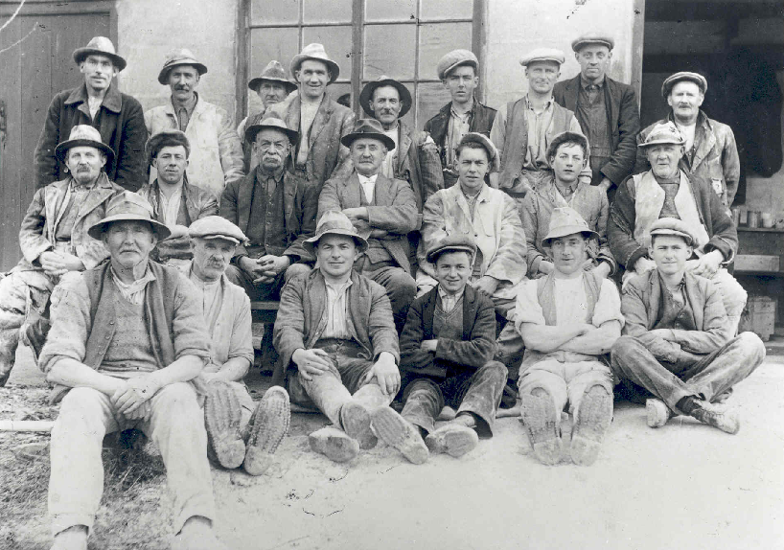
Wheal Martyn Clay Works. P1989.1920.2
June Trethewy offers “Life for both men and women in the villages was hard. Nearly all the men worked in the china-clay industry, a few on the farms. In the china clay works in the 1930s, much of the work was still manual. Men stood at the bottom of the clay pits in all weathers training the huge hoses on to the sides of the pit.” This would indicate that the china clay mining industry would have played a significant role in the personal lives of clay country villagers.
During its peak the china clay industry employed upwards of 6000 people, many of them from the neighbouring clay villages surrounding St. Austell. A.L Rowse was a prominent Cornish historian from St Austell whose father was employed in the china clay industry during the nineteenth century. – Richard Ollard Even today, it seems that almost every local person in the clay country has some kind of connection to the industry, which is still operating today predominantly by Imerys Minerals Lts. Arguably, the china clay mining industry is a significant part of the mid-Cornish identity. . Today there are five active china clay pits in the Mid Cornwall area, producing a total of around 700,000 tonnes of clay a year.
The work during the nineteenth century would have required a lot of physical labour, long hours, and potential danger.
June Trethewey touches upon the hard work performed by the men during the week when she recollects that Sunday lunch, dinner and high tea were all served by the women. “Men took no part in any of this. They laboured during the week to provide money for the family and worked in the garden to provide vegetables and fruit. On Sundays, they were waited on hand and foot by the women. There was no contention about this. Everyone accepted it as a fair division of labour.”
This passage also highlights that outside of the backbreaking work of the clay pits, most families belonging to the clay country also had to care for their own homesteads and gardens, often keeping chicken.
When exploring the china clay industry and the feelings of local people towards it, it would be remiss not to highlight the 1913 China Clay Strike, which ensured that the clay country was the scene for Cornwall’s largest industrial dispute ever. There had been other smaller strikes and wage disputes by clay workers, such as a period between 1875 and 1876.
Just prior to the strike, In 1911 Charles Vincent, a socialist book seller from Truro, was appointed as the organiser for the Worker’s Union in Cornwall. He made recruiting clay workers into the union an absolute priority presumably with strike action in mind. However, Cornwall was a comparatively strike free region when considering industrialised areas. Perhaps this was due to the rural nature of industrial Cornwall as compared to the larger towns and cities in the North of England that grew alongside industry.
As Deacon (2010) highlights:
“The clay workers were prepared to struggle for their rights and for a decent standard of living. They were among the first groups of working men in Cornwall to form trade unions. A bitter strike in 1913 to secure union recognition and an increase in the 18 shillings (80 pence) a week wage became a part of local lore.”
It could be argued that this almost sets apart the mid Cornwall china clay workers from the rest of the mining population of Cornwall who did not take up the habit of striking or ever unionising. The strike saw 5000 workers who stopped their work in order to win better pay and to have a union represent them. (South West TUC 2013). The dispute itself brought the clay country to national awareness when South Glamorgan police were sent to break up the strikers. This has been fictionalised in the 1972 BBC production “Stocker’s Copper”.
The clay worker strike was built around the demands of a longer lunch break, to be payed weekly instead of fortnightly and to work less hours in a day. So despite this industrial boom in mid Cornwall many people of clay country had to have a homestead as well and sell produce from their animals. Many women at home would work farms and homesteads whilst looking after the household and raising children. Although the strike was not initially a success, the power of unionisation and the community action of workers marching and walking together ensured that the wage was raised.
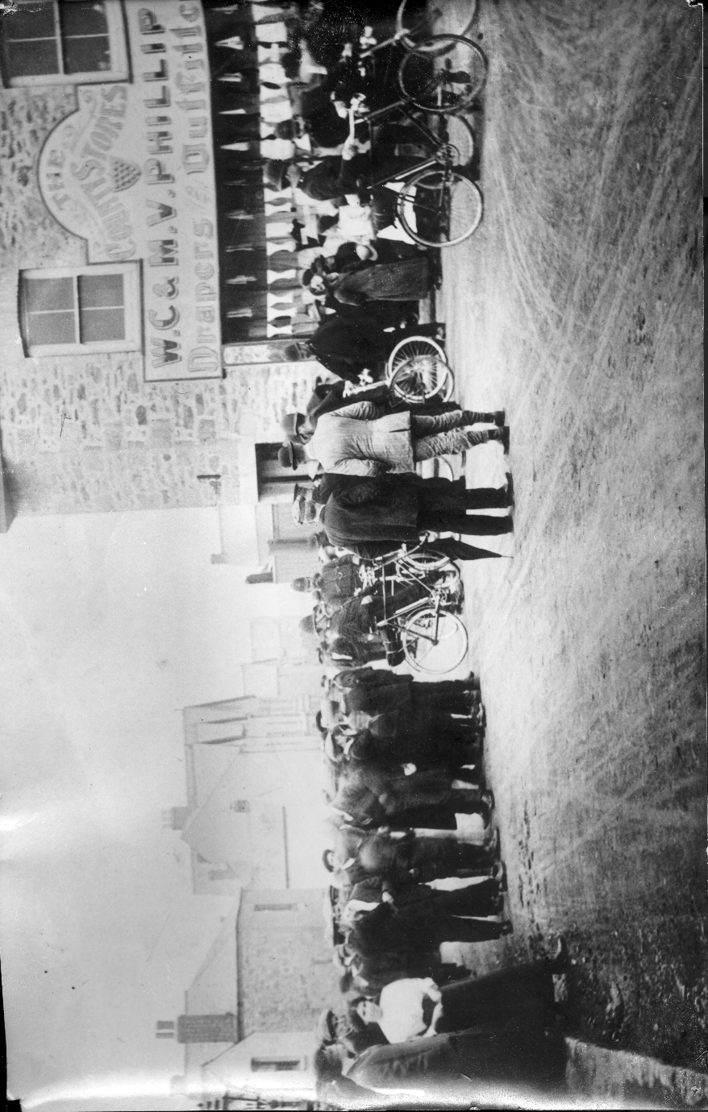
Wheal Martyn Clay Works, P2007.65.
The caption on the back of this image references two clay workers who were taunted on their way home and that police had blocked the road.
Despite this mocking; after events came to a violent clash at a clay workings in Bugle, the South Glamorgan police were often shunned by the local community with many refusing to lodge them and cut their hair in solidarity with the injured clay workers. This is another indication of strong community spirit.
However, despite this type of industrial dispute the social life of clay workers and indeed the whole of the clay country communities was a busy one with many festivals, parades and carnivals taking place in a comparatively small area (roughly 25 miles).

Social Life
Jacob describes St Austell as a thriving town. “F. W. L. Stockdale, in 1824, records that the people of the town were ‘industrious and thriving’.
“The villages around St Austell were thriving communities too and the importance of the town was obvious on market days, Saturdays and feast days when the population from outlying areas congregated in the streets. The shops thrived with trade, staying open until 9 or 9.30 pm on Saturdays. Cannon Hammond, the vicar of St Austell in 1897, called it the ‘most flourishing town in the county’”. Cannon Hammond is also specifically mentioned by Dolly Warne who amusingly recollects his sermons being rather boring for the children.
The thriving communities seemed to take part in almost innumerable activities. Some of the best evidence available of these various carnivals and fairs exists within these photographs.

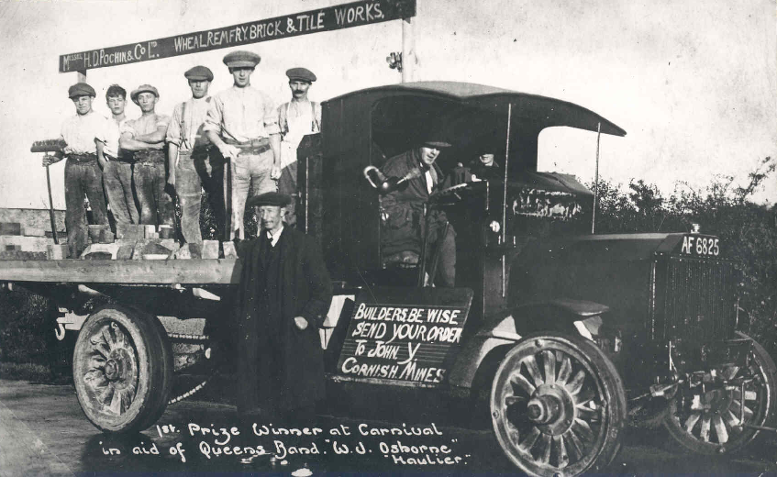
Wheal Martyn Clay Works – P1989.1928.1 Indian Queens Carnival 1st place winner Peerless.
Wright (1986) chronicles a comprehensive list of Cornish traditional food and cultural customs, the 8th chapter of “Cornish Treats” is entitled “Fairs”.
“In addition to the weekly markets, large trading fairs were held by tradition at various Cornish venues. However, the clay country villages hosted smaller fairs often and enthusiastically.
Dolly Warne makes references to “local carnivals all over the district”. These images paint a picture of mid-Cornwall as thriving, community based and a population readily eager to engage in cultural customs and activities.

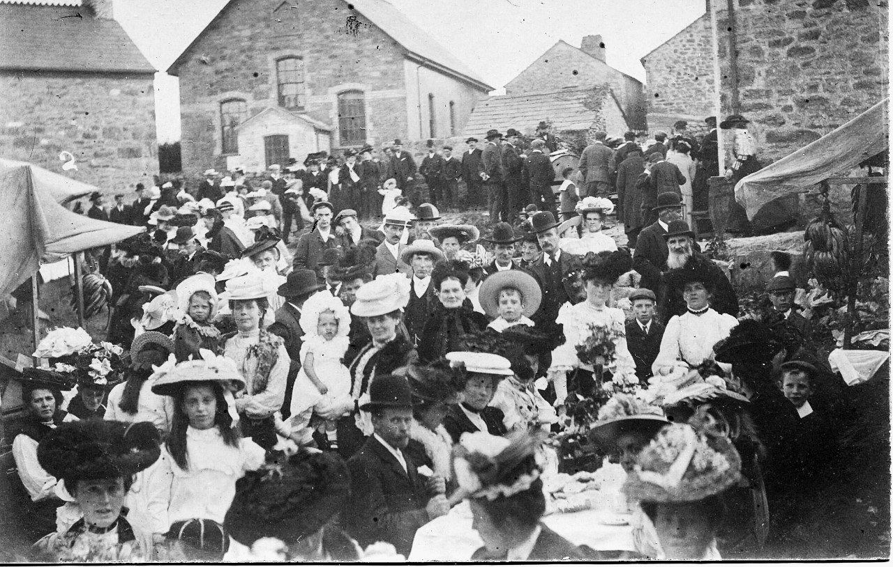
- Rescorla village 1900s pre-war. Eric Johns collection at Rescorla Centre.
This image shows an incredibly busy Rescorla at the beginning of the twentieth century. The women and men are all dressed smartly. This does not seem to be a community that is in decline. Rescorla is a fascinating case study in itself of a clay country village as in the present day the Rescorla Centre seeks to assert itself as a centre for Cornish cultural activities within mid-Cornwall.
An example of a particular folk custom found in mid Cornwall is that of the “snail creep” which would take part in Rescorla annually. Grego posits that: ‘perhaps the ancient ‘Snail Creep’ dance and ceremony of the Rescorla Festival, in which a musical band marches leading a long procession of couples around in a spiral, led by two people holding up branches (the snail’s eyestalks) harkens back to a distant memory of a similar rain of snails over Cornwall in medieval times?’’
The Rescorla Snail creep was revived in 2007. It has been mentioned in 19th century journals but possibly has its roots in medieval period. Campbell remarks:
“Methodism was not always antithetical to children enjoying music and dancing. In mid-Cornwall a fascinating custom developed known as the “snail creep”. This is a unique dance, involving a long procession of both adult and child couples following a band, led by two individuals holding up branches representing the eyestalks of a snail. The dancers then form a large circle and spiral back and forth, as if showing the markings of a snail shell.”
The snail creep was abandoned for quite a time, but seems that it was in existence and performed during the nineteenth century and the very beginning of the twentieth century in Cornwall
This would indicate, alongside the need of many people to earnestly document their childhoods in clay country that the nineteenth century was a time of strong cultural identity whereas the latter half of the twentieth century would prove to show a social and cultural decline. Camphell posits that the snail creep was likely an adaptation of an earlier folk dance and even notes some similarities to the Breton-style dancing later adopted in Cornwall. This is evidence of a strange and fascinating custom belonging solely to mid-Cornwall.
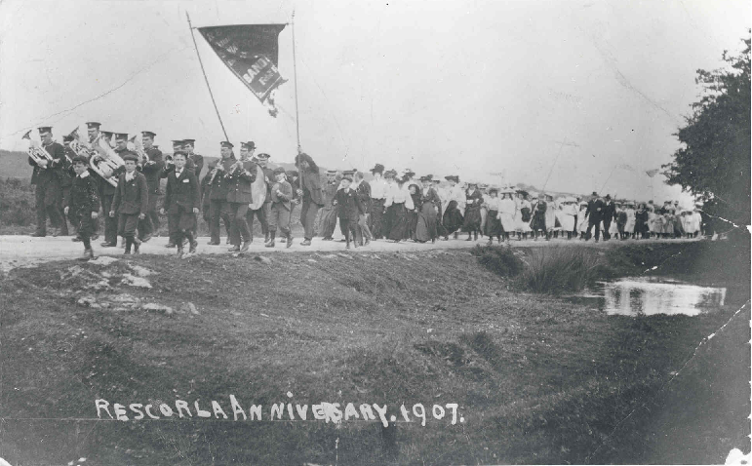

Wheal Martyn Clay Works. Rescorla Anniversary 1907 P1989.1819.1
These images of Rescorla in the first decade or so of the twentieth century show an incredible busy and thriving community.

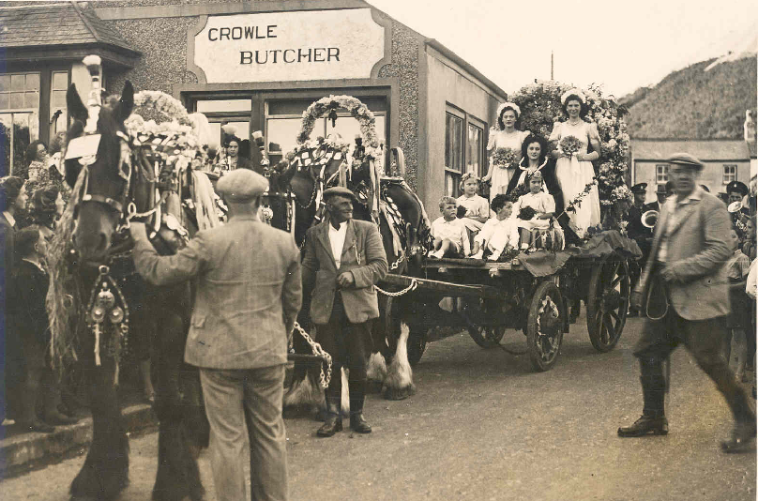
Wheal Martyn Clay Works. Carthew Carnival Queen. P2007. 86.
Carnivals seem to be prevalent throughout the clay villages. This paints a picture of a community that took great joy in coming together to celebrate, to compete and to dress up smart. The caption on the back of this image names the Carnival Queen and describes the events taking place in Carthew village centre.

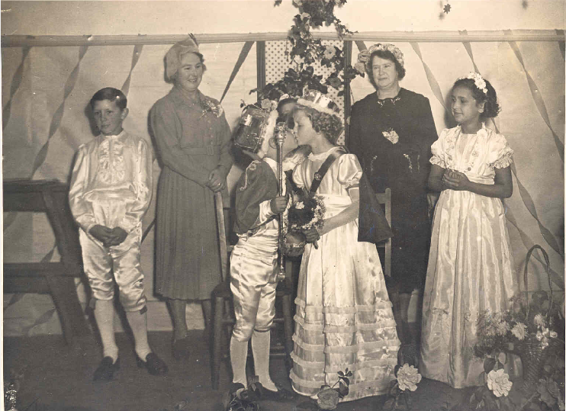
Wheal Martyn Clay Works. St Dennis Carnival. P2007.87.
The caption on the back of this image names the Junior King and Junior Queen and describes that the image was taken at a concert given by the St Dennis Male Voice Choir.
This small collection of photos highlights Indian Queens Carnival, St Dennis Carnival, Carthew Carnival and a Rescorla anniversary parade. They do not paint a complete and full picture of the events that took place in the clay country villages but they help to highlight that these communities, although often plagued by hardship, tragedy and poverty, were nonetheless thriving socially.
Singing and music also played a significant role within the clay country communities with many inhabitants of the villages being a member of a brass band or local choir.
June Trethewey lists the Foxhole brass band and St Dennis brass band as examples of their prevalence. (page 17) She offers a credible first-hand account of the significance that they played within the community.
“All the children were signed up members of the Band of Hope, an organisation set up to combat the problems of alcoholism in the difficult years after the First World War. Many men turned to drink to find escape from the harsh realities of their working lives”
This growth in alcoholism after the First World War would seem to indicate that the types of social and cultural decline that Deacon, as well as others highlighted was happening in the latter half the twentieth century instead of the nineteenth century as claimed.
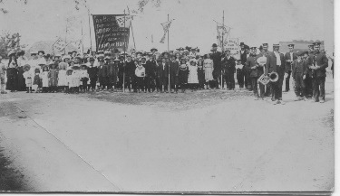
Rescorla Centre. Eric Johns collection. Band of Hope.
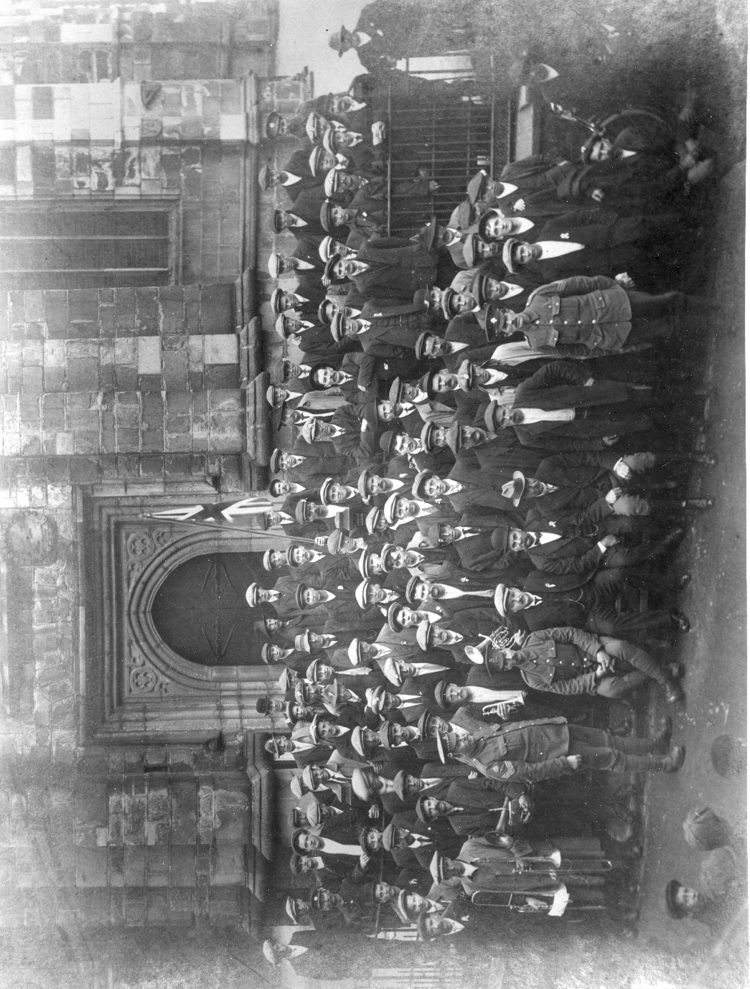
Wheal Martyn Clay Works.
St Austell, First World War recruits, 1915. Clay worker recruits for the First World War standing outside St Austell parish church, band members in front. You can see the band members at the front of the crowd in the image. This shows the significance of brass bands in the beginning of the twentieth century within mid-Cornwall.
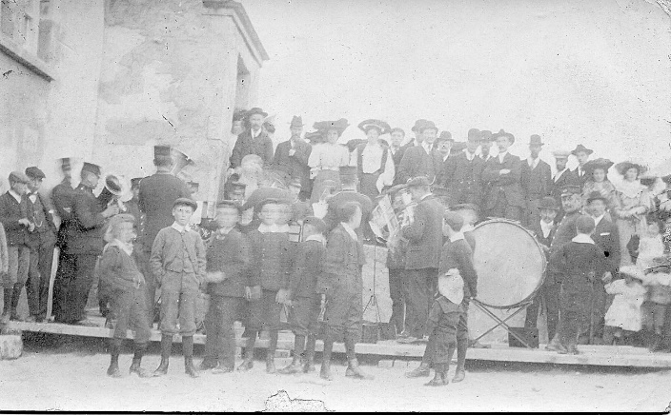
Rescorla Centre. Eric Johns collection. Penwithick in the early 1900s, pre-war.
It seems that each little village had its own brass band. Brass bands were a huge part of community life in the clay country and a strong part of the mid-cornwall identity with many villages competing against each other in various competitions or performing alongside each other at numerous events.

Chapter 3: Growth and Decline

The notion that Cornwall was in a state of industrial, social and cultural decline in the latter half of the nineteenth century is shared by many historians and authors. Bernard Deacon, the much respected and prolific Cornish historian asserts that Cornwall was undergoing a kind of ‘’social and cultural paralysis’’ during this period. Deacon goes on to attribute this stagnation to declining populations and miners emigrating, leaving old Cornish mines for new ones elsewhere. He posits that the Cornish during this period “looked inwards and backwards for reassurance, mired in nostalgia and settling for the familiar and the familial, resisting change and dreaming of the good old days”.
Similarly, Payton describes the period that stretches from the latter half of the nineteenth century until post Second World War as “The Great Paralysis”. Barton (1961) titles the chapter on 1850 onwards ‘’decline’’ when discussing copper mining in Cornwall and Devon. The declining tin and copper mining industries are arguably a convenient and attractive metaphor to reflect back a culture that was in a parallel decline.
The concept of industrial decline in nineteenth century Cornwall is nearly entirely connected to the dwindling tin and copper industries. Barton (1961) titles the chapter on 1850 onwards ‘’decline’’ when discussing copper mining in Cornwall and Devon. In relation to those industries the assertion of ‘’decline’’ has some validity. However, it could be argued that it is a narrow way in which to view Cornwall as a whole. Is this picture of a backwards Cornwall really accurate? It could be argued that the china clay mining industry was undergoing an industrial boom during the nineteenth century rather than a decline. It seems as though this industry has been ignored as part of the more complete look at Cornwall in favour of exploring the more romantic mining industries and their dwindling returns.
Industrialisation helped to embolden the people of Cornwall, it gave them something to be proud of, to be ahead of the game on. “Above all is the character of the Cornish miner – who since the dawn of history has demonstrated that he is among the best in the world – which gives the Cornish people their pride – Allen Buckley, The Story of Mining in Cornwall: A World of Payable Ground”
This idea of a decaying industry, married to the picturesque ruins of beam engines dotted around the coast is a stark one and one that has permeated into Cornish identity and Cornishness even today in the twenty first century. The iconic ruined ‘’beam engine’’ is often an image seen on car stickers and company logos in order to promote and connect to an idea of Cornishness. But is it really all that genuine claim that Cornwall in the latter half of the nineteenth century was undergoing de-industrialisation and widespread social decline?
Indeed, even Payton who has described the “great paralysis” concedes that “In the early years of the twentieth century, china clay was seen by many as the natural successor to copper and tin, a means of filling the vacuum left by the decline of mining proper. Indeed, there was healthy expansion between 1900 and 1916.” So why is the industry and Mid-Cornwall often forgotten about in discourse concerning Cornish identity and Cornwall’s identity in general? Using Mid Cornwall as a case study highlights that a huge amount of activity was happening during this period when it comes to the complete change of Mid Cornwall’s landscape, coastline and industry.
St Austell
The main market town of Mid-Cornwall’s clay district is St Austell. In Valeria Jacob’s St Austell Through Time collection of images and captions she includes a section on Palace Road which was newly built in the middle of the nineteenth century after the advent of the Great Western Railway from Plymouth to Cornwall. “Several new residences were built by the clay magnates or prosperous business people in the town set back off the road within their own spacious grounds. The walls remain today, but the fine gas lamps and seats have disappeared”. St Austell saw a host of new and significant buildings in the nineteenth century including the Corn Exchange (page 8) built in 1859 and the Victorian red-brick bank dominating Church street, which are also included in the collection.
The collection of photographs found within St Austell through time certainly a paint a picture of a thriving down and one that was constantly undergoing change and expansion during the nineteenth and early twentieth centuries. To quote Jacob:
“The clay industry employed much of the local work force, the economic and social effects on St Austell being of great importance. The town developed and grew in all directions during the nineteenth and twentieth centuries and fine houses, avenues and buildings were added to the main streets.”
Although the china clay industry was significant in changing the whole of mid-Cornwall and it would arguably be impossible to tell any kind of history of St Austell without mentioning the industry; there were other buildings and changes happening in the town outside of the industry. The population of St Austell almost tripled in the nineteenth century. It can be argued that St Austell was an exciting and thriving down during the latter half of the nineteenth century when new buildings, streets and town expansions were developed continuously. To list a few: A Liberal club was built in 1890, the first YMCA building in Cornwall was built in 1893, a replacement viaduct was built in 1898, a workhouse in 1839, police station in 1866, Wesleyan Chapel 1873and Boarding School built in the 1880s (67).
However, not only was the town of St Austell drastically changed but all of the local ports soon became sites of china clay exporting most notably Charlestown, Par and Fowey but also briefly Pentewan. This huge expansion into exporting goods directly from Mid-Cornwall meant that the ports became thriving communities in their own right, with many businesses such as shipbuilding, cooperages and Charlestown Foundry establishing themselves as adjacent clay industries.
Ports
Pentewan Railway and Pentewan Harbour are only a small part of the china clay story but they are a key piece of evidence in highlighting how just how significantly Mid-Cornwall was changing in the nineteenth century. Fogg explains how it was briefly built “to take China Clay from St Austell down to the harbour at Pentewan for onward shipment. (page 20)
Charlestown was originally developed to export tin and copper but it quickly became a principle china clay port. McCarthy (2018) describes an image of Charlestown filled with china clay tall ships in “Victorian Cornwall”. The caption reads: “these vessels at this time during the 1890s would have been exploring locally mined China clay” and on the next page captions a similar image of Charlestown dock “after the 1850s, the copper trade slowed, and china clay became the main local cargo to be exploited.”
Samuel Drew, a prominent historian and Methodist theologian born in St Austell, offers a fascinating history of Charlestown before it became a thriving china clay port. Taken from “The History of Cornwall”.
“In the year 1790, Charlestown which lies at the extremity of a gentle declivity, and from which the ascent is remarkably easy, presented nothing but an open sandy beach to the violence of the surf, without affording neither inlet nor shelter. At this time it contained nine inhabitants, some fish cellars, and a few miserable cottages, that corresponded with the scant population.”
This is a profoundly different picture of Charlestown as opposed to the bustling china clay port with Foundry, cooperages and brick building companies established. Charlestown Foundry, as detailed by Russel “made heavy machinery for the Cornish mining and clay industries including an enormous 35 foot pitchblack water wheel, which operated at what is now a Clay Museum at Wheal Martyn by 1884 (after the death of James Thomas). It was used to pump clay slurry up to the surface from the bottom of the china clay pits.” This provides an interesting direct link from the businesses establishing themselves near the ports and the china clay industry.
Today, Fowey is the only significant Cornish port still shipping china clay but during the nineteenth century it was only one of many. Fogg offers: “Fowey has always been one of the main ports for the export of china clay, its main advantage being that it can accommodate large ocean going ships, and the docks and wharves are not greatly affected by the state of the tide.” Par harbour, hidden away and mostly protected from visitors was “built between 1830 and 1836 my Thomas Treffry who was by then at the height of his powers. He needed to not only get the metal ore away from the many mines that he owned, but also to service the growing china clay trade”
Decline
This huge expansion is a far cry from the assertion that Cornwall was undergoing a “Great Paralysis” during the nineteenth century.
Deacon describes the china clay mining industry as having been “strangely marginal to Cornish life”, however this cannot be further from the truth when exploring the clay country villages which were consumed by it. He goes on to elaborate that “for Cornish historians such as AK Hamilton Jenkin in the 1920s and ‘30s, the clay labourer wielding his shovel in the open air struck a less romantic figure than the underground miner, seeking ore by the dim light of a guttering candle. The clay industry was also relatively new, and did not enjoy all the ancient historical associations of metal mining.”
It could be argued that this dismissal of clay country and clay country workers is echoed by the rest of Cornwall who often ignore it in their histories and explorations of Cornish identity. It has also famously never been a popular “beauty spot” for tourists in Cornwall such as the far West of Cornwall and the rugged cliffs surrounding North Cornwall villages such as Boscastle and Tintagel. These landscapes are much easier to romanticise, however, as evidenced by the accounts of clay country village life, picturesque remote landscapes don’t always boast the strongest Cornish identities.

Conclusion
In conclusion, life in the clay country of mid Cornwall during the nineteenth century was often poor, religious and industrial. It was a life governed by Methodism, the China Clay industry and strong community spirit. However, this was by no means a land in cultural, industrial or social stagnation as has been asserted by some historians. During the nineteenth century, Mid-Cornwall underwent huge expansion primarily focused on the china clay mining industry. The whole landscape of mid-Cornwall completely changed during this period with the expansion of ports and harbours to export the clay. It can be argued that almost evert part of the region was sculpted and changed by china clay mining. During its peak the industry employed upward of 6000 people and as such almost everyone living in clay country was connected to the industry in some way.
This area of Cornwall produced a high amount of literate people, and many artists and authors hail from clay country villages specifically. Among them the Hocking siblings and Jack Clemo. Not only were these authors simply from clay country but it was specifically the clay country of Mid Cornwall and the communities that it uniquely forged that featured heavily in their work and influenced all of their writings. There was a unique sense of Cornish identity that belonged within these clay country villages, one that was neither consumed with romanticised nostalgia for “better days” nor one that was part of the equally romantic Celtic Revival of the nineteenth century.
The personal accounts found in Salome Hocking, June Trethewey and Dolly Warne’s childhood recollections of clay country life hint at a strong community spirit with villages populated by close knit families and distinct individuals. These communities were often devoutly Methodist. This faith, which simultaneously promoted individual thought and communal compassion and respect, influenced all aspects of their lives from Sunday routines, to hobbies such as singing and brass brands. There was no shortage of feasts, parades and carnivals for these communities to attend and the desire for a number of authors to recollect and chronicle their childhood there suggests an understanding that these communities were strangely unique and worth preserving if only in words.
The huge expansion of St Austell and its neighbouring ports paint a picture of a part of the world that was thriving with industry and people. The many building works and growing population of St Austell indicate that people were specifically moving to the area presumably viewing it as somewhere undergoing an industrial, social and cultural boom.
Whilst there is validity to the assertion of “decline” when considering the metiliferous mining industries of Cornwall, it does not quite adequately describe what was happening in mid-Cornwall at the time. So the nineteenth century was simultaneously an era of decline and growth in various parts of Cornwall. The area of mid Cornwall, where the majority of china clay mining took place, maintained a strong identity during this period. The people there were by no means wealthy and many of them lived in poverty or bleak conditions but the sense of Cornish pride and identity had not dulled or altered with the de-industrialisation of the mining areas in much the same way it had done in other parts of Cornwall.
Nineteenth century mid Cornwall paints a picture of a heavily expanding, culturally rich land populated by numerous villages and one which was thriving whilst the rest of Cornwall was decidedly not.

References
Books
Deacon, B. Cornwall and the Cornish. (United Kingdom: Alison Hodge Publishers. 2010)
Payton, Phillip. Cornwall: A History: Revised and Updated Edition. (United Kingdom. University of Exeter Press. 2017)
Alan M. Kent. Pulp Methodism: The Lives & Literatures of Silas, Joseph and Salome Hocking: The Three Cornish Novelists. (United Kingdom. Cornish Hillside Publications. 2002)
Salome Hocking. Some Old Cornish Folk. (United Kingdom: Cornish Hillside Publications. 1903. Republished: 2002).
A Childhood in Retew: The Memories of Dolly Warne, ed. by Chris Miller (Online publisher: blurb.com)
June Trethewey. A Memoir of Trethosa Village in the 1930s. (United Kingdom: Lyfrow Trelyspen, The Roseland Institute. 2015)
The History of Cornwall: From the earliest records and traditions to the present time. Completed by Fortescue Hitchins. Ed, by Mr. Samuel Drew. (United Kingdom. Printed and published by William Penaluna. 1824)
Peter Grego. Cornwall’s Strangest Tales: Extraordinary but true stories. (United Kingdom: Pavillion Books. 2013)
Roger Fogg. Cornwall’s China Clay Country: Exploring the Land of the White Pyramid. (United Kingdom. Halsgrove. 2011.)

Jack Clemo: Selected Poems, ed. by Luke Thompson. (United Kingdom: Central Books. 2015)

B Trevail. Curious Cornwall. (United Kingdom: Tor Mark Press. 1969)
Bernard Deacon The Cornish Family: The Roots of Our Future. (United Kingdom: Cornwall Editions Ltd. 2004)
Bernard Deacon, Industrial Celts: Making the Modern Cornish Identity, 1750-1870. (Amazon Digital Services LLC – Kdp Print Us. 2018)
Life in Cornwall in the Early Nineteenth Century Selected, ed. by R. M. Barton. (United Kingdom. Dyllanslow Truran 2017)
Malcolm McCarthy. Victorian Cornwall: A Look at Cornwall Through the Eyes of Our Forefathers. (United Kingdom: Fonthill Media Limited. United Kingdom. 2018)

Valerie Jacob St Austell Through Time. (United Kingdom. Amberley Publishing Plc. 2009)
Richard Ollard. A Man of Contradictions: A Life of A. L. Rowse. (United Kingdom: Faber & Faber 2013.)
“The 1913 china clay strike” published by South West TUC. Pamphlet 2013

Chapters

Hillary Orange, ‘Cornish Mining Heritage and Cornish Identity: Images, Representations and Narratives’ in ‘Constructing Industrial Pasts: Heritage, Historical Culture and Identity in Regions Undergoing Structural Economic Transformation’, ed. by Stefan Berger (United Kingdom: Berghahn Books. 2020) pp107-127.

Phillip Pinch, ‘Making the wrecker seem not at all malevolent: re-regulating the UK’s china clay mining industry’ in Local Environmental Sustainability’, ed. by Susan Buckingham and Kate Theobald (United Kingdom: Woodhead Publishing. 2003) pp46-73

Shelley Trower, ‘Regional Writing and Oral History, from China Clay to Eden’ in ‘Place, Writing and Voice in Oral History’ ed. by Shelley Trower. (New York: Palgrave Macmillan. 2011)

Journals
Patrick Laviolette, ‘Landscaping Death: Resting Places for Cornish Identity’ Journal of Material Culture. 8:2 (2003) 215-240

Sam Turner, ‘The Changing Ancient Landscape: South-West England c. 1700–1900’ Landscapes, 5:1 (2004) 18-35

Amy Hale, ‘Representing the Cornish: Contesting heritage interpretation in Cornwall’ Tourist Studies, 1: 2. (2001) Pp185-196.

Deacon, Bernard. The reformulation of territorial identity: Cornwall in the late eighteenth and nineteenth centuries. Doctoral thesis. Open university. 2001.
Campbell, P. S. Wiggins The Oxford Handbook of Children’s Musical Cultures, 2 (2013) p 205.
USA: Oxford University Press.
Photographs
Wheal Martyn Clay Works. P1989.1920.2
Wheal Martyn Clay Works, P2007.65.
Wheal Martyn Clay Works – P1989.1928.
Wheal Martyn Clay Works. Rescorla Anniversary 1907 P1989.1819.1
Wheal Martyn Clay Works. Carthew Carnival Queen. P2007. 86.
Wheal Martyn Clay Works. St Dennis Carnival. P2007.87.
Rescorla Centre Eric Johns Collection

Bernard Deacon. Cornwall and the Cornish. (United Kingdom: Alison Hodge Publishers. 2010). Pp6-7.
Phillip Payton.. Cornwall: A History: Revised and Updated Edition. (United Kingdom. University of Exeter Press. 2017)
Salome Hocking. Some Old Cornish Folk. (United Kingdom: Cornish Hillside Publications. 1903. Republished: 2002).
A Childhood in Retew: The Memories of Dolly Warne, ed. by Chris Miller (Online publisher: blurb.com)
June Trethewey. A Memoir of Trethosa Village in the 1930s. (United Kingdom: Lyfrow Trelyspen, The Roseland Institute. 2015)
Phillip Payton.. Cornwall: A History: Revised and Updated Edition. (United Kingdom. University of Exeter Press. 2017)
The History of Cornwall: From the earliest records and traditions to the present time. Completed by Fortescue Hitchins. Ed, by Mr. Samuel Drew. (United Kingdom. Printed and published by William Penaluna. 1824) page 61
Alan M. Kent. Pulp Methodism: The Lives & Literatures of Silas, Joseph and Salome Hocking: The Three Cornish Novelists. (United Kingdom. Cornish Hillside Publications. 2002)
Peter Grego. Cornwall’s Strangest Tales: Extraordinary but true stories. (United Kingdom: Pavillion Books. 2013) pp10.
Roger Fogg. Cornwall’s China Clay Country: Exploring the Land of the White Pyramid. (United Kingdom. Halsgrove. 2011.) page 10.
Patrick Laviolette, ‘Landscaping Death: Resting Places for Cornish Identity’ Journal of Material Culture. 8 (2003) pp-215-240
Sam Turner, ‘The Changing Ancient Landscape: South-West England c. 1700–1900’ Landscapes, 5:1 (2004) p22.
Hillary Orange, ‘Cornish Mining Heritage and Cornish Identity: Images, Representations and Narratives’ in Constructing Industrial Pasts: Heritage, Historical Culture and Identity in Regions Undergoing Structural Economic Transformation’, ed. by Stefan Berger (Berghahn Books) pp107-127.
Alan M. Kent. Pulp Methodism: The Lives & Literatures of Silas, Joseph and Salome Hocking: The Three Cornish Novelists. (United Kingdom. Cornish Hillside Publications. 2002) p11.
Deacon, B. Cornwall and the Cornish. (United Kingdom: Alison Hodge Publishers. 2010) p9.
Amy Hale, ‘Representing the Cornish: Contesting heritage interpretation in Cornwall’ Tourist Studies, 1: 2. (2001) Pp185-196.
Phillip Pinch, ‘Making the wrecker seem not at all malevolent: re-regulating the UK’s china clay mining industry’ in Local Environmental Sustainability’, ed. by Susan Buckingham and Kate Theobald (United Kingdom: Woodhead Publishing. 2003) pp46-73
Phillip Pinch, ‘Making the wrecker seem not at all malevolent: re-regulating the UK’s china clay mining industry’ in Local Environmental Sustainability’, ed. by Susan Buckingham and Kate Theobald (United Kingdom: Woodhead Publishing. 2003) p56
Shelley Trower, ‘Regional Writing and Oral History, from China Clay to Eden’ in ‘Place, Writing and Voice in Oral History’ ed. by Shelley Trower. (New York: Palgrave Macmillan. 2011)
Patrick Laviolette, ‘Landscaping Death: Resting Places for Cornish Identity’ Journal of Material Culture. 8 (2003) pp-215-240
Patrick Laviolette, ‘Landscaping Death: Resting Places for Cornish Identity’ Journal of Material Culture. 8 (2003) p231.
Patrick Laviolette, ‘Landscaping Death: Resting Places for Cornish Identity’ Journal of Material Culture. 8 (2003) p237
Salome Hocking. Some Old Cornish Folk. (United Kingdom: Cornish Hillside Publications. 1903. Republished: 2002) p153.
Salome Hocking. Some Old Cornish Folk. (United Kingdom: Cornish Hillside Publications. 1903. Republished: 2002) p157
Deacon, B. Cornwall and the Cornish. (United Kingdom: Alison Hodge Publishers. 2010) p21
Jack Clemo: Selected Poems, ed. by Luke Thompson. (United Kingdom: Central Books. 2015)
Jack Clemo: Selected Poems, ed. by Luke Thompson. (United Kingdom: Central Books. 2015) p21
Jack Clemo: Selected Poems, ed. by Luke Thompson. (United Kingdom: Central Books. 2015) p23
Jack Clemo: Selected Poems, ed. by Luke Thompson. (United Kingdom: Central Books. 2015) p25
A Childhood in Retew: The Memories of Dolly Warne, ed. by Chris Miller (Online publisher: blurb.com) p7
B Trevail. Curious Cornwall. (United Kingdom: Tor Mark Press. 1969)
Wheal Martyn Clay Works Museum, temporary exhibition ‘#CelebrateClayCountry’ 2020
Council of Europe. Framework Convention for the Protection of National Minorities. 2014.
Deacon, B. Cornwall and the Cornish. (United Kingdom: Alison Hodge Publishers. 2010) pp7-9
Deacon, Bernard. The reformulation of territorial identity: Cornwall in the late eighteenth and nineteenth centuries. Doctoral thesis. Open university. 2001.
Bernard Deacon The Cornish Family: The Roots of Our Future. (United Kingdom: Cornwall Editions Ltd. 2004)
Deacon, B. Cornwall and the Cornish. (United Kingdom: Alison Hodge Publishers. 2010) pp116-117
Bernard Deacon, Industrial Celts: Making the Modern Cornish Identity, 1750-1870. (Amazon Digital Services LLC – Kdp Print Us. 2018)
Roger Fogg. Cornwall’s China Clay Country: Exploring the Land of the White Pyramid. (United Kingdom. Halsgrove. 2011.)
Life in Cornwall in the Early Nineteenth Century Selected, ed. by R. M. Barton. (United Kingdom. Dyllanslow Truran 2017)
Alan M. Kent. Pulp Methodism: The Lives & Literatures of Silas, Joseph and Salome Hocking: The Three Cornish Novelists. (United Kingdom. Cornish Hillside Publications. 2002)
Alan M. Kent. Pulp Methodism: The Lives & Literatures of Silas, Joseph and Salome Hocking: The Three Cornish Novelists. (United Kingdom. Cornish Hillside Publications. 2002)
Salome Hocking. Some Old Cornish Folk. (United Kingdom: Cornish Hillside Publications. 1903. Republished: 2002).
June Trethewey. A Memoir of Trethosa Village in the 1930s. (United Kingdom: Lyfrow Trelyspen, The Roseland Institute. 2015) p5
June Trethewey. A Memoir of Trethosa Village in the 1930s. (United Kingdom: Lyfrow Trelyspen, The Roseland Institute. 2015) p6
A Childhood in Retew: The Memories of Dolly Warne, ed. by Chris Miller (Online publisher: blurb.com) p15
A Childhood in Retew: The Memories of Dolly Warne, ed. by Chris Miller (Online publisher: blurb.com) p16
June Trethewey. A Memoir of Trethosa Village in the 1930s. (United Kingdom: Lyfrow Trelyspen, The Roseland Institute. 2015)
Deacon, B. Cornwall and the Cornish. (United Kingdom: Alison Hodge Publishers. 2010) pp107-109
Deacon, Bernard. The reformulation of territorial identity: Cornwall in the late eighteenth and nineteenth centuries. Doctoral thesis. Open university. 2001 p272
Deacon, Bernard. The reformulation of territorial identity: Cornwall in the late eighteenth and nineteenth centuries. Doctoral thesis. Open university. 2001 p272
Payton, Phillip. Cornwall: A History: Revised and Updated Edition. (United Kingdom. University of Exeter Press. 2017)
Alan M. Kent. Pulp Methodism: The Lives & Literatures of Silas, Joseph and Salome Hocking: The Three Cornish Novelists. (United Kingdom. Cornish Hillside Publications. 2002)
June Trethewey. A Memoir of Trethosa Village in the 1930s. (United Kingdom: Lyfrow Trelyspen, The Roseland Institute. 2015)
June Trethewey. A Memoir of Trethosa Village in the 1930s. (United Kingdom: Lyfrow Trelyspen, The Roseland Institute. 2015) p12
June Trethewey. A Memoir of Trethosa Village in the 1930s. (United Kingdom: Lyfrow Trelyspen, The Roseland Institute. 2015) p13
June Trethewey. A Memoir of Trethosa Village in the 1930s. (United Kingdom: Lyfrow Trelyspen, The Roseland Institute. 2015) p16
A Childhood in Retew: The Memories of Dolly Warne, ed. by Chris Miller (Online publisher: blurb.com) p13
A Childhood in Retew: The Memories of Dolly Warne, ed. by Chris Miller (Online publisher: blurb.com) p15
Salome Hocking. Some Old Cornish Folk. (United Kingdom: Cornish Hillside Publications. 1903. Republished: 2002) p154
June Trethewey. A Memoir of Trethosa Village in the 1930s. (United Kingdom: Lyfrow Trelyspen, The Roseland Institute. 2015)
Malcolm McCarthy. Victorian Cornwall: A Look at Cornwall Through the Eyes of Our Forefathers. (United Kingdom: Fonthill Media Limited. United Kingdom. 2018)
Valerie Jacob St Austell Through Time. (United Kingdom. Amberley Publishing Plc. 2009)
June Trethewey. A Memoir of Trethosa Village in the 1930s. (United Kingdom: Lyfrow Trelyspen, The Roseland Institute. 2015)
Richard Ollard. A Man of Contradictions: A Life of A. L. Rowse. (United Kingdom: Faber & Faber 2013.)
(Sheffield Daily Telegraph Saturday 16th December 1876).
“The 1913 china clay strike” published by South West TUC. Pamphlet 2013
Deacon, B. Cornwall and the Cornish. (United Kingdom: Alison Hodge Publishers. 2010)
(Diss Express. Friday 10th October 1913 (clay strike)
Valerie Jacob St Austell Through Time. (United Kingdom. Amberley Publishing Plc. 2009)
A Childhood in Retew: The Memories of Dolly Warne, ed. by Chris Miller (Online publisher: blurb.com)
Rescorla Centre (https://www.gunwen.org.uk/rescorla-centre/)
Peter Grego. Cornwall’s Strangest Tales: Extraordinary but true stories. (United Kingdom: Pavillion Books. 2013)
Friend, H. The Antiquary; London Vol 5. May 1882. Pp 204-206)
Campbell, P. S. Wiggins The Oxford Handbook of Children’s Musical Cultures, 2 (2013) p 205. USA: Oxford University Press.
(Cornish Guardian. Friday 23rd May 1902).
June Trethewey. A Memoir of Trethosa Village in the 1930s. (United Kingdom: Lyfrow Trelyspen, The Roseland Institute. 2015)
Deacon, B. Cornwall and the Cornish. (United Kingdom: Alison Hodge Publishers. 2010)
Payton, Phillip. Cornwall: A History: Revised and Updated Edition. (United Kingdom. University of Exeter Press. 2017)
Deacon, B. Cornwall and the Cornish. (United Kingdom: Alison Hodge Publishers. 2010)
Valerie Jacob St Austell Through Time. (United Kingdom. Amberley Publishing Plc. 2009)
Roger Fogg. Cornwall’s China Clay Country: Exploring the Land of the White Pyramid. (United Kingdom. Halsgrove. 2011.)
The History of Cornwall: From the earliest records and traditions to the present time. Completed by Fortescue Hitchins. Ed, by Mr. Samuel Drew. (United Kingdom. Printed and published by William Penaluna. 1824) p50
Roger Fogg. Cornwall’s China Clay Country: Exploring the Land of the White Pyramid. (United Kingdom. Halsgrove. 2011.)
Deacon, B. Cornwall and the Cornish. (United Kingdom: Alison Hodge Publishers. 2010)

