Graphics and Games Programming Assignment 1 – Parametric Curves

by

Ben Kiddie

Student Number: 1800242

Submitted: 11 / 12 / 2020

Abstract

Table of Contents
1. Generating the Curve – Methods and Functions 1
2. Point on Curve Calculation 12
3. 14
4. Bibliography 15

Table of Figures
Figure 1 Setting up the user interface with cRenderClass::Create v
Figure 2 Mouse manages the placement of control points vi
Figure 3 Keyboard allows the user to toggle curve placements vi
Figure 4 SpecialKeyboard manages control point steps and curve resolution changes vii
Figure 5 renderScene performs all the necessary decisions on how control points and curves are rendered vii
Figure 6 Struct types stored in globals.h viii
Figure 7 cBSpline manages the storage and calculations of curves and control points, in addition to interfaces for such data ix
Figure 8 Initialisation of our container class, cBSpline x
Figure 9 InitialiseBasisFunctionsLUT pre-calculates and stores all potential basis functions x
Figure 10 PlaceControlPoint is called when a left mouse click is performed xi
Figure 11 UndoControlPoint lets users reset a control points' position xii
Figure 12 mContinuity interface method xii
Figure 13 DeleteCurveSegment allows users to select a previously placed curve and seamlessly erase it xii
Figure 14 ControlPointStepForward and ControlPointStepBack allow users to navigate across control points xiii
Figure 15 Increase and Decrease resolution, or pixels per line xiii
Figure 16 GetCurveSegments returns the entirety of stored control points xiv
Figure 17 GetCurrentResolution returns a value which can change at any point by the user xiv
Figure 18 Point on a cubic curve formula [1, Eq. 17.8] xv
Figure 19 Simplified derivation of a point on a uniform non-rational b-spline [2] xv
Figure 20 Control points placed on-screen for use in calculation testing xv
Figure 21 The four positions, of both X and Y coordinates, in addition to the calculated X and Y values xvi

1. Generating the Curve – Methods and Functions
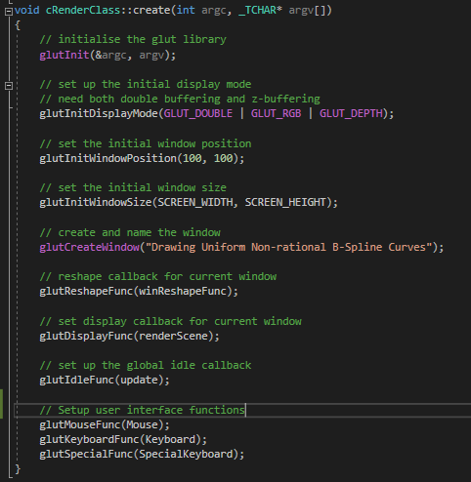
Figure 1 Setting up the user interface with cRenderClass::Create
The author modified a cRenderClass template to provide a user interface. The adjustments made include the methods called at the bottom, which provide keyboard and mouse interactions.
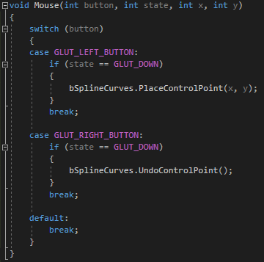
Figure 2 Mouse manages the placement of control points
Mouse allows a user to put down a new control point or move a currently selected control point. Additionally, points can be ‘undone’ – where the previously placed point is moved outside the viewable window.
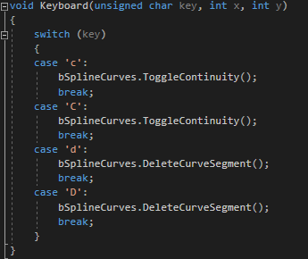
Figure 3 Keyboard allows the user to toggle curve placements
Pressing ‘c’ with the keyboard toggles continuity. When enabled, the next control point placement will put down a whole new curve with C2 continuity. Pressing ‘d’ will delete the curve currently selected.
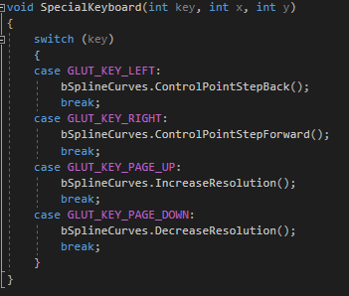
Figure 4 SpecialKeyboard manages control point steps and curve resolution changes
SpecialKeyboard allows the user to perform ‘stepping’ by pressing left or right on the keyboard. This is a process by which the user can select previously placed points by moving incrementally backwards, or forwards if already stepped back. Page Up and Page Down keys increase and decrease resolution (i.e. pixels per curve) respectively.
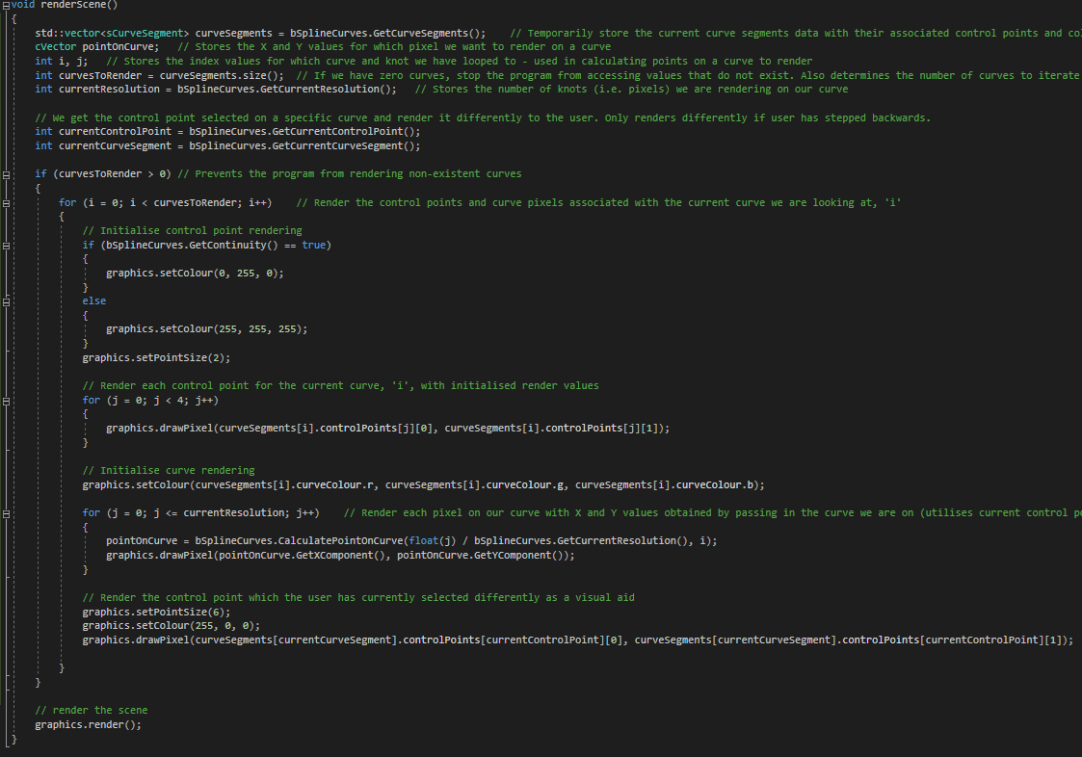
Figure 5 renderScene performs all the necessary decisions on how control points and curves are rendered
renderScene manages the rendering for three items. First is control points – we render the colour for these differently based on the state of continuity, where the number of control points is four per curve. Next is the control point currently selected, which renders larger and in red relative to other control points. Lastly, we render pixels on our curve, for which the X and Y coordinates are stored in a vector calculated through the CalculatePointOnCurve function.
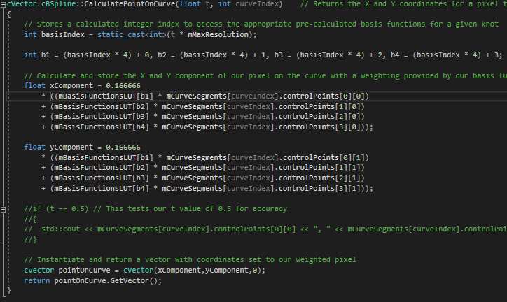
Figure 6 CalculatePointOnCurve is the means for which we render our b-spline curve
This function, given the knot value and set of control points garnered from our curve index, returns a vector with X and Y positions for rendering a pixel on our curve.
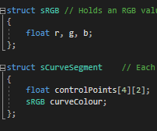
Figure 7 Struct types stored in globals.h
sRGB is used in storing colour combinations. sCurveSegment defines four control points of X and Y coordinates, with an associated colour.
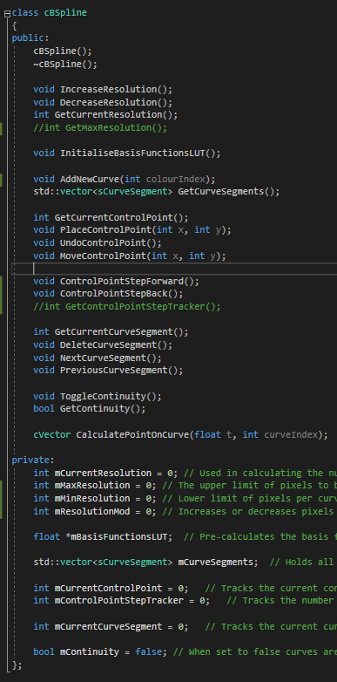
Figure 8 cBSpline manages the storage and calculations of curves and control points, in addition to interfaces for such data
cBSpline provides the foundations for storage and interfacing of curve data. Of note is the vector of curve segments, where we store all our control points. Furthermore, a look-up table holding pre-calculated values used in weighting assigned to this class.
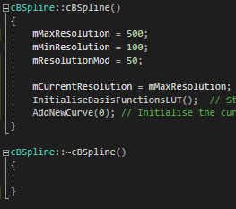
Figure 9 Initialisation of our container class, cBSpline
The constructor ensures the program starts correctly by initialising the curve vector. The basis functions look-up table is automatically populated on program start-up.
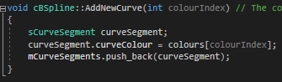
Figure 10 AddNewCurve pushes a new curve object into our vector, ready for control point assignment
The parameter colourIndex can be in the range 0-6. Once all details of our new curve are established, we add it to the vector.
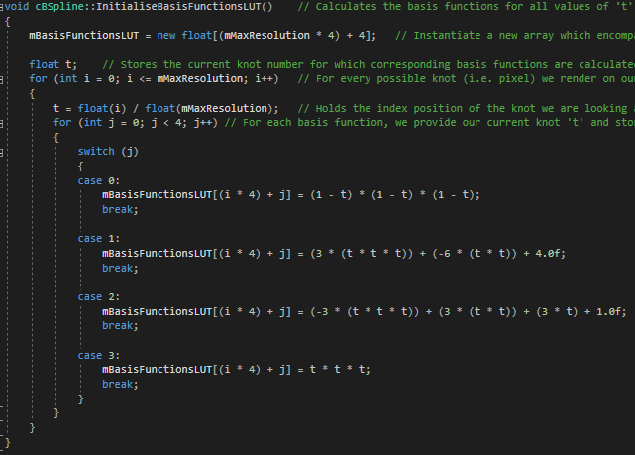
Figure 11 InitialiseBasisFunctionsLUT pre-calculates and stores all potential basis functions
For all values 0 – mMaxResolution, we calculate four basis functions. The results are stored in an array, mBasisFunctionsLUT.
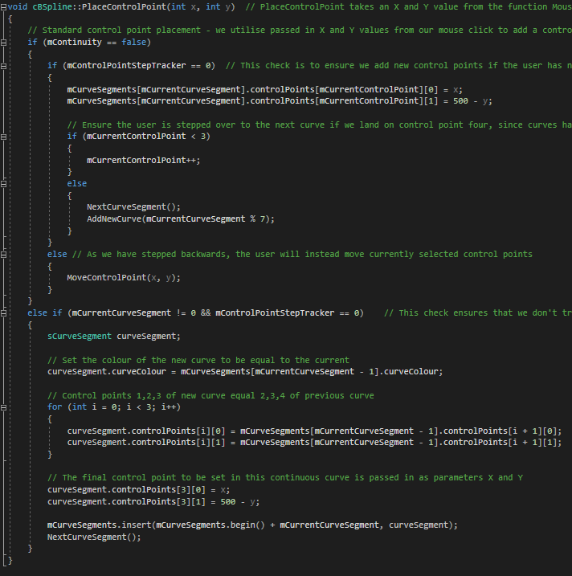
Figure 12 PlaceControlPoint is called when a left mouse click is performed
The X and Y position of the users’ mouse when this function is called will serve as the basis for one of two approaches. If mContinuity is false, we add this control point to next appropriate array position. Otherwise, this position, in addition to the three previous, will serve as control points 1 – 4 in a new curve to be added to our vector.

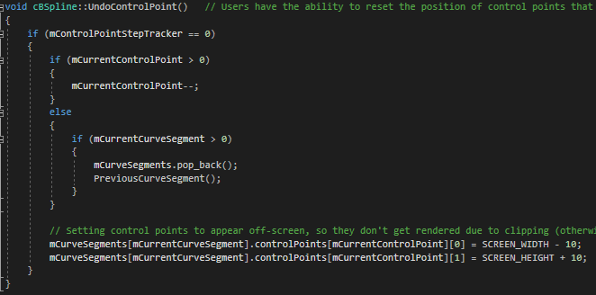
Figure 13 UndoControlPoint lets users reset a control points' position
Upon the user pressing right mouse button, the previously placed control point has its position set to outside the render window.
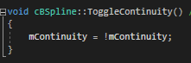
Figure 14 mContinuity interface method
ToggleContinuity lets the user shift between continuous and non-continuous curve placement by pressing ‘c’.
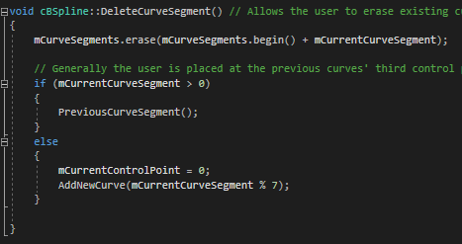
Figure 15 DeleteCurveSegment allows users to select a previously placed curve and seamlessly erase it
When the user presses ‘d’, the curve currently selected is deleted, and the user is sent to the previous curve.
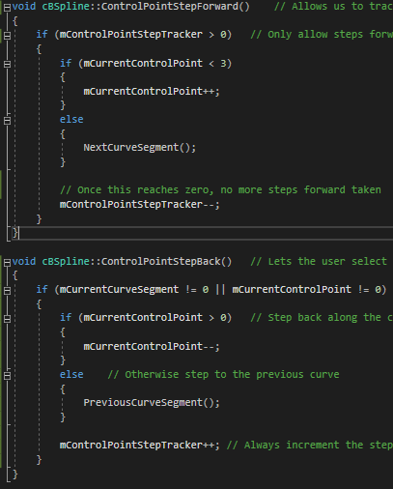
Figure 16 ControlPointStepForward and ControlPointStepBack allow users to navigate across control points
The step forward is called when the right key is pressed, while step back runs on left key press. They move the user forwards or backwards incrementally along all placed control points.
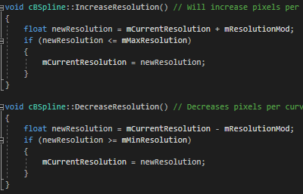
Figure 17 Increase and Decrease resolution, or pixels per line
When the user presses the page up or page down key, the number of pixels rendered per line is increased or decreased respectively by a set modifier, defaulted to 10.
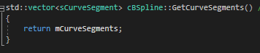
Figure 18 GetCurveSegments returns the entirety of stored control points
When rendering control points, we want to pass said points to the render loop.
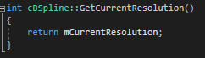
Figure 19 GetCurrentResolution returns a value which can change at any point by the user
This lets the render loop know how many pixels to draw.

2. Point on Curve Calculation
To calculate the point we wish to render, we must look to the below:
Figure 20 Point on a cubic curve formula [1, Eq. 17.8]
Which can be simplified to:
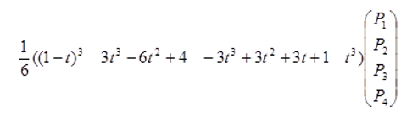
Figure 21 Simplified derivation of a point on a uniform non-rational b-spline [2]
Where 0 <= t <= 1, where any number which lies in this range represents the knot we are calculating a pixel to draw for.
With regards to Figure 6, the results of a point on curve calculation will be compared to the result of calculating Figure 21, accurately determining X and Y coordinates of the pixel on our curve. The value of ‘t’ evaluated will be 0.1 in both cases, the X and Y of our control points will be shown in Figure 23.
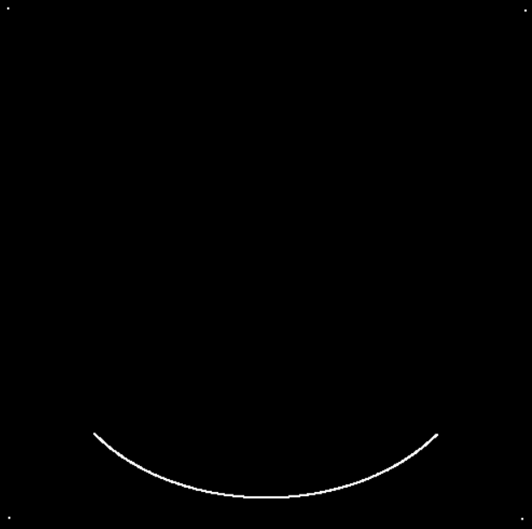
Figure 22 Control points placed on-screen for use in calculation testing
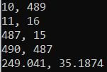
Figure 23 The four positions, of both X and Y coordinates, in addition to the calculated X and Y values
With regards to Figure 17, and t = 0.1, we calculate the basis functions using the formula in Figure 21:
$${\left(1-0.5\right)}^{3}×10=1.25,{ 3(0.5)}^{3}-6{\left(0.5\right)}^{2}+4=2.875$$
$$(\left({(-3\left(0.5\right)}^{3}\right)+\left(3\left({0.5)}^{2}\right)+ 3\left(0.5\right)+ 1\right)= 2.875, {\left(0.5\right)}^{3}= 0.125$$
Now that we have each basis weighting, we multiply each by both X and Y coordinates:
$$xPos=\frac{1}{6}×(\left(1.25 ×10\right)+\left(2.875 ×11\right)+\left(2.875 ×487\right)+\left(0.125×490\right)=250.917$$
$$yPos=\frac{1}{6}×(\left(1.25 ×489\right)+\left(2.875 ×16\right)+\left(2.875 ×15\right)+\left(0.125×487\right)=35.188$$
As seen above, the results are incredibly close to the computed values.

3. Functionality
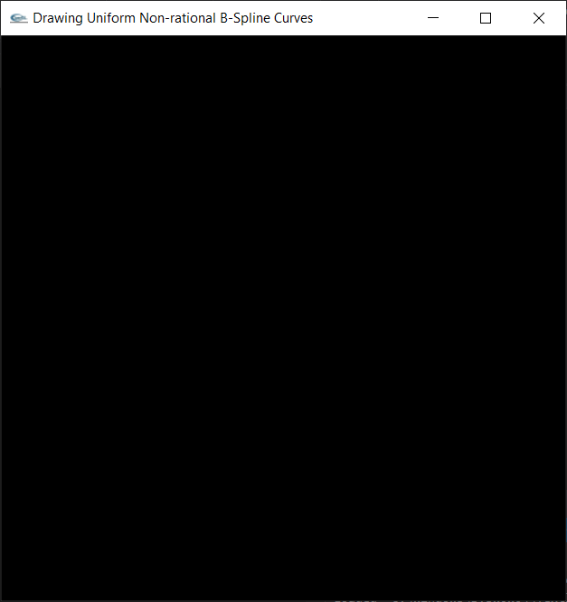
Figure 24 Empty grapics window

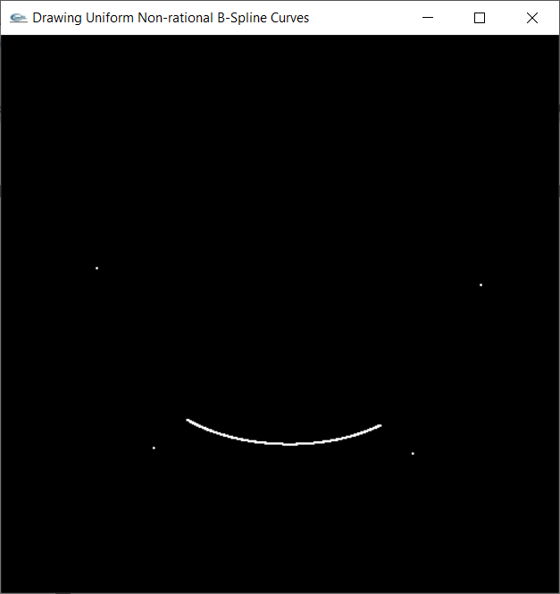
Figure 25 Four control points placed via mouse clicks, with curve rendered on screen pixel by pixel (no interpolation between pixels)

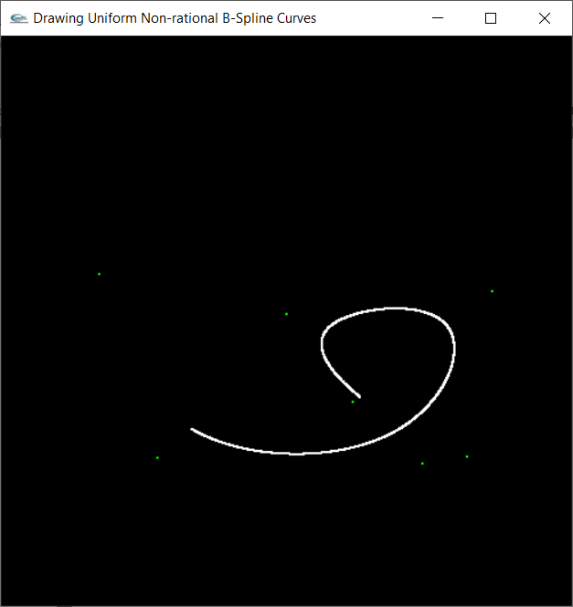
Figure 26 Continuous curve placement

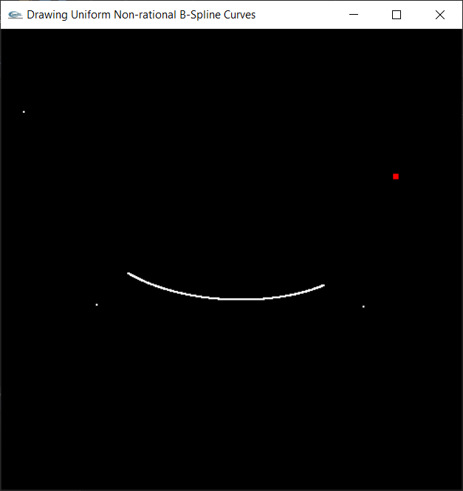
Figure 27 Selecting a previous control point
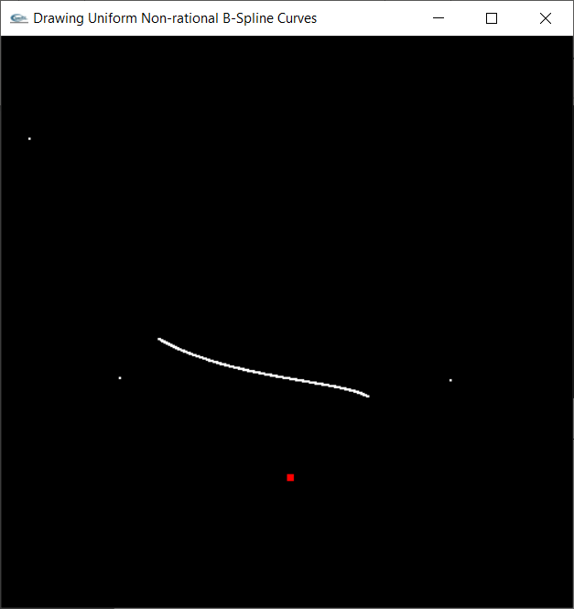
Figure 28 Moving previous control points selected with left mouse click

4. Bibliography

[1] | T. Akenine-M¨oller, E. Haines, N. Hoffman, A. Pesce, M. Iwanicki and S. Hillaire, Real-Time Rendering Fourth Edition, Taylor & Francis Group, LLC: Taylor & Francis, 2018.
[2] | A. Baker, “Parametric Curves,” 2020.

