

MODULE: QUALITY ASSURANCE AND SERVICE IMPROVEMENTS
MODULE CODE: LCHS7006

SERVICE IMPROVEMENT REPORT COMPONENT 2

Student Name: Salomi Rasikbhai Khristi
Student ID: 2433236
Lecturer:Arif Ahmed
Words: 3000

Service Improvement in Healthcare: A Critical Evaluation of Quality Failures Using the Shrewsbury and Telford NHS Trust Case

TABLE OF CONTENTS
Introduction 3
Main Body 4
Application of Root Cause Analysis Models 4
5 Whys Analysis 6
Application of the Donabedian Model 8
Strategic Analysis Using SWOT 9
Model and Approach Critical Discussion 10
Recommendations 11
Conclusion 15
Reference List 16

Introduction
Quality in healthcare is a multidimensional concept which includes the provision of safe, effective, patient-centred, timely, efficient and equitable healthcare. The case study on which the study is founded is premised on a significant issue, to be more exact, a quality issue noticed within the healthcare organizations. The research will attempt to identify root causes of the particular issue in order to form a holistic opinion of the concept of quality management. The case study chosen is the Shrewsbury and Telford Hospital NHS Trust UK Maternity Scandal. Between the period of 1970s and 2019, it was reported that the maternity care at the Shrewsbury and Telford Hospital NHS Trust led to deaths of mothers, babies, along with neonatal injuries, stillbirths, as well as long-term harm. The Ockenden report 2022 identified that lack of compassion, poor quality management, ineffective care, inadequate monitoring, and other systematic failures led to the deadly outcomes as identified from the website of Gov.UK (2026).
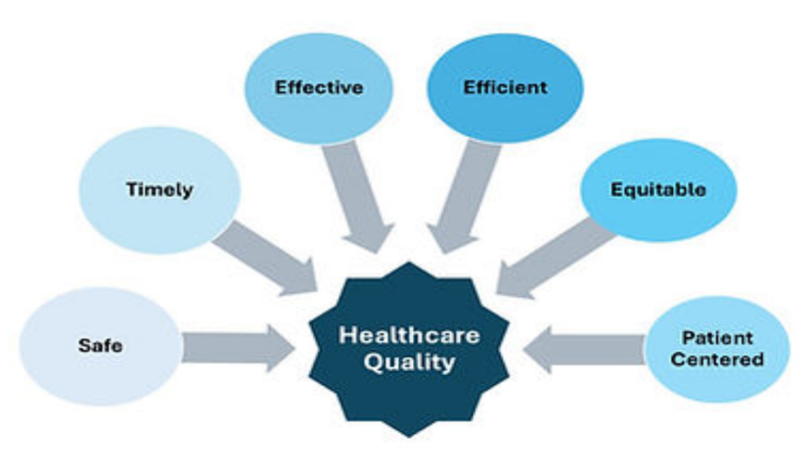
Figure 1: Healthcare Quality Domains
(Source: Quick Quality Healthcare, 2023)
The given report focuses on a specific healthcare quality issue that occurs in a real-life situation, which may either be patient safety or service delivery failures (Al-Assaf, Bahroun and Ahmed, 2024). Data about healthcare systems point out that preventable mistakes, such as medication mistakes, delayed interventions, and lack of communication, still play a role in unfavourable patient outcomes and harm that can be prevented (Rodziewicz et al., 2024).
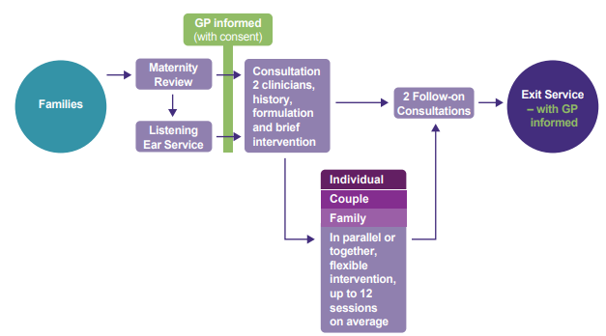
Figure 2: Maternity Care Pathway Flowchart
(Source: Gov.UK, 2026)
The importance of the chosen issue is that it has a far-reaching effect. Poor quality in care may cause injuries, loss of trust and ill health outcomes to patients (Kumah, 2025). It may create additional work, stress, and burnout in the case of healthcare professionals. Organisationally, it will add to the lack of efficiency, financial pressure, and loss of reputation. Consequently, it is crucial to tackle these problems in order to not only promote better patient outcomes but also contribute to the sustainability and efficiency of healthcare services (Khammissa et al., 2022).
The current report adopts a critical approach to shape the discussion of causal factors of the identified problem in terms of the specified quality improvement frameworks and models. By incorporating both theoretical and practical applications, it will create evidence-based recommendations that will aid in meaningful and lasting service enhancement as per the suggestion of Lachman, Batalden and Vanhaecht (2021).

Case Study Overview
The maternity scandals in Shrewsbury and Telford Hospital NHS Trust can be termed as one of the most colossal medical events in the United Kingdom. The inquiry was initiated in 2017 after complaints were made by 23 families that they had poor maternity care. The size of the issue grew extremely large throughout the years and nowadays, we have more than 1862 families under the review and the cases themselves were covered during the period of 2002-2019 (Gov.UK, 2026).
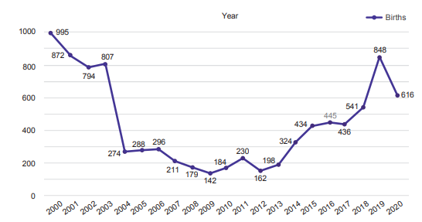
Figure 3: Birth Trends Over Time (2000–2020)
(Source: Gov.UK, 2026)
The observations showed that there was an overall clinical negligence in terms of failure to check fetal distress, lateness of action as well as wrong judgement made during labour. The Ockenden Review detected that most of these events were avoidable and meant by systemic failures that were neither due to inadequate clinical conduct but instead, inherent to the system. Also, the complaints made by about 1486 families were disregarded several times which is also indicative of a major issue with communication and accountability in the organisation (Gov.UK, 2026).

Main Body

Application of Root Cause Analysis Models
Healthcare failures are practically never the outcome of a specific element; instead, they represent the outcomes of a broad intersection of systemic liabilities, human errors and organisational shortcomings. Root Cause Analysis (RCA) is a process that entails a procedural approach of uncovering these underlying issues and preventing repeat (Singh et al., 2024).
The scheme of the Shrewsbury and Telford Hospital NHS Trust has been found to have been in the summer of 2017. The initial case involving 23 families aided in the initiation of the review or independent investigation. In July 2020, more 1862 individual families were included in the review. Most of them are those between 2002 and 2019. Primarily, it has been found that The Shrewsbury and Telford Hospital NHS trust contributed to the death of babies and mothers in the entire period (Oliverandco, 2026). Report developed out of the maternity scandal; one that is known as findings, conclusions and key actions due to the independent review of the maternity services in the Shrewsbury and Telford Hospital NHS Trust.

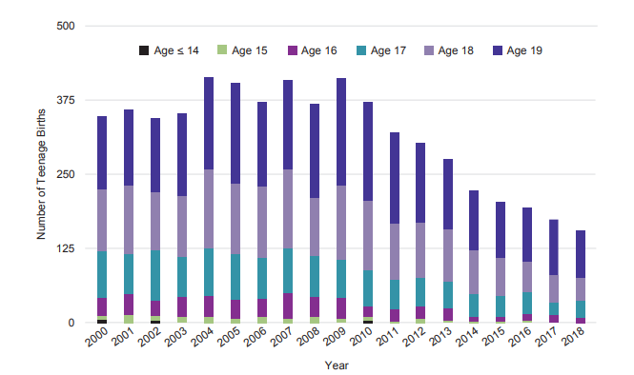
Figure 4: Distribution of Teenage Births by Age Category
(Source: Gov.UK, 2026)

Fishbone Diagram Analysis
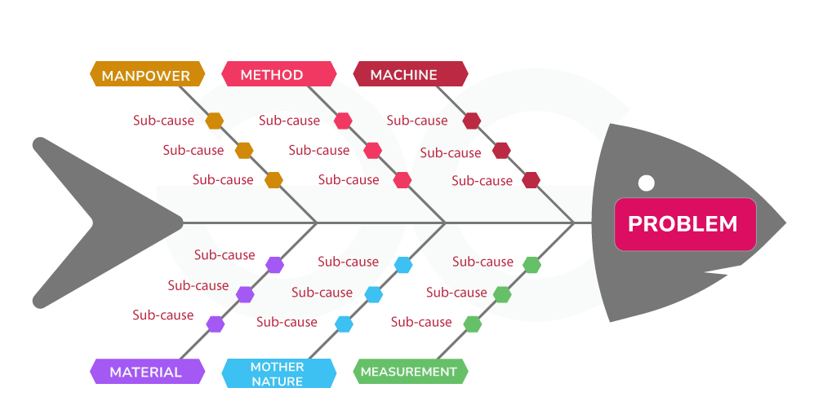
Figure 5: Fishbone diagram
(Source: GeeksforGeeks, 2024)
The Fishbone Diagram is a logical framework that allows categorizing the central causes of failures in the healthcare context into the larger categories of people, processes, environment, and policy (Lawless, 2024). Applying this model to the case study, it may be discovered that there is a set of factors of contributing factors which is multifactorial (Kumah et al., 2024).
Individually, poor staff training, clinical incompetence and poor working team were major factors. It has been hinted that there was failure on the medical care providers to detect the signs of the fetal distress very early and knowledge and decision-making deficit (Gov.UK, 2026). The resultant focus on individual performance is however perilous of reducing the problem to simple because such human factors are more likely to be influenced by organisational factors (Rosen, 2020).
On the issue of process failures, as there were no standardised guidelines and there was variation of adherence as a result of the application of the clinical guidelines it was variable in care provision (Gawthorne, Curtis and McCloughen, 2025). The report points out recurring malfunctions of fatal heart rate monitoring which directly led to avoidable deaths. Such results imply that the current processes were either ill-constructed or not well put in place.
These were also worsened further due to environmental factors most of which were linked to the limitation of resources and workload pressure (Thakkar, 2025). The insufficiency of staffing and a high influx of patients must have worsened the capacity of healthcare personnel to deliver safe and quality care, although it is not an exception in the field of healthcare quality (Anderson et al., 2023).
Finally, such failures were perpetuated with time by the poor governance frameworks and the lack of accountability because of the policy related issues (Rashdan et al., 2025). Regulatory intervention took place despite a large number of complaints and red flags, showing an inappropriate dislocation between the policy frameworks and the real practice (Sath, 2026).

5 Whys Analysis
The 5 Whys approach is more of an in-depth analysis of a specific issue identified in a Fishbone analysis that will enable searching for the source of a problem of Shrewsbury and Telford Hospital (Gangidi, 2019). As an illustration, a breakdown in clinical intervention (the delay in clinical intervention) is a problem of interest; the analysis can go in the following way.
The first reason is that there are delays as patients are not identified when they get worse. The second reason is that staff might not be well-trained to recognise early warning signs. In the third why, it is suggested that the training programme does not exist, or is inconsistent in its use (Markey et al., 2025). The fourth reason is the organisational constraints as a result of limited resources and time to develop staff. The fifth reason why speaks of the long-term systemic causes, such as the absence of emphasis on workforce development in the organisational strategy.
This rise can be seen as a manifestation of how a seemingly simple matter is embedded within the convoluted organisational and structural factors. It is also important to note that all the sections of the analysis are supposed to be supported (Reddy et al., 2022).

Application of the Donabedian Model
The Donabedian Model provides a theoretical framework of quality of healthcare performance measurement that is grounded on three interlinking dimensions: the structure, process and outcome. Such a model is especially useful when it comes to the correlation of Shrewsbury and Telford Hospital aspects with patient outcomes, thus allowing a comprehensive assessment of healthcare performance (Guzmán-Leguel and Rodríguez-Lara, 2025).
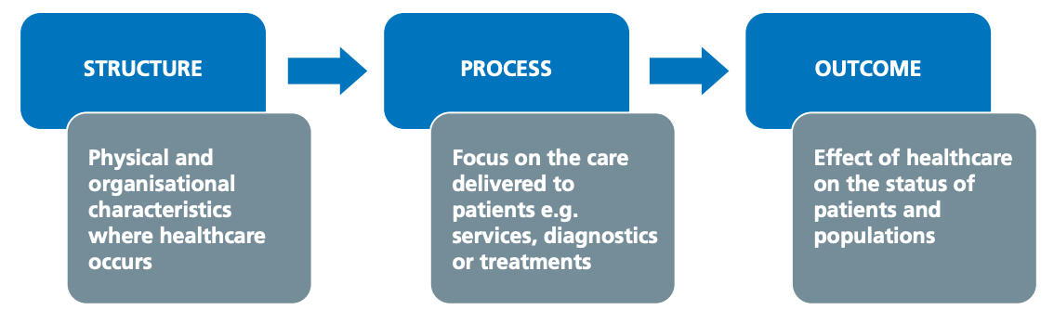
Figure 6: The Donabedian model for quality of care
(Source: Creighton, 2023)
The structural factors include staffing, infrastructure, and availability of resources. The shortage of resources and staffing issues can be among the key structural issues within the environment of the selected case (Oniyire et al., 2025). It has been shown that staffing ratios are related to elevated patient mortality and diminished quality of care (Yang et al., 2025).
Process factors are how care is being delivered, i.e. whether or not practices are adhered to in clinical procedures, yet also communicate practices and decision-making practices. Ineffective communication as well as the inaccessibility of standardisation in care delivery are issues process-related and contribute to variability in outcomes (Pereira et al., 2022). Although considerations to improve processes can result in major quality changes, obstacles like resisting change and organisational inertia can impede the implementation process (McDermott et al., 2022).
Outcome measures are patient outcome measures, i.e. mortality rates, complication rates and patient satisfaction (Tanjuakio, 2019). These can all be scientifically measured with the help of standardised performance measures that include the Healthcare Effectiveness Data and Information Set (HEDIS), which offers measurable data to assess the quality of care, effectiveness of interventions and patient safety across the healthcare systems in an organised system (Keheyan, Yasin and Al-Hamad, 2025).

Strategic Analysis Using SWOT
Strategic analysis also extends the knowledge base by placing the problem that has been identified in Shrewsbury and Telford Hospital. The SWOT framework offers a methodological way of examining internal strengths and weaknesses, and external opportunities and threats.
Strengths | Weakness
Shrewsbury and Telford Hospital’s strengths can be in the use of experienced personnel, well-developed clinical guidelines, and advanced technology. These aspects present the grounds to carry out service improvements (Nilsen et al., 2020). Nonetheless, these strengths are applicable only to the degree of organisational leadership and organisational culture. | The root causes, as discerned in the RCA, are closely associated with weaknesses of Shrewsbury and Telford Hospital NHS Trust. They might include a shortage of staff, ineffective communication, and insufficiency of training (Delgado et al., 2020). More importantly, these intricacies point out the structural nature of the problems that cannot be addressed with veneer solutions
Opportunities | Threats
Policy endeavours, technological changes, and putting more attention on patient-centred care may bring about opportunities for improvement. As an illustration, using digital health technologies can improve communication and streamline the processes (Mauro et al., 2024). The opportunities are, however, feasible based on the availability of resources and the readiness of Shrewsbury and Telford Hospital NHS Trust. | The external factors that are considered threats are funding limitations, a dearth of workforce, and the growing demand for healthcare services (Khan, 2023). The issues are especially topical in the case of the UK, where the healthcare system is under great pressure because of demographic shifts and restrictions on funding of Shrewsbury and Telford Hospital NHS Trust.
Table 1: SWOT Analysis
(Source: Self-created)

Model and Approach Critical Discussion
The level of analysis is differentiated; it differs by having critical engagement with theoretical perspectives, the comparison of various viewpoints, and the assessment of their relevance (Dower, 2012). Whereas systems-based models like the Fishbone Diagram and the Swiss Cheese Model maintain a focus on organisations like Shrewsbury and Telford Hospital, there are those authors who believe that personal responsibility is still a significant aspect (Wiegmann et al., 2022). Herein lies a continued discussion in healthcare quality literature concerning whether the responsibility should be high at the system level or the individual level.
The Swiss Cheese Model
Swiss Cheese Model is a description of how bad things occur as defences on various levels defect in concert due to coordinated weaknesses (Thedecisionlab, 2025). The malfunctioning occurred at several levels in the example of Shrewsbury case. The clinical level frontline errors that directly affected patient safety were poor fetal monitoring and responding to toddler movements. In these failures, there are weaknesses in clinical competence and decision-making (Gov.UK, 2026). Nevertheless, these mistakes cannot be considered individually. At the organisational levels, poor communication and ineffectiveness of reporting regimes did not enable concerns to increase. The frequent denial of patient complaints is the evidence of ineffectiveness in detecting and acting against risks in a systematic way.
Addictions to the problem include cultural issues and leadership. Learning and improvement was avoided due to some sort of overconfidence culture and fear of external criticism. The presence of these latent conditions allowed the presence of unsafe practices through the years. Also contributing factors were policy and regulatory deficiencies in the sense that national guides were not well enforced, and governance frameworks were not put in place to drive accountability (Oliverandco, 2026). These failures are coordinated and resulted in the great damages thus showing the systemic nature of the issue (Ettorchi-Tardy, Levif and Michel, 2012).

Recommendations
These recommendations are based on the root cause analysis and strategic review in the foregoing section based on Shrewsbury and Telford Hospital. Instead of generic solutions, these recommendations directly combat the perceived systemic issues, such as a lack of staffing, communication, training, and organisational processes (Sarre et al., 2018). A systematic quality improvement strategy is embraced to be effective, namely the Plan-Do-Study-Act (PDSA) cycle, which is generally regarded as a convenient and flexible framework for bringing change in healthcare environments.
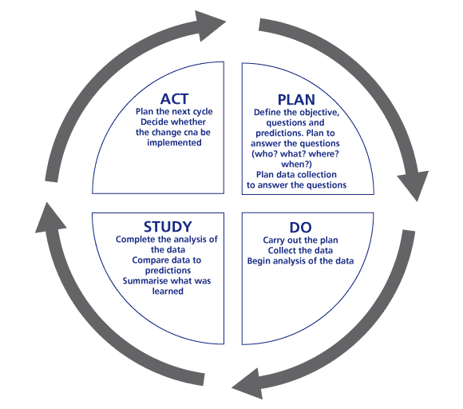
Figure 7: PDSA model
(Source: Coachingandleading, 2020)
- The planning phase, which is the first stage, entails the clear definition of the objectives of the improvement according to the root causes identified (ASQ, 2026). The main emphasis in this regard should be on communication, workforce capability and compliance with clinical protocols. To illustrate, the implementation of formalised communication systems like SBAR (Situation, Background, Assessment, Recommendation) can formalise the process of information sharing among medical workers and minimise the probability of ineffective communication (Müller et al., 2018). Also, specific training courses need to be created to enhance clinical decision-making and early identification of patient deterioration (Bacelar et al., 2023).
- The implementation stage is the stage whereby these interventions are tested on a small scale in a controlled environment. This can mean providing piloting to the communication structure within Shrewsbury and Telford Hospital training for a team of select employees as per the idea of McHugh et al., (2023). This step aims to determine the viability and effectiveness of the suggested changes to be extended across the board. Engagement of stakeholders is a critical success factor at this level. To guarantee acceptance and sustainability, healthcare professionals need to actively participate in designing and implementing the interventions (Pellegrini and Lovati, 2025). Resistance to change is a phenomenon that has been well documented in hindering healthcare, and hence, leadership is important in promoting a culture that will promote continuous improvement in reference to the context of Krijgsheld et al., (2024).
- The study phase is aimed at assessing the results of the changes implemented based on measurable indicators. These can decrease adverse events, improve patient satisfaction and better staff performance as identified in the work of De Rosis, Ferrè and Pennucci, (2022). Analysis and collection of data are necessary to identify whether the interventions have brought the desired results or not. As an example, it could be useful to monitor incident reports and patient feedback, which will help to understand the success of communication improvements as influenced by the idea of Wong, Mavondo and Fisher (2020). It should be noted, though, that not every improvement might be easily noticed, and constant monitoring must be carried out to detect trends and patterns.
- The last phase, the action phase, entails refining and expanding successful interventions. As long as the pilot achieves good results, it should be applied to the entire organisation and the required changes made according to the feedback and evaluation as per the suggestion of Scarbrough et al., (2024). On the other hand, in the event that the interventions fail to give the desired outcomes, they should be revised before any additional effort is made on them. This iterative process makes sure that the improvements are evidence-based and can respond to the changes in reference to the context of Eriksen et al., (2021).
- Along with the PDSA cycle, organisational culture and leadership also need to be discussed since these variables considerably affect the effectiveness of the service improvement programs as per idea of Taylor et al., (2014). To maintain improvements, a culture of patient safety, transparency, and continuous learning is essential. Strategies that can lead to increased engagement and motivation of staff include leadership approaches like fostering open communication, seeking staff feedback and rewarding good practice (Page, 2024).

Conclusion
This report has explored a crucial issue in healthcare quality critically through the application of various theoretical frameworks and service improvement models. This analysis has provided evidence that the failures in healthcare systems can hardly be associated with one isolated event; they are generally the results of an intricate interaction of human, organisational, and systemic elements. In a manner that allowed the application of root cause analysis, as evidenced by the Fishbone Diagram and 5 Whys technique, the report managed to pinpoint several important contributing factors, such as ineffective communication, lack of appropriate training, process inefficiencies, and structural limitations. Such outcomes support the need to adopt a systems-based approach in handling healthcare quality issues. The Donabedian Model also allows for the conduct of a systematic analysis of the impact of structural and process deficiencies on patient outcomes. The model is clear in connecting these dimensions, but there is also a discussion on its limitations in terms of the dynamic and complex nature of healthcare settings. In a similar manner, the strategic analysis also discussed how the weaknesses and various pressures in the external environment of Shrewsbury and Telford Hospital, including workforce shortages and limited funding, interact with internal organisational weaknesses and necessitate context-sensitive approaches to improvement.

Reference List
Al-Assaf, K., Bahroun, Z. and Ahmed, V. (2024). Transforming Service Quality in Healthcare: A Comprehensive Review of Healthcare 4.0 and Its Impact on Healthcare Service Quality. Informatics, 11(4), p.96. doi:https://doi.org/10.3390/informatics11040096.
Anderson, D.M., Mahamane, E., Bauza, V., Mahamadou, K.O.B., Tantum, L. and Salzberg, A. (2023). Effects of environmental conditions on healthcare worker wellbeing and quality of care: A qualitative study in Niger. PLOS Global Public Health, [online] 3(12), p.e0002590. doi:https://doi.org/10.1371/journal.pgph.0002590.
ASQ (2026). PDCA Cycle - What is the Plan-Do-Check-Act Cycle? | ASQ. [online] Asq.org. Available at: https://asq.org/quality-resources/pdca-cycle?srsltid=AfmBOorBu6P5B_mCuCNXLMJQibETi5Dg_0CHQ28M0Sv209anul_6fLsY [Accessed 12 Apr. 2026].
Bacelar, L., de Jesus Meszaros, M., de Freitas Neves Silva, M. and São‐João, T.M. (2023). Nursing Training for early clinical deterioration risk assessment: Intervention Protocol (Preprint). JMIR Research Protocols, [online] 12(1), pp.e47293–e47293. doi:https://doi.org/10.2196/47293.
Coachingandleading, 2020. Available at: https://coachingandleading.wordpress.com/presentation1/pdsa-and-types-of-change/ [Accessed on 17th March 2026].
Creighton, S. (2023). Avedis Donabedian: The creator of the Donabedian Model of Care. [online] blog.lifeqisystem.com. Available at: https://blog.lifeqisystem.com/avedis-donabedian.
De Rosis, S., Ferrè, F. and Pennucci, F. (2022). Including patient‐reported measures in performance evaluation systems: Patient contribution in assessing and improving the healthcare systems. The International Journal of Health Planning and Management, 37(S1), pp.144–165. doi:https://doi.org/10.1002/hpm.3596.
Delgado, J.M., García, A.M., Andres, J.M.A., Martín, J.L.V. and Mira, J.J. (2020). How Much of Root Cause Analysis Translates to Improve Patient safety. a Systematic Review. Medical Principles and Practice, [online] 29(6), pp.524–531. doi:https://doi.org/10.1159/000508677.
Dower, N. (2012). Development Ethics. Encyclopedia of Applied Ethics, [online] pp.779–788. doi:https://doi.org/10.1016/b978-0-12-373932-2.00368-9.
Eriksen, S., Schipper, E.L.F., Scoville-Simonds, M., Vincent, K., Adam, H.N., Brooks, N., Harding, B., Khatri, D., Lenaerts, L., Liverman, D., Mills-Novoa, M., Mosberg, M., Movik, S., Muok, B., Nightingale, A., Ojha, H., Sygna, L., Taylor, M., Vogel, C. and West, J.J. (2021). Adaptation interventions and their effect on vulnerability in developing countries: Help, hindrance or irrelevance? World Development, [online] 141(1), p.105383. doi:https://doi.org/10.1016/j.worlddev.2020.105383.
Ettorchi-Tardy, A., Levif, M. and Michel, P. (2012). Benchmarking: A Method for Continuous Quality Improvement in Health. Healthcare Policy, [online] 7(4), p.e101. Available at: https://pmc.ncbi.nlm.nih.gov/articles/PMC3359088/.
Gangidi, P. (2019). A systematic approach to root cause analysis using 3 × 5 why’s technique. International Journal of Lean Six Sigma, [online] 10(1), pp.295–310. doi:https://doi.org/10.1108/ijlss-10-2017-0114.
Gawthorne, J., Curtis, K. and McCloughen, A. (2025). The Barriers and Enablers to Implementing Nurse‐Initiated Protocols in the Emergency Department: A Focus Group Study. Journal of Clinical Nursing, 34(6). doi:https://doi.org/10.1111/jocn.17744.
GeeksforGeeks (2024). Fishbone Diagram Cause and Effect. [online] GeeksforGeeks. Available at: https://www.geeksforgeeks.org/biology/fishbone-diagram-example-use/.
Gov.UK, 2026. Final-report-of-the-ockenden-review. Available at: https://www.gov.uk/government/publications/final-report-of-the-ockenden-review [Accessed on 17th March 2026].
Guzmán-Leguel, Y.M. and Rodríguez-Lara, S.Q. (2025). Assessment of Patients’ Quality of Care in Healthcare Systems: A Comprehensive Narrative Literature Review. Healthcare, [online] 13(14), p.1714. doi:https://doi.org/10.3390/healthcare13141714.
Kehyayan, V., Yasin, Y.M. and Al-Hamad, A. (2025). Toward a clearer understanding of value‐based healthcare: A concept analysis. Journal of Nursing Management, 2025(1). doi:https://doi.org/10.1155/jonm/8186530.
Khammissa, R.A., Nemutandani, S., Shangase, S.L., Feller, G., Lemmer, J. and Feller, L. (2022). The burnout construct with reference to healthcare providers: A narrative review. SAGE Open Medicine, 10(1), p.205031212210830. doi:https://doi.org/10.1177/20503121221083080.
Khan, Z. (2023). The Emerging Challenges and Strengths of the National Health Services: A Physician Perspective. Cureus, [online] 15(5). Available at: https://pmc.ncbi.nlm.nih.gov/articles/PMC10240167/.
Krijgsheld, M., Eduard (J.E.T.) Schmidt, Levels, E. and Marieke (M.J.) Schuurmans (2024). Healthcare Professionals as Change Agents: Factors Influencing Bottom-Up, Personal Initiatives on Appropriate Care A Qualitative Study in the Netherlands. Health policy, 147(1), pp.105120–105120. doi:https://doi.org/10.1016/j.healthpol.2024.105120.
Kumah, A. (2025). Poor quality care in healthcare settings: an overlooked epidemic. Frontiers in Public Health, [online] 13(13). doi:https://doi.org/10.3389/fpubh.2025.1504172.
Kumah, A., Nwogu, C.N., Issah, A.-R., Obot, E., Kanamitie, D.T., Sifa, J.S. and Aidoo, L.A. (2024). Cause-and-Effect (Fishbone) Diagram: a Tool for Generating and Organizing Quality Improvement Ideas. Innovations Journals, [online] 7(2), pp.85–87. doi:https://doi.org/10.36401/JQSH-23-42.
Lachman, P., Batalden, P. and Vanhaecht, K. (2021). A multidimensional quality model: an opportunity for patients, their kin, healthcare providers and professionals to coproduce health. F1000Research, [online] 9(1), p.1140. doi:https://doi.org/10.12688/f1000research.26368.3.
Lawless, J. (2024). Fishbone Diagram (Ishikawa). [online] Purple Griffon. Available at: https://purplegriffon.com/blog/fishbone-diagram-ishikawa.
Markey, S., Chadwick, L., O’Dowd, E. and Doherty, E.M. (2025). Why Do Escalation Pathways Fail? A Human Factors Perspective on Early Warning Systems in Acute Irish Hospitals. Human Factors in Healthcare, p.100117. doi:https://doi.org/10.1016/j.hfh.2025.100117.
Mauro, M., Noto, G., Prenestini, A. and Sarto, F. (2024). Digital transformation in healthcare: Assessing the role of digital technologies for managerial support processes. Technological Forecasting and Social Change, [online] 209(123781), p.123781. doi:https://doi.org/10.1016/j.techfore.2024.123781.
McDermott, O., Antony, J., Bhat, S., Jayaraman, R., Rosa, A., Marolla, G. and Parida, R. (2022). Lean Six Sigma in Healthcare: A Systematic Literature Review on Challenges, Organisational Readiness and Critical Success Factors. Processes, [online] 10(10), p.1945. doi:https://doi.org/10.3390/pr10101945.
McHugh, S., Riordan, F., Kerins, C., Curran, G., Lewis, C.C., Presseau, J., Wolfenden, L. and Powell, B.J. (2023). Understanding tailoring to support the implementation of evidence-based interventions in healthcare: The CUSTOMISE research programme protocol. HRB open research, [online] 6(6), pp.7–7. doi:https://doi.org/10.12688/hrbopenres.13675.1.
Müller, M., Jürgens, J., Redaèlli, M., Klingberg, K., Hautz, W.E. and Stock, S. (2018). Impact of the Communication and Patient hand-off Tool SBAR on Patient safety: a Systematic Review. BMJ Open, 8(8), pp.1–10. doi:https://doi.org/10.1136/bmjopen-2018-022202.
Nilsen, P., Seing, I., Ericsson, C., Birken, S.A. and Schildmeijer, K. (2020). Characteristics of successful changes in health care organizations: An interview study with physicians, registered nurses and assistant nurses. BMC Health Services Research, [online] 20(147), pp.1–8. doi:https://doi.org/10.1186/s12913-020-4999-8.
Oniyire, F., Ajose, T., Andu, L., Adepase, A., Abayomi, A., Ogunyemi, O., Ogboye, O., Oyenuga, O., Ibiyemi, O., Abdulrahman-Giwa, Z., Adejumo, A., Ajanaku, B., Adewale, B. and Mogaji, H. (2025). Infrastructure, service delivery, and staffing gaps in primary health care facilities in Lagos State, Nigeria: a state-wide assessment. Discover Public Health, 22(1). doi:https://doi.org/10.1186/s12982-025-01321-y.
Page, A. (2024). Creating and sustaining a culture of safety. [online] www.ncbi.nlm.nih.gov. National Academies Press (US). Available at: https://www.ncbi.nlm.nih.gov/books/NBK216181/.
Pellegrini, G. and Lovati, C. (2025). Stakeholders’ engagement for improved health outcomes: a research brief to design a tool for better communication and participation. Frontiers in Public Health, [online] 13. doi:https://doi.org/10.3389/fpubh.2025.1536753.
Pereira, V.C., Silva, S.N., Carvalho, V.K.S., Zanghelini, F. and Barreto, J.O.M. (2022). Strategies for the Implementation of Clinical Practice Guidelines in Public health: an Overview of Systematic Reviews. Health Research Policy and Systems, [online] 20(1). doi:https://doi.org/10.1186/s12961-022-00815-4.
Quick Quality Healthcare (2023). Healthcare Quality Domains | Quick Quality Health. [online] Quick Quality Health. Available at: https://www.quickquality-healthcare.com/why-healthcare-improvement-matters/healthcare-quality-domains-%E2%80%93-.
Rashdan, D., Farha, R.A., Yasin, H. and Hadi, M.A. (2025). Human Factors Frameworks in Analysis of Contributory Factors to Medication Error: A Systematic Review. Research in Social and Administrative Pharmacy, [online] 21(9). doi:https://doi.org/10.1016/j.sapharm.2025.04.005.
Reddy, B., Thomas, S., Karachiwala, B., Sadhu, R., Iyer, A., Sen, G., Mehrtash, H. and Tunçalp, Ö. (2022). A Scoping Review of the Impact of Organisational Factors on Providers and Related Interventions in LMICs: Implications for Respectful Maternity Care. PLOS Global Public Health, [online] 2(10), p.e0001134. doi:https://doi.org/10.1371/journal.pgph.0001134.
Rodziewicz, T.L., Houseman, B., Vaqar, S. and Hipskind, J.E. (2024). Medical error reduction and prevention. [online] National Library of Medicine. Available at: https://www.ncbi.nlm.nih.gov/books/NBK499956/.
Rosen, M.A. (2020). Teamwork in healthcare: Key Discoveries Enabling safer, high-quality care. American Psychologist, [online] 73(4), pp.433–450. doi:https://doi.org/10.1037/amp0000298.
Sarre, S., Maben, J., Aldus, C., Schneider, J., Wharrad, H., Nicholson, C. and Arthur, A. (2018). The Challenges of training, Support and Assessment of Healthcare Support workers: a Qualitative Study of Experiences in Three English Acute Hospitals. International Journal of Nursing Studies, 79(79), pp.145–153. doi:https://doi.org/10.1016/j.ijnurstu.2017.11.010.
Sath, 2026. Charity. Available at: https://www.sath.nhs.uk/about-us/charity/ [Accessed on 18th March 2026].
Scarbrough, H., Sanfilippo, K.R.M., Ziemann, A. and Stavropoulou, C. (2024). Mobilizing pilot-based evidence for the spread and sustainability of innovations in healthcare: The role of innovation intermediaries. Social Science & Medicine, [online] 340, p.116394. doi:https://doi.org/10.1016/j.socscimed.2023.116394.
Singh, G., Patel, R.H. and Boster, J. (2024). Root cause analysis and medical error prevention. [online] PubMed. Available at: https://www.ncbi.nlm.nih.gov/books/NBK570638/.
Tanjuakio, K. (2019). What is lean six sigma? [online] GoLeanSixSigma.com. Available at: https://goleansixsigma.com/what-is-lean-six-sigma/.
Taylor, M.J., McNicholas, C., Nicolay, C., Darzi, A., Bell, D. and Reed, J.E. (2014). Systematic Review of the Application of the Plan–do–study–act Method to Improve Quality in Healthcare. BMJ Quality & Safety, [online] 23(4), pp.290–298. doi:https://doi.org/10.1136/bmjqs-2013-001862.
Thakkar, M.M. (2025). Strengthening Governance and Policy Frameworks for Sustainable Development: Addressing Corruption, Transparency, and Regulatory Challenges. Zenodo. [online] doi:https://doi.org/10.5281/zenodo.15422818.
Thedecisionlab, 2025. Swiss-cheese-model. Available at: https://thedecisionlab.com/reference-guide/management/swiss-cheese-model [Accessed on 18th March 2026].
Wiegmann, D.A., J. Wood, L., N. Cohen, T. and Shappell, S.A. (2022). Understanding the ‘Swiss cheese model’ and its application to patient safety. Journal of Patient Safety, [online] 18(2), pp.119–123. Available at: https://www.ncbi.nlm.nih.gov/pmc/articles/PMC8514562/.
Wong, E., Mavondo, F. and Fisher, J. (2020). Patient feedback to improve quality of patient-centred care in public hospitals: A systematic review of the evidence. BMC Health Services Research, 20(1), pp.1–17. doi:https://doi.org/10.1186/s12913-020-05383-3.
Yang, J., Liu, F., Yang, C., Wei, J., Ma, Y., Xu, L., Xie, J. and Wang, J. (2025). Application of Donabedian Three‐Dimensional Model in Outpatient Care Quality: A Scoping Review. Journal of Nursing Management, 2025(1). doi:https://doi.org/10.1155/jonm/6893336.

