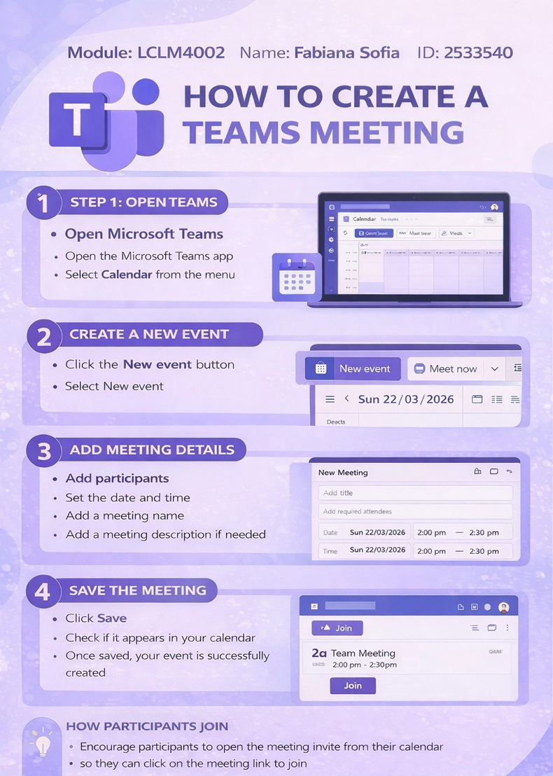
1) STEP 1: OPEN TEAMS
- ﻿﻿Open Microsoft Teams
- ﻿﻿Open the Microsoft Teams app
- ﻿﻿Select Calendar from the menu

2) CREATE A NEW EVENT
- ﻿﻿Click the New event button
- ﻿﻿Select New event

3) ADD MEETING DETAILS
- ﻿﻿Add participants
- ﻿﻿Set the date and time
- ﻿﻿Add a meeting name
- ﻿﻿Add a meeting description if needed

4) SAVE THE MEETING
- ﻿﻿Click Save
- ﻿﻿Check if it appears in your calendar
- ﻿﻿Once saved, your event is successfully created

HOW PARTICIPANTS JOIN
- ﻿﻿Encourage participants to open the meeting invite from their calendar
- ﻿﻿They can click on the meeting link to join

