

Title Page
University of Wales Trinity Saint David
BA (Hons) Leadership and Management Skills for the Workplace
Module - Developing Emotional Intelligence Skills
Module Code - LCLM 5006
Assignment Title – Component 2 – Individual Report
Student name: Riccardo Sterling
Student number: 2334990
Lecturer: Taonga Kaonga Sobere-Snithers
Submission date: 20.07.2026

Table of Contents
1.0 Introduction ............................................................................................. 3
2.0 Task 1: Emotional Intelligence in the Workplace ................................. 3
2.1 Defining Emotional Intelligence ............................................................ 3
2.2 Mayer and Salovey’s Ability Model ........................................................ 4
2.3 Goleman’s Competency Framework ....................................................... 5
2.4 Bar-On’s Emotional-Social Intelligence Model ..................................... 6
2.5 Mindfulness in the Workplace ................................................................ 7
2.6 Critical Evaluation of Emotional Intelligence Models ....................... 10
2.7 Analysis of Emotional Intelligence in Communication, Conflict Management, Leadership and Decision-Making ....................................... 11
3.0 Task 2: Managing a Multigenerational Workforce .............................. 12
3.1 Generational Context ............................................................................. 12
3.2 Generations X, Y and Z .......................................................................... 12
3.3 Recruitment, Retention and Inclusive Leadership ............................. 14
3.4 Mindfulness and Recommendations for the SMT ................................. 15
4.0 Gibbs’ Reflective Cycle .......................................................................... 17
5.0 Key Takeaways ....................................................................................... 18
6.0 Conclusion .............................................................................................. 18
7.0 Reference List ........................................................................................ 19
Appendices .................................................................................................... 23
Appendix A1: Cross-Generational Learning and Multigenerational Effectiveness ................................................................................................ 23
A1.1 Cross-Generational Learning Interventions and Organisational Enablers ...................................................................................................... 23
A1.2 Evaluating Cross-Generational Knowledge Transfer ........................ 25
Appendix A2: Organisational Drivers and Evaluation of Psychological Safety ............................................................................................................ 26
A2.1 Psychological Safety and Strategic Retention Indicators ................ 26
A2.2 Organisational Drivers of Psychological Safety ............................... 27
A2.3 Psychological-Safety Intervention Thresholds ................................. 28

1.0 Introduction
Emotional intelligence (EI) enables individuals to recognise, understand and regulate emotions in ways that support judgement, relationships and performance. Salovey and Mayer (1990) introduced EI as the monitoring and use of emotional information, while Goleman (1998) popularised its organisational relevance.
Mindfulness complements EI by encouraging present-centred awareness and considered, rather than impulsive, responses (Kabat-Zinn, 2003). These capabilities are increasingly relevant because emotions influence workplace relationships and decisions (Ashkanasy and Dorris, 2017), requiring leaders to combine technical competence with empathy, communication and ethical judgement.
In the scenario, mindfulness and emotionally intelligent leadership improved departmental morale, communication and conflict resolution. The Head of Department, therefore, requires an analytical report for the Senior Management Team (SMT) before its September 2026 strategic planning meeting. This report critically evaluates Mayer and Salovey's Ability Model, Goleman's Competency Framework and Bar-On's Emotional-Social Intelligence Model, applying them to performance, collaboration, well-being, leadership and psychological safety. It then evaluates how EI and mindfulness can support the recruitment, management, and retention of Generations X, Y, and Z.
2.0 Task 1: Emotional Intelligence in the Workplace
2.1 Defining Emotional Intelligence
EI concerns the processing and management of emotional information in oneself and others. Mayer and Salovey (1997) treat it as a cognitive ability; in contrast, Goleman (1998) emphasises workplace competencies and Bar-On (2006) includes emotional-social functioning, adaptability and wellbeing.
This disagreement matters because assessments bearing the same EI label may measure different constructs (Mayer, Roberts and Barsade, 2008). EI may improve performance by supporting emotional regulation, communication and cooperation. Meta-analyses report positive associations with job performance, particularly in interpersonal roles, although effect sizes vary by model and measurement method (Joseph and Newman, 2010; O'Boyle et al., 2011). In this scenario, managers who recognise the anxiety behind resistance to change can investigate its cause rather than automatically interpreting it as poor performance. EI should nevertheless complement technical knowledge, resources and ethical judgement rather than replace them.
This distinction between EI and cognitive intelligence is important. Cognitive ability assists analysis and technical problem-solving, whereas EI concerns how emotional information influences attention, judgment, and relationships. Contemporary work often requires both: a technically correct decision may still fail if it is communicated without empathy or introduced without considering employee anxiety. Conversely, strong interpersonal skills cannot compensate for inadequate occupational knowledge. The strategic value of EI, therefore, lies in integrating rational evidence with awareness of human consequences (Côté 2014).
2.2 Mayer and Salovey's Ability Model
According to Mayer and Salovey (1997, cited in BusinessBalls, n.d.), the Ability Model comprises four interconnected branches—perception, facilitation, understanding and regulation—which connect emotional information with workplace reasoning and behaviour, as illustrated in Figure 1 below.
Figure 1. Mayer and Salovey’s Four-Branch Ability Model
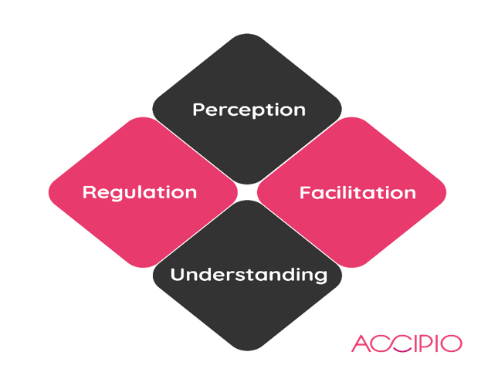
Source: Reproduced from BusinessBalls (n.d.), based on Mayer and Salovey (1997).
Perception helps managers notice disengagement through tone, expression or behaviour; however, cultural variation and deliberate concealment make emotional signals ambiguous. Interpretation should therefore be checked through respectful conversation. Using emotion can direct attention to workload concerns, while understanding emotions helps leaders anticipate how disappointment may escalate into frustration or conflict. Managing emotion enables composure, acknowledgement of competing views and a proportionate response.
The model's strength is its separation of emotional ability from broad personality traits and its suitability for performance-based assessment. Its limitation is that emotionally 'correct' answers may depend on culture and context, while some problems have several defensible responses (Roberts, MacCann and Matthews, 2010). It is consequently strongest as a developmental framework supported by scenarios, coaching, and feedback, rather than as the sole basis for recruitment or promotion.
Applied to collaboration, the four branches operate sequentially but also influence one another. Accurate perception supports understanding; understanding improves regulation; and regulation makes communication more constructive. For example, a manager chairing a tense meeting may notice withdrawal, invite quieter employees to contribute, recognise that uncertainty is driving disagreement and summarise a shared way forward. The model is less explicit about organisational power and culture, so policy, leadership accountability and employee voice must accompany individual ability.
2.3 Goleman's Competency Framework
Goleman’s (1998) framework translates emotional intelligence into five workplace competencies: self-awareness, self-regulation, motivation, empathy and social skills. Figure 2 below illustrates how these interconnected competencies can support effective leadership and workplace relationships.
Figure 2. Goleman's Emotional Intelligence Framework 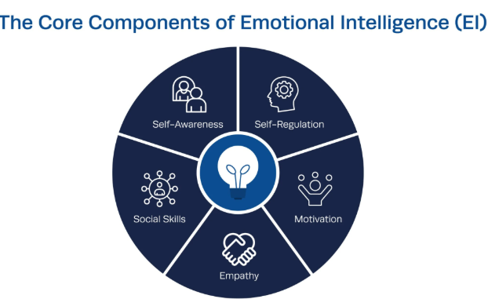
Source: Reproduced from Schofield (2025), Institute of Project Management.
The five components enable leaders to recognise their emotional responses, regulate behaviour, remain motivated, understand employees’ perspectives and manage workplace relationships constructively (Goleman, 1998).
Self-awareness allows a manager to recognise when frustration is producing defensive communication; self-regulation supports calm responses during conflict. Motivation encourages persistence, while empathy helps leaders understand different employee circumstances. Social skills convert these capabilities into listening, influence, feedback and conflict resolution. These behaviours can cascade through the department because employees observe the emotional standards modelled by leaders (Goleman, Boyatzis and McKee, 2002).
The framework is accessible for leadership development and appraisal, and EI is positively related to leadership effectiveness (Miao, Humphrey and Qian, 2018). However, it combines abilities, personality, motivation and social behaviour, making measurement less precise (Mayer, Roberts and Barsade, 2008). Motivation must also not be disguised as excessive workloads, while empathy requires boundaries to prevent inconsistent decisions. The SMT should therefore use Goleman for coaching and behavioural standards rather than as an exact intelligence test.
Communication illustrates its practical value. A self-aware leader notices personal assumptions, empathy encourages attention to an employee's perspective, and social skills support clear feedback. Yet emotionally skilled behaviour can be used manipulatively when influence serves personal rather than organisational interests. Ethical standards are therefore essential: empathy should improve fairness and understanding, not enable leaders to conceal unpopular decisions or manufacture agreement. Multi-source feedback can help distinguish genuine behavioural development from confident self-presentation.
2.4 Bar-On's Emotional-Social Intelligence Model
Bar-On (2006) defines EI in terms of intrapersonal competence, interpersonal competence, adaptability, stress management and general mood. As Figure 3 indicates, the model extends beyond emotional reasoning towards resilience and social functioning. Adaptability and reality testing support organisational change; stress tolerance and impulse control aid measured leadership under pressure; and interpersonal skills strengthen empathy and collaboration. Bar-On’s model is highly applicable to the scenario’s focus on psychological well-being.
However, its breadth overlaps with personality, optimism and general well-being, while self-report responses may be distorted by limited self-awareness or social-desirability bias. It should therefore guide the development of resilience and well-being but should not independently determine selection decisions. Figure 3 below presents the five domains and their principal emotional-social competencies. This approach balances employee well-being with organisational accountability
Figure 3. Bar-On’s Five Domains of Emotional-Social Intelligence.
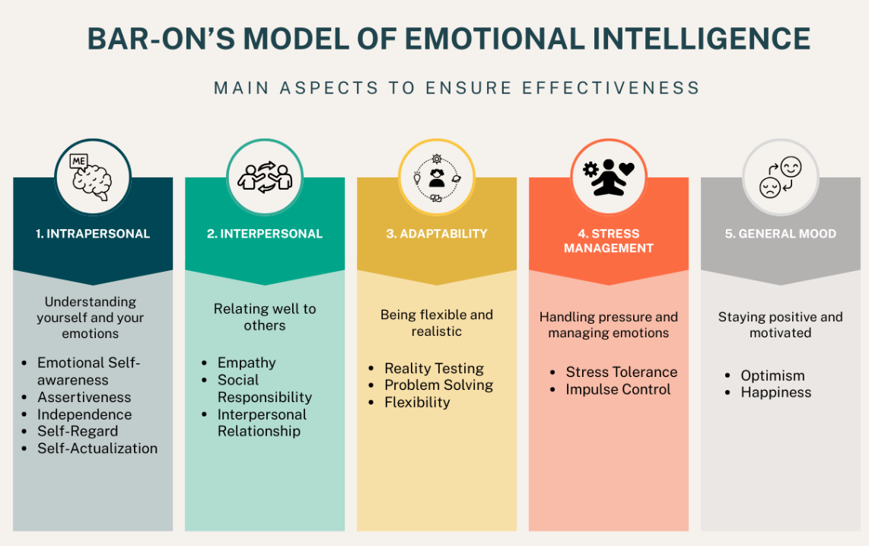
Source: Reproduced from My Courses Editor (2025), based on Bar-On’s Emotional-Social Intelligence Model.

2.5 Mindfulness in the Workplace

2.5.1 Mindfulness and Emotional Intelligence
Mindfulness involves deliberate, present-centred and non-judgemental awareness (Kabat-Zinn, 2003). Langer (1989) additionally emphasises openness to novelty and context. According to Lippincott (2017), mindfulness strengthens emotional self-awareness and enables leaders to recognise how emotions influence their behaviour and workplace relationships. emotional, balance, social awareness and relationship management.
Figure 4 below illustrates how mindfulness connects self-awareness,
Figure 4. Mindfulness and Emotional Regulation
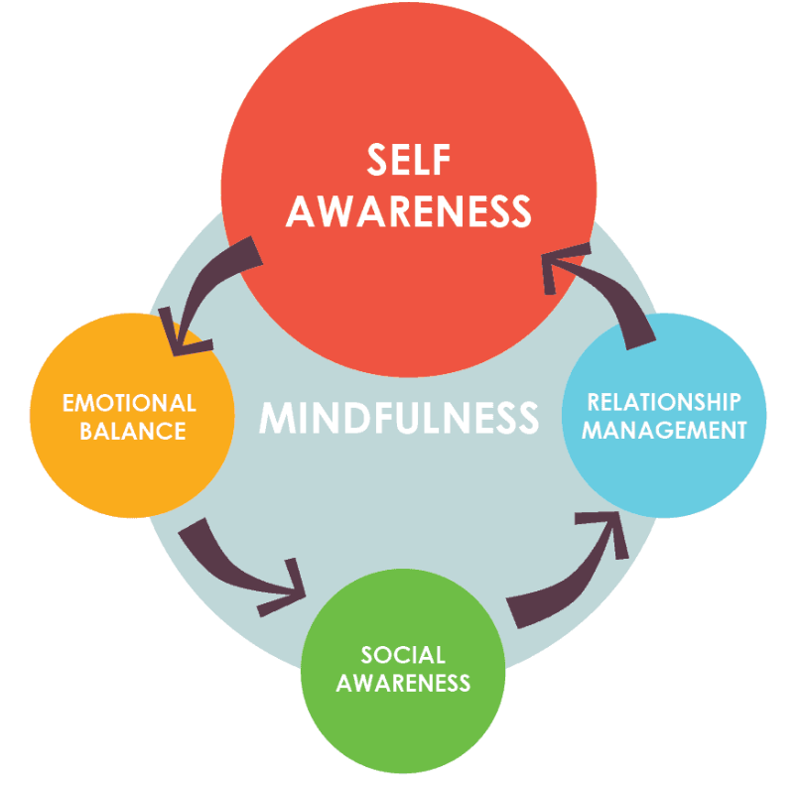
Source: Reproduced from Lippincott (2017), Key Step Media.
During a disagreement, a manager can notice frustration, pause, and choose constructive language. This reinforces Mayer and Salovey's emotion management, Goleman's self-regulation and Bar-On's impulse control. Workplace mindfulness is associated with lower emotional exhaustion and higher job satisfaction (Hülsheger et al., 2013), and broader reviews identify benefits for attention, cognition and interpersonal behaviour (Good et al., 2016).
Nevertheless, mindfulness must not individualise structural problems such as discrimination, understaffing or unreasonable workloads. It is most credible when voluntary practice is combined with supportive management and fair working conditions

2.5.2 Mindfulness, EI and Workplace Application
Figure 5 below synthesises evidence concerning how mindfulness may support emotional recognition, self-regulation, empathy, resilience and employee well-being within emotionally demanding workplace environments (Jiménez-Picón et al., 2021).

Figure 5. Mindfulness, Emotional Intelligence and Workplace Application
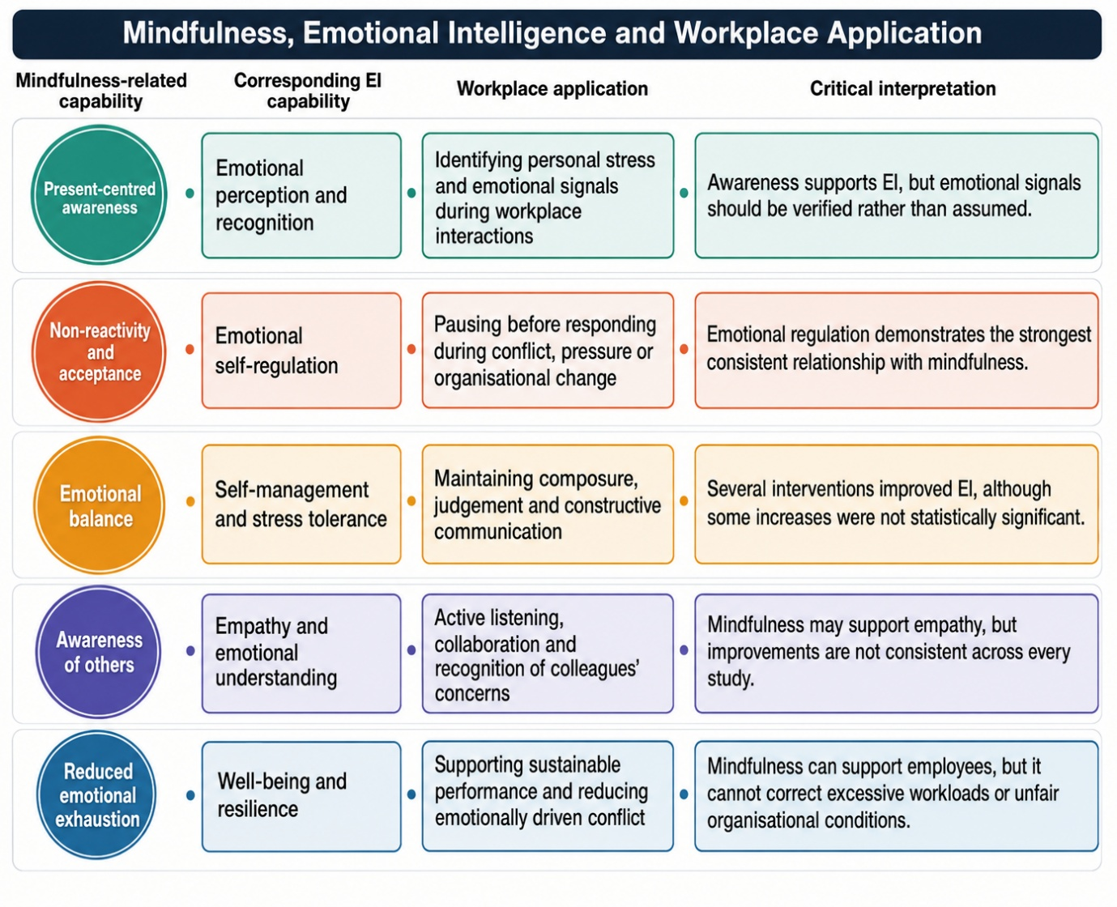
Source: Author’s synthesis of findings reported by Jiménez-Picón et al. (2021, Table 2).
The evidence summarised in Figure 5 indicates a predominantly positive relationship between mindfulness and EI, particularly emotional regulation. However, the reviewed studies were concentrated within healthcare settings and used different measurement instruments and intervention durations. Therefore, their findings should be applied cautiously within wider organisational contexts rather than treated as universally applicable (Jiménez-Picón et al., 2021).

2.5.3 Practical Implementation
Implementation also requires realistic expectations. A short breathing pause before complex discussions may be more accessible than compulsory meditation. Managers could begin meetings with one minute for participants to review objectives and notice emotional reactions, then use reflective questions after decisions. Brown and Ryan (2003) associate
mindful awareness with well-being, but individual preferences and cultural interpretations may be varied. Participation should be voluntary, confidential and separated from performance assessment to protect psychological safety.

2.6 Critical Evaluation of Emotional Intelligence Models
The table below compares the principal strengths, limitations and organisational applications of each emotional intelligence model.
Table 1. Critical Comparison of Emotional Intelligence Models
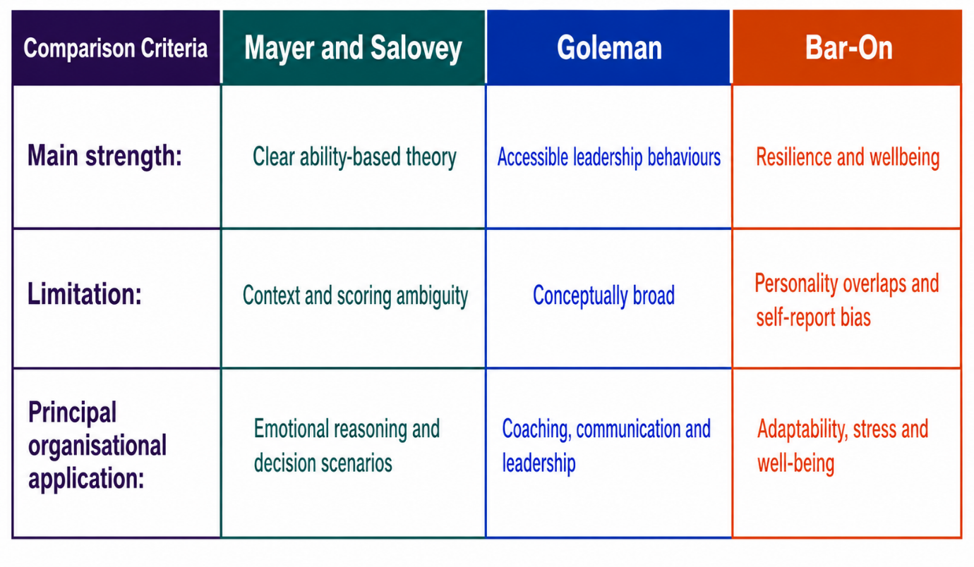
Source: Author’s synthesis, informed by Mayer and Salovey (1997), Goleman (1998) and Bar-On (2006).
No model fully explains workplace behaviour. Mayer and Salovey offer the strongest scientific foundation, Goleman the clearest leadership application, and Bar-On the broadest contribution to well-being. When combined carefully, the models explain how leaders recognise emotion, regulate behaviour, communicate, resolve conflict and remain adaptable. Conflict itself is not necessarily harmful: task disagreement may expose operational weaknesses, but unmanaged emotion can turn it into relationship conflict. EI helps leaders distinguish these forms and facilitate evidence-based solutions.
2.7 Analysis of Emotional Intelligence in Communication, Conflict Management, Leadership and Decision Making

2.7.1 Effective Communication
Effective communication depends on recognising spoken content and emotional signals. Mayer and Salovey’s perception and understanding branches help managers detect anxiety or frustration, while Goleman’s empathy and social skills support active listening, feedback and explanation. Bar-On’s interpersonal competence and impulse control enable respectful dialogue under pressure. However, emotional interpretations should be verified through questions rather than treated as facts. Effective communication therefore combines emotional awareness, active listening and clarification to ensure that workplace messages are understood accurately and respectfully (Coronado-Maldonado and Benítez-Márquez, 2023).

2.7.2 Conflict Management
Conflict management requires regulation rather than avoidance. Mayer and Salovey’s emotion-management branch help employees prevent escalation. Goleman’s self-regulation and empathy facilitate recognition of competing perspectives, while Bar-On’s stress tolerance supports composure. Effective leaders distinguish constructive task disagreement from damaging relational conflict, since suppressing challenges may restrict learning. Mindful pauses create opportunities for evidence-based discussion. However, fair procedures remain essential when misconduct or unequal power dynamics influence the dispute.

2.7.3 Leadership

Leadership integrates these capabilities by demonstrating calmness, accessibility, and ethical influence. Goleman’s framework provides a clear behavioural application, whereas Mayer and Salovey elucidate the emotional reasoning underlying leadership responses. Bar-On emphasises adaptability under pressure. The Management by Walking About approach can enhance trust when leaders actively listen and respond to concerns (Wietrak and Gifford, 2024); however, it may be perceived as intrusive if implemented as a form of surveillance. The effectiveness of leadership should be evaluated using employee feedback, observed behaviours, and measurable outcomes, rather than relying solely on self-reported emotional intelligence.

2.7.4 Decision-Making
Effective decision-making requires balance. Emotion can highlight risks, injustice or low morale, while analysis determines if these concerns are evidence-based. Leaders should empathise with employees in difficulty but maintain consistent standards, considering possible adjustments and support. Emotionally intelligent decisions combine perspective-taking, facts, ethical responsibilities and clear communication, which can improve acceptance even if the outcome is unpopular.
Task 2
3.0 Managing a Multigenerational Workforce
3.1 Generational Context

A multigenerational workforce can combine institutional experience with emerging technical knowledge, improving mentoring, innovation and organisational learning. It may also lead to misunderstandings when communication and career expectations differ. However, generational labels are imprecise: apparent differences may reflect age, career stage, economic conditions or tenure rather than shared birth-period characteristics. (Rudolph et al., 2021). Managers must therefore use categories as a tentative context rather than predictive stereotypes.

3.2 Generations X, Y and Z

Table 2 below synthesises the indicative values, communication, motivation and technological experiences associated with Generations X, Y and Z. However, individuals within each generation may differ considerably (Rudolph et al., 2021).
Table 2. Indicative Workplace Characteristics of Generations X, Y and Z
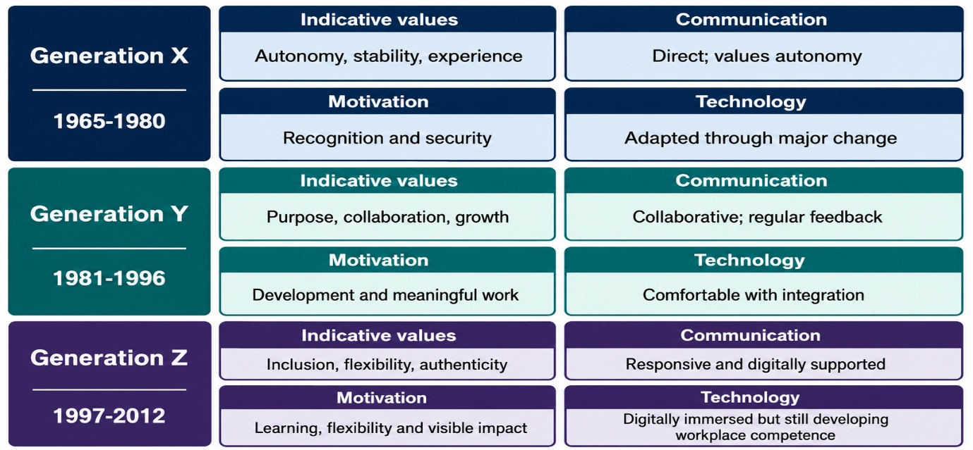
Source: Author’s synthesis, informed by Schroth (2019), Machová et al. (2020), Gabrielova and Buchko (2021) and Rudolph et al. (2021).

3.2.1 Generation X: 1965–1980
Generation X may value independence, direct communication and work-life balance. Its members can contribute organisational memory and mentoring, but managers should not assume technological resistance, as many have adapted to successive digital changes (Machová et al., 2020). EI supports recognition of experience without over-supervision.

3.2.2 Generation Y: 1981–1996
Generation Y, or Millennials, is often associated with collaboration, meaningful work and feedback (Gabrielova and Buchko, 2021). Coaching and project responsibility may support advancement, although loyalty is also influenced by pay, workload and leadership rather than generation alone.

3.2.3 Generation Z: 1997–2012
Adult members of Generation Z entered the workforce amid smartphones, rapid information flows, and strong public discussion of inclusion. They may expect responsive communication, technological efficiency and visible development (Schroth, 2019). Digital fluency does not equate to full occupational competence; structured onboarding, mentoring, and cultural explanation remain necessary. Evidence of small generational differences and considerable within-group variation further cautions against age-based assumptions (Rudolph et al., 2021).

3.2.4 Comparative Organisational Impact of X, Y, Z
These differences can positively influence organisational effectiveness. Generation X may preserve organisational memory, Generation Y may connect established practice with collaborative change, and Generation Z may question inefficient digital processes. When knowledge is shared respectfully, mixed-age teams can combine experience, adaptability and innovation. The same diversity can become negative when direct communication is interpreted as inflexibility, frequent feedback as dependency, or digital brevity as disrespect. EI enables managers to test these interpretations before attributing behaviour to attitude or age.

3.3 Recruitment, Retention and Inclusive Leadership

3.3.1 Recruitment

Emotionally intelligent recruitment requires awareness of age bias and inclusive communication. Job descriptions should avoid age-coded terms such as ‘digital native’, explain development and flexibility clearly, and use structured scoring. Scenario questions may assess listening, conflict and judgement, but EI self-report measures should not independently determine appointments because different instruments measure different constructs (O’Connor et al., 2019; Rudolph et al., 2021).

3.3.2 Retention
Retention requires a flexible employee value proposition. Generation X may value autonomy and recognition; Generation Y coaching and advancement; and Generation Z structured learning and inclusion. These remain indicative preferences rather than fixed traits. Fair pay, manageable workloads, respectful leadership and individual development conversations remain important across generations (Gabrielova and Buchko, 2021).
Indicative cross-generational learning modalities and adaptable training interventions are presented in Appendix A1.

3.3.3 Inclusive Leadership
Inclusive leadership establishes shared standards while adapting communication fairly. Mayer and Salovey support emotional interpretation; Goleman contributes empathy and relationship management; and Bar-On adds adaptability and stress tolerance. Managers should verify preferences, document decisions and provide comparable access to support. This application may convert generational diversity into complementary knowledge rather than conflict (Gerhardt, Bauwens and van Woerkom, 2026).
Figure 6 below demonstrates how positive employee experience, collaborative working and compassionate leadership can strengthen workforce attraction and retention (NHS Employers, 2023).
Figure 6. Employee Experience, Workforce Attraction and Retention
Figure 6 demonstrates how inclusive leadership, positive employee experiences and collaborative cultures strengthen workforce attraction, engagement and sustainable retention outcomes.

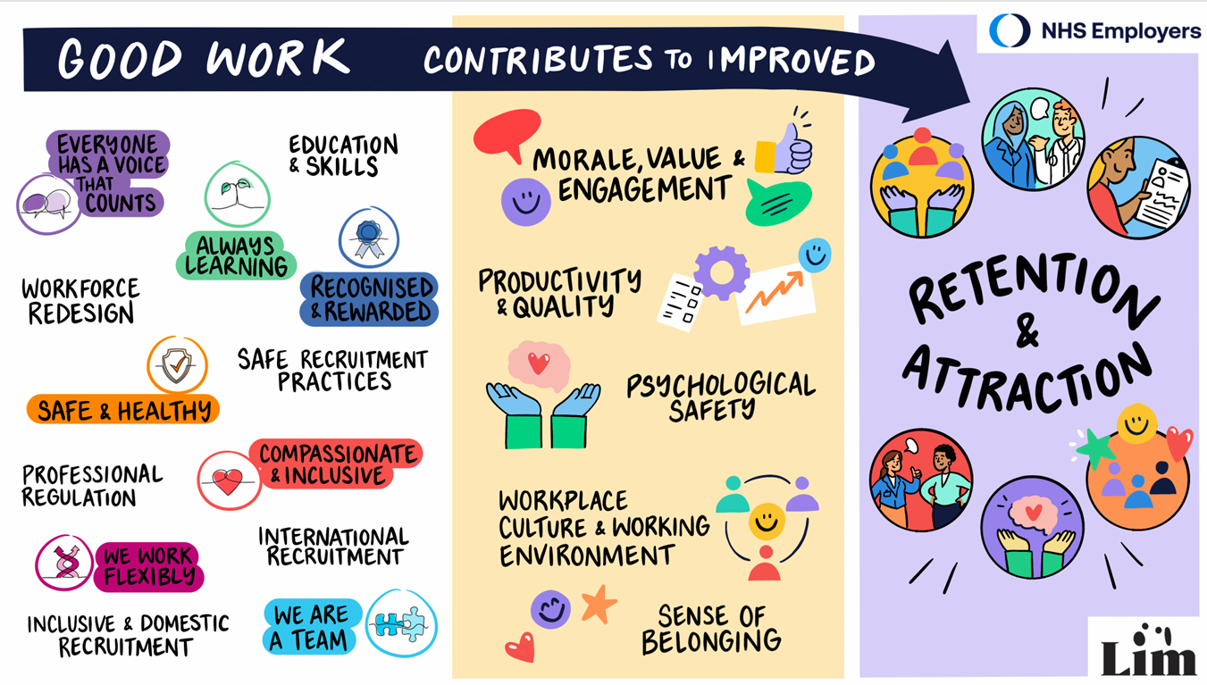
Source: Reproduced from NHS Employers (2023, p. 1).
Although developed within an NHS context, the model demonstrates that recruitment and retention are interconnected outcomes influenced by inclusive leadership, development opportunities and employees’ everyday workplace experiences. Its wider organisational implications include:
- Inclusive leadership strengthening trust, belonging and retention.
- Collaborative cultures supporting engagement and employee experience.
- Development opportunities improving workforce attraction and commitment

3.4 Mindfulness and Recommendations for the SMT

3.4.1 Mindfulness Across Generations
Mindfulness helps employees pause and question assumptions during intergenerational disagreement (Eby et al., 2019). A concise digital message may appear efficient to one employee but disrespectful to another; mindful listening clarifies intent before conflict escalates. Formal practice should remain voluntary and culturally sensitive. Nevertheless, EI and mindfulness cannot replace fair workloads, anti-discrimination procedures or accountable management.

3.4.2 SMT Recommendations
The SMT should:
- Provide quarterly EI development, monthly reflective discussions and management coaching.
- Train recruiters in age bias, structured selection and cross-generational mentoring.
- Review climate, retention, grievances, absence, development and recruitment annually.
These measures should be incorporated within appraisal and psychological-safety expectations rather than treated as isolated training (Edmondson, 2019).

3.4.3 Cultural-Change Connection
Cultural transformation requires continuous feedback, review and adjustment. Leadership behaviour, organisational climate and fair management strengthen trust and psychological safety (Wietrak and Gifford, 2024). Accordingly, EI and mindfulness should be embedded within listening, reflective meetings, collaborative problem-solving and proportionate conflict responses. Evaluating observable practices rather than aspirational values enables the SMT to assess whether change is experienced consistently and implemented with integrity across generations (CIPD, 2022).

3.4.4 Pilot Implementation and Evaluation
A six-month departmental pilot should establish baseline data and provide monthly discussions, confidential coaching and accessible participation. At three and six months, the SMT should compare behavioural feedback, retention, absence and conflict indicators against baseline results. Unintended effects should inform adaptation before organisational rollout.

3.4.5 Long-Term Cultural Embedding
Senior leaders should model emotionally intelligent behaviour (Northouse, 2022). Recruitment, induction, appraisal and promotion should assess observable listening, regulation and inclusive decision-making. Developmental feedback and transparent annual reporting would strengthen credibility and redirect resources where outcomes remain limited. Supporting psychological-safety and retention indicators are provided in Appendix A2.
4.0 Gibbs Reflective Cycle
Figure 7. Gibbs’ Reflective Cycle
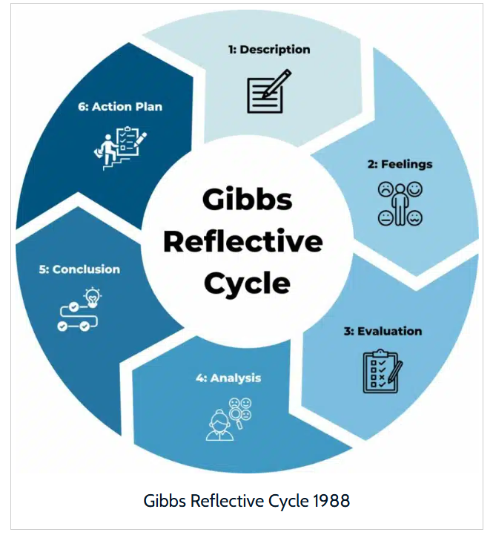
Gibbs’ (1988) cycle structures reflection through description, feelings, evaluation, analysis, conclusion and action planning. Although Hashim et al. (2023) demonstrate its continuing value, its linear sequence may simplify interactions between emotion, context and relationships. It should therefore guide, rather than constrain, critical reflection. Contemporary EI research similarly frames emotional capability as relational and embedded within leadership, group learning and performance (Gerhardt, Bauwens and van Woerkom, 2026).
Leadership across football response management, university groups and peer mentoring required clear communication, conflict management and proportionate action under pressure. Although rapid judgement occasionally emerged, recognising emotional signals and remaining calm produced safer responses. Reflection identified growth in situational awareness, empathy and resilient decision-making, while revealing a tendency to become overly task focused. Mayer and Salovey explain emotional perception, Goleman clarifies regulation and empathy, and Bar-On contributes stress tolerance. Future debriefings, feedback and learning records will evaluate communication and conflict outcomes, ensuring that professional confidence is supported by evidence, procedural integrity and continuous development.

5.0 Key Takeaways
EI and mindfulness are complementary rather than identical. Mayer and Salovey explain emotional ability, Goleman provides leadership competencies and Bar-On emphasises resilience and well-being (Mayer and Salovey, 1997; Goleman, 1998; Bar-On, 2006). Collectively, they may strengthen communication, conflict management, decision-making and psychological safety, but cannot replace competence, ethical judgement or fair systems. Inclusive implementation therefore requires individualised communication, cultural integration and measurable evaluation.

6.0 Conclusion
In conclusion, EI and mindfulness can strengthen performance, collaboration, well-being and leadership by supporting emotional awareness, regulation and considered responses. Mayer and Salovey provide an ability-based foundation, Goleman translates EI into workplace behaviour, and Bar-On extends its application to adaptability and stress management. However, conceptual overlap, measurement limitations and organisational context prevent EI from becoming a universal solution. Generations X, Y and Z may exhibit indicative differences in communication, motivation and technological experience, but individual variation makes stereotyping unreliable. Inclusive leadership must therefore combine equitable standards with verified personal preferences.
The SMT should incorporate EI and mindfulness into recruitment, mentoring, appraisal and leadership development, supported by accountable policies and measurable outcomes. Ultimately, resilient organisational transformation depends upon leaders preserving empathy, integrity and meaningful dialogue while using artificial intelligence, technology and innovation responsibly across a multigenerational workforce. Ultimately, the evolution of emotional intelligence offers a vision for human-centred workplaces and responsible technological innovation, uniting past and present generations through empathy, resilience and inclusive leadership worldwide. Moreover, emotional intelligence can shape inclusive organisational cultures and strengthen workplace communities worldwide.

7.0 Full Harvard Reference List
Ashkanasy, N.M. and Dorris, A.D. (2017) ‘Emotions in the workplace’, Annual Review of Organizational Psychology and Organizational Behavior, 4, pp. 67–90.
Bar-On, R. (2006) ‘The Bar-On model of emotional-social intelligence (ESI)’, Psicothema, 18(Suppl.), pp. 13–25.
Brough, P., Troth, A., Radford, K., Meissner, E., Gai, S., Langerud, D. and Rose, M. (2023) Multi-generational workplaces research: Final report. Brisbane: Griffith University. Available at: https://www.dewr.gov.au/download/15815/multi-generational-workplaces-research-final-report/35289/multi-generational-workplaces-research-final-report/pdf (Accessed: 24 July 2026).
Brown, K.W. and Ryan, R.M. (2003) ‘The benefits of being present: Mindfulness and its role in psychological well-being’, Journal of Personality and Social Psychology, 84(4), pp. 822–848.
BusinessBalls (n.d.) ‘Emotional and social intelligence: theories and models’. Available at: https://www.businessballs.com/self-awareness/main-theories-of-emotional-and-social-intelligence-esi/ (Accessed: 26 July 2026).
Chartered Institute of Personnel and Development (CIPD) (2022) Organisational culture and climate: An evidence review. London: CIPD. Available at: https://www.cipd.org/uk/knowledge/evidence-reviews/evidence-culture-climate/ (Accessed: 20 July 2026).
Coronado-Maldonado, I. and Benítez-Márquez, M.D. (2023) ‘Emotional intelligence, leadership, and work teams: A hybrid literature review’, Heliyon, 9(10), article e20356. Available at: https://doi.org/10.1016/j.heliyon.2023.e20356 (Accessed: 21 July 2026).
Côté, S. (2014) ‘Emotional intelligence in organizations’, Annual Review of Organizational Psychology and Organizational Behavior, 1, pp. 459–488.
Eby, L.T., Allen, T.D., Conley, K.M., Williamson, R.L., Henderson, T.G. and Mancini, V.S. (2019) ‘Mindfulness-based training interventions for employees: A qualitative review of the literature’, Human Resource Management Review, 29(2), pp. 156–178. Available at: https://doi.org/10.1016/j.hrmr.2017.03.004.
Edmondson, A.C. (1999) ‘Psychological safety and learning behavior in work teams’, Administrative Science Quarterly, 44(2), pp. 350–383.
Edmondson, A.C. (2019) The Fearless Organization: Creating Psychological Safety in the Workplace for Learning, Innovation, and Growth. Hoboken, NJ: Wiley.
Gabrielova, K. and Buchko, A.A. (2021) ‘Here comes Generation Z: Millennials as managers’, Business Horizons, 64(4), pp. 489–499. Available at: https://doi.org/10.1016/j.bushor.2021.02.013.
Gerhardt, K., Bauwens, R. and van Woerkom, M. (2026) ‘Emotional intelligence and leader outcomes: A comprehensive review and roadmap for future inquiry’, Human Resource Development Review, 25(1), pp. 29–79. Available at: https://doi.org/10.1177/15344843251342689.
Gibbs, G. (1988) Learning by Doing: A Guide to Teaching and Learning Methods. Oxford: Further Education Unit, Oxford Polytechnic.
Goleman, D. (1998) Working with Emotional Intelligence. New York: Bantam Books.
Goleman, D., Boyatzis, R. and McKee, A. (2002) Primal Leadership: Realizing the Power of Emotional Intelligence. Boston, MA: Harvard Business School Press.
Good, D.J., Lyddy, C.J., Glomb, T.M., Bono, J.E., Brown, K.W., Duffy, M.K., Baer, R.A., Brewer, J.A. and Lazar, S.W. (2016) ‘Contemplating mindfulness at work’, Journal of Management, 42(1), pp. 114–142.
Hashim, S.N.A., Yaacob, A., Suryani, I., Mohd Asraf, R., Bahador, Z. and Supian, N. (2023) ‘Exploring the use of Gibbs’ reflective model in enhancing in-service ESL teachers’ reflective writing’, Arab World English Journal, 14(2), pp. 236–253. Available at: https://doi.org/10.24093/awej/vol14no2.17.
Hülsheger, U.R., Alberts, H.J.E.M., Feinholdt, A. and Lang, J.W.B. (2013) ‘Benefits of mindfulness at work: The role of mindfulness in emotion regulation, emotional exhaustion, and job satisfaction’, Journal of Applied Psychology, 98(2), pp. 310–325.
Jiménez-Picón, N., Romero-Martín, M., Ponce-Blandón, J.A., Ramirez-Baena, L., Palomo-Lara, J.C. and Gómez-Salgado, J. (2021) ‘The relationship between mindfulness and emotional intelligence as a protective factor for healthcare professionals: A systematic review’, International Journal of Environmental Research and Public Health, 18(10), article 5491. Available at: https://doi.org/10.3390/ijerph18105491 (Accessed: 24 July 2026).
Joseph, D.L. and Newman, D.A. (2010) ‘Emotional intelligence: An integrative meta-analysis and cascading model’, Journal of Applied Psychology, 95(1), pp. 54–78.
Kabat-Zinn, J. (2003) ‘Mindfulness-based interventions in context: Past, present, and future’, Clinical Psychology: Science and Practice, 10(2), pp. 144–156.
Langer, E.J. (1989) Mindfulness. Reading, MA: Addison-Wesley.
Lippincott, M. (2017) ‘Mindful self-awareness as the basis for effective leadership’, Key Step Media, 31 January. Available at: https://www.keystepmedia.com/mindful-self-awareness-leadership-research/ (Accessed: 26 July 2026).
Machová, R., Zsigmond, T., Lazányi, K. and Krepszová, V. (2020) ‘Generations and emotional intelligence: A pilot study’, Acta Polytechnica Hungarica, 17(5), pp. 229–247. Available at: https://doi.org/10.12700/APH.17.5.2020.5.12.
Mayer, J.D. and Salovey, P. (1997) ‘What is emotional intelligence?’, in Salovey, P. and Sluyter, D.J. (eds.) Emotional Development and Emotional Intelligence: Educational Implications. New York: Basic Books, pp. 3–31.
Mayer, J.D., Roberts, R.D. and Barsade, S.G. (2008) ‘Human abilities: Emotional intelligence’, Annual Review of Psychology, 59, pp. 507–536.
Miao, C., Humphrey, R.H. and Qian, S. (2018) ‘A cross-cultural meta-analysis of how leader emotional intelligence influences subordinate task performance and organizational citizenship behavior’, Journal of World Business, 53(4), pp. 463–474.
My Courses Editor (2025) ‘In Bar-On’s model, what does the domain of empathy refer to?’, My Courses, 6 August. Available at: https://mycourses.co.za/in-bar-ons-model-what-does-the-domain-of-empathy-refer-to/ (Accessed: 26 July 2026).
Newman, A., Donohue, R. and Eva, N. (2017) ‘Psychological safety: A systematic review of the literature’, Human Resource Management Review, 27(3), pp. 521–535.
NHS Employers (2023) ‘Retention and attraction: a visual model’, 5 December. Available at: https://www.nhsemployers.org/articles/retention-and-attraction-visual-model (Accessed: 26 July 2026).
Northouse, P.G. (2022) Leadership: Theory and Practice. 9th edn. Thousand Oaks, CA: SAGE.
O’Boyle, E.H., Humphrey, R.H., Pollack, J.M., Hawver, T.H. and Story, P.A. (2011) ‘The relation between emotional intelligence and job performance: A meta-analysis’, Journal of Organizational Behavior, 32(5), pp. 788–818.
O’Connor, P.J., Hill, A., Kaya, M. and Martin, B. (2019) ‘The measurement of emotional intelligence: A critical review of the literature and recommendations for researchers and practitioners’, Frontiers in Psychology, 10, article 1116. Available at: https://doi.org/10.3389/fpsyg.2019.01116.
Roberts, R.D., MacCann, C. and Matthews, G. (2010) ‘Should emotional intelligence be included within personality space?’, Emotion Review, 2(4), pp. 318–326.
Rudolph, C.W., Rauvola, R.S., Costanza, D.P. and Zacher, H. (2021) ‘Generations and generational differences: Debunking myths in organizational science and practice and paving new paths forward’, Journal of Business and Psychology, 36, pp. 945–967. Available at: https://doi.org/10.1007/s10869-020-09715-2.
Salovey, P. and Mayer, J.D. (1990) ‘Emotional intelligence’, Imagination, Cognition and Personality, 9(3), pp. 185–211.
Schofield, B. (2025) ‘Emotional intelligence for effective project leadership’, Institute of Project Management, 8 October. Available at: https://projectmanagement.ie/blog/emotional-intelligence-for-effective-project-leadership/ (Accessed: 26 July 2026).
Schroth, H. (2019) ‘Are you ready for Gen Z in the workplace?’, California Management Review, 61(3), pp. 5–18.Wietrak, E. and Gifford, J. (2024) Trust and psychological safety: An evidence review—Practice summary and recommendations. London: Chartered Institute of Personnel and
Development. Available at: https://www.cipd.org/globalassets/media/knowledge/knowledge-hub/evidence-reviews/2024-pdfs/8542-psych-safety-trust-practice-summary.pdf (Accessed: 24 July 2026)

Appendices

Appendix A1: Cross-Generational Learning and Multigenerational Effectiveness

A1.1 Cross-Generational Learning Interventions and Organisational Enablers
Table A1.1. Indicative Cross-Generational Learning Interventions
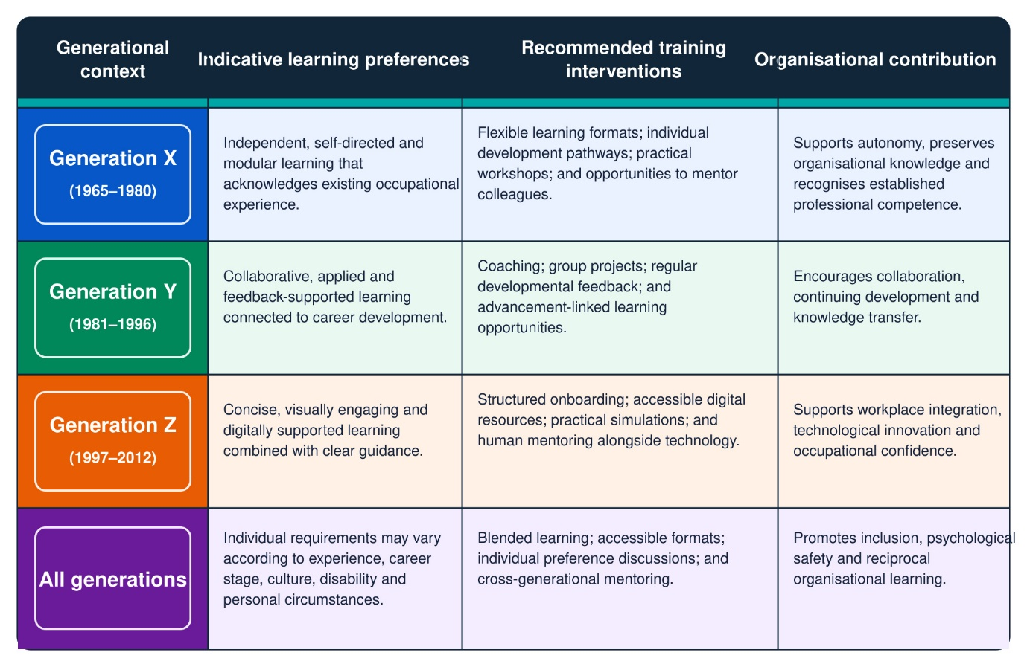
Source: Author’s synthesis, informed by Gabrielova and Buchko (2021) and Rudolph et al. (2021).
The learning options presented in Table A1.1 are indicative rather than prescriptive. Managers should assess learning requirements individually because occupational experience, career stage and personal circumstances may be more influential than generational membership. Applying these categories rigidly could reinforce stereotypes and weaken inclusive development practices (Rudolph et al., 2021).
Figure A1.1 below illustrates that positive and productive multigenerational workplaces are supported by interconnected factors, including mentoring, communication, leadership training, employee well-being and age-diversity awareness (Brough et al., 2023).
Figure A1.1. Characteristics of Positive and Productive Multigenerational Workplace
Figure A1.1 below illustrates that positive and productive multigenerational workplaces are supported by interconnected factors, including mentoring, communication, leadership training, employee well-being and age-diversity awareness practices (Brough et al., 2023).

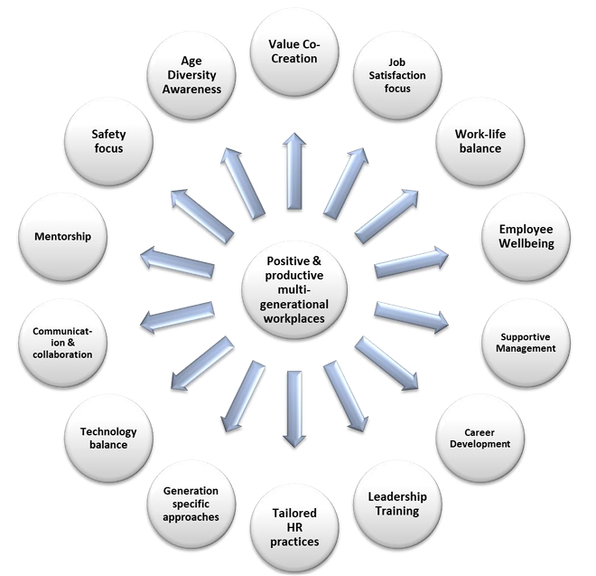
Source: Reproduced from Brough et al. (2023, p. 21).
Figure A1.1 also demonstrates that training in isolation is insufficient to secure multigenerational effectiveness. Learning interventions require supportive management, employee well-being, communication, technological balance and tailored HR practices. Therefore, these interconnected organisational factors enable knowledge exchange, inclusion and collaboration across age-diverse teams. However, generation-specific approaches should remain flexible because employees’ requirements may be shaped more strongly by experience, career stage and personal circumstances than by generational membership. Ultimately, sustainable multigenerational effectiveness depends upon organisations evaluating individual requirements while providing equitable opportunities for learning, mentoring and professional development.

A1.2 Evaluating Cross-Generational Knowledge Transfer
Cross-generational development should be evaluated through workplace application rather than participation alone. Productive multigenerational working depends upon learning, supportive management and equitable development opportunities (Brough et al., 2023).
- Use reciprocal mentoring so that occupational and technological knowledge move in both directions.
- Review observable knowledge transfer after three and six months.
- Audit participation across career stages, disabilities and working arrangements.
- Combine completion data with employee feedback and demonstrated behavioural change.
- Increased participation does not automatically demonstrate effective learning. Evaluation should determine whether mentoring improves confidence, cooperation and practical knowledge without reinforcing generational stereotypes (Rudolph et al., 2021).

Appendix A2: Organisational Drivers and Evaluation of Psychological Safety

A2.1 Psychological Safety and Strategic Retention Indicators.
Evaluation should combine employee voice and reporting confidence with turnover, absence and grievance data. Comparing findings across employee groups and against baseline evidence can expose hidden inequalities while preventing unsupported claims that improvements resulted solely from EI or mindfulness interventions (Newman, Donohue and Eva, 2017).

Table A2.1 below presents complementary indicators through which the SMT can evaluate psychological safety, employee retention and leadership behaviour.

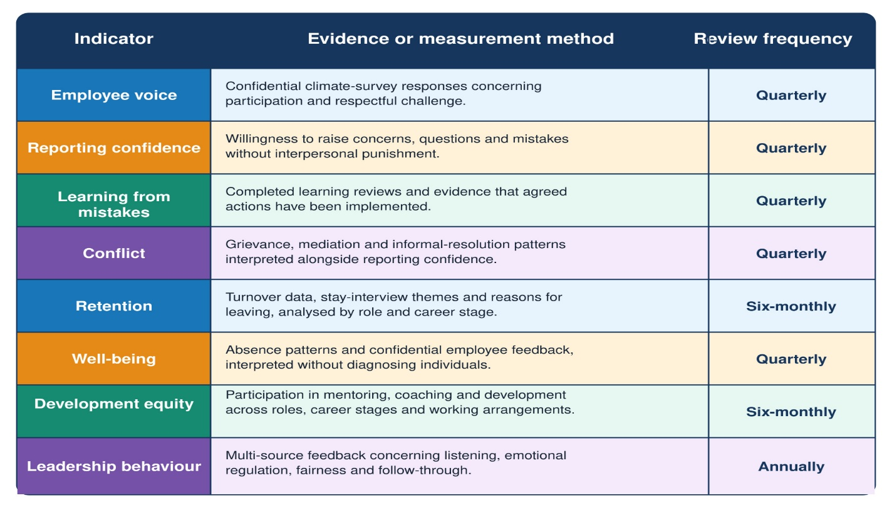
Source: Reproduced from Wietrak and Gifford (2024, p. 17).

A2.2 Organisational Drivers of Psychological Safety.
Table A2.1 should be interpreted collectively because reduced grievances may indicate either healthier relationships or declining reporting confidence. The SMT should therefore triangulate confidential feedback with workforce data and observed leadership behaviour when evaluating EI and mindfulness interventions.

Figure A2.1 below illustrates how organisational climate, leadership, fairness, conflict management and team-building influence trust and psychological safety, which subsequently affect employee attitudes, team dynamics, learning and organisational performance

Figure A2.1. Workplace Influences and Outcomes Trust and Psychological Safety

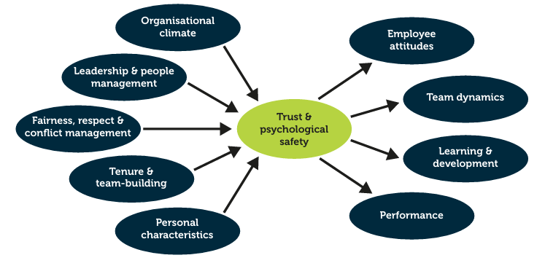

Source: Reproduced from Wietrak and Gifford (2024, p. 17).
Figure A2.1 demonstrates that psychological safety is influenced by organisational and interpersonal conditions rather than individual emotional capability alone. Emotionally intelligent leadership may support these conditions through empathy, self-regulation, respectful communication and proportionate conflict management, while mindfulness can encourage considered responses. Ultimately, the SMT should evaluate both the drivers and
outcomes of psychological safety to determine whether leadership interventions produce sustainable improvements in employee voice, learning, performance and retention.

A2.3 Psychological-Safety Intervention Thresholds
Psychological safety requires confidence to question, report mistakes and challenge decisions respectfully; it does not mean avoiding accountability or disagreement (Edmondson, 1999; Newman, Donohue and Eva, 2017).
- Fewer grievances combined with lower reporting confidence should trigger a confidential investigation.
- Increased employee voice without management follow-through should prompt an action review.
- Declining well-being should initiate examination of workload and resources before additional EI training.
- Unequal experiences between employee groups should be explored through confidential consultation.
- Significant findings should be reviewed jointly by Human Resources, employee representatives and the SMT.
These thresholds prevent favourable statistics from being accepted without critical interpretation. They also distinguish psychologically safe challenge from silence, compliance or reduced confidence in organisational reporting systems (Wietrak and Gifford, 2024).
Collectively, Appendices A1 and A2 demonstrate that sustainable organisational development requires more than training participation or favourable workforce statistics. Equitable access to reciprocal learning should be supported by confidential employee voice, transparent leadership follow-through and evidence gathered over time. By connecting knowledge transfer with psychological-safety indicators, the SMT can identify unequal experiences, challenge generational assumptions and direct resources towards interventions that produce demonstrable improvements in inclusion, learning and organisational trust
Strategically, the two appendices enable the SMT to protect organisational knowledge while identifying early warning signs of workforce disengagement. This evidence can guide succession planning, resource allocation and timely organisational intervention.

