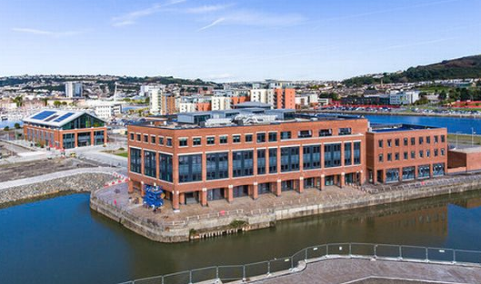

Name: James Cullen
Student Number: P151951
Module Name: Built Environment Services
Assignment Title: Renewable Energy Solutions for Building Services

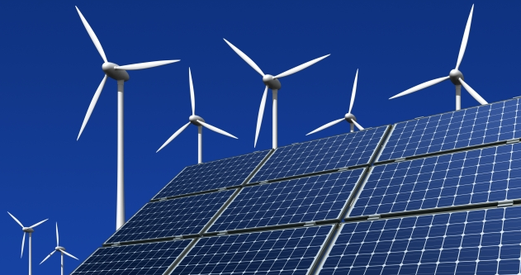
Contents

- Page 1 – Introduction

- Page 2 – Review of Options

- Page 3 – Solar Energy

- Page 5 – Case Study – Princess Royal Sports Arena

- Page 6 – Case Study – Clifton Lido

- Page 7 – Financial and usage analysis of Solar Energy

- Page 9 – Conclusion

- Page 10 – Evaluation

- Page 11 – List of Figures

- Page 12 – List of References

Introduction
Following the signing of the Kyoto Protocol in 2005, the UK has been obligated to reduce their Carbon emissions. This mantra was reinforced “in 2008 with the introduction of the historic Climate Change Act, setting an ambitious legally-binding target to reduce greenhouse gas emissions to 80% of 1990 levels by 2050 (Perry MP, 2018). Sources dispute the successfulness of the UK’s efforts so far, although there is a concerted drive for the country to reduce reliance on energy sources that contribute heavily to Carbon emissions as a by-product. One method of achieving this is the increased use of renewable, low Carbon energy production sources and their subsequent incorporation into architectural design of new developments.
This report will review one potential renewable energy source with a view of its integration into the latest stage of the University of Wales Trinity Saint David’s (UWTSD) SA1 campus – a single storey swimming pool and gymnasium complex. SA1 is situated in the City of Swansea in South Wales. The area is a former docklands site which has experienced extensive development and now houses several restaurants, bars, offices, residential complexes and the University Campus.

Review of options
There are a vast array of technologies and systems that can be utilised into construction projects that can provide green, renewable energy. Some of the options available will be described briefly and their relative suitability to UWTSD’s latest phase below:
- Biofuels and Biomass Boilers – Energy considered green and renewable obtained from burning of biological matter. On a large scale, the fuel needs to be sourced from timber, which would need to be bought in by the University. Small buildings could be powered by food waste, but this is unlikely to produce enough energy for the needs of the Swimming Pool and Gymnasium.

- Cogeneration – Involves the use of by-produced heat during other processes. While relevant to some industrial practices such as manufacturing and milling which produce excess heat, it is unlikely that activities taking place on a University campus would produce enough energy to make the cogeneration viable.

- Ground Source Heating and Cooling – Converts heat stored in the substrate to warm buildings during the colder periods and the lower temperatures present beneath ground to heat structures during summer. However, the previous land usage of the SA1 region indicates that these measure may not be reliable due to the disturbed ground layers and it is unlikely that such a large building and swimming pool could be fully heated using this method.

- Air Source Heat Pumping – Extracted heat from the surrounding environment is piped into building, primarily for small domestic or localised regions of larger buildings. This is unlikely to be capable of powering a large swimming pool and gymnasium complex. In addition “special planning permissions are required in Wales and Northern Ireland” (Green Match, 2018).

- District Heating and Cooling – Exploits heat produced from a large centralised source and transports it to multiple sources via underground piping systems. They often work in conjunction with large scale industrial operations, of which there are very few in close vicinity to the SA1 development.

- Wind Power and Wind Turbines – The coastal location of the SA1 campus is subject to wind all year round, so harnessing this wind power could be a viable option, although the winds could potentially be too erratic and strong to suit the turbines. Furthermore, turbines integrated onto buildings have received criticisms relating to their reliability, and “the need for high speeds is why we tend to make wind turbines as tall as possible” (Herrschaft, 2016), means they are an unlikely option for an integration into gymnasium.

Having reviewed the options, this report will focus on investigating the use of obtaining energy by converting solar energy for use in the proposed Swimming Pool and Gymnasium building.

Solar Energy
There is a vast array of products and technology available to harness solar radiation and convert it into useful energy for human use and there are several systems that could benefit the swimming pool and gymnasium development at SA1.
Solar Thermal Panels convert radiation from the directly into heated water for use, in pools and showers and as such could be a suitable option for the new complex. Panels named ‘collectors’ which contain tubes filled with water and other chemicals which optimise the incoming heat which is then passed through a cylinder, acting as a heat exchanger which increases the temperature of a water supply as per below:
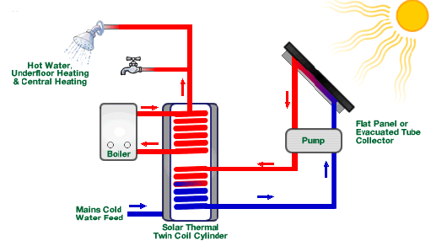
(Picture 3 – Diagram of a domestic Solar Thermal Panel configuration)

While usually mounted upon South facing roof’s, the panels can be mounted on walls or on the ground if more are required than the roof-space can cater for and can be used efficiently in colder, milder climates such as Swansea. Some sources claim that South Wales receives the perfect intensity solar radiation for the use of Thermal Panels.
While considered a reliable, ‘free’ form of hot water that could potentially be used in a swimming pool, they cannot be used as a stand- alone system as some form of power will be required to power the pump feeding the panels and the heating cylinder. Relatively cheap, the panels have a lifespan of roughly 20 years – “the general rule of thumb is that panels will degrade by about 1% each year (Lombardo, 2014) and can lead to large savings as efficiencies in the conversion of sunlight into heat waves rather than electricity can save money. A small arrangement on a domestic rooftop can produce up to 60% of a household’s annual hot water requirement.
Although Solar Thermal Panels are generally considered cheaper to buy and more efficient Photovoltaic panels, an option to also attach a small array of these could be a prudent one as these could provide the electricity required to power the pump. Roughly 72 Photovoltaic cells which each capture sunlight make up a panel constructed from a semi conductive material. When solar energy falls upon its surface, electrons are disturbed and manipulated by negatively and positively charged components causing them to flow. This produces current and direct electricity that can be used immediately or stored is transported via wires. The panels are unobtrusive and as such are likely to comply with the image of the University Campus and there is no limit to the amount of panels that can be utilised in one cluster, it is only space and cost dependant and can be accurately tailored to the energy requirements of the centre. In addition, the developers will have the ability to easily “add modules every few years as their energy usage and financial resources” (CET, 2019) dictate.
Albeit the exploitation of Solar Energy would be potentially be a cost effective, green option for use in conjunction with the new structures, as with all forms of energy generation, both Solar Thermal as well as Photovoltaic do share several disadvantages, primarily relating to cost. Efficiencies and technological advances are resulting in cost decreases, but the initial expenditure in relation to the number of panels required to heat and power a swimming pool and gymnasium complex will be significant. Additional expense is associated to the storage of power generated indicating that it is economically beneficial to use the energy instantaneously, which for the proposed centre, operating in normal hours, is likely to be the case anyway. Further outlay will be incurred from apparatus that will have to be installed alongside the panels, they “require not only Inverters but also storage batteries; thus increasing the investment cost” (Green, 2012).
Despite being considered ‘green’ and low Carbon emitting sources, various toxic substances are used in the manufacture of the panels which will present disposal issues when they have reached the end of their useful life. Research however is ongoing with aim of creating a more recyclable model in the near future. Furthermore, some Carbon discharge is related to the transportation and installation of the materials required to harness the solar energy, although this factor is not unique to these forms.

Case Studies

Princess Royal Sports Arena

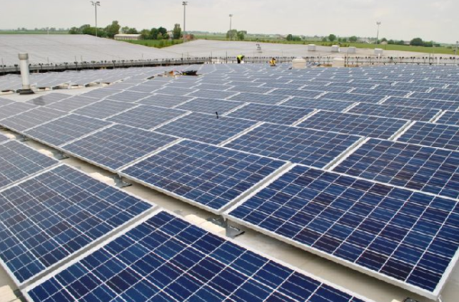
(Picture 4: view of PV panels at the Princess Royal Sports Arena)

Refurbished and retrofitted with 364 Photovoltaic Solar panels in 2015, the Princess Royal Arena in Boston, Lincolnshire houses a health spa and sports facilities. The system delivers roughly 79 kilowatts of ‘free energy’ for the site with the savings generated used to pay for ongoing repairs and maintenance. Aimed to reduce the arena’s Carbon Footprint, annual carbon emission savings are estimated to reach 35,225kg.

Clifton Lido

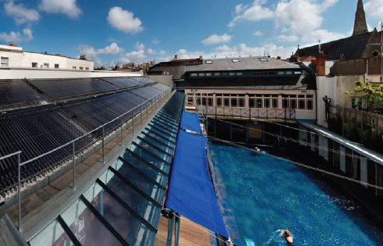
(Picture 5: view of the Solar harnessing system at Clifton Lido)

A historic Lido in Bristol was restored in 2008 complete with spa facilities and a cafe. The £2 million project featured the use of 720 ‘Solar Thermomax Vacuum Tube Collectors’ which cover “80 square metres of the South-facing roof (Kingspan Solar, 2019). The 24 metre outdoor swimming pool is heated via this method as are large storage cylinders supplying the facility’s showers.

Financial and usage analysis of solar energy
For the purposes of this analysis the costs (or savings) of using Solar Energy will be analysed using the details relating to Photovoltaic systems and not Solar Thermal Panels as the exact amount of water required for the swimming pool and other purposes in the building have not been specified.
According to ‘The Green Age’, “Most solar panels are 250 watts; therefore to get a 3.5kW system you would need 14 panels. 250 watt solar PV panels are all pretty much a standardised size – they are around 1.6m x 0.9m and about 5cm thick” (The Green Age, 2014). Therefore, one panel measures:

1.6m x 0.9m = 1.44m squared.

And one full array of 14 panels measures:

1.44m squared x 14 panels = 20.16m squared.

The Centre for Alternative Technology states that “a 3.5kW south-facing domestic system will produce about 3,000 kWh per year” (CAT, 2019). Therefore, assuming that that the full roof area of the centre could house panels (floor area recorded as 600m squared):

6000m squared ÷ 20.16m squared = 297 arrays of Photovoltaic panels on the roof.

Therefore the amount of electricity produced:

297 arrays x 3000 kilowatt hours per year = 891000 kWh of energy produced per year.

The Chartered Institution of Building Services publishes energy consumption figures to act as benchmarks of energy consumption in sports and leisure complexes. They categorize such premises based on the facilities within them. ‘Type 3 – Leisure Pool Centre’ contains a pool, but no gymnasium as UWTSD require, while ‘Type 4 – Combined Centre’ also houses facilities such as sports halls that are assumed beyond the scope of this construction project.
Accordingly, the benchmarks for each ‘type’ have been averaged:
Benchmark for ‘Typical’ Electricity Usage in type 3 per year: 237 kWh/m squared. Benchmark for ‘Typical’ Electricity Usage in type 4 per year: 258 kWh/m squared.
Benchmark for ‘Good’ Electricity Usage in type 3 per year: 152 kWh/m squared. Benchmark for ‘Good’ Electricity Usage in type 4 per year: 164 kWh/m squared.
Midway Benchmark for ‘Typical’ Usage across both ‘types’: 258 – 237 = 21 ÷ 2 = 10.5 + 237 = 247.5 kWh/m squared Midway Benchmark for ‘Good’ Usage across both ‘types’: 164 – 152 = 12 ÷ 2 = 6 + 152 = 158 kWh/m squared

To discover what would represent typical practice in UWTSD’s proposed facility:
247.5 kWh x 6000m squared floor area = 1485000 kWh

To discover what would represent good practice in UWTSD’s proposed facility:
158 kWh x 6000m squared floor area = 948000 kWh

Conclusion
This report has demonstrated that utilizing Solar Radiation to provide enough energy to power the proposed Swimming Pool and Gymnasium complex is a viable concept. Although analysis shows that CIBSE’s good practice benchmark could not be achieved by using Photovoltaic panels alone (of the amount covering the roof footprint), they would only represent a shortfall of 57000 kWh per annum. However as Solar Thermal panels are of even greater efficiency, it’s likely that this figure in reality would be lower if a mix of both types of panels were installed to provide energy for separate parts of the complex. Even without these potential efficiency accumulations, the output is comfortably within the typical range for similar building uses. The case studies outlined have accentuated further that these solutions are affective and there is potential for University to benefit from grants and initiatives.
What is probable is that advances in technology will lead to even more financially adept systems, “in the past year alone, there have been milestones in solar efficiency, solar energy storage, wearable solar tech and solar design tech” (Energysage, 2019).

Evaluation
This report investigated the prospect of integrating renewable energy resources into a Swimming Pool and Gymnasium complex in Swansea, however there is potential for the subject to be explored further:
- This investigation to be carried out when the full design scope has been developed – the pool size etc.
- Other buildings with our uses could be analysed.
- Other buildings in other locations in the UK could be inspected.
- Other buildings in different global locations could be looked at.
- Existing building could be reviewed to see if the measures profiled in this report could be retrofitted.
- Other renewable energy sources could be considered in further when technology has advanced.

List of Figures
- Front page (top) – Youle (2018), Aerial view of UWTSD SA1 campus, https://www.walesonline.co.uk/news/wales-news/inside-stunning-new-university-campus-15214794, UK
- Front page (bottom) – Jameson (2018), View of Solar Panels and Wind Turbines, https://www.climatecounts.org/renewable-energy/top-renewable-energy-sources/, UK
- Picture 3 – Solar Utilities (2013), Diagram of a domestic Solar Thermal Panel configuration, http://www.solarutilities.co.uk/how-solar-thermal-works.php
- Picture 4 – Boston Standard (2013), View of Solar Panels at Princess Royal Sports Arena, https://www.bostonstandard.co.uk/news/solar-panels-aim-to-save-at-prsa-1-6795396, UK
- Picture 5 - Kingspan Solar (2019), View of Solar Harnessing System at Clifton Lido, Kingspan Environmental, UK

List of References
Alternative Energy Tutorials (2019), Photovoltaic Array, http://www.alternative-energy-tutorials.com/solar-power/pv-array.html, UK
Boston Standard (2015), Solar Panels aim to save at PRSA, https://www.bostonstandard.co.uk/news/solar-panels-aim-to-save-at-prsa-1-6795396, UK
Centre for Alternative Technology (2019), Solar Photovoltaic (PV), https://www.cat.org.uk/info-resources/free-information-service/energy/solar-photovoltaic/, UK
Centre for EcoTechnology (2019), Advantages and disadvantages of photovoltaics, http://www.energybc.ca/cache/solarpv/www.cetonline.org/Renewables/PV_pro_con.html, USA
CIBSE (2001), Energy use in Sports and Recreation Buildings, Crown Copyright, UK
Energysage (2019), New Solar Panel Technology: learn about advances in Solar Energy, https://news.energysage.com/solar-panel-technology-advances-solar-energy/, UK
Green (2012), Advantages and disadvantages of Solar Photovoltaic – Quick Pros and Cons of Solar PV, https://www.renewableenergyworld.com/ugc/articles/2012/12/advantages-and-disadvantages-of-solar-photovoltaic--quick-pros-and-cons-of-solar-pv.html, UK
Green Match (2018), Heat Pumps Explained – Discover the pros and cons!, https://www.greenmatch.co.uk/blog/2014/08/heat-pumps-7-advantages-and-disadvantages, UK
Herrschaft (2016), Stop putting Wind Turbines on Buildings, Energy in Transition, USA
Kingspan Solar (2019), Case Studies – Bristol Lido – A Solar Hotspot, Kingspan Environmental, UK
Lombardo (2014), What is the lifespan of a Solar Panel?, https://www.engineering.com/DesignerEdge/DesignerEdgeArticles/ArticleID/7475/What-Is-the-Lifespan-of-a-Solar-Panel.aspx, UK
Perry MP (2018), 13 years since Kyoto and the UK is still leading the charge to a low Carbon future, https://www.gov.uk/government/speeches/13-years-since-kyoto-and-the-uk-is-still-leading-the-charge-to-a-low-carbon-future, UK
Solar Utilities (2013), Solar Thermal (Hot Water) - How a Solar Thermal Hot Water System Works, http://www.solarutilities.co.uk/how-solar-thermal-works.php, UK
Stoker (2015), Princess Royal Sports Arena, https://www.solarpowerportal.co.uk/news/princess_royal_sports_arena_2891, UK
The Green Age (2014), How many Solar Panels can I fit on my roof, https://www.thegreenage.co.uk/how-many-solar-panels-can-i-fit-on-my-roof/, UK
The Renewable Energy Centre (2019), Solar Heating, https://www.therenewableenergycentre.co.uk/solar-heating/, UK
Zuccari et al (2017), Energy analysis of swimming pools for sports activities: cost effective solutions for efficiency improvement, Energy Procedia, 126, pp123-130, Italy

