
9/8/2023
Lecturer: Suneth Fernando
Student: Stanimira Staneva (2023696)

Cloud Computing Architecture
ACCA5025

BSc Cloud Computing Level 5 Term 1
Assignment 2

  - Table of Contents
Introduction 2
Virtual Machine Resources 2
CPU as a Virtual Machine Resource 3
Memory as a Virtual Machine Resource 4
Storage as a Virtual Machine Resource 5
Network as a Virtual Machine Resource………………………………………………………………………………………….6-7
vNets and Network Security Groups…………………………………………………………………………………………………..8
Images in Azure………………………………………………………………………………………………………………………………….9
Additional Exercise..……………………………………………………………………………………………………………………10-14
References List…………………………………………………………………………………………………………………………………15
Table of Figures………………………………………………………………………………………………………………………………..16

Introduction

In this report it is required to analyse the different resources that are allocated when virtual machines and virtual networks are being created, as well as network security groups and Azure images. Additionally, an exercise of putting the theory into practise has been demonstrated and presented in this report.

Virtual Machine Resources

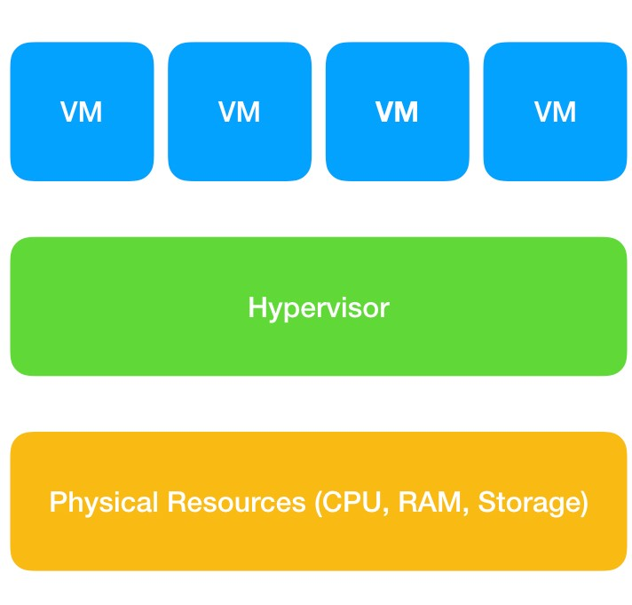
Virtual machine (VM) represents a virtual environment which operates exactly like a virtual computer system. Virtual machines have access to different resources like memory, storage, CPU, network interface which are created on a physical hardware system. Hypervisor is the software that manages the hardware and separates the physical resources from the virtual environment and uses them as a pool of resources so that the virtual machine can easily relocate them then required to do so (Figure 01). When the virtual machine is running and requires access to the physical resources then the hypervisor sends the request to the physical system so that the virtual machine’s operating system can access the resources from the shared pool. Part of the main effects of the virtualization is the either little or no difference in the performance between the physical and the virtual machines. However, if one of the resources is constrained, then the whole performance of the virtual machine will be affected. [1] [2]

(Figure 01)

CPU as a Virtual Machine Resource

The CPU is considered to be the heart of the computer. Therefore, virtualization of the CPU is a critical part for a good performance of the virtual machine. The CPU’s function is to execute the programs which run in the form of instruction set. In order the virtualize the CPU, slices of time from the physical CPU are scheduled by the hypervisor so that the instructions can run. The virtual machine should execute a set of commands on the virtual hardware, then the hypervisor receives a request, and an execution session is scheduled to be performed. The physical CPU executes the instructions and sends the results back again to the hypervisor which function is to return them to the virtual machine (Figure 02). As a result of the whole process, the virtual machine is efficiently and timely serviced and the physical CPU is working effectively as well. [1]
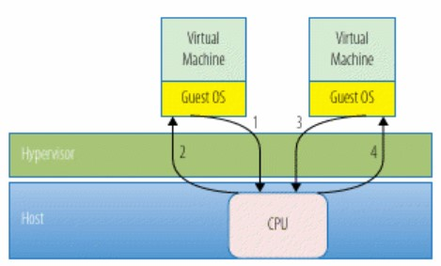

(Figure 02)

A CPU may contain more than one processor and each of these processors is called a core. There are multicore CPU computers, consequently there are more processing resources available for virtual machines’ utilization. [1]
Virtualizing CPU is defined as a time scheduling process, therefore the more efficient the scheduling, the better the performance is. [1]
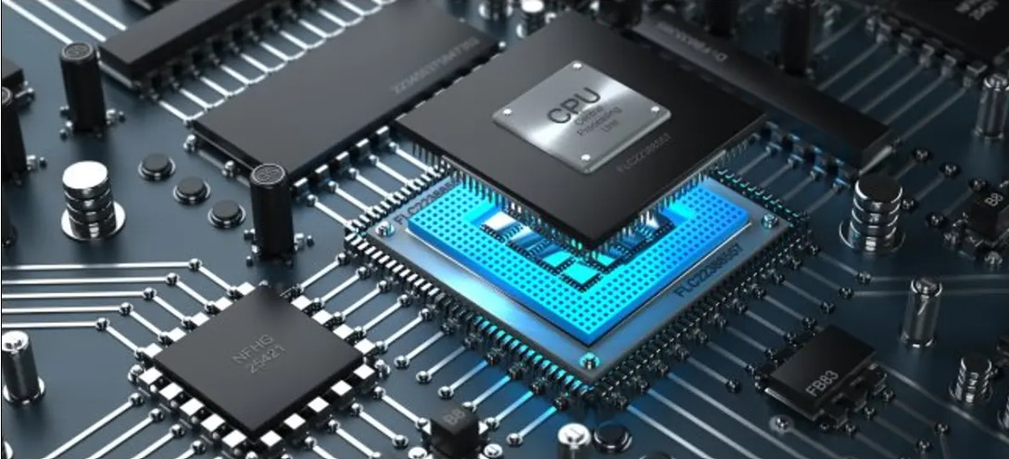
Certain benefit of the virtual machines is that they can run simultaneously numerous different operating systems on a single computer. However, there are some operating systems that can run only a limited number of CPUs. Example of this is Windows XP Professional Edition which will only use two processors on a server with four. Similarly, a virtual machine with four virtual CPUs and installed Windows XP Professional Edition, will use only two of the CPUs. [1]
(Figure 03)
Figure 03 depicts the physical representation of the CPU (Central Processing Unit).

Memory as a Virtual Machine Resource

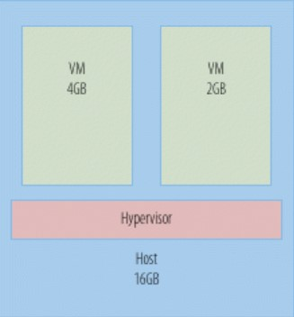
Similarly to the CPU, memory is also a crucial part of the virtual machine. It is considered as the fastest consumed resource. Computers can access and process faster larger amounts of data if they have more memory. The amount of memory that has been allocated to the virtual machine is what the virtual machine can actually use. For instance, as depicted on Figure 04, the physical host may have available many gigabytes, but the virtual machine is unaware of that and uses only what has been allocated to it. When virtualizing memory, there is only one adjustment that can be made - it can either increase or decrease in size. Memory adjustments depend on the operating system which is installed on the virtual machine. Although programs are not directly responsible (Figure 04)
for managing physical memory, they perform very important management tasks in the virtual space. In order the physical resources to be allocated, the management requests should come from the administrator, then go through the operating system and the virtual machine system. [1] [3]
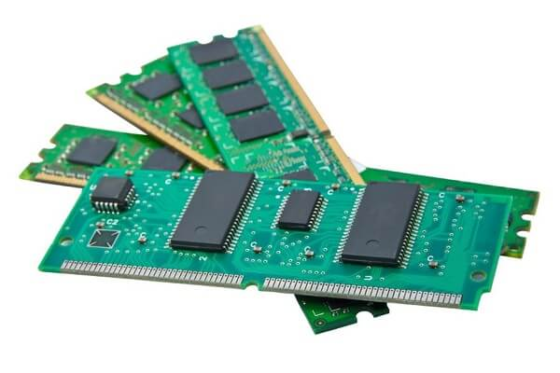

(Figure 05)
Figure 05 depicts a physical representation of computer memory.

Storage as a Virtual Machine Resource

Data storage is considered as an ever-expanding resource which can be extended further to support the high availability of the data. A certain amount of storage is dedicated to a specific virtual machine and then that virtual machine can access and use that storage as if it is an actual physical storage which is attached to the virtual machine.
Storage virtualization is mainly seen as a benefit for maintaining a replica, backup and recovery of the data that is stored on the virtual machines. The whole process works efficiently, provides flexibility and requires less time to perform. To prevent data loss in case of a disk failure, disk mirroring could be used. Disk mirroring is a type of optimization which uses a second disk to mirror the data and provides the benefit of having two copies to read from. Another commonly used strategy is data deduplication. Data deduplication is a technology which identifies the identical pieces of data in the storage system, locates the original and replaces the duplicates. Disk stripping is also a technique which is used to prevent data loss. Disk stripping works by stripping a single file system into pieces across multiple disks so when the data is being used, the multiple drives can work together and increase the data availability and performance. [1] [4]

Network as a Virtual Machine Resource

Network functions as the transport mechanism of the system and is a critical component of the architecture because it ensures that the data arrives at all virtual machines on time. Virtual networking has two key components – virtual switch and virtual Ethernet adapters. A virtual switch is similar to a physical switch because it supports the standard VLAN implementation and also both types of switches have a forwarding table. Virtual networks are intended to be used by virtual devices and all communication between the physical network and the virtual machines goes through virtual network standard switches and distributed switches. [5]

Virtual networks operate on layer 2 of the OSI model – data link layer. A virtual machine can be configured with up to ten vNICs which are the virtual representations of the Ethernet adapters and are displayed on Figure 06 on the left. [5]
Virtual networks are highly flexible and scalable because users can easily add or remove VMs, change the network configurations, etc.

(Figure 06)
(Figure 07)
vNets and Network Security Groups

In Microsoft Azure, vNets and Network Security Groups are fundamental components for designing and securing a cloud infrastructure. Virtual networks (vNets) allow creation of isolated network environments within the Azure cloud like one vNet for database servers, another vNet for web servers, etc. vNets can be connected either to each other or to on-premises networks using Azure VPN Gateways, vNet peering, Azure ExpressRoute and allows the establishment of communication between different network segments. vNets IP addresses and subnets can be defined within the IP address ranges. Additionally, vNets support custom DNS and DHCP settings. Inbound and outbound traffic can be controlled via Azure Firewall and Network Security Groups. [6]
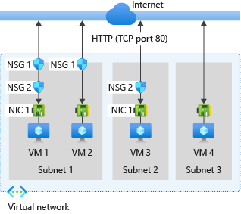
Network security groups are Azure resources acting as a firewall for network traffic control between Azure resources. Network security groups consist of inbound and outbound security rules which allow or deny traffic between Azure resources. Each rule has a specific source, port, destination and protocol and can be applied at the subnet level or directly to the network interfaces. [6] Network security groups also filter the incoming traffic but apply a rule that allows outbound traffic by default. Rules in a network security group are evaluated in priority order and start from the lowest number until a matching rule is found. Network security groups are associated with subnets, NICs and individual virtual machines. [6]
(Figure 08)
vNets and Network security groups together provide foundation for designing, isolating and securing Azure infrastructure. A proper configuration of vNets and NSGs can allow control of the traffic between Azure resources, implement good security policies and ensure well-organized cloud environment.

Images in Azure

In Microsoft Azure, virtual images typically represent templates containing an operating system or additional software and configurations. They can be used as a starting point for creating new virtual machine instances. Azure provides a wide selection of virtual images on the marketplace and all of them are created and maintained by Microsoft and third-party providers. Azure Marketplace offers multiple applications and operating systems images and users can deploy directly a virtual machine based on these images from Azure portal. Additionally, Azure portal offers to the users to create their own custom virtual machine images and share them across multiple Azure subscriptions and regions using the Shared Image Gallery service. [7] [8]

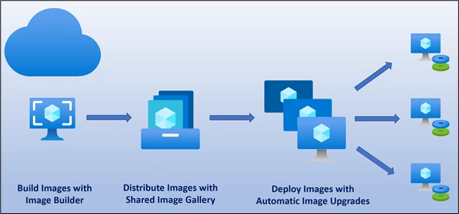
(Figure 09)

Additional Exercise

Additional exercise part of this Assignment 2 includes screenshots documenting the creation of virtual machines, virtual networks, establishing and testing connection between two virtual machines.
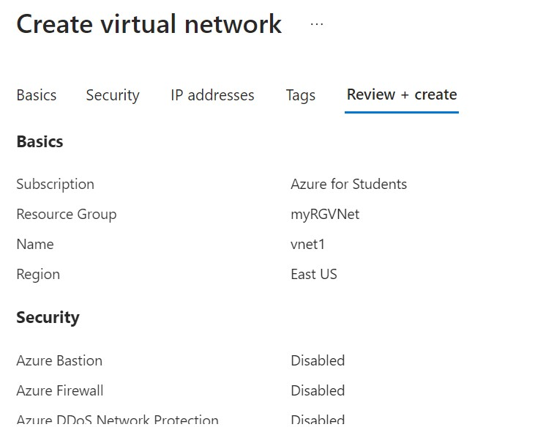
Initially a virtual network vnet1 was created.
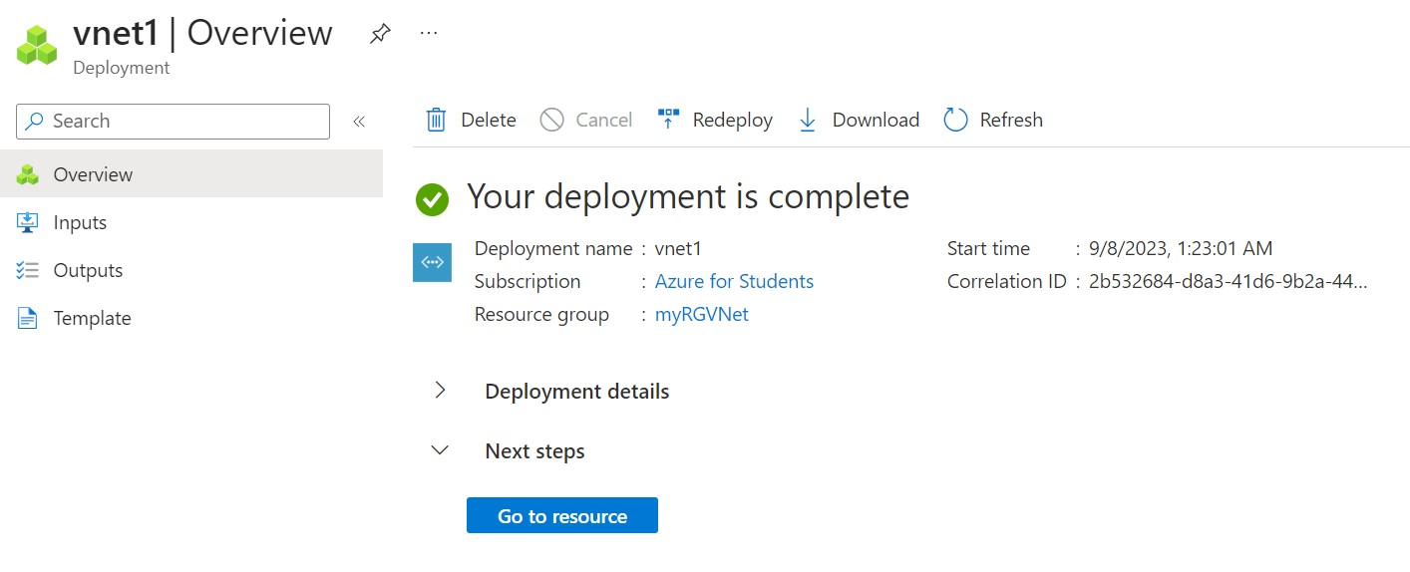
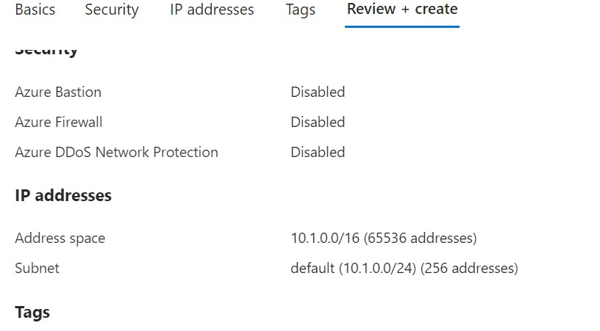
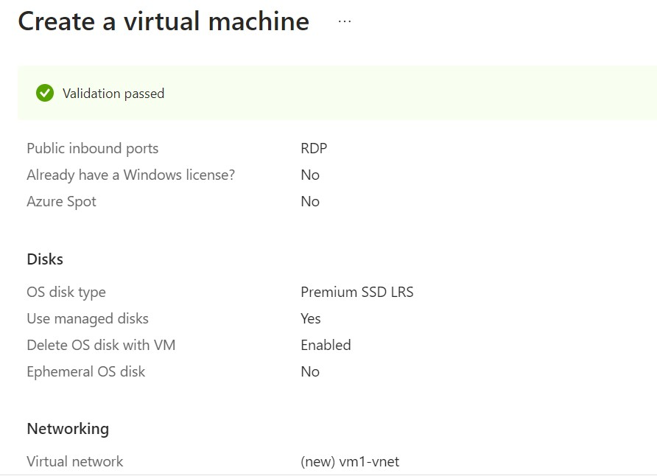
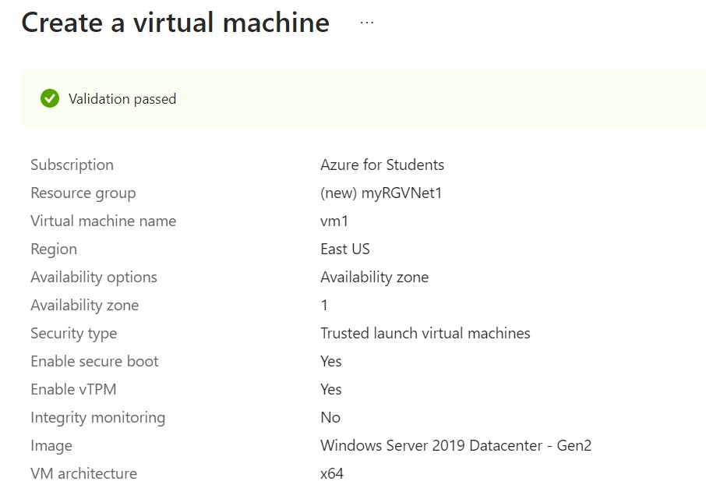
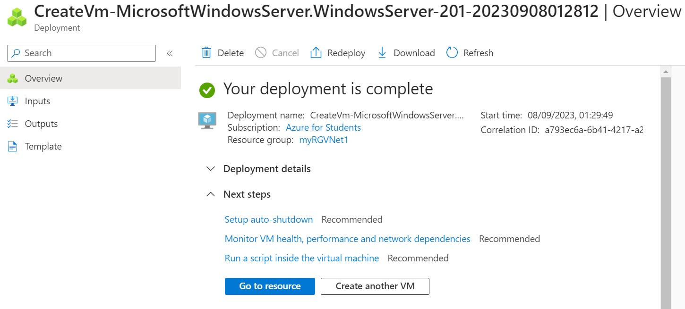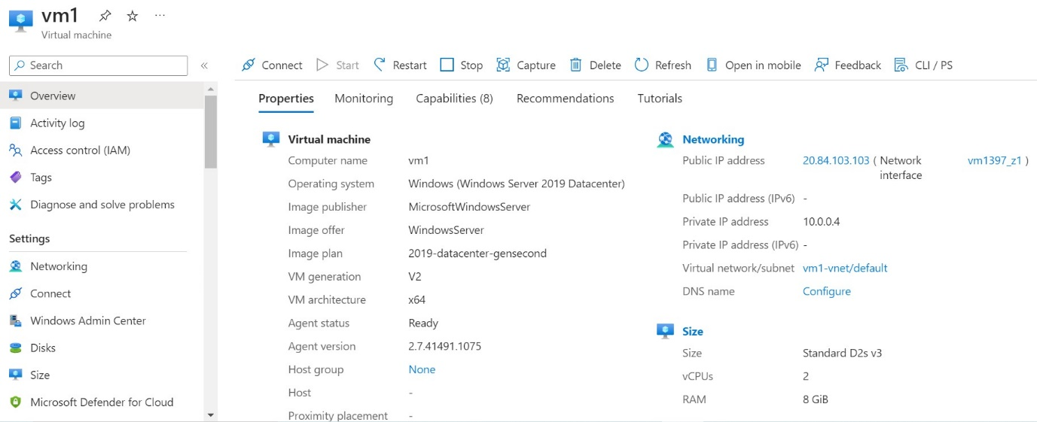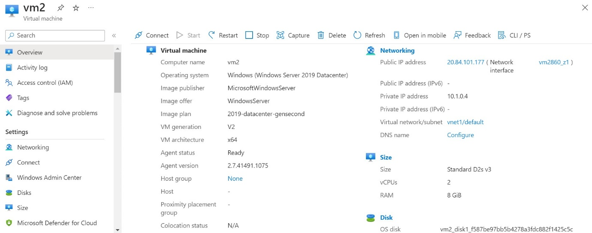
Two virtual machines vm1 and vm2 were created.
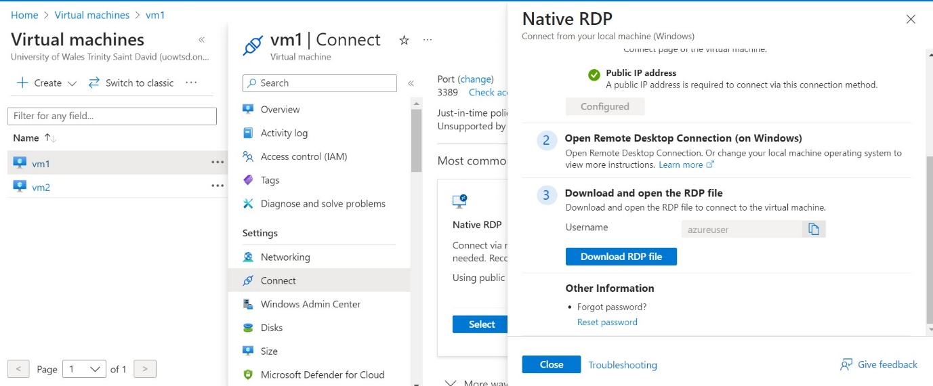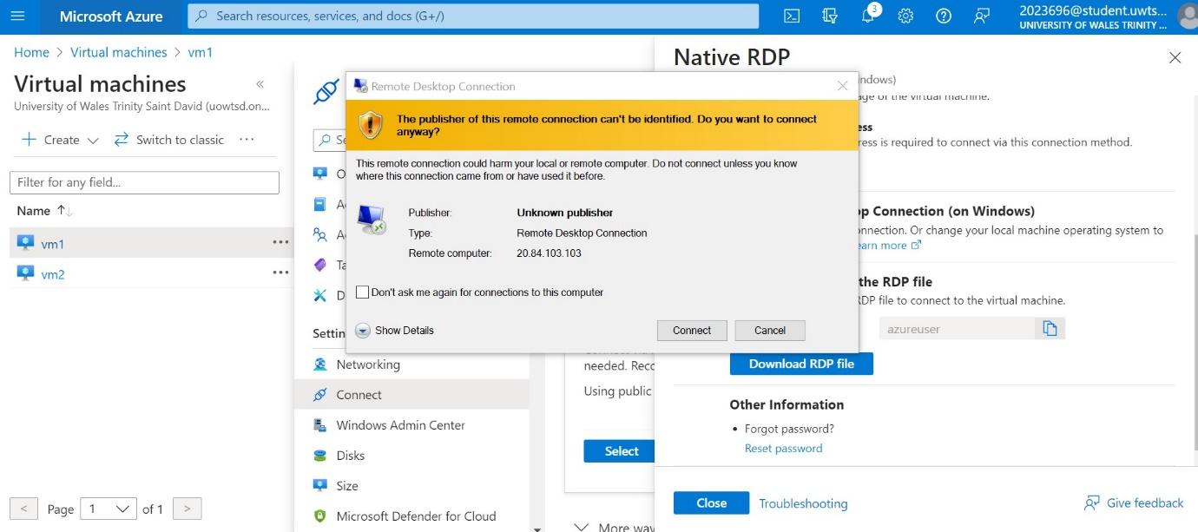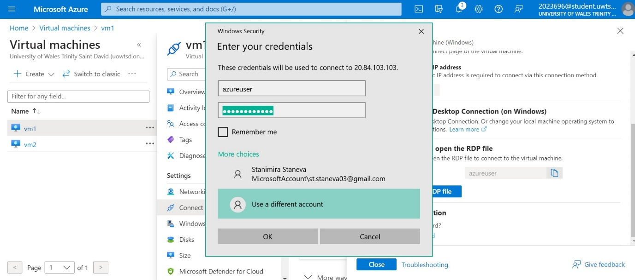

Testing the connection and successful ping.
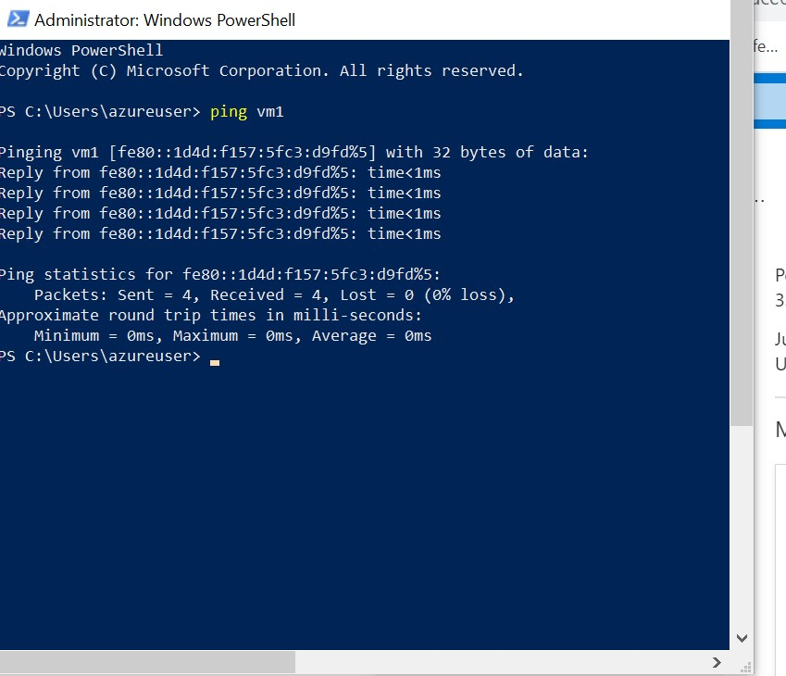

References List
[1] M. Portnoy, Virtualization: Essentials, Second edition. Sybex, 2016, pp. 37–190. Accessed: May 02, 2023. [Online]. Available: https://librarysearch.uwtsd.ac.uk/discovery/fulldisplay?docid=alma99100326059602421&context=L&vid=44WHELF_UWTSD:44WHELF_UWTSD_VU1&lang=en&search_scope=MyInst_and_CI&adaptor=Local%20Search%20Engine&isFrbr=true&tab=Everything&query=any,contains,virtual%20machines&facet=rtype,include,books&offset=0

[2] “What is a virtual machine?” Redhat.com, May 11, 2022. https://www.redhat.com/en/topics/virtualization/what-is-a-virtual-machine (accessed May 02, 2023).

[3] A. Bhattacharjee and D. Lustig, Architectural and Operating System Support for Virtual Memory, 1st ed. Springer Nature, 2018, pp. 1–21. Accessed: May 02, 2023. [Online]. Available: https://librarysearch.uwtsd.ac.uk/discovery/fulldisplay?docid=alma99100320996902421&context=L&vid=44WHELF_UWTSD:44WHELF_UWTSD_VU1&lang=en&search_scope=MyInst_and_CI&adaptor=Local%20Search%20Engine&tab=Everything&query=any,contains,virtual%20machines&facet=rtype,include,books&offset=0

[4] C.-H. Hong, I. Spence, and D. S. Nikolopoulos, “GPU Virtualization and Scheduling Methods,” ACM Computing Surveys, vol. 50, no. 3, pp. 1–8, Oct. 2018, doi: https://doi.org/10.1145/3068281.

[5] R. Fitzhugh, “vSphere Virtual Machine Management,” Packt, Mar. 2014. https://www.packtpub.com/product/vsphere-virtual-machine-management/9781782172185 (accessed Sep. 07, 2023).

[6] mbender-ms, “Azure network security groups overview,” learn.microsoft.com, Mar. 16, 2023. https://learn.microsoft.com/en-us/azure/virtual-network/network-security-groups-overview (accessed Sep. 07, 2023).

[7] “VM Image Builder | Microsoft Azure,” azure.microsoft.com. https://azure.microsoft.com/en-gb/products/image-builder (accessed Sep. 07, 2023).

[8] M. Azure, “VM Image | Azure Blog | Microsoft Azure,” Azure Blog, Apr. 14, 2014. https://azure.microsoft.com/en-us/blog/vm-image-blog-post/ (accessed Sep. 07, 2023).
Table of Figures

[1] S. Keck-Warren, “What’s a Virtual Machine?,” www.thisprogrammingthing.com, Jan. 05, 2021. https://www.thisprogrammingthing.com/2021/Whats-a-virtual-machine/ (accessed May 02, 2023).

[2] M. Portnoy, Virtualization essentials, Second edition. Indianapolis, Indiana: Sybex, 2016, p. 135. Accessed: May 02, 2023. [Online]. Available: https://ebookcentral.proquest.com/lib/trinity/reader.action?docID=4644086

[3] I. Paul, “What Is a CPU, and What Does It Do?,” How-To Geek, Oct. 30, 2020. https://www.howtogeek.com/694869/what-is-a-cpu-and-what-does-it-do/ (accessed May 02, 2023).

[4] M. Portnoy, Virtualization essentials, Second edition. Indianapolis, Indiana: Sybex, 2016, p. 149. Accessed: May 02, 2023. [Online]. Available: https://ebookcentral.proquest.com/lib/trinity/reader.action?docID=4644086

[5] “Computer Memory - javatpoint,” www.javatpoint.com. https://www.javatpoint.com/computer-memory (accessed May 02, 2023).

[6] R. Fitzhugh, vSphere Virtual Machine Management. Packt Publishing Ltd, 2014. Accessed: Sep. 08, 2023. [Online]. Available: https://www.packtpub.com/product/vsphere-virtual-machine-management/9781782172185

[7] S. Walleit, “What is a Virtual Network?,” Parallels Remote Application Server Blog - Application virtualization, mobility and VDI, Apr. 19, 2021. https://www.parallels.com/blogs/ras/what-is-a-virtual-network/ (accessed Sep. 08, 2023).

[8] asudbring, “Network security group - how it works,” learn.microsoft.com, Apr. 05, 2023. https://learn.microsoft.com/en-us/azure/virtual-network/network-security-group-how-it-works (accessed Sep. 08, 2023).

[9] M. Nayar, “Build, distribute, and deploy application updates to Azure virtual machine scale sets,” azure.microsoft.com, Jul. 01, 2020. https://azure.microsoft.com/en-us/blog/build-distribute-and-deploy-application-updates-to-azure-virtual-machine-scale-sets/ (accessed Sep. 08, 2023).

