5HR01 – Employment Relationship Management
Task 1
AC 1.1
Looking at employee engagement there are three main areas, which are intellectual engagement, this looks at how the employee thinks about the job and how they can do it better. The affective engagement looks at how you are feeling towards the job, and if you have a positive outlook and feel positive within your role. The third would be the social engagement, this would see if your employees were actively taking opportunities to discuss work-related improvements with others at work.
‌Gifford, J. and Young, J. (2021) looked at REA’s which are rapid evidence assessments, these look at what constitutes employee engagement, how can it be measured, and what is the evidence surrounding employee engagement and does it predict performance.
With a large organisation such as Bluestone it is important that people analytics looks at and understands the strengths and weaknesses of an organisation. How do we look at employee engagement? Is this done through surveys, or qualitative methods such as focus groups. It is a vital part of an organisation to give their employees a voice and allow them to have effective channels to be listened to and for the employee to be heard.
Using different approaches can influence better working lives as employees feel valued, have an increased job satisfaction, greater influence on their role/department and give better opportunities for development. It is all about creating an inclusive and safe working environment for your staff. AC 1.1
AC 1.3
According to Practical advice for HR professionals (2021) there are several employee voice tools that can be used. These range from team meetings, committees, forums, focus groups and surveys to name a few. By introducing a wide range of employee communication channels, they can promote and build relationships and create and cultivate an environment of trust.
People Insight Model - PEARL TM. (n.d.). has undertaken a comprehensive study which looks at the employee engagement including the organisational factors which influence it. It looks at five main global factors which drive employee engagement, these are Purpose, Enablement, Autonomy, Reward and Leadership.
This would be a great employee survey to implement, as per the questions provided below. It can then provide vital information to access all elements of employee engagement, and provide a robust, well-benchmarked engagement score, which could also improve and drive employee engagement, as they feel as though the employee is being listened too.
I also think its important to assess and look for the best tools for your organisation, and the number of employees that you have. As what works for one, may not work for another.
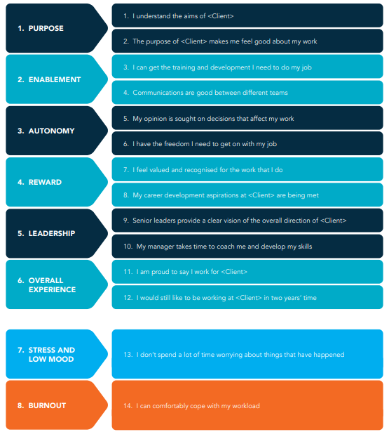
AC 1.3
AC 1.5
The definition of better working lives is that the organisation should set out to achieve and ideal balance between an employee/person’s working life and private life. Having this balance can maximise happiness and can fuel the productivity and allow workers to be fulfilled. For this to be possible it is vital for both employer and employee to be responsible.

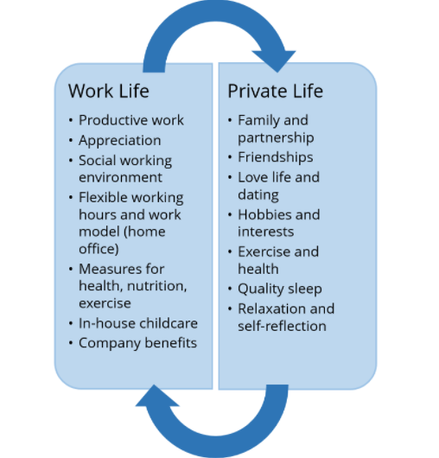
Since the pandemic it is vital that we build better working lives, and workplaces for everyone. We need to ensure that trust wins out over fear. We need to look at new opportunities that present themselves for the organisation. It is important to look at adapting certain dimensions of the working day and what this looks like to help contribute to wellbeing, productivity and good employment relationships.
www.acas.org.uk. (n.d.). has looked at a series of questions that we should be looking at to see if we can improve our employees working time, and some of the core elements surrounding this, from the psychological contract, namely respect, compassion, fairness and critically, trust. To include these elements ACAS has included a series of questions. How can we create a fair balance between flexibility and fairness? How do we review and revitalise voice mechanisms to build fairer, more inclusive workplaces? Can we make flexible work arrangements the norm? How do we balance the needs of employee wellbeing and business productivity? Can we accept that short and long-term conflict will emerge; prepare for it and see it a creative force for positive change?
All of which are relevant to trying to create better working lives for your employees. AC 1.5

AC 1.4
There are strong arguments linking both employee voice and organisational performance. Lavelle, J., Gunnigle, P. and McDonnell, A. (2010) look at patterning employee voice in multinational companies. They define that the employee voice is a type of mechanism, structure and practice, which provides organisations and employees to express their opinions, along with having the opportunities to make decisions for the organisation. There are two areas, which can be evaluated, these are direct voice, and indirect voice. Direct voice looks at the impact and involvement that the employee has when making decisions affecting their jobs, and immediate working environment. This can be done through focus groups, surveys, suggestion schemes, appraisals and direct meetings between managers and workers. Indirect voice looks at how the employees’ views and inputs are presented through a collective employee representation. This can be through trade unions, or non-unions structures, for example consultative committees.
The argument is, does having an employee voice lead to improved organisational performance? And the answer is yes! It can pay a crucial role in enhancing work productivity, not only through engagement, retention, effectiveness and creativity. It can also leave employees feeling valued, having the feeling of greater influences and better opportunities and increased job satisfaction.
The difficulties could be that the organisation find it difficult to measure performance, and weather or not the best means of methods can be used and be effective. For example, my organisation has used 360 reviews in the past to gauge and create a high performing culture. This has allowed employees to self-evaluate, and provide a comprehensive look at efficiency, productivity, contributions and work behaviour. AC 1.4
AC 1.2
Employee involvement looks at ways in which the employee takes part in planning, making sure the work is done well and making decisions. Whereas employee participation refers to activities and measures in which employees can participate in together and use their initiative to be able to achieve the common goal.
Situational decision-making | CIPD Profession Map (2019) describes that situational decision making is a good example of how making effective and pragmatic decisions or choices, can purely be based on the specific situation or context. It’s a good tool to use to ensure that the identification of different options, such as the benefits and risks that are associated with them, are in alignment to professional principles and values.
This can also be linked to unitarism and pluralism as both can be linked to employee involvement and participation. Unitarism is a more straightforward approach when it comes to what this offers the organisation, it looks at how the employees should work for the welfare of the organisation, and not just the personal growth and benefit of the individual. Whereas pluralism give due importance to every employee and management. It particularly focuses on every person within your organisation, and what their needs and demands could be, and this can strongly be linked to the strategy of the organisation ensuring that everyone benefits from this.
Mayo, 1933, 1945; Roethlisberger & Dickson, 1939 launched the classic Hawthorne studies. These look at how motivation can be improved. They conducted a study to see if improving the environmental conditions would have an impact on the overall productivity of the staff. In this case they were looking at changing the lighting to see of this had an overall impact on the employee productivity. What they found is that by taking an interest and listening to the employees’ opinions increased the drive-in employee job satisfaction and productivity. AC 1.2
AC 4.1
Collective employment law is a branch of employment law that regulates the activities and behaviours of the trade unions, work councils, and employers’ associations (Heery, E. and Noon, M. (2008). It looks at the collective agreement and advice for employees and employers and looks at the important law provisions. Under the statutory recognition processes, and employer would need to voluntarily recognise it, if this does not happen then the trade union could apply to the Industrial Court, which would look for the legal right for this to be recognised. This can allow bargaining for pay hours and holiday, this is also known as the ‘bargaining unit’.
Picketing can be linked to the above as this is defined as a picket line which workers and union reps stand outside of an organisation to inform people of why they are striking.
The legal enforceability of a collective agreement may not be legally binding, as it can be assumed to be voluntary unless it is in writing and contains a statement that the parties intend it to be of legal effect. They can be incorporated into employee contracts, which can be referenced to such items as the contract may change in the event of a variation to a collective agreement. The principles of a collective agreement can be applied to an employee if they are not a trade union member. AC 4.1
AC 4.2
There are several different types of employee bodies that can be compared. The first would be a joint negotiating committee, this would be representatives who would be nominated by, for example, the public service labour unions. They would look at representing them by bilateral negotiations and in a consultative way, with the employers’ representatives.
Employee forums are a strong tool to use when looking at non-union forms of employee representation, it is a way to get feedback in a confidential environment, along with building a sense of trust, and can also get decisions made quickly and with everyone’s involvement. ACAS states that around half of the employee representatives in the UK are non-union. ACAS (2014)
Staff councils are a peer-elected committee, they look at staff policies, benefits, and can provide a formal way of communication for all staff. It allows staff to have a voice and input in the decision making, by listening and responding to ideas.
Work councils are representations that look at the interests of the employees. The employer must consult and inform the council of any issues that are affecting their organisation.
As you can see all four types of employee bodies can have their benefits, depending on your type of organisation it may vary in which one works best. This can be discussed and decided with the employees in mind, to be able to find the best use and solutions for all. AC 4.2
AC 4.3
Collective bargaining is a way in which negotiations of wages and other conditions of employment are made by an organisational body of employees. Collective bargaining is a communication between relevant stakeholders, not outsiders (Sarvaiya et al., 2018)
It looks at clear evidence which shows that both parties have mutually recognised one another. This needs to be done for the purpose of collective bargaining, and evidence needs to be provided for the actual negotiations on the collective agreement. Collective agreement cannot be enforced unless this has been incorporated into an employee contract. CIPD (2021)
It is important to look at the impact and structure change as the UK’s economy has moved from an industrial base to a service base, as collective bargaining can take many forms.
Collective bargaining has a general structure and starts from the preparation, proposal, the bargaining and then onto the final agreement. The purpose is for employees to have better working conditions, higher wages and better benefit packages. AC 4.3
AC 2.1
Organisational conflict is where there is workplace conflict. It is where there is a state of disagreement or misunderstanding. This can be from the actual or perceived dissent of needs, resources, beliefs and relationships of employees and employers. There are many factors which can influence workplace conflict, such as unclear responsibility, interpersonal relationships, scarcity of resources and conflict of interest. The types of conflict can stem from relationships, tasks and the process. You can also have conflict between two people who do not see eye to eye. These can stem and have an impact from management and from the leadership style, as communication, misunderstandings and lack of accountability can cause conflict. This links to conflict and misbehaviour as all the points above can stem from how employees and employers conduct themselves and communicate.
Formal and informal conflict also looks at two options, you have informal resolution and formal resolution. Formal resolution looks at the processes which include things such as grievances or lawsuits, whereas informal resolution looks at and is less focused on the process and more focused on the outcome.
The positive and negative effects of conflict can cause people to consider different ideas and alternatives. This can result in increased participation and more commitment to the decisions and goals of the group. Results in issue clarification and/or reassessment, and it also helps build cohesiveness as people learn more about each other. AC 2.1
AC 2.2
The difference between official and unofficial industrial action, this states that officially the industrial actions allow the trade union to have authority and to be able to endorse this action. Whereas employees who are involved in unofficial industrial action would have no protection at all.
Official action, or also known as lawful action can be covered by a broad range of pressures. This can include strikes, overtime bans, boycotting and working to rule. As within law a strike can be defined as both concerted stoppage of work and cessation of work by a body of an employed person. For this to be lawful you would have to provide written notice, provide sample voting papers, and have at least 14 days’ notice of intended industrial action. CIPD (2021).
Unofficial action would be where actions such as strike, would not be authorised or endorsed by a trade union. By doing this unofficially any employee participation in this action would not have statutory protection from unfair dismissal. AC2.2
AC 2.3
Below is a table of how much working time has been lost due to stoppages, you can see there was an incline from 2017 to 2018. These were caused by labour disputes between employers and workers.
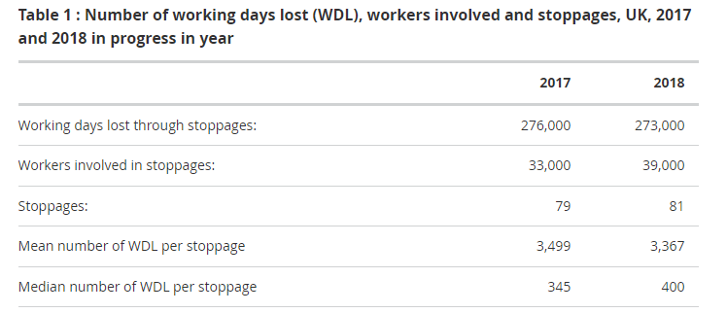
It is believed that strikes have been on the decrease, since the 1980’s because there has been a shift in manufacturing towards the private sector, due to this it has been poorly unionised, which is a significant factor to why strikes are reducing.
New legislation was introduced in 2015 which allows strikes and the laws surrounding this to be fair for working people. This is applied to ensure that there is a fair balance for people to be able to go about their daily lives and work. This new law will ensure that strikes are clear and positive and that they reduce the disruption to millions of people.
It is important to understand your contract to see if there is a breach when it comes to strikes, as this may noy be part of your employers’ policies and principals. There can also be sanctions applied and convictions can be given where an offence has taken place, and there would be disqualification periods. This would be 13 weeks for one strike, 26 weeks for two, and up to and resulting in a conviction of 3 years for 3 strikes. AC 2.3
AC 2.4
Gov.uk (2012) explains the difference between conciliation, mediation and arbitration. Starting with conciliation, this can be interpreted to be very similar to mediation. It looks at how you may be entitled to make a claim to an employment tribunal, or if you have already made a claim. This process is voluntary, and you would need a mutual agreement with your employer before it happens.
Mediation is where a third party who is also independent can discuss any issues or problems with your employer. This is done to try and find the best solution possible and is normally used after discussions if there has not been a solution. This process is also voluntary, and you and your employer must agree to solve any disputes.
Arbitration is where third parties can make firm decisions, once all the issues have been considered. For this to be legally binding your employer would need to agree to the decision. However, this can still be taken to an employment tribunal. AC 2.4
Bibliography
ACAS (2014). Non-Union Representation in the Workplace booklet. [online] Available at: https://www.acas.org.uk/sites/default/files/2021-03/non-union-representation-in-the-workplace.pdf.

CODE OF PRACTICE on Picketing Code of Practice on Picketing 2 Contents. (2017). [online] Available at: https://assets.publishing.service.gov.uk/government/uploads/system/uploads/attachment_data/file/594788/Code_of_Practice_on_Picketing.pdf.

CIPD. (n.d.). The future of employee voice. [online] Available at: https://www.cipd.co.uk/knowledge/work/future-voice.

CIPD (2020). Employee Voice | CIPD Viewpoint. [online] CIPD. Available at: https://www.cipd.co.uk/news-views/viewpoint/employee-voice.

CIPD (2020). Dealing with conflict at work: a guide for people managers. [online] CIPD. Available at: https://www.cipd.co.uk/knowledge/fundamentals/relations/disputes/workplace-conflict-people-manager-guide.
CIPD. (n.d.). Empowering employee voice. [online] Available at: https://www.cipd.co.uk/knowledge/work/future-voice/employee-voice-guide.

CIPD (2021). Trade Union Recognition & Industrial Action Q&As | CIPD. [online] CIPD. Available at: https://www.cipd.co.uk/knowledge/fundamentals/relations/employees/trade-unions-questions.

Heery, E. and Noon, M. (2008). A dictionary of human resource management. Oxford: Oxford University Press.

‌Gifford, J. and Young, J. (2021). Employee Engagement & Motivation | Factsheets | CIPD. [online] CIPD. Available at: https://www.cipd.co.uk/knowledge/fundamentals/relations/engagement/factsheet.

GOV.UK. (n.d.). New legislation to make strike laws fair for working people. [online] Available at: https://www.gov.uk/government/news/new-legislation-to-make-strike-laws-fair-for-working-people.

Gov.uk (2012). Solve a workplace dispute. [online] GOV.UK. Available at: https://www.gov.uk/solve-workplace-dispute/mediation-conciliation-and-arbitration.

Grant, A. and Fried, Y. (n.d.). WORK MATTERS: JOB DESIGN IN CLASSIC AND CONTEMPORARY PERSPECTIVES. [online] Available at: https://faculty.wharton.upenn.edu/wp-content/uploads/2012/06/GrantFriedJuillerat_WorkMattersHandbook.pdf.
‌Lavelle, J., Gunnigle, P. and McDonnell, A. (2010). Patterning employee voice in multinational companies. Human Relations, 63(3), pp.395–418.
People Insight Model - PEARL TM. (n.d.). [online] Available at: https://peopleinsight.co.uk/wp-content/uploads/2021/12/People-Insight-PEARL-Whitepaper-2022.pdf [Accessed 5 Apr. 2022].

Practical advice for HR professionals (2021) GUIDE TO USING GROUP VOICE CHANNELS. (n.d.). [online] Available at: https://www.cipd.co.uk/Images/guide-to-using-group-voice-channels-web_tcm18-100118.pdf.

Sarvaiya, H., Eweje, G. and Arrowsmith, J., 2018. The roles of HRM in CSR: strategic partnership or operational support? Journal of Business Ethics, 153(3), pp.825-837.

Situational decision-making | CIPD Profession Map (2019). Situational decision-making | CIPD Profession Map. [online] CIPD Profession for the Future. Available at: https://peopleprofession.cipd.org/profession-map/core-behaviours/situational-decision-making.

Taylor, S. and Woodhams, C. (2016). Human resource management: people and organisations. 2nd ed. London: Chartered Institute of Personnel And Development.

Tamkin, P. (2004). High Performance Work Practices. [online] Available at: https://www.employment-studies.co.uk/system/files/resources/files/mp36.pdf.
www.acas.org.uk. (n.d.). Building back: making working lives better | Acas. [online] Available at: https://www.acas.org.uk/building-back-making-working-lives-better [Accessed 5 Apr. 2022].
‌Task 2
AC 3.3
Active listening is being able to have the right tools to deal with grievances and discipline-handling. In this instance as you are looking at possible action against an employee it is vital that you look into active listening. This is where you ensure that it is used as an effective tool of communication. It is all about listening to the content, intent and feelings of the speaker, and showing that the correct processes have been followed.
ACAS (2014) looks at active listening and questioning techniques. To be able to manage a difficult conversation, such as taking disciplinary action, could be difficult to manage, you would need to think carefully about how the situation would be approached. This would be done through your ability to take control during a meeting. How you communicate and your levels of self-belief. It is important to ensure that the tone of voice, the words that you use, and the facial and body language are not interpreted in the wrong way. Active listening is an important part of communication and can strengthen your links with the employee. It is also important to be non-bias in these situations. AC 3.3
AC 3.2
Whilst going through any disciplinary hearing it is important to ensure that all policies and procedures regarding this matter are followed, as it could be the case that a grievance is put in against your organisation. A grievance is a real or imagined cause for complaint, especially unfair treatment. This could be linked to such items as working conditions, bullying or harassment, lack of flexibility and unfair rules to name a few.
Khan v Stripestar LTD is a fine example of what could go wrong and an example of a grievance that could be made against your organisation. In this case it was bought to the employer that they had committed gross misconduct. Following this the employee bought a claim for unfair dismissal. It was later known that the disciplinary meeting only took 6 minutes, which was deemed unfair.
It is important for any organisation to follow your disciplinary and grievance process and use the Acas code as an important resource. It is important to undergo a fair investigation and hearing, and employees should always have the right to appeal.
As an employer it is vital that you aim to do things correctly at each stage, rather than rely on the appeals process to rectify any issues. AC 3.2
AC 3.4
ACAS (2015) provides information on how to effectively handle grievances and to ensure that it is the most effective way possible. This includes that an employer must follow a full and fair procedure, and to ensure that this is in line with the ACAS code for any possible discipline or grievance case. This code looks at how it could be applied to anyone legally classed as an employee.
It is important to follow this code as it can allow your organisation to avoid legal claims and uphold the reputation of the organisation and the individual.
Due to the nature of this disciplinary it is also important to look at the possible impact that this could have on the team, but also the individual. It is about looking at how to act fairly and reasonably, to ensure that the wellbeing and possible psychological impact that this could have on both members of the team is considered, before, during and after a disciplinary.
It is important to establish the facts with each case, inform the employee of the problem, allow the employee to be accompanied in the meeting, decide the appropriate action an provide employees with the option to appeal. It is important to deal with any grievances that have been bought to your attention in a timely manner. This can relate to such issues as poor moral, absence, resignation, resistance to change and employee frustration. AC 3.4
AC 3.1
Unfair dismissal law was first introduced by the Industrial Relations Act 1971. Because of this section 94 of the Employment Rights Act 1996. Legislation.gov.uk. (2019) explains that the employee has the right to not be unfairly dismissed by the employer.
ACAS (2021) also explains that the employer must follow a full and fair procedure, if this is not followed correctly, an employee may have a case for unfair dismissal, even if the reason for dismissing them was valid.
With regards to capability and misconduct issues it is important to look at issues like these separately. Capability can be described in many forms, as it can describe if someone has the power or ability to do something, it can also look at the extent of someone, or something’s ability. As capability issues can have a reasonable outcome for all parties involved. It can look at other roles that may be suitable, and reasonable adjustments that could be put in place.
Whereas conduct in this case can be investigated, as it is regarding how the one employee has allegedly been bullying a fellow colleague. Conduct is described as the way a person behaves, especially in a particular place or situation.
There are many outcomes of disciplinary meetings from, formal warnings to gross misconduct. All of which can be discussed at the time of the meeting to enable the fairest and most reasonable outcome.

Bibliography
ACAS (2015). Acas Code of Practice on disciplinary and grievance procedures | Acas. [online] Acas.org.uk. Available at: https://www.acas.org.uk/acas-code-of-practice-on-disciplinary-and-grievance-procedures.

ACAS (2014). Challenging conversations and how to manage them. [online] Available at: https://www.acas.org.uk/sites/default/files/2021-04/challenging-conversations-and-how-to-manage-them.pdf.

ACAS (2021). Unfair dismissal | Acas. [online] www.acas.org.uk. Available at: https://www.acas.org.uk/dismissals/unfair-dismissal.

‌Discipline & Grievance Cases | CIPD (2016). Discipline & Grievance Cases | CIPD. [online] CIPD. Available at: https://www.cipd.co.uk/knowledge/fundamentals/emp-law/discipline/cases.

Legislation.gov.uk. (2019). Employment Rights Act 1996. [online] Available at: https://www.legislation.gov.uk/ukpga/1996/18/section/94.
www.acas.org.uk. (n.d.). The art of consultation: talking, listening and much more | Acas. [online] Available at: https://www.acas.org.uk/the-art-of-consultation-talking-listening-and-much-more.

‌

