Assignment Title: Component 1 Written Report
NHS App, A Digital Solution for Healthcare
Student Name: Thaira Bano
Student ID: 2328508
BSc (Hons) Health and Social Care
Module: BMHP6026 - Digital Transformation in the Health and Care Professions
Word Count: 2125
Lecturer: Tomy Adattu Chacko

Contents
1. Introduction: 2
2. The Problem and the Solution: 3
2.1. Barriers to Access 3
3. Workforce Outcomes 4
4. Patient/Service Outcomes 4
5. Service Delivery: 5
6. Impact on Community: 6
7. Conclusion: 8
8. Reference list 9

Introduction:
Digital Transformation is a revolutionary shift owned by Industry 4.0. in the healthcare sector by improving consumer satisfaction and service delivery. Modern technologies, and innovative solutions such as digitisation, artificial intelligence, user response data (ergonomics), human psychology, the Internet of Things, machine learning, big data mining, and augmented reality, are all part of contemporary healthcare industry (Popov et al., 2022). In UK, due to ageing population and constant rise in demand of health services to tackle chronic and long-term health conditions and to bridge the health disparities, it is frequently stated that these digital innovations are the solutions to enhance efficiency and greater access to the health care services (Reidy et al., 2025).
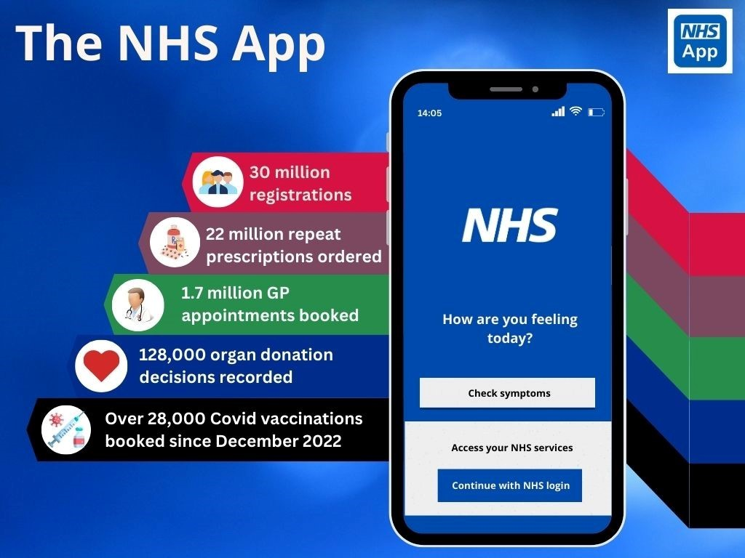
The NHS App and other patient-led digital applications are transforming the efficacy and efficiency of the healthcare system. It serves as a digital gateway to the NHS, facilitating access and enhancing results and service efficiency. People can easily and safely access a variety of NHS services on their smartphone or tablet by using the NHS App (Fig.1 NHS Digital, 2026). The app helps in managing personal health and handles about 4 million requests every month. About three minutes of GP time are saved for every prescription ordered through the app, which is significant in maximising clinical resources and lowering administrative costs (Health Innovative Network, 2024).
Fig.1(NHS Digital, 2026)

Using the Problem-Solution-Outcome Approach, the report will critically assess how the use of NHS App across the health and social care system in UK has affected the workforce, service delivery, patients and service users, and the community. According to the research, the NHS App targets the burden on the healthcare system and gives consumers greater control over their health outcomes by putting a variety of services at their fingertips.

The Problem and the Solution:
According to Wes Streeting, Secretary of Health and Social Care, the NHS appears increasingly outdated and slow to the generation that makes life decisions at the touch of a button. Patients need quick access to their medical records for more proactive care management. Many patients were forced to miss their appointments due to lengthy wait time and barriers to receiving services (Hadley, 2024). Richer people have access to better care and more information about the institutions under the existing system. Everyone, even members of working-class communities, needs access to the information they require regarding their conditions to democratise care (GOV.UK, 2025).
The 10-year Health plan 2019 shows a stark commitment to digitalise health system. NHS App proved to be the most significant step taken to shift analogue to digital transformation. This App targeted to provide health information and access to GP just by a single click. The result was a reduction in waiting times and a rapid patient flow. Digitalisation of health system helped in eliminating disparities that millions of people face by not having access to relevant information and health services that NHS was offering. The NHS App offers people knowledge, choice, and control so they have all the relevant information at their fingertips. "People won't accept paying higher and higher taxes to fund a health service that no longer meets their needs," stated Wes Streeting, the secretary of health and social care (GOV.UK, 2025).

Barriers to Access
Although the Health Plan targets the most crucial health issues the whole system is facing but there are gaps in accessing these technologies. The reliance on this transformation will assist or makes the gap worse it is still needed to be ruled out. Patients, particularly those from vulnerable groups and ethnic minorities, discourage the use of health Apps like NHS App due to concerns about data security and privacy.
The access and affordability of digital tools and platforms is a major barrier to access these innovations. In less privileged areas, people have limited knowledge about the features of the App and they do not know how to seek help. About 7.9 million adults in the UK lack basic digital skills, and 1.6 million do not have a smartphone, tablet, or laptop, and low-income groups do not have access to dependable internet connections due to financial constraints (Laverty et al., 2026; Colivicchi, 2025).

Workforce Outcomes
The NHS App's adoption of digital technology has drastically changed staff responsibilities, productivity, and service delivery in the UK healthcare industry (Mallorie, 2024). With more than 1.4 million employees, the NHS feels an immediate need to develop technologically assisted workforce solutions to reduce staff workloads and improve patient outcomes (NHS Digital, 2024).
Stoumpos, Kitsios, and Talias (2023), claimed in their research that digital technologies help in building sustainable employment models, retain skilled workforce and save working hours. For instance, according to NHS England (2025), the NHS App saved over 400,000 hours of GP time last year (NHS England). Professionals claim that the NHS App and other technology initiatives assisted in increasing GP productivity has modernised general practice (NHS England, 2025). The NHS App and other patient-facing services have already freed up 3.2 million hours of administrative time, 416,000 hours of GP time, and 99,000 hours of nursing time (Colivicchi, 2025). However, this change demand new job skills and competencies different from traditional work attributes, such as data management, digital literacy, and virtual communication skills. In order to develop a future workforce with the appropriate skills and shape, it is imperative to address present and future capability and capacity issues. There is need for training, technical assistance, and alternative management techniques for a robust workforce ready for future (NHS, 2021).

Patient/Service Outcomes
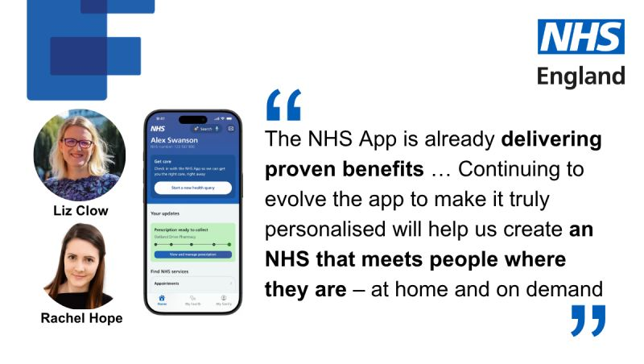

Fig.2 (NHS Transformation Directorate, 2026)
Blog post of Liz Clow (Director Digital Citizen) Rachel Hope (Director Digital Services NHS, England

The NHS App is constantly under the process of development. It gives the user choice, and control over their personal healthcare and assist them with all kind of relevant information needed. The government's 10-year health plan reduces the major health inequities that millions of people experience through digital transformation of the healthcare service like NHS App and other digital healthcare platforms. With a new feature My Choices introduced in the App, users will be able to find the location of their nearest pharmacy and the top doctors for surgeries like knee, hip, or heart. It will give a range of data about healthcare providers across the country, such as which ones have the highest patient satisfaction ratings, the best patient outcomes, and the lowest wait times (GOV.UK, 2025).
According to the most recent data, a record number of people are using the NHS App to manage their health. The NHS claimed that the NHS App currently has over 39 million registered users. From December 2024 to 30 November 2025, 67.8 million repeat prescriptions were ordered through the app. According to the most recent usage statistics, there were 62.3 million NHS App logins in November alone, which is 43% more than the monthly average over the previous 12 months (NHS England, 2025a).
According to NHS England (2025), the app now includes a family feature that helps parents and carers better manage the health of their loved ones, as well as an Amazon-style prescription tracker that is available at almost 2,000 pharmacies and allows patients to see when their medication is ready to be picked up. The NHS App will also play a significant role in the new NHS Online service, scheduled to launch in 2027, will enable patients to make direct online appointments with specialists throughout the nation without having to leave their homes or wait longer for an in-person consultation.
However, the barriers remain in adopting these digital innovations. Digital inclusion is the most crucial component and a key enabler if the government wants to meet its goal of making the NHS App the universal front door to the NHS by 2028. According to latest statistics, in the UK, almost 1.6 million people do not use the internet, including 5% of those in the 50–59 age group and 13% of those in the 60–69 age group. An estimated 23% of people may find it difficult to use online services. The only way to have a digitally equipped NHS is to actively include people in the digital space (The NHS Alliance, 2026).

Service Delivery Outcomes:
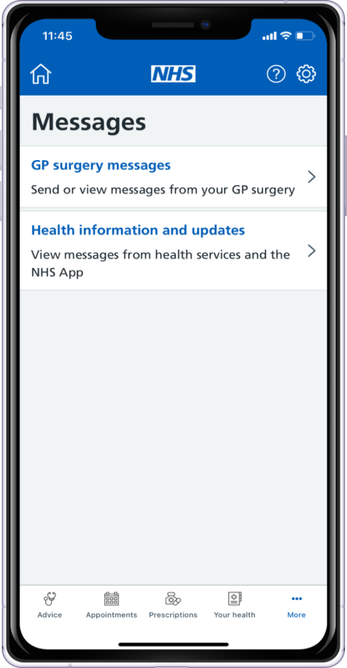
The National Health Service (NHS) App, introduced in 2019 as the "digital front door" to the National Health Service in England. Its primary functions include scheduling appointments with general practitioners (GPs), filling repeat prescriptions, providing patient access to records, and eventually certifying COVID-19 vaccinations (Reidy et al., 2025). To get repeat prescriptions, the user can choose a pharmacy right within the app. To avoid needless travel nominations can be updated on the App, patients are facilitated by the delivery of medicines from the pharmacy closest to their home or from a pharmacy that can deliver. Since the feature was enabled, over 100,000 pharmacy nominations have been submitted (Day, 2020). According to Day (2020), the access to COVID-19 test results are made possible by the testing team in NHS Digital directly through the NHS App. A new concept of a messaging "hub" where various kinds of messages may appear has been incorporated in the app. The users can communicate with their practice which is significant for effective service delivery. The app is working on creating a platform for stakeholder communication with features like Patients Know Best and eConsult. It will provide access to the capability, which can be utilised for online consultations and referral appointment reminders, eliminating additional paper and time wastage from the system.
(Day, 2020).
According to Reidy et al. (2025), the NHS App is a complex innovation in the constantly evolving healthcare industry, therefore it is crucial to work constantly to maintain its potential to satisfy patient, service, and policy demands. However, several barriers limit its equitable use. There was a level of health system literacy needed to fully understand and benefit from the features of the NHS App. Due to the app's requirement for integration and access to many background systems and IT infrastructures, not all users have default access to all functionalities (such as their own health records). Additionally, scheduling appointments and many other features are not available to everyone (Reidy et al., 2025). These inconsistencies highlight a significant gap between the ambition of NHS App and the reality of fragmented service delivery, raising concerns on equity and accessibility.

Impact on Community:
The NHS App opens up entirely new digital care pathways by offering a fundamentally different approach to promoting health and delivering healthcare. With fewer phone calls, less printing costs, and less time spent looking for prescriptions because they can scan digital barcodes, using the app also relieves pressure on GP staff (Rachael, 2025). The NHS App allows users to diagnose, refer, treat, and discharge themselves from digital services. Its effectiveness and benefiting full potential solely rely on digital literacy, engagement and access (Tony Blair Institute, 2025). Having all the information in one place makes it possible to avoid unnecessary medications and have deeper discussions with doctors about how to manage conditions like Parkinson's or diabetes. Patients will be able to utilise a single website to cancel and reschedule appointments, as well as check all of their forthcoming appointments in their health system. This important development opens the door to exciting new developments in the future (Health, 2024). However, consumer-focused design must be its unwavering focus. The ten-year plan is prescriptive regarding the characteristics the App should have, but it’s success or failure depends on how easy, sleek, and convenient the usage is (Tony Blair Institute, 2025).
Data handling is the biggest hurdle in adaptation of these technologies. Patient’s data is needed for both monitoring treatment and planning health services. By striking a balance between security and usability, the NHS App has won the trust of public. The General Data Protection Regulation (GDPR) of 2018 significantly tightens the privacy of the secondary use of patient data (Evans, 2018). The program successfully incorporated NHS login authentication, ensuring secure access while preserving usability—a challenge for many healthcare apps (NHS Digital, 2024). Overall, the NHS App has enhanced communication between patients, families, and healthcare providers by expanding data access and openness. When patients have access to the same information as their physicians, they may make better decisions about their health.
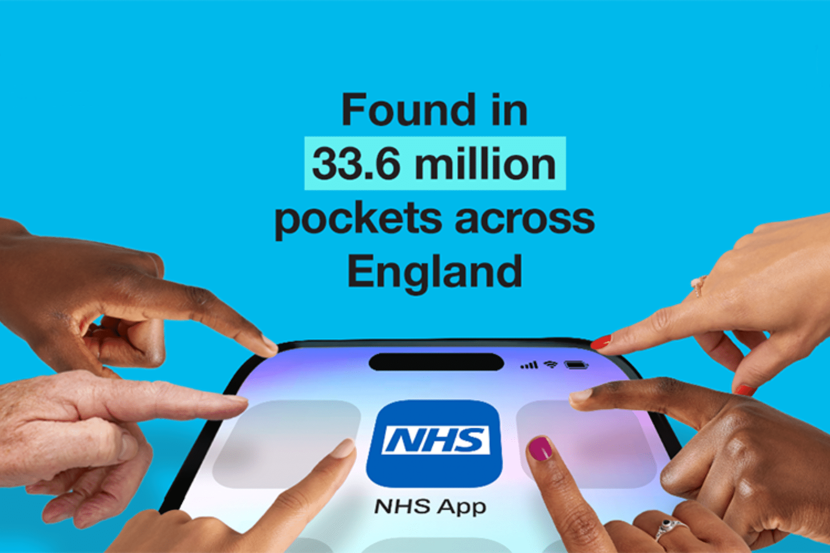

Fig. 3 (Rachael, 2025)

Conclusion:
To sum up, the NHS App is a revolutionary step toward a patient-centred digital health care system. It improved accessibility, lessened burden, and gave patients more control over their medical decisions. But there are still issues with equitable access and digital inclusion. To make it more accessible for underprivileged communities, funding for digital literacy initiatives, improved functionality, and access to stable internet connection is required. The new analysis on patient views of digital access to primary care highlights the importance of aligning digital health solutions with consumer feedback. Patient insights must be integrated into the development of the NHS App to optimise its functionality and ensure that it successfully meets user needs.

Reference list
Colivicchi, A. (2025) NHS App saved 400,000 hours of GP time last year, NHS England claims, Pulse Today. Available at: https://www.pulsetoday.co.uk/news/technology/nhs-app-saved-400000-hours-of-gp-time-last-year-nhs-england-claims/ (Accessed: 12 June 2026).
Day, S. (2020) How the NHS App is upping its game, NHS Digital. Available at: https://digital.nhs.uk/blog/transformation-blog/2020/how-the-nhs-app-is-upping-its-game (Accessed: 18 June 2026).
Evans, H. (2018) Using Data In The NHS: The Implications Of The Opt-Out And GDPR | The King’s Fund, The King’s Fund. Available at: https://www.kingsfund.org.uk/insight-and-analysis/long-reads/using-data-nhs-gdpr#conclusion.
GOV.UK (2025) NHS App overhaul will break down barriers to healthcare and reduce inequalities, GOV.UK. Available at: https://www.gov.uk/government/news/nhs-app-overhaul-will-break-down-barriers-to-healthcare-and-reduce-inequalities.
Hadley, T. (2024) The NHS App and how it is scaling personalised and effective care - Health Innovation Network, Health Innovation Network. Available at: https://healthinnovationnetwork.com/insight/the-nhs-app-and-how-it-is-scaling-personalised-and-effective-care (Accessed: 4 July 2025).
Health Innovative Network (2024) The NHS App and how it is scaling personalised and effective care - Health Innovation Network, Health Innovation Network. Available at: https://healthinnovationnetwork.com/blogs/the-nhs-app-and-how-it-is-scaling-personalised-and-effective-care/.
Health, O. (2024) Using the NHS App and existing tech to empower citizens, Orion Health. Available at: https://orionhealth.com/global/blog/nhs-app-and-existing-tech-to-empower-citizens/.
Laverty, A.A. et al. (2026) ‘The NHS App should focus on inequalities to improve population health’, Journal of the Royal Society of Medicine, 119(2), pp. 37–41. Available at: https://doi.org/10.1177/01410768261421427.
Mallorie, S. (2024) NHS workforce in a nutshell, The King’s Fund. The King’s Fund. Available at: https://www.kingsfund.org.uk/insight-and-analysis/data-and-charts/nhs-workforce-nutshell.
NHS (2021) Data Driven Healthcare in 2030: Transformation Requirements of the NHS Digital Technology and Health Informatics Workforce, Health Education England. Available at: https://www.hee.nhs.uk/our-work/building-our-future-digital-workforce/data-driven-healthcare-2030.
NHS (2026a) Online Access - Patient Access and NHS App, Warwick House Medical Practice. Available at: https://warwickhouse.org.uk/patient-access/ (Accessed: 15 June 2026).
NHS (2026b) Standards for NHS App integration, NHS England Digital. Available at: https://digital.nhs.uk/services/nhs-app/how-to-integrate-with-the-nhs-app/standards-for-nhs-app-integration.
NHS Digital (2024) NHS Workforce Statistics - NHS Digital, NHS Digital. Available at: https://digital.nhs.uk/data-and-information/publications/statistical/nhs-workforce-statistics (Accessed: 18 June 2026).
NHS Digital (2026) NHS App, NHS Digital. Available at: https://digital.nhs.uk/services/nhs-app (Accessed: 8 June 2026).
NHS England (2025a) NHS England» Record numbers using NHS App to manage health, England.nhs.uk. Available at: https://www.england.nhs.uk/2025/12/record-numbers-using-nhs-app-to-manage-health/ (Accessed: 20 June 2026).
NHS England (2025b) NHS England» Review of NHS performance and delivery, England.nhs.uk. Available at: https://www.england.nhs.uk/long-read/review-of-nhs-performance-and-delivery (Accessed: 8 June 2026).
NHS Transformation Directorate (2026) The NHS App, from digital front door to lifelong companion , LinkedIn. Available at: https://www.linkedin.com/posts/nhsapp-analoguetodigital-share-7462146596370157568-85tf/ (Accessed: 8 June 2026).
Popov, V.V. . et al. (2022) ‘Industry 4.0 and Digitalisation in Healthcare’, National Library of Medicine [Preprint]. Available at: https://doi.org/10.3390/ma15062140.
Rachael (2025) Health project helps communities benefit from NHS app - Community First Yorkshire, Community First Yorkshire. Available at: https://www.communityfirstyorkshire.org.uk/health-project-helps-communities-benefit-from-nhs-app/ (Accessed: 8 June 2026).
Reidy, C. et al. (2025) ‘Qualitative evaluation of the implementation and national roll-out of the NHS App in England’, BMC Medicine, 23(1). Available at: https://doi.org/10.1186/s12916-024-03842-w.
Stoumpos, A.I., Kitsios, F. and Talias, M.A. (2023) ‘Digital Transformation in healthcare: Technology Acceptance and Its Applications’, International Journal of Environmental Research and Public Health, 20(4). Available at: https://www.mdpi.com/1660-4601/20/4/3407.
The NHS Alliance (2026) Assessing digital inclusion in the NHS the NHS app, thenhsalliance. Available at: https://thenhsalliance.org/resources/assessing-digital-inclusion-in-the-nhs-the-nhs-app (Accessed: 18 June 2026).
Tony Blair Institute (2025) The NHS at a Crossroads: The App That Can Transform Britain’s Health, Institute.global. Tony Blair Institute. Available at: https://institute.global/insights/public-services/the-nhs-at-a-crossroads-the-app-that-can-transform-britains-health.

