STUDENT NAME: DRAGOS NICOLAE BUCATARU
STUDENT NUMBER:1919242
MODULE TITLE: STRATEGIC MANAGEMENT AND SUSTAINABILITY
ASSESSMENT TYPE: ASSIGNMENT 1
LECTURER NAME: EJIRO ESOHWODE

Strategic Management and Sustainability Assessment 1

Introduction
Strategic management depicts the techniques of setting objectives and goals as well as the techniques that are being used to make the organization more competitive in performance. Strategic management refers to the evaluation of the company's internal methods, resource availability and the internal potential to apprehend the process of its growth. Strategic management refers to the planning, monitoring, assessment and all the requirements that the organisation to meeting to goals and objectives. Sustainability is an important factor in the contemporary business environment and its changes lead to the optimal operations of the business (Sullivan et al., 2018, p.235). The present essay refers to the analysis and evaluates the various aspects of the Volkswagen case study and the recommendations for future career goals.
Overview of the case study
The case study focuses on the operational failures of VW in England. The company had to depend $ 216 m from various drivers in England and Wales due to the failure of the claim of establishing emission cheat devices in its vehicles (Volkswagen Group homepage, 2022). The company failed because it cannot maintain the right and proper standards for the level of nitrogen emissions. But it implemented false techniques to handle the pollution standards. For example, the sustainability scoring of its vehicle was faked which infringes the consumer's code of trust. Due to the failure of the trust of the consumers, the company had to face trials in the High Court and was also forced to pay compensation for the damage to the claimants.

Discussion
Key Business strategies used by VW over the past five years through the use of the relevant framework explain and justify its use
Volkswagen’s strategic journey in the past five years depending on the sustainability ideas of the business development which is driven by transitions from the conventions combustion engine models to cars of the zero-emission. Further, the zeal to achieve a competitive value in the sector the company has managed to undergo various strategic changes that sometimes lead to the expense of quality (Calabrese et al.,2019, p.155).The various strategies has been used by Volkswagen over the past years and the investigation of the different tools of business analysis has also been analysed.
Ansoff Matrix
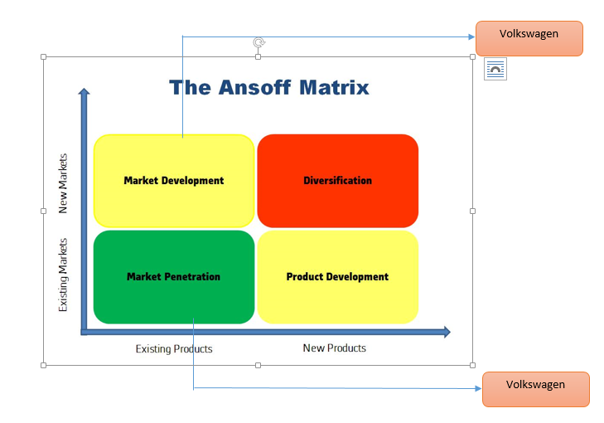
Figure 1: Ansoff matrix
(Source: Developed by author)
The company had developed a corporate-wide strategy since 2019 which highlighted making the company the most demanding and fascinating vehicle in 2019. In order to gain this purpose the company put forward technology and innovations as the mode of strategic tools. Further, the company tapped its resource potential of big data to classify and define its growth and success (Shad et al., 2019, p.415). The evaluation of this manual guide of VW is to be made against the dimensions of the strategy or the strategy dimensions that are being laid under the Ansoff Matrix.
The Ansoff Matrix specialises in four separate categories of market development, product diversification and development, and market penetration. The strategic journey of the company in the past five years has been inspired by the dimensions of product diversification and market penetration (Rossi et al., 2020, p.119). The company is evident to achieve higher market share in the current or the existing market of UK through the implementation of product diversification as the tool of development. The company introduced different models of its name which had its alignment with the products needs of the UK market. VW Jetta and VW polo are some of the essential products that the company spread in the market for attaining higher results.

Porter's Generic Strategy
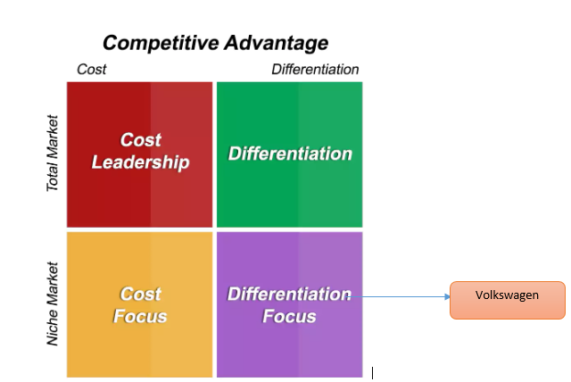
Figure 2: Porter’s generic strategy
(Source: Developed by author)
Porter’s generic strategy is another business analytical tool that is being used to understand the pattern of strategic direction journey by an organisation. It emphasises on the division of the strategic dimensions based on the advances of the market scope and its dependence in gaining competitive value (Gil-Gomez et al., 2020, p.273). The four key strategies are cost focus, differentiation, leadership, and differentiation focus. Each strategic dimension has a separate value linked with the application which plays a significant role in business development. VW has been focused on providing revenue by accessing its market capability. To gain this the company has been enhancing the incorporation of differentiation as the strategic direction. This is evaluated through developing differentiation items in the current market. Porter’s generic strategy is usually referred by the combination or the association with the Ansoff matrix of business development. The merged analysis of these tools elucidates the company's various dimensions of the strategic journey over the last five years to achieve higher market access. Further implementing of engine efficiency and by the reduction of their emission and pollutants volume, the company enables to bring variations of its product quantity.
Identification of their resources and the capabilities of the case study compared over the past five years
Financial | The sale revenue of the company has increased by 9% to 91.1 billion Euros as the firm as gained a return on sales of 4.3%which has risen of 06% from 2021. The company has been developing globally and it has its various investor portfolio which has been its major financial strength.
Operational | The company works on 140 production plants in 17 European countries and it sells its machines or vehicles over 157 distinct areas over the globe. Further, it has various brands under its own brand name such as Bentley, SKODA, commercial vehicles and Lamborghini.
Human Resource | The present employee number of VW is estimated to be 656, 585 which includes different members from various backgrounds. The existence of an innovative and technologically inclined employee base caters to drive the company towards its strategic direction progression.
Intangible | Higher brand Identification and goodwill of the company are regarded as the intangible assets in the resource potential of the company. The company had reported as an aggregate of 24,318m GBP in 2021 under the goodwill by working dimensions in its annual track record.

VRIO

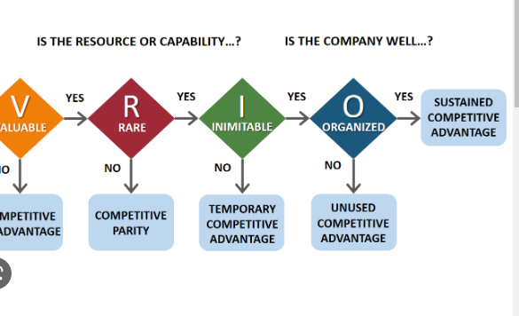
Figure 3: VRIO Framework
(Source: Banalysis, 2022)

Attributes | Valuable | Rare | Immutable | Organizational Capability | Competitive Advantage
Resources | Yes | Yes | No | Gives operational stability and strength in functionality | Providing the firm to strategically place itself in the automotive industry.
Sustainability Stategy | Yes | No | Yes | Gives the company with the potential to diversify its products to enable consumer choices | Provides the enhancement of the market outreach of the company.
Consumer Base | Yes | No | Yes | The loyalty of the brand identification is generated. | Needs to achieve higher brand identification and recognition in the industry.

Analysis of the extent to which the company has aligned its resources and capabilities to its current business strategies
The resource potential of the company has been analysed through the use of various analytical tools as well as directions of resource allocation (Armenia et al., 2019, p.266). VW's major strength depends on its consumer base which is implemented by the building of trust and virtue. It is discussed in the case study that the company's consumer base is losing its trust towards its brand value due to false techniques and the infringement of the product in the competitive market. Hence to change the brand image the company in order to understand what leads to the loss of faith of the customers towards its product. The company faced six months of prudent trial in English courts and was settled for making payments worth $ 216m to the claimants However, the company is still in the strategic value place because of its relevance operational regarding operational and financial. As discussed above VW has operational plants near European Nations which gives it higher authority and power in the automobile supply chain in UK.
Value Chain Analysis
Value Chain Analysis is a tool that emphasises on the evaluation and identification of each of the company's behaviour to understand where opportunities lie (Yong et al., 2020, p.212). The primary behaviour of VW is dependent on the manufacture of automobiles, production, and management of inbound and outbound logistics. Consequently, this domain emphasises on the activities which the company implements in relation to sales and marketing services. Furthermore, the support behaviours of the firm are majority HRM, procurement of the raw materials by executing a global chain, technology development using big data and the maintenance of the firm infrastructure. The united use of these two activities provides the firm to maintain and generate profit margins in its operations.
Financial | It is an important part of the support behaviour of the firm where it handles and manages its investor relations and maintains a steady supply of funds to drive its primary activities.
Operational | Operation resources rely or depend upon the categories of the primary activities which are mainly specified as the logistics of the company’s finished items, production procurement and as well as raw material supply.
Human Resource | The HR and the employee potential is a part to support various activities. Volkswagen implements a regionalized structure of recruitment through local employees to apprehend its cultural coherence in the market. (Barykin et al.,2021, p 321)
Intangible Resources | Intangible resources are not included in the value chain but they however plays a significant role in understanding the profit margins of the company and maintaining its brand value as well as the sales figures of the company

Evaluation of the manner in which VW has tried to become more competitive while taking into consideration sustainability and the environment
VW's current strategic journey is focussed on the execution and achievement of "New Auto- Mobility for the generation to come". The group strategy entails on enhancing the sustainability dimension of the firm and generating its position on a zero-emission automotive company. The company has been funding extensively in the R&D segment to enhance electric vehicles that can help the business in combination with the SDG goals of sustainable development. The achievement of the strategic journey is understood through the engagement of several initiatives of the new auto strategy (Moutinho et al., 2018).
Battery: The development of EV automobiles needs a regular supply of efficient batteries as well as procurement which the companies plan to develop in the Cell using the battery strategy initiative. This requires the engagement of various experts from the field which efficiently guides the transformation.
Software: Software-based consumer-enabled automated vehicles or driver-assisting software are in the development phases. The company has to engage in the development of the CARIAD's new software architecture E 2.0 to enhance the efficiency of the process.
Charging: The attainment of the charging process is to be implemented through successful synergies between various brands and the discovery of a comprehensive charging network across the world (Ferreira et al., 2018).
Mechatronics: The Company is planning to adopt substantial alterations in its product development and has implemented a standard platform named SSP or Scalable Systems Platforms. Through this the company assist its synergy effects, paced transitioning, reduced investments and new technology advancements.
Mobility Solutions: The theme of the company is “ Mobility for generations to come”, which is encountered by adopting global trends patterns and alteration of consumer preferences.
Business Model: The Company emphasises on engaging in connection with the customers through the vehicle lifestyle. This can help the firm in enhancing its consumer base and as well as the service quality to match the requirements of the product.

BCG matrix
The BCG matrix is the growth-share matrix which guides business effectively to handle and manage their portfolios and emphasize how to prioritise their different business units. The model has four separate quadrants of the cash cow, star, pet and question mark. Each of these departments plays a significant role in the evaluation of the product or service value of the company's differentiated portfolio of offerings (Hunger et al., 2020)

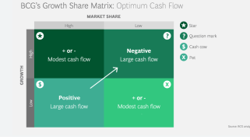
Figure 3: BCG matrix
(Source: BCG, 2022)
Question marks (Low share, high growth) the traditional model combustible engine vehicles faced several loopholes in the UK market and also failed to maintain the standard emission standards that are prescribed by the government. The products of VW Management are replaced across the worldwide market as they are hindering the company's brand value.
Cash Cows (High Share, Low Growth): Products of VW that come under this category give the company revenues that can be implemented to dive into other developmental behaviours of the business. The Jetta and VW are some of the company's products that come under this category.
Pets (Low Share, Low growth): The items or products of VW failed to cater to the needs of the consumer choices and preferences of the market demands under this category. Production of these units has been eliminated and the liquidation or divestment is to be fulfilled.
Stars (High Share, High Growth): The product portfolio of VW conveys that automobiles have great future career goals. Zero emissions and automated vehicles EV by VW come under this category (Johnsen et al., 2018).
Recommendations
It is recommended the green economics theory should helped to enhance growth opportunities in employment and the income is fuelled by private and public investments. The behaviour of economic development and the advancement of the infrastructure is to be carried out in a way that justifies the proper usage of the resources as well the prevention and protection of the environment. The strategic journey of VW in the current times is encountered by the inclination towards sustainability and its future implications of the successful theme of "New Auto-Mobility for generations to come " by 2032. It is suggested that the company plans to make important changes and as well as important transitions in its product portfolio to gain this purpose. However as evaluated from the case study and the company's reports, it has been apprehended that the firm is planning to make a substantial change in the product or the outside outlook of the business. This highlights its focus on making alterations in the production and as well as the output process which is referred to as relatively low. The company's brand image was hampered and it suffered a setback because it proved to be causing harm to the environment and it suffered accusations which is related to false equipment installation. To solve this issue, a three-fold approach of sustainability in production, quality maintenance and the enhanced focus on the customer relationship is implemented by the firm. The first strategy is recommended the firm to set appropriate standard methods to evaluate product efficiency before launching in the market. This approach will help in maintaining sustainability in the operation of the competitive market demand. This strategy can help the firm to reduce its carbon footprint and emissions on the planet striking to maintain a balance between the company and the environment. Consequently, it recommended that the company in encountering brand trust, goodwill of the company, and as well as community relationships. The customer relationship can also be developed and as well as improved through the amalgamation of the different consumer feedbacks for enhancing consumer experience through the life cycle of the vehicle. It is suggested that following various environmental friendly vehicles it can contribute to the positive outlook to the environment.
Conclusion
The current study refers to the comprehensive impact of the infringement or the violation of sustainable practices in product quality on the functioning and the operations of VW. The company’s strategic journey in the past five years has been evaluated and analysed by the strategic directions used of the firm. A detailed analysis of the various strategic business tools adopted by the company is also discussed. The future implications of the firm towards the environment and its approaches to sustainability measures have also been analysed. Through the recommendations, a higher attain of the sustainability inclination in future has also been analysed and evaluated.

References
Journals
Armenia, S., Dangelico, R.M., Nonino, F. and Pompei, A., 2019. Sustainable project management: A conceptualization-oriented review and a framework proposal for future studies. Sustainability, 11(9), p.266.https://www.mdpi.com/459616
Bai, C.A., Cordeiro, J. and Sarkis, J., 2020. Blockchain technology: Business, strategy, the environment, and sustainability. Business Strategy and the Environment, 29(1), pp.321-322. https://www.researchgate.net/profile/Joseph-Sarkis/publication/338146121_Blockchain_technology_Business_strategy_the_environment_and_sustainability/links/5e0ded73a6fdcc2837512a47/Blockchain-technology-Business-strategy-the-environment-and-sustainability.pdf
Barykin, S., Kapustina, I., Sergeev, S., Kalinina, O., Vilken, V., De la Poza, E., Putikhin, Y. and Volkova, L., 2021. Developing the physical distribution digital twin model within the trade network. Academy of Strategic Management Journal, 20(1), pp.1-24.https://riunet.upv.es/handle/10251/183983
Calabrese, A., Costa, R., Levialdi, N. and Menichini, T., 2019. Integrating sustainability into strategic decision-making: A fuzzy AHP method for the selection of relevant sustainability issues. Technological Forecasting and Social Change, 139, pp.155-168.https://www.sciencedirect.com/science/article/pii/S0040162518303676
Ferreira, J., Mueller, J. and Papa, A., 2018. Strategic knowledge management: theory, practice and future challenges. Journal of knowledge management.https://www.emerald.com/insight/content/doi/10.1108/JKM-07-2018-0461/full/htmlInvestment
Gil-Gomez, H., Guerola-Navarro, V., Oltra-Badenes, R. and Lozano-Quilis, J.A., 2020. Customer relationship management: digital transformation and sustainable business model innovation. Economic research-Ekonomska istraživanja, 33(1), pp.273-275https://hrcak.srce.hr/file/370046https://www.researchgate.net/profile/Joseph-Sarkis/publication/338146121_Blockchain_technology_Business_strategy_the_environment_and_sustainability/links/5e0ded73a6fdcc2837512a47/Blockchain-technology-Business-strategy-the-environment-and-sustainability.pdf
Hitt, M.A., Ireland, R.D. and Hoskisson, R.E., 2019. Strategic management: Concepts and cases: Competitiveness and globalization. Cengage Learning. https://books.google.com/books?hl=en&lr=&id=WbWLDwAAQBAJ&oi=fnd&pg=PP1&dq=Strategic+management+and+sustainability+in+business&ots=uTuZ19R4GZ&sig=KCSJE35IMOJUjvhFIHI1
Hunger, J.D., 2020. Essentials of strategic management.http://elibrary.gci.edu.np/bitstream/123456789/718/1/BM%20-542%20Essentials%20of%20Strategic%20Management%2C%205th%20Edition%20by%20J.%20David%20Hunger%2C%20Thomas%20L.%20Wheelen.pdf
Johnsen, T.E., Howard, M. and Miemczyk, J., 2018. Purchasing and supply chain management: A sustainability perspective. Routledge.https://www.taylorfrancis.com/books/mono/10.4324/9781315160245/purchasing-supply-chain-management-thomas-johnsen-mickey-howard-joe-miemczyk
Moutinho, L. and Vargas-Sanchez, A. eds., 2018. Strategic management in tourism, cabi tourism texts. Cabi.https://books.google.com/books?hl=en&lr=&id=u3tSDwAAQBAJ&oi=fnd&pg=PR5&dq=Strategic+management+and+sustainability&ots=sum5QjBpfX&sig=EpNMtx29FRZXvNS9g9rXSguHph
Rossi, E., Bertassini, A.C., dos Santos Ferreira, C., do Amaral, W.A.N. and Ometto, A.R., 2020. Circular economy indicators for organizations considering sustainability and business models: Plastic, textile and electro-electronic cases. Journal of Cleaner Production, 247, p.119.https://www.sciencedirect.com/science/article/pii/S09596526193400
Shad, M.K., Lai, F.W., Fatt, C.L., Klemeš, J.J. and Bokhari, A., 2019. Integrating sustainability reporting into enterprise risk management and its relationship with business performance: A conceptual framework. Journal of Cleaner production, 208, pp.415-425.https://www.sciencedirect.com/science/article/pii/S0959652618331366
Sullivan, K., Thomas, S. and Rosano, M., 2018. Using industrial ecology and strategic management concepts to pursue Sustainable Development Goals. journal of cleaner production, 174, pp.237-246.https://www.sciencedirect.com/science/article/pii/S0959652617325106
Yong, J.Y., Yusliza, M.Y., Ramayah, T., Chiappetta Jabbour, C.J., Sehnem, S. and Mani, V., 2020. Pathways towards sustainability in manufacturing organizations: Empirical evidence on the role of green human resource management. Business Strategy and the Environment, 29(1), pp.212-228.https://onlinelibrary.wiley.com/doi/abs/10.1002/bse.2359
Websites
BCG (2022), What is the growth share matrix Global. Available at: https://www.bcg.com/about/overview/our-history/growth-share-matrix (Accessed: December 14, 2022).
Volkswagen Group homepage (2022) Volkswagen Group Homepage. Available at: https://www.volkswagenag.com/ (Accessed: December 14, 2022).

