
Effective Teamwork and Communication
BMSW4002_LON
Lecturer Saqib Shamim

Presented by: Maria Ignat (2028345)
Mihai Cicu (2028265)
Lavinia Bulete (2027951)
Mihaita Niculae (2028439)
Mohammad Hasanuzzaman (2028345)
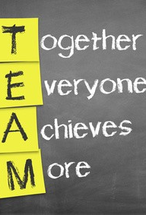Introduction to Benefits of Team Working:
Global HR Services

The four letters of the word TEAM best explain the benefits of Teamwork
T=Together
E=Each
A-Achieve
M=More
What are the benefits of Teamwork?
For Employees
Tasks are completed more quickly
Greater job satisfaction
Work is often more enjoyable – happier workplace
Ability to draw on other people's experiences and ideas
Getting support in the workplace
For Employer
Improved production and higher staff morale
Reduced staff turnover
Increased profits and product quality

Features of Good Teamwork
Positive Attitude from all team members
Tolerance, Honesty and Respect
Co-Operation
Commitment and Dedication
Trust and Support for each team member
Team members take pride in the teams' achievements and accept credit as a group rather than individuals
Sense of Humor

The Qualities of a Team
People listen to each other
People share ideas
People use time effectively
Problems are solved together
People communicate with each other
Tolerance
People make decisions together
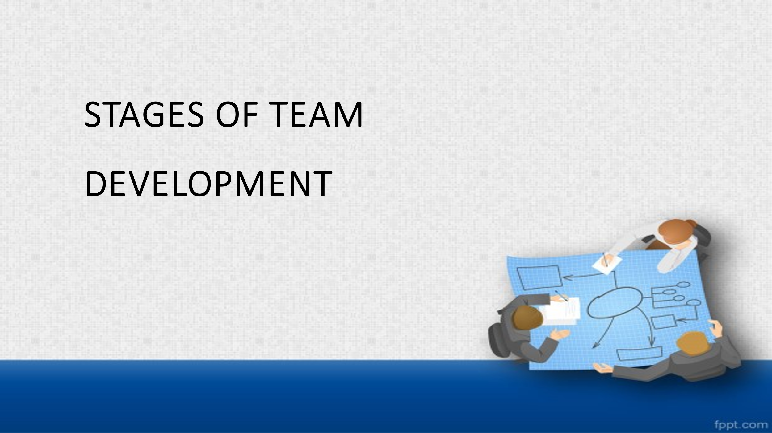


- This step is sprinkled by anticipation and excitement
- Group members stay always excited (Lacerenza et al. 2018)
- Everyone tries to put their best foot forward
- Every member sees their role from the view of independent performance

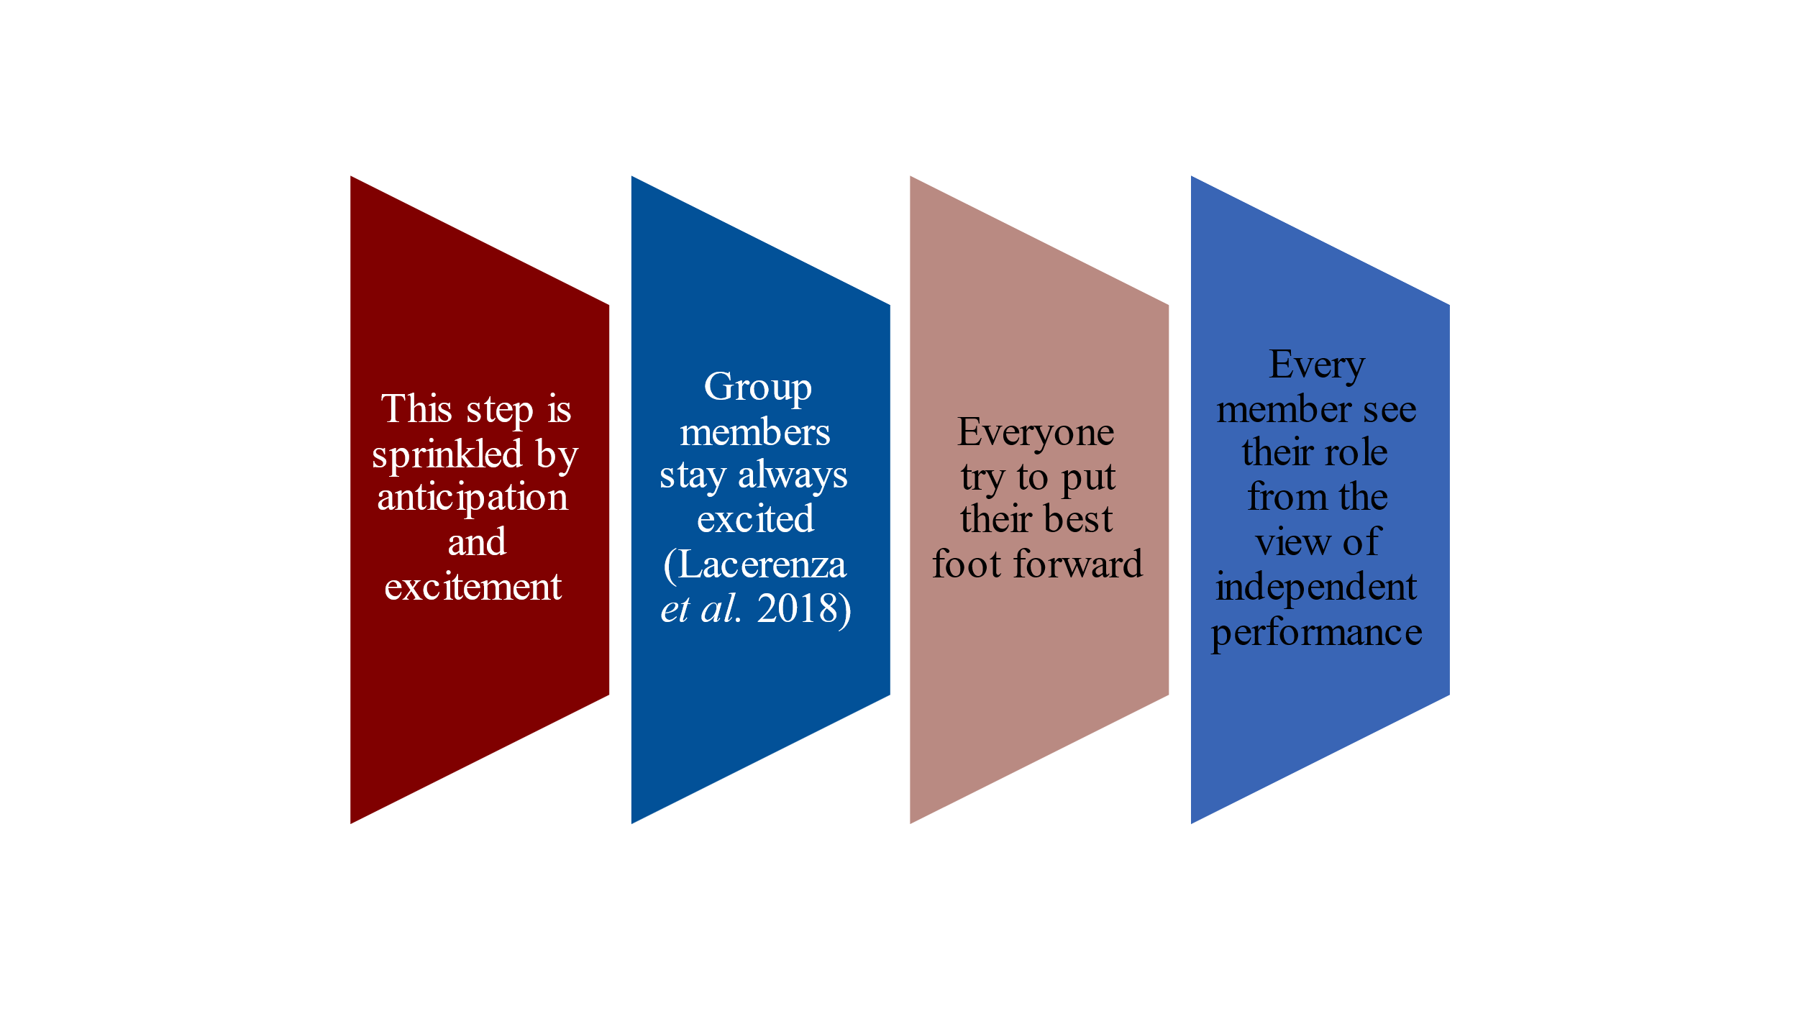
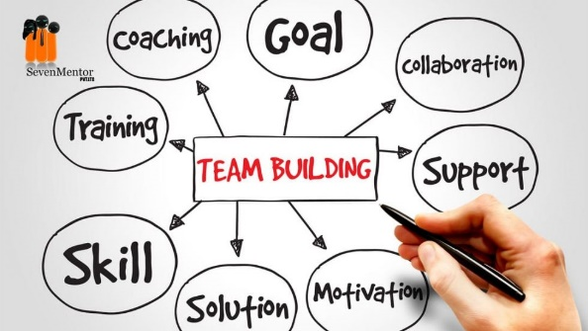
- Team members start sorting things in between.
- Start recognizing contributions of other members (Reyes et al. 2018).
- The performance of the team increases.

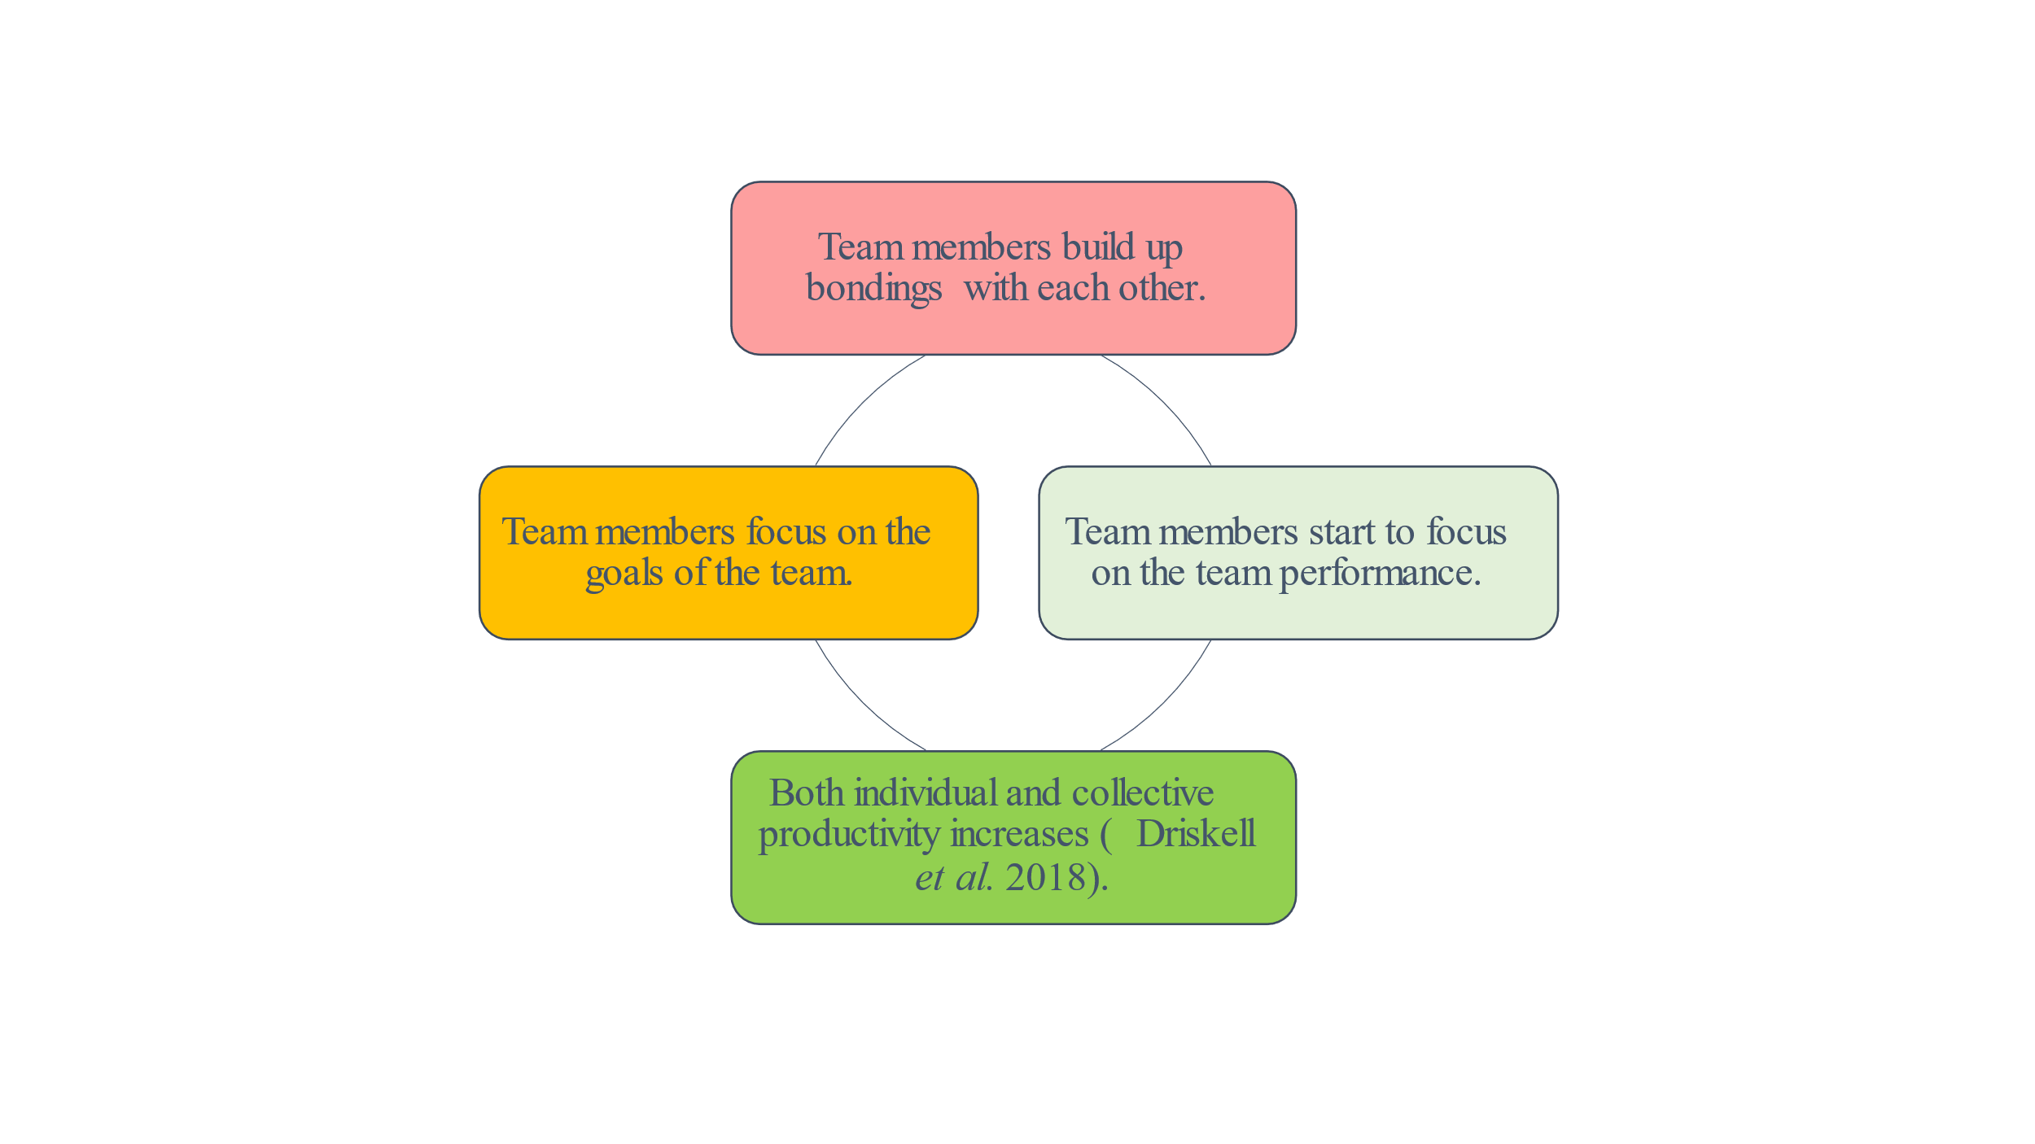
- Members start concluding the functions.
- Members concentrate on completing the deliverables.
- Members start to finalize the documentation.
- Members concentrate to finalize the required documents (Morgan et al. 2021).
- Members start to look forward to the new assignments.
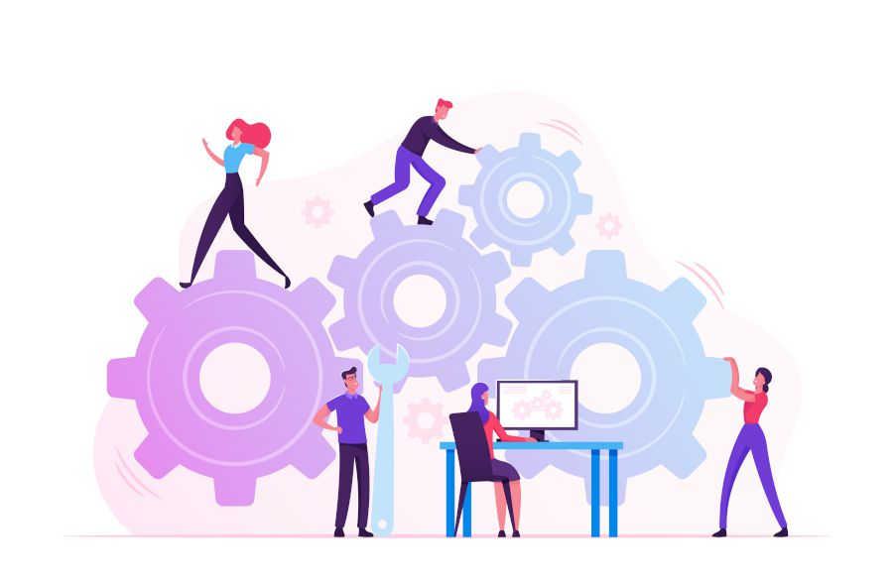
TEAM ROLES
- Creativity, imagination, able to solve difficult problems
- Enthusiasm, communication, search-friendly occasions, he makes useful links
- Dynamism, oriented perseverance, courage in overcoming obstacles, faces pressures
- Discipline, seriousness, efficiency, initiate practical measures
- Methodical and conscientious attitude, detect errors and omissions, meet deadlines

The role of individual profiles within a team can determine areas that need to be developed to improve individual performance. The first starting point is to compare the team profile with the type of work you are currently doing that requires this type of contribution. Not surprisingly, we may need to develop some secondary roles.
This means that we need to tackle the aspects of our work that those roles require. Once you understand the types of skills required for the tasks they perform and the specific actions of the team's role, you need to decide in which direction to develop and the best way to achieve this.
This decision is especially important when discussing future career steps and future requirements.

Lavinia Bulete
Current position: Financial Director
Previous position: Financial Director
Main profile: TEAM WORKER (TW)
Side profile: MONITOR EVALUATOR (ME), SHAPER (SH)
TW is the one that supports the team the most.
Financial Director Officer:
- good mental skills,
- keep the team together
- helps others
- open to new idea
working under stress

Maria Ignat
Current position: Economist
Previous position: Economist
Main profile: RESOURCE INVESTIGATOR (RE)
Side profile: PLANT (PL)
In this case PL is the role to focus on, as every team needs a new team idea. In addition, she acts in an original and radical style and is recommended for the team facing financial problems and company problems.

Mihai Cicu
Current position: Accountant
Previous position: Accountant
Main profile: IMPLEMENTER (IMP)
Side profile: COMPLETER-FINISHER (CF), MONITOR EVALUATOR (ME)
- a great self-control
- disciplined
- work hard and address the problems in a systematic manner

Mihaita Niculae
Current position: Economist
Previous position: Economist
Main profile: MONITOR EVALUATOR (ME)
Side profile: IMPLEMENTOR (IMP), COORDINATOR (CO), PLANT (PL)
- always tries to support the team
- ensure greater unity within the group and durability over time

Mohammad Hasanuzzaman
Current position: Secretary – HR Inspector
Previous position: Referee Database
Main profile: COMPLETER FINSHER (CF)
Side profile: TEAM WORKER (TW), MONITOR EVALUATOR (ME)
- meeting deadlines and program fulfilling

Conflict management
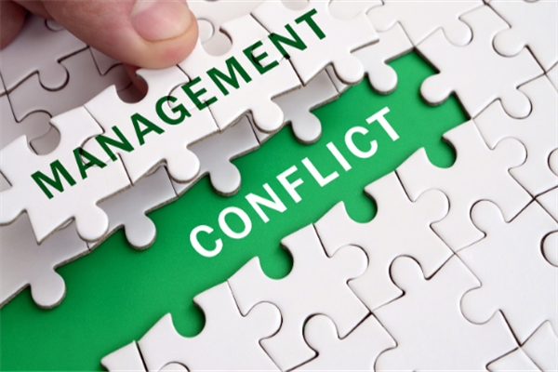
Table of Contents
- Introduction
- Conflict management
- Thomas–Kilmann Conflict Mode Instrument
- Recommendations
- Conclusion
- Reference List

Introduction
- The presentation has been prepared to demonstrate the conflict management in Human Resource
- In the conflict management leaders of the company plays an important role
- HR management team need to implement policies against the conflicts so that employees must think twice before indulging into any conflicts (Sara et al., 2021)
- Human Resource can implement Thomas–Kilmann’s model in order to manage conflicts
- In a group environment managing conflicts properly improves the productivity of the company (Lacerenza et al., 2018)


Thomas–Kilmann Conflict Mode Instrument
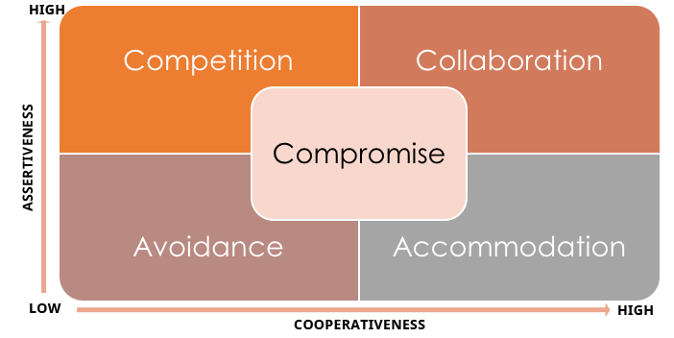
- This framework is very much beneficial in reducing conflicts within Human Resource as it provides five methods of managing the conflict
- Collaborating with active communication makes both parties happy and solutions are easily found (Ibrahim et al., 2020)
- In some cases, avoiding is the best that can be taken for conflict management
- Being generous and accommodating the matter by one of the parties will do no harm for anyone
- In worst case competition need to be use for managing this and compromising is the most productive method of conflict management (Ibrahim et al., 2020)
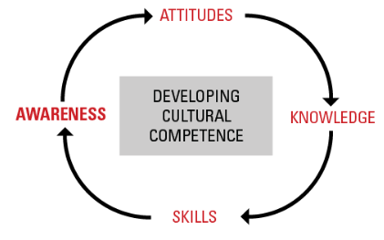
- One of the major reasons for conflicts in Human Resource is cross cultural differences. Therefore, it can be recommended to the HR managers to implement proper training facilities for developing cross cultural competencies (Kruse et al., 2018)
- Having acceptance attitude among employees is very important for managing these issues (Papadonikolaki et al., 2019)
- It can be suggested that employees practice active listening skills for communicating in better way that avoids conflicts
- A respective and inclusive culture need to be developed within the organisation for avoiding conflicts
- Developing resilience skills among worker is essential (Papadonikolaki et al., 2019)
Conclusion
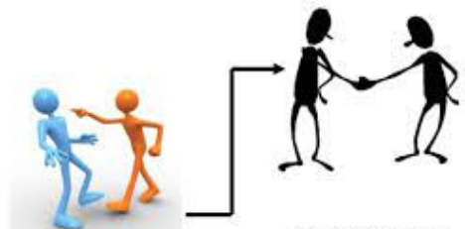
- It can be easily concluded that conflict management in Human Resource is important for enhancing their productivity.
- It will help in creating positive work environment where every employee will enjoy working
- HRM team along with leaders of Human Resource play the major role in conflict management
- Conflict management helps in creating a positive brand image of the company in society (Zhou and Ki, 2018)
- Thomas–Kilmann Conflict framework gives innovative idea for conflict management
Benefits of teamwork
- In the professional environment, employees are mostly suggested to work in groups so that the tasks that are assigned to them can be finished within a possible deadline.
- Working together helps people to generate more ideas and showcase more creativity in work.
- Teamwork also provides better results as the discussed ideas are well furnished by the team members.

(Coetzer and Trimble, 2011)
Stages of team development
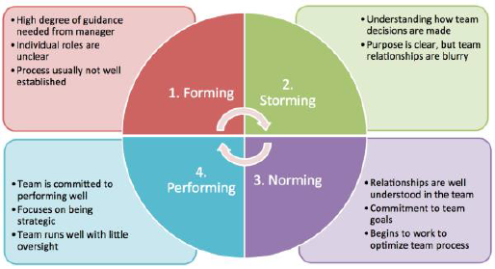

Stages of team development
In the first step of developing a team, forming is necessary. The first step requires forming a team with different members with different skillsets and the minimum synchronization among them. The first step requires high degree of guidance from the managers since the coordination of the team members are not well established at this stage. The team members need to focus on the decisions an instruction of the manager and follow central instructions in order to work together as a team.
(Eriksen, 2012).

Team Roles
- Belbin has developed a team role model that is popular all over the world. The model includes different roles for a different set of people who can form an effective team.
- The role of a Plant in a team is to create, imagine problem-solving. The role is for people who have a creative mind that can shape works that are assigned to the team in a way that makes it easier for other people to approach the work in a structured way.
(Harrington and Lewis, 2014).

Managing Team Conflict
- Guidance of manager: Proper guidance and overview of work from the manager often solves a lot of miscommunications and conflicts of a team. If one member tries to take a decision which another one opposes, the manager needs to come forward and make a decision for the team so that no conflict arises. Here, the manager needs to be diplomatic and should not hold any bias towards any teammate.

(van Donk and Esser, 2019).
- Building an empathetic culture: Building an empathetic culture in the team helps all the team members to consider and value the opinions of the team members and make the teamwork more efficient by thinking and executing tasks from a neutral point of view.

Conclusion
Effective teamwork and proper communication can make works easier for organizations and businesses. The core feature of doing works effectively is to develop a team full of unique roles that can form the perfect combination of approaching works and getting tasks done in due time
(Zedeck, 2019).
Reference List
- www.slideplayer.com (Effective Teamwork Team Building)
Published by Christopher Palmer.
- Lacerenza, C.N., Marlow, S.L., Tannenbaum, S.I. and Salas, E., 2018. Team development interventions: Evidence-based approaches for improving teamwork. American Psychologist, 73(4), p.517.
- Peralta, C.F., Lourenço, P.R., Lopes, P.N., Baptista, C. and Pais, L., 2018. Team development: definition, measurement and relationships with team effectiveness. Human Performance, 31(2), pp.97-124.
- Reyes, D.L., Tannenbaum, S.I. and Salas, E., 2018. Team development: The power of debriefing. People & Strategy, 41(2), pp.46-52.
- Driskell, T., Salas, E. and Driskell, J.E., 2018. Teams in extreme environments: Alterations in team development and teamwork. Human Resource Management Review, 28(4), pp.434-449.
- Morgan, S.E., Mosser, A., Ahn, S., Harrison, T.R., Wang, J., Huang, Q., Reynolds, A., Mao, B. and Bixby, J.L., 2021. Developing and evaluating a team development intervention to support interdisciplinary teams. Journal of clinical and translational science, 5(1).

- http://www.belbin.com/rte.asp
- http://www.belbin.com/rte.asp?id=8
- http://ro.wikipedia.org/wiki/Meredith_Belbin
- http://www.rosscon.ro/BelbinTeamRoles.asp

- Caputo, A., Marzi, G., Pellegrini, M.M. and Rialti, R., 2018. Conflict management in family businesses: A bibliometric analysis and systematic literature review. International Journal of Conflict Management.
- Ibrahim, S.A., Mohamed, H.A. and El-Gazar, H.E., 2020. Conflict Management Strategies Utilized by Nurse Managers and its Relationship to Vertical Dyad Linkage with Nurses. Port Said Scientific Journal of Nursing, 7(2), pp.1-19.
- Kruse, S.D., Rakha, S. and Calderone, S., 2018. Developing cultural competency in higher education: An agenda for practice. Teaching in Higher Education, 23(6), pp.733-750.
- Lacerenza, C.N., Marlow, S.L., Tannenbaum, S.I. and Salas, E., 2018. Team development interventions: Evidence-based approaches for improving teamwork. American Psychologist, 73(4), p.517.
- Sara, I., SAPUTRA, K.A.K. and Utama, I.W.K.J., 2021. The effects of strategic planning, human resource and asset management on economic productivity: A case study in Indonesia. The Journal of Asian Finance, Economics and Business, 8(4), pp.381-389.
- Zhou, Z. and Ki, E.J., 2018. Exploring the role of CSR fit and the length of CSR involvement in routine business and corporate crises settings. Public Relations Review, 44(1), pp.75-83.



