

Postgraduate/Distance Learning
Assignment coversheet & feedback form

THIS SHEET MUST BE THE FIRST PAGE OF THE ASSIGNMENT YOU ARE SUBMITTING (DO NOT SEND AS A SEPARATE FILE)

For completion by the student:
Student Name: Natalie Copeland

Student University Email: 2234147@student.uwtsd.ac.uk
Module code: HPCA7015  Module title: Foundations in Cultural Astronomy and Astrology | Student ID number: 2234147 |  |  | Educational support needs:  Yes/No
Assignment title: 2000 word essay on a topic in the subject area

Assignment due date: November 30, 2023
This assignment is for the 1st 2nd 3rd 4th 5th 6th module of the degree
I confirm that this is my original work and that I have adhered to the University policy on plagiarism.
Signed Natalie Copeland
Email submission: if you are submitting this form via email, please tick this box □
(as a substitute for your signature) to confirm that you agree to the above declaration.
Assignment Mark
1st Marker’s Provisional mark
2nd Marker’s/Moderator’s provisional mark
External Examiner’s mark (if relevant)
Final Mark

NB. All marks are provisional until confirmed by the Final Examination Board.

ALL COMMENTS ARE ON THE PDF OF YOUR PAPER IN TURNITIN

For completion by Marker 1 :
Comments:

Marker’s signature: |  |  | Date:
For completion by Marker 2/Moderator:

Comments:

Marker’s Signature: |  | Date:
External Examiner’s comments (if relevant)

External Examiner’s Signature: |  | Date:

2000 word essay on a topic in the subject area
Word Count: 2080

This essay is an exploration of my sky journal, which chronicles the phenomenon of twilight during October and November 2023 in and around Seattle, Washington. I am accustomed to taking copious nature photos and voice-to-text notes with my Google Pixel phone on my neighborhood walks, so I chose these same tools for this project. I began by noting my observations at all times of day, from planets to eclipses. However, I was consistently able to walk in the twilight, and it was this that inspired me the most. Prominent themes that arose from this journal were light quality, crepuscular creatures, and liminality. This essay examines these themes within the context of the following quote from Dutch painter Vincent Van Gogh’s letters: ‘Be clearly aware of the stars and infinity on high. Then life seems most enchanted after all.’ Using this quote, my sky journal, and secondary sources, this essay will paint a picture of my inner world at twilight, beginning with the light itself.

Light Quality

The quality of light in the sky has many aspects: color, direction, and luminosity; all of which change dramatically in the hours before and after sunset. The prominence of this theme was no surprise to me - light quality has always been a fascination of mine. My first career was in theatre, which allowed me to design and enact fantasies in giant dioramas of light and shadow. I also stated in a previous nature notebook on January 1, 2022, that ‘a lot of my walks [last year] occurred in the dusk - I like the way light, or lack of light, can open a portal to the magical world.’ With this foundation, I set upon my sky journal. On October 26, I wrote the following:

This evening the sun is obscured by low clouds and some trees on the western horizon, but I can see some higher, closer clouds reflecting the sunlight, and it is brilliant. In the moment, I can’t help adoring the color differences on the tops and bottoms of the clouds - the loveliest golden orange I’ve ever seen, and a sleepy purple. The sky is most colorful when there’s a ‘goldilocks of clouds’ - not so many as to block out the sun, and not so few as to give its light nothing to play with. I want to say the sky is dusky, but of course it is because it is dusk. How do I describe it then? The gradient tonight is less pink, and more orange, leaving the contrasting blue left in the sky looking muted, almost greened. (Fig. 1)

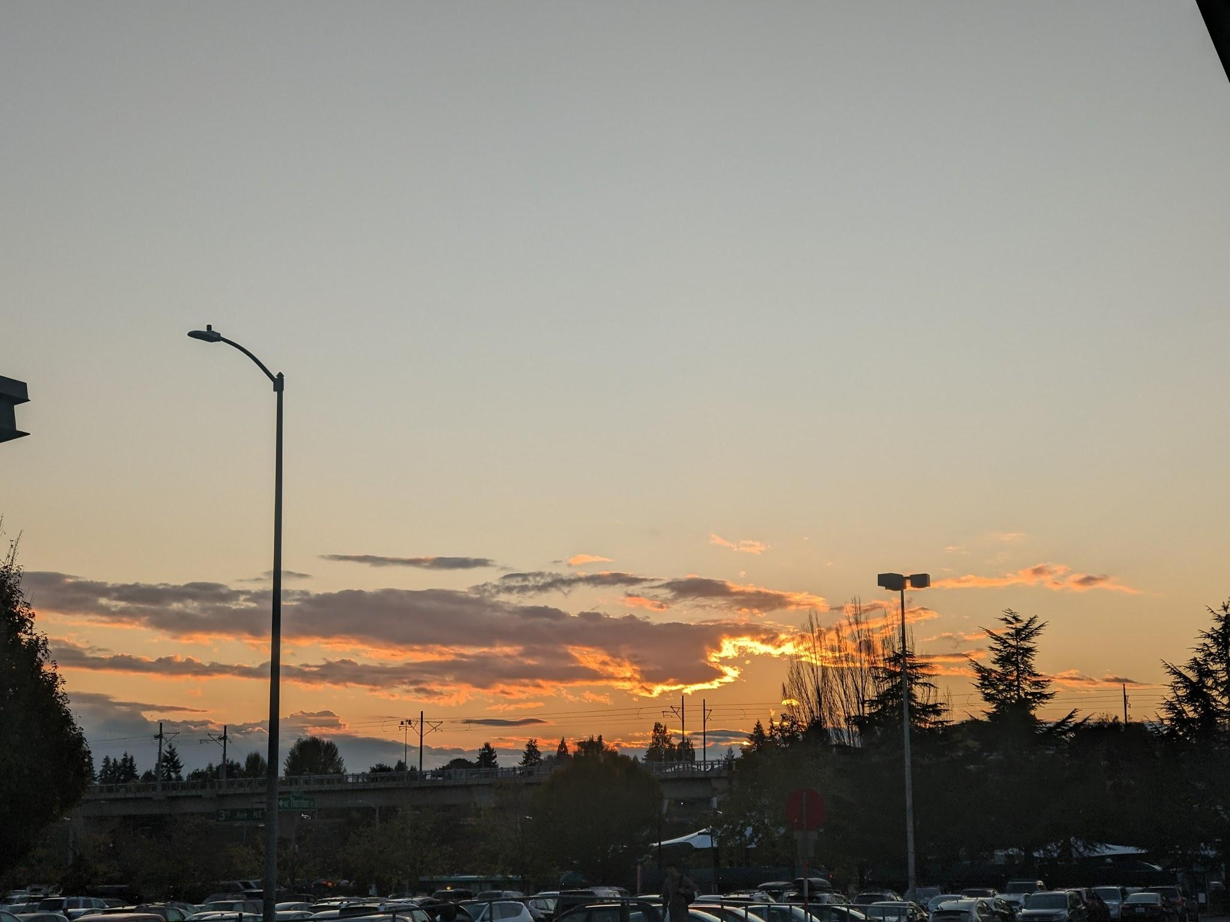
Figure 1. Multiple colors in the clouds and sky. 26 October 2023, 17:50. Photo: Natalie Copeland.

This poetry of sky colors (gold, orange, purple, pink, blue, and green) occurs throughout my journal, extolling the colors seemingly exclusive to twilight. It also becomes a game to try to solve the puzzle of the light. Just as prominent is the phenomenon of ‘golden hour’. On November 8, I wrote, ‘All the trees are radiating the sky’s gold, and I am so grateful to bask in their fleeting glory. Fall must be the golden hour of the year.’ (Fig. 2-4)

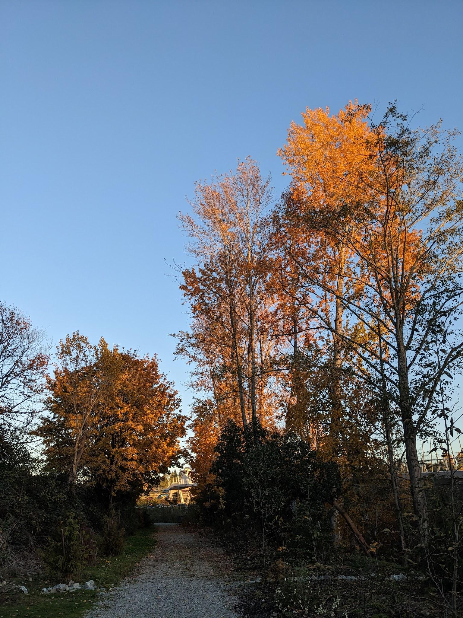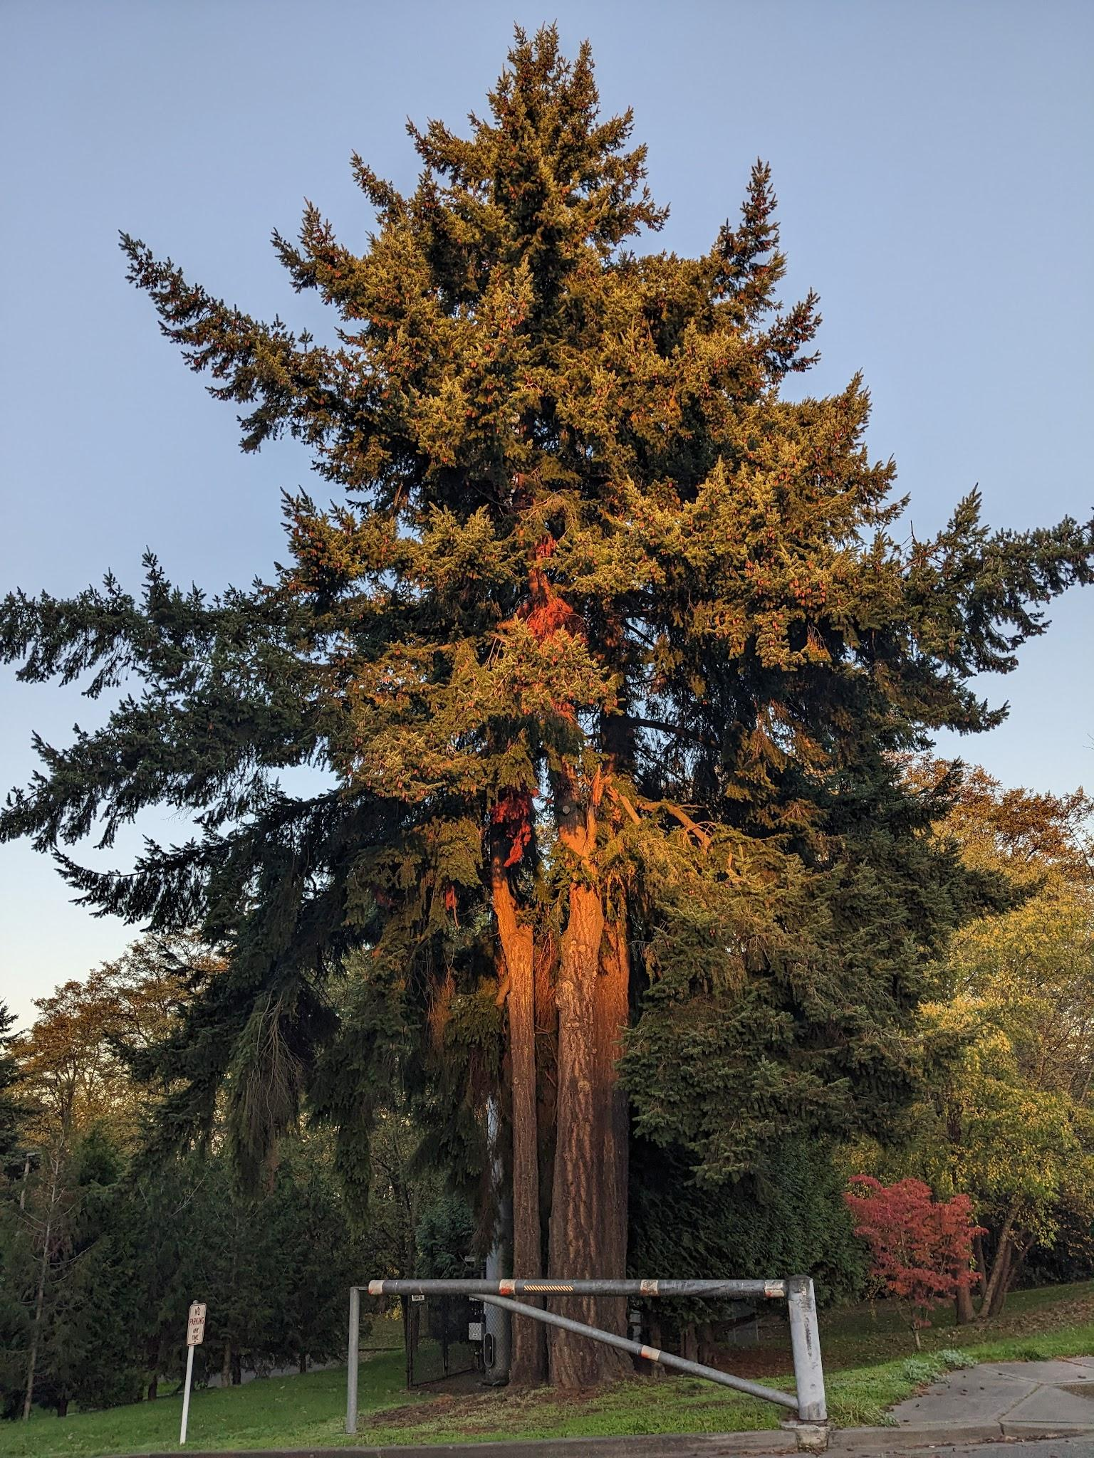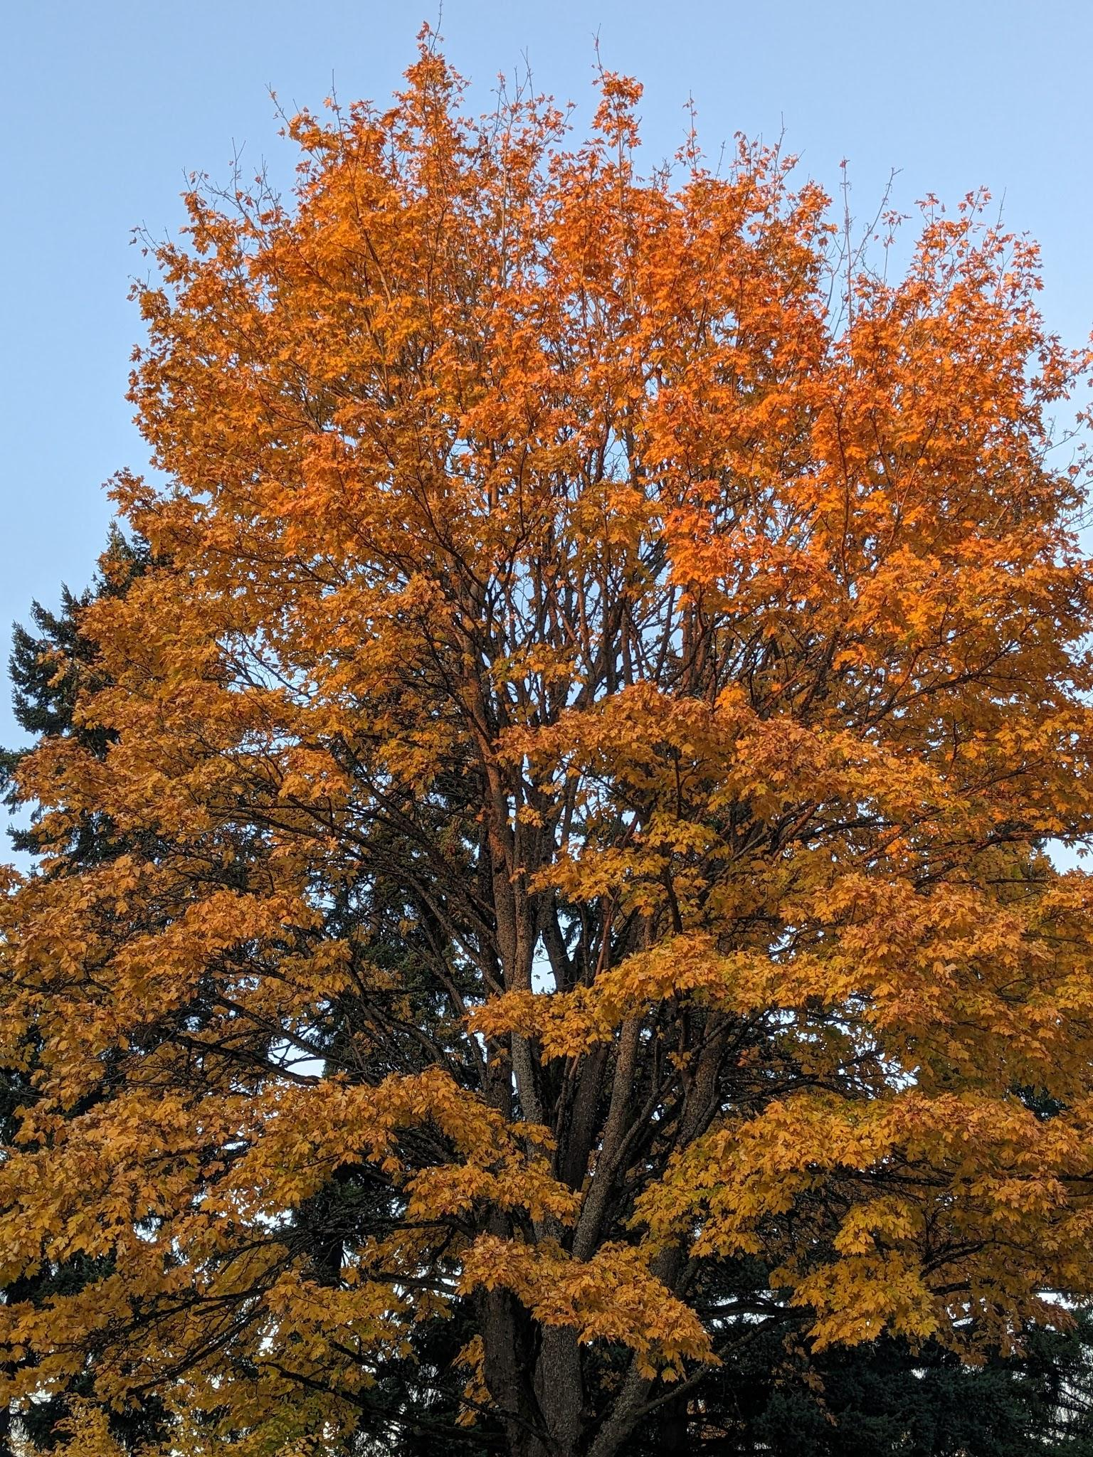
Figures 2-4. Cottonwood, Western Red Cedar, and Maple at golden hour. 8 November 2023, 16:10, 16:23, 16:31. Photos: Natalie Copeland.

I went on to hypothetically compare the cycle of a day and a year, complain about how the ‘golden hour’ isn’t given the same scientific definitions as twilight with phases dictated by degrees, and speculate on the etymology of the word ‘twilight.’ In this extensive passage, I was spurred into deep musings by the profundity of golden skies. Finally, I was able to experience all of the moon’s twilight phases (waxing crescent through full) twice. On October 26, I wrote:

As I drive home, BOOM, out of NOWHERE I see the full moon rising on the Eastern horizon. I can’t help myself from dribbling a series of expletives and sending a photo to a loved one. The moon hangs like the most gorgeous beacon in the rapidly pinking east - so desperately romantic - and seconds later I receive a nearly identical photo in return. (Fig. 5)

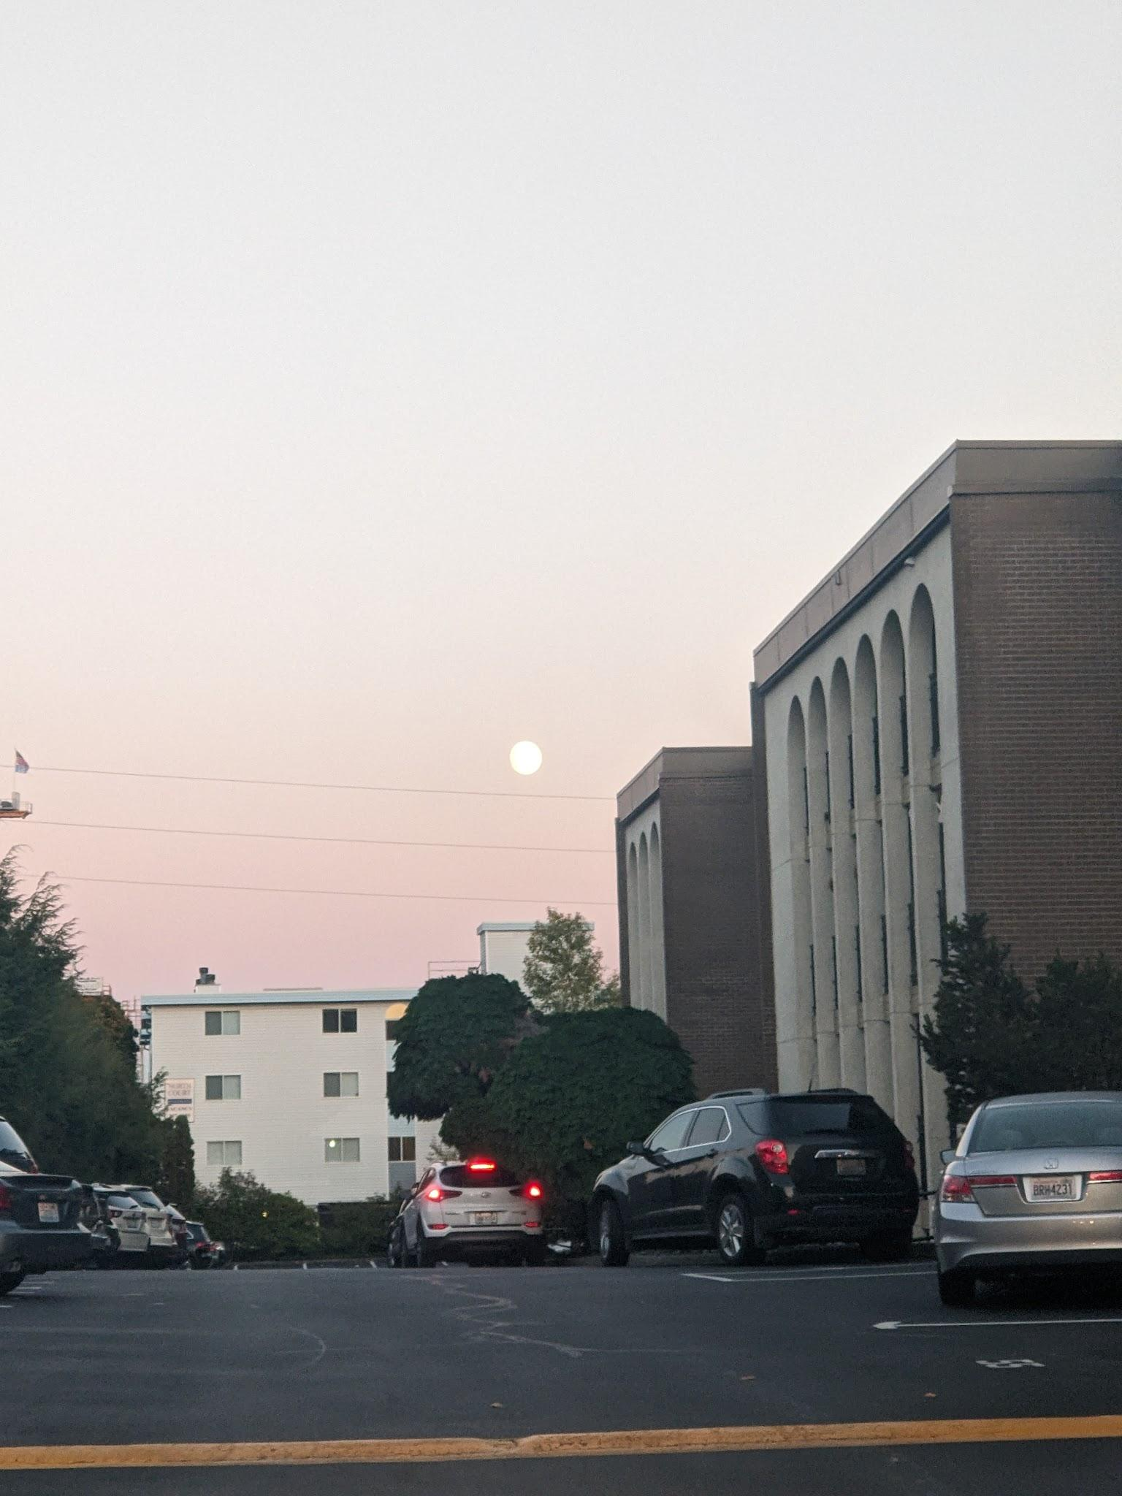
Figure 5. The full moon rises in the pink sky. 26 October 2023, 18:03. Photo: Natalie Copeland.

I was deeply aware of the lunar phase, as I teach an outdoor night nature connection class, and I had planned to teach a lesson the following evening that depended on the light of the full moon. However, this knowledge did not impede me from feeling overcome and enraptured by the appearance of the full moon at dusk. In each example, my primary feeling is one of ‘enchantment’, defined loosely by Patrick Curry as ‘existential wonder’. In the common theory of enchantment put forth by Max Weber, scientific thinking and the ability to know the universe’s answers leave no room for enchantment. However, that is not the case in my examples. In my work as a science educator, I find awe to be the most important component of the learning cycle. Without it, there is nothing worthwhile to investigate, and once I know how anything works, I am jumping to experience it again. As physicist Richard Feynman explains, ‘a science knowledge only adds to the excitement, the mystery and the awe of a flower.’ Thus, it is by becoming aware of the stars and infinity on high that my life becomes more enchanted. This becomes more evident in my relationship with nature.

Crepuscular Creatures

The changing light also allowed me to witness and participate in multiple changes in the animal world. One of the most prominent creatures I found myself tracking was rabbits. On October 11, I wrote, ‘The leaves of the cottonwoods are going gold, and the rabbits are out foraging after a wet day. Final count, four rabbits.’ I recorded seeing rabbits on six other days, with my highest count being five rabbits. (Fig 6.)

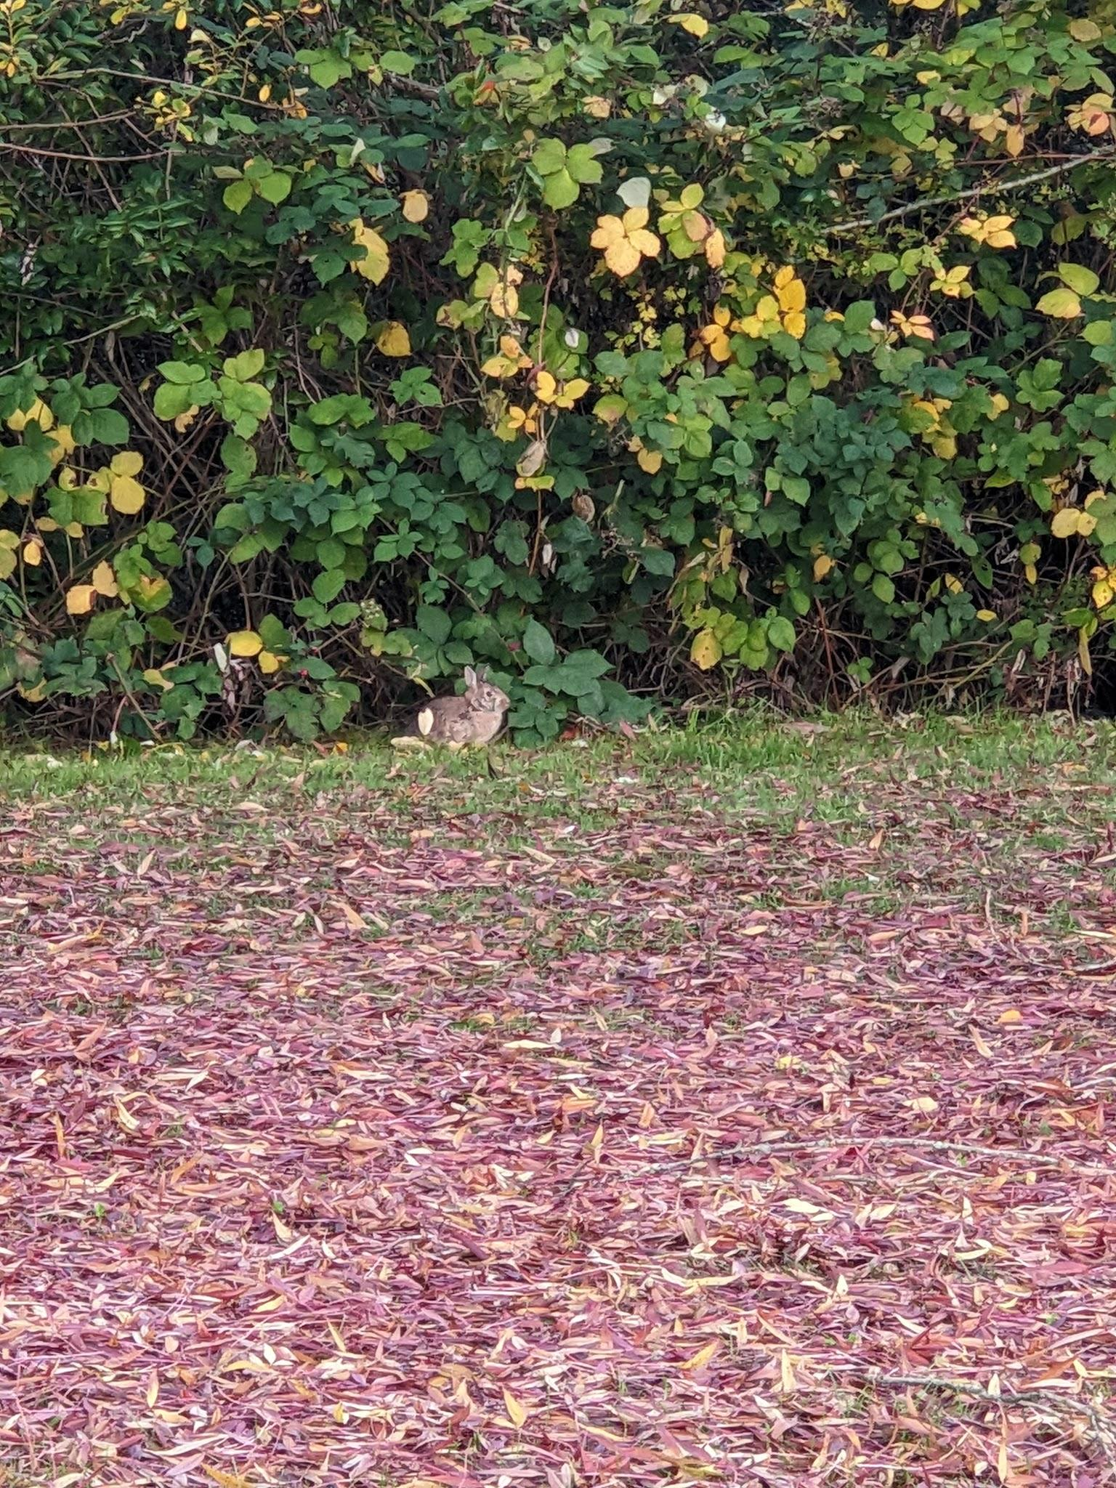
Figure 6. Rabbit emerges from a blackberry hedge. 8 November 2023. 16:15. Photo: Natalie Copeland.

On November 13 I wrote,

I wonder what it is that makes these creatures so crepuscular - is the waning light another protection against predators? I could check a field guide. Or I can leave this as a sacred mystery for the rabbits to answer in time.

Rabbits have always been important animals in my life, and I chose to honor them by prolonging the mystery - not indefinitely, but until I could observe the answer. Looking up also allowed me to catch multiple avian species in transition. On October 4, I wrote:

I saw the spectacular sight of high bird flight in the dark of astronomical twilight - I would have missed them if their bellies weren’t so white. They were distinct, but softer and slower than a plane or a satellite. I’m guessing Canada Geese.

Then on October 5, I wrote:

I could see the fiery disk of the sun, interrupted by trees, and crows, crows, so many crows. We have several different large murders of crows nearby, and I’ve heard that the Seattle Feminist Bird Club meets up for Crow Happy Hour. It seems like that's what I caught today! It must have taken entire minutes for the whole flock to take off because I tracked them for quite some time and couldn't quite see where they came from or where they went, other than vaguely southeast to northwest. And as I write, some 15 minutes later, I still see more, more, and more. (Fig. 7)

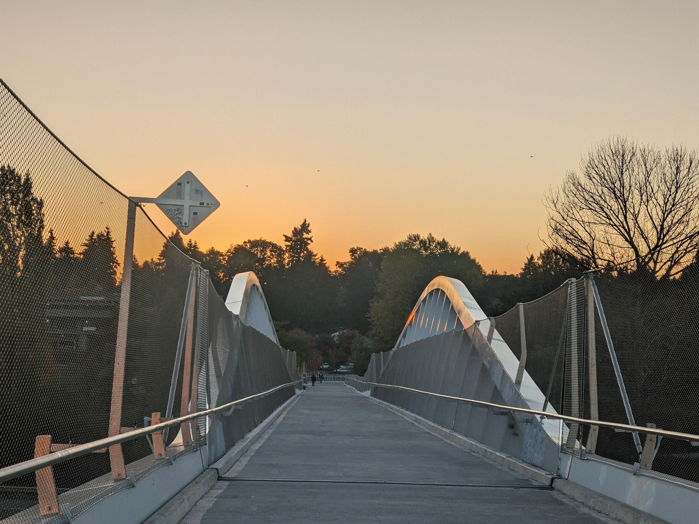
Figure 7. Tiny crows dot the western sky. 5 October 2023. 18:30. Photo: Natalie Copeland.

Watching birds allows me to travel beyond the place where I’m standing and learn about other places nearby. Connecting a patch of softly blurred white to the size and speed of a Canada goose moving south, and connecting a group of crows to a community story are both ways in which tracking connects me to the wider web of nature. To tie it all together, on October 3rd I wrote:

The pink-gold light does the most profound thing to the bright red maple leaves, and as I look, my eyes are repeatedly drawn by geese, who have all been flying north. Of course, that's not where they're supposed to be going per se, but maybe they're stationed north of here for the night? Frogs begin to croak as the sky above goes periwinkle. One of the high-pitched birds calls out as I pass, and warns a rabbit up ahead that I’m passing through. Further south, I’m delighted by an owl swooping down Corliss Avenue - the first owl I've ever seen inside city limits. (Fig. 7-8)

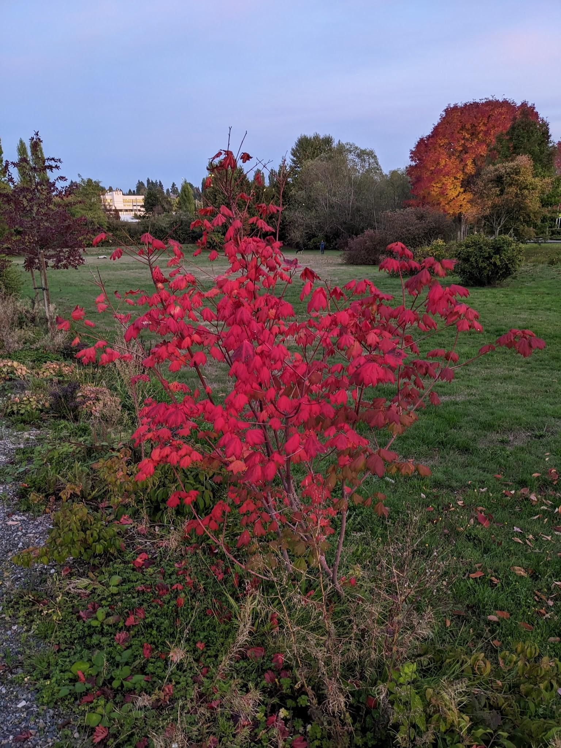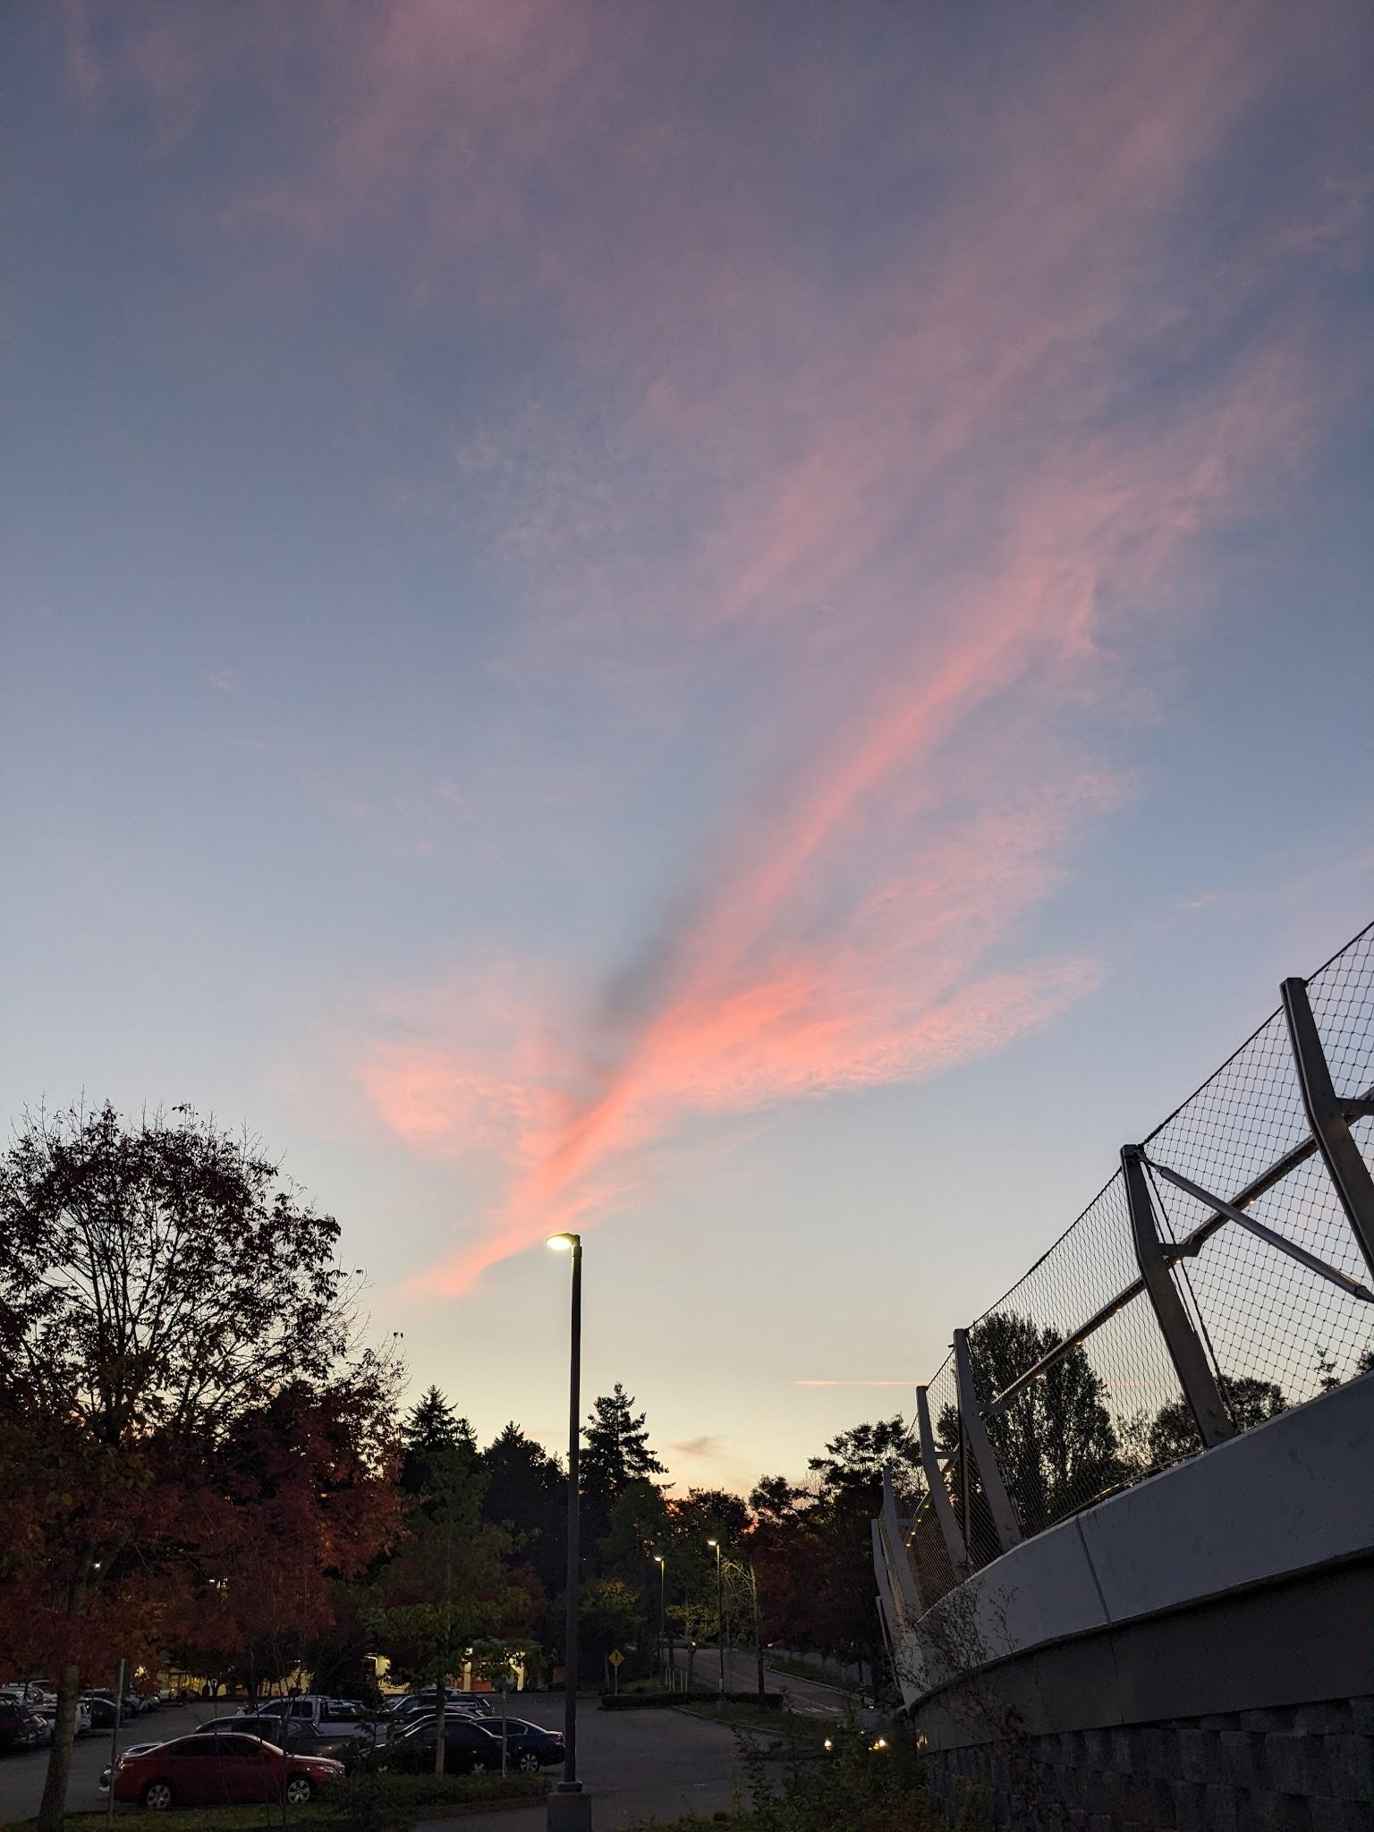
Figure 7. A Japanese maple glows red in the pink-gold sunlight. 3 October 2023. 19:00.
Figure 8. Pink clouds in the opposite direction of Figure 7, moments after geese have flown by. 3 October 19:01. Photos: Natalie Copeland.

This example highlights the interconnectedness of my nature observations and demonstrates sensory awareness beyond vision as a tracking tool. All of these skills - tracking, the art of questioning, bird language, and sensory awareness - are fundamental to my connecting with nature, and have been refined by my experience working at Wilderness Awareness School, the heart of the contemporary nature connection movement. In Coyote’s Guide, the handbook used by many such schools, Jon Young says:

To fully connect to nature in the most powerful way, all sensory systems must be engaged and developed, and pattern recognition must be infused with both imagination and rational thought processes.

The aim, Young explains, of ‘coyote mentoring’ is to create a vacuum for learning by sending a student out in the field, then asking them questions upon their return about the highlights and gaps in their experience that in turn, spur them to deepen and expand their connection. Many of these practices were gifted to Young and his school by Ndaka, Akamba, Apache, Hodonoshonee, Lakota, Odawa, and Haida peoples. I am not an indigenous person, but because these practices have given my worldview deep roots, I consider my relationship to the web of nature to be, if not spiritual (as David Shorter explains, a less colonized term for the indigenous ‘spiritual’ experience may be ‘related’), sacred and embodied. Once again, it is in being clearly aware of ‘infinity on high’ and its influence on the world around me that I am able to find life so enchanting. This transition observed in the animal world can be seen just as readily in the animal of myself and my inner landscape in my final observations.

Liminality

This final theme I encountered was my own experience of liminality. After another meeting of my outdoor evening class on November 17, I reflected on my experience chopping wood in preparation:

I began to feel a twinge of anxiety - it was already so dark at only 4:30, and we wouldn’t begin until 6:00! I’d planned for a dark evening, but what if it was TOO dark to complete our lampless walk in the woods without losing anyone? (Fig. 9)

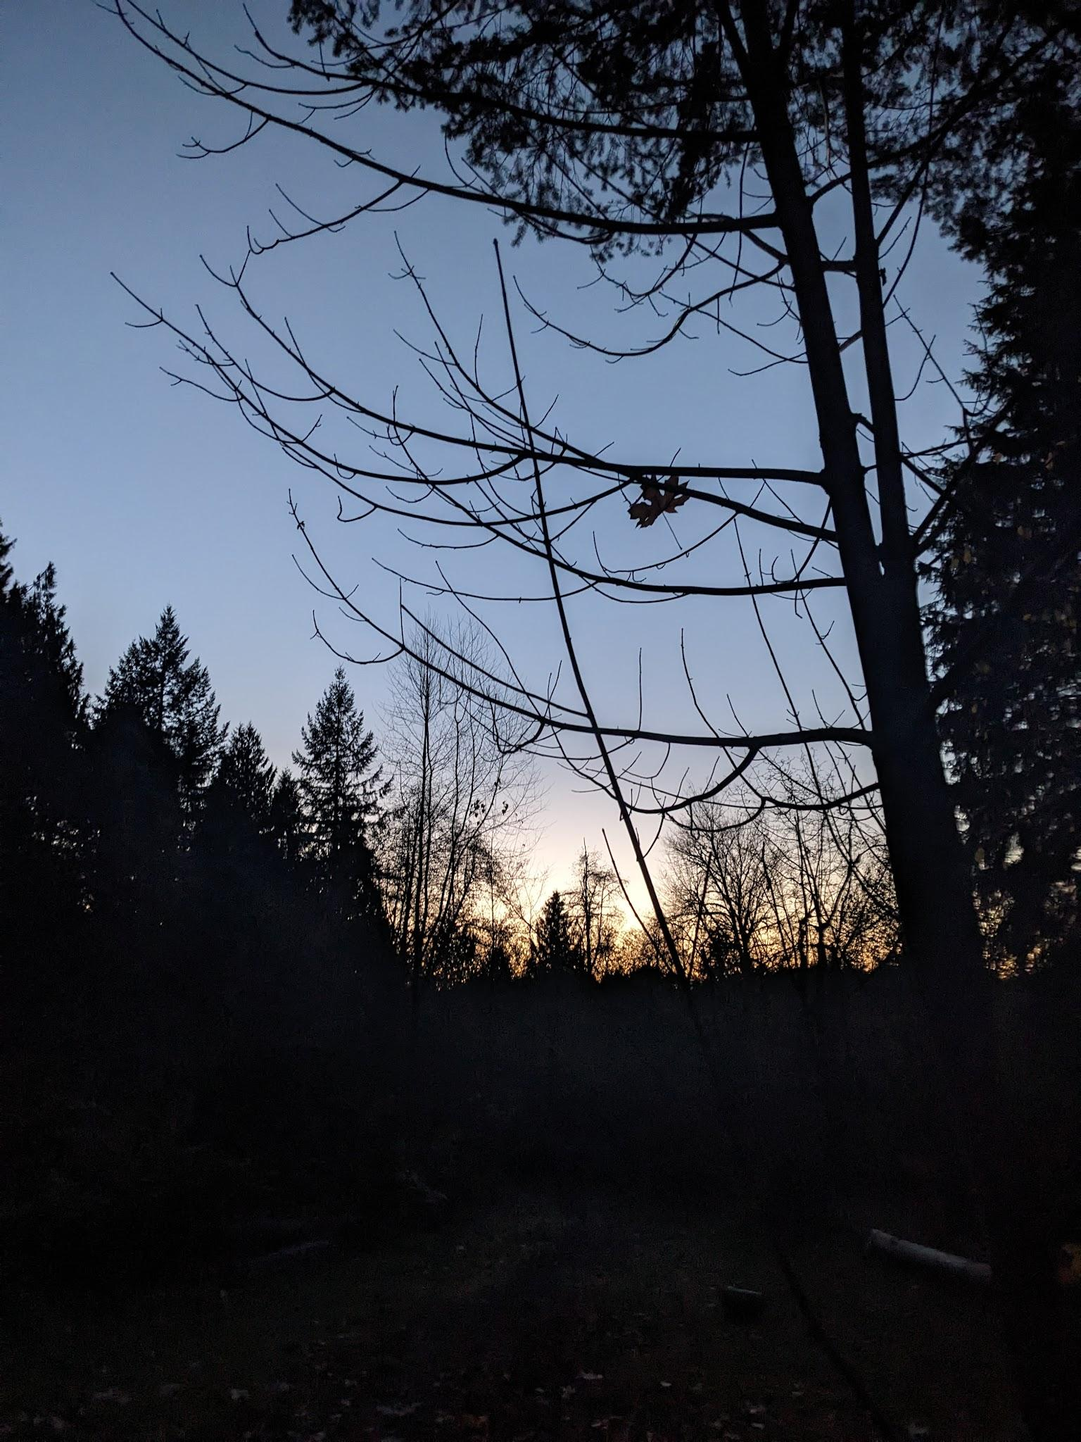
Figure 9. Anticipating darkness in the woods. 17 November 2023. 17:00. Photo: Natalie Copeland.

In pop culture, the part of the mind where ‘imagination and reality are fused’, and one can speculate ‘about the future’ is so analogous to this time of day that it’s called ‘The Twilight Zone.’ On November 13 I wrote about the appearance of the first stars, saying:

Seeing just a little bit of Cassiopeia coming out leads me to Polaris, then back to the Big Dipper, and on to Arcturus. Seeing my familiar friends where they should be puts me at ease.

The familiarity of star patterns brings certainty to the chaos of darkness. These passages echo the initial phase of ‘The Hero’s Journey’ that Joseph Campbell describes as ‘The Departure.’ The sunset is the call to adventure, the anxiety of doubting my lesson plan is a refusal of the call, the appearance of the stars is a supernatural aid, and moving forward into the night is the crossing of the first threshold. I have utilized a similar structure when executing rites of passage for teenage students, in an illustration of myth informing ritual. (Fig. 10-11) This myth also emerged when observing rabbits. On October 3rd, I wrote about the correlations between rabbits, dusk, Venus as the morning and evening twilight ‘star’, and the myth of the goddess Inanna, which in turn follows the myth of the hero’s journey. The idea that every evening we have the opportunity to confront the dark within and without by stepping into a story of magic and transformation is certainly one of enchantment.

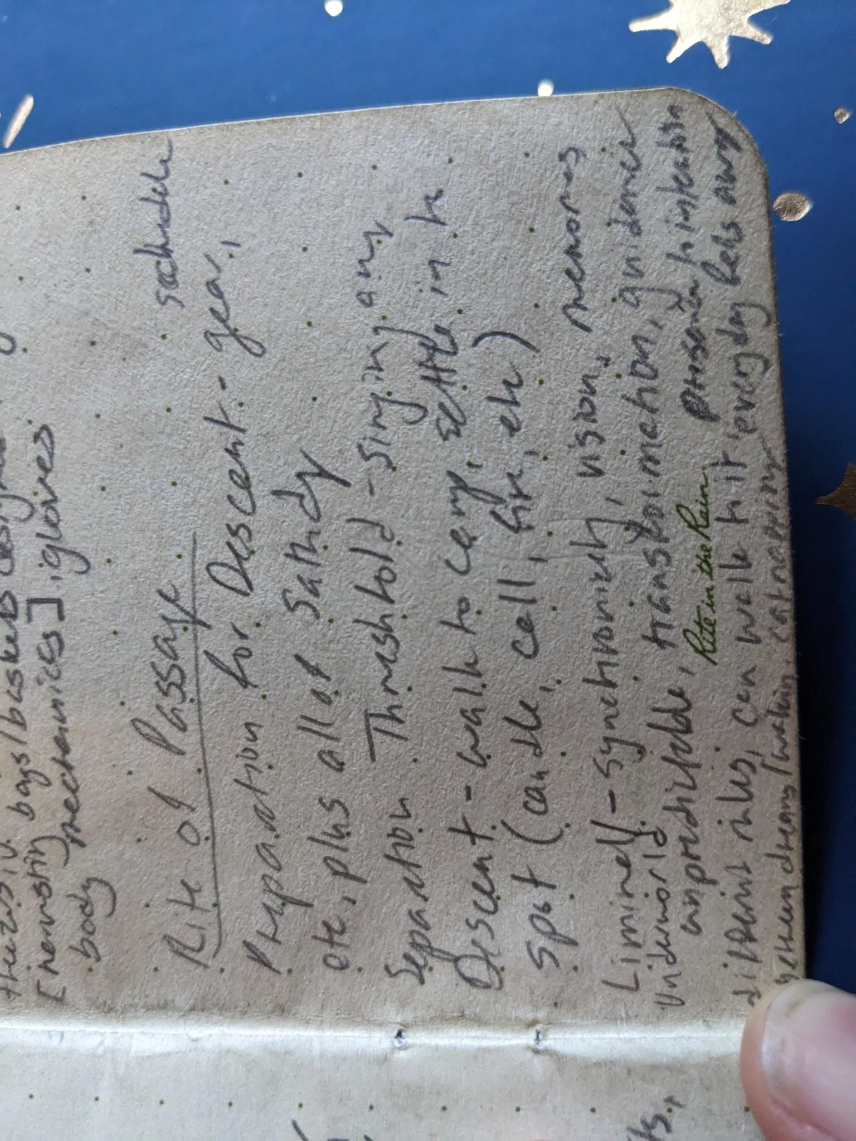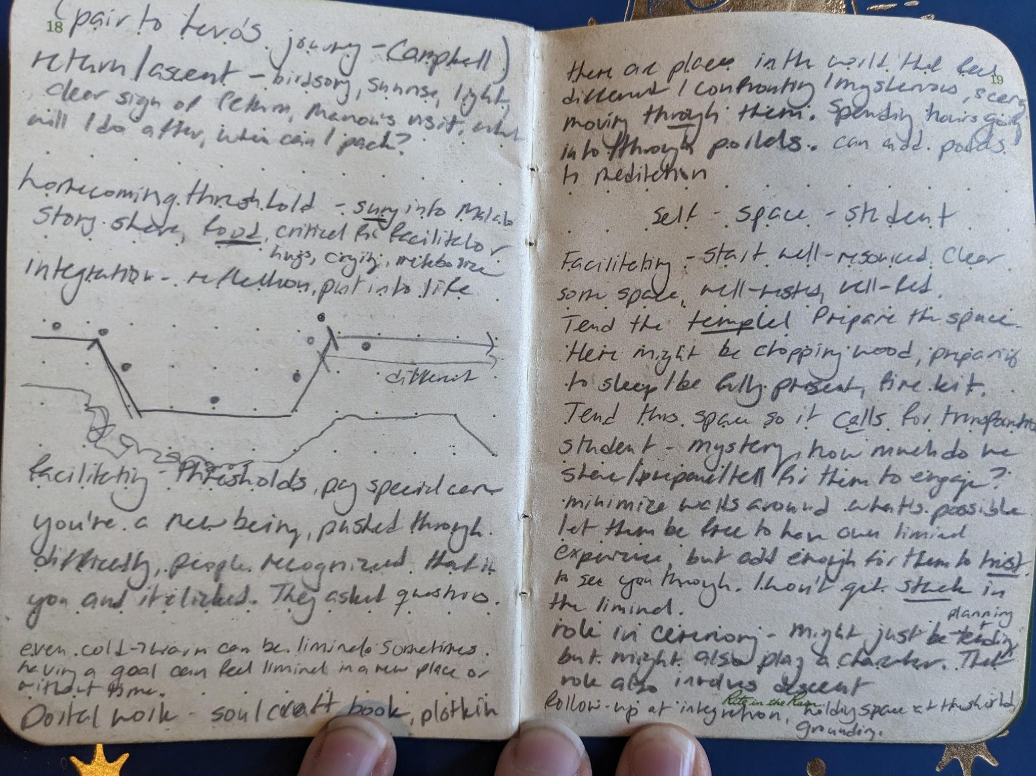
Figures 10-11. Notes from an evening fire tending Rite of Passage at Wilderness Awareness School, including references to the phases of the Hero’s Journey and the liminal, April 2022. Photos: Natalie Copeland.

Conclusion

My exploration of Seattle’s twilight skies as chronicled in my sky journal reveals an experience of the sky that is both rational and irrational. This essay argues that my observations of light, color, patterns, and nature are well-aligned with Van Gogh’s directive to be ‘clearly aware of the stars and infinity on high,’ and that comprehending aspects of these observations only amplifies their ability to enchant me. Furthermore, the observation of relationality in nature is a view both sacred and scientifically sound. The navigation of twilight liminality through the archetypal Hero’s Journey emphasizes enchantment’s ability to allow one to embrace uncertainty when it occurs. In conclusion, experiencing the changing canvas of the twilight sky is akin to viewing the work of a celebrated painter: the experience is enhanced by inviting both heart and mind to admire both art and craft.
References

Campbell, Joseph, The Hero with a Thousand Faces, 3rd edm. (Novato: New World Library, 2008)

Curry, Patrick, ‘The Experience of Enchantment and the Sense of Wonder’, Green Letters: Studies in Ecocentrism, 25.2 (2021), 115-129 <DOI: 10.1080/14688417.2021.1928530>

Gogh, Vincent van, The Letters of Vincent Van Gogh, VLeBooks ePub ed. (London: Penguin Books, 1997) <https://www-vlebooks-com.ezproxy.uwtsd.ac.uk/Product/Index/662139?page=0&startBookmarkId=-1> accessed 12 November 2023]

Hill, Rodney, ‘ANTHOLOGY DRAMA: Mapping The Twilight Zone’s Cultural and Mythological Terrain’, in The Essential Science Fiction Television Reader, ed. by J. P. Telotte (Lexington: Kentucky University Press, 2008) pp. 111-126 <https://www.jstor.org/stable/j.ctt2jch2x]> [accessed 29 November 2023

Joas, Hans, The Power of the Sacred: An Alternative to the Narrative of Disenchantment, (Oxford: Oxford University Press, 2021) <https://doi.org/10.1093/oso/9780190933272.001.0001> [accessed 29 November 2023]

Slaven, Kyla, and Robyn Williams, The late great physicist Richard Feynman, [podcast] Australian Broadcasting Company, In Conversation, 26 June 2008 <https://www.abc.net.au/listen/programs/inconversation/the-late-great-physicist-richard-feynman/3273144> [accessed 26 November 2023]

Wilderness Awareness School, About Us (N/A) <https://wildernessawareness.org/about/> [accessed 20 November 2023]

Winandy, André and Rita Winandy, ‘The Twilight Zone: Imagination and Reality in Jules Verne's Strange Journeys’, Yale French Studies, No. 43 The Child's Part (1969) <https://www.jstor.org/stable/2929639]> [accessed 29 January 2023

Young, Jon, Ellen Haas, and Evan McGown, Coyote’s Guide to Connecting with Nature, 2nd ed. (Shelton: Owlink Media Corporation, 2010) p. xxviii

Patrick Curry, ‘The Experience of Enchantment and the Sense of Wonder’, Green Letters: Studies in Ecocentrism, 25.2 (2021), 115-129 (p. 116) <DOI: 10.1080/14688417.2021.1928530>.
Hans Joas, The Power of the Sacred: An Alternative to the Narrative of Disenchantment, (Oxford: Oxford University Press, 2021) pp. 110-112 <https://doi.org/10.1093/oso/9780190933272.001.0001> [accessed 29 November 2023].
Jon Young, Ellen Haas, and Evan McGown, Coyote’s Guide to Connecting with Nature, 2nd ed. (Shelton: Owlink Media Corporation, 2010) p. xxviii
Young, Haas, McGown, Coyote’s Guide, p. xxix
Wilderness Awareness School, About Us (N/A) <https://wildernessawareness.org/about/> [accessed 20 November 2023].
Joseph Campbell, The Hero with a Thousand Faces, 3rd edm. (Novato: New World Library, 2008), pp. 41-73.
Vincent van Gogh, The Letters of Vincent Van Gogh, VLeBooks ePub ed. (London: Penguin Books, 1997) p. 164 <https://www-vlebooks-com.ezproxy.uwtsd.ac.uk/Product/Index/662139?page=0&startBookmarkId=-1> accessed 12 November 2023].
André Winandy and Rita Winandy, ‘The Twilight Zone: Imagination and Reality in Jules Verne's Strange Journeys’, Yale French Studies, No. 43 The Child's Part (1969), pp. 97-110 (p. 98) <https://www.jstor.org/stable/2929639> [accessed 29 November 2023].
Rodney Hill, ‘ANTHOLOGY DRAMA: Mapping The Twilight Zone’s Cultural and Mythological Terrain’, in The Essential Science Fiction Television Reader, ed. by J. P. Telotte (Lexington: Kentucky University Press, 2008) pp. 111-126 (p. 115) <https://www.jstor.org/stable/j.ctt2jch2x> [accessed 29 November 2023].
Kyla Slaven and Robyn Williams, The late great physicist Richard Feynman, [podcast] Australian Broadcasting Company, In Conversation, 26 June 2008 <https://www.abc.net.au/listen/programs/inconversation/the-late-great-physicist-richard-feynman/3273144> [accessed 26 November 2023].

