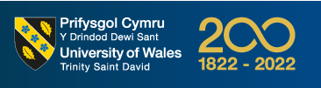
University of Wales – Trinity Saint David

Report Title
Business Review of Aston Marten and BMW Utilising Published Financial Statements.

By
Fredrick Emeka Okwute (2134193)

Module
Financial Management and Planning (ACPA7002)
Lecturer
Howard Davies

29 September 2023

Contents
Contents 1
Executive Summary 2
Introduction 3
Detailed Review of Financial Statements 4
Aston Martin Lagonda Limited 4
BMW (UK) Limited 4
Comparisons of Trends and Risks 5
Explanation of the Use of Financial Statement 6
Calculation of Ratios 7
Critical Evaluation of Ratios 9
Profitability Ratio 9
Liquidity Ratio 10
Investment and Assets Turnover Ratio 11
Return on Investment Ratio (ROI) 12
Stability Ratio 13
Growth Ratio 14
Summary of Findings 15
Trends and Risks 15
Financial Ratios and Analysis 15
Conclusion and Recommendation 16
Appendices 17
Reference 17
Ration Calculations 21
The Statements 23

Executive Summary
This report offers a comprehensive examination of the £5 million joint venture opportunity with Aston Martin Lagonda Limited, with the overarching objective of fostering mutual growth and innovation. The analysis draws upon a meticulous review of both the target company and a competitor's financial statements, with a specific focus on discerning trends, identifying risks, and evaluating key financial ratios. The ultimate aim of this report is to provide a thorough assessment of the joint venture's feasibility and offer strategic recommendations to the senior management team.
Financial ratios, a pivotal aspect of financial management and operational assessment, represent a central theme in this report. Acknowledged as essential tools for gauging a company's performance and financial health, these ratios facilitate comparisons among businesses operating within the same industry, providing valuable insights into their future prospects (Financial Ratios, 2010). Equally significant is their role in guiding investor decisions, enabling the identification of a company's financial strengths, weaknesses, debt management practices, and creditworthiness. Moreover, financial ratios serve as indicators of credit and debt policies, investment potential, operational efficiency, employee performance, and year-on-year performance trends (Konchitchki and Patatoukas, 2014).
This report employs six key categories of financial ratios: Profitability, Liquidity, Asset Turnover, Return on Investment, Stability, and Growth ratios, as the analytical framework for assessing both Aston Martin and its competitor. While the financial analysis reveals a consistent pattern of sales growth, it also highlights instability in other pivotal ratios. Notably, concerns arise from elevated debt levels and declining investor confidence, warranting thorough consideration. After a comprehensive evaluation, BMW emerges as the more compelling choice for the £5 million project investment when compared to its competitor, Aston Martin.
In conclusion, this report underscores the crucial role of financial ratios in shaping strategic decisions and advocates for BMW as the preferred partner for the proposed £5 million joint venture. This recommendation is grounded in a meticulous analysis of financial performance and potential risks, aligning with the objective of mutual growth and innovation.

Introduction
The UK automotive industry is a vital sector of the country's economy, characterised by innovation and global competitiveness. Recent trends include a growing emphasis on electric vehicles (EVs) to meet sustainability goals, with the government's commitment to banning new petrol and diesel car sales by 2030 (SMMT, 2020). However, Brexit-related disruptions have posed significant risks, impacting supply chains and export relationships (Dhingra et al., 2021). On the bright side, opportunities exist in the development of EV technologies, battery manufacturing, and emerging mobility solutions (BIEE, 2021). Collaboration with academia and investment in research and development are crucial to navigating these challenges and seizing future opportunities (Horizonscan, 2020).
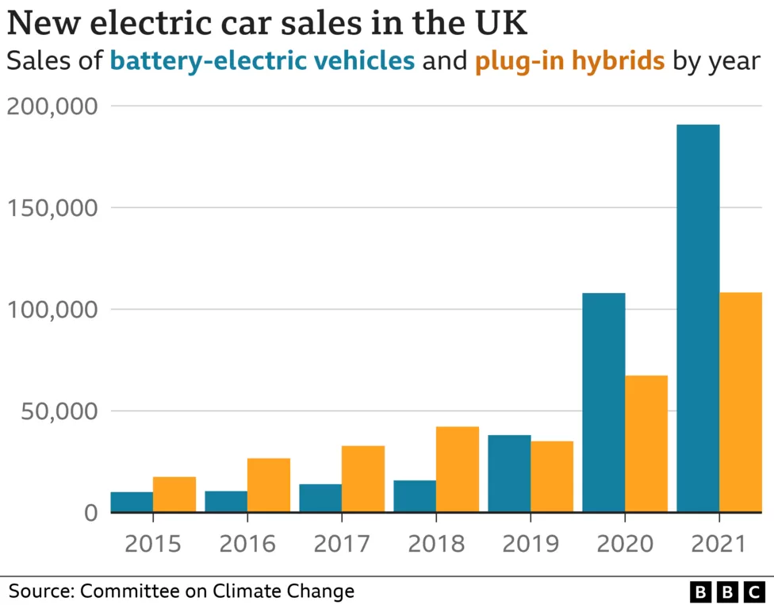
Nanji, N. (2022) 'Electric car drivers must pay tax from 2025’
Aston Martin Lagonda Limited and its competitor BMW (UK) Limited are leading player in the automotive sector. Aston Martin Lagonda Limited, founded in 1913, is a British luxury sports car manufacturer renowned for its craftsmanship and association with James Bond's iconic vehicles (Aston Martin, 2021). In contrast, BMW (UK) Limited, a subsidiary of the BMW Group, is a leading player with a broader presence in the UK automotive sector, offering a diverse range of vehicles under the BMW and MINI brands (BMW Group, 2021).
Below, both companies will be analysed using financial ratios, and their financial performance compared based on information published on their annual reports.



Detailed Review of Financial Statements

Aston Martin Lagonda Limited
In 2020, Aston Martin reported total revenue of £530.1 million, which represented a decrease compared to the previous year due to the COVID-19 pandemic's impact on production and sales. The company also faced operating losses. However, Aston Martin launched several new models and expanded into the luxury SUV market with the DBX, aiming to diversify its product portfolio and increase sales. The impact of these changes can be seen in the 72% increase in revenue in 2021 (£991.5M) and another 35% revenue increase in 2022 (£1.2B). Despite these growths, the company's figures outlines a pre-tax loss of £345.0M in 2022 and £253.0M in 2021. Net Liabilities of £693.7M in 2022 and £336.2M in 2021.

BMW (UK) Limited
In recent years, BMW has been actively investing in EV technology and sustainability. The company's BMW-i sub-brand includes electric and plug-in hybrid vehicles, such as the BMW i3 and BMW i8. BMW's EV efforts align with the global automotive industry's transition towards cleaner and more sustainable transportation.
BMW UK has experienced a steady growth over the last few years, growing in revenue by 18.8% from 2020 (£3.9B) to 2021 (£4.6B). in 2022 the company grew in revenue by another 15% making a total revenue of £5.3B. The company's figures show an increasing operating profit in the last year and pre-tax profit of £91.4M in 2021 and £99.6m in 2022.

Comparisons of Trends and Risks
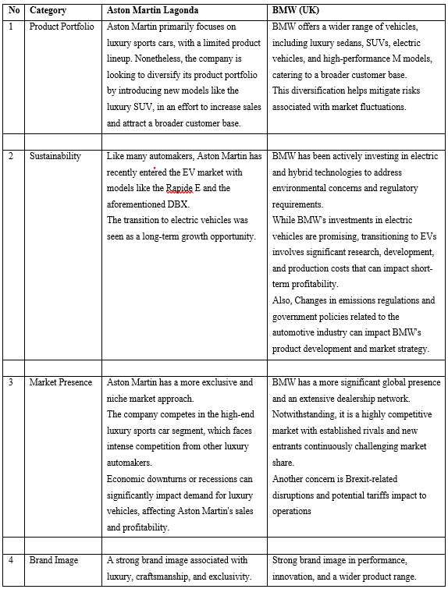

Explanation of the Use of Financial Statement
Financial statements, comprising the income statement, balance sheet, and cash flow statement, are pivotal documents in the realm of accounting and finance. These statements play a critical role in conveying a comprehensive understanding of a company's financial condition and performance to various stakeholders, including investors, creditors, management, and regulatory bodies (Akulenko and Esina, 2021).

Income Statement
This is often referred to as the profit and loss statement which delineates a company's revenues, expenses, and net income over a specific reporting period (e.g., quarterly, or annually). Investors and financial analysts frequently utilise the income statement to scrutinise a firm's profitability trends, cost management efficiency, and revenue sources (Penman, 2013).

Balance Sheet
This is sometimes identified as the statement of financial position, providing a picture of a company's financial standing at a precise point in time. It encapsulates the company's assets, liabilities, and shareholders' equity. For investors and creditors, the balance sheet serves as a crucial tool to assess liquidity, solvency, and the organisation’s ability to meet short-term and long-term commitments (Penman and Sougiannis, 1998).

Cash Flow Statement
This is a dynamic document, traces the inflow and outflow of cash during a designated period. It classifies cash flows into financing, operating, and investing activities. Stakeholders closely examine the cash flow statement to evaluate a company's cash generation capabilities, liquidity management, and ability to finance operations and investments (Mulford and Comiskey, 2002).
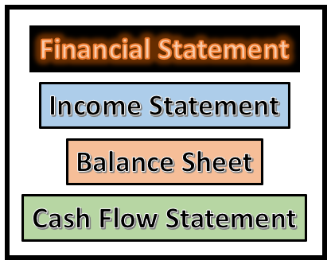
These financial statements serve multifaceted purposes including:
- Investment Decision-Making: Investors use financial statements to gauge the attractiveness of investment opportunities. They analyse income statements for profitability, balance sheets for financial stability, and cash flow statements for cash generation prospects (Damodaran, 2012).
- Credit Assessment: Creditors, including banks and bondholders, rely on financial statements to assess a company's creditworthiness. They assess the balance sheet to determine asset coverage and the income statement to evaluate earnings consistency (Altman, 1968).
- Management and Strategic Planning: Company management utilises financial statements for performance assessment and strategic decision-making. These statements assist in identifying areas for improvement and in making resource allocation choices (Higgins, 1981).
- Regulatory Compliance: Regulatory authorities mandate the preparation of accurate financial statements for transparency and adherence to accounting standards. These statements are also integral to tax assessment (Financial Accounting Standards Board, 2021).
Financial statements serve as fundamental instruments in the realm of accounting and finance. They provide a structured and systematic framework for presenting a company's financial performance, position, and cash flows. The significance of these statements is underscored by their ability to furnish invaluable insights to a diverse array of stakeholders, thereby facilitating investment decisions, credit evaluations, strategic planning, and regulatory conformity. Prudent and transparent financial reporting is pivotal for upholding trust in financial markets and fostering informed decision-making.

Calculation of Ratios
Financial ratios are essential tools for assessing a company's financial strength and performance. They provide valuable insights into various aspects of a firm's operations and are used by investors, creditors, and management for decision-making (Mbona and Yusheng, 2019). According to Lane 2012, ratio analysis (comparative analysis) is a financial statement analysis that is used to obtain hints of a business’s financial performance. There are various aspects of ratio analysis calculations and below are the few used to analyse and compare Aston Martin Lagonda Limited and its competitor BMW (UK) Limited through information acquired from their financial statement.
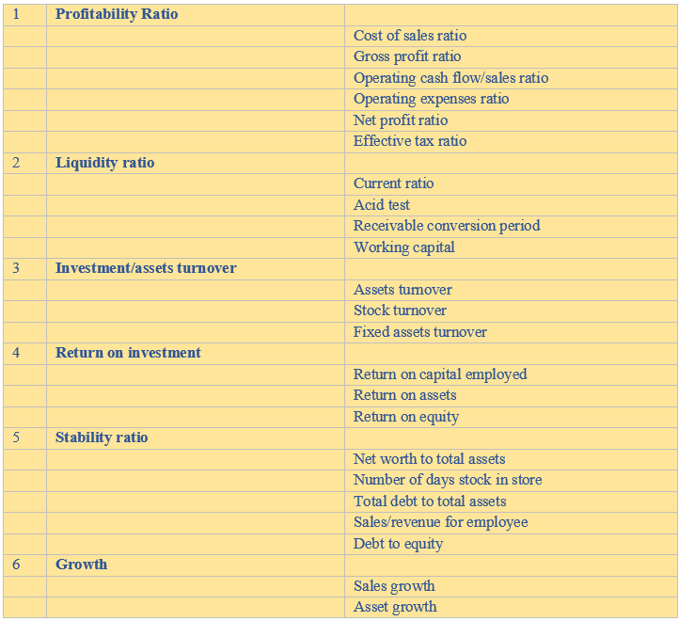

Limitations of Ratio Analysis
Ratio analysis is a widely used financial assessment tool, but its utility is constrained by several limitations. Varying accounting practices among firms can introduce discrepancies, affecting the comparability of ratios (Bhattacharyya, 2010). Specific nuances within the UK automotive industry, such as differing production models and marketing strategies, can make industry-specific benchmarks less applicable (Keefe et al., 2018). Furthermore, external factors like inflation and economic instability can distort ratio interpretations (Wild et al., 2015). These limitations underscore the need for a nuanced and context-aware approach when employing ratio analysis in evaluating the financial health of companies.

Critical Evaluation of Ratios
In this comprehensive analysis, we delve into a critical evaluation of financial ratios for both Aston Martin Lagonda Limited and BMW, aiming to gain deeper insights into their financial health and performance. These ratios provide valuable information regarding profitability, liquidity, investment, and asset turnover, return on investment, stability, and growth.

Profitability Ratio
- Cost of sales ratio (COSR):
Aston Martin exhibited a lower COSR of 65.51% in 2021, which increased to 69.16% in 2022 due to expanding product ranges. BMW, on the other hand, experienced an increase from 94.61% in 2021 to 95.24% in 2022, indicating higher operating costs. Aston Martin has the advantage in COSR efficiency.
- Gross profit ratio:
The gross profit ratio, reflecting the percentage of profit generated after subtracting only the cost of sales from sales revenue, improved for Aston Martin from 26.42% in 2021 to 30.84% in 2022. Conversely, BMW saw a decline from 5.39% in 2021 to 4.7% in 2022. Aston Martin's higher ratio indicates a more profitable operation.
- Operating cash flow/sales ratio
In both 2021 and 2022, Aston Martin had negative ratios (-9.33% and -11.09%, respectively), whereas BMW had positive ratios (2.00% and 1.44%, respectively). However, both companies struggled with low operating cash flow, with BMW having a slightly better performance.
- Operating expense to sales
Aston Martin's ratio increased from 103.66% in 2021 to 112.65% in 2022, while BMW's improved slightly from 98% in 2021 to 98.56% in 2022. Both companies had high operating expense ratios, but BMW was marginally more efficient.
- Net profit ratio
Aston Martin's net profit ratio decreased from -25.52% in 2021 to -28.10% in 2022, while BMW's declined from 1.43% in 2021 to 0.31% in 2022. Both companies struggled with low profitability, but BMW performed slightly better.
- Effective tax ratio
Aston Martin's moderate and stable effective tax ratio stands out compared to BMW's significant negative value in 2022.

Liquidity Ratio
This ratio measures the short-terms efficiency of a company. It explains how liquid the business is and determines if it can pay its ongoing bills. Below are the types of liquidity ratios used in this report:
- Current ratio
Aston Martin and BMW both had current ratios below 2, indicating challenges in meeting debt obligations. However, BMW had a slightly better current ratio in 2021.
- Acid test
Both companies had quick ratios below the ideal 1:1 ratio, indicating a longer time for paying back loans. BMW had a marginally better quick ratio.
- Receivable conversion period
Aston Martin had shorter average days for receiving payments from customers in both 2021 and 2022, making it more efficient in cash flow management in this aspect.
- Working capital
BMW had better working capital, indicating its ability to cover operational expenses and short-term obligations more effectively.

Investment and Assets Turnover Ratio
- Assets turnover
BMW consistently outperformed Aston Martin in asset turnover, demonstrating that it produced more sales revenue per unit of assets.
- Stock turnover
Aston Martin had 3.56 times in 2021 and decreased to 3.24 times in 2022. BMW had 9.54 times in 2021 and decreased to 7.71 times in 2022. BMW achieved better stock turnover, indicating a quicker inventory turnover compared to Aston Martin.
- Fixed assets turnover
This ratio determines valuableness of the fixed assets in the business’s operation. BMW had a substantially higher fixed assets turnover, reflecting its efficient utilisation of fixed assets for generating sales revenue.

Return on Investment Ratio (ROI)
- Return on capital employed (ROCE)
Considering the average of both years, Aston Martin can be said to have achieved better than BMW that made a ROCE of -0.06 in 2022 and 0.18 in 2021. Aston Martin outperformed BMW in ROCE in both 2021 and 2022, indicating better capital utilisation.
- Return on assets (ROA)
Both companies achieved low ROA due to low net profits relative to total assets, with BMW having a slightly better performance.
- Return on equity (ROE)
BMW outperformed Aston Martin in ROE in both years, signifying a better return to shareholders.

Stability Ratio
- Net worth to total assets
This connects the equity to the total assets, indicating the long-term money owned by the business. BMW had a higher net worth to total assets ratio, indicating a stronger long-term financial position.
- Number of days stock in store
In 2021 Aston Martin had 102 days, which increased to 113 days in 2022 because of the increase in average stock from 182.2 in 2021 to 262.1 in 2022. BMW had lower number of days, 38 days in 2021 and 47 days in 2022. BMW had a lower number of days for stock turnover, implying better inventory management.
- Total debt to total assets
BMW had a lower total debt to total assets ratio, indicating lower reliance on debt financing for its operations.
- Sale/revenue for employee
Each company operates with a significantly different number of employees. However, Aston Martin had higher sales/revenue per employee in both years, indicating more efficient utilisation of human resources.
- Debt to equity
This is also known as equity ratio and determines the level of debt on each unit of the business equity. Aston Martin had a better debt to equity ratio, indicating a safer level of debt for each unit of equity.

Growth Ratio
- Sales growth
Aston Martin had a sales growth of 46.54% in 2021 and a decrease to 19.23% in 2022. BMW made growth sales of 15.82% in 2021 and a decrease to 13.08% in 2022. Aston Martin achieved higher sales growth in both years, indicating stronger sales performance.
- Assets growth
Aston Martin had a decline of 9.41% in 2022 and BMW had a decline of 11.96 in 2022. In 2021, Aston Martin has a growth of 0.98% while BMW in 2021 had a growth of 6.82%. Both companies experienced a decline in assets, with BMW's decline being slightly more significant.

Summary of Findings

Trends and Risks
Notable trends for Aston Martin include steady revenue growth and cost optimisation. However, risks such as increased debt and fluctuations in cash flow were identified. The company grapples with uncertainties stemming from global economic fluctuations and market volatility, which impact the luxury car market. Aston Martin also faces significant competition in the high-end automotive sector, necessitating continuous innovation and differentiation. Despite these challenges, the company exhibits signs of resilience with a modest uptick in revenue, driven by successful product introductions and extension into new markets. However, profitability remains a concern, as high production costs and heavy investments in research and development to electrify its lineup have pressured margins.
Conversely, BMW faces geopolitical and macroeconomic uncertainties, with Brexit-related disruptions and potential tariffs impacting its operations. Concurrently, the shift towards electric vehicles (EVs) poses a strategic challenge as BMW adapts to meet stringent emissions regulations. Despite these challenges, the company's financials show resilience with stable revenue growth, underpinned by a diversified product portfolio and robust sales in the luxury car segment. However, profitability margins have come under pressure due to increased R&D expenses associated with EV development. In conclusion, BMW UK Ltd faces both risks and opportunities as it navigates through the evolving automotive landscape, emphasising the need for strategic agility and innovation.

Financial Ratios and Analysis
Various financial ratios were calculated to evaluate profitability, liquidity, return on investment, stability, growth, and investment/asset turnover. While the profitability and liquidity ratios of both companies remained a concern, growth ratios indicated a strong position. The debt-to-equity ratio showed an upward trend, possibly indicating increased financial leverage for both companies. Efficiency ratios indicated insufficient asset utilisation especially for Aston Martin. Investor ratios highlighted declining investor confidence due to lower earnings per share and a higher price-to-earnings ratio. In summary, conducted analysis indicates a healthy demand for both Aston Martin and BMW's products. Both Aston Martin and BMW faced challenges in various aspects of financial performance, BMW generally exhibited better financial health and efficiency in several key areas, making it a more favourable choice for the £5 million project investment over Aston Martin.

Conclusion and Recommendation
The automotive industry has the potential to successfully generate revenue returns on investment. The level of competition and need for consistent product innovation in the sector has made it quite difficult for adequate returns. From the ratio analysis conducted above, it is clearly seen that the financial performances of both Aston Martin and BMW are almost unstable, and it is as a result of the conditions in the industrial sector. Nonetheless, both corporations tend to strike a balance on the financial performance evaluation, but BMW would be a better recommendation for investment over its competitor Aston Martin. In reference to return on capital and sales growth, Aston Martin made higher ratios but in the aspects of stability, liquidity and return on investments, BMW stands a better chance.

Appendices

Reference
Akulenko, and Esina, A. R. (2021) ‘Approaches to Forming the Rating of Automotive Industry Enterprises Based on Financial Statements’, IOP Conference Series. Earth and Environmental Science, 666 (6), pp. 62068–. doi.org/10.1088/1755-1315/666/6/062068.
Altman, E. I. (1968). Financial Ratios, Discriminant Analysis, and the Prediction of Corporate Bankruptcy. The Journal of Finance, 23(4), 589-609.
Arnold, G . (2013) Essentials of Corporate Financial Management. (2nd Ed). Pearson.
Atrill, P. (2014) Financial Management for Decision Makers. (7th Ed), Financial Times/Prentice Hall.
Aston Martin. (2021). About Us. Retrieved from https://www.astonmartin.com/en-us/about-us.
Besley, S., & Brigham, E. F. (2008). Principles of Finance (4th ed.). Cengage Learning.
Bhattacharyya, A. K. (2010). Essentials of financial management. PHI Learning Pvt. Ltd.
BIEE. (2021). Electric Vehicles: What's Needed for Success? British Institute of Energy Economics.
Brigham, E. F., & Houston, J. F. (2011). Fundamentals of Financial Management (12th ed.). Cengage Learning.
Brown, and Whittington, M. (2008) ‘Financial statement analysis and accounting policy choice: What history can teach us’, Journal of Applied Accounting Research, 8 (3), pp. 1–47. doi.org/10.1108/96754260880001053.
BMW Group. (2021). Company. Retrieved from https://www.bmwgroup.com/en/company.html.
Collier, Paul M. (2013) Accounting for Managers. 5th Edition, Wiley.
Damodaran, A. (2012). Investment Valuation: Tools and Techniques for Determining the Value of Any Asset (3rd ed.). Wiley.
Davies, T. and Crawford, I. (2011) Business Accounting and Finance. FT Prentice Hall.
Dhingra, S., Ottaviano, G. I. P., Sampson, T., & Reenen, J. V. (2021). The Impact of Brexit on UK Firms. CEP Discussion Paper No 1742.
Dowdell, K. B. K., and Andersen, M. L. (2020) ‘Internal Controls and Financial Statement Analysis’, The Journal of Theoretical Accounting Research, 15 (2), pp. 34–57.
Drake, Q. P. J., and Thornock, J. R. (2017) ‘Who Uses Financial Statements? A Demographic Analysis of Financial Statement Downloads from EDGAR’, Accounting Horizons, 31 (3), pp. 55–68. doi.org/10.2308/acch-51736.
Dyson, R, (2010) Accounting for Non-Accounting Students. 8th Edition, Pearson
Entwistle. (2015) ‘Reflections on Teaching Financial Statement Analysis’ Accounting Education (London, England), 24 (6), pp. 555–558. doi.org/10.1080/09639284.2015.1075314.
Financial Accounting Standards Board. (2021). Accounting Standards Codification 205: Presentation of Financial Statements. Retrieved from https://asc.fasb.org/topic&trid=2122149.
Gary Entwistle (2015) ‘Reflections on Teaching Financial Statement Analysis’, Accounting Education, 24 (6), pp. 555-558. DOI: 10.1080/09639284.2015.1075314.
Gitman, L. J., & Joehnk, M. D. (2019). Fundamentals of Investing (13th ed.). Pearson.
Gregory, and Chasomeris, M. (2016) ‘JSE-listed companies in the food and drug retail sector : a content analysis of financial statements to determine their primary purpose’, Journal of Economic and Financial Sciences, 9 (3), pp. 927–950. https://doi.org/10.4102/jef.v9i3.77.
Gujarathi. (2008) ‘Sachiko Corporation: A Case in International Financial Statement Analysis’, Issues in Accounting Education, 23 (1), pp. 77–101. doi.org/10.2308/iace.2008.23.1.77.
Higgins, R. C. (2002). Analysis for Financial Management (7th ed.). McGraw-Hill/Irwin.
Hofmann, and Lampe, K. (2013) ‘Financial statement analysis of logistics service providers: ways of enhancing performance’, International Journal of Physical Distribution & Logistics Management, 43 (4), pp. 321–342. doi.org/10.1108/IJPDLM-08-2012-0229.
Horizonscan. (2020). The UK Automotive Industry in 2030: A Horizon Scan. Automotive Council UK.
Higgins, R. C. (1981). The Impact of Firm Size on Profitability: A Comparative Study. The Journal of Finance, 36(4), 1035-1050.
Jackson. (2022) ‘Financial statement analysis: a review and current issues’, China Finance Review International, 12 (1), pp. 1–19. doi.org/10.1108/CFRI-10-2021-0208.
Jannah. (2017). Financial ratio analysis (case study on pharmaceutical industry in indonesia listed on the indonesia stock exchange year 2012-2014. JRAMB (Jurnal Riset Akuntansi Mercubuana) (Online), 2(1), 1–20. https://doi.org/10.26486/jramb.v2i1.233.
Keefe, M. J., Wright, P., & Sclater, N. (2018). Sectoral differences in financial management practices in the UK. Accounting and Business Research, 48(2), 205-231.
Konchitchki,and Patatoukas, P. N. (2014) ‘Taking the Pulse of the Real Economy Using Financial Statement Analysis: Implications for Macro Forecasting and Stock Valuation’, The Accounting Review, 89 (2), pp. 669–694. doi.org/10.2308/accr-50632.
Longinidis, and Georgiadis, M. C. (2011) ‘Integration of financial statement analysis in the optimal design of supply chain networks under demand uncertainty’, International Journal of Production Economics, 129 (2), pp. 262–276. doi.org/10.1016/j.ijpe.2010.10.018.
Mbona, M., and Yusheng, K. (2019) ‘Financial statement analysis Principal component analysis (PCA) approach case study on China telecoms industry Reginald School of Economics and Finance, Jiangsu University, Zhenjiang, China’, Asian Journal of Accounting Research, 4 (2), pp. 233-245. DOI 10.1108/AJAR-05-2019-0037.
Mclaney, E.I. (2014) Business Finance Theory and Practice. (10th Ed). Financial Times/Prentice Hall.
Mehta, and Bhavani, G. (2018) ‘Financial Statements Analysis on Tesla. Academy of Accounting and Financial Studies Journal, 22 (6), pp. 1–9.
Mitrovic, K., S., and Velickovic, M. (2015) ‘Ratio analysis specifics of the family dairies’ financial statements’, Ekonomika Poljoprivrede (1979), 62 (4), pp. 1061–1078. doi.org/10.5937/ekoPolj1504061M.
Mulford, C. W., & Comiskey, E. E. (2002). The Financial Numbers Game: Detecting Creative Accounting Practices. John Wiley & Sons.
Nanji, N. (2022) 'Electric car drivers must pay tax from 2025', BBC News, 17 November. Available at: https://www.bbc.co.uk/news/business-63660321 (Accessed: 2 September 2023).
Nießner, G, D. H., and Schumann, M. (2022) ‘Evidential Strategies in Financial Statement Analysis: A Corpus Linguistic Text Mining Approach to Bankruptcy Prediction’, Journal of Risk and Financial Management, 15 (10), pp. 459–. doi.org/10.3390/jrfm15100459.
Penman, S. H. (2013). Financial Statement Analysis and Security Valuation (5th ed.). McGraw-Hill/Irwin.
Penman, S. H., and Sougiannis, T. (1998). A Comparison of Dividend, Cash Flow, and Earnings Approaches to Equity Valuation. Contemporary Accounting Research, 15(3), 343-383.
Riedl, and Srinivasan, S. (2010) ‘Signaling Firm Performance Through Financial Statement Presentation: An Analysis Using Special Items’, Contemporary Accounting Research, 27(1), pp. 289–332. doi.org/10.1111/j.1911-3846.2010.01009.x.
Rodríguez-González, C., R., Guldris-Iglesias, F., Gómez-Berbís, J. M., and García-Crespo, A. (2012) ‘FAST: Fundamental Analysis Support for Financial Statements. Using semantics for trading recommendations’, Information Systems Frontiers, 14 (5), pp. 999–1017. doi.org/10.1007/s10796-011-9321-1.
Rodríguez-Pérez, Slof, J., Solà, M., Torrent, M., And Vilardell, I. (2011) ‘Assessing the Impact of Fair-Value Accounting on Financial Statement Analysis: A Data Envelopment Analysis Approach’, Abacus (Sydney), 47 (1), pp. 61–84. doi.org/10.1111/j.1467-6281.2011.00331.x.
Ross, S. A., Westerfield, R. W., & Jordan, B. D. (2019). Essentials of Corporate Finance (10th ed.). McGraw-Hill Education.
Shawl, & Nayak, K. M. (2023). Financial Statement Analysis: Case Study of Apar Industries. Asian Journal of Management Cases. https://doi.org/10.1177/09728201231169131.
SMMT. (2020). Road to Zero: The UK Automotive Sector's Route to Net Zero. Society of Motor Manufacturers and Traders.
Swamy. (2014). Case studies of corporate misgovernance: a new approach to financial statement analysis. International Journal of Business, 19(1), 99–.
Tian, E. X., and Robert Yu, T. (2018) ‘Financial Statement Analysis: Evidence from Chinese Firms’, Review of Pacific Basin Financial Markets and Policies, 21 (4), pp. 1850027–. doi.org/10.1142/S0219091518500273.
Thottoli, I., M. A., Sobhani, F. A., Rahman, S., and Hassan, M. S. (2022) ‘Auditing and Sustainability Accounting: A Global Examination Using the Scopus Database’, Sustainability (Basel, Switzerland), 14 (23), pp. 16323–. doi.org/10.3390/su142316323.
Weetman, P. ( 2011) Financial and Management Accounting. 5th Edition FT Prentice Hall.
Wild, J. J., Subramanyam, K. R., & Halsey, R. F. (2015). Financial statement analysis. McGraw-Hill Education.

Ration Calculations
Aston Martin Lagonda
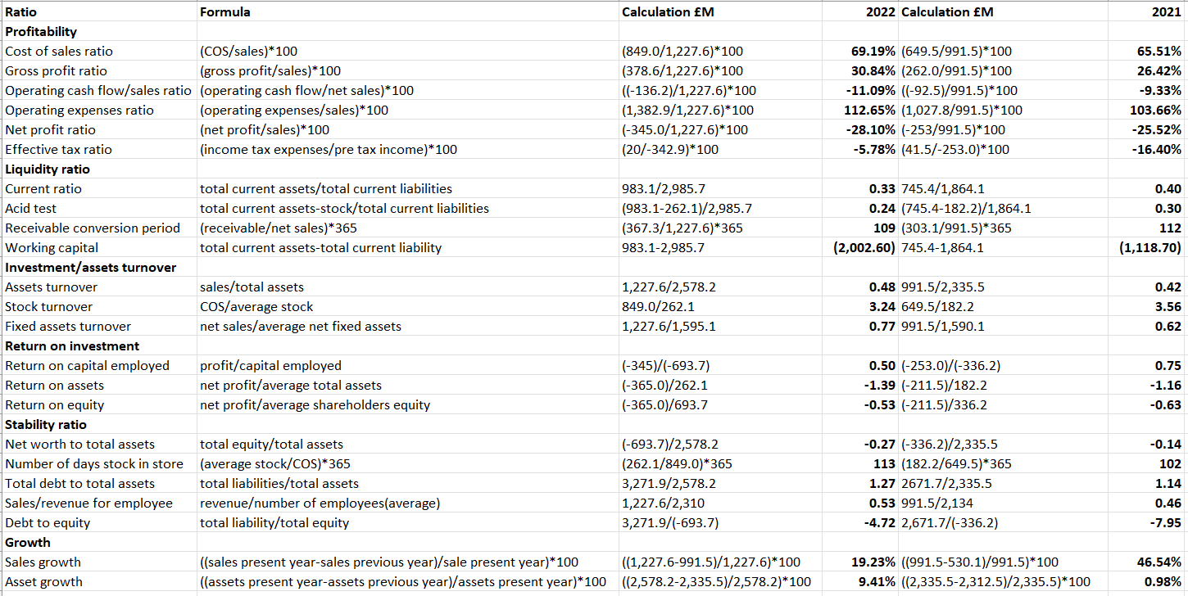
BMW (UK) Ltd
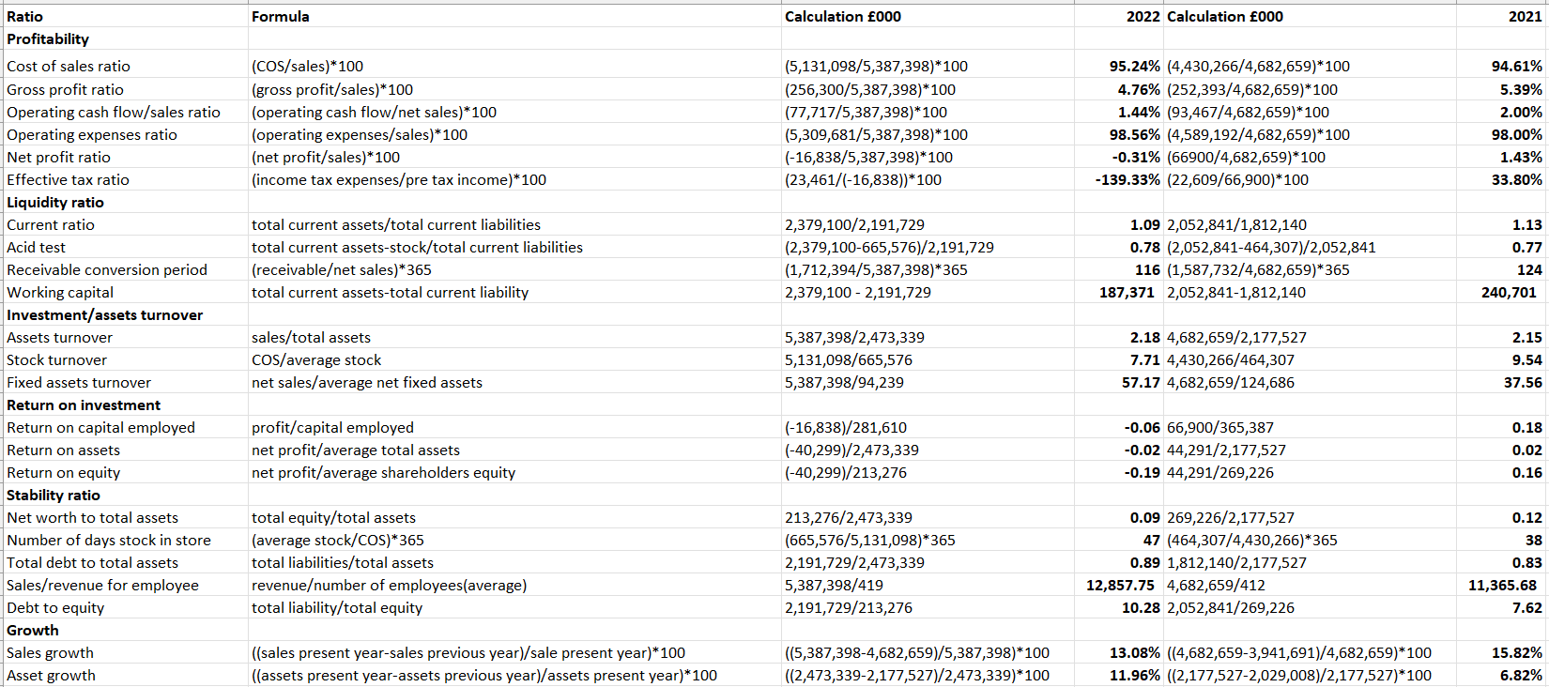

The Statements


