

Master of Business Administration (MBA)
Module Title: Strategic Management
Module Code: LCMB7003

Assessment Title: Strategic Analysis and Recommendations for Enhancing Competitive Advantage: Dove India

Student Name: Darshil Rana
Student ID: 2529562

Lecturer Name: Mr. Ghulam Mujtaba

Table of Contents
Section 1 5
1. Organisational Context and Strategic Position 5
1.1 Company Overview 5
1.2 Mission, Vision and Business Model 7
1.3 Industry Context and Competitive Landscape 7
2. External and Internal Analysis 8
2.1 External Strategic Environment Analysis (PESTEL) 8
2.2 Internal Strategic Analysis (VRIO) 11
2.3 SWOT Synthesis 14
3. Comprehensive and Holistic View 17
3.1 Corporate Social Responsibility as a Strategic Capability 17
3.2 Balanced Scorecard Evaluation for Dove India 20
4. Strategic Choice and Implementation 22
4.1 Evaluation of Strategic Alternatives 22
4.2 Validation of Strategic Recommendation 23
4.3 Recommended Strategic Direction 25
4.4 Strategy Implementation and Risk Management 26
Section 2 27
5. Reflective Account Using Gibbs’ Reflective Cycle 27
References 30
Appendices 34

Table of Figures
Figure 1: Dove by Unilever 5
Figure 2: PESTEL Analysis 8
Figure 3: BPC Growth in Quick Commerce (CY22–CY25) 10
Figure 4: SWOT Framework 14
Figure 5: Unilever Beauty & Wellbeing Portfolio 15
Figure 6: Dove Self-Esteem Project: Building Body Confidence 18
Figure 7: Porter’s Five Forces 23
Figure 8: Ansoff Matrix 24
Figure 9: Gibbs’ Reflective Cycle 27

List of Tables
Table 1: VRIO Analysis 13
Table 2: SWOT Elements 16
Table 3: Balanced Scorecard Evaluation 21
Table 4: Strategy Implementation and Risk Management 26

Section 1

1. Organisational Context and Strategic Position

1.1 Company Overview
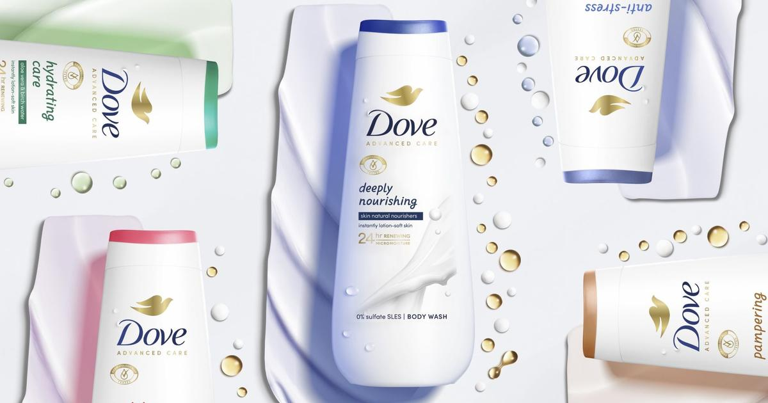
Figure 1: Dove by Unilever
(Source: Unilever, 2024)
Dove was established by Unilever in 1957 as a functional cleansing product but it has since transformed to be a global personal care brand that is in operation in the skincare, haircare, deodorants and body care segments. Its strategic change indicates how it has ceased product differentiation to purpose-driven differentiation where the Real Beauty platform generates emotional value, in addition to functional benefits. This represents an important intangible resource within the Resource-Based View since other competitors can easily imitate product characteristics, but not easily copy Dove brand trust and relationships (Unilever PLC, 2025a). Nonetheless, purpose positioning generates a strategic urgency to remain authentic as consumers become more critical on whether corporate promises are translated into real social change.
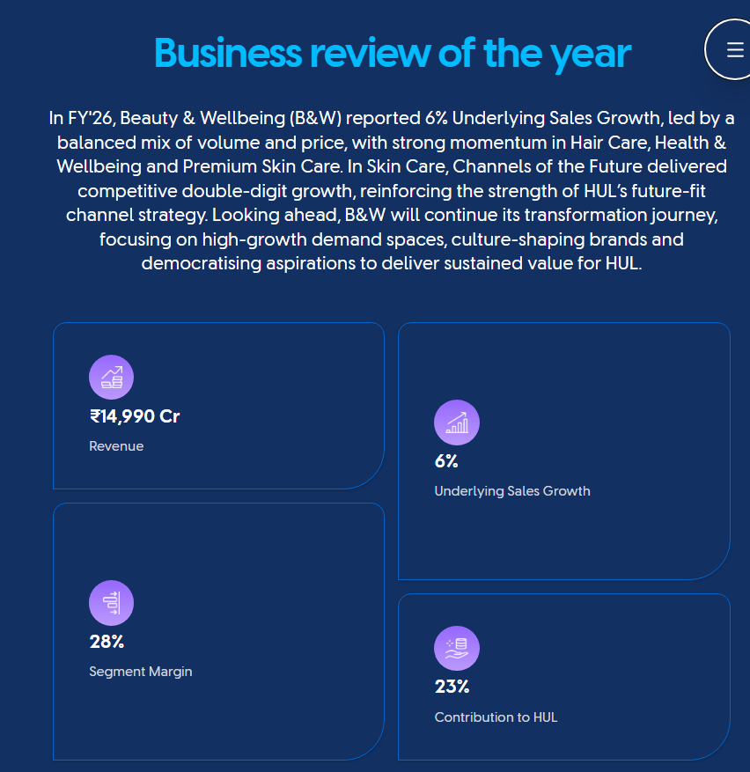
(Hindustan Unilever Limited, 2026)
In India Dove has Hindustan Unilever Limited (HUL) as its operation partner which benefits from the innovation power of Unilever and the vast distribution network of Hul. India is a strategically important country since HUL has identified India as one of its key growth markets, whereas its Beauty and Wellbeing division has brought about ₹14,990 crore revenue with 6% underlying sales growth and it signifies the appeal of high-end personal care segments (Hindustan Unilever Limited, 2026a).
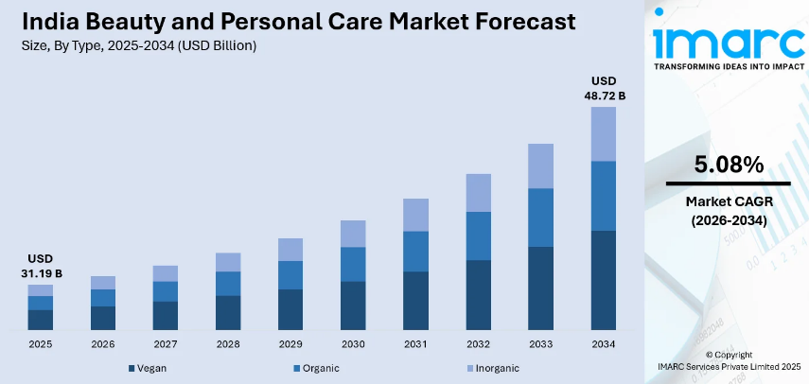
In addition, the beauty and personal care sector in India is projected to be USD 31.19 billion in 2025 and USD 48.72 billion by 2034 as a result of the growing disposable income, urbanisation, the use of digital and the growing consumer buying power of high quality and premium beauty products (IMARC Group, 2025).

1.2 Mission, Vision and Business Model
Mission: Dove seeks to transform self-esteem by disrupting the slender beauty ideals, influencing universal marketing choices.
Vision: It aims to achieve sustainable growth by establishing itself as a trusted wellbeing brand with positive social impact.
Business Model: Dove employs differentiation based on product quality, innovation and purpose-led branding to create a premium value by utilizing the resources of Unilever and the capabilities of HUL in the Indian market.

1.3 Industry Context and Competitive Landscape
Digital commerce, premiumisation and evolving consumer expectations are leading to structural growth in the beauty and personal care industry in India. Dove is competing with international brands like Nivea and L’Oréal Paris, and local digital native brands are further making competition more intense by positioning themselves in a targeted manner. Despite the growing competitive rivalry, Dove has the strategic resilience to its combination of global brand equity, the ability and purpose-based differentiation of HUL (Basu, 2024). Thus, the future of Dove India will be the ability to turn the brand purpose into quantifiable innovation and sustainable consumer value instead of historical reputation.

2. External and Internal Analysis

2.1 External Strategic Environment Analysis (PESTEL)
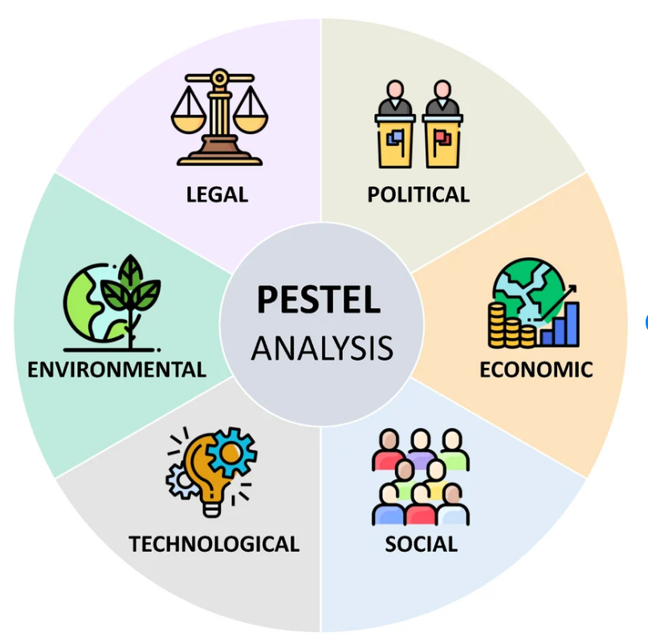
Figure 2: PESTEL Analysis
(Segura et al., 2023)
Political Factors
The policy environment in India is becoming more inclined towards large scale FMCG players with local manufacturing, compliance prospects and distribution networks. Government policies to favour local production and investment empower Hindustan Unilever Limited (HUL) to be efficient and operate in India (HDFC Securities Institutional Equities, 2026). This is a strategic necessity since the competitive advantage of Dove does not lie solely on the brand equity but also on the capability of HUL to provide constant quality in a heterogeneous market in geographical terms. Unilever announced that the emerging markets were still key drivers of growth and India was one of the markets that facilitated growth (Unilever PLC, 2026).
Yet, the regulatory demands on product claims, sustainability reporting and consumer protection are also rising due to political developments. In the case of Dove, this poses a strategic paradox: regulation complicates operations but also favors trusted brands that can ensure transparency (Hindustan Unilever Limited, 2025). Hence, compliance is no more than a strategic ability that safeguards the reputation of Dove but not just a legal mandate.
Economic Factors
Economic conditions have a strong impact on the Dove strategy of premium differentiation since the premium brand competes based on the perceived value and not price leadership. The Indian luxury beauty and personal care market is projected to grow by 15 percent to reach INR132.2 billion in 2025, with the rising disposable income and the shift in attitude of consumers towards investing in beauty routines as self-care (Marketresearch, 2026). This trend is a direct complement to Dove since its products are oriented in terms of quality, dermatological validity and emotional advantage (Syaharani, 2021).
Nevertheless, the premiumisation increases the competition as well as the segments with higher value bring global competition and digitally native brands. The Beauty and Wellbeing segment of HUL recorded 6% underlying sales growth and a revenue of ₹14,990 crore, indicating a good category momentum, yet further indicating that the company needs to keep the innovation alive (Hindustan Unilever Limited, 2026a). Moreover, the increase in input prices puts a strain on margins within FMCG segments. Hence, Dove should not solely use the premium pricing strategy, but should implement a balanced approach of premium innovation and affordability by using smaller packs and segmenting its portfolio (Misra, 2026).
Social Factors
Social change is the most powerful opportunity of Dove as Indian buyers are shifting more towards authenticity, health and self-expression than sticking to traditional beauty ideals. This is a direct reinforcement of the Real Beauty positioning of Dove, which makes the brand stand out based on emotional attachment and not a functional value only. In India, personal care and beauty recorded 9% retail sales growth in 2025 due to the demand of efficacy through science, ingredient transparency, wellness-related products and more (Euromonitor, 2026).
Nonetheless, the strategic issue is that the purpose-led positioning of Dove is no longer a one-off. The similar stories about natural ingredients, inclusivity and ethical consumption are increasingly used by competitors. Thus, the future strength of Dove lies in its ability to transform purpose into tangible consumer value by innovating its products, engaging in plausible social actions and engaging with consumers on a personalised level. The opportunity is big, and to ensure that differentiation is sustained, there must be constant renewal (Kim and Kim, 2025).
Technological Factors
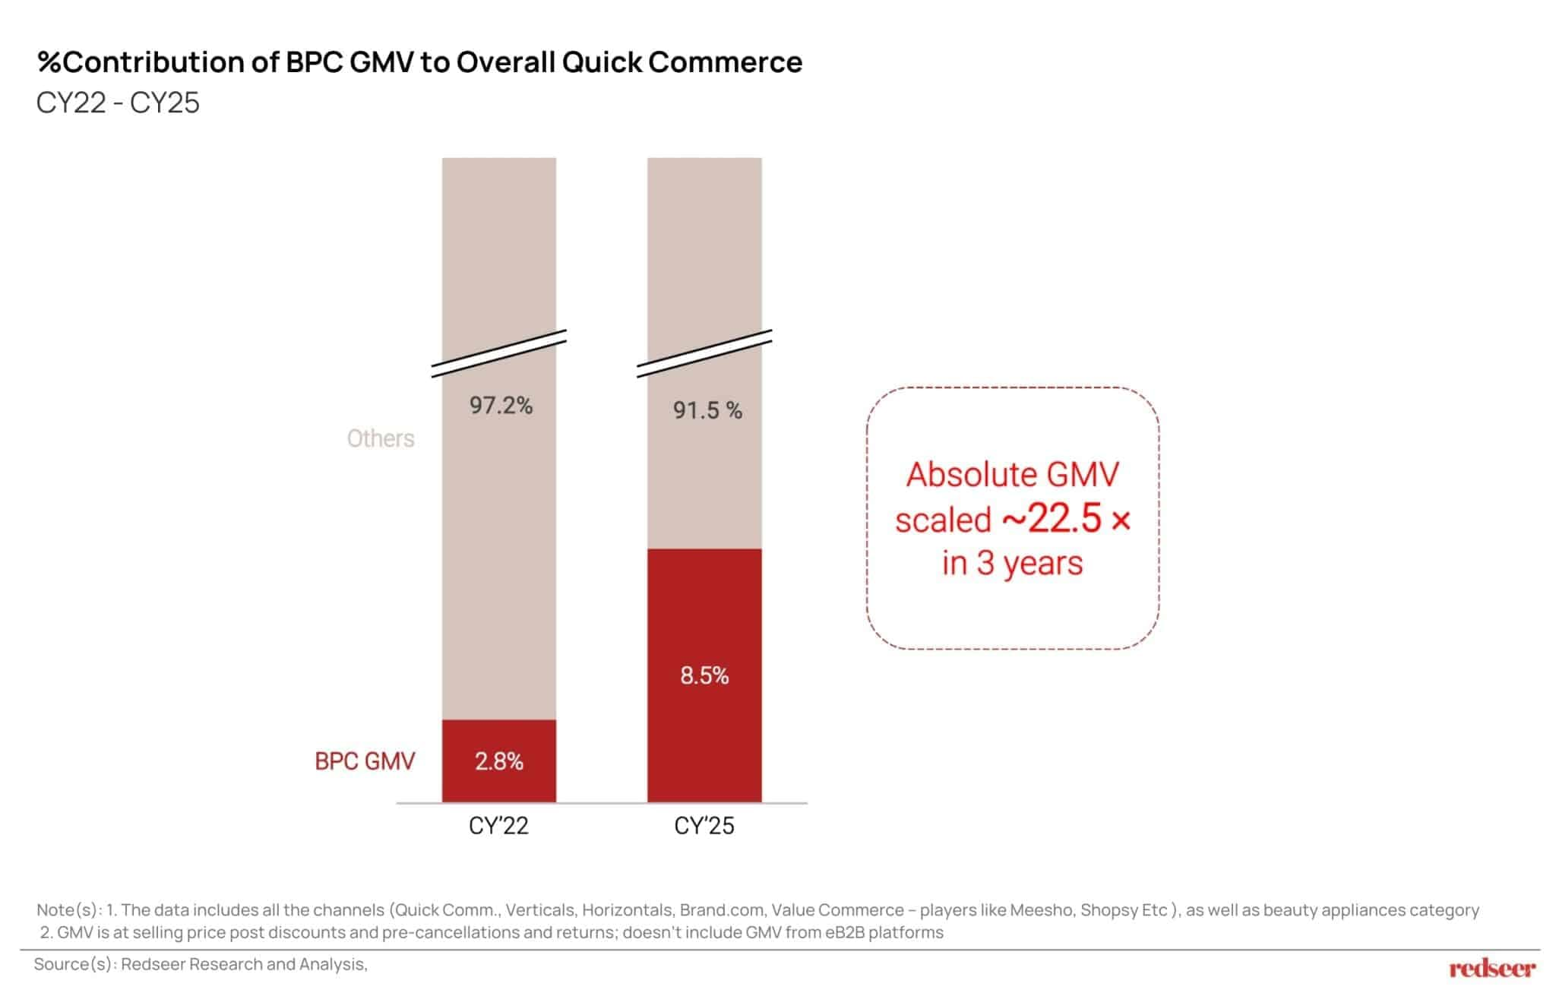
Figure 3: BPC Growth in Quick Commerce (CY22–CY25)
(Source: Dalal, 2026)
Technology is redefining the way Indian consumers learn about and shop personal care products. The online beauty and personal care markets saw a massive growth, with the online BPC market in India growing between ₹21,000 crore in 2022 to ₹52,000 crore in 2025. Rapid growth in quick commerce beauty sales were also witnessed with BPC GMV growing by about 22.5 times during the period of 2022-2025 (Dalal, 2026).
In the case of Dove, it is a possibility to leverage AI and consumer analytics and digital platforms to personalise recommendations and build stronger relationships. Nevertheless, technology helps to overcome traditional barriers to entry, and smaller brands can compete with the help of influencer communities and direct-to-consumer models. Thus, the digital presence is not the strategic need of Dove, but rather the digital capability of Unilever that will unite the scale and agility of consumers (Unilever PLC, 2025b).
Environmental Factors
The environmental expectations are also playing an ever-increasing role in purchasing behavior in the personal care industry since consumers are demanding sustainable packaging, responsible sourcing and less environmental impact. Unilever has instilled the principle of sustainability in its long-term strategy, whereas Dove has integrated sustainability pledges in its brand positioning (Unilever PLC, 2025b). This helps Dove differentiate as environmental responsibility is in line with its current purpose-led identity.
However, sustainability generates reputational risk as the consumers continue to question whether corporate commitments are yielding quantifiable results. Thus, Dove should focus on showing environmental improvements by reporting transparently, packaging innovatively, improving supply-chain and not only by communicating on sustainability (Unilever PLC, 2025b).
Legal Factors
Existing legal pressures on the accuracy of advertising, disclosure of ingredients and privacy of consumer data are direct effects on the operations of Dove. With the growth of digital personalisation, the importance of responsible consumer data management is growing. In the case of a trust-based brand, law-abiding can enhance credibility and build confidence in the customer. Hence, legal governance should be a strategic asset that Dove ought to leverage to build brand trust over the long term (Aaker and Moorman, 2023).
Strategic Evaluation
Premiumisation, digital transformation and purpose-led differentiation are the biggest opportunities of Dove India, as they fit the current organisational strengths. Competitive imitation, cost inflation and sustainability scepticism are the most significant threats (Syaharani, 2021). Generally speaking, the external environment of Dove is positive, sustainable advantage is going to be determined by the ability to convert brand purpose into quantifiable innovation, transparency and consumer-focused experience.

2.2 Internal Strategic Analysis (VRIO)
The intangible resources and organisational capabilities influencing the internal strategic position of Dove India dictate the ability of the company to maintain its differentiation strategy. According to the Resource-Based View, competitive advantage relies on resources that produce a high customer value and are hard to be copied by the competitors (Barney, 1991). Thus, the evaluation is based on whether Dove resources create sustainable advantage as opposed to merely determining the strengths of the company.
Strategic Resource | VRIO Evaluation | Strategic Implication
Global brand equity | The global brand of Dove that has been developed over decades generates trust and premium positioning. Products are easy to copy, but it is difficult to duplicate a built-up relationship with consumers (Sivakumar and Ramani, 2026). | Sustainable competitive advantage
Real Beauty brand platform | Produces emotional differentiation through the association of personal care and inclusivity and self-esteem. Nevertheless, rivals are increasingly turning to purpose-led branding, which makes it less unique (Syaharani, 2021). | Potential sustainable advantage requiring renewal
HUL distribution network | Gives a wide market coverage, presence and size of operation in India. Nevertheless, the rivals like P&G and L’Oréal have similar distribution capacities (Basu, 2024). | Competitive parity
Unilever innovation and R&D capability | Availability to worldwide science, development skill and consumer knowledge underpins ongoing product advancement. Unilever announced that in 2025 Beauty and Wellbeing will have growth of 4.3% underlying sales which will be supported by brands such as Dove (Unilever PLC, 2025b). | Temporary to sustainable advantage through continuous innovation
Sustainability capability | Unilever also incorporates sustainability within the business strategy, enhancing brand credibility and resilience. Sustainability is however becoming an industry requirement and not a special ability (Unilever PLC, 2025b). | Emerging strategic capability
Marketing and consumer engagement capability | Dove and HUL have purpose-driven campaigns that build high emotional bonds and, with 6% underlying sales growth and ₹14,990 crore revenue, the Beauty and Wellbeing business offers a good future-channel capability (Hindustan Unilever Limited, 2026a). | Temporary competitive advantage
Table 1: VRIO Analysis
Critical Evaluation of Strategic Resources
Brand equity is the strongest strategic resource of Dove India, and it is socially complex as it was created over decades of the consistent positioning. Consumer trust is a major source of differentiation since it cannot be easily duplicated as is the case with tangible resources. This benefit is augmented by the Real Beauty platform, which generates emotional value that goes beyond product benefits, but as competitors start to use similar stories rarity is diminished (Xuan, 2025). Thus, Dove has to transform purpose into quantifiable consumer value.
The distribution network of HUL and the size of Unilever give it operational advantages without specificity because they have similar capabilities in FMCG (Hindustan Unilever Limited, 2026b). Responsiveness can be enhanced by innovation capability, although the benefits are short-lived unless they are commercialised and met by the consumer insight (Yahoo Finance, 2026). The biggest weakness that Dove has in the wake of increasing competition and purpose scepticism is reputation dependency.
Strategic Judgement
Generally, Dove India has a good resource base and the differentiation is based on brand equity, consumer trust and organisational capability. Nevertheless, the sustainable benefit will be based on safeguarding the scarce intangible assets with the help of ongoing breakthroughs, plausible sustainability initiatives and enhanced digital customer interactions. It is not the creation of awareness, but rather the ability to remain differentiated in a market that is getting more and more saturated with personal care brands (Syaharani, 2021).

2.3 SWOT Synthesis
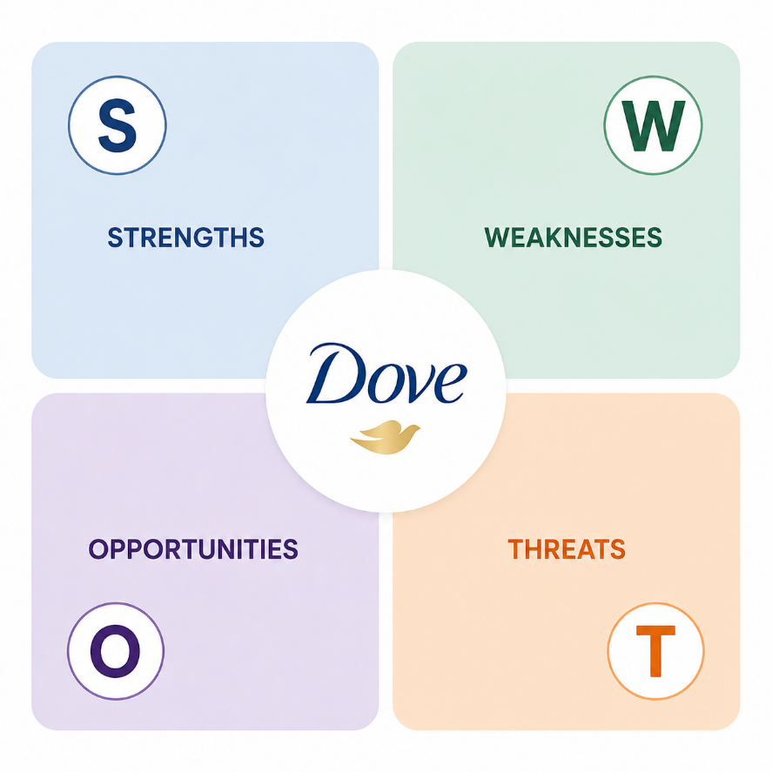
Figure 4: SWOT Framework
(Source: Self-developed)
The SWOT synthesis of Dove India is a combination of the internal capabilities determined using VRIO analysis and external conditions determined using PESTEL analysis. It will be to assess the ability of Dove resources to drive competitive advantage into the future as the Indian beauty and personal care marketplace grows more premium, digital and sustainability oriented.
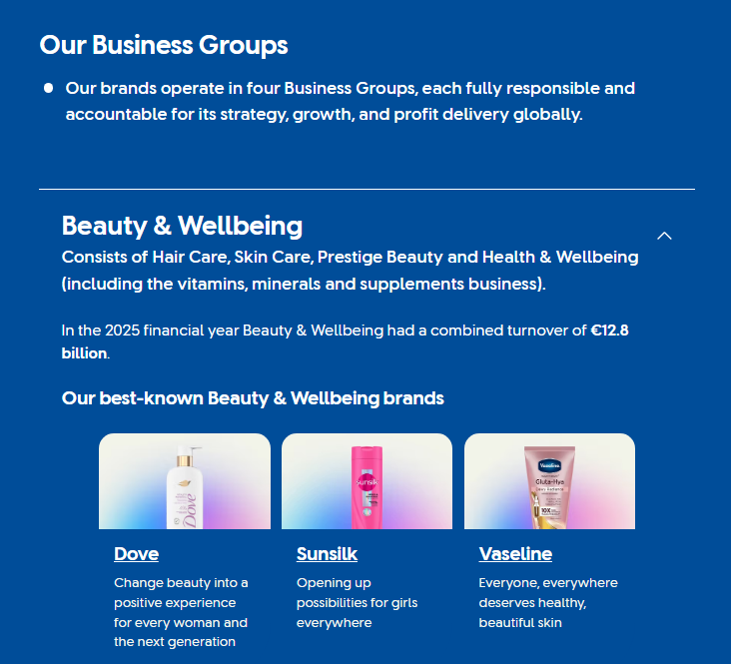
Figure 5: Unilever Beauty & Wellbeing Portfolio
(Source: Unilever, 2026)
SWOT Element | Evidence-Based Strategic Assessment
Strengths | Brand equity and purpose differentiation: Dove has an important intangible asset in its positioning of Real Beauty, which allows it to differentiate at an emotional level rather than the functional level of its product benefits. This helps in premium positioning since decades-long trust cannot be easily imitated by competitors. Unilever announced that Beauty & Wellbeing realized a turnover of €12.8 billion in 2025 and that its brands such as Dove have driven growth, illustrating the commercial power of its business (Unilever, 2026).
Weaknesses | HUL ecosystem capability: Dove enjoys the Indian market experience, distribution strength and category leadership of HUL. The Beauty and Wellbeing segment of HUL registered ₹14,990 crore turnover and 6 percentage point underlying sales increase, which implies that the organisation has the strength to facilitate the growth of Dove (Hindustan Unilever Limited, 2026a).
Opportunities | Premium positioning poses accessibility issues: Premium pricing enhances margins and brand recognition, but on the other hand, it might limit entry into the price-sensitive Indian market. Thus, Dove has to find a balance between aspiration and affordability (Syaharani, 2021). .
Threats | Risk of imitation of purpose: Competitors are increasingly co-opting sustainability and inclusivity stories, making the differentiation of Dove less distinctive (Syaharani, 2021).
Table 2: SWOT Elements
Strategic Implications
The SO strategy reveals that Dove ought to leverage its brand equity and HUL capabilities in seizing premium beauty growth by innovation-led and personalised products (Hindustan Unilever Limited, 2026b). The ST approach demands that Real Beauty should be turned into a communication benefit into a quantifiable social and sustainability performance since messages are repeatable by competitors, but not genuine capabilities (Syaharani, 2021).
The WO strategy emphasizes the necessity to eliminate the premium access barriers by differentiated products formats. The WT approach involves the need to lessen reliance on past brand strength by enhancing digital agility, speed of innovation and transparency of sustainability(Hindustan Unilever Limited, 2026b).
In general, the SWOT synthesis recommends that Dove must aim at developing capabilities-based differentiation where competitive advantage is generated through the combination of brand authenticity, innovation, sustainability and consumer intelligence and not depending solely on the reputation.

3. Comprehensive and Holistic View

3.1 Corporate Social Responsibility as a Strategic Capability
Corporate Social Responsibility (CSR) strategy is a strategic capability of Dove in that it helps in differentiation, relationship with stakeholders and brand equity over the long term as opposed to being merely a reputational exercise. Dove strives to transform social purpose into commercial value through Unilever Positive Beauty strategy, sustainable sourcing promises, initiatives empowering women and inclusive marketing. Nevertheless, the strategic success of CSR is determined by the presence or absence of the perception of the initiatives as legitimate and backed by quantifiable results by the stakeholders (Unilever, 2021).
Positive Beauty Strategy and Inclusive Marketing
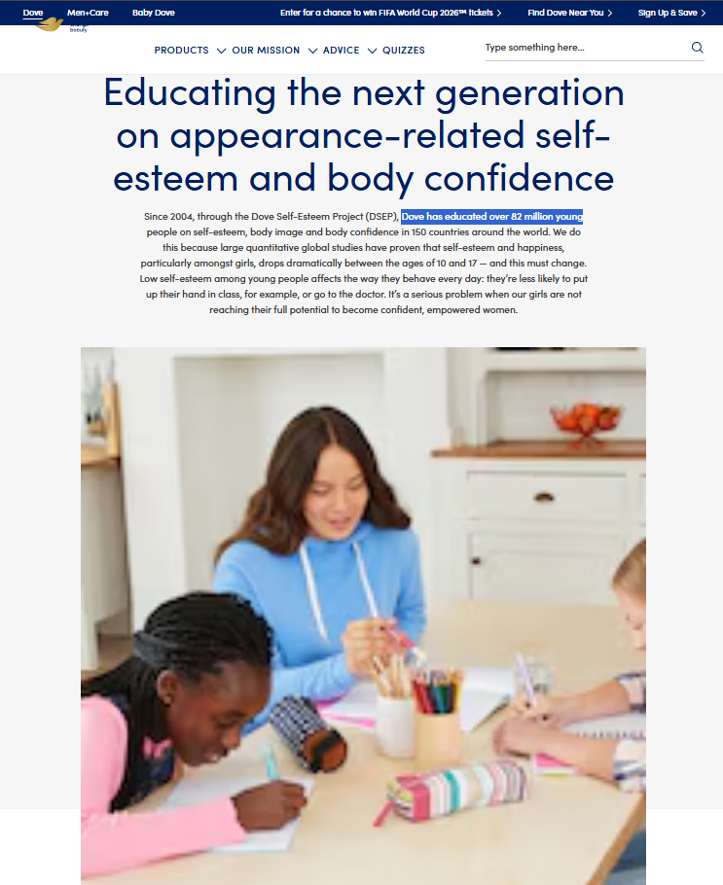
Figure 6: Dove Self-Esteem Project: Building Body Confidence
(Source: Dove, 2025)
Positive Beauty strategy of Dove reinforces its differentiation by making beauty a source of confidence, instead of insecurity. The Dove Self-Esteem Project has also proven to have a social impact that can be measured as it has already reached over 82 million youths worldwide via self-esteem education programs. This enhances the stakeholder value by meeting the social concerns on body image as well as building consumer trust. This has a strategic benefit in that it develops an intangible advantage as emotional relationships and brand authenticity cannot be easily replicated by competitors (Dove, 2025). The limitation, however, is that purpose-led positioning is becoming more prevalent in the beauty industry; thus, the strength of Dove would not be based on communicating but a consistent evidence of effect.
Sustainable Sourcing and ESG Capability
The sustainability activities of dove are in line with the broader ESG strategy of Unilever such as responsible sourcing and packaging transformation. Unilever has announced that it has met its target of recycling 25% of its post-consumer plastic by 2025, indicating a move towards circular packaging. These efforts contribute to competitive advantage through enhancing supply-chain resilience and resonating with conscientious consumers of the environment. However, sustainability poses strategic risk as giant consumer brands are under increasing question when it comes to greenwashing (Unilever, 2024a). Hence, Dove should make sure that environmental claims can be supported with transparent reporting and measurable improvements instead of sustainability accounts.
Women’s Empowerment and Stakeholder Value
The empowerment of women is the most prominent aspect of the Dove brand that the Real Beauty platform is still based on as it questions the limiting beauty ideals and encourages representation. This will add value to various stakeholders such as consumers, communities and employees, and build brand reputation. Nonetheless, social programs can become ineffective strategically when the consumers feel that they are not related to the overall business operations. Authenticity thus demands that there is congruency in advertising, product innovation and organisational behaviour (Dove, 2023).
Strategic Evaluation
In general, the CSR ability of Dove helps it to enhance its competitive advantage by enhancing brand trust, emotional loyalty and differentiation. But, CSR is not necessarily a sustainable benefit since companies can replicate campaigns and messages. The strategic priority of Dove must be to make CSR a capability-based strength by converting its communication-based asset into a measurable ESG performance, responsible innovation and stakeholder engagement (Kim and Kim, 2025). This confirms the VRIO conclusion that the strongest resources that Dove possesses are intangible capabilities founded on trust, authenticity and consumer relationships.

3.2 Balanced Scorecard Evaluation for Dove India
The Balanced Scorecard used by Dove India ensures that the differentiation strategy is translated into measurable goals by connecting the financial performance with the customer value, operational capability and organisational learning. The framework aids strategic implementation, in the sense that purpose-led positioning of Dove is transformed into quantifiable business results instead of being just a branding exercise. The Beauty & Wellbeing division of Unilever provides strategic background, where the division is expected to have a turnover of at least €12.8 billion in the year 2025, and the growth will be guided by high-quality innovation and brands such as Dove. HUL in India has a Beauty and Wellbeing segment, which registered revenue of ₹14,990 crore, 6% underlying sales growth, and 28% segment margin, indicating the commercial significance of high-end beauty brands (Hindustan Unilever Limited, 2026a).
Perspective | Strategic Objective | KPI | Target | Strategic Initiative
Financial | Achieve sustainable premium growth while protecting profitability | Revenue growth, market share, operating margin, premium product contribution | Sustain growth and contribute more to premium portfolio. | Grow science-based skincare and haircare development; streamline premium and masstige portfolio.
Customer | Strengthen trust, loyalty and emotional connection | Brand preference, customer satisfaction, repeat purchase rate, digital engagement | Boost the loyalty scores and solidify Dove among younger consumers. | Individualised online marketing, inclusive marketing, consumer groups.
Internal Business Processes | Improve innovation, sustainability and supply-chain efficiency | New product launch success rate, sustainable packaging adoption, supply-chain efficiency | Use more sustainable packaging and speed up the innovation process. | Make sustainable formulations, responsible sourcing, and data-driven product development investments.
Learning and Growth | Build capabilities required for future beauty markets | Employee digital skills, innovation capability, sustainability expertise | Enhance analytics, AI and consumer insights capacity. | Establish digital marketing and cross-functioning innovation teams
Table 3: Balanced Scorecard Evaluation
Strategic Evaluation
The financial viewpoint indicates the transformation of Dove in terms of its volume-based competition in FMCG to a premiumisation. Nevertheless, the focus of growth should be on profitable expansion as opposed to revenue because of affordability pressure (Bohra, Nagansur and Anute, 2022).
Trust and emotional connection is a difficult-to-copy VRIO resource emphasized by the customer perspective. Nonetheless, the imitation by competitors poses authenticity problems.
The internal process lens relates CSR to quantifiable innovation, sustainability and responsible sourcing (Unilever, 2023).
The learning and growth view focuses on the digital potential, analytics and staff skills to enable accommodation (Kim and Kim, 2025).
Comprehensively, Balanced Scorecard alignment will help Dove change purpose into quantifiable talents, maintaining differentiation and future competitiveness.

4. Strategic Choice and Implementation

4.1 Evaluation of Strategic Alternatives
The strategic issue facing Dove India is not entering the market but maintaining competitive advantage in an industry where rivals can slowly follow suit and copy the benefits of their products and purpose-driven communication. Thus, the right course of action should be in line with the greatest strengths of Dove: brand equity, consumer trust, the ability to innovate and social positioning (Prabhakar, 2025).
Cost Leadership Strategy
Cost leadership is not a strategic option since Dove does not compete based on lowest cost. Dove value proposition relies on high-end perception, product efficacy and emotional connection, although HUL offers scale of operation. Unilever positions Dove as a Power Brand that it supports with brand investment and science-led innovation, and Personal Care performance that is not guided by price competition but rather strong brands (Jerab and Mabrouk, 2023).
Cost-based strategy would result in a strategic trade-off. Reduced prices could boost short-term volume, but would dilute the premium positioning of Dove and resources available to innovate and be sustainable. Thus, the competitive advantage of resources that form the competitive advantage of Dove would be compromised by cost leadership (Jerab and Mabrouk, 2023).
Focus Strategy
Focus strategy may help in enhancing interaction with certain groups like younger digital users, high-quality skincare users or eco-friendly customers. Nevertheless, a pure focus approach would limit Dove to take advantage of its extensive consumer awareness and distribution potential of HUL. Segmentation must not compete with the strategy in general but must assist in the execution with personalised campaigns (Pathange et al., 2024).
Differentiation Strategy
The optimal strategic fit is differentiation since the benefit of Dove is based on hard-to-copy intangible assets. Real Beauty position, consumer trust and dermatological credibility generate value on top of functional product performance. Nonetheless, purpose-led differentiation is getting simpler to copy by competitors. Consequently, Dove needs to have an evolved differentiation, where sustainability, innovation and digital consumer intelligence would be organisational capabilities, as opposed to marketing messages (Zhou, 2024).

4.2 Validation of Strategic Recommendation
Porter’s Five Forces
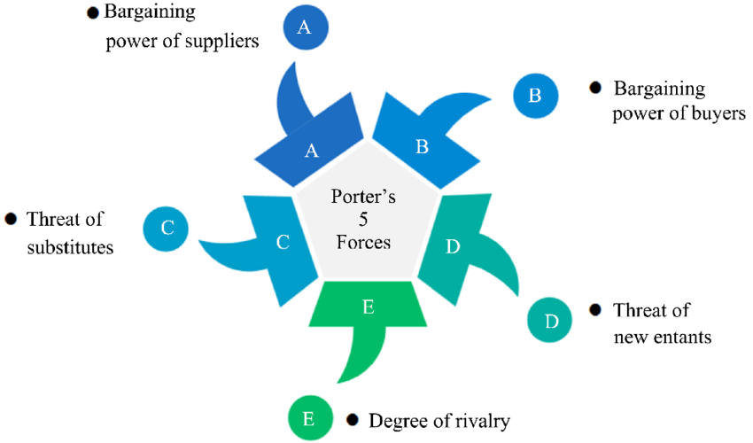
Figure 7: Porter’s Five Forces
(Source: Mao, 2023)
Porters Five Forces promotes differentiation as competitive pressures in the personal care industry are more willing to reward brands that establish a unique value.
The level of competitive rivalry is very high as Dove is competing with multinational brands and digitally native companies that are relying on influencer marketing, specialised products and ingredient-based positioning. Smaller brands have found it easier to enter through digital platforms, which has put a strain on the larger ones. Thus, Dove has to develop an ever-growing ability that will be difficult to imitate by competitors (Basu, 2024).
The threat of new entrants is moderate. Although the e-commerce helps novice brands to access consumers with limited retail infrastructure, it is hard to replicate the years of trust Dove has built and the organisational competencies of Unilever (Basu, 2024).
The buyer power is growing due to the fact that consumers are able to compare the products with the help of reviews, social platforms and online marketplaces. This minimizes the switching costs and renders emotional loyalty to be strategically significant. The differentiation of dove thus offers defense against the pure price-based rivalry (Srivastava, 2025).
The risk of substitutes is high because the consumers are more exposed to natural, Ayurvedic and specialist skincare substitutes. Therefore, we need to be constantly innovative to stay relevant (Basu, 2024).
Ansoff Matrix
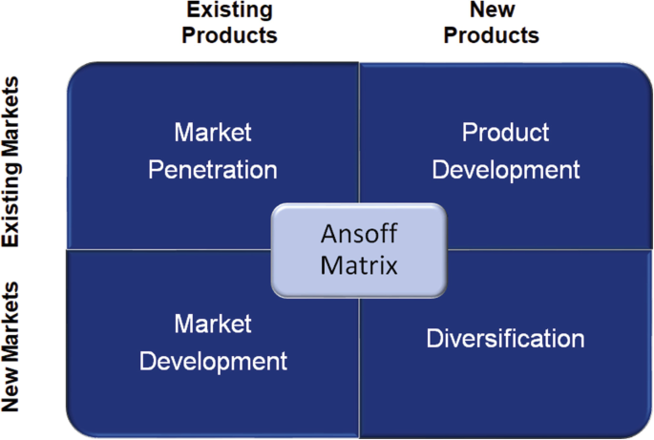
Figure 8: Ansoff Matrix
(Source: Helmold, 2022)
Ansoff analysis contributes to the market penetration and product development as the most suitable growth strategies.
Growing customer lifetime value by personalised digital interactions, loyalty programs and more impactful consumer communities should be the market penetration. Product development offers greater strategic fit since Unilever keeps investing in science-led premium personal care development, such as the Advanced Care and serum-based product lines of dove (Unilever, 2024b).
Expansion into the new Indian consumer markets offers potential, but needs to be affordable managed to prevent erosion of the premium positioning. The greatest risk is diversification as the unrelated growth may dilute the Dove brand (Unilever, 2024c).
Strategic Judgement
The facts favor a developed differentiation strategy of Dove India. Cost leadership would undermine brand equity whereas pure focus would curtail scale benefits. Sustainable innovation, digital personalisation and creation of consumer value are the three elements that Dove must use to change differentiation as a communication advantage into a capability advantage (Syaharani, 2021). This suggestion is also consistent with the VRIO resources of Dove, CSR capability and Balanced Scorecard objectives, developing a logical channel through strategic analysis and implementation.

4.3 Recommended Strategic Direction
The suggested approach to Dove India is the capability-based differentiation based on sustainable innovation, digital consumer knowledge and genuine purpose implementation. The choice of this strategy is explained by the fact that it is the best way to leverage the strongest strategic assets of Dove found during VRIO analysis: global brand equity, positioning Real Beauty, the ability of Unilever to innovate and the ability of HUL to implement its strategies in a local market (Syaharani, 2021).
Cost leadership is inappropriate since the value proposition of Dove is based on trust, product credibility and emotional differentiation as opposed to low prices. Price rivalry would undermine premium perception and capacity to invest in innovation and sustainability. Equally, with a narrow focus strategy, Dove would not be able to tap into the extensive network of HUL and its widespread consumer relevance (Jerab and Mabrouk, 2023).
Differentiation is still a strategically relevant move; Dove, however, needs to develop beyond the purpose-based communication. The SWOT analysis revealed a major strategic issue: as Dove engages in an inclusive positioning strategy, it develops a robust consumer connection, but competitors are starting to replicate the same sustainability and purpose stories. Thus, the key to the future is to turn intent into quantifiable abilities (Syaharani, 2021).
This is an applicable strategy at this time due to the fact that India is in its phase of a more digitally disrupted beauty market, amid heightened consumer demands in terms of transparency and heightened competition by more nimble digital-native companies. The opportunity that Dove can capitalise upon is to unite the global research capacity of Unilever with the consumer knowledge of HUL to provide personalised, sustainable and science-based solutions (Basu, 2024).
The customer value strategy generates a functional effectiveness, emotional trust, and responsible consumption decisions. It also fosters long term sustainability since the construction of competitive advantage is based on capabilities that cannot be easily duplicated as opposed to one-time campaigns (Kanimozhi and Sengottuvel, 2024). This is a direct correlation of the CSR analysis, where authenticity and quantifiable ESG results were found to be the key to safeguarding reputation.

4.4 Strategy Implementation and Risk Management
Challenge | Strategic Risk | Mitigation
Consumer acceptance | Purpose initiatives can be viewed as promotional and not genuine by the consumers. | Determine social impact results and report transparent evidence.
Competitor reactions | Inclusive and sustainability messages can be emulated by competitors. | Build proprietary knowledge, accelerated innovation processes and differentiated products.
Economic uncertainty | The premium positioning can decrease the accessibility at the time of low purchasing power. | Tiered product formats and maintain premium brand identity.
Sustainability risks | ESG assertions can lead to greenwashing issues. | Enhance sustainability reporting and responsible sourcing validation.
Digital transformation | Brands with a digital-first can seize younger consumers. | Make investments in AI-based personalisation and omnichannel interaction.
Supply-chain resilience | Sustainable sourcing can cause complexity in operations | Develop strong supplier relationships and accountable procurement practices.
Table 4: Strategy Implementation and Risk Management
Strategic judgement: Dove India needs to seek advanced differentiation and not change its current strategy. Dove can transform the already established brand equity into a competitive advantage that is more defensible and robust by incorporating innovation, sustainability, digital capability and authentic purpose (Tserenbat, Lee Alm and Kusche, 2024).

Section 2

5. Reflective Account Using Gibbs’ Reflective Cycle
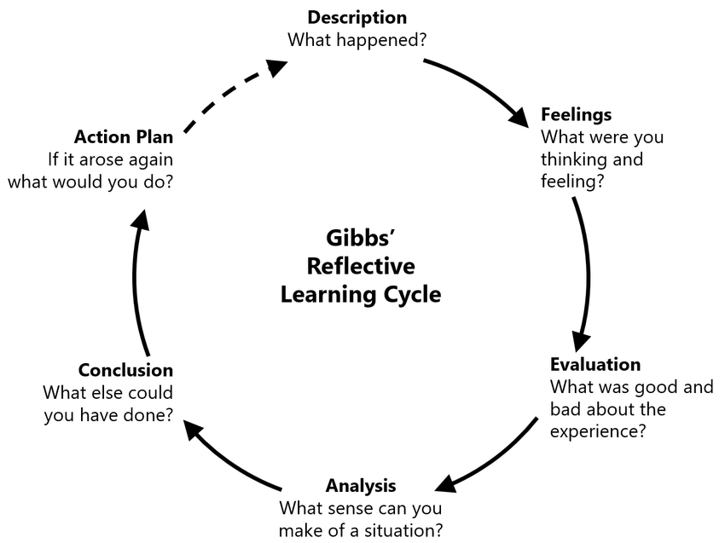
Figure 9: Gibbs’ Reflective Cycle
(Source: Harithuddin, 2021)
Description
My first strategy approach towards this strategic analysis of Dove India was largely framework based. I considered strategic management models (PESTEL, VRIO, SWOT and Porters Five Forces) to be a tool that had to be used to accomplish an academic activity individually. At first, I was interested in finding out the data on the market position, competitors, and CSR activities of Dove. But, over the course of the research, my view of strategy evolved. I started to realise that frameworks are not useful since they are practised, but to explain the complex strategic decisions and to offer evidence-based recommendations.
The greatest change was observed when comparing the competitive advantage of Dove (‌Bassot, 2024). At first, I thought that Dove achieved success primarily due to its Real Beauty campaign and good reputation in the world. This assumption was however questioned by further study on the Resource-Based View. I understood that brand reputation does not necessarily bring forth sustainable advantage but advantage is created when resources are constantly developed, preserved and combined with organisational capabilities.
Feelings and Initial Assumptions
I was optimistic when starting the project that I could be able to use strategic frameworks as it gave me a clear outline on how to approach the analysis. I later realised, though, that this confidence was founded, in part, on a scanty knowledge of strategic evaluation. The first step that I took in collecting evidence was to find information that would confirm my assumptions regarding the success of Dove. This gave a possible confirmation bias as I was concentrating more on positive brand attributes as opposed to doubting strategic constraints.
My thinking was particularly challenged by the CSR analysis. My understanding of CSR prior to this project was that it was primarily a good thing that enhanced reputation. When studying Dove and the Positive Beauty strategy and its sustainability commitments, I became more critical in my view. I realised that CSR can only bring competitive advantage in a situation where the stakeholders feel that they are authentic and where organisations can deliver quantifiable results. This altered my perception of CSR as generating goodwill to CSR generating strategy value when it is part of organisational capability.
Evaluation
A major success of this research process was developing a more critical approach to evidence evaluation (Bassot, 2024). Instead of considering organisational reports as full-fledged manifestations of performance, I have learned to evaluate potential constraints in corporate communication and contrast the evidence provided by academic literature, industry reports and the outside opinion. This was especially essential when examining the sustainability strategy of Dove, where the corporate commitments have to be compared to the implementation challenges and expectations of the stakeholders. Nonetheless, the research process was also challenging. I also found it hard to sort out strategically useful information among the vast amount of data provided by the market in the beginning. This experience has shown that good consultancy involves prioritisation and judgement and not information accumulation.
Analysis
This project was the most important intellectual growth because of the realization of strategic integration. I used to think of frameworks as individual analysis tools, but the analysis of Dove showed that a successful strategy means linking a variety of perspectives. VRIO was used to determine internal capabilities, PESTEL to evaluate external pressures, SWOT to translate findings into strategic priorities, and Balanced Scorecard to facilitate implementation planning (Morris, 2023). I also gained an appreciation of strategic tensions. The purpose-based differentiation of dove is a source of competitive advantage due to emotional association, but rising use by competitors poses a weakness. This enhanced my capability of making balanced strategic judgements as opposed to descriptive analysis.
Conclusion
This project has changed my perception of strategy to the use of frameworks to making evidence-based decisions. I also found out that sustainable competitive advantage is not solely based on the valuable resources but also on the ever-growing capabilities that cannot be easily imitated by the competitors. In the case of Dove, this involves transforming the brand purpose, sustainability, and consumer trust into quantifiable strategic capabilities that can help it remain competitive in the long run.
Action Plan
In order to enhance my future consultancy ability, I will enhance my research ability by making a more systematic approach to source appraisal, involving, more use of academic works and independent industry evidence. I will also enhance my skills in converting analysis into practical recommendations by paying more attention to the implementation feasibility, risks and measurable outcomes.
In leadership growth, I wish to enhance my skills on how to share strategic insights with various stakeholders in a clear manner. This project made me understand that consultants need not only analytical skills, but also the ability to impact decisions by providing evidence, being clear and exercising professional judgement.

References
Aaker, D. A., & Moorman, C. (2023). Strategic market management. John Wiley & Sons.
Barney, J.B. (1991) ‘Firm Resources and Sustained Competitive Advantage’, Journal of Management, 17(1), pp. 99–120. Available at: https://josephmahoney.web.illinois.edu/BA545_Fall%202022/Barney%20(1991).pdf
‌Bassot, B. (2024). The reflective journal. Bloomsbury Publishing.
Basu, S. (2024). Top 11 Indian Beauty and Personal Care Companies | IMARC Group. [online] Imarcgroup.com. Available at: https://www.imarcgroup.com/blog/beauty-personal-care-manufacturing-companies-india
Bohra, D.K., Nagansur, S. and Anute, N. (2022) 'Comparative Analysis of FMCG Products with Special Reference to HUL and ITC,' OmniScience a Multi-disciplinary Journal [Preprint]. https://doi.org/10.37591/omniscience.v12i2.3395
Dalal, N. (2026) Beauty & Personal Care in Quick Commerce: From Convenience to Everyday Relevance. https://redseer.com/articles/beauty-personal-care-in-quick-commerce
‌Dove (2023). Female empowerment and breaking beauty stereotypes – Dove. [online] dove. Available at: https://www.dove.com/us/en/stories/about-dove/breaking-down-narrow-beauty-stereotypes.html
‌Dove (2025) Our mission to help young people build self-esteem – Dove. https://www.dove.com/us/en/stories/about-dove/educating-the-next-generation.html
Euromonitor. (2026). Euromonitor International. [online] Available at: https://www.euromonitor.com/beauty-and-personal-care-in-india/report
Harithuddin, A.S.M. (2021) 'A first experience of using failure report as a reflective tool in engineering education,' International Journal of Emerging Technologies in Learning (iJET), 16(18), p. 23. https://doi.org/10.3991/ijet.v16i18.24271.
‌HDFC Securities Institutional Equities (2026) India FMCG: Building newer moat crucial. Available at: https://www.hdfcsec.com/hsl.docs/FMCG%20-%20Sector%20Thematic%20-%20Jul26%20-%20HSIE%20Signed-202607201504440528661.pdf
‌Helmold, M. (2022) 'Marketing management as part of the corporate strategy,' in Management for professionals, pp. 13–34. https://doi.org/10.1007/978-3-031-10097-0_2.
Hindustan Unilever Limited (2025) Integrated Annual Report 2024–25. Available at: https://www.hul.co.in/files/hul-integrated-annual-report-2024-25.pdf
Hindustan Unilever Limited (2026a) Beauty & Wellbeing: Performance Highlights FY 2025–26. Available at: https://hul-performance-highlights.hul.co.in/performance-highlights-fy-2025-2026/segments/beauty/
Hindustan Unilever Limited (2026b) Strengthening HUL’s Supply Chain with Advanced Technology. Available at: https://www.hul.co.in/news/news-search/2026/strengthening-huls-supply-chain-with-advanced-technology/
Jerab, D.A. and Mabrouk, T. (2023) 'Achieving Competitive Advantage through Cost Leadership Strategy: Strategies for Sustainable Success,' SSRN Electronic Journal [Preprint]. https://doi.org/10.2139/ssrn.4574945.
‌Kanimozhi, G. and Sengottuvel, C. (2024) 'Customer value and sustainable choice behaviour in social commerce,' Economics, 12(3), pp. 75–94. https://doi.org/10.2478/eoik-2024-0021.
‌Kim, J. and Kim, M. (2025) 'From comparison to confidence: the Dove Self-Esteem Project and the transformation of beauty perceptions on social media,' Behavioral Sciences, 15(4), p. 414. https://doi.org/10.3390/bs15040414.
Ma’arif, M.S. (2022). SWOT Analysis: Definition, Benefits, and Effective Implementation for Business Products and Brands. [online] Medium. Available at: https://medium.com/@samsulliwan/swot-analysis-what-why-and-how-to-use-it-for-business-products-and-brands-35fac2ccf619
Mao, N. (2023) 'Investigation of the commercial potential of emulsified asphalt Cold In-Place recycling based on SWOT analysis,' Open Journal of Business and Management, 11(06), pp. 3135–3151. https://doi.org/10.4236/ojbm.2023.116172.
Marketresearch.com. (2026). Premium Beauty and Personal Care in India. [online] Available at: https://www.marketresearch.com/Euromonitor-International-v746/Premium-Beauty-Personal-Care-India-45112381/
‌Misra, S. (2026) 'India’s FMCG sector faces margin squeeze as costs spike amid strong demand, price hikes,' Reuters, 22 July. https://www.reuters.com/world/india/indias-fmcg-sector-faces-margin-squeeze-costs-spike-amid-strong-demand-price-2026-07-22
Morris, J. (2023). Strategic management. Oregon State University.
Pathange, R. et al. (2024) 'A Study on Consumer Preference towards Dove Products,' International Research Journal on Advanced Engineering and Management (IRJAEM), 2(04), pp. 650–655. https://doi.org/10.47392/irjaem.2024.0090.
‌Prabhakar, V. (2025) 'Dove’s Real Beauty Campaign in India: Localizing a global purpose brand,' Journal of Business and Management Studies, 7(6), pp. 15–23. https://doi.org/10.32996/jbms.2025.7.6.3.
‌Segura, E. et al. (2023) 'A Strategic analysis of photovoltaic energy projects: The case Study of Spain,' Sustainability, 15(16), p. 12316. https://doi.org/10.3390/su151612316.
Sivakumar, V. and Ramani, S. (2026). An analytical study of customer perception and purchase decisions regarding dove brand products. International Journal of Research Publication and Reviews, [online] 7(2), pp.2015–2020. https://doi.org/10.55248/gengpi.07.0226.0332.
Srivastava, N. (2025) 'Effect of online reviews and social media recommendations on consumer purchase decisions,' International Journal of Innovations in Science Engineering and Management., pp. 140–145. https://doi.org/10.69968/ijisem.2025v4i4140-145.
Syaharani, D.I. (2021) 'THE EFFECTIVENESS OF DOVE CAMPAIGN FOR REAL BEAUTY IN AFFECTING CUSTOMERS’ PURCHASE DECISION TOWARD DOVE PRODUCTS,' Advanced International Journal of Business Entrepreneurship and SMEs, 3(9), pp. 244–264. https://doi.org/10.35631/aijbes.39017.
Tserenbat, U., Lee Alm, D. and Kusche, F. (2024). Why Longevity Wins - The Dove Blueprint for Long-Term Marketing Success. [online] Lub.lu.se. Available at: https://lup.lub.lu.se/student-papers/search/publication/9177705
Unilever PLC (2025a) Annual Report and Accounts 2025: European Single Electronic Format (ESEF). Available at: https://www.unilever.com/files/esef-nl-2025.html
Unilever PLC (2025b) How AI is transforming Unilever’s Personal Care business. Available at: https://www.unilever.com/news/news-search/2025/how-ai-is-transforming-unilevers-personal-care-business/
‌Unilever PLC (2026) Annual Report and Accounts 2025: European Single Electronic Format (ESEF). Available at: https://www.unilever.com/files/esef-nl-2025.html
‌Unilever. (2021). We’re saying no to ‘normal’ and yes to Positive Beauty. [online] Available at: https://www.unilever.com/news/news-search/2021/we-are-saying-no-to-normal-and-yes-to-positive-beauty/
Unilever. (2023). Behind the brand: Dove’s products, purpose and commitment to care. [online] Available at: https://www.unilever.com/news/news-search/2023/behind-the-brand-doves-products-purpose-and-commitment-to-care/
Unilever. (2024a). Plastics. [online] Available at: https://www.unilever.com/sustainability/plastics/
Unilever. (2024b). Scaling innovation. [online] Available at: https://www.unilever.com/our-company/innovation-and-rd-at-unilever/scaling-innovation/
Unilever. (2024c). Dove transforms skin cleansing portfolio launching its most advanced body wash range to date. [online] Available at: https://www.unilever.co.uk/news/press-releases/2024/dove-transforms-skin-cleansing-portfolio-launching-its-most-advanced-body-wash-range-to-date/
Unilever. (2026). Overview q4-2025. [online] Available at: https://www.unilever.com/investors/results-events/results-events-webcasts/overview-q4-2025/.
‌Xuan, S. (2025) 'Managing Brand Image in the Digital Era: A Strategic analysis of DoVe’s advertising controversy and recovery strategy,' Proceedings of Business and Economic Studies, 8(5), pp. 155–161. https://doi.org/10.26689/pbes.v8i5.12171.
Yahoo Finance (2026) Dove Scalp Launch Highlights Unilever Push Into Premium Science Led Beauty. Available at: https://finance.yahoo.com/markets/stocks/articles/dove-scalp-launch-highlights-unilever-070620939.html.
Zhou, Y. (2024) 'Analyzing Dove’s brand knowledge conveyance: A case study on the “Real Beauty” campaign,' SHS Web of Conferences, 207, p. 02003. https://doi.org/10.1051/shsconf/202420702003.

Appendices
Appendix 1: PESTEL Analysis Summary – Dove India
Factor | Key External Issue | Strategic Impact on Dove India
Political | FMCG regulations, manufacturing policies, consumer protection requirements. | Enhances operational advantage of HUL, but raises compliance levels.
Economic | Premiumisation, increase in disposable income, inflation pressures. | Provides growth opportunities, but needs affordability management.
Social | Altering beauty standards, inclusivity, wellness consumption. | Promotes positioning of Real Beauty but heightens the pressure on authenticity.
Technological | The use of AI, online stores, fast commerce, online consumer interaction. | Needs online competence to match nimble online brands.
Environmental | Sustainable packaging, ESG expectations, circular economy. | Develops differentiation at the expense of greenwashing.
Legal | Advertising standards, product claims, Data Protection. | Makes transparency a strategic trust ability.
Appendix 2: VRIO Analysis Table – Dove India
Resource/Capability | Valuable | Rare | Difficult to Imitate | Organised | Strategic Outcome
Global brand equity | ✓ | ✓ | ✓ | ✓ | Sustainable competitive advantage
Real Beauty platform | ✓ | Partial | ✓ | ✓ | Potential sustainable advantage
HUL distribution network | ✓ | ✗ | ✗ | ✓ | Competitive parity
Unilever R&D and innovation | ✓ | ✓ | Partial | ✓ | Temporary advantage
Sustainability capability | ✓ | Partial | Partial | ✓ | Emerging capability
Marketing capability | ✓ | Partial | Partial | ✓ | Temporary advantage
Appendix 3: SWOT Synthesis Matrix – Dove India
Strengths | Weaknesses
Strong global brand equity | Dependence on brand reputation
Real Beauty differentiation | Purpose messaging easier to imitate
HUL distribution capabilities | Premium positioning may restrict affordability
Unilever innovation resources | Slower adaptation compared with digital-first brands
Opportunities | Threats
Premium beauty market growth | Increasing competitive imitation
Digital commerce expansion | Emerging challenger brands
AI-driven personalisation | Sustainability scepticism
Sustainable product innovation | Inflation and cost pressures

Appendix 4: Balanced Scorecard Implementation Framework
Perspective | Strategic Objective | KPI | Initiative
Financial | Achieve profitable premium growth | Revenue growth, premium contribution, margins | Expand science-based premium products
Customer | Strengthen trust and loyalty | Brand preference, retention, engagement | Personalised digital consumer experiences
Internal Processes | Improve innovation and sustainability | Sustainable packaging %, innovation speed | Responsible sourcing and R&D investment
Learning & Growth | Build future capabilities | Digital skills, analytics capability | AI, consumer insight and employee development
Appendix 5: Strategic Alternatives Evaluation
Strategy | Suitability for Dove India | Evaluation
Cost Leadership | Low | Risks weakening premium positioning and brand equity
Focus Strategy | Moderate | Useful for segmentation but limits HUL scale benefits
Differentiation Strategy | High | Aligns with brand equity, innovation and purpose capabilities
Appendix 6: Porter’s Five Forces Analysis
Force | Intensity | Strategic Implication
Competitive Rivalry | High | Requires continuous differentiation
Threat of New Entrants | Moderate | Digital brands can enter easily but lack trust
Buyer Power | High | Consumers compare products through digital platforms
Supplier Power | Moderate | Sustainability requirements increase sourcing complexity
Threat of Substitutes | High | Natural, Ayurvedic and specialist brands increase pressure
Appendix 7: Strategy Implementation and Risk Management
Implementation Area | Risk | Mitigation
Purpose strategy | Perceived inauthenticity | Measure social impact transparently
Digital transformation | Losing younger consumers | Invest in AI and omnichannel engagement
Sustainability | Greenwashing accusations | Improve ESG reporting
Premiumisation | Reduced affordability | Introduce accessible product formats

