

LCMB7023
Assessment Component 2: Group presentation
Strategic Human Resource Management and Organisational Transformation: A Global Analysis of Rolls-Royce
Name of Student: Samuel Kirvej
Student ID: 2120449

Table of Contents
1 Slide 1: Title Slide 4
2 Slide 2: Outline of the Slides 4
3 Slide 3: Introduction 5
4 Slide 4: Recruitment and Selection of Rolls-Royce in a Global Context 6
5 Slide 5: Current Policies and Practices 7
6 Slide 6: Person–Organisation Fit (P–O Fit) Theory 8
7 Slide 7: Key Challenges 9
8 Slide 8: Role of Line Managers 10
9 Slide 9: Recommendations 11
10 Slide 10: Training and Development for Global Competitiveness 12
11 Slide 11: Current Practices 13
12 Slide 12: Kirkpatrick’s Four-Level Training Evaluation Model 14
13 Slide 13: Key Challenges 15
14 Slide 14: Role of Line Managers 16
15 Slide 15: Recommendations 17
16 Slide 16: Performance Management and Reward Alignment 18
17 Slide 17: Current Policies 19
18 Slide 18: Vroom’s Expectancy Theory of Motivation 20
19 Slide 19: Key Challenges 21
20 Slide 20: Role of Line Managers 22
21 Slide 21: Recommendations 23
22 Slide 22: Diversity, Equity, and Inclusion (DEI) and HR Technology 24
23 Slide 23: Current Policies 25
24 Slide 24: Lewin’s Three-Stage Change Model 26
25 Slide 25: Key Challenges 27
26 Slide 26: Role of Line Managers 28
27 Slide 27: Recommendations 29
28 Slide 28: Conclusion 30
29 Slide 28: References 31

Slide 1: Title Slide
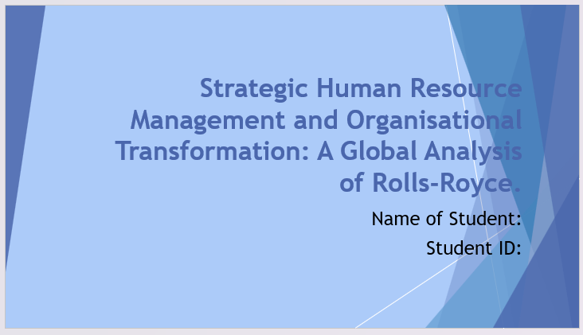

Slide 2: Outline of the Slides
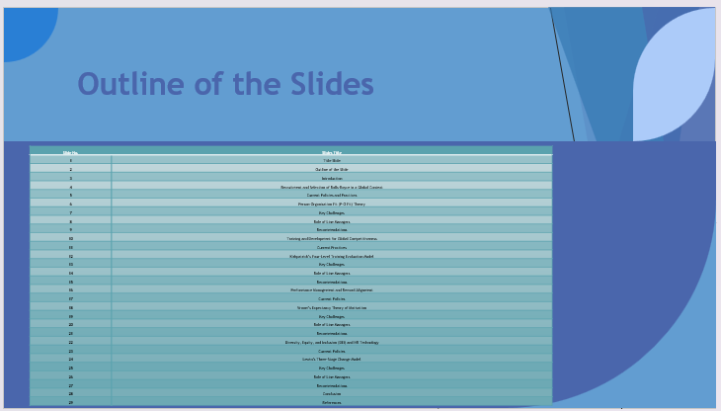

Slide 3: Introduction
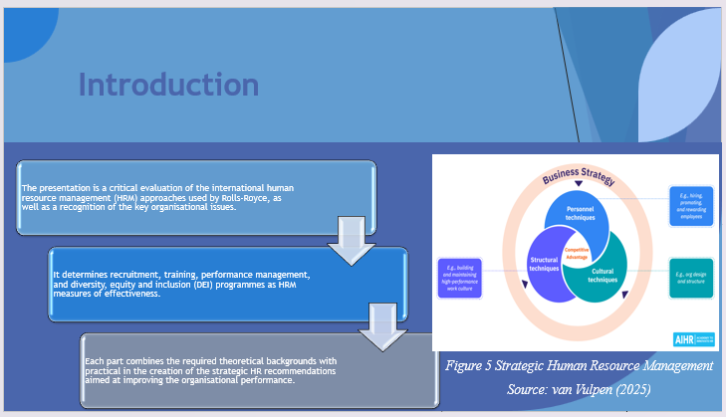
This presentation critically evaluates the global human resource strategies used by Rolls Royce and how these strategies are relevant to the performance of organisations. It examines the recruitment, training, performance management, and the aspect of diversity, equity and inclusion dimensions thus incorporating theoretical construct as well as empirical practise. The research paper outlines the role of HR policies in supporting the strategic goals of the company concerning innovation and sustainability, as well as recommendations, based on action, to enhance the efficiency of the organisation and competence of the employees.

Slide 4: Recruitment and Selection of Rolls-Royce in a Global Context
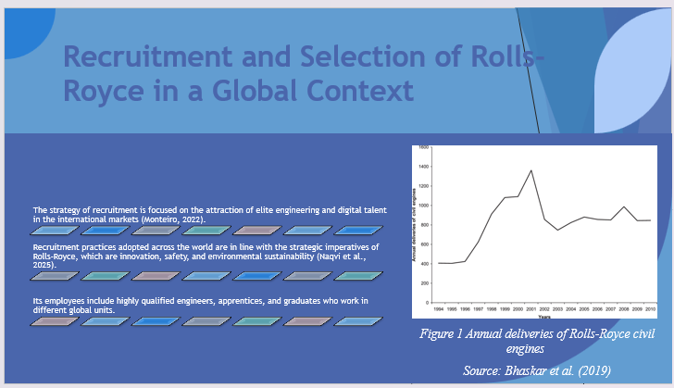
Recruitment and selection are vital processes that support the ability of Rolls-Royce to acquire high-quality engineering and digital talent across the globe (Monteiro, 2022). The international approach of recruiting new staff enhances the goals of the enterprise, which are to promote innovation, safety, and environmental care (Naqvi et al., 2025). Through active recruitment of talented engineers, graduates, and apprentices globally, Rolls-Royce is developing a talent pool that recreates its work ethos and reaffirms its top-placed status in aerospace technology.

Slide 5: Current Policies and Practices
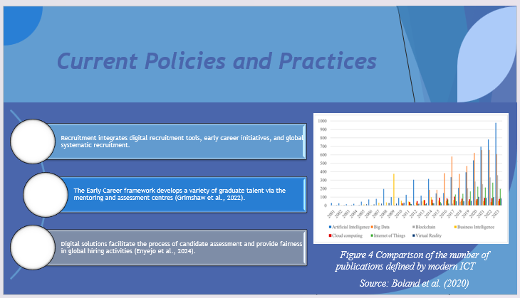
The protocols of recruitment of Rolls-Royce combine formalised programmes and computerised applications in ensuring a high level of consistency and equity. The Early Career structure, targeting graduates and apprentices, helps to develop various leadership opportunities (Grimshaw et al., 2022). Digital selection tools and virtual assessment centres support the process of hiring by facilitating and enhancing transparency (Enyejo et al., 2024). All these measures enable the organisation to tap into talent in the global market in an affordable way and at the same time ensure that there is uniformity in the recruitment standards within the organisation.

Slide 6: Person–Organisation Fit (P–O Fit) Theory
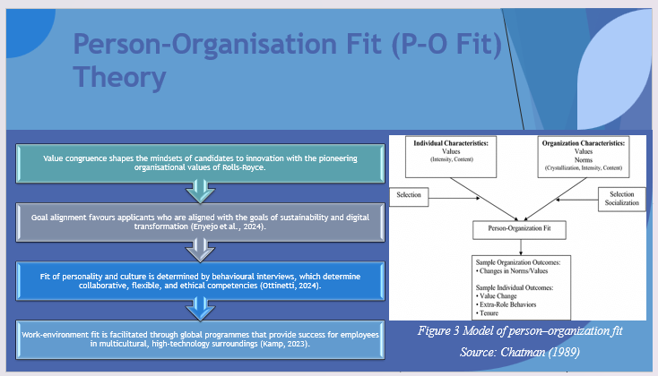
The recruitment philosophy by Rolls-Royce has a theoretical basis in the Person-organisation fit theory. Value congruence guarantees that the mindset of innovation among candidates and the pioneering culture in the company are congruent with each other. Goal alignment highlights common practices of sustainability and digital transformation (Enyejo et al., 2024). The behavioural interviews are used to determine personality and cultural fit, but work-environment fit is strengthened through global induction programmes (Kamp, 2023). These dimensions, taken as a whole, enable the effective mechanism of introducing candidates into the Rolls-Royce collaborative and high-technical culture.

Slide 7: Key Challenges
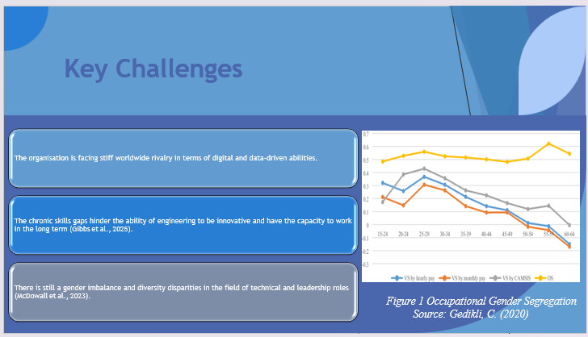
Although the company has the best employer brand reputation, Rolls-Royce faces the salient problem of recruiting specialised digital and engineering skills. There is still strong competition in the world, widespread skills gaps, and imbalances in population (Gibbs et al., 2025). Moreover, there are several diversity gaps, especially the imbalance in the representation of women and minorities in technical and leadership positions, which affects inclusivity (McDowall et al., 2023). These challenges highlight the critical need to have new talent recruitment practices and stronger global workforce practices.

Slide 8: Role of Line Managers
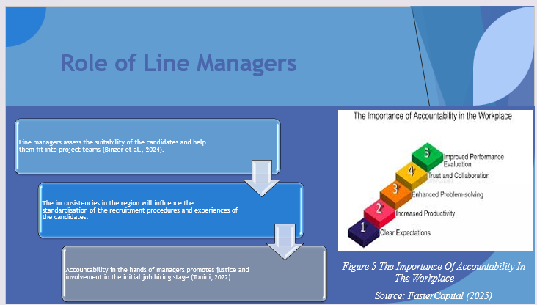
The Line managers are critical towards managing the recruitment and onboarding processes. They consider technical appropriateness and cultural adaptation and provide a smooth assimilation (Binzer et al., 2024). However, unfairness and the candidate experience may be undermined by regional inconsistencies. Strong managerial participation will ensure that new employees obtain guidance and mentorship to adjust and perform well in the multidiverse high-margin teams (Tonini, 2022).

Slide 9: Recommendations
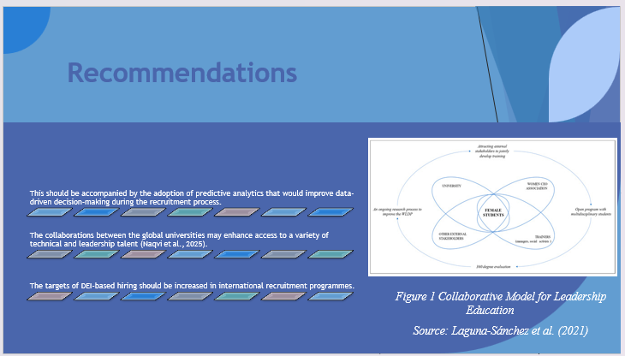
Rolls-Royce should expand its data-based recruitment model by incorporating predictive analytics and therefore optimise the prediction of candidate assessment and retention. Access to emergent technical talent can be enhanced by augmenting collaborations with universities across the world (Naqvi et al., 2025). Furthermore, the increase in diversity-oriented recruitment aims would be a step toward inclusiveness and reflect the commitment of the company to diversifying its global workforce.

Slide 10: Training and Development for Global Competitiveness
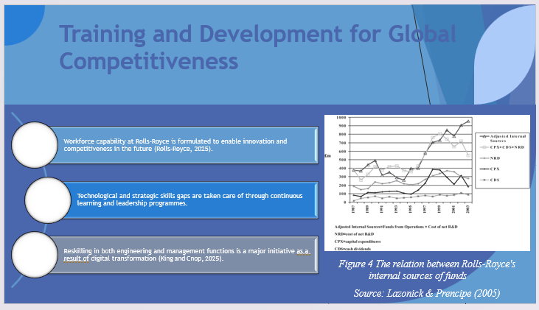
Training and development are the foundation of the competitiveness of Rolls-Royce as they provide the staff with the means to overcome the fast changes in technology. The company is focused on leadership, technical training, and the growth of digital skills. The agility that the employees can maintain and assist innovation and sustainability goals effectively is ensured by the perpetual focus on learning. The investment in a global training infrastructure is an indication of an investment in talent and long-term organisational resilience (Tonini, 2022).

Slide 11: Current Practices
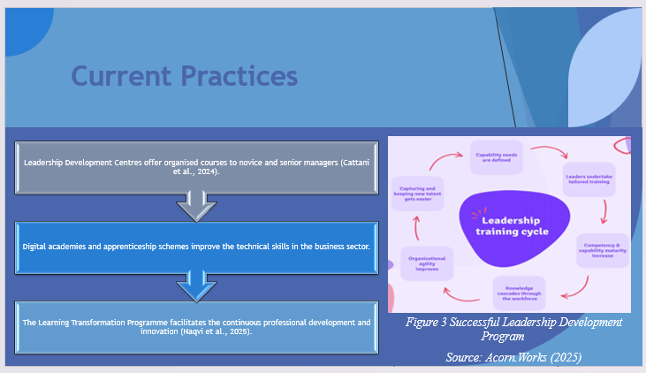
Rolls-Royce provides a collection of training programmes, including Leadership Development Centres, apprenticeship programmes, and online academies (Cattani et al., 2024). The programs provide frameworked learning paths that combine technical expertise and managerial expertise. Learning Transformation Programme is the united action of digital studies and operational training, which cultivates creativity and adaptability (Naqvi et al., 2025). Collectively, these programmes ensure the coordination of workforce development and an innovation-based strategy of the company.

Slide 12: Kirkpatrick’s Four-Level Training Evaluation Model
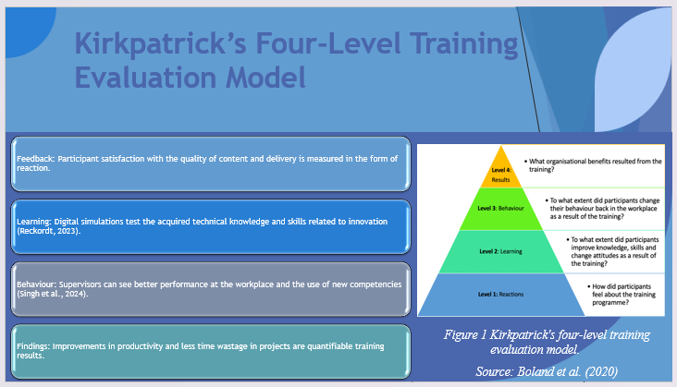
The framework by Kirkpatrick outlines a methodical way of determining the effectiveness of training. The reaction level measures the satisfaction of the participants with the course content and delivery. Digital simulations and assessments are used to measure the learning outcomes (Reckordt, 2023). Managerial feedback and performance appraisal are used to track behavioural change, and the improvement in productivity and the reduction of project delays are the areas of results (Singh et al., 2024). Accordingly, the model correlates training effect to physical organisational results.

Slide 13: Key Challenges
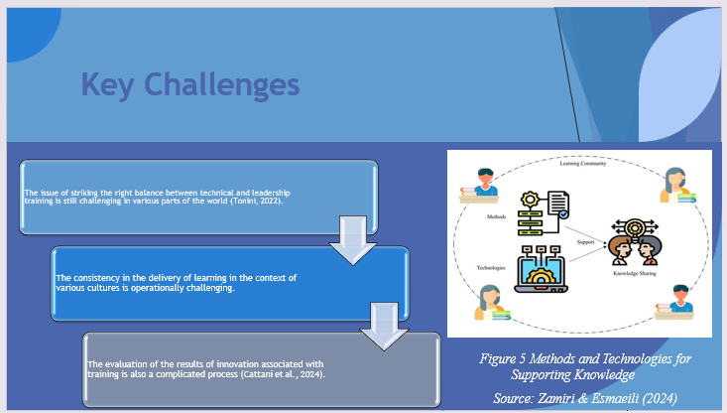
The alignment of coherent training in the international business is still quite a challenge due to the cultural and working differences. Balancing between technical and leadership is another challenge (Tonini, 2022). In addition, it is complex to measure the learning impact on the results of innovation. To counter such issues, standardised learning systems should be used with the support of analytics to effectively measure training ROI (Cattani et al., 2024).

Slide 14: Role of Line Managers
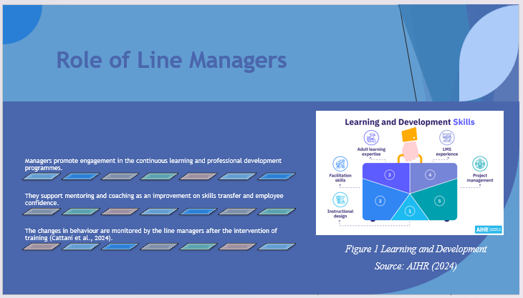
The Line managers help in continuous learning by supporting the development plans and offering mentorship. They strengthen the utilisation of learned skills in daily activities and evaluate behaviour change after training (Cattani et al., 2024). Their participation ensures that training results are reflected in performance improvement and innovation, hence closing the gap between HR strategy and operational implementation at the international business units.

Slide 15: Recommendations
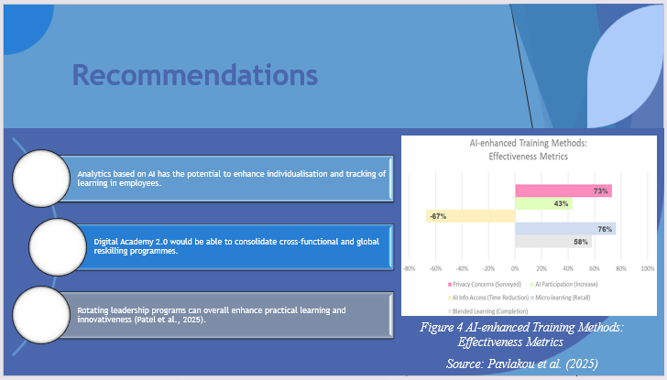
To improve learning performance, Rolls-Royce could adopt AI-based analytics to create individual learning frameworks and track the development. The Digital Academy 2.0 would align training programmes in all global units and thus promote teamwork and sharing of knowledge. Also, the rotational leadership programmes might further develop the managerial agility and cross-functional skills that are invaluable to innovation in the global complex operation (Patel et al., 2025).

Slide 16: Performance Management and Reward Alignment
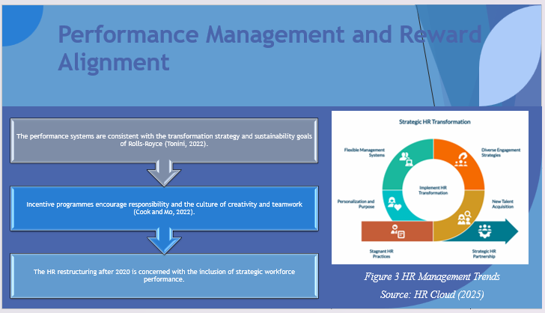
Rolls–Royce performance management is structured in a way that helps to align the efforts of employees with corporate transformation goals (Tonini, 2022). The system is used to encourage accountability, innovation and teamwork through the use of clear performance metrics and reward systems. Within the framework of organisational restructuring aftermath, performance management has become the key tool in maintaining motivation and connecting individual goals with the wider strategic agenda.

Slide 17: Current Policies
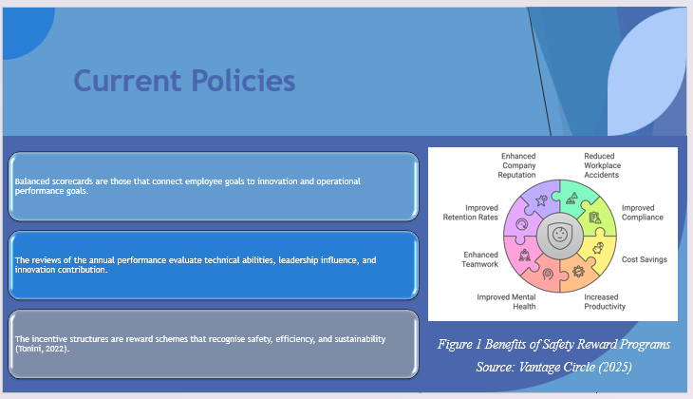
The organisation employs the use of balanced scorecards in order to connect the goals of the employees with the strategic results. Leadership capability, technical competence, and contribution to innovation are evaluated through annual appraisals, whereas performance in the areas of safety, sustainability, and efficiency is also rewarded through incentive schemes (Tonini, 2022). These systems promote openness and make employees understand how personal outcomes would serve the long-term goals of the company.

Slide 18: Vroom’s Expectancy Theory of Motivation
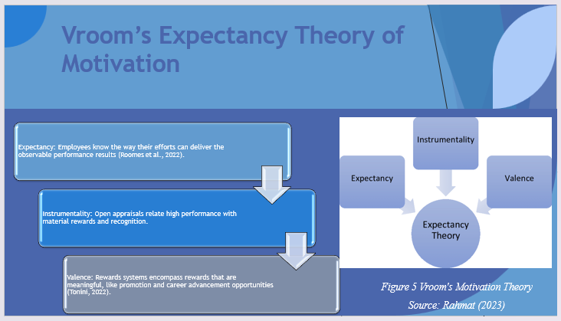
The expectancy theory developed by Vroom explains the issue of employee motivation in three parts. Expectancy refers to the perception that one will perform after effort, as evidenced by clear KPIs (Roomes et al., 2022). Instrumentality focuses on trust in the fact that the performance is going to be rewarded through appraisal and bonuses. Valence deals with the perceived worthiness of such rewards, such as career advancement and appreciation (Tonini, 2022). The implementation of this theory will make the reward system of Rolls-Royce transparent and motivating.

Slide 19: Key Challenges
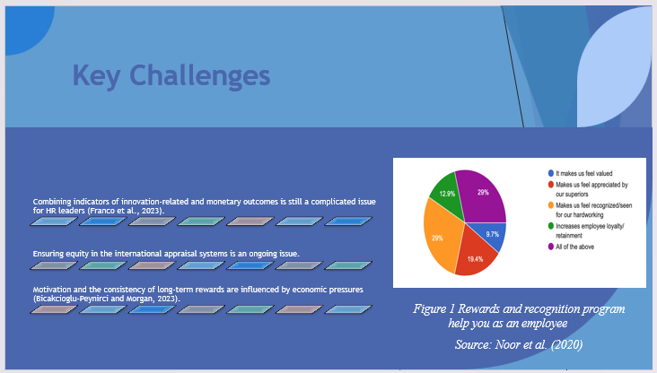
Rolls-Royce faces challenges in balancing between innovation-based and financial performance indicators in global units (Rolls-Royce, 2025). Differences in cultural requirements and regional compensation systems promote equity issues. Besides, the consistency of rewards may be impacted by the economic constraints, which, in turn, has an impact on motivation (Bıçakcıoğlu-Peynirci and Morgan, 2023). The system needs to be continuously refined to ensure credibility and be able to drive high performance in the changing business environment.

Slide 20: Role of Line Managers
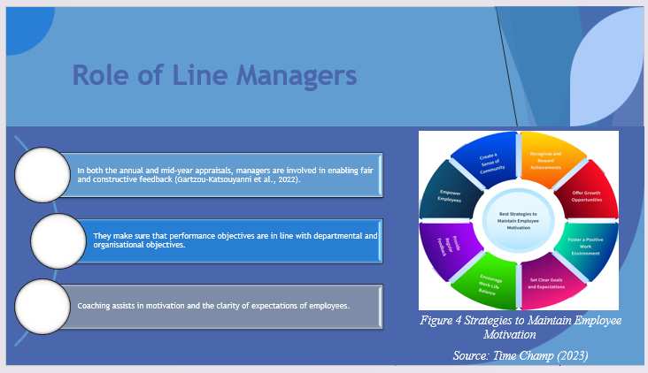
Line managers are evaluators and coaches, as they review personal performance and make it consistent with team activity (Gartzou-Katsouyanni et al., 2022). They provide constructive feedback and make appraisals remain impartial. Their contribution is essential in making strategic targets personalised and creating a culture of engagement and constant improvement within teams.

Slide 21: Recommendations
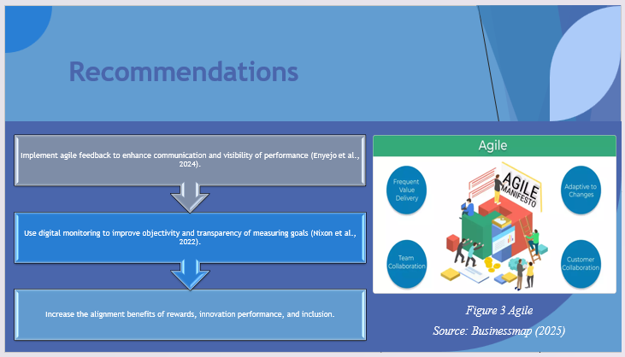
Performance management can also be improved by introducing agile feedback systems that will improve communication and responsiveness (Enyejo et al., 2024). Digital dashboards can be used to enhance visibility and allow employees to monitor their progress in real-time (Nixon et al., 2022). The policy on rewards should be changed to include innovation, teamwork, and inclusion, thus guaranteeing that it is in tandem with the long-term transformation and sustainability goals of Rolls-Royce.

Slide 22: Diversity, Equity, and Inclusion (DEI) and HR Technology
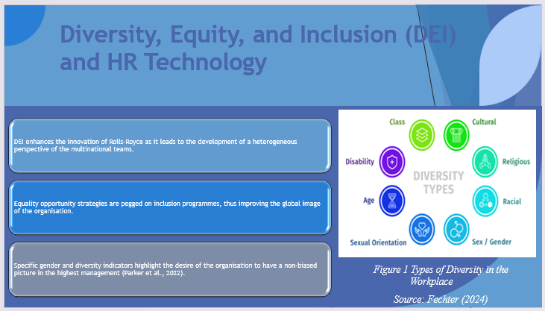
Diversity and inclusion are strategic forces of innovation and collaboration in Rolls-Royce. A heterogeneous workforce also includes innovative thinking that is needed to meet the multifaceted engineering problems (Cattani et al., 2024). Diversity programmes strengthen equality and the image of the organisation. Digital dashboards and analytics, which are part of HR technology, enable the monitoring of the progress being made toward diversity goals and integrate DEI into the day-to-day decision-making process.

Slide 23: Current Policies
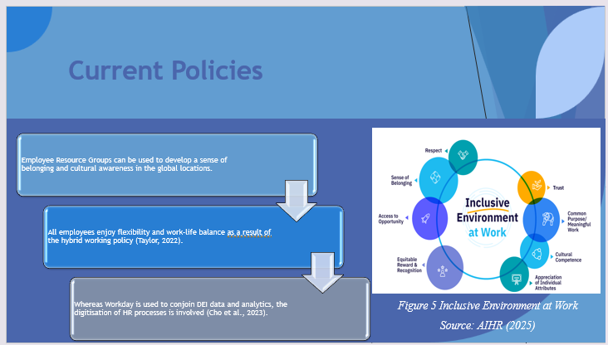
The DEI system used in the company includes the Employee Resource Groups that promote a feeling of belonging and cultural awareness. The ability to work on a hybrid basis improves flexibility and increases the talent pool (Taylor, 2022). The DEI data are incorporated into HR digital systems, especially into Workday, to track the representation and engagement (Cho et al., 2023). Such programmes enhance inclusivity and foster transparency in the management of the workforce across the operations of the organisation worldwide.

Slide 24: Lewin’s Three-Stage Change Model
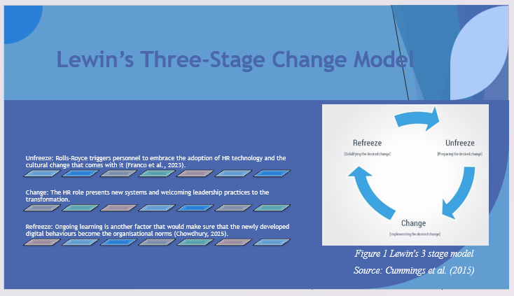
The model by Lewin explains the successful way in which Rolls-Royce can handle change in culture and technology. The unfreeze stage builds the consciousness of the necessity to change (Franco et al., 2023). In the change phase, the HR puts in place digital systems and inclusive leadership practices. These new behaviours are solidified in the refreeze stage, where recognition is done and new learning continues (Chowdhury, 2025). This is a process that would make innovation and inclusion sustainable.

Slide 25: Key Challenges
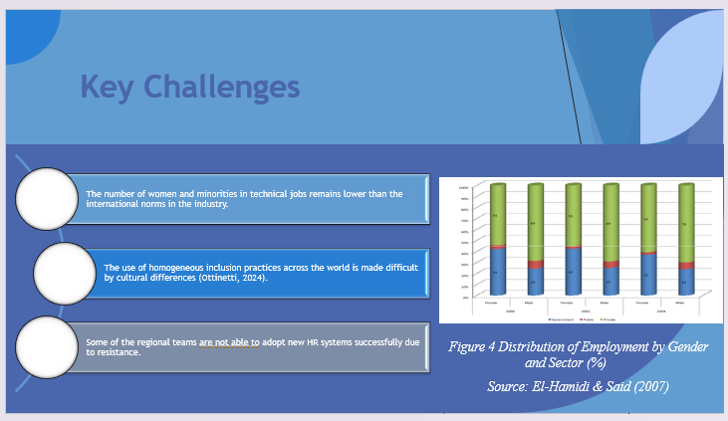
The company still faces the challenge of the lack of representation of women and minorities in technical areas. Cultural diversity and local laws make it difficult to implement standard DEI practices on the global level (Ottinetti, 2024). The unwillingness to embrace new HR technologies still exists among some of the staff. All of these problems require a firm leadership dedication and specific interventions to realise significant improvements.

Slide 26: Role of Line Managers
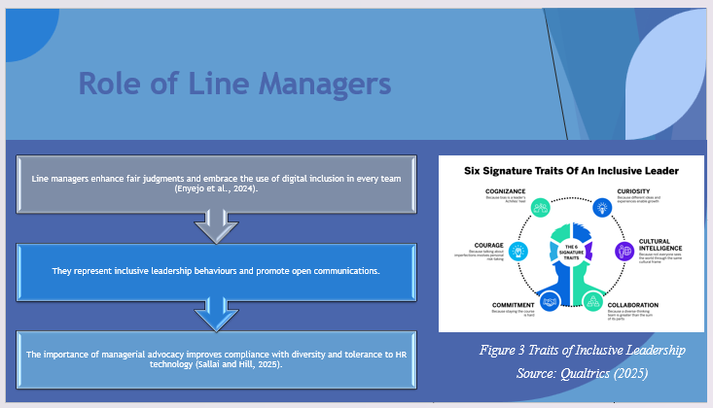
It is essential that managers lead progress in the area of inclusion by demonstrating fair leadership behaviours (Enyejo et al., 2024). They guarantee unbiased assessments and advocate for a digital revolution in teams. Their advocacy encourages open-minded communication, safety in the psyche, and diversity (Sallai and Hill, 2025). Well-established managerial leadership promotes organisational values and culture that allow all employees to succeed.

Slide 27: Recommendations
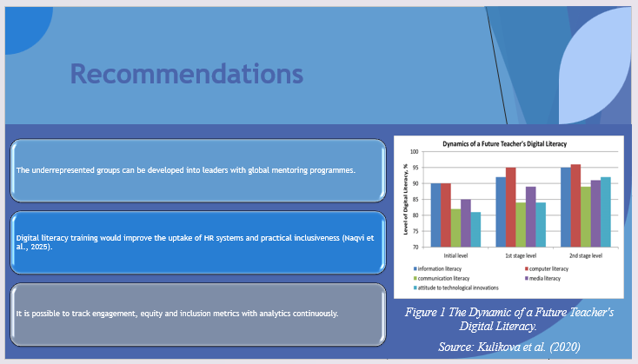
Increasing mentoring and sponsorship programmes would increase the visibility of underrepresented employees. Digital literacy training will enhance the use of HR tools as well as enhance inclusion analytics (Naqvi et al., 2025). Periodic reviews of the DEI data would be useful to trace the progress and gaps related to the accountability and constant improvement of the process of creating an equitable global workforce.

Slide 28: Conclusion
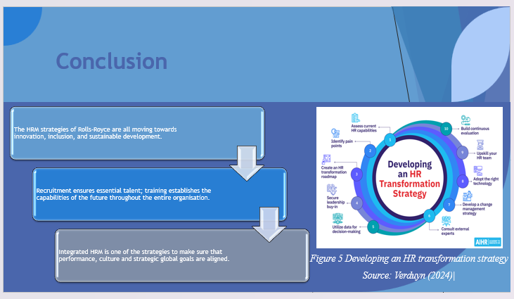
To summarise it, Rolls-Royce has a consistent HRM strategy that incorporates recruitment, training, performance management, and inclusion as components to facilitate strategic change. Recruitment guarantees the availability of talent in the world, training develops future competencies, and performance systems match effort and innovation. INC programs foster diverse teamwork. These practices collectively form a high-performing workforce that is sustainable and is propelling the long-term success of Rolls-Royce.

Slide 29: References
Academy to Innovate HR (AIHR) (2024) Learning and Development: A Comprehensive Guide. Available at: https://www.aihr.com/blog/learning-and-development/ (Accessed: 6 November 2025).
Academy to Innovate HR (AIHR) (2025) 7 Actions HR Can Take to Help Create an Inclusive Environment at Work. Available at: https://www.aihr.com/blog/inclusive-environment-at-work/ (Accessed: 6 November 2025).
Acorn.Works (2025) The Value of Leadership Development and How to Create a Successful Leadership Program. Available at: https://acorn.works/blog/leadership-development (Accessed: 6 November 2025).
Bhaskar, M.P., Pawar, S. and Hole, Y. (2019) Annual deliveries of Rolls-Royce plc civil engines 1995-2010 [online image]. Available at: https://www.researchgate.net/figure/Annual-deliveries-of-Rolls-Royce-civil-engines-1995-2010-Source-Rolls-Royce-Annual_fig3_260115550 (Accessed: 6 November 2025).
Bıçakcıoğlu-Peynirci, N., and Morgan, R. E. (2023). International servitization: theoretical roots, research gaps and implications. International Marketing Review, 40(2), 338-364. https://orca.cardiff.ac.uk/id/eprint/157651/1/IMR%202023%20-%20Final%20preprint%20manuscript%20%281%29.pdf
Binzer, B., Elshan, E., Fürstenau, D., and Winkler, T. J. (2024). Establishing a low-code/no-code-enabled citizen development strategy. MIS Quarterly Executive, 23(3), 253-273. https://www.researchgate.net/profile/Bjoern-Binzer/publication/384040958_Establishing_a_Low-CodeNo-Code-Enabled_Citizen_Development_Strategy/links/66e5c98f0463442fa84f4175/Establishing-a-Low-Code-No-Code-Enabled-Citizen-Development-Strategy.pdf
Boland, J., Brown, M. and Dueñas, A. (2020) “Comparison of the number of publications defined by modern ICT for the years 2001-2023” [online image]. Available at: https://www.researchgate.net/figure/Comparison-of-the-number-of-publications-defined-by-modern-ICT-for-the-years-2001-2023_fig1_382478029 (Accessed: 6 November 2025).
Boland, J., Brown, M., Dueñas, A. and Gibbins, J. (2020) “Kirkpatrick’s four‐level training evaluation model: Reproduced from … (Figure 1)” [online image]. Available at: https://www.researchgate.net/figure/Kirkpatricks-four-level-training-evaluation-model-Reproduced-from-41-on-September-15_fig1_344232579 (Accessed: 6 November 2025).
Businessmap (2025) Agile. Available at: https://businessmap.io/agile (Accessed: 6 November 2025).
Cattani, G., Mastrogiorgio, M., and Carignani, G. (2024). Resource reallocation across successive systemic innovations: How Rolls‐Royce shaped the evolution of the turbojet, turboprop, and turbofan. Strategic Management Journal. https://sms.onlinelibrary.wiley.com/doi/pdf/10.1002/smj.3655
Chatman, J.A. (1989) “Model of person–organization fit” [online image]. Available at: https://www.researchgate.net/figure/Model-of-person-organization-fit-Chatman-1989_fig1_282974170 (Accessed: 6 November 2025).
Cho, W., Choi, S., and Choi, H. (2023). Human resources analytics for public personnel management: Concepts, cases, and caveats. Administrative Sciences, 13(2), 41. https://www.mdpi.com/2076-3387/13/2/41
Chowdhury, R. H. (2025). Digital leadership and organisational learning: Technologies for business transformation and operational excellence. Deep Science Publishing. https://www.researchgate.net/profile/Rakibul-Chowdhury-6/publication/392071228_Digital_Leadership_and_Organizational_Learning_Technologies_for_Business_Transformation_and_Operational_Excellence/links/68340d038a76251f22e8a2b0/Digital-Leadership-and-Organizational-Learning-Technologies-for-Business-Transformation-and-Operational-Excellence.pdf
Cook, M. C., and Mo, J. P. (2022). Architectural approach for analysing and managing innovation in complex system design projects. Product: Management and Development, 20(1), 0-0. https://app.periodikos.com.br/article/10.4322/pmd.2021.014/pdf/pmd-20-1-e20210019.pdf
Cummings, S., Bridgman, T. and Brown, K.G. (2015) “Lewin’s 3-stage model: Unfreeze – This stage prepares individuals for the change” [online image]. Available at: https://www.researchgate.net/figure/Lewins-3-stage-model-Unfreeze-This-stage-prepares-individuals-for-the-change-In_fig3_334736458
El-Hamidi, F. and Said, M. (2007) ‘Distribution of employment by gender and sector (%)’, Have economic reforms paid off? Gender occupational inequality in the new millennium in Egypt. Available at: https://www.researchgate.net/figure/Distribution-of-Employment-by-Gender-and-Sector_fig2_24111428 (Accessed: 6 November 2025).
Enyejo, J. O., Babalola, I. N. O., Owolabi, F. R. A., Adeyemi, A. F., Osam-Nunoo, G., and Ogwuche, A. O. (2024). Data-driven digital marketing and battery supply chain optimization in the battery powered aircraft industry through case studies of Rolls-Royce’s ACCEL and Airbus's E-Fan X Projects. International Journal of Scholarly Research and Reviews, 5(02), 001-020. https://www.researchgate.net/profile/George-Osam-Nunoo/publication/385381784_Data-driven_digital_marketing_and_battery_supply_chain_optimization_in_the_battery-powered_aircraft_industry_through_case_studies_of_Rolls-Royce's_ACCEL_and_Airbus's_E-Fan_X_Projects/links/6745343a868c966b93304209/Data-driven-digital-marketing-and-battery-supply-chain-optimization-in-the-battery-powered-aircraft-industry-through-case-studies-of-Rolls-Royces-ACCEL-and-Airbuss-E-Fan-X-Projects.pdf
FasterCapital (2025) The Importance of Accountability in the Workplace. Available at: https://fastercapital.com/topics/the-importance-of-accountability-in-the-workplace.html/1 (Accessed: 6 November 2025).
Fechter, J. (2024) Inclusion vs Diversity: What’s the Difference? [online]. HR University. Available at: https://hr.university/dei/inclusion-vs-diversity/ (Accessed: 6 November 2025).
Franco, M., Minatogawa, V., and Quadros, R. (2023). How Transformative Business Model Renewal Leads to Sustained Exploratory Business Model Innovation in Incumbents: Insights from a System Dynamics Analysis of Case Studies. Systems, 11(2), 60. https://www.mdpi.com/2079-8954/11/2/60
Gartzou-Katsouyanni, K., Kiefel, M., and Olivas Osuna, J. J. (2022). Voting for your pocketbook, but against your pocketbook? A study of Brexit at the local level. Politics and Society, 50(1), 3-43. https://journals.sagepub.com/doi/pdf/10.1177/0032329221992198
Gedikli, C. (2020) “Overall occupational gender segregation (OS) and the vertical dimension (VS) by age” [online image]. Journal of Family and Economic Issues, 41(1). Available at: https://www.researchgate.net/figure/Overall-occupational-gender-segregation-OS-and-the-vertical-dimension-VS-by-age_fig2_337871776 (Accessed: 6 November 2025).
Gibbs, E., Mackenzie, E., McKinlay, A., McNulty, D., Phillips, J., and Procter, S. (2025). Rolls-Royce engineers and deindustrialization in Scotland from the 1950s to the 2020s. Modern British History, 36(2), hwaf002. https://academic.oup.com/tcbh/article-pdf/36/2/hwaf002/62858501/hwaf002.pdf
Grimshaw, S. D., Clark, C. J., Taylor, J. V., and Spataro, R. (2022). Student research projects with industrial impact. Journal of Engineering for Gas Turbines and Power, 144(6), 061008. https://www.repository.cam.ac.uk/bitstreams/e6ab60a5-08e0-426f-b684-47c2686ec1ac/download
HR Cloud (2025) 10 Latest HR Management Trends in 2025 That Are Shaping the Future of Work. Available at: https://www.hrcloud.com/blog/10-latest-hr-management-trends-for-the-year (Accessed: 6 November 2025).
Kamp, A. (2023). Engineering Education in the Rapidly Changing World: Rethinking the Vision for Higher Engineering Education|. TU Delft OPEN Publishing. https://repository.tudelft.nl/file/File_2d3a14d8-ff2f-4011-b6ae-f5188f824e6b
King, K. A., and Cnop, A. (2025). Transformation in the automotive sector: the management challenges of AI and the digital revolution. https://eprints.lse.ac.uk/128775/1/0d5be932-2b53-4929-879e-e40103d33542.pdf
Kulikova, T.A., Poddubnaya, N.A., Bagdasaryan, L.Sh. and Ardeev, A.H. (2020) ‘The Dynamic of a Future Teacher’s Digital Literacy [Figure 1]’, The technique for future teachers’ digital literacy development. Available at: https://www.researchgate.net/figure/The-Dynamic-of-a-Future-Teachers-Digital-Literacy_fig1_349045218 (Accessed: 6 November 2025).
Laguna-Sánchez, P., Segovia-Pérez, M., de la Fuente-Cabrero, C. and Vargas-Pérez, A.M. (2021) ‘A Collaborative Model for Leadership Education in High-Potential University Women Students’, Journal of Open Innovation: Technology, Market, and Complexity, 7(2), p.138. Available at: https://doi.org/10.3390/joitmc7020138 (Accessed: 6 November 2025).
Lazonick, W. and Prencipe, A. (2005) ‘Shows the relation between Rolls-Royce plc’s internal sources of funds and its most important uses of funds, not including acquisitions’ [online image]. Available at: https://www.researchgate.net/figure/shows-the-relation-between-Rolls-Royces-internal-sources-of-funds-and-its-most-important_fig1_5212528 (Accessed: 6 November 2025).
McDowall, A., Doyle, N., and Kiseleva, M. (2023). Neurodiversity at work: demand, supply and a gap analysis. https://orca.cardiff.ac.uk/id/eprint/164435/1/50834c.pdf
Monteiro, L. F. (2022) The Global Talent Competitiveness Index 2022: The tectonics of talent: Is the world drifting towards increased talent inequalities? INSEAD / Portulans Institute. Available at: https://www.insead.edu/sites/default/files/assets/dept/fr/gtci/GTCI-2022-report.pdf (Accessed: 6 November 2025)
Naqvi, S. R., Sareen, P., Sharma, T., and Naqvi, A. (2025). Humane Approach of e-learning Utilization: Case Study of Rolls-Royce. Emerging Economies Cases Journal, 7(1), 14-18. https://journals.sagepub.com/doi/pdf/10.1177/25166042241249529
Nixon, J., Clewley, R., and Rukasha, T. (2022, July). Automation transparency and the design of intelligent aircraft engine interfaces. In the 35th International BCS Human-Computer Interaction Conference (pp. 1-5). BCS Learning and Development. https://www.scienceopen.com/document_file/0e7af1ff-bc29-4b80-8efd-a6ee3b44ec17/ScienceOpen/001_Nixon_HCI2022.pdf
Noor, Z., Nayaz, N., Solanki, V., Sharma, A. (2020) “Rewards and recognition program help you as an employee” [online image]. Available at: https://www.researchgate.net/figure/Rewards-and-recognition-program-help-you-as-an-employee_fig4_343459504 (Accessed: 6 November 2025).
Ottinetti, D. (2024). The importance of cross-cultural management skills in companies applied to service and sales. https://riunet.upv.es/bitstream/handle/10251/210188/Ottinetti%20-%20The%20Importance%20of%20cross-cultural%20Management%20Skills%20in%20Companies%20Applied%20to%20Service%20an....pdf?sequence=1
Parker, J., and Parker Review Committee. (2022). Improving the ethnic diversity of UK boards. https://www.nedaglobal.com/assets/files/New_site_PDFs/2022%20ey-what-the-parker-review-tells-us-about-boardroom-diversity.pdf
Patel, J. N., Hartman, N. W., Deck, A., and Moore, R. A. (2025, June). Engagement in Practice: Bridging the Gap between Industry, Universities, and K-12 Outreach. In 2025 ASEE Annual Conference and Exposition. https://peer.asee.org/56351.pdf
Pavlakou, E., Katsarou, M., Misiou, M., Papavasilopoulos, V. (2025) ‘AI-enhanced Training Methods: Effectiveness Metrics [Figure 1]’, The Impact of Artificial Intelligence on Learning and Development – Case Studies in Companies of Different Sectors. Available at: https://www.researchgate.net/figure/AI-enhanced-Training-Methods-Effectiveness-Metrics_fig1_393894843?_tp=eyJjb250ZXh0Ijp7ImZpcnN0UGFnZSI6InB1YmxpY2F0aW9uIiwicGFnZSI6InB1YmxpY2F0aW9uIn19 (Accessed: 6 November 2025).
Qualtrics (2025) Inclusive leadership and why it matters. Available at: https://www.qualtrics.com/en-au/experience-management/employee/inclusive-leadership/ (Accessed: 6 November 2025).
Rahmat, H. (2023) “Rooms: Motivation Theory (source: Vroom 1964)” [online image]. Available at: https://www.researchgate.net/figure/rooms-Motivation-Theory-source-Vroom-1964_fig1_355383317 (Accessed: 6 November 2025).
Reckordt, T. (2023). The creation of a framework for assessing innovation capability maturity of supply chains. Analysing the status quo and developing an improvement strategy for the Scottish aerospace industry during the Covid-19 pandemic. http://stax.strath.ac.uk/downloads/q524jp559
Rolls-Royce (2025) Homepage [online]. Available at: https://www.rolls-roycemotorcars.com/en_GB/home.html (Accessed: 6 November 2025).
Roomes, D., Abraham, L., Russell, R., Beck, C., Halsby, K., Wood, R., ... and Burton, K. (2022). Quantifying the employer burden of persistent musculoskeletal pain at a large employer in the United Kingdom: a non-interventional, retrospective study of Rolls-Royce employee data. Journal of occupational and environmental medicine, 64(3), e145-e154. https://journals.lww.com/joem/_layouts/15/oaks.journals/downloadpdf.aspx?an=00043764-202203000-00020
Sallai, D., and Hill, I. (2025). auticon: promoting a neurodiverse workforce. https://eprints.lse.ac.uk/128776/3/673b25ba-afa1-4d61-b744-05e9d77343af.pdf
Singh, R., Singh, C. D., Singh, T., and Singh, J. (2024, January). Impact of core functional competencies on Indian manufacturing industry: Case study. In AIP Conference Proceedings (Vol. 2962, No. 1, p. 020062). AIP Publishing LLC. https://pubs.aip.org/aip/acp/article-pdf/doi/10.1063/5.0192273/19303799/020062_1_5.0192273.pdf
Taylor, P. (2022). Redistribution of working time: achieving a better work-life balance. https://strathprints.strath.ac.uk/82214/1/Taylor_IER_2022_Redistribution_of_working_time_achieving_a_better_work_life_balance.pdf
Time Champ (2023) Best Strategies to Maintain Employee Motivation. Available at: https://www.timechamp.io/blogs/strategies-to-maintain-employee-motivation/ (Accessed: 6 November 2025).
Tonini, F. (2022). A critical analysis of Rolls-Royce Holdings plc’s Shareholder Wealth creation in the five-year period from 2017 to 2021. https://unitesi.unive.it/bitstream/20.500.14247/15619/1/866744-1267698.pdf
van Vulpen, E. (2025) Strategic Human Resource Management 101: Your Essential Guide [online]. AIHR – Academy to Innovate HR, 2 years ago. Available at: https://www.aihr.com/blog/human-resource-strategy/ (Accessed: 6 November 2025).
Vantage Circle (2025) Everything You Need to Know About Safety Reward Programs for Employees. Available at: https://www.vantagecircle.com/en/blog/safety-reward-programs-for-employees/ (Accessed: 6 November 2025).
Verduyn, M. (2024) HR Transformation: A 2025 Comprehensive Guide [online]. AIHR. Available at: https://www.aihr.com/blog/hr-transformation/ (Accessed: 6 November 2025).
Zamiri, M. and Esmaeili, A. (2024) ‘Methods and Technologies for Supporting Knowledge Sharing within Learning Communities: A Systematic Literature Review’, Administrative Sciences, 14(1), p.17. doi:10.3390/admsci14010017. Available at: https://www.mdpi.com/2076-3387/14/1/17 (Accessed: 6 November 2025).

