ECIE4017

Additional Needs in Context

Portfolio

Name: Rebekah Walters Student Number: 250316

I acknowledge the use of [AI Tool] [(AI Tool url)] on [Date] to [Purpose].
I used the prompt(s):
1. [Prompt] Make this more concise
2. [Prompt] Spell and grammar check
3. [Prompt]
I confirm that I have not presented any AI generated text as my own work. I confirm I have copies of my drafts, notes, and other resources I used before, and after the use of AI tools which I may be asked to provide in evidence.
OR
I confirm that I have not used any AI tools in the research and creation of this assignment. I confirm that I have not presented any AI generated materials as my own work. I confirm I have copies of my drafts, notes, and other resources I used, which I may be asked to provide in evidence.

Element 1:
Individual Development Plan
(Use template provided.
Taken from ALN Code of Practice Wales 2021, pages 353-355)

Section 1C: Profile (About me)
My name is Child A. I am 5 years old and autistic. I am a curious learner with a strong passion for space and mathematics. I have an excellent memory for facts and enjoy sharing my knowledge. I am also hyperlexic and can independently read books above my expected reading age.

I have a great sense of humour and enjoy having a laugh and a joke. I live with my Mum and Dad and my cat, Suggs.

• What is important to the learner

Space and Maths-Planets, stars, Rockets and space facts.
Numbers, counting, patterns and problem solving.
Sharing my knowledge with others.

Reading independently, books and new information.

Routine and familiarity-Familiar people and places, knowing what will happen next and preparing for changes.

Food-Familiar beige food and comfortable eating experiences.

Feeling comfortable-Quiet environments, visual information like the class timetable on display and someone showing me my now and next board, predictable routines, time to process information, activities linked to my interests. Opportunities for take a break while feeling overwhelmed.

• What is important for the learner
Communication and social development

I need support to interact and develop friendships with other children. Take turns and listen to others. Understand that conversations involve different interests. Communicate when I need help or a break.

My interests in space and mathematics should be used as a bridge to social interaction, rather than being removed. Adults can support me by sharing facts, such as “Did you know Saturn has rings? towards asking other questions and showing an interest in their ideas.

Sensory needs

Loud noises, busy environments and changes to familiar routines can be difficult for me. I benefit from predictable routines, visual information, preparation for changes and access to a quiet space when I become overwhelmed.

I have a restricted diet and mainly eat beige foods. Adults should encourage regular drinking and monitor my fluid intake. I should be offered a familiar cup or bottle and unfamiliar foods should not be forced. Sensory factors such as texture, smell, colour and temperature should be considered.

Toileting and Independence

I am not yet toilet trained and currently find sitting on a toilet difficult. Adults should explore possible sensory, emotional and environmental reasons rather than viewing this as simply refusal.

A gradual approach is being used, beginning to look at the toilet, entering the cubicle, standing near the toilet, sitting with clothes on and gradually increasing my tolerance before establishing a consistent toileting routine.

Physical development-I need support to develop my gross and fine motor skills, stamina and independence. I find longer walks, , PE and pencil control difficult. Adults should gradually increase my opportunities for walking and physical activity rather than suddenly removing familiar supports.

Fine motor activities such as playdough, Lego, threading, tweezers, pegs, drawing, tracing and finger-strengthening activities can help develop my hand strength, coordination and pencil control. Alternative ways of recording my learning, including technology should also be available when appropriate.

• What is working and should be built on

My interests in space and mathematics should be used to motivate and engage me.

Visual supports and positive, consistent encouragement to help me.

My advanced reading and mathematical abilities provide opportunities to extend my learning.

A gradual approach to toileting is supporting me to develop independence.

Visiting P.E spaces when they are quiet, using photographs and visual timetables, preparing me for what will happen, allowing me time to observe and beginning g with short activities help me feel safer and more prepared.

• What is not working and needs to change.

Being pushed everywhere in my pushchair means that my gross motor skills haven’t yet developed past toddler stage.

Section 2A: Description of the child or young person’s additional learning needs (ALN)

Cognition and Learning
Child A demonstrates significant strengths in mathematics, reading, memory and knowledge acquisition. He is hyperlexic and can independently read books significantly above his expected reading age.
His strong mathematical ability requires appropriately differentiated and challenging activities to extend his knowledge and understanding. His interests in space and mathematics should be incorporated into learning opportunities to increase motivation and engagement.
Child A also experiences difficulties with fine motor control and pencil skills, which can create a barrier to recording his learning. He therefore requires support to develop the hand strength, coordination and control required for greater independence.

Communication and Interaction
Child A requires support to develop social communication and interaction skills. He can become highly focused on his own interests and requires adult support to develop reciprocal interactions and recognise that other children may have different interests.
He requires support with:
- Taking turns.
- Listening and responding to others.
- Developing reciprocal conversations.
- Developing friendships with peers.
- Communicating when he needs help or a break.
- Using his interests as a starting point for positive social interaction.
Visual supports, including now-and-next boards, visual timetables and photographs, support Child A's understanding and communication.

Sensory Needs
Child A experiences sensory difficulties, particularly in relation to loud noises, busy environments, changes to routines and unfamiliar situations.
He currently finds PE challenging and may refuse to participate when the environment feels overwhelming. He benefits from preparation, visual information, quiet visits to unfamiliar spaces, opportunities to observe before participating, reduced unnecessary noise and gradual increases in participation.
Child A also has a restricted diet and mainly eats familiar beige foods. He has a low fluid intake and requires sensitive support around eating and drinking. Sensory factors including texture, smell, colour and temperature should be considered.

Physical Development
Child A requires support to develop his gross and fine motor skills, coordination, balance, stamina and physical independence.
He experiences difficulty with longer walks PE, pencil control and some everyday fine motor activities. Frequent use of his pushchair has reduced opportunities to develop walking stamina and gross motor skills. A gradual increase in walking and physical activity is therefore required.
Child A also requires opportunities to develop hand strength, coordination and control through activities such as playdough, Lego, threading, tweezers, pegs, drawing and tracing.
He is not yet toilet trained and requires a gradual, sensory-informed approach to developing toileting independence.

Behaviour, Emotional and Social Development
Child A benefits from predictability, routine, familiarity and preparation for change. Loud or unexpected environments can cause him to feel overwhelmed.
He requires access to a quiet space, opportunities to take a break and sufficient processing time when overwhelmed.
A consistent, positive and strengths-based approach is required to support Child A's emotional wellbeing, confidence and engagement. Adults should consider sensory, communication and emotional factors when Child A finds an activity difficult rather than interpreting this simply as refusal.

Identify and complete 2 separate targets (showing the ALP for each).
1.
Section 2B1: Description and delivery of the child or young person’s additional learning provision (ALP)
2B1.1) Intended outcome:  These outcomes should be SMART (Specific, Measurable, Achievable, Realistic,  Timebound). | To take part in fine motor intervention daily and compare outcome by christmas  SMART Intended Outcome  Within 12 weeks, Child A will actively participate in a 15-minute structured social interaction session 4 times per week, engaging in at least three shared interaction activities with an adult, including turn-taking, responding to a question and showing or asking about another person's interest, with no more than three adult prompts in 4 out of 5 sessions.
2B1.2) ALP to be provided:  This should include how often (daily, weekly); the type of support; who provides the support. The description of the Additional Learning Provision (ALP) should be very clear and precise, the above could then be split into smaller goals and targets. |  | 2B1.3) Should the ALP be provided in Welsh? | 2B1.4) Organisation/  Service to provide the ALP, (e.g. NHS, Inclusion Service, Specialist Teacher, etc.): | 2B1.5) Start date: | 2B1.6) End / Review date:
Child A will receive a 15-minute structured social communication session four times per week, delivered by a familiar adult.  Sessions will include at least three shared interaction activities, for example:  - Taking turns in a game.  - Sharing an activity linked to Child A's interests.  - Responding to simple questions.  - Asking another person a question.  - Sharing an interest and then giving the other person an opportunity to respond.  - Practising listening and responding to another person's ideas.  Child A's interests in space and mathematics will be used as a starting point for interaction. Adults will gradually extend interactions beyond Child A's preferred topics and explicitly model reciprocal communication.  Progress will be measured through the number of shared interactions completed and the level of adult prompting required. The target will be reviewed after 12 weeks. |  | No | Schoolssss
2B1.7) Rationale for the ALP listed above:
If there is a difference of opinion it should be recorded here e.g. a difference of opinion between the child, child’s parent or young
person and professionals. The section could explain ho

Rationale
Child A has strong knowledge and communication skills when discussing his preferred interests but requires support to develop reciprocal social communication. He can become highly focused on sharing his own knowledge and may find it difficult to recognise or respond to another person's interests.
Developing reciprocal interaction is important because it will support Child A to develop friendships, participate more successfully with peers, take turns, listen to others and communicate his needs.
Using his strong interests in space and mathematics as a starting point provides a motivating and familiar context in which these social communication skills can be practised. The aim is not to reduce his interests, but to use them as a bridge towards meaningful shared interaction.

2.
Section 2B1: Description and delivery of the child or young person’s additional learning provision (ALP)
2B2.1) Intended outcome:  These outcomes should be SMART (Specific, Measurable, Achievable, Realistic,  Timebound). | Within 12 weeks, Child A will participate in a 10-minute fine motor activity at least 4 times per week and will complete at least three different activities designed to develop hand strength, coordination and control, achieving this with no more than two adult prompts in 4 out of 5 observed sessions.
2B2.2) ALP to be provided:  This should include how often (daily, weekly); the type of support; who provides the support. The description of the Additional Learning Provision (ALP) should be very clear and precise, the above could then be split into smaller goals and targets. |  | 2B2.3) Should the ALP be provided in Welsh? | 2B2.4) Organisation/  Service to provide the ALP, (e.g. NHS, Inclusion Service, Specialist Teacher, etc.): | 2B2.5) Start date: | 2B2.6) End / Review date:
Additional Learning Provision  Child A will receive targeted fine motor provision four times per week for approximately 10 minutes, delivered by a familiar adult.  Activities will include:  - Playdough manipulation.  - Lego and construction activities.  - Threading.  - Tweezers.  - Peg activities.  - Finger-strengthening games.  - Drawing and tracing.  - Early pencil-control activities.  Activities should be linked to Child A's interests wherever possible to increase motivation and engagement. Progress will be recorded through brief observations and reviewed after 12 weeks. |  | Yes / No | School
2B2.7) Rationale for the ALP listed above:
If there is a difference of opinion it should be recorded here e.g. a difference of opinion between the child, child’s parent or young
person and professionals. The section could explain how different opinions have been taken into consideration before a particular decision was reached.
The learner has autistic needs.
Child A has autism and experiences difficulties with both his gross and fine motor development. He requires targeted opportunities to develop the hand strength, coordination and control needed for greater independence in everyday activities such as writing, dressing, using tools and completing self-care tasks.
Developing these foundational skills will also support Child A to access classroom learning and demonstrate his knowledge more independently. His strong cognitive and academic abilities mean that fine motor difficulties could otherwise become a barrier to showing what he knows.

Element 2:
Poster – Outlining good practice in terms of supporting learners with a specific learning need
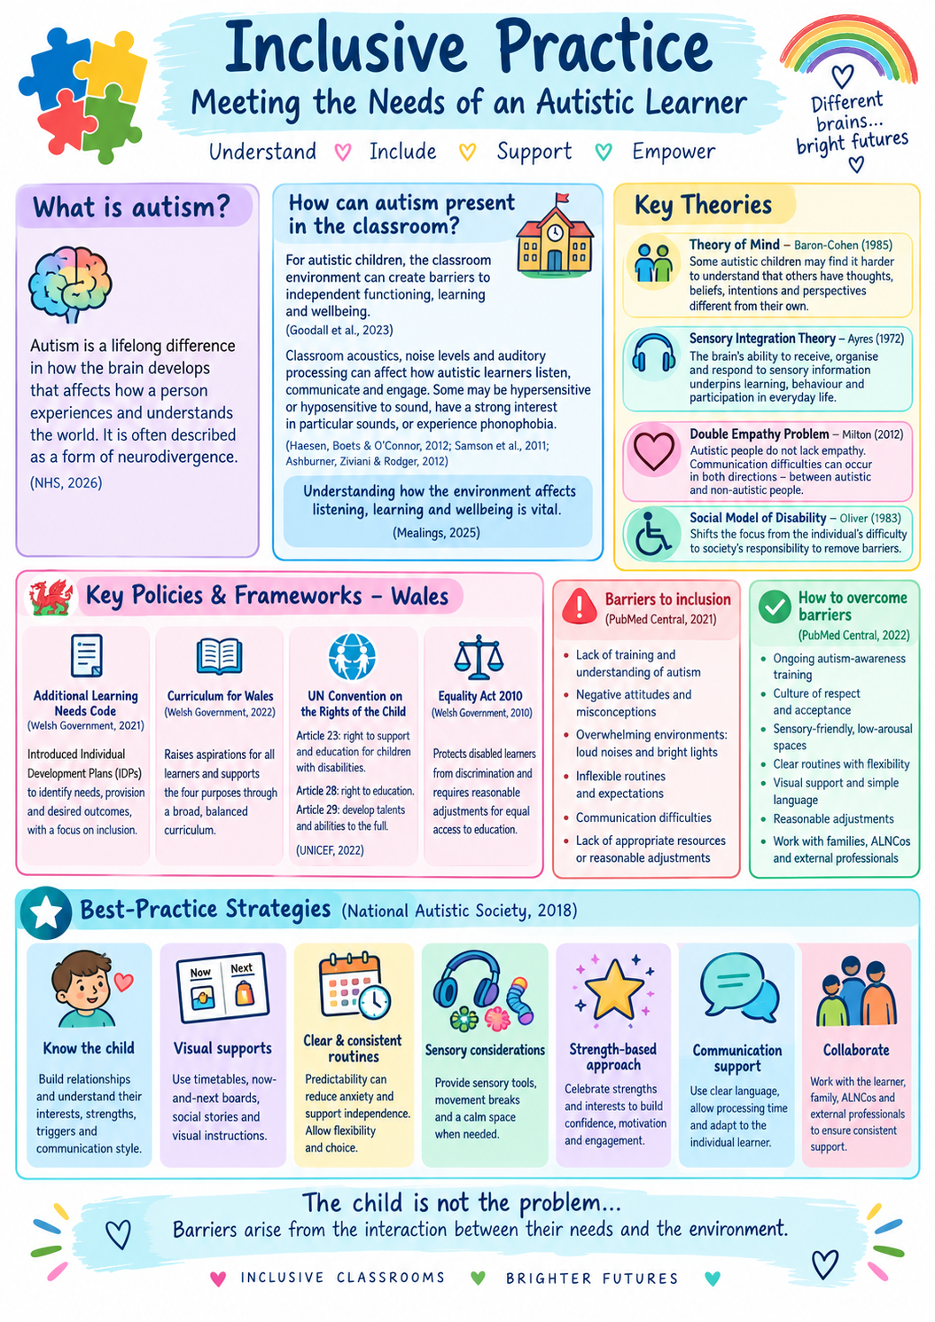

Element 3:
Link to your video presentation –
https://1drv.ms/p/c/dfb828952ef55a84/IQBDyCtr63NbSbXZ0rbamoE8AVZyhHNqrm7S1pquwbfvmk8

Reference list for the portfolio
Follow Harvard referencing guidelines
Reference list
Gov.uk. (2013). Equality Act 2010:guidance. [online] Available at: https://www.gov.uk[Accessed 8 Sept. 2026].
gov.wales. (2021). The additional learning needs code. [online] Available at: https://www.gov.wales [Accessed 2026].
Guardo, K. (2023). Sensory integration. [online] National institute of health. Available at: http://www.ncbi.nlm.nih.gov [Accessed 8 Sept. 2026].
Mealings (2025). What we do and do not know about how classroom environment affects listening, learning and wellbeing in autistic children. [online] https://www.tandfonline.com. Available at: https:/taylor and francis online [Accessed 8 Sept. 2026].
NHS (2023). NHS. [online] NHS. Available at: https://www.nhs.uk [Accessed 8 Sept. 2026].
Snap Cymru. (2018). Home - snap Cymru. [online] Available at: https://www.snapcymru.org/[Accessed 8 Sept. 2026].
Social model of disability. (2025). Social model of disability. [online] Available at: https://aod.org.uk [Accessed 8 Sept. 2026].
UNCRC. (2022). https://unicef.
Vaurio, R. (2016). What is autism spectrum disorder? https://www.kennedykrieger.org.
Waisman (2022). https:/pmc.ncbi.nlm.nih.gov. Barriers to inclusive learning for autistic individuals.
Welsh government (2022). Curriculum for Wales . www.gov.uk.

