
marketing Plan
Student Name: Haider Ali Saddiqui
Student number: 2209990
Name of Hotel: Travelodge Walsall
Module name: Marketing Essentials BMIH4005
Name of lecturer: Ruth Taylor



University of Wales Trinity Saint David

This marketing plan is based on Travelodge Walsall. The key areas of marketing strategies such as situational analysis, actions, planning, and objectives will be discussed thoroughly, it will also highlight the marketing mix in detail and give suggestions in terms of how the company can potentially grow and improve. The perspective of this marketing plan is to attract customers and have customer satisfaction through intense research within the marketing planning according to contemporary times.
Tesco’s
McDonald’s
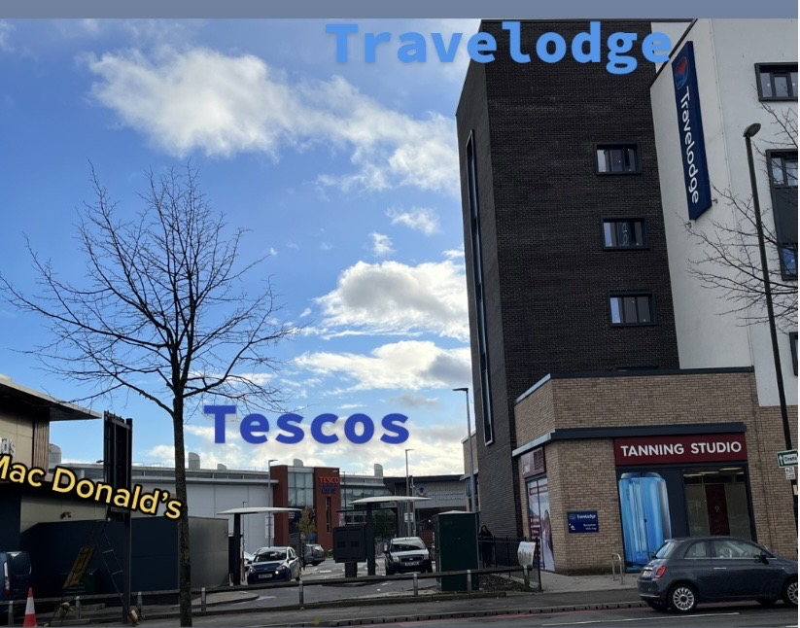

Strengths Weaknesses Opportunities Threats
Town centre is a 5 Minute’s walking distance (Travelodge, Walsall 2021) | No Access to café | Refurbishing their hotel with a contemporary look | Competitors are taking customers away due to better facilities such as village hotels, park inn, etc.
Cheap rates | Wi-Fi charge | Customer Loyalty | The flu rate in England has risen also, during December and January it will increase a lot (Pickover, 2022). This a huge loss in customers
Air cooling unit | Paid parking | Become a luxury hotel
4.5 Star rated | Not ideal for luxury customers | Improving with sustainability
Good Location | No Loyalty Program | Free Parking
Travelodge Walsall has targeted multiple kinds of customers. It is ideal for anyone due to being in an excellent location. As prices are reasonably cheap, young adults can stay at Travelodge. They have also targeted couples and families as they have double beds, kingside beds, and family rooms. Businessmen from different cities will also use Travelodge as they are a renowned hotel brand.
Porter’s Five Forces
Bargaining power of supply | Threats of substitute | Industry rivalry | Bargaining power of the buyer | Threat of entrants
- Hotel Staff members | - Working from home  - Relatives  - Air Bmb in Walsall | - Premier Inn  - Village,  - The Beverley Hotel  - Holiday Inn | - Booking.com  - Trip Advisor | Low threat of entrance due to strong branding and geolocation
Travelodge collaborates with a lot of organizations to benefit the communities. For example, they had announced an exciting partnership with the British heart foundation (Travelodge, 2018), an ongoing charity company, alongside other organizations displayed below.

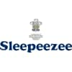

(Travelodge, Our Partners 2022).

Pestel macro analysis of Travelodge

Political Economical Sociological Technology Environment Legal

Uk Can bring National minimum wage | Interest rate | Attracting customers through new updated social media | Providing effective technology within contemporary times | Travelodge Walsall lose customers during summer seasons as customers tend to go abroad | Adhering to UK policies and regulations such as.  Data protection act (2018)
Introducing new legislation in health and safety act | Competitive Industries | Collaborating in social activities | Using digital systems | Although it is cold in Walsall during the year, the hotel provides air colling facilities | Digital Economical act (2010)
 | Inflation in currency could harm the hotel |  | CCTV cameras | Travelodge provides sustainability equipment to improve the environment | General data protection act (2016) and Health and safety act (2021)

Smart Target


Travelodge Walsall should operate a gym within the premises. Before the end of 2024, they should achieve this task as it is important in modern times. Customers are aware of mental health issues going on around the town. It is reported that before covid pandemic the rate of a citizen being satisfied in Walsall was 7.6 %. Although the covid pandemic has died out completely figures prove that the satisfaction rate of an individual has reduced by 3% (Dowdeswell, 2022). Customers will want to join the Travelodge fitness club as the hotel is in a busy area. The outcome of providing this facility is customer satisfaction and loyalty as it will bring local customers popping in regularly. Local customers going to the gym regularly will boost the hotel financially and recommend anyone they know to stay there as it will become a hotel that facilitates people with various facilities



Travelodge provides three types of rooms with a large range of products facilitating each customer. The double room which is mainly suitable for two adults features a comfortable king-size bed, shower access, Television access, a wide desk, and toiletries such as hand hair and body wash. Tea and coffee-making facilities are also found in all rooms (Travelodge Walsall, 2022). The family room consists of the same products with an addition of a spare bed and a few extra pillows as this is mainly suitable for 4 family members. Travelodge also accommodates customers with a double-accessible twin room which is for anyone who wishes to sleep alone. They provide access to parking and Wi-Fi which is charged per hour. Customers can visit the town which is a 5-minute walk away to shop or buy food. They will approach Travelodge through online websites to learn more about them. TripAdvisor, Travelodge website, and google reviews provide much information about the franchise. Customers will also book online, by telephone, or by physically visiting them.

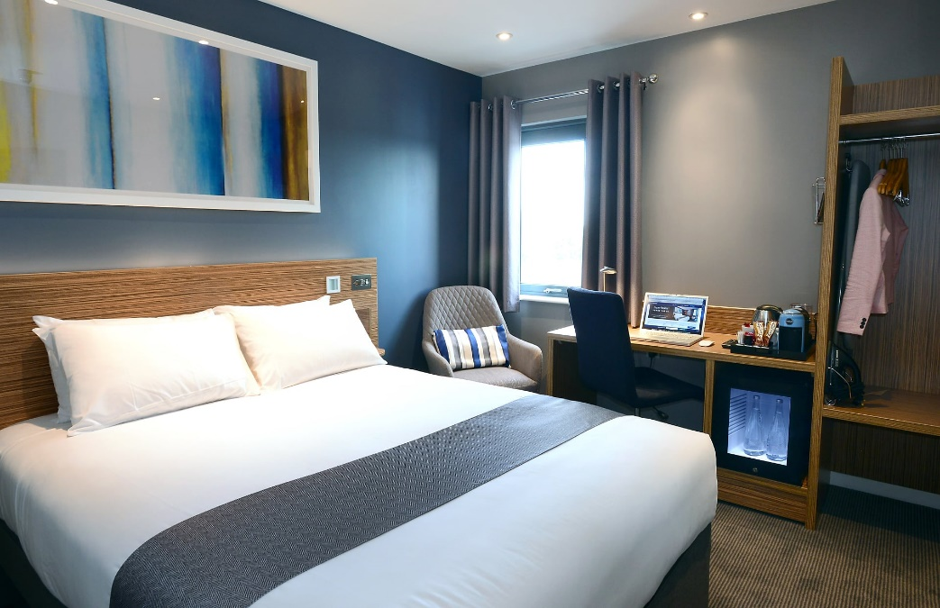

The hotel is reasonably cheap in price and very similar to the premier inn hotel. Walsall isn’t a tourist area therefore the prices are always low. London Travelodge is more expensive due to being in a famous tourist area. To stay at Travelodge in London will cost up to £100 per night based on averaging it whereas it will cost £60 in Walsall (Price finder, 2022). The busiest time of the week in the Walsall Travelodge is on a Saturday night therefore the hotel inflates the price by going up to £80 per night. During this winter in 2022, it is reported that the company will give out deals for £34 per night or less (Graziano, 2022). Travelodge has done exceptionally well in the promotion that up to 1000 rooms will be from £8.50pp.
The company promotes its messages on social media platforms such as Facebook and Instagram. They also pay a lot towards advertisements which recently Travelodge paid 25 million to inspire Britain to get up and go. Travelodge Walsall can notify their regular customers whenever promotions are on during seasonable festivals. The message the brand attracts customers with is to have a comfortable good night’s sleep
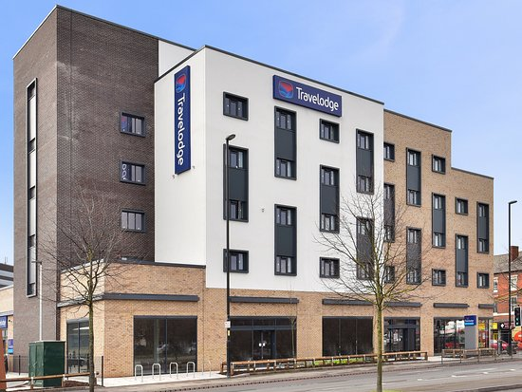


The organization’s value proposition is to sustain strong revenue growth, they also have invested highly in websites with the perspective of improving the customer journey. Their customers offer help by improving website conversion (Travelodge, 2022). Recently Travelodge improved with their direct booking accounts for more than 85% of their sales (Travelodge, 2022). They also launched a mobile app that was downloaded double the amount of their website. They have comfortable King size beds in every room and give away 30 minutes of free Wi-Fi access. They use social media marketing to attract customers and advertise on paid media such as Google and Facebook ads. They contact their customers through emails and phone numbers. Travelodge Walsall should advertise its services more on social media such as TikTok and YouTube vlogs. They should collaborate with famous travelers who can promote their services.
Gantt Chart Walsall Travelodge 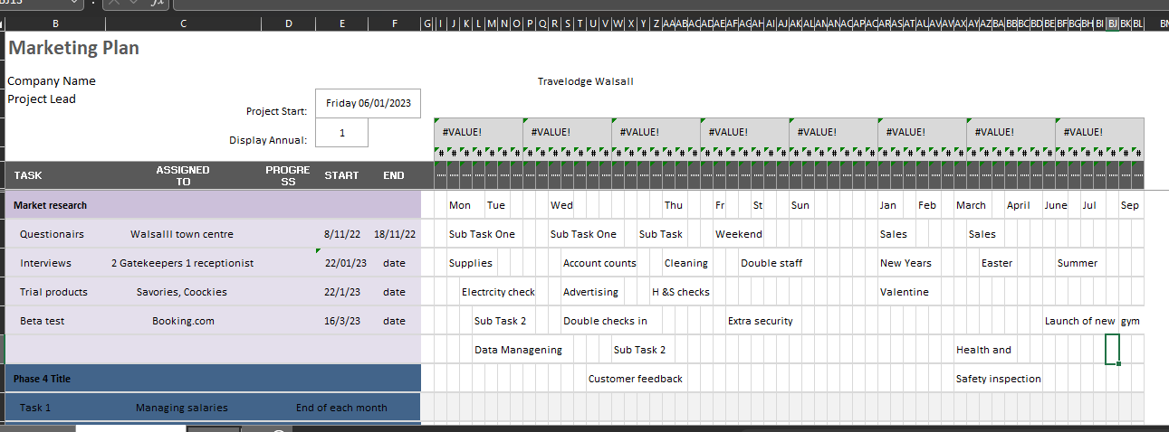

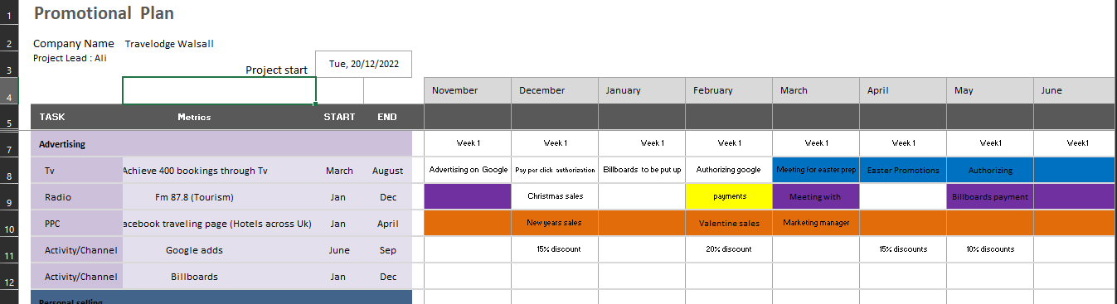

As demonstrated in the charts above, within Travelodge Walsall these actions are very important to achieve weekly and monthly during 2023. There should be regular checks in rooms during the week, Gatekeeper should ensure the hotel is spotless to fulfil recent customer demands through feedback. The goal of this hotel during 2023 is to launch the gym centre to accommodate customers as well as facilitate the local community. Discounts on sales should be met according to the market to receive more customers. Recruitment within Gatekeeping and reception is needed due to the lack of staff.

The Unique selling point of Travelodge Walsall is to deliver affordable rates for any sort of customer. They provide low-cost choices for all sorts of customers (Travelodge, Our company). In an effort to obtain more customers, they need to provide similar facilities to what premier inn and holiday inn offers. If the hotel chain improves its services, slowly it will gain customer loyalty due to better services Hudson & Hudson, 2017).
In conclusion, the hotel has done exceptionally well in targeting its customers with reasonable prices. As they have a 4.5-star they will gain more customers within the next year. In terms of facilities, customers are happy due to receiving a comfortable stay. It would be nice to see the branch expand its facilities towards targeting luxury customers. Walsall is growing rapidly, and businesses are being established instantly therefore Travelodge can potentially become the number one hotel by providing new services such as the gym centre, bare café, and conference hall.

Reference
Arif, T.M.H. and Hossin, M.Z., 2016. A comparative analysis of internal and external environments between Hotel Hyatt, UK and Hotel The Cox Today, Cox’s Bazar, Bangladesh. IOSR Journal of Humanities and Social Science, 21(6), pp.13-22. Available at: https://www.researchgate.net/publication/312320719_A_comparative_analysis_of_internal_and_external_environments_between_Hotel_Hyatt_UK_and_Hotel_The Cox_Today_Bangladesh (Accessed 25 November 2022)
BBC News (2022) External factors - National 5 business management revision - BBC bitesize BBC News. BBC. Available at: https://www.bbc.co.uk/bitesize/guides/zgfrpbk/revision/1 (Accessed: 1 November 2022).
Digital Economy Act (2010), Legislation.gov.uk. Statute Law Database. Available at: https://www.legislation.gov.uk/ukpga/2010/24/contents (Accessed: 28 November 2022).
Dowdeswell, A (2022) Walsall people still feeling less satisfied than before coronavirus pandemic MSN. <Available at: https://www.msn.com/en-gb/health/familyhealth/walsall-people-still-feeling-less-satisfied-than-before-coronavirus-pandemic/ar-AA13UxYp> (Accessed: 20 November 2022).
Google Travel (2022). Travelodge Walsall. Available at: https://www.google.co.uk/travel/hotels/entity/CgsI6cyNys6M5PmfARAB?utm_campaign=sharing&utm_medium=link&utm_source=htls&ved=0CAAQ5JsGahcKEwjw8M_Irc37AhUAAAAAHQAAAAAQAw&ts=CAESABogCgIaABIaEhQKBwjmDxALGBwSBwjmDxALGB0YATICEAAqCQoFOgNHQlAaAA (Accessed: 19 November 2022).
Graziano, G. (2022) Travelodge Christmas sale has thousands of rooms from £8.50pp, The Sun. The Sun. Available at: https://www.thesun.co.uk/travel/20278607/travelodge-sale-christmas-markets-cheapest-rooms-winter/ (Accessed: 23 November 2022).
Hudson, S. and Hudson, L. (2017) Marketing for tourism, hospitality & events: A Global & Digital Approach. Los Angeles: SAGE.
Pickover, E. (2022) 'flu is back' – scientists warn of risk to NHS as data shows early rise in cases, Evening Standard. Evening Standard. Available at: https://www.standard.co.uk/news/health/nhs-people-flu-experts-england-b1037046.html (Accessed: 26 November 2022).
Travelodge (2018) British Heart Foundation - Our New Charity Partner, Travelodge. Available at: <https://www.travelodge.co.uk/blog/news/new-charity-partnership/ (Accessed: 12 November 2022

Travelodge (2020) Our company, Available at: https://travelodge.wpengine.com/about/our-company/ (Accessed 20 November 2022)
Travelodge (2022) Our partners Travelodge. Available at: https://www.travelodge.co.uk/partners (Accessed: 27 November 2022).

Travelodge (2020) Privacy Policy. Available at: https://www.travelodge.co.uk/about/privacy-policy/ (Accessed: 16 November 2022).
Travelodge (2016) Upgraded customer experience drives a record year. Available at: https://www.travelodge.co.uk/press-centre/press-releases/Upgraded-customer-experience-drives-record-year#:~:text=We%20have%20continued%20to%20strengthen%20the%20appeal%20of,awareness%20and%20heightening%20awareness%20of%20our%20upgraded%20rooms. (Accessed: 22 November 2022).
Travelodge (2022) Travelodge Walsall. Available at: https://www.travelodge.co.uk/hotels/653/Walsall-hotel?sb=1&utm_source=bing&utm_medium=cpc&utm_campaign=UK+-+Brand+-+Exact+-+T1+-+North+-+Birmingham+-+Birmingham+Walsall (Accessed: 24 November 2022).
Travelodge Walsall (2022)- updated 2022 reviews, price comparison (TripAdvisor). Available at: https://www.tripadvisor.co.uk/Hotel_Review-g187059-d15347029-Reviews-Travelodge_Walsall-Walsall_West_Midlands_England.html (Accessed: 27 November 2022).


