Marriot Hotel Ratio Analysis

Financial Management Analysis: Marriott International

Module: Financial Management for the Hotel Industry
Module Code: BMIH5007
Lecturer: Dale Clarke

Student Name: Mohammad Prince
Student ID: 2027484

Executive Summary
The paper examines Marriott International, a leading global hoteliers. Ratios for profitability, solvency, and leveraging were calculated. The profitability efficiency ratio's overall emphasis is that Marriott's profits has greatly increased in all areas. In 2021, the profitability scenario is favourable, but liquidity of the company are adverse. The entire indebtedness is extremely high, according to leverage ratios. Even though things are better now than they were in 2020, the change is not much satisfactory.
Contents
Executive Summary 2
Introduction 4
Marriott International Ratios and trends interpretation 4
Liquidity Ratio 4
Trends in Liquidity Ratios 7
Leverage Ratios 7
Trends in leverage ratios 9
Profitability Ratios 9
Trends in Profitability Ratios 15
The essentiality of the proper understanding of the ratios and their fluctuations 15
Ratios and importance of ratios for decision making 15
Limitations of Ratios 16
Conclusion 16
Reference list 17
Appendix 19

Introduction
Marriott International, Inc. is a global company with its headquarters in the US that operates, permits, and franchises lodging establishments such hotels, residences, and resorts. According to the company website (2022), Maryland's Bethesda serves as its administrative centre. This report aims to interpret the ratios of Marriott International, Inc. Besides, the limitations of ratios are discussed in this report. Moreover, the importance of ratios for decision making also discussed.

Marriott International Ratios and trends interpretation

Liquidity Ratio
Current Ratio

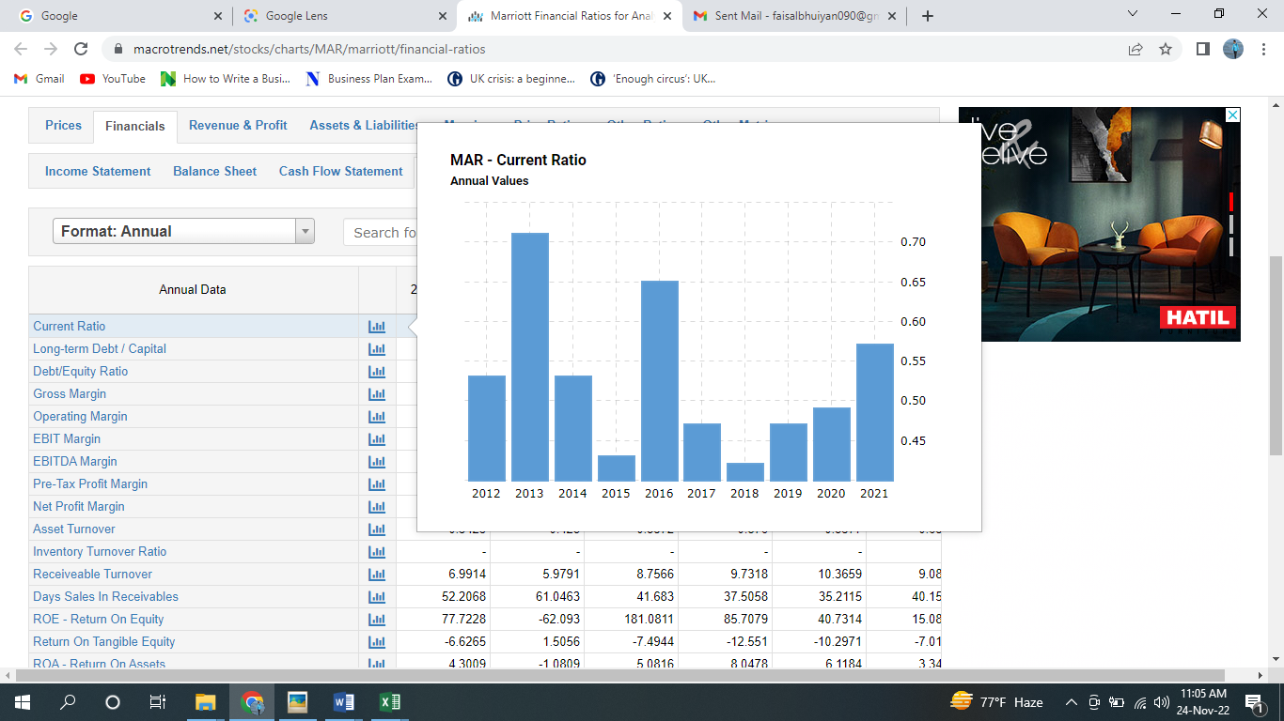
(Source: www.macrotrends.net, 2022)
From the chart, it can be seen that the current ratio of Marriot Hotel was 0.49 in 2020 and it rose to 0.565 in 2020. The current ratio of Marriot hotel has a positive trend compared to the previous year. However, the current ratio indicates that Marriot Hotel has $0.565 current assets against $1 current liability which is not satisfactory.
Operating Cash Flow Per Share
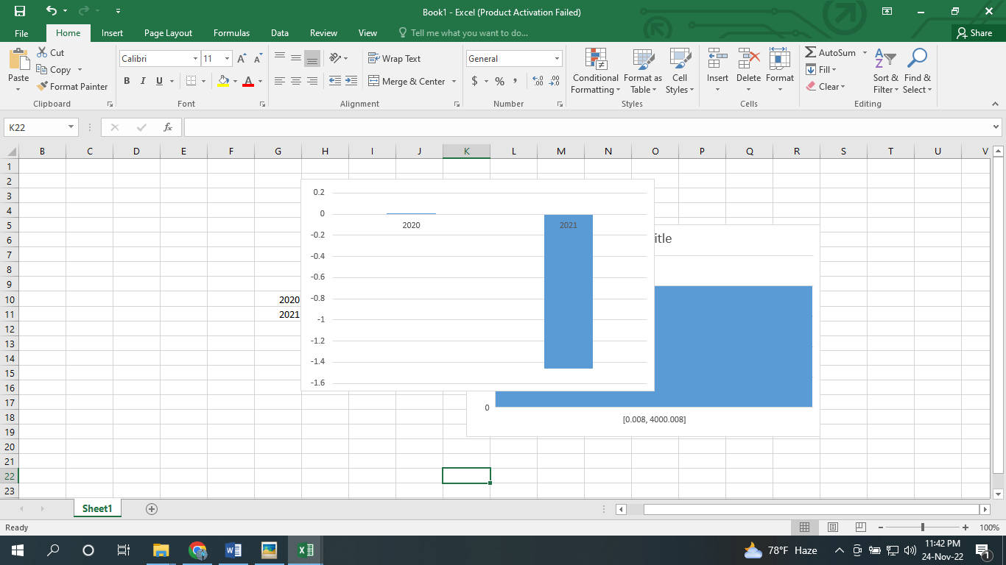
(Source: www.macrotrends.net, 2022)
From the above chart, it can be seen that Operating Cash Flow Per Share was 0.008 in 2020 and it decreased to – 1.46 in 2021 which is a negative trend for the firm as the rate has reduced significantly from positive to negative. It is said that above 1 Operating Cash Flow Per Share can be perceived as good for the hotel industry (Guilding and Mingjie Ji, 2022). However, Marriot’s is Operating Cash Flow Per Share lower than the ideal one i.e. – 1.46 in 2021 which indicates that the company might face short-term cash-related problems.
Free Cash Flow Per Share
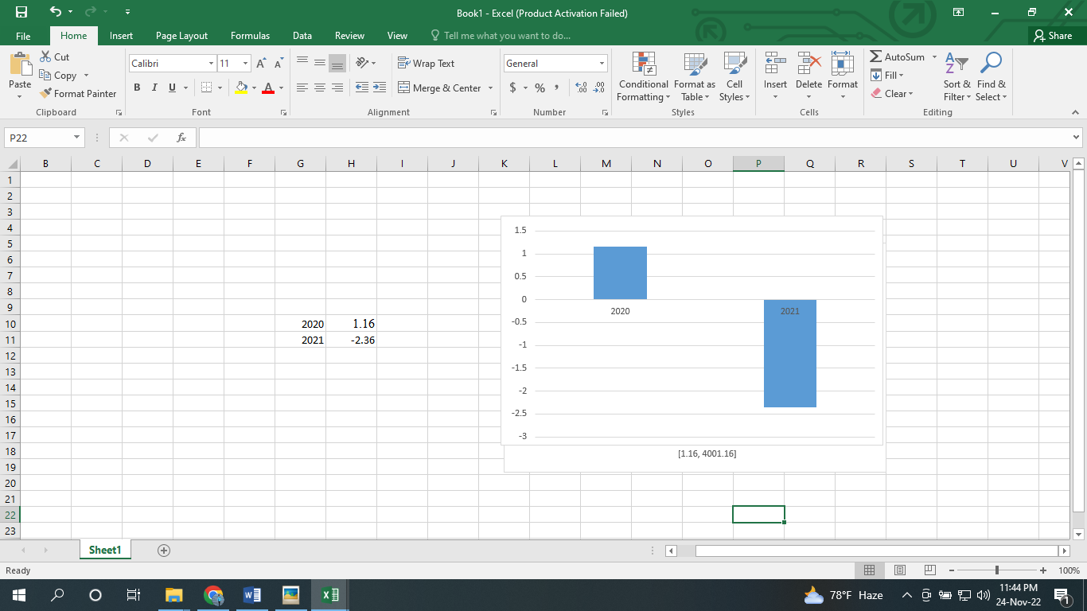
(Source: www.macrotrends.net, 2022)
From the above chart, it can be seen that Free Cash Flow Per Share was 1.16 in 2020 and it decreased to –2.36 in 2021 which is a negative trend for the firm as the rate has reduced significantly from positive to negative. It is said that positive Free Cash Flow Per Share can be perceived as good (Guilding and Mingjie Ji, 2022). Positive free cash flow indicates the financial flexibility of the business. However, Marriot’s is Free Cash Flow Per Share lower than the ideal one i.e. – 2.36 in 2021 which indicates that the company has an inability in making sufficient cash for supporting the business operation which is a negative sign for the company.
Days Sales on Receivables

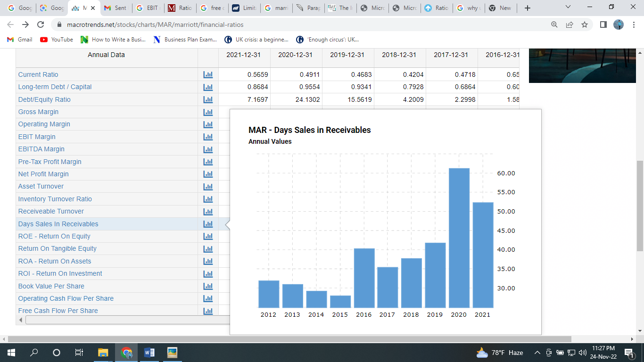
(Source: www.macrotrends.net, 2022)
From the above chart, it can be seen that days sales on receivables were 61.04 in 2020 and it reduced to 52.20 in 2021 which is a positive trend for the firm as the rate is decreasing. It is said that under 45 days of sales on receivables can be perceived as ideal (Fabozzi and Peterson, 2003). However, Marriot’s days' sales on receivables are slightly more than the ideal one i.e. 52.20 in 2021 which indicates that the company is somewhat efficient in collecting receivables.
Receivable Turnover Ratio

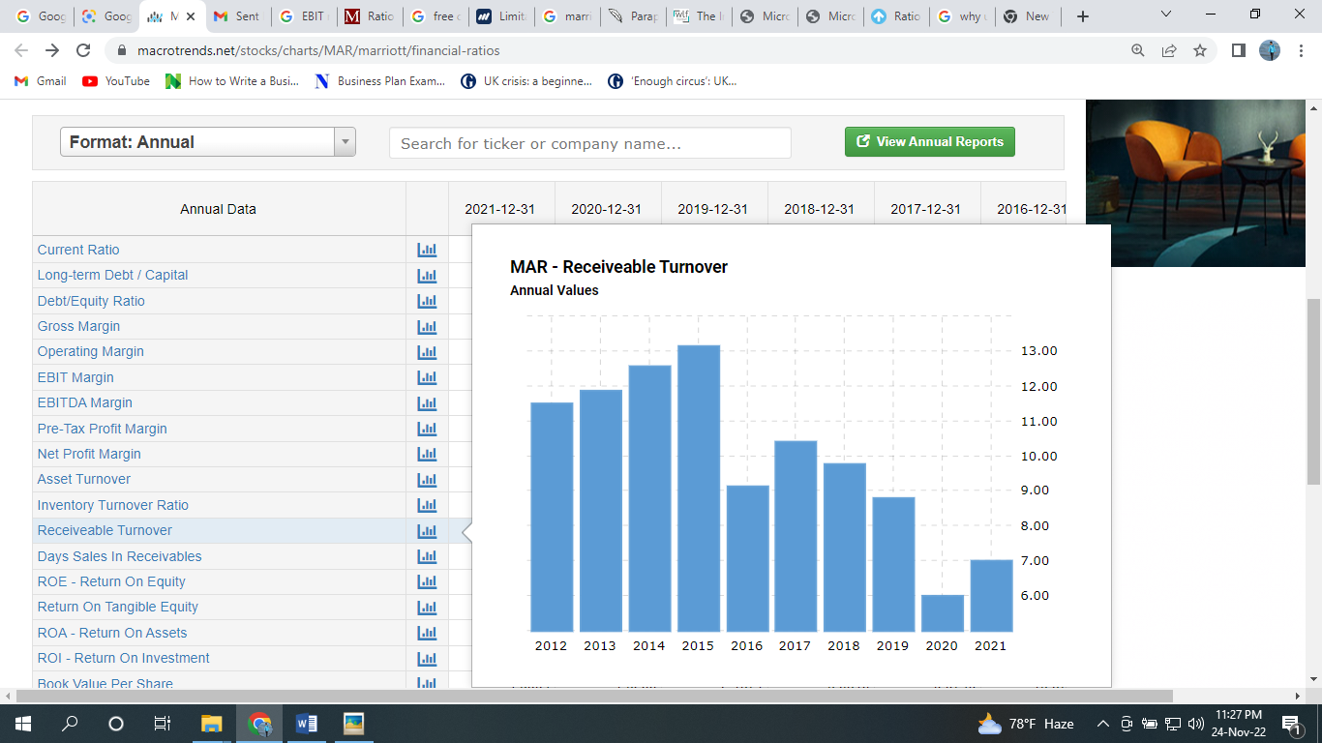
(Source: www.macrotrends.net, 2022)
From the above chart, it can be seen that the receivable turnover was 5.98 in 2020 and it enhanced to 6.99 in 2021 which is a positive trend for the firm as the rate is increasing. It is said that the above 10 receivable turnover ratio can be perceived as ideal (Chibili, 2019). However, Marriot’s receivable turnover is less than the ideal one i.e. 6.99 in 2021 which indicates that the company is somewhat efficient in collecting sales generated on credit.

Trends in Liquidity Ratios
Although the company has improved its performance compared to the previous year, the liquidity situation of the company is not much satisfactory. As per the liquidity ratios, overall liquidity situation of the company has been deteriorated.

Leverage Ratios
Long-term Debt and Capital ratio

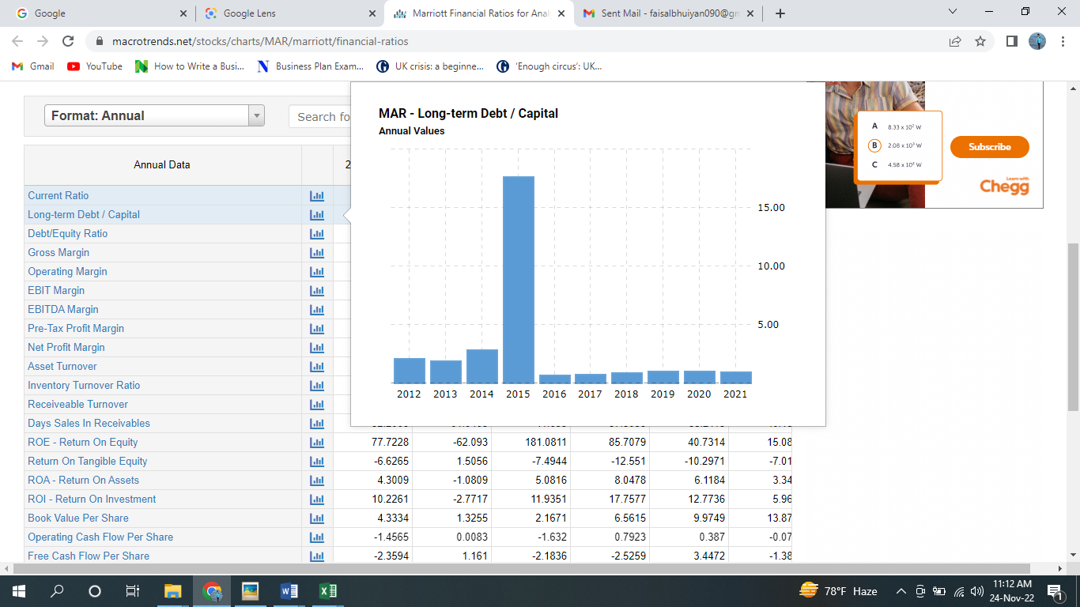
(Source: www.macrotrends.net, 2022)
From the above chart, it can be seen that the long-term debt and capital ratio was 0.955 in 2020 and it reduced to 0.868 in 2021 which is a positive trend. However, the debt is higher compared to the capital. It is said that 40-60% of debt against capital can be perceived as acceptable (Böhm, 2008). However, Marriot’s debt is far higher than capital.
Debt equity Ratio

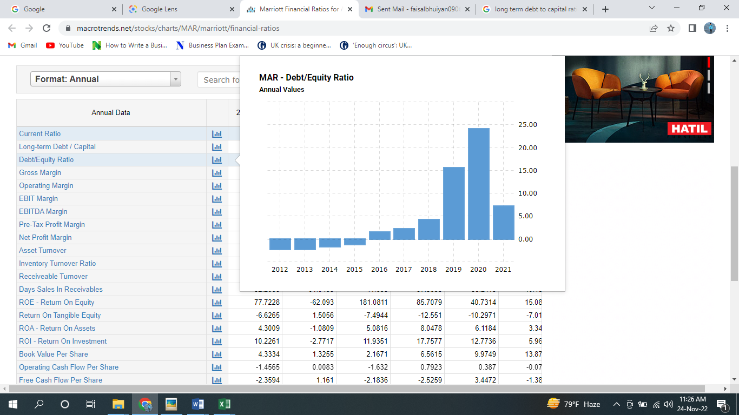
(Source: www.macrotrends.net, 2022)
From the above chart, it can be seen that the debt and capital equity were 24.13 in 2020 and it reduced to 7.169 in 2021 which is a positive trend. However, the debt is higher compared to the equity. It is said that 2-2.5 debt against equity can be perceived as ideal (Borosky, 2020). However, Marriot’s debt is far higher than equity i.e. $7.17 debt against $1 equity in 2021. The investment of the company mostly comes from debt.
Book Value Per Share
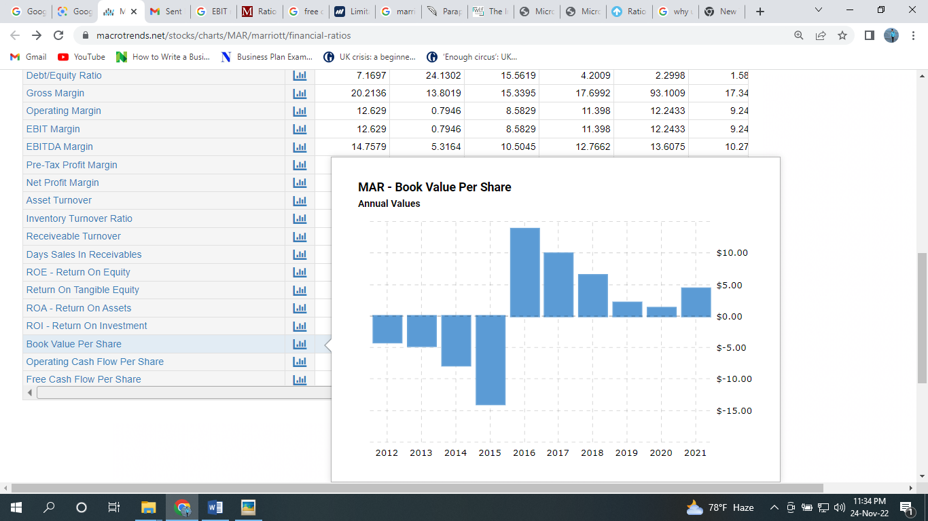
(Source: www.macrotrends.net, 2022)
From the above chart, it can be seen that Book Value Per Share was 1.33 in 2020 and it increased to 4.30 in 2021 which is a positive trend for the firm as the rate has increased significantly. However, the book value per share of Marriot Hotel is much lower than the market value of Marriot Hotel's share. According to Nasdaq (2022), the market value per share of the company is $165.24 in 2021 which is much higher than the book value. Therefore, the stock price is overvalued.

Trends in leverage ratios
From the evaluation of the leverage of the company, it can be easily perceived that the overall leverage situation of the company is much beyond the standard level. However, the situation of leverage has improved in 2021 compared to that of 2020. If the situation does not impoved in the subsequent years, Marriot might face tough situation due to excessive debt against its assests.

Profitability Ratios
Gross margin
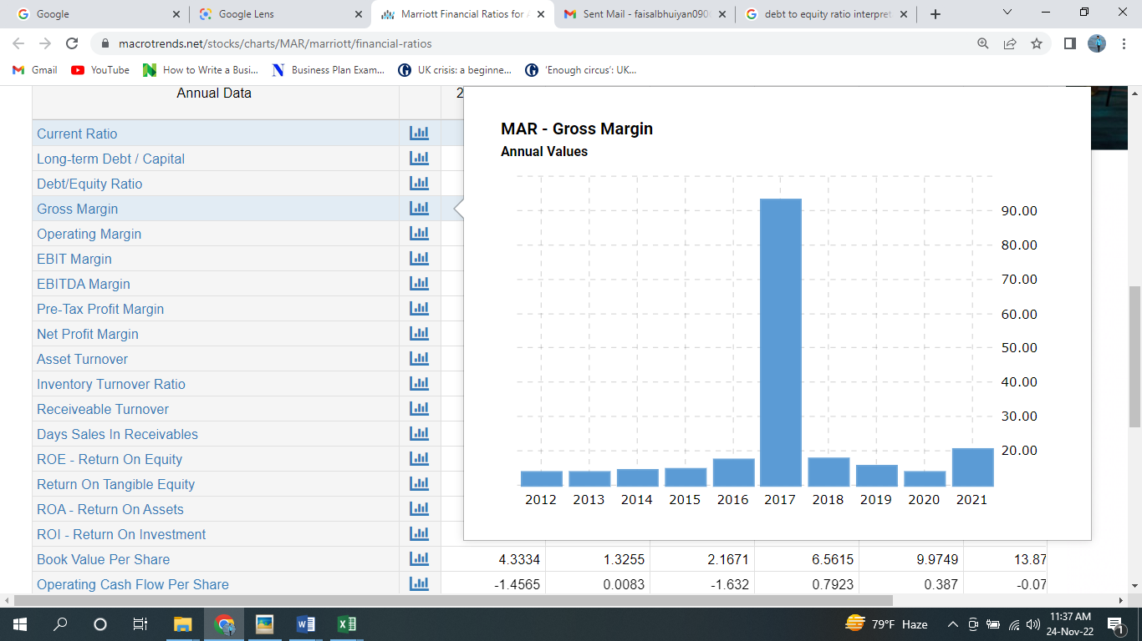
(Source: www.macrotrends.net, 2022)
From the above chart, it can be seen that the gross margin was 13.80 in 2020 and it rose to 20.21 in 2021 which is a positive trend. The company has made significant progress in 2021 compared to 2020. However, Marriot’s gross margin is less i.e. 20% of per dollar revenue generated in 2021.
Operating Margin

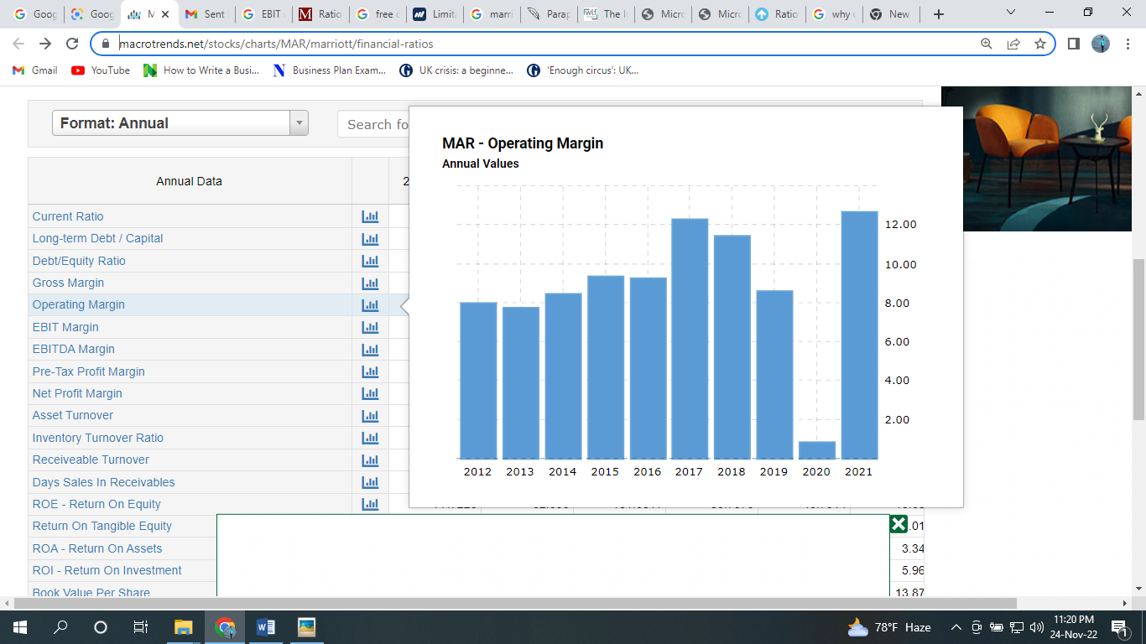
(Source: www.macrotrends.net, 2022)
From the above chart, it can be seen that the operating margin was 0.79 in 2020 and it rose to 12.62 in 2021 which is a positive trend. The company has made significant progress in 2021 compared to 2020. It is said that a 20% operating margin can be perceived as healthy in the hotel industry (Voigt, 2005). However, Marriot’s operating margin is far better i.e. 12.62% of per dollar revenue generated in 2021. However, due to the pandemic, the company suffered much in 2020. The profitability of the firm is average.
Net Profit Margin

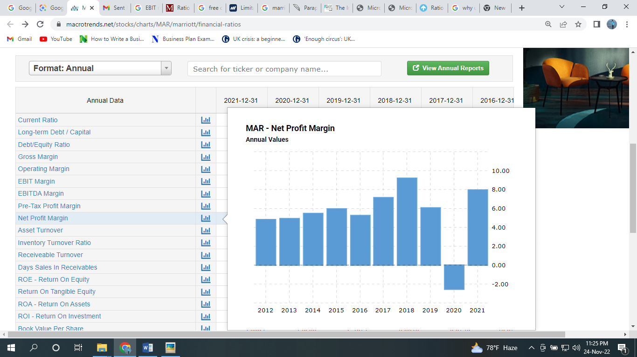
(Source: www.macrotrends.net, 2022)
From the above chart, it can be seen that the Net Profit margin was -2.53 in 2020 and it rose to 7.93 in 2021 which is a positive trend. The company has made significant progress in 2021 compared to 2020. It is said that a 10% net profit margin can be perceived as healthy in the hotel industry and 5% is considered average (Guilding, 2007). However, Marriot’s net profit margin is average i.e. 7.93% of per dollar revenue generated in 2021. However, due to the pandemic, the company suffered much in 2020 and had shown a loss in 2020.
Asset Turnover Ratio
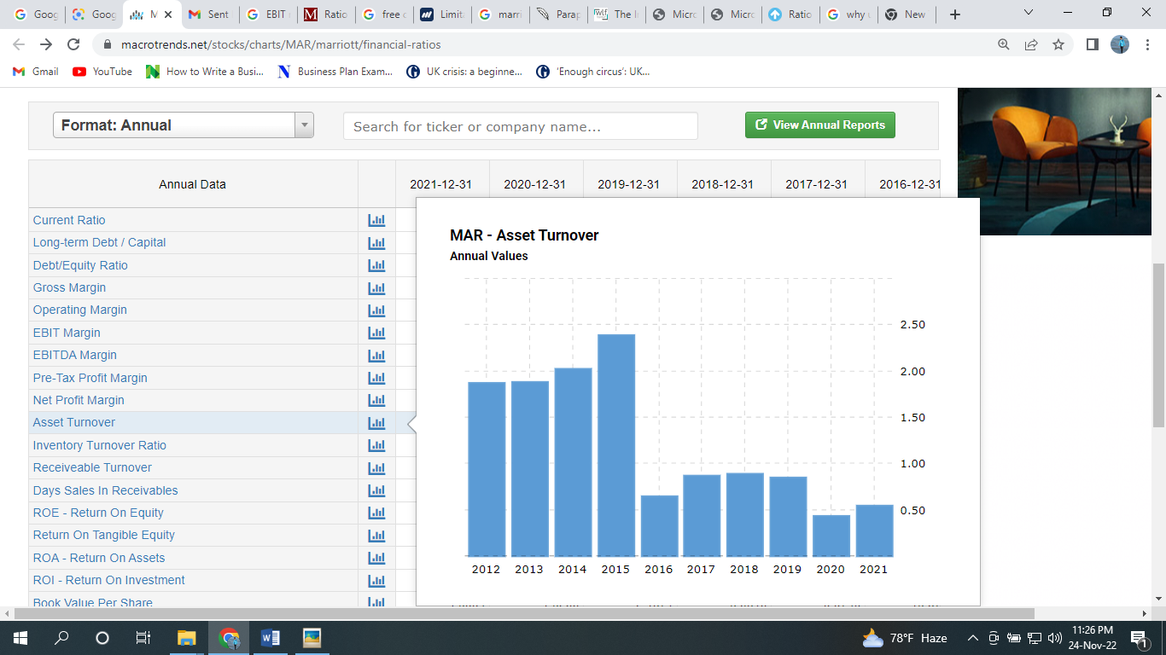
(Source: www.macrotrends.net, 2022)

From the above chart, it can be seen that the asset turnover was 0.43 in 2020 and it reduced to 0.54 in 2021 which is a positive trend. It is said that the above 1 asset turnover ratio can be perceived as ideal (Guilding and Mingjie Ji, 2022). However, Marriot’s asset turnover is far less than the ideal one i.e. 0.54 in 2021 which indicates that the company is not much efficient in generating revenue from its assets.
Return on Equity (ROE)

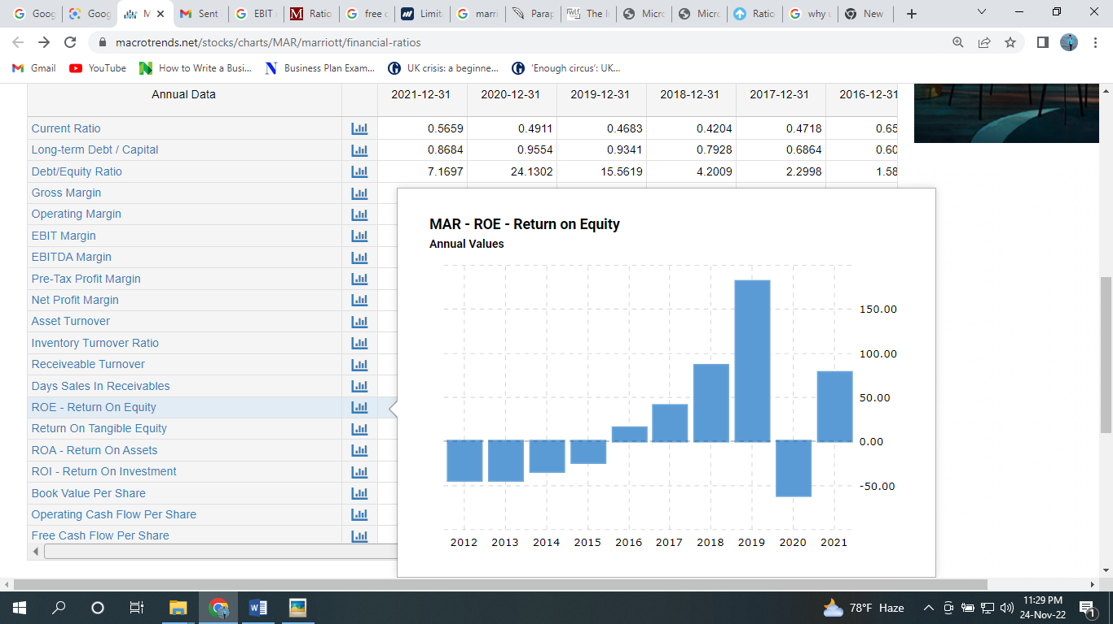
(Source: www.macrotrends.net, 2022)
From the above chart, it can be seen that ROE was -62.09 in 2020 and it increased to 77.72 in 2021 which is a positive trend for the firm as the rate has increased significantly. It is said that above 10 ROE can be perceived as ideal (Defranco and Lattin, 2007). However, Marriot’s ROE is much more than the ideal one i.e. 77.72 in 2021 which indicates that the company is efficient in utilizing its equity to generate profits.
Return on Tangible Equity
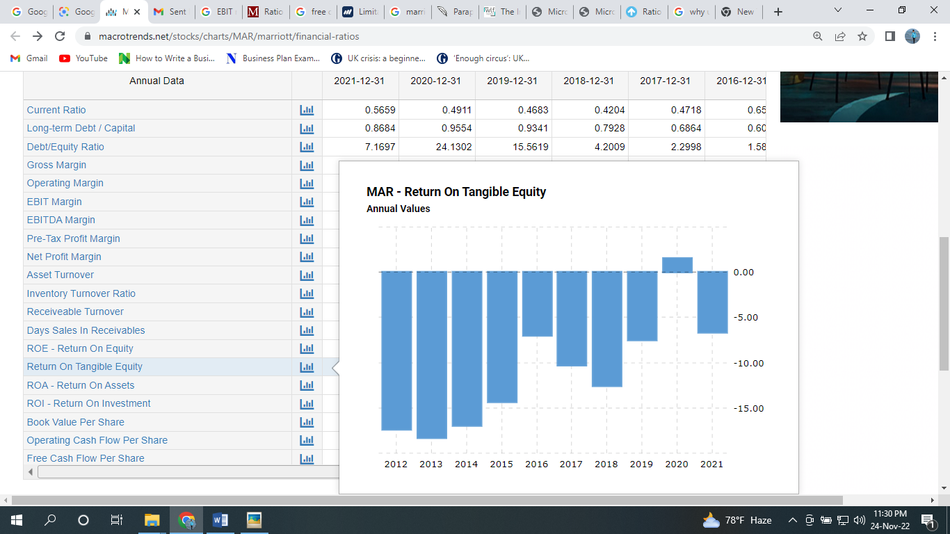
(Source: www.macrotrends.net, 2022)
From the above chart, it can be seen that Return on Tangible Equity was 1.51 in 2020 and it reduced to -6.62 in 2021 which is a negative trend for the firm as the rate has increased significantly. It is said that the above 10 Return on Tangible Equity can be perceived as ideal (Defranco and Lattin, 2007). However, Marriot’s ROE is much lower than the ideal one i.e. -6.62 in 2021 which indicates that the company is performing poorly in utilizing its tangible equity to generate profits.
Return on Assets (ROA)

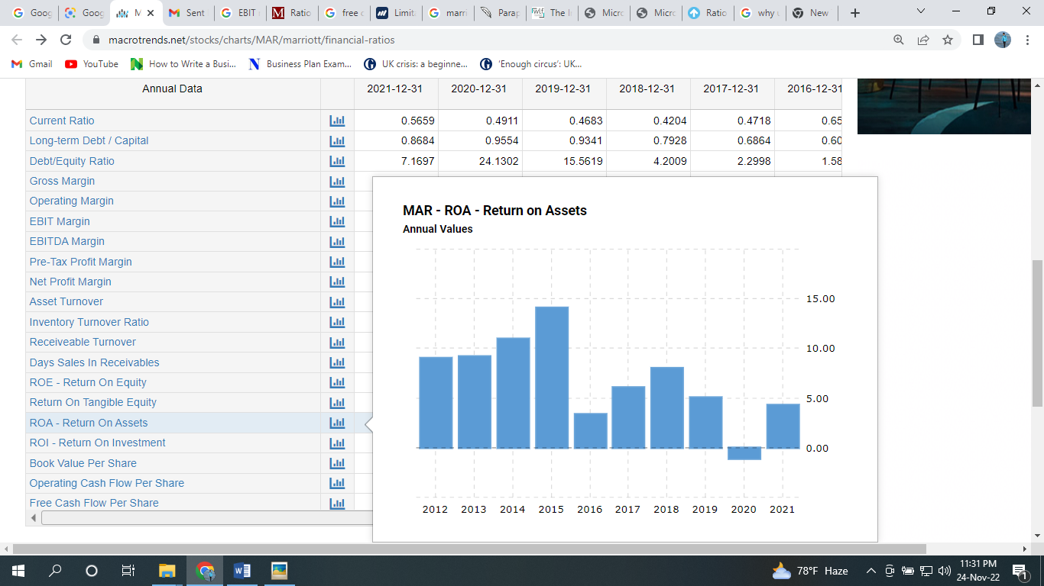
(Source: www.macrotrends.net, 2022)
From the above chart, it can be seen that ROA was -1.08 in 2020 and it increased to 4.30 in 2021 which is a positive trend for the firm as the rate has increased significantly from negative to positive. It is said that above 5% ROA can be perceived as ideal (Rahayu and Amalia, 2022). However, Marriot’s ROE is lower than the ideal one i.e. 4.30 in 2021 which indicates that the company is somewhat efficient in utilizing its assets to generate profits and performing well in generating a return on assets.
Return on Investment (ROI)
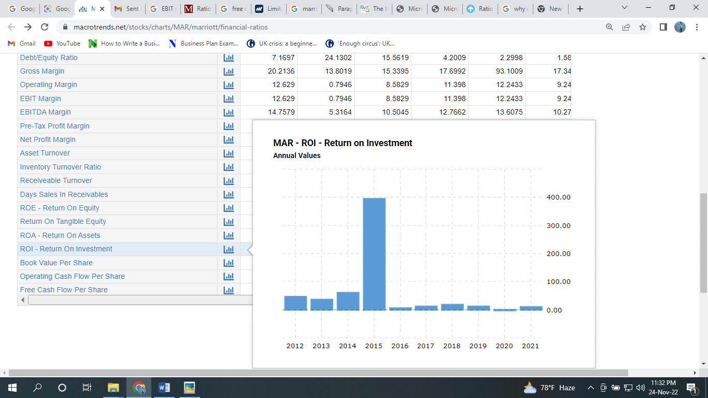
(Source: www.macrotrends.net, 2022)
From the above chart, it can be seen that ROI was -2.77 in 2020 and it increased to 10.22 in 2021 which is a positive trend for the firm as the rate has increased significantly from negative to positive. It is said that above 15% ROI can be perceived as good for the hotel industry (Jang and Yu, 2002). However, Marriot’s ROI is lower than the ideal one i.e. 10.22 in 2021 which indicates that the company is somewhat efficient in investment to generate profits and performing well in generating a return on investments.

Trends in Profitability Ratios
From the profitability assessment ratio of Marriot Hotel, it can be perceived that the overall profitability of the company has been improved in all aspects.

The essentiality of the proper understanding of the ratios and their fluctuations
Understanding the ratios and their fluctuations are necessary for understanding the organization, its strengths, weaknesses and the overall performance of the company. If someone is not efficient in understanding the ratios and the fluctuations, he/she might misinterpret the performance and the overall organizational condition (Ramsden, 2012). .

Ratios and importance of ratios for decision making
Analysis of financial ratios can be used to determine a company's advantages and disadvantages. According to the financial reports, the company is able to assess its productivity and profitability and has a way of figuring out how one accounting variable on its financial information relates to another. A company's performance can be evaluated over time, and significant indications can be identified that indicate whether adjustments or improvements are required. The financial ratio will support or refute the firm's finance, investment, and operational decisions (Steffy, Zearley and Strunk, 2014). They break down the financial report into comparative data, which aids management in comparing and assessing the company's financial situation and the outcomes of its decisions. It reduces complicated financial balance sheet reports to straightforward ratios of operational and financial effectiveness, liquidity, long-term prospects, etc (Ramsden, 2012). Such ratios can help a corporation to better comprehend:
- how much profit is generated for each dollar of sales,
- how rapidly their inventory sold,
- whether they are having problems with cash flow, how they have been monitoring their daily expenses,
- the ratio of a company's workforce to its efficiency,

Limitations of Ratios
Economic leverage ratios can help stakeholders assess a company's long-term viability in the hotel industry. These ratios evaluate an organization's capacity to service its long-term liabilities. However, ratio analysis has some limitations (Steffy, Zearley and Strunk, 2014). These include-
- The corporation might modify their accounting records at year-end to boost their ratios. The ratios then show themselves to be nothing more than superficial ornamentation.
- Ratios ignore changes in market prices caused by inflation. The cost analysis, which ignores differences in price levels between the two time periods, is used to build a lot of ratios. It doesn't accurately depict the financial situation.
- The qualitative traits of the firm are completely ignored by accounting ratios. They merely take financial factors into account. For illustrate, Marriot's data for 2020 disregarded the situation with the COVID-19 pandemic.

Conclusion
Marriot is an American-based hotel chain. Ratio analysis aided in evaluating the financial performance of the company in 2020 and 2021 as well as their trends. The company has positive trends as per the ratios of 2021 compared to 2020. The profitability of the hotel is somewhat satisfactory. However, the company has liquidity concerns as per the ratios. However, the company is somewhat efficient in its business operation. There has room for improvement for the company as per the ratios. Overall financial health is not much satisfactory as most of the investment of the company comes from debt and it is beyond the standard rate. The company might face insolvency in the long run. So, they must care about the debt related to equity.

Reference list
Böhm, A. (2008). Interpretation of Key Figures in Financial Analysis. GRIN Verlag.
Borosky, P. (2020). Beginner’s guide to understanding financial statements and financial ratios.
Chibili, M.N. (2019). Basic management accounting for the hospitality industry. London: Routledge.
Defranco, A.L. and Lattin, T.W. (2007). Hospitality financial management. Hoboken, N.J.: John Wiley & Sons.
Fabozzi, F.J. and Peterson, P.P. (2003). Financial Management and Analysis. John Wiley & Sons.
Guilding, C. (2007). Financial Management for Hospitality Decision Makers. Routledge.
Guilding, C. and Mingjie Ji, K. (2022). Accounting essentials for hospitality managers. London: Routledge.
Hales, J. (2006). Accounting and Financial Analysis in the Hospitality Industry. Routledge.
Jang, S. (Shawn) and Yu, L. (2002). Analysis of Return on Hotel Investment: A Comparison of Commercial Hotel Companies and Casino Hotel Companies. Journal of Hospitality & Tourism Research, 26(1), pp.38–53. doi:10.1177/1096348002026001003.
Marriott (2022). Hotels & Resorts | Book your Hotel directly with Marriott Bonvoy. [online] Marriott.com. Available at: https://www.marriott.com/default.mi.
Rahayu, M.P. and Amalia, D. (2022). Pengaruh Return on Assets, Return on Assets, Return on Equity, Earning per Share, Dividend Payout Ratio Terhadap Harga Saham. Accounthink : Journal of Accounting and Finance, 7(01). doi:10.35706/acc.v7i01.6338.
Ramsden, P. (2012). The essentials of management ratios. Aldershot ; Brookfield, Vt., Usa: Gower.
Steffy, W., Zearley, T. and Strunk, J. (2014). Financial ratio analysis : an effective management tool. Ann Arbor: Industrial Development Division, Institute Of Science And Technology, University Of Michigan.
Voigt, F. (2005). Financing decision. GRIN Verlag.
www.google.com. (2022). Marriott International Inc (MAR) Stock Price & News - Google Finance. [online] Available at: https://www.google.com/finance/quote/MAR:NASDAQ?sa=X&ved=2ahUKEwim5b7ojcf7AhUB63MBHfgsBp0Q3ecFegQIMRAi [Accessed 24 Nov. 2022].
www.macrotrends.net. (2022). Marriott Financial Ratios for Analysis 2005-2020 | MAR. [online] Available at: https://www.macrotrends.net/stocks/charts/MAR/marriott/financial-ratios.

Appendix



