Contents
1.0 Sensor 3
1.0.1 sensor(void) 3
1.0.2 void carPresent() 3
1.0.3 void carAbscent() 3
1.0.4 int getSensorState() 3
1.0.5 int update(int st) 3
2.0 Reader 3
2.0.1 num_plate(void) 3
2.0.2 char * returnNP() 4
2.0.3 void update() 4
2.0.4 int check() 4
2.0.5 Test Case Number Plate Entry 4
2.1.1 ID_Reader(void) 5
2.1.2 void Read(int sn) 5
2.1.3 int getCheckState() 5
2.1.4 int Check(int sn) 5
2.1.5 void update() 5
2.1.6 int * returnID() 5
2.1.7 Test Cases ID Entry 6
2.2.1 setReader(int ty); 6
2.2.2 int getReader(); 6
2.2.3 Reader(int ty) 6
3.0 Full_sign 7
3.0.1 full_sign(void) 7
3.0.2 void SwitchOn() 7
3.0.3 void SwitchOff() 7
3.0.4 int getFullSignState() 7
3.0.5 int update(int st) 7
4.0 Car_park 8
4.0.1 car_park(void) 8
4.0.2 void incrementSpaces() 8
4.0.3 void decrementSpaces() 8
4.0.4 int getFreeSpaces() 9
4.0.5 int anySpacesLeft() 9
4.0.6 void update(int st) 9
4.0.7 int checkID() 9
4.0.8 Test Case Capacity Reached 10
5.0 Barrier 10
5.0.1 Barrier(void) 10
5.0.2 void raise() 10
5.0.3 void lower() 10
5.0.4 void update(int st) 10
6.0 Source.cpp 10
6.0.1 void update(int st) 10
7.0 User Guide 11
7.0.1 Run OOProgramming.Exe 11
7.0.2 Basic Functionality 11
7.0.3 Car Arrives At Car Park 11
7.0.4 Driver Scans ID Barcode 11
7.0.5 Car Park System Records License Plate 12
7.0.6 Barrier Raises 12
7.0.7 Car Exits 12
References 13
Appendices 14
Appendix 1 – Barrier.h 14
Appendix 2 – Barrier.cpp 14
Appendix 3 – CarPark.h 15
Appendix 4 – CarPark.cpp 15
Appendix 5 – FullSign.h 18
Appendix 7 – FullSign.cpp 18
Appendix 7 – Reader.h 19
Appendix 8 – Sensor.h 20
Appendix 9 – Sensor.cpp 20
Appendix 10 – Source.cpp 21
Appendix 11 – Reader.cpp 21

1.0 Sensor

1.0.1 sensor(void)
Type | Constructor
Relationship | Car_Park.cpp
Responsibilities (knowing and doing) | Intializes attribute ‘sensState’ = 0
Attributes | Int sensState

1.0.2 void carPresent()
Type | Operation
Responsibilities (knowing and doing) | Increments attribute sensState to 1. 1 represents the state that the car is present at the car park sensor

1.0.3 void carAbscent()
Type | Operation
Responsibilities (knowing and doing) | Increments attribute sensState to 0. 0 represents the state that the car is abscent at the car park sensor

1.0.4 int getSensorState()
Type | Operation
Responsibilities (knowing and doing) | Returns the current attribute sensState whether 1 or 0 to indicate state.

1.0.5 int update(int st)
Type | Operation
Responsibilities (knowing and doing) | Function receives a 1 or 0 from car_park.cpp to indicate whether the car is entering or exiting the car park.  If 1 is received from parent object this indicates car is entering car park.  St is passed to either carAbscent() if 0, carPresent() if 1.  If St is zero a message is returned to user that exit car park process running.

2.0 Reader

2.0.1 num_plate(void)
Type | Constructor
Relationship | Car_Park.cpp
Responsibilities (knowing and doing) | Intializes char array attribute  str[0] = 'X';  str[1] = 'X';  str[2] = 'X';  str[3] = 'X';  str[4] = 'X';  str[5] = 'X';  str[6] = 'X';
Attributes | char str[7];

2.0.2 char * returnNP()
Type | Operation
Responsibilities (knowing and doing) | Function is designed to return a pointer to char[] value to be utilized in the cap_park.cpp. Within car_park.cpp exists a two dimensional char array that holds the number plate value [1]. A pointer is a reference to a memory address that can be used to procure the value of a previously entered data value [2]. To reference the char address is this case the function return must have the * applied. This enables a pointer address to be returned to the calling object. In most cases a & is applied to the value being returned for reference; in this case C++ is able to bypass this addition and reference without the & [3]

2.0.3 void update()
Type | Operation
Responsibilities (knowing and doing) | While loop runs requesting a cin user input of alphanumerical entry. Each input is passed to the check() function, which returns a 1 or a 0 to break out of the while loop and return to the car_park.cpp object.

2.0.4 int check()
Type | Operation
Responsibilities (knowing and doing) | The user entered number plate is passed from the update() function to the check() function to iterate through each character of the char array.  This function checks:  - Array does not contain spaces  - Array does not contain characters where numbers are expected  - Array does not contain numbers where characters are expected  If a 1 is returned from the this function to the update() function, the while loop exits, returns a 1 to the car_park.cpp.

2.0.5 Test Case Number Plate Entry
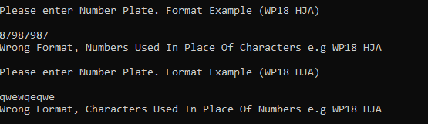

2.1.1 ID_Reader(void)
Type | Constructor
Relationship | Car_Park.cpp
Responsibilities (knowing and doing) | Intializes attributes  checkState = 0;  cserialNumber = 0;  fail = 0;  length = 0;
Attributes | int cserialNumber;  int checkState;  int fail;  int length;

2.1.2 void Read(int sn)
Type | Operation
Responsibilities (knowing and doing) | Car_park.cpp triggers this function to set the cserialNumber attribute as the ID number that is read within the update() function.

2.1.3 int getCheckState()
Type | Operation
Responsibilities (knowing and doing) | Returns checkState attribute

2.1.4 int Check(int sn)
Type | Operation
Responsibilities (knowing and doing) | This function receives the cserialNumber attribute from the update() function. It then checks the serial number is the correct length; must be 4 digits long not longer or less than 4.

2.1.5 void update()
Type | Operation
Responsibilities (knowing and doing) | The function reads the serial number from user input; passes the input to the read() function that initializes the cserialNumber attribute and passes the cserialNumber attribute to the checkstate() function.

2.1.6 int * returnID()
Type | Operation
Responsibilities (knowing and doing) | Returns a pointer to the id attribute within the class to the car_park.cpp, which is then stored in an two dimensional integer array.

2.1.7 Test Cases ID Entry
Correct length Check: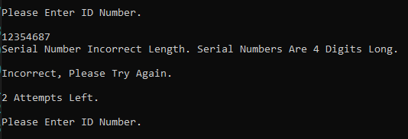
Duplicate ID Check:
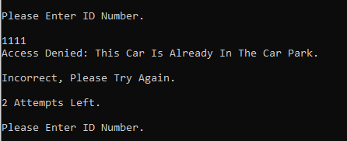

2.2.1 setReader(int ty);
Type | Operation
Responsibilities (knowing and doing) | Sets the type to the relevant child class type:  1 = Id  2 = Number Plate

2.2.2 int getReader();
Type | Operation
Responsibilities (knowing and doing) | Increments attribute sensState to 1. 1 represents the state that the car is present at the car park sensor

2.2.3 Reader(int ty)
Type | Constructor
Relationship | Car_Park.cpp
Responsibilities (knowing and doing) | Initialize attribute type to zero.  This class is a base class to two derived class classes by using inheritance [4].  Derived class 1 – Idreader  Idreader is a specialization of the base Reader class and utilizes one main attribute from the Reader class, type. The attribute type is used to set the type of the derived class. In this case Type equals 1. This means this derived class is a type of IDReader.  Derived class 2 - NumPlate  Numplate is a specialization of the base Reader class and utilizes the type attribute, setting the attribute to the value of 2. This indicates that the type of reader this a number plate reader.
Attributes | Reader(int ty);  int type;

3.0 Full_sign

3.0.1 full_sign(void)
Type | Constructor
Relationship | Car_Park.cpp
Responsibilities (knowing and doing) | Intializes attribute ‘lightOn’ = 0;
Attributes | int lightOn;

3.0.2 void SwitchOn()
Type | Operation
Responsibilities (knowing and doing) | This functions increments the lightOn attribute to turn on light to indicate car park is full.

3.0.3 void SwitchOff()
Type | Operation
Responsibilities (knowing and doing) | This functions decrements the lightOn attribute to turn on light to indicate car park is not at capacity.

3.0.4 int getFullSignState()
Type | Operation
Responsibilities (knowing and doing) | Returns lightOn attribute.

3.0.5 int update(int st)
Type | Operation
Responsibilities (knowing and doing) | Freespaces attribute from car_park.cpp is passed to this function.  If freespaces is 0 switchOff() function is activated.  If freespaces > 1 switchOn() function is activated.

4.0 Car_park

4.0.1 car_park(void)
Type | Constructor
Relationship | Car_Park.cpp
Responsibilities (knowing and doing) | Intializes attributes:  - capacity = 10;  - freeSpaces = 10;  - idPtr = 0;  Global objects created:  - full_sign* fulls = new(full_sign);  - Barrier* barr = new(Barrier);  - IDReader idread(1);  - numPlate nump(2);  - sensor* sens = new(sensor);  Each object provides abstraction to the functionality of the car park program. Each object has its own member functions that behave a certain way and can be called from the car_park.cpp [5]. The use of classes within objects allows the objects to be utilized within the program life cycle [6]. The composition of the objects is a parent child relationship that once the parent object is deleted the child objects cease to exist [7].
Attributes | int capacity;  int state;  int freeSpaces;  int idcheck = 0;  int* idPtr = 0;  char * charPtr = 0;  int id[10][2] {  {1234,0},  {5678,0},  {9101,0},  {2131,0},  {1207,0},  {3259,0},  {8659,0},  {1111,0},  {1222,0},  {1223,0}  };  std::string numberPlate[10][2]{  };

4.0.2 void incrementSpaces()
Type | Operation
Responsibilities (knowing and doing) | Increments the attribute freeSpaces by 1

4.0.3 void decrementSpaces()
Type | Operation
Responsibilities (knowing and doing) | decrements the attribute freeSpaces by 1

4.0.4 int getFreeSpaces()
Type | Operation
Responsibilities (knowing and doing) | This function returns the attribute value of freespaces.

4.0.5 int anySpacesLeft()
Type | Operation
Responsibilities (knowing and doing) | This function checks if freespaces is equal to zero.  If freespaces returns the value zero, return message.  If freespaces over 1, return the value 1 to update() function.

4.0.6 void update(int st)
Type | Operation
Responsibilities (knowing and doing) | State is passed from source.cpp to indicate whether the car is exiting or entering the car park.  1 if car park is entering, function anyspacesleft() is triggered to return the freespaces attribute check. The sensor passed the st attribute to check if car is present.  The for loop checks 3 times whether the idreader returns a valid result, a correctly formed ID. This id is returned as a pointer and then checked against the id array inside the checkID() function. The barrier is raised and lowered by passing the required value to two the function update().  If exit 0 value is applied the id state in the id is found in the id array and it set to 0 to indicate car is exiting the car park. The number plate is also removed from the second array. The barrier is then raised using the update() functions in the barrier object.

4.0.7 int checkID()
Type | Operation
Responsibilities (knowing and doing) | This member function calls the idread() member function to return the pointer to the place in memory where the idreader object returns the value of user inputted id. This value is compared to all the id values in the id array. If successful the second dimension of the array is assigned a 1 over the zero to show the car has entered the car park. This is used to validate the presence of an ID which is already in the car park, denying access to duplicate id’s. The number plate function update is also called to add a number plate corresponding to the id entered. As car enters car park the number of spaces is decremented using the member function decrementSpaces().

4.0.8 Test Case Capacity Reached
Car 10 will always return the message:
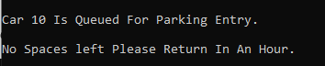
Due to the car park having a capacity of 9 spaces.

5.0 Barrier

5.0.1 Barrier(void)
Type | Constructor
Relationship | Car_Park.cpp
Responsibilities (knowing and doing) | Intializes attribute ‘up’ = 0;
Attributes | int up;

5.0.2 void raise()
Type | Operation
Responsibilities (knowing and doing) | Increments attribute up to 1 indicating the barrier has raised.

5.0.3 void lower()
Type | Operation
Responsibilities (knowing and doing) | Decrements attribute up by 1 indicating the barrier has lowered.

5.0.4 void update(int st)
Type | Operation
Responsibilities (knowing and doing) | State from car_park.cpp is passed to function.  If st (state) is 1 function raise() is triggered  If st (state) is 1 function lower() is triggered

6.0 Source.cpp

6.0.1 void update(int st)
Type | Main
Responsibilities (knowing and doing) | A single car_park object is created called NCP; NCP is updated ten times in a for loop to add cars to the car park.

7.0 User Guide

7.0.1 Run OOProgramming.Exe
Run OOProgramming.exe from a Windows command prompt or via the OOProgramming.exe.

7.0.2 Basic Functionality
The OOprogramming.exe run through two processes:
- Car Entry – the program will loop 10 times, each time requesting Car input data and processing said information (e.g. Checking if car exists in car park currently).
- Car Exit – the program will loop a further 10 times to show cars exiting the car park and the free spaces in the car park incrementing as the cars leave.

7.0.3 Car Arrives At Car Park

Sensor scans if car is present at car park entry. User expected to act as sensor, 1 for Yes 0 For No.
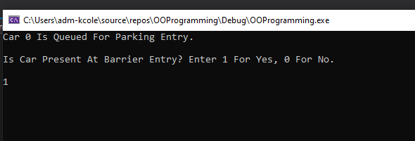

7.0.4 Driver Scans ID Barcode
Car ID’s to use in program:
- 1234
- 5778
- 9101
- 2131
- 1207
- 3259
- 8759
- 1111
- 1222
- 1223
Enter one of the codes above to progress further.
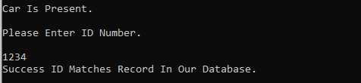

7.0.5 Car Park System Records License Plate
The system scans the License Plate, as to be entered by the user.
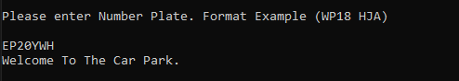

7.0.6 Barrier Raises
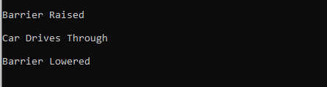

7.0.7 Car Exits
Each car exits consecutively, the user act as the sensor a second time. After each sensor choice of yes, the program waits five seconds.
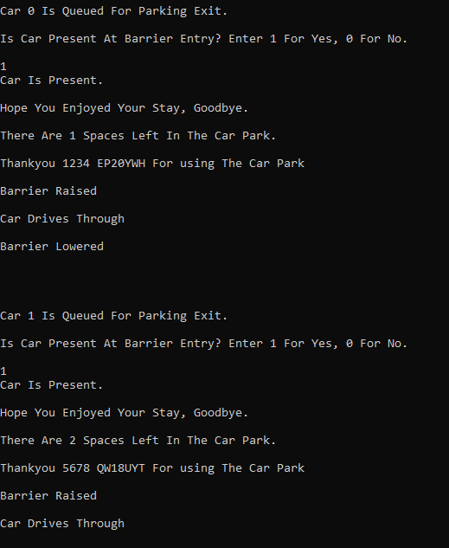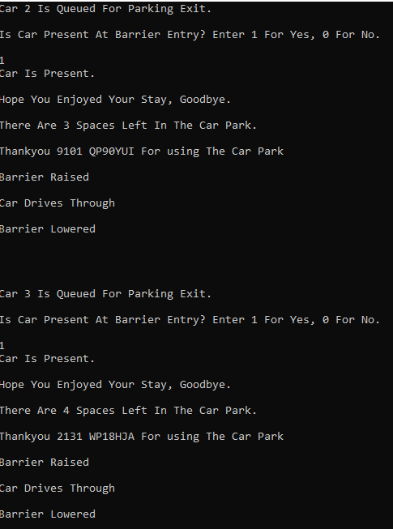
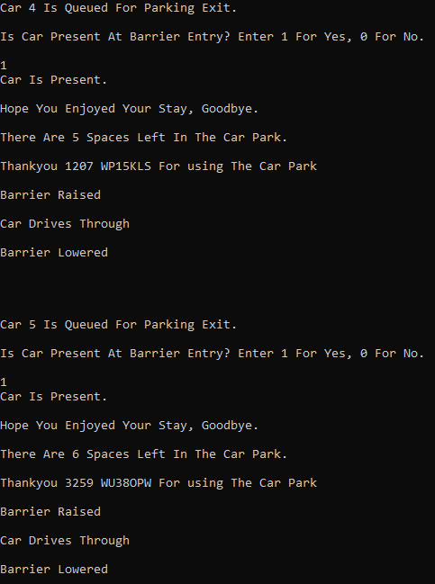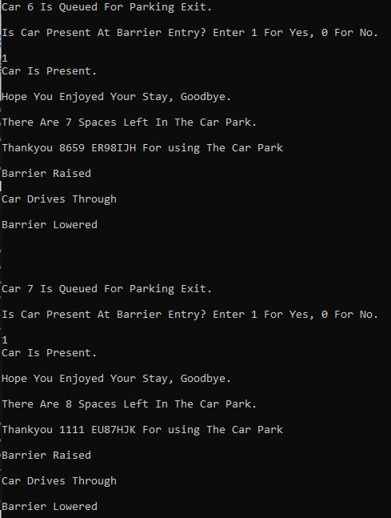
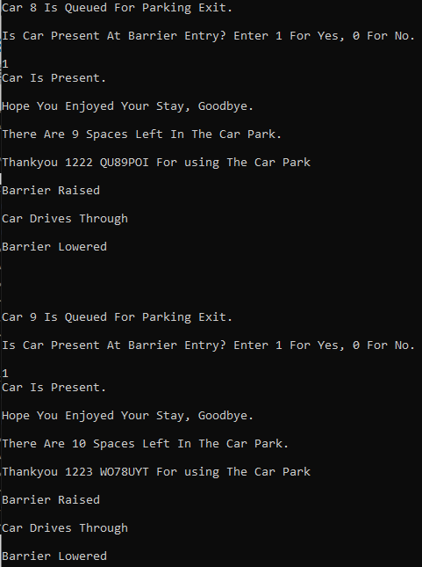
Word Count: 1750

References

[1] | G. Dickers, “Arrays Stacks and Queues,” Swansea, 2021.
[2] | G. Dickers, “Pointers and arrays,” Swansea, 2020.
[3] | OverIQ, “Character Array and Character Pointer in C,” OverIQ, 27 6 2020 . [Online]. Available: https://overiq.com/c-programming-101/character-array-and-character-pointer-in-c/. [Accessed 13 01 2021].
[4] | G. Dickers, “Inheritance,” Swansea, 2020.
[5] | B. Stroustrup, “The C++ Programming Language 4th Edition,” in The C++ Programming Language 4th Edition.pdf, Addison Wesley, 2013, p. 451.
[6] | G. Dickers, “Into C++,” Swansea, 2021.
[7] | G. Dickers, “Composition and Aggregation in C++,” Swansea, 2021.

Appendices

Appendix 1 – Barrier.h

#pragma once
class Barrier
{
public:
Barrier(void);
void raise();
void lower();
void update(int st);

private:
int up;
};

Appendix 2 – Barrier.cpp

#include "Barrier.h"
#include <string>
#include <iostream>
using namespace std;
//constructor
Barrier::Barrier(void)
{
up = 0;
}

void Barrier::raise()
{
cout << "Barrier Raised \n" << endl;
cout << "Car Drives Through \n" << endl;
up++;
}
void Barrier::lower()
{
cout << "Barrier Lowered \n\n\n\n" << endl;
up--;
}
void Barrier::update(int st)
{
if (st == 1)
{
raise();
}
else
{
lower();
}
}

Appendix 3 – CarPark.h

#pragma once
#include <string>
class car_park
{
public:
car_park(void);
void incrementSpaces();
void decrementSpaces();
int getFreeSpaces();
int anySpacesLeft();
void update(int st);
int checkID();
private:
int capacity;
int state;
int freeSpaces;
int idcheck = 0;
int* idPtr = 0;
char * charPtr = 0;
int id[10][2] {
{1234,0},
{5778,0},
{9101,0},
{2131,0},
{1207,0},
{3259,0},
{8759,0},
{1111,0},
{1222,0},
{1223,0}
};
std::string numberPlate[10][2]{
};
};

Appendix 4 – CarPark.cpp

#include "CarPark.h"
#include "Barrier.h"
#include "FullSign.h"
#include "Reader.h"
#include "Sensor.h"
#include <string>
#include <iostream>
#include <thread>
#include <chrono>
using namespace std;

full_sign* fulls = new(full_sign);
Barrier* barr = new(Barrier);
IDReader idread(1);
numPlate nump(2);
sensor* sens = new(sensor);

//constructor
car_park::car_park(void)
{
capacity = 10;
freeSpaces = 10;
idPtr = 0;
}
int car_park::checkID()
{
idcheck = 0;
idPtr = idread.returnID();
for (int ii = 0;ii < 10;ii++)
{
if (id[ii][0] == (*idPtr) && id[ii][1] == (1) && state == 1)
{
idcheck = 0;
cout << "Access Denied: This Car Is Already In The Car Park. \n" << endl;

}
else if (id[ii][0] == (*idPtr) && id[ii][1] == (0))
{
idcheck = 1;
if(state == 1)
{
cout << "Success ID Matches Record In Our Database. \n" << endl;
id[ii][1] = (1);
nump.update();
charPtr = nump.returnNP();

numberPlate[ii][0] = charPtr;

std::string tmpNum = std::to_string(*idPtr);
char const* num_char = tmpNum.c_str();

numberPlate[ii][1] = num_char;

decrementSpaces();
}
else
{
cout << "Updating ID State In Records. \n" << endl;
id[ii][1] = (0);
incrementSpaces();
}
break;
}
}
return idcheck;
}
void car_park::incrementSpaces()
{
//cout << "In increment" << endl;
//cout << "freespace: " << freeSpaces << endl;
freeSpaces++;
cout << "Hope You Enjoyed Your Stay, Goodbye. \n" << endl;
cout << "There Are " << freeSpaces <<" Spaces Left In The Car Park. \n" << endl;
}
void car_park::decrementSpaces()
{
//cout << "In decrement" << endl;
//cout << "freespace: " << freeSpaces << endl;
freeSpaces--;
fulls->update(freeSpaces);
if (freeSpaces > 0)
{
cout << "Welcome To The Car Park. \n" << endl;
}

}
int car_park::getFreeSpaces(void)
{
return freeSpaces;
}
int car_park::anySpacesLeft()
{
int sp = 0;
if (getFreeSpaces() == 0)
{
cout << "No Spaces left Please Return In An Hour. \n" << endl;
}
else
{
sp = 1;
}
return sp;
}
void car_park::update(int st)
{
state = st;
if (state == 1 && anySpacesLeft() == 1)
{
sens->update(state);
int check = 0;
int count = 3;
for (int i = 0; i < 3; i++)
{
idread.update();
check = checkID();
if (check == 1)
{
break;
}
else
{
count--;
cout << "Incorrect, Please Try Again. \n" << endl;
cout << count << " Attempts Left. \n" << endl;
}
}
if (idcheck == 1)
{
barr->update(1);
//Lower Barrier
barr->update(0);
}
}
else if (state == 0)
{
for (int ii = 0;ii < 10;ii++)
{
if (id[ii][1] == 1)
{
sens->update(0);
incrementSpaces();
cout << "Thankyou " << id[ii][0] << " " << numberPlate[ii][0] << " For using The Car Park \n" << endl;
id[ii][1] = 0;
numberPlate[ii][0] = ' ';
numberPlate[ii][1] = ' ';
barr->update(1);
//Lower Barrier
barr->update(0);
std::this_thread::sleep_for(std::chrono::seconds(5));
break;
}
}
}
}

Appendix 5 – FullSign.h

#pragma once
class full_sign
{
public:
full_sign(void);
void SwitchOn();
void SwitchOff();
int getFullSignState();
int update(int st);

private:
int lightOn;
};

Appendix 7 – FullSign.cpp

#include "FullSign.h"
#include <string>
#include <iostream>
using namespace std;
//constructor
full_sign::full_sign(void)
{
lightOn = 0;
}
void full_sign::SwitchOn()
{
lightOn++;
cout << "CAR PARK IS FULL. PLEASE TRY IN AN HOUR. \n" << endl;
}
void full_sign::SwitchOff()
{
lightOn--;
}
int full_sign::getFullSignState()
{
return lightOn;
}
int full_sign::update(int st)
{
if (st == 0)
{
SwitchOn();
}
else
{
SwitchOff();
}
return lightOn;
}

Appendix 7 – Reader.h
#pragma once
#include <iostream>
#include <string>
class Reader
{
public:
void setReader(int ty);
int getReader();
protected:
Reader(int ty);
int type;
};

class IDReader : public Reader {
public:
// Constructor
IDReader(int ty);
void Read(int sn);
int getCheckState();
int Check(int sn);
void update();
int * returnID();
private:
int cserialNumber;
int checkState;
int fail;
int length;
};
class numPlate : public Reader {
public:
numPlate(int ty);
char * returnNP();
void update();
int check();
private:
char str[7];
};

Appendix 8 – Sensor.h

#pragma once

class sensor
{
public:
sensor(void);
void carPresent();
void carAbscent();
int getSensorState();
int update(int st);

private:
int sensState;
};

Appendix 9 – Sensor.cpp

#include "Sensor.h"
#include <string>
#include <iostream>

using namespace std;
//constructor
sensor::sensor(void)
{
sensState = 0;
}
int sensor::getSensorState()
{
return sensState;
}
void sensor::carPresent()
{
sensState++;
cout << "Car Is Present. \n" << endl;
}
void sensor::carAbscent()
{
sensState--;
cout << "Car Is Not Present. \n" << endl;
}
int sensor::update(int st)
{
sensState = st;
if (st == 1)
{
cout << "Is Car Present At Barrier Entry? Enter 1 For Yes, 0 For No. \n" << endl;
cin >> sensState;
if (sensState == 1)
{
carPresent();
}
else if (sensState == 0)
{
carAbscent();
}
}
else
{
cout << "Car is Present At Exit. \n" << endl;
}

return sensState;
}

Appendix 10 – Source.cpp

//source.cpp

#include "CarPark.h"
#include <iostream>
#include <conio.h>

using namespace std;

int main(void)
{
car_park* NCP = new(car_park);

//Car Entry
for (int i = 0;i < 11;i++)
{
cout << "Car " << i << " Is Queued For Parking Entry. \n" << endl;
NCP->update(1);
//_getch();
}

//Car Exit
for (int i = 0;i < 10;i++)
{
cout << "Car " << i << " Is Queued For Parking Exit. \n" << endl;
NCP->update(0);
//_getch();
}
return 0;

delete NCP;
}

Appendix 11 – Reader.cpp
#include "Reader.h"
#include <string>
#include <iostream>
using namespace std;
//constructor
Reader::Reader(int ty)
{
type = ty;
}

void Reader::setReader(int ty)
{
type = ty;
}
int Reader::getReader()
{
return type;
}

//Number Plate
numPlate::numPlate(int ty) : Reader(type)
{
Reader::setReader(ty);
str[0] = 'X';
str[1] = 'X';
str[2] = 'X';
str[3] = 'X';
str[4] = 'X';
str[5] = 'X';
str[7] = 'X';
};

int numPlate::check()
{
int check = 0;
if (isdigit(str[0]) ||
isdigit(str[1]) ||
isdigit(str[4]) ||
isdigit(str[5]) ||
isdigit(str[7])
)
{
check = 0;
cout << "Wrong Format, Numbers Used In Place Of Characters e.g WP18 HJA \n" << endl;
}
else if (!isdigit(str[2]) || !isdigit(str[3]))
{
check = 0;
cout << "Wrong Format, Characters Used In Place Of Numbers e.g WP18 HJA \n" << endl;
}
else if (str[0] == ' ' ||
str[1] == ' ' ||
str[2] == ' ' ||
str[3] == ' ' ||
str[4] == ' ' ||
str[5] == ' ' ||
str[7] == ' '
)
{
check = 0;
cout << "Wrong Format, Too Many Spaces Used e.g WP18 HJA \n" << endl;
}
else
{
check = 1;
}

return check;
}
char* numPlate::returnNP()
{
char* p;
p = str;
return p;
}
void numPlate::update()
{
int count = 0;
while (count == 0)
{
cout << "Please enter Number Plate. Format Example (WP18 HJA)\n" << endl;
cin >> str;
count = numPlate::check();
}
}

//ID Reader

IDReader::IDReader(int ty) : Reader(type)
{
Reader::setReader(ty);
checkState = 0;
cserialNumber = 0;
fail = 0;
length = 0;
}
void IDReader::Read(int sn)
{
cserialNumber = sn;
}
int IDReader::Check(int csnum)
{
length = std::to_string(cserialNumber).length();
if (length > 4 || length < 4)
{
checkState = 0;
cout << "Serial Number Incorrect Length. Serial Numbers Are 4 Digits Long. \n" << endl;
}
else
{
checkState = 1;
}

return checkState;
}
int IDReader::getCheckState()
{
return checkState;
}
int* IDReader::returnID()
{
int* idPtr;
idPtr = &cserialNumber;
return idPtr;
}
void IDReader::update()
{
cout << "Please Enter ID Number. \n" << endl;
cin >> cserialNumber;
Read(cserialNumber);
checkState = Check(cserialNumber);
}

