

Programme: BSc Health and Social Care
Module: Changemakers: Creativity and Value Creation

Module code: BMHP5014

Component 1: Online Portfolio of Set Exercises
Student name: Ionica Madalina Trufanda
Student ID: 2330230

Table of Contents
Task 1 – Concept Map 3
Task 2 - Self-Reflection of Group Activity 4
What? 4
So what? 4
Now what? 4
Task 3 - Case Study of a UK innovation 4
Task 4 - Research Task 5
Task 5 - Podcast 6
Task 6 - NHS Leadership Framework Analysis 6
Task 7 - Self-Reflection Journal Entry 7
Reference List 9

Task 1 – Concept Map
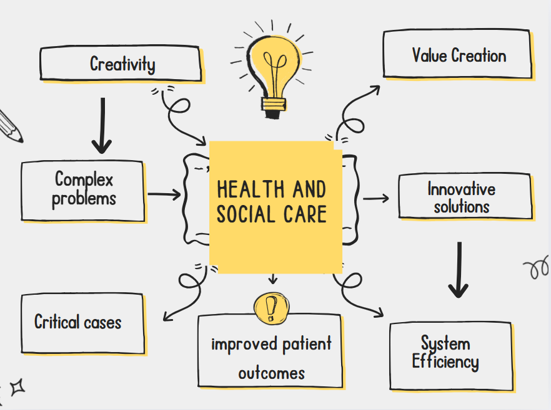
Figure 1: Concept Map
(Self-created)
Explanation:
The concept map has presented a clear picture of how value creation is driven through creative solutions within the healthcare sector. According to Eardley and Cassimjee (2025), the emergence of creativity could help promote the development of innovative systems as well as technologically-assisted interventions. Innovation plays a critical role in health and social care services. This arises due to the increasing demand for transformative treatments and assessments that help improve public health outcomes. In the end, it enhances patient-centered outcomes positively. Such systems help in redesigning challenges in health and social care dimensions. Advanced technologies, such as AI, big data, and machine learning, are an essential approach taken by healthcare organisations.
These innovative systems can enhance care delivery and improve the models of healthcare systems, thus revolutionising overall health management. The aspect of value creation is depicted as a vital factor that shows how healthcare organisations can satisfy patients through the developments, driving growth of positive treatments. Focusing on the overall well-being of patients, by integrating critical technologies into the healthcare approaches, high levels of efficiency can be achieved as well. As per the views of Chianumba et al. (2021), using big data for accessing patient records and AI solutions during intervention can streamline health and care activities. Thus, the concept map also sheds light on the enhanced system optimisation. Likewise, it is viewed that such integrated systems of technology within the healthcare process can drive productivity and improve quality of life.

Task 2 - Self-Reflection of Group Activity

What?
During the Convergent/Divergent thinking class activities, I was able to use my critical thinking and problem-solving skills effectively. These sessions were extremely interesting because it allowed me to brainstorm and develop creative solutions while addressing a problem. I worked in a group during this activity with 2 other girls. We shared a sense of common understanding that helped us to work creatively and collaborate effectively. I pitched diverse ideas for our task: Paper clip. I thought of key rings, hair pins and zipper pull hooks as solutions to the problem.

So what?
Based on the activities and experience, I have detected my core strengths and weaknesses. I have good creative thinking skills that allow me to think critically about the problems, break down the issues and identify potential solutions. As per Almulla (2023), critical thinking and innovation skills are vital competencies for learners which can help to overcome complex problems in assignments and improve academic performance. As I mentioned earlier, I also have good teamwork and communication skills. However, I feel that I have low emotional intelligence as I was unable to identify that one of my team members was struggling during the brainstorming process.

Now what?
To improve emotional intelligence, I have now decided to undertake vital actions and enhance self-awareness skills. I will engage in simulation-based games to situate myself in complex teamwork scenarios and practice effective responses to the environment. Such activities will help me to overcome my shortcomings and enhance development.

Task 3 - Case Study of a UK innovation
An innovative service initiative has been designed by the Oxford Health NHS Foundation Trust to address the insomnia problems among the people in the Thames Valley region. This initiative is focused to mitigate the challenge of chronic insomnia issues faced by a large number of people in the UK. According to Espie (2020), almost 12% of the adults are experiencing chronic symptoms of insomnia which is a critical case. It is a severe issue because of escalating health disorders including anxiety and depressive symptoms among people. The report indicates that lack of trained specialists is limiting the access to CBT (cognitive behavioural therapies), an effective treatment for insomnia patients.
The innovative approach undertaken in the initiative includes the use of digital tools to scale up the psychological intervention of CBT. A programme was created to redefine the treatment of insomnia for the people in the Thames Valley region. With the help of advanced technologies, the treatment has been transformed into an automated digital system that can be accessed through web-based platforms (Oxford Health, 2018). The name of the tool is Sleepio, a transformative health care and assistant service that does not require professional mediation. It is freely accessible to the people seeking support for sleeping, addressing anxiety and depression due to extreme stress and fatigue. Recent evaluations indicate that Sleepio has helped to reduce anxiety and other health symptoms by 72%, thus drawing positive results (NHS, 2025). This tool has been devised with the help of machine learning capabilities, offering interactive online sessions to patients.

Task 4 - Research Task
NHS UK has been facing issues related to the workforce crisis. According to Morgan (2022), the estimated workforce in the NHS was 30,000 too few nurses and midwives in 2022. The vacancy rate in doctors was more than 7% and the nurses were 12% in 2022 (Morgan, 2022). The shortages are not among nurses and doctors. The shortages are in language therapy, sexual and reproductive health care, dietetics, midwifery, pathology, occupational health, dentistry and pharmacy etc. The impact of these staff shortages is on the operational management of the NHS. In this stressful sector, shortages of staff can lead towards decreasing patient’s well-being and increased sickness. Staff shortages in the healthcare sector led to weak agreement of employment contracts which reflect on the UK labour market condition. Due to ongoing chronic staff shortage in the NHS, decisions about terms and conditions have been separated from the demands of employers. This can limit them as a crucial tool for identifying the local labour shortage in the UK.
On the other hand, according to Shemtob et al. (2023), in the healthcare sector, the number of workforces highlights the increased demand due to demographic changes. From 2021 to 2022, in the NHS, over 200000 joins compared to 170000 leaves the institute (Shemtob et al., 2023). These leavers had different roles in the NHS. The reasons behind their leaving are mainly completing their training, retirement, promotion, relocations and also stable work-life balance. Most of the doctors or clinicians are in the NHS working in the general practices with the contracts of zero-hours. Due to high degree of work stress, burnouts and moral injuries are triggering the staff reduction in the NHS. The relations between reduced staffing numbers and patient safety and mortality are correlated with each other. Temporary staffing plans can lead to poor patient outcomes. These are associated with the patient’s safety and professional well-being in the healthcare sector. General practices are effective for patient care as well as staff welfare in the NHS.

Task 5 – Podcast

Task 6 - NHS Leadership Framework Analysis
The NHS has introduced an integrated framework for healthcare leaders to improve internal efficiency, promote ethical duties and responsible conduct. The NHS Leadership Framework offers consistency in activities, emphasising on shared understanding and beliefs to improve health outcomes. It is derived from the “Clinical Leadership Competency Framework” and “Medical Leadership Competency Framework” (NHS, n.d.). By combining key elements from these two frameworks, these theoretical views and essential principles intend to improve clinical practice and inform staff of the main factors. The key components include emphasis on high quality outcomes, developing strong relationships with patients, establishing positive culture, driving strategic governance, equality and inclusivity. Based on these main areas, the leaders are expected to perform their duties, which is to set clear goals and manage the workforce so that positive patient engagement is maintained.
Across the five domains, the NHS leadership framework requires staff to enhance skills and competencies including self-awareness and engaging in continuous development. This is extremely important because teamwork across multidisciplinary teams is vital to improve clinical practices and enhance health outcomes (Din et al., 2024). Another factor that has been stressed in the framework is the improvement of services through innovation and technology. According to Benjamin and Chung (2022), healthcare leaders are directed to undertake stringent actions and drive organisational culture towards innovation thinking and creativity. These activities will be intended to achieve efficiency in clinical operations and improve patient-centered care facilities.
Teamwork and collaboration are an integral factor within healthcare that must be managed by the leaders. Leaders may use this component as a strategic technique to boost efficiency in multidisciplinary teams so that patient care delivery remains consistent. This would require the leaders to establish an inclusive work culture at the organisations such as hospitals or care homes and engage diverse teams to work collaboratively with a shared goal (Willcocks and Conway, 2022). Such initiatives can help healthcare leaders to boost optimisation of clinical practices and achieve positive health goals and satisfy patient needs.

Task 7 - Self-Reflection Journal Entry
From this module, I have learned about the changing nature of the health and social care sector in the UK. Initially, my knowledge on creativity in health and social care (H&SC) was limited due to the traditional education system. This kind of education system has only focused on the standardisation over innovative thinking and understanding the H&SC. This module particularly focuses on the frameworks and operational and leadership management in the NHS UK. The NHS is one of the most famous health systems, globally and the base of the UK healthcare system. From this module, my professional approach of learning has been modified by building theoretical and practical understanding.
This module is not limited to the H&SC but also focuses on how to become an effective leader by establishing a creative and positive atmosphere of working. This can help the employees to work freely without feeling any extra pressure and stress. My approach has been modified by understanding the issues faced by the NHS due to staff reduction and developing a long-term value. I am now focusing on my creative understanding to evaluate the administration of the NHS in the UK for further improvement in their leadership strategy, employee and patient's well-being. This assignment helps me to think more about the operational management and related issues faced by the health and social care sectors in the UK.

Reference List
Almulla, M.A., (2023). ‘Constructivism learning theory: A paradigm for students’ critical thinking, creativity, and problem solving to affect academic performance in higher education’, Cogent Education, 10(1), p.2172929.
Benjamin, C. and Chung, D., (2022). ‘Leadership practices and behaviours that enable and inhibit a continuous improvement culture in an NHS trust’, BMJ leader, 7(2), pp.117-121.
Chianumba, E.C., Ikhalea, N.U.R.A., Mustapha, A.Y., Forkuo, A.Y. and Osamika, D.A.M.I.L.O.L.A., (2021). ‘A conceptual framework for leveraging big data and AI in enhancing healthcare delivery and public health policy’, IRE Journals, 5(6), pp.303-310.
Din, B.R.U., Anjum, F. and Malik, A., (2024). ‘Cross-disciplinary collaboration in healthcare: Enhancing outcomes through team-based care’, Multidisciplinary Journal of Healthcare (MJH), 1(1), pp.11-19.
Eardley, L.K. and Cassimjee, N., (2025). ‘Technologically assisted interventions for neurological and psychological applied outcomes: a scoping review’, South African Journal of Psychology, 55(3), pp.306-320.
Espie, C. (2020) Improving mental health with digital CBT: bridging the treatment gap for insomnia. Available at: https://www.hsj.co.uk/mental-health/improving-mental-health-with-digital-cbt-bridging-the-treatment-gap-for-insomnia/7028029.article (Accessed 13 November 2025)
Morgan, B. (2022) ‘NHS staffing shortages’, Why do politicians struggle to give the NHS the staff it needs.
NHS (2025) New study reveals the potential of digital sleep aid Sleepio. Available at: https://www.leadershipacademy.nhs.uk/wp-content/uploads/2012/11/NHSLeadership-Framework-LeadershipFramework.pdf (Accessed 13 November 2025)
NHS (n.d.) Leadership Framework. Available at: https://oxfordhealth.nhs.uk/news/new-study-reveals-the-potential-of-digital-sleep-aid-sleepio/?utm_source=chatgpt.com (Accessed 13 November 2025)
Oxford Health (2018) Sleepio in the Thames Valley. Available at: https://www.oxfordhealth.nhs.uk/wp-content/uploads/sites/17/2020/08/Sleepio-in-the-Thames-Valley_Big-Health-and-Oxford-AHSN-case-study_2020.pdf (Accessed 13 November 2025)
Shemtob, L., Asanati, K., Pahl, N. and Majeed, A. (2023) ‘What needs to be done to address staffing shortages in health and social care?’,. British Journal of General Practice, 73(728), pp.102-103.
Willcocks, S. and Conway, T., (2022). ‘The shift to collaborative working and integration in the English NHS: developing shared leadership in primary care networks’, Journal of Integrated Care, 30(1), pp.28-41.

