

Stitching Sustainability: Unravelling the Impact of Eco-Conscious Consumers on Luxury Fashion Brands: A Case Study of Louis Vuitton and Yves Saint Laurent

Subject Code: LCMB7020
Lecturer: Dr Jia Miao
Course: MBA Marketing Management
Term: 3
Student Name: Basil Sleeba
Student Number: 2131205

Acknowledgements
I would like to express my deepest gratitude to Dr Jia Miao, my esteemed professor and mentor, whose unwavering guidance and insightful feedback were instrumental in shaping this dissertation. Your dedication to excellence and your passion for sustainability inspired me throughout this academic journey.
To my friends and peers, whose encouragement and support provided a constant source of motivation, I am truly thankful. Your enthusiasm for my research and willingness to engage in meaningful discussions enriched this dissertation.
My heartfelt appreciation goes to my parents for their unending love, encouragement, and sacrifices that made my education possible. Your belief in my abilities has been my greatest strength.
I am also indebted to the many individuals who generously shared their expertise and insights during the course of this research. Your contributions were invaluable in shaping the outcome of this study.
To everyone who played a part, no matter how small, in helping me accomplish this milestone, I extend my sincere thanks. Your collective efforts have made this dissertation possible, and I am profoundly grateful.

Declaration

Master’s Degrees by Examination and Dissertation
Declaration Form.
1. This work has not previously been accepted in substance for any degree and is not being concurrently submitted in candidature for any degree.
Signed: Basil Sleeba
Date: 06/10/2023

2. This dissertation is being submitted in partial fulfilment of the requirements for the degree of Master of Business Administration.
Signed: Basil Sleeba
Date: 06/10/2023

3. This dissertation is the result of my own independent work/investigation, except where otherwise stated.
Other sources are acknowledged by footnotes giving explicit references.
A bibliography is appended.
Signed candidate: Basil Sleeba
Date: 06/10/2023

4. I hereby give consent for my dissertation, if accepted, to be available for photocopying, inter- library loan, and for deposit in the University’s digital repository
Signed (candidate): Basil Sleeba
Date: 06/10/2023
Supervisor’s Declaration.
I am satisfied that this work is the result of the student’s own efforts.
Signed: Dr Jia Miao
Date: 06/10/2023

E-Thesis Deposit Agreement
University of Wales: Trinity Saint David E-Thesis Deposit Agreement
Details of the Work
I would like to deposit the following item in the digital repository maintained by the University, and/or in any other repository authorized for use by the University:
Title: Stitching Sustainability: Unravelling the Impact of Eco-Conscious Consumers on Luxury Fashion Brands: A Case Study of Louis Vuitton and Yves Saint Laurent
This item is a product of my own research endeavours and is covered by the agreement below in which the item is referred to as “the Work”. It is identical in content to that deposited in the Learning Resources Centre, subject to point 4 below.
I agree that the University of Wales: Trinity Saint David may electronically store, copy or translate the Work to any approved medium or format for the purpose of future preservation and accessibility. The University is not under any obligation to reproduce or display the Work in the same formats or resolutions in which it was originally deposited.
UWTSD Digital Repository
I understand that work deposited in the digital repository will be accessible to a wide variety of people and institutions, including automated agents and search engines via the World Wide Web.
I understand that once the Work is deposited, the item and its metadata may be incorporated into public access catalogues or services, such as national databases of electronic theses.
I agree as follows:
- That I am the author or have the authority of the author/s to make this agreement and do hereby give the University of Wales: Trinity Saint David the right to make available the Work in the way described above.
- That the electronic copy of the Work deposited in the digital repository and covered by this agreement, is identical in content to the paper copy of the Work.
- That I have exercised reasonable care to ensure that the Work is original, and to the best of my knowledge, does not breach any laws including those relating to defamation, libel and copyright.
- That I have, in instances where the intellectual property of other authors or copyright holders is included in the Work, gained explicit permission for the inclusion of that material in the Work, and in the electronic form of the Work as accessed through the open access digital repository, or that I have identified and removed that material for which adequate permission has not been obtained and which will be inaccessible via the digital repository
- That University of Wales: Trinity Saint David does not hold any obligation to take legal action on behalf of the Depositor, or other rights holders, in the event of a breach of intellectual property rights, or any other right, in the material deposited.
- That I undertake to indemnify the University of Wales: Trinity Saint David against all actions, suits, proceedings, claims, demands and costs occasioned by the University in consequence of any breach of this agreement

Signature: Basil Sleeba
Date: 15/10/2023

Abstract
As sustainability becomes increasingly central to consumer expectations, the fashion industry, particularly in the realm of luxury fashion, is undertaking a profound transformation. This dissertation focuses on Louis Vuitton and Yves Saint Laurent (YSL) to examine the complex relationship between eco-conscious consumer behaviour and sustainable initiatives in the luxury fashion industry. The study incorporates a thorough analysis of sustainability practises, consumer engagement patterns, and their implications for branding. Both Louis Vuitton and YSL have embarked on ambitious endeavours to incorporate sustainability into their brand identities and business models. Their sustainability initiatives include a wide range of practises, including responsible sourcing, eco-friendly materials, and supply chain transparency. These initiatives demonstrate their dedication to addressing urgent environmental and social issues. Depending on a number of factors, eco-conscious consumers engage with sustainability initiatives in a variety of methods. The study uncovers unique patterns of consumer engagement with luxury brands, influenced by brand image, communication strategies, and the perceived authenticity of sustainability efforts. Several significant variables emerge as influential drivers of consumer perceptions, attitudes, and behaviours concerning sustainability in luxury fashion. These elements include brand reputation, individual values, product quality, and the efficacy of sustainability communication. Understanding these factors is crucial for luxury brands seeking to appeal to environmentally conscious consumers.

Table of Contents
Acknowledgements 1
Declaration 2
E-Thesis Deposit Agreement 3
Abstract 4
Chapter 1: Introduction 6
1.1 Background and Context 7
1.2 Research Aim and Objectives 8
1.3 Rationale for the Study 9
1.4 Research Questions 10
1.5 Significance of the Study 11
1.6 Scope and Limitations 12
1.7 Dissertation Structure 14
Chapter 2: Literature Review 16
2.1 Sustainable Fashion and Luxury Brands 16
2.1.1 Conceptualizing Sustainable Fashion 16
2.1.2 Integration of Sustainability in Luxury Brands 17
2.2 Consumer Behavior in the Context of Sustainability 18
2.2.1 Eco-Conscious Consumerism 18
2.2.2 Factors Influencing Sustainable Consumer Behaviour 19
2.3 Eco-Conscious Consumer Engagement 21
2.3.1 Engagement with Luxury Brands 21
2.3.2 Engagement with Sustainability Initiatives 22
2.4 Sustainable Practices of Louis Vuitton 23
2.4.1 Overview of Louis Vuitton's Sustainability Efforts 24
2.4.2 Consumer Perceptions of Louis Vuitton's Sustainability 24
2.5 Sustainable Practices of Yves Saint Laurent 25
2.5.1 Overview of Yves Saint Laurent's Sustainability Efforts 26
2.5.2 Consumer Perceptions of Yves Saint Laurent's Sustainability 27
Chapter 3: Research Methodology 28
3.1 Research Design 28
3.1.1 Research Approach 28
3.1.2 Data Collection Methods 29
3.1.3 Data Analysis Techniques 30
3.2 Data Sources and Collection 31
3.3 Ethical Considerations 32
Chapter 4: Data Analysis 34
4.1 Louis Vuitton 34
4.1.1 Sustainable Initiatives 34
4.1.2 Sustainability Goals 37
4.2 Yves Saint Laurent 40
4.2.1 Sustainable Initiatives 40
4.2.2 Sustainability Goals 44
4.3 Comparative Analysis 46
4.3.1 Nature of Sustainability Practices 46
4.3.2 Sustainability Goals 47
4.3.3 Metrics and Impact Assessment 49
Chapter 5: Discussion of Findings 52
5.1 Factors Influencing Consumer Perceptions and Behaviours 52
5.2 Impact on Branding and Positioning 53
5.3 Insights into Consumer Behaviour 54
Chapter 6: Recommendations 57
Chapter 7: Scope for Future Research 59
Chapter 8: Conclusion 61
Final Remarks 61
References 63
Appendix 69
Ethics Form 69

Chapter 1: Introduction

1.1 Background and Context
The convergence of the fashion industry and sustainability has garnered significant interest in recent years, as consumer awareness of environmental and social issues has increased. This convergence of factors is of particular interest to the luxury apparel industry, whose brands have historically been associated with conceptions of exclusivity and opulence. In light of growing global concerns about climate change, resource depletion, and ethical considerations, luxury businesses are being compelled to reevaluate their current business models and incorporate sustainability as a core component of their strategy.
Luxury fashion labels, such as Louis Vuitton and Yves Saint Laurent (YSL), have a significant impact on the formulation of trends, the establishment of benchmarks, and the exertion of influence over consumer behaviour. These businesses are presently faced with the challenge of not only maintaining their appeal, but also adapting to shifting consumer demands for ethical and environmentally responsible practises. The emergence of sustainability as a prominent aspect of luxury fashion has prompted a complex interaction between various factors, including consumer preferences, branding strategies, supply chain management, and technological advancements in materials and production methods.
The notion of sustainable fashion transcends the conventional notion of fashion as a fleeting endeavour. The concept of garment lifespan encompasses all phases of a garment's creation, distribution, consumption, and disposal, from the sourcing of raw materials to its end-of-life administration. The concept of sustainable fashion seeks to mitigate environmental impacts, promote societal well-being, and ensure the long-term economic viability of fashion products (McNeill and Moore, 2015).
Understanding the potential efficacy of sustainable initiatives in luxury fashion firms requires a thorough understanding of consumer participation and behaviour within the context of eco-consciousness. As a result of their choices, preferences, and demands, modern consumers exert considerable influence over industry practises. Consequently, an examination of consumer responses and engagement with sustainability initiatives implemented by well-known luxury brands such as Louis Vuitton and Yves Saint Laurent provides valuable insights into the current dynamics of the luxury fashion industry.

1.2 Research Aim and Objectives
Research Aim
The primary purpose of this dissertation is to comprehend and analyse in depth the participation and behaviour of eco-conscious consumers in the domain of sustainable fashion, particularly within luxury companies. This study's primary objective is to investigate consumer response and engagement with sustainability initiatives in the context of renowned luxury fashion brands Louis Vuitton and Yves Saint Laurent. These companies were chosen as case studies to facilitate an exhaustive investigation.
Research Objectives
To achieve the overarching aim of this research, the following specific objectives are delineated:
Primary Objectives
- To critically assess the sustainable initiatives implemented by Louis Vuitton and Yves Saint Laurent, including the nature of their sustainability practices, goals, and communication strategies.
- To examine and compare the eco-conscious consumer engagement patterns in response to sustainable fashion initiatives between Louis Vuitton and Yves Saint Laurent.
- To identify the key factors influencing consumers' perceptions, attitudes, and behaviors towards sustainability in the luxury fashion context.
- To analyze the implications of consumer engagement with sustainable initiatives on the branding and positioning of Louis Vuitton and Yves Saint Laurent.
Secondary Objectives
- To provide insights into the broader context of sustainable fashion and its integration within the luxury fashion industry.
- To contribute to the existing body of literature by enhancing the understanding of consumer behavior and engagement in the realm of sustainable luxury fashion.
- To offer recommendations to luxury fashion brands, including Louis Vuitton and Yves Saint Laurent, for effective communication and engagement strategies that resonate with eco-conscious consumers.
- To highlight potential avenues for further research in the evolving field of sustainable fashion, particularly within the luxury brand sector.

1.3 Rationale for the Study
The rationale for conducting this research stems from the convergence of two significant trends: the growing significance of sustainability in the luxury fashion industry and the increasing influence of consumer behaviour on industry standards. The examination of environmentally responsible consumer participation and behaviour in the luxury fashion industry, as exemplified by well-known brands such as Louis Vuitton and Yves Saint Laurent, incorporates a number of significant drivers:
- Bridging the Gap in Knowledge: The fashion industry has been the focus of considerable scholarly inquiry into sustainability. However, there is a paucity of research examining the participation of environmentally conscious consumers in sustainability activities in the luxury sector. This study's primary objective is to address the existing information vacuum by conducting a comprehensive examination of consumer engagement and behaviour trends in relation to the implementation of sustainable practises within the luxury apparel industry.
- Practical Implications: The luxury fashion industry faces the challenge of reconciling its traditional perception with the growing demand for ethical and sustainable products. The examination of consumer responses to sustainability initiatives implemented by luxury brands provides valuable insights that can inform the development of engaging and communicative consumer engagement strategies. Using compelling sustainability narratives, the findings of this study have the potential to make a significant contribution to strengthening consumer-brand relationships and fostering brand loyalty.
- Industry Implications: In light of consumers' expanding concern for ethical and environmental considerations in their purchasing decisions, luxury businesses must adapt their strategies in order to maintain market relevance. By analysing the factors that influence consumer engagement and behaviour, this research seeks to provide valuable insights for luxury companies such as Louis Vuitton and Yves Saint Laurent. These findings can be applied to the development of sustainability programmes that effectively resonate with the intended audience.
- Theoretical Advancements: The term "theoretical advancements" refers to the development of new theories and conceptual frameworks. The examination of consumer participation and behaviour in the domain of sustainable luxury fashion contributes significantly to the advancement of luxury branding, consumer behaviour, and sustainability theory. This study seeks to enhance and refine current theoretical frameworks by comparing and contrasting engagement patterns across various luxury businesses, thereby advancing our understanding of the complex dynamics between luxury and sustainability.
- Future Prospects for Research: The purpose of the present study is to provide a foundation for future research endeavours by elucidating the crucial factors that either facilitate or impede consumer interaction with sustainable luxury fashion. The findings of this study have the potential to serve as a springboard for future research in a variety of fields, including communication strategies, consumer motivations, and the long-term effects of luxury companies' sustainable endeavours.

1.4 Research Questions
Main Research Questions
- How do Louis Vuitton and Yves Saint Laurent integrate sustainability into their branding and business strategies, and how do their respective sustainability initiatives resonate with eco-conscious consumers?
- What are the patterns of eco-conscious consumer engagement and behavior in response to the sustainable fashion initiatives of Louis Vuitton and Yves Saint Laurent, and how do these patterns compare between the two luxury brands?
Subsidiary Research Questions
- What are the key factors that influence eco-conscious consumers' perceptions, attitudes, and behaviors towards sustainability in the luxury fashion context, and how do these factors vary between Louis Vuitton and Yves Saint Laurent?
- How does consumer engagement with sustainability initiatives impact the branding and positioning of Louis Vuitton and Yves Saint Laurent, and what are the implications for these luxury brands' long-term sustainability strategies?

1.5 Significance of the Study
Examining the intricate relationship between sustainability, consumer behaviour, and luxury branding, this study has considerable significance for both the academic community and the luxury fashion industry. In the following ways, the research makes significant contributions to the dynamic and ever-changing field of sustainable fashion and luxury companies:
- Contributing to the Body of Knowledge: The research contributes to the existing body of knowledge by investigating the relatively unexplored domain of eco-conscious consumer interaction and behaviour in the luxury clothing industry. Examining two renowned luxury brands, Louis Vuitton and Yves Saint Laurent, this research seeks to deepen our understanding of the intricate relationship between sustainability and luxury.
- Guiding Industry-Wide Best Practises: While navigating the complex task of integrating sustainability into their operations while preserving their brand image, the findings of this study provide luxury firms with actionable insights. Examining consumer responses to sustainability initiatives can help luxury brands such as Louis Vuitton and Yves Saint Laurent formulate effective engagement strategies that are in line with the ideals and expectations of environmentally conscious consumers.
- Strengthening Consumer-Brand Relationships: To foster stronger consumer-brand partnerships, it is essential to comprehend how environmentally conscious consumers interact with sustainability initiatives in luxury businesses. Businesses are able to cultivate a sense of loyalty and commitment among their target demographic by identifying the characteristics that elicit a positive response from customers. In turn, this can result in increased consumer confidence and endorsement.
- Formulating Sustainability Stories: This study has the potential to contribute significantly to the development of sustainability narratives within the luxury apparel industry. In light of consumers' growing preference for products that align with their personal values, luxury businesses have the opportunity to effectively communicate their sustainability initiatives by applying the knowledge gained from this research. By doing so, these brands can influence the perceptions and decisions of consumers.
- Theoretical Contributions: The study makes theoretical contributions to the disciplines of premium branding, sustainable fashion, and consumer behaviour. Through an analysis and comparison of customer engagement patterns among various luxury brands, this study seeks to enhance current theories and provide novel insights into the interplay between luxury, sustainability, and consumer engagement.
- Future Research Directions: This study provides a foundation for future research endeavours by identifying areas in need of additional study. The acquired insights have the potential to inspire further research in areas such as the impact of digital media on sustainable participation, cultural differences in consumer behaviour, and the lasting effects of sustainability activities in the luxury brand industry.

1.6 Scope and Limitations
Scope
This research aims to examine the participation and behaviour of environmentally concerned consumers in the realm of sustainable fashion, specifically within the domains of two renowned luxury labels, Louis Vuitton and Yves Saint Laurent. The study incorporates the subsequent facets:
- In-depth analysis of sustainable initiatives undertaken by Louis Vuitton and Yves Saint Laurent, including their communication strategies, goals, and approaches.
- Examination of consumer responses and engagement patterns with the sustainability initiatives of the two luxury brands.
- Comparative analysis of consumer engagement to identify similarities, differences, and potential implications.
- Exploration of factors influencing consumer perceptions, attitudes, and behaviors towards sustainability within the luxury fashion domain.
- Investigation into the impact of consumer engagement with sustainability initiatives on the branding and positioning of the selected luxury brands.
Limitations
While this research aims to provide valuable insights, it is essential to acknowledge its limitations:
- Sample Size and Generalization: The study's sample size is limited to two luxury companies, which may restrict the capacity to generalise the findings to the broader luxury clothes market. The strategies and consumer responses of various brands may exhibit considerable variation that may not be adequately addressed within the confines of this study.
- Secondary Data Reliance: The study exclusively depends on secondary data sources, specifically internet databases and annual reports. The aforementioned constraint has the potential to impact the comprehensiveness and precision of findings in relation to primary data gathering techniques.
- Lack of Consumer Direct Input: The dearth of consumer direct input hinders the ability to directly access the viewpoints and experiences of customers through primary data collection. This constraint has the potential to impede the comprehensive comprehension of consumer motivations and behaviours.
- Temporal and Contextual Constraints: Temporal and contextual constraints should be acknowledged when interpreting the study's findings, as they may be limited to a particular time period and context. It is important to recognise that consumer behaviours, branding tactics, and sustainability initiatives may have evolved beyond the scope of this study, and therefore, may not be fully recorded or represented.
- Potential Biases in Secondary Data: The accuracy and objectivity of the secondary data sources utilised for analysis may be susceptible to biases or inconsistencies.
- Brand-Specific Dynamics: Various luxury brands exhibit distinct historical backgrounds, market positions, and consumer demographics. Hence, the implications of the research may not possess universal applicability across all premium brands.
- Ethical Considerations: The study is based on publicly accessible data; yet, it is important to acknowledge that ethical concerns about data usage and privacy may not be fully regulated.
- External Influences: Consumer behaviour and attitudes can be influenced by various external influences, such as cultural, economic, and social elements. The findings of the study may not comprehensively consider all potential influences.

1.7 Dissertation Structure
The structure of the dissertation is as follows:
- Chapter 2: This chapter functions as the dissertation's introduction and investigates the relationship between sustainable fashion and luxury brands. It begins with a definition of sustainable fashion and then explores how luxury brands have incorporated sustainability into their practises. The paper then examines consumer behaviour in the context of sustainability, discussing the emergence of eco-conscious consumerism and the factors that influence sustainable consumer behaviour. The chapter also examines the engagement of eco-conscious consumers with luxury brands and sustainability initiatives.
- Chapter 3: Provides an overview of the dissertation's research design and methodology. It describes the research strategy and explains the data collection and analysis techniques employed. In addition to providing insight into the data sources and collection process, this chapter addresses the ethical considerations necessary for maintaining the integrity of research.
- Chapter 4: This chapter delves into the empirical findings of the dissertation. It is divided into two sections, one devoted to the environmentally responsible practises of Louis Vuitton and the other to those of Yves Saint Laurent. Within each section, the sustainable initiatives and objectives of the respective luxury brands are examined. The chapter concludes with a comparative analysis that contrasts the nature of sustainability practises, objectives, and metrics employed by both brands, thereby shedding light on their sustainability efforts.
- Chapter 5: Transitions from analysis to action by providing Louis Vuitton and Yves Saint Laurent with a set of data-driven recommendations. These recommendations are derived from the data analysis findings and serve as a practical road map for enhancing their sustainability efforts.
- Chapter 6: Examines prospective future research areas within the field of sustainable fashion and luxury brands. It identifies unexplored avenues and research gaps and provides guidance for academics and industry stakeholders interested in advancing knowledge in this field.
- Chapter 7: Summarises the dissertation's most important findings and insights. It concludes with a summary of the contributions, implications, and significance of the research in the context of sustainable fashion and luxury brands. The "Final Remarks" section provides concluding opinions and reflections on the study's wider implications.

Chapter 2: Literature Review

2.1 Sustainable Fashion and Luxury Brands
The dynamic relationship between sustainable fashion and luxury brands has garnered significant interest from academics and industry professionals alike. As global awareness of environmental degradation and ethical considerations grows, luxury firms confront the challenge of managing the convergence of luxury and sustainability. According to Henninger, Alevizou and Oates (2016), sustainable fashion goes beyond its traditional environmental focus and incorporates social and economic factors, demonstrating a holistic perspective on conscientious consumption.
In the domain of luxury brands, sustainability has evolved from a secondary factor to an integral component of strategic decision making. The incorporation of sustainable practises within luxury firms is prompted by shifting consumer demands and a broader societal movement towards conscious consumption (Athwal et al., 2019). The requirement to incorporate sustainable practises that maintain brand identity and attract consumers who prioritise ethical considerations necessitates luxury companies to reevaluate their conventional comprehension of luxury.
As evidenced by their implementation of concrete changes in production methods, procurement practises, and supply chain management, luxury businesses demonstrate a commitment to sustainability that exceeds superficial marketing strategies (Hennigs et al., 2013). This shift in viewpoint reflects the evolving definition of luxury, in which the notion of exclusivity is now intertwined with ethical manufacturing practises and conscientious consumption. The academic discourse on sustainable fashion in the context of luxury businesses examines the paradoxical challenge of incorporating social and environmental responsibility while maintaining the inherent attractiveness and desirability of luxury goods.

2.1.1 Conceptualizing Sustainable Fashion
Sustainable fashion incorporates a multidimensional perspective that transcends the limitations of conventional fashion paradigms. Sustainable fashion, also known as eco-fashion or ethical fashion, incorporates an all-encompassing view of the environmental, social, and economic aspects of the fashion industry (Gwilt and Rissanen, 2012). The concept of sustainable fashion is founded on the ideas of responsible consumption and production. Its primary objective is to address and mitigate the negative impacts of the fashion industry on the environment and society throughout the entire product lifecycle.
Sustainable fashion is based on the principle of minimising negative externalities and maximising positive contributions. According to Shen (2014), advocacy entails carbon footprint reduction, resource conservation, and adoption of ethical labour practises. This includes the selection of materials, production methods, waste reduction, and circularity, with the intention of fostering a more harmonious relationship between the fashion industry and the environment.
The emergence of new design strategies, such as upcycling, repurposing, and the use of sustainable materials, such as organic fibres, recycled textiles, and alternative leather substitutes, is directly attributable to the evolution of sustainable fashion (Todeschini et al., 2017). These techniques represent a departure from conventional notions of beauty and reinvent the domain of fashion as a platform for artistic self-expression and conscientious consumption.

2.1.2 Integration of Sustainability in Luxury Brands
The incorporation of sustainability into luxury companies represents a significant effort to reconcile the notions of exclusivity and responsibility. Luxury brands, which have historically been associated with notions of grandeur and excess, are presently adapting to the concept of sustainability to conform to changing customer values and global concerns. The process of integration necessitates that luxury companies reevaluate their objectives, guiding principles, and brand identities (Faraoni, 2021).
The incorporation of sustainability into luxury companies is a complicated process involving multiple operational and branding aspects. According to Zadek (2007), the participation of luxury brands in responsible procurement practises is on the rise. This requires a conscious decision to use ethically produced materials and a commitment to maintaining supply chain transparency. This strategy effectively addresses the inherent issues of exploitation of labour, environmental degradation, and social injustice in conventional fashion production.
Moreover, it has been observed that luxury brands are actively employing sustainable practises in their production processes, brand narratives, and communication strategies. This involves communicating sustainability initiatives to consumers, nurturing awareness, and influencing consumption patterns (Vázquez, Rangel and Fernández, 2023). These companies are effectively managing the complex task of communicating their commitment to sustainability while maintaining the exclusivity that defines the luxury industry.
The incorporation of sustainability into luxury goods goes beyond mere gestures, signalling a fundamental shift in the luxury industry. This trend indicates that ethical and environmentally conscious practises are increasingly associated with attractiveness and high social status. Gucci and Prada are redefining their brand identities by incorporating sustainability as a fundamental principle, transcending conventional notions of luxury and establishing new benchmarks (Kelleci, 2022).

2.2 Consumer Behavior in the Context of Sustainability
The impact of consumer behaviour on the growth of sustainable fashion and luxury brands is of the uttermost significance. The advent of environmentally conscious consumerism has altered consumer preferences and decision-making processes, thereby placing ethical considerations at the forefront of purchasing (Szmigin, Carrigan and McEachern, 2009). The shift in consumer mindset has significant implications for luxury companies seeking to integrate sustainable product offerings.

2.2.1 Eco-Conscious Consumerism
Eco-conscious consumerism is a notable paradigm in contemporary consumer behaviour, influencing consumer choices and consequently effecting industries such as sustainable fashion and luxury brands. The phenomenon exemplifies a change in consumer mentality, in which environmental and social responsibility considerations are integrated into the fundamental aspects of purchasing behaviour (Hameed and Waris, 2018). Customers' expanding awareness of the ecological and moral repercussions of their choices has increased the demand for products that adhere to sustainable standards.
In addition to practical consumption, the phenomenon of eco-conscious consumerism also incorporates symbolic consumption. Individuals, according to Hollenbeck and Kaikati (2012), view objects as representations of their own ideals and objectives. Consequently, the consumption of these products is a form of self-expression and a contribution to society. Within the realm of luxury brands, this phenomenon refers to the process of imbuing luxury goods with a more profound sense of meaning and ethical significance by elevating them above their mundane physical characteristics.
Strategically, luxury brands that actively employ sustainable practises are positioned to appeal to environmentally conscious consumers. The allure of luxury items is closely tied to their scarcity, craftsmanship, and limited availability. Combining these attributes with sustainability, according to Amatulli et al. (2017), allows luxury businesses to construct a narrative that resonates with consumers who wish to reconcile their indulgent demands with ethical concerns. Consuming luxury products can be viewed as a manifestation of responsible luxury when individuals derive pleasure not only from possessing a prestigious object, but also from having a positive impact on society and the environment.

2.2.2 Factors Influencing Sustainable Consumer Behaviour
Multiple internal and external factors influence the development of sustainable consumer behaviour, particularly in the context of sustainable fashion and luxury products. Understanding these variables is of the uttermost importance for luxury companies attempting to navigate the dynamic landscape of conscientious consumption.
Intrinsic Motivations
Intrinsic motivations refer to the internal factors that motivate individuals to engage in particular activities or behaviours (Ryan and Deci, 2000). Personal values and beliefs are the primary source of the significance of intrinsic motivations in guiding sustainable consumer behaviour. Lundblad and Davies (2015) assert that those who place a premium on ethical consumption are motivated by their concerns for the environment, social equality, and the welfare of future generations. Adopting a values-based strategy encourages individuals to align their decision-making with their ethical principles, thereby encouraging them to choose sustainable options. Individuals in the domain of luxury are driven by intrinsic motivations to reconcile their indulgent desires with moral considerations. Therefore, there is a preference for luxury brands that incorporate sustainable practises.
Extrinsic Motivations
External factors that contribute to the influence and efficacy of sustainable consumer behaviour are referred to as extrinsic motivations (Gilal et al., 2019). These aspects include social influence and information accessibility. Salazar, Oerlemans and Van Stroe-Biezen (2012) state that the influence of peers and social networks on consumer decisions is exemplified by the normalisation of sustainable practises and the establishment of a communal environment centred on responsible consumption. In addition, the availability of information empowers customers to make well-informed decisions, as the transparency of production processes and procurement practises enables them to evaluate businesses' claims and assurances with scepticism.
Social Norms and Cultural Contexts
The investigation of social norms and cultural contexts is an important field of study. It entails examining the unwritten rules and expectations that govern behaviour within a particular society or group, taking into consideration the broader cultural, historical, and social factors that shape these social norms and cultural conditions have a significant impact on consumer behaviour. According to Peattie (2010), the concept of sustainable consumption, which is influenced by ethical considerations, is consistent with the evolving societal principles of environmental preservation and social justice. Cultural contexts influence the prioritisation of sustainability, as countries with diverse cultural backgrounds place varying degrees of importance on ethical consumerism (Steenkamp, 2001). When luxury companies enter sustainable markets, they must take into consideration a variety of cultural nuances in order to successfully connect with diverse customer segments.

2.3 Eco-Conscious Consumer Engagement
The term "eco-conscious consumer engagement" refers to the active participation of consumers in the field of sustainability, particularly in relation to luxury brands. The shift in consumer preferences towards ethical considerations and responsible purchasing has had a profound effect on how customers interact with sustainable fashion and luxury businesses (Lundblad and Davies, 2015).
Consumer engagement with luxury brands extends beyond transactional relationships to include emotional connections and experience exchanges. The allure of luxury is inextricably linked to the yearning for extraordinary experiences, and luxury brands strive to create narratives that reflect consumer aspirations (Gurzki, Schlatter and Woisetschläger, 2019). When the concept of sustainability is incorporated into this discourse, the act of engaging with consumers acquires additional layers of significance, as it establishes a connection between the consumers' ideals and aspirations and the brand's commitment to ethical conduct.
Moreover, involvement in sustainability initiatives has a significant impact on consumer perceptions of luxury businesses. According to Hur, Moon and Kim (2020), individuals who participate in or endorse sustainable initiatives experience a sense of empowerment and involvement, which results in a stronger emotional connection with the brand. Luxury companies that effectively communicate their sustainability initiatives and cultivate consumer engagement inspire individuals to actively pursue ethical luxury.

2.3.1 Engagement with Luxury Brands
Involving emotional attachments, experiential engagements, and the formation of brand loyalty, the relationship between consumers and luxury brands is intricate and constantly evolving (Joshi and Garg, 2020). In the domain of sustainability, luxury companies are increasingly recognising the significance of involving customers in their efforts to incorporate responsible practises.
The formation of emotional attachment is crucial in determining the relationship between premium brands and consumers. The emotional attachments that consumers form with luxury brands extend beyond the utilitarian qualities of the products to include their aspirational and symbolic value (Choo et al., 2012). When luxury brands incorporate sustainability activities into their engagement strategy, they provide consumers with the opportunity to align their ethical principles with their emotional attachments to the brand.
Consumer engagement is also enhanced and intensified by experiential interactions. Luxury brands design distinctive experiences that cultivate a sense of exclusivity and profound engagement, allowing consumers to develop a more personal relationship with the brand (Grassi, 2020). The incorporation of sustainability into these experiences increases consumer engagement by encouraging their participation in the brand's commitment to responsible practises. Luxury fashion events that prioritise sustainability, for instance, not only serve as platforms to showcase the brand's sustainability initiatives, but also cultivate opportunities for discourse and discussion, thereby increasing consumer engagement (Kong, Witmaier and Ko, 2021).
Brand loyalty is a predictable consequence of effective engagement initiatives. According to So, Parsons and Yap (2013), there is a positive correlation between consumers who establish an emotional connection with luxury companies and their propensity to demonstrate brand loyalty, actively promoting the brand and retaining a firm commitment to its products or services. Through the incorporation of sustainability into their engagement strategies, luxury businesses cultivate a unique facet of brand loyalty in which consumers demonstrate allegiance not only to the brand's aesthetic appeal and prestige, but also to its ethical principles and ongoing pursuit of sustainability (De Kerviler, 2021).

2.3.2 Engagement with Sustainability Initiatives
Consumers' participation in environmental activities illustrates the increased level of engagement. According to Amatulli et al. (2017), luxury businesses that extend invitations to consumers to participate in sustainable endeavours, such as events, partnerships, or community activities, allow consumers to actively contribute to causes that align with their values. This interactive participation fosters a sense of empowerment and inclusion, transforming customers from passive buyers into active contributors to the brand's pursuit of ethical opulence.
Involvement in sustainability initiatives is also dependent on the cultivation of awareness. According to Todeschini et al. (2017), luxury brands have a substantial impact on consumer education regarding sustainable practises, materials, and the environmental and social impacts of their products. By enhancing consumers' understanding of sustainability, brands play a crucial role in promoting informed decision-making and empowering consumers to align their choices with their beliefs (Kumar and Dholakia, 2020). This instructional involvement extends beyond simple transactions, thereby contributing to the broader goal of promoting ethical consumerism awareness.
Establishing shared values between luxury businesses and consumers serves as the foundation for fostering meaningful engagement with sustainability initiatives. According to MacInnis and Folkes (2017), customers develop a sense of resonance and connection when they perceive congruence between their personal beliefs and a brand's commitment to sustainability. Luxury businesses that effectively communicate their sustainability initiatives and actively engage consumers in dialogue about their shared values foster a sense of community and affiliation, thereby fostering deeper connections.

2.4 Sustainable Practices of Louis Vuitton
The sustainable practises used by luxury labels extend beyond mere superficial gestures, encompassing comprehensive strategies that tackle several phases of the apparel lifecycle. Louis Vuitton, a well-regarded brand recognised for its long-standing tradition of skillful artistry and limited availability, has undertaken a concerted effort to embrace sustainability across various aspects of its operations, including the procurement of materials, manufacturing procedures, and the use of circular economy ideas (Colombi and D’Itria, 2023). These endeavours indicate an acknowledgment of the necessity to synchronise luxury with environmental awareness.
The manner in which consumers perceive Louis Vuitton's sustainability activities significantly influences the formation of its brand identity. According to Freire and Loussaïef (2018), the integration of sustainability by luxury brands such as Louis Vuitton entails not only the alteration of their operational practises but also the participation in a discourse that fundamentally redefines the concept of luxury. The entire evaluation of a brand by consumers is influenced by their perceptions of these initiatives, which in turn affect their emotional attachments and choices regarding purchases.

2.4.1 Overview of Louis Vuitton's Sustainability Efforts
Louis Vuitton demonstrates a commitment to sustainability throughout their supply chain, which encompasses several stages including material sourcing, production methods, and post-consumer phases. Karaosman, Morales-Alonso and Brun (2017) asserts that the brand's dedication to responsible sourcing encompasses the deliberate choice of products that mitigate environmental harm and foster ethical conduct. This entails a concentration on the utilisation of sustainable raw materials and the establishment of partnerships with suppliers who demonstrate a shared dedication to responsible practises.
Louis Vuitton is progressively incorporating elements of the circular economy into its production processes, with a particular focus on promoting longevity, repairability, and recycling (Maranesi and De Giovanni, 2020). The brand's commitment to skilled workmanship is in accordance with sustainable methodologies that enhance the durability of its products, so promoting waste reduction and fostering a more sustainable pattern of consumption.
In addition, Louis Vuitton's environmental initiatives entail a dedication to promoting transparency and effective communication. According to LVMH (2023), the brand effectively conveys its intentions to consumers, hence promoting awareness and facilitating education regarding its ethical practises. The practise of transparent communication not only serves to actively involve consumers, but also plays a significant role in influencing their impressions of the brand's dedication to sustainability.

2.4.2 Consumer Perceptions of Louis Vuitton's Sustainability
The impact of luxury brands' sustainability initiatives, such as those implemented by Louis Vuitton, on consumer perceptions is crucial to the formation of brand identity, customer loyalty, and purchasing decisions. Examining consumer perceptions of sustainability activities in the luxury industry yields valuable insights into the efficacy of methods used by luxury firms at the intersection of luxury and sustainability.
The evaluation of Louis Vuitton's sustainability activities by consumers is affected by multiple factors, such as their personal beliefs, level of environmental consciousness, and brand experiences (Atkinson and Kang, 2021). The connection between brand ideals and individual ethical considerations frequently functions as an impetus for favourable consumer opinions. When consumers perceive that a luxury brand is strongly committed to ethical practises, their emotional connection and brand loyalty are strengthened.
Transparency and sincerity in communication have a significant impact on the perceptions of the consumer. According to Jung, Kim and Kim (2020), the effective communication of sustainability activities is essential for enhancing consumers' trust and confidence in a brand's commitment to sustainability. Sustainability efforts are more likely to be perceived as genuine and trustworthy by consumers when they are presented as an integral part of the brand's identity, rather than as straightforward marketing strategies (Ginsberg and Bloom, 2004).
In addition to the immediate context, consumer perceptions of Louis Vuitton's environmental initiatives also encompass the broader societal implications. According to Black and Veloutsou (2017), favourable impressions among consumers could result in their active support for the brand's activities and their participation in driving transformational changes within the industry. Through the incorporation of sustainable practises, prestigious luxury brands such as Louis Vuitton have a significant impact on consumer expectations, thereby establishing new industry standards for responsible conduct.

2.5 Sustainable Practices of Yves Saint Laurent
Yves Saint Laurent's sustainable practises encompass all facets of the fashion lifecycle, exemplifying a dedication to mitigating environmental consequences. The company's sustainability efforts include material selection, manufacturing techniques, and post-consumer phases (Kering Group, 2023). Yves Saint Laurent's incorporation of responsible materials and eco-friendly production methods enhances the sustainability and conscientiousness of the fashion environment.
The ecological practises of Yves Saint Laurent have implications beyond the operational domain. According to Safeer and Liu (2022), consumers' perceptions of the company's objectives influence their involvement, loyalty, and brand advocacy. The commitment of Yves Saint Laurent to ethical and responsible practises contributes to the enhancement of consumer perceptions, thereby generating emotional connections that transcend the ordinary features of the products and incorporate the brand's larger ethos.
Yves Saint Laurent's incorporation of sustainable practises corresponds with its alignment with evolving consumer expectations and industry trends. Through the incorporation of sustainable practises, the brand establishes itself as a pioneer in the dynamic world of high-end fashion, exerting influence on both consumer behaviour and prevalent industry standards (Kering Group, 2023). The sustainable practises implemented by Yves Saint Laurent have a significant impact on the collective consciousness of the luxury industry as they successfully align responsibility with exclusivity.

2.5.1 Overview of Yves Saint Laurent's Sustainability Efforts
Yves Saint Laurent's sustainability trajectory begins with the conscientious procurement of materials. The company's emphasis on integrating sustainable materials is consistent with its commitment to minimising the environmental impacts of its products (Kering Group, 2023). Yves Saint Laurent demonstrates its commitment to sustainability by selecting materials that adhere to ethical and ecological standards. This strategic approach not only contributes to the establishment of a more sustainable supply chain, but also elevates the luxury status of the brand.
The company's sustainable practises include its production methods, with an emphasis on efficiency, waste reduction, and adherence to circular economy principles. Yves Saint Laurent's commitment to reducing waste and extending the lifecycle of its products is illustrative of the recognition of the interdependence between responsible practises and superior craftsmanship (Kering Group, 2023). This technique not only reduces the brand's environmental impact, but also enhances the value proposition of its products.
Additionally, consumers are engaged in Yves Saint Laurent's sustainability initiatives through transparent communication and educational efforts. Through effective communication of its sustainability efforts, the company cultivates consumer knowledge and comprehension, thereby encouraging their active participation in the broader dialogue encircling ethical fashion consumption. This interaction strengthens the bond between consumers and the brand, as consumers identify with Yves Saint Laurent's commitment to ethics.

2.5.2 Consumer Perceptions of Yves Saint Laurent's Sustainability
The evaluation of Yves Saint Laurent's sustainability initiatives by consumers is impacted by various elements, such as the brand's genuineness, openness, and compatibility with consumer beliefs. When consumers believe that a brand's sustainability initiatives are driven by genuine commitment rather than marketing strategies, their trust in the brand increases, resulting in more favourable perceptions (Widyastuti et al., 2019).
Transparency in communication is crucial for influencing consumer perspectives. Yves Saint Laurent engages in effective communication strategies to increase consumer understanding of its sustainability goals, methodologies, and achievements. Transparent communication enables consumers to evaluate a brand's ethical convictions and make well-informed, value-aligned purchasing decisions (Parris et al., 2016).
Consumers' perceptions of Yves Saint Laurent's sustainability initiatives extend beyond the brand to incorporate broader societal implications. According to Kim and Hall (2015), favourable impressions have the potential to inspire consumers to actively support the brand's initiatives and contribute to the transformation of industry-wide practises. Yves Saint Laurent's incorporation of sustainability has a significant impact on the larger discourse surrounding ethical luxury consumption, thereby shaping customer expectations and industry standards.
Chapter 3: Research Methodology

3.1 Research Design
The research design for this study is founded on qualitative secondary research. This methodology is ideally suited for analysing complex and multifaceted phenomena, such as the participation and actions of environmentally conscious consumers in the sustainable fashion domains of premium brands. Qualitative research, which is grounded in the constructivist paradigm, seeks to comprehend and interpret the experiences, perceptions, and meanings of participants within their authentic environments (Hammarberg, Kirkman and De Lacey, 2016).
Examining and interpreting data that has already been collected by other researchers or organisations is the objective of qualitative secondary research. This method permits the researcher to combine and reevaluate data in order to address novel research questions (Church, 2002). Secondary research enables researchers to scrutinise a vast array of information sources, including scholarly literature, industry reports, and company documents. This allows them to develop a comprehensive understanding of the research topic at hand.
One of the primary advantages of qualitative secondary research is its capacity to utilise the abundant and valuable insights already present in the data. This technique is particularly advantageous when examining complex phenomena that have already been thoroughly examined, or when acquiring original data is impractical due to time or resource constraints. This study employs a research design that makes use of current data to investigate patterns, trends, and associations regarding the engagement and behaviour of eco-conscious consumers within luxury fashion firms.

3.1.1 Research Approach
This research employs a deductive methodology within the context of qualitative secondary research. The deductive approach in research is formulating research hypotheses or inquiries by drawing upon established theories, models, or frameworks, and subsequently subjecting them to empirical data analysis (Elo and Kyngäs, 2008). Within the context of this study, the use of deductive methodology enables a methodical examination of eco-conscious consumer participation and behaviour, particularly within the luxury apparel industry. This method is based on well-established theories and ideas.
Utilising a deductive research strategy has numerous advantages for the current investigation. In the beginning, it provides a systematic and focused orientation for the research process by situating the investigation within prior knowledge. In addition, this methodology enables the researcher to conduct a thorough and rigorous examination of the applicability of theories and concepts to the unique circumstances surrounding luxury brands and sustainable fashion. In addition, the deductive method facilitates the formulation of research questions that are consistent with the study's objectives and theoretical foundations.
Using a deductive research methodology, this study aims to enhance and validate current theories in the field of sustainable fashion and luxury brands. In addition, the proposed methodology permits the identification of gaps in the current body of knowledge and the generation of novel insights with the potential to extend or challenge established theoretical frameworks.

3.1.2 Data Collection Methods
The process of data collection requires careful consideration of the secondary sources chosen. Academic databases, Internet archives, and company reports were chosen as the primary sources for this study. This compilation of sources represents a broad range of perspectives, including scholarly research, industry opinions, and brand communications.
- Academic Databases: Academic databases, such as ProQuest and JSTOR, offer a comprehensive collection of scholarly articles, research papers, and studies related to sustainable fashion, luxury brands, consumer behaviour, and engagement. These sources provide a comprehensive foundation of theoretical frameworks, empirical findings, and methodological techniques to guide and inform the research process. Utilising an academic database search facilitates the integration of multiple perspectives, thereby promoting a comprehensive understanding of the investigated topic.
- Web Repositories: Web repositories offer access to studies, whitepapers, and publications published by industry groups, research institutions, and non-governmental organisations (NGOs). These sources offer insightful perspectives on the trends, industry dynamics, and consumer attitudes concerning sustainable fashion and luxury brands. By combining data from various archives, the research gains a broader industry perspective that complements the scholarly discourse.
- Corporate Reports: Corporate documents, such as annual reports and sustainability publications, provided by Louis Vuitton and Yves Saint Laurent offer significant value as direct information sources from the respective companies. The materials provide insightful perspectives on the brands' sustainability strategies, efforts, achievements, and consumer interaction techniques. Examining corporate reports provides a direct understanding of brands' perspectives on eco-conscious consumer behaviour and their efforts to promote sustainable practises.

3.1.3 Data Analysis Techniques
The data obtained from secondary sources will undergo a rigorous process of content analysis and thematic analysis in order to extract significant insights, patterns, and themes pertaining to the involvement and behaviour of environmentally-conscious consumers within the sustainable contexts of luxury fashion firms.
Content Analysis
Content analysis is a methodical methodology employed to classify and analyse written, visual, or auditory content in order to ascertain reoccurring themes and patterns. This study will employ content analysis to thoroughly examine the secondary material that has been gathered, which includes scholarly articles, industry reports, and company publications. The procedure involves the utilisation of coding and categorization techniques to discern significant concepts, patterns, and arguments pertaining to sustainable fashion, premium branding, consumer interaction, and behaviour.
The content analysis procedure will be directed by predetermined categories and topics, which will be drawn from the research inquiries and theoretical frameworks. The data will be encoded in order to represent these categories, facilitating the recognition of relationships and patterns within the data. This study aims to utilise text analysis to explore the various facets of eco-conscious consumer involvement and behaviour within the luxury clothes industry.

3.2 Data Sources and Collection
The selection and acquisition of data sources, as well as the methods used for data collection, are of the utmost importance for facilitating the study of eco-conscious consumer participation and behaviour within the sustainable settings of luxury fashion brands. This section provides an overview of the procedure used to select secondary sources and the strategies used to acquire data pertinent to the current investigation.
- Choosing Secondary Sources: The process of selecting secondary sources is a crucial aspect of the research methodology. To facilitate a comprehensive and balanced investigation of the research phenomenon, a diverse range of sources has been meticulously selected. The relevant sources include various scholarly publications, online archives, and company reports.
- Scholarly Literature: Accessible via databases such as Elsevier, Sage, ProQuest, JSTOR, and Google Scholar, academic literature is a fundamental source of information. This study utilises a variety of scholarly sources, such as peer-reviewed publications, research papers, and studies, to investigate the topics of sustainable fashion, luxury brands, consumer behaviour, and engagement. These sources provide the theoretical frameworks, empirical data, and insightful observations that serve as the basis for this research. The systematic evaluation of scholarly literature provides a firm academic foundation for conducting an analysis.
- Internet Repositories: Internet repositories contain a plethora of studies, whitepapers, and publications from a variety of sources, including industry groups, research organisations, and non-governmental organisations (NGOs). On the topics of sustainable fashion and luxury branding, these sources provide valuable industry data, market trends, and consumer perspectives. Utilising online resources enhances the depth and breadth of the study by incorporating real-world perspectives and market dynamics.
- Corporate Reports: The research incorporates corporate data, such as annual reports and sustainability publications, from luxury brands Louis Vuitton and Yves Saint Laurent. These materials provide valuable insight into the sustainable initiatives undertaken by the brands, their strategy for engaging consumers, and the general public's perception of their eco-friendly efforts. Corporate reports include primary sources that contain information on the objectives, strategies, and perspectives of brands, making them essential for conducting a comprehensive study.

3.3 Ethical Considerations
Ethical concerns are fundamental to research, serving to uphold the principles of candour, openness, and the preservation of participants' rights. Even though the current study relies on secondary data, the researcher adheres to ethical standards throughout data selection, analysis, and presentation to ensure a responsible approach.
- Respect for Intellectual Property: The ethical principle of protecting intellectual property rights is accorded the uttermost importance in this study. When referencing and incorporating information derived from scholarly publications, online repositories, and company reports, appropriate citation formats will be used. This practise ensures that the intellectual contributions of the original authors are properly acknowledged and reduces the likelihood of accidental plagiarism.
- Confidentiality and Data Security: When handling company documents, annual reports, and sustainability publications acquired from Louis Vuitton and Yves Saint Laurent, confidentiality and data security are crucial considerations. The aforementioned documents are proprietary to the respective firms, and their use will be restricted to the scope of this research alone. The management of confidential information and sensitive data will be conducted with care, and the results will be disseminated in a way that protects the confidentiality of the brands involved while also contributing to the academic discourse at large.
- Transparent Reporting: The practise of transparent reporting is considered essential for upholding ethical standards in research conduct. In this study, the researcher intends to provide a clear and comprehensive account of the data collection sources, analysis methods, and resultant conclusions. The openness of the research procedure facilitates the evaluation and expansion of the study's findings by other academics and scientists.
- Mitigating Biassed Interpretation: The researcher is committed to avoiding a biassed interpretation of the results. Although content and thematic analysis involve interpretation, it is essential to endeavour for objectivity and provide a fair and impartial account of the findings. To maintain objectivity and ensure that the analysis is firmly rooted in the collected data, the researcher will appropriately acknowledge and address their personal viewpoints and predispositions.
- Implementation of Data Validation and Verification: To increase the credibility and dependability of the research outcomes, a standardised procedure for data validation and verification would be implemented. Reducing the likelihood of misrepresentation and inaccuracy, the practise of cross-referencing data from multiple sources and contrasting it with well-established concepts and empirical evidence is essential for ensuring data integrity.
- Ethical Considerations: Since this research involves the analysis of secondary data, it does not directly involve human participants. Therefore, it is regarded unnecessary to obtain approval from an institutional review board (IRB). To ensure the practise of responsible research, the investigation will adhere to ethical principles and criteria established by academic institutions and organisations.

Chapter 4: Data Analysis

4.1 Louis Vuitton

4.1.1 Sustainable Initiatives
The commitment to sustainability at Louis Vuitton begins with healthcare. Since 2011, the Maison has been actively involved in the battle against sickle cell anaemia, a genetic disorder that affects millions worldwide. Their partnership with the Robert Debré Hospital in Paris, a prominent centre for sickle cell anaemia research, exemplifies both corporate social responsibility and a commitment to addressing widespread genetic disorders. The "Diner des Maisons Engagées," an annual fundraising dinner, exemplifies Louis Vuitton's ability to utilise its influence and partnerships to raise funds for medical research and patient care. Collaborations with medical professionals have produced tangible results, advanced research and enhancing patient care. In these healthcare initiatives, Louis Vuitton aligns itself with the broader objective of enhancing global health, transcending the realm of luxury fashion.
Another essential aspect of Louis Vuitton's sustainable practises is their dedication to gender equality and diversity. Initiated in 2007, the EllesVMH initiative demonstrates the Maison's commitment to promoting gender diversity within its workforce. This multifaceted programme includes professional development, pay equity, and leadership roles for women, among others. Importantly, it establishes specific goals with the objective of attaining 50 percent female representation in key positions by 2025, reflecting a comprehensive approach to gender diversity. Between 2007 and 2022, the percentage of women in essential positions increased from 23% to an impressive 45%, as indicated by empirical data. Moreover, women make up 65 percent of Louis Vuitton's administrators and managers, with 18 women serving as CEOs. This data-driven strategy highlights Louis Vuitton's commitment to nurturing a diverse and inclusive workplace, recognising diversity as a crucial success factor in the luxury industry.
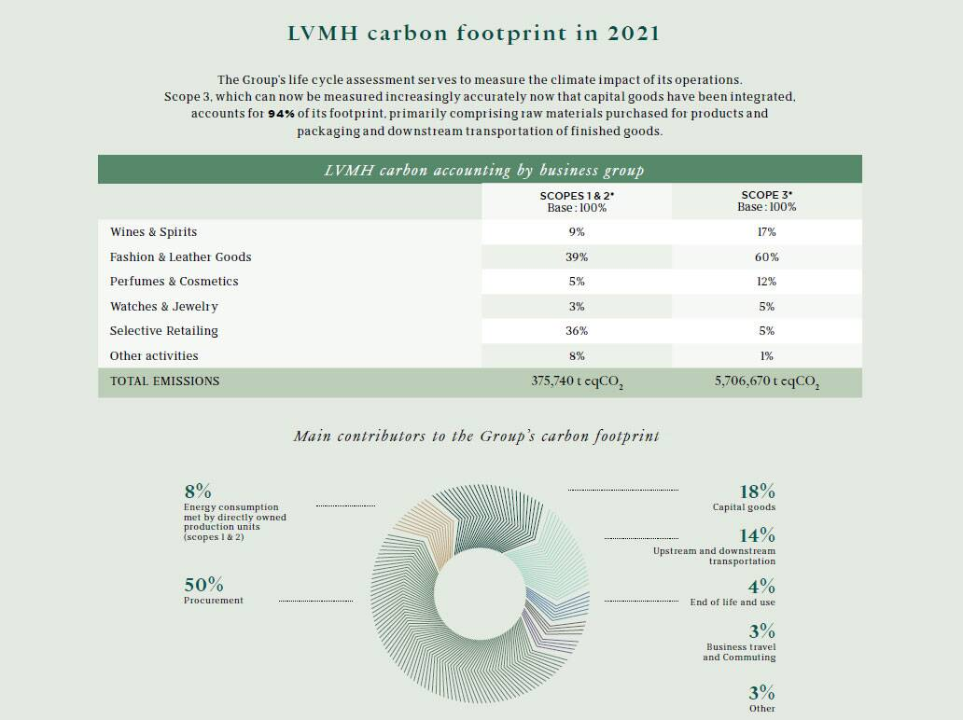
Source: LVMH 2022 Social and Environmental Sustainability Report
The sustainability practises of Louis Vuitton extend to the realm of climate action, where the Maison actively participates in environmental initiatives. They organised the LVMH Climate Week in 2020, a monumental effort involving all 150,000 employees to champion the program's main priorities. This programme is devoted to addressing biodiversity, circularity, and transparency – pillars of sustainability. Beyond rhetoric, Louis Vuitton's approach to climate action focuses on tangible results and innovation. The strategic support extended to Desserto, a finalist for the LVMH Innovation Award 2020, demonstrates their commitment to environmentally friendly materials. Desserto specialises in cactus-derived plant-based vegan leather, which aligns with Louis Vuitton's pursuit of eco-friendly alternatives for luxury products. This vigilant participation in climate action and innovation highlights Louis Vuitton's unwavering dedication to environmental sustainability.
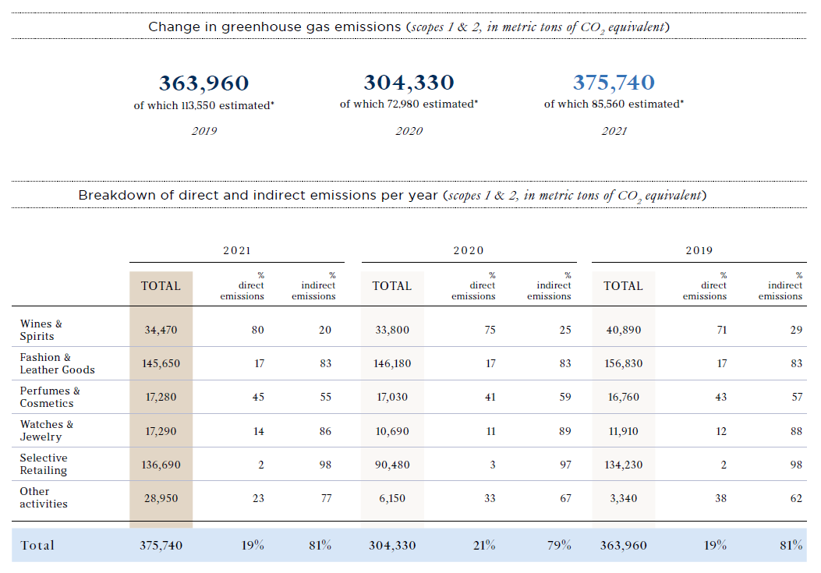
Source: LVMH 2022 Social and Environmental Sustainability Report
The conservation of biodiversity emerges as an additional crucial aspect of Louis Vuitton's sustainability practises. Their partnership with UNESCO's Man and Biosphere programme exemplifies a significant commitment to biodiversity preservation. This partnership includes initiatives addressing reforestation, sustainable employment, and alternative sources of income for local populations, particularly in the vulnerable Amazon basin. The allocation of a sizeable budget to combating deforestation in this region emphasises the significance of their efforts. In addition, Louis Vuitton's participation in the IUCN World Conservation Congress reaffirms the company's global commitment to biodiversity conservation. Their joint pavilion with the United Nations Educational, Scientific, and Cultural Organisation (UNESCO) serves as a vivid exhibition of their collaborative work in biodiversity preservation, emphasising the necessity of aligning luxury with nature and creativity.

4.1.2 Sustainability Goals
The following tables illustrates the key sustainability goals of the company (LVMH, 2023):
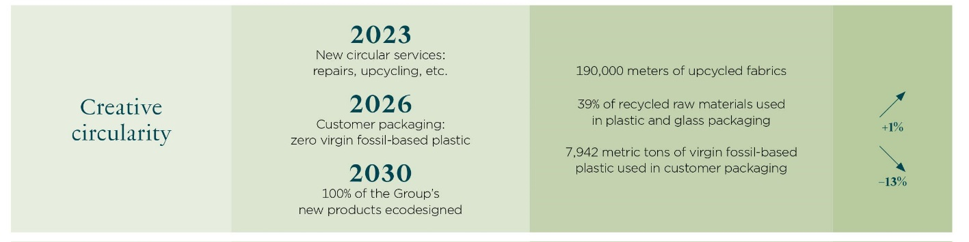
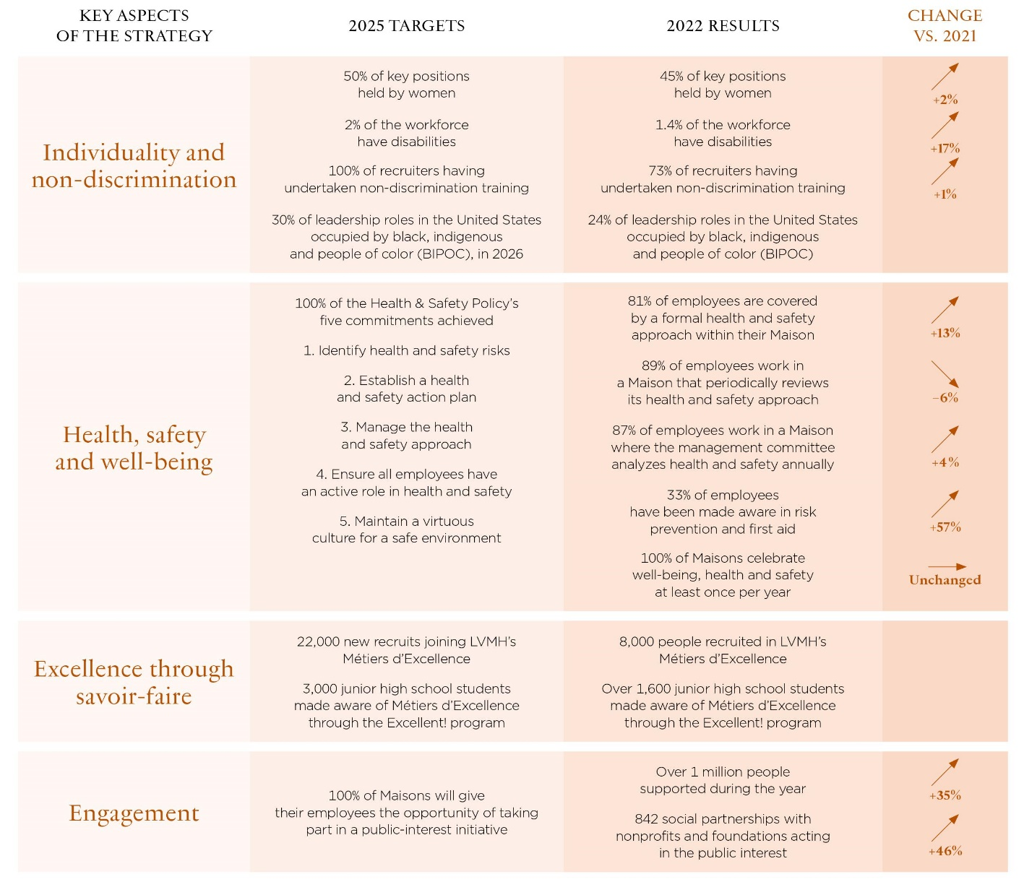
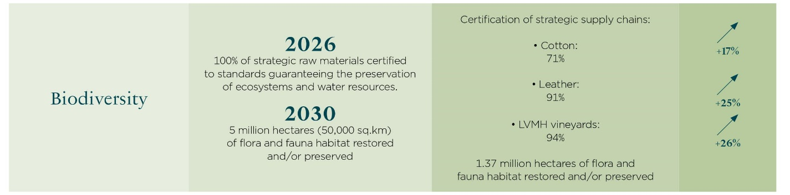

At the core of Louis Vuitton's sustainability objectives is a commendable dedication to improving healthcare. Since 2011, Louis Vuitton has participated actively in the struggle against sickle cell anaemia, one of the most prevalent genetic disorders affecting over five million people worldwide. Their mission is to provide robust support to the devoted teams at Robert Debré Hospital in Paris, a renowned sickle cell anaemia research centre. This assistance goes far beyond philanthropy. It is a strategic investment designed to stimulate innovative research, improve patient care, and ultimately contribute to the development of effective remedies for this prevalent genetic disorder. The annual "Diner des Maisons Engagées" functions as a focal point for resource mobilisation and awareness-raising, demonstrating Louis Vuitton's commitment to having a substantial and lasting impact on global healthcare.
The sustainability objectives of Louis Vuitton are also intrinsically linked to the principles of gender equality and diversity. Under the EllesVMH initiative, they have meticulously outlined a road map that prioritises gender equality in critical positions. By establishing a clear goal of attaining a 50 percent female representation in these key positions by 2025, Louis Vuitton is championing a gender diversity agenda that transcends mere symbolism. Their commitment includes assuring equitable compensation, career advancement, and recruitment practises that promote diversity. Between 2007 and 2022, the percentage of women in key positions increased from 23% to a remarkable 45%, as demonstrated by the Maison's empirical evidence. In addition, an astounding 65 percent of Louis Vuitton's executives and supervisors are women, and 18 women have risen to the position of CEO. These numbers demonstrate their dedication to achieving measurable gender diversity objectives, proving that actions speak louder than words at Louis Vuitton.
Similarly, Louis Vuitton's sustainability objectives include an unwavering pursuit of climate action and innovation. At the heart of these objectives is the need to transition to a more eco-friendly and sustainable business model. The 2020 LVMH Climate Week represented a turning point in their commitment to climate action. It was not solely an internal engagement exercise, but also a venue for presenting concrete LIFE 360 programme priorities. This programme, which focuses on biodiversity, circularity, and transparency, serves as the foundation of Louis Vuitton's sustainability strategy. Exemplified by partnerships with pioneering organisations such as Desserto, makers of vegan leather made from cactus, the emphasis also extends to nurturing innovative solutions. These partnerships demonstrate Louis Vuitton's unwavering dedication to eco-friendly materials and practises. Their sustainability objectives hinge on measurable outcomes, emphasising the significance of developing and adopting eco-friendly alternatives in the luxury fashion industry.
Moreover, Louis Vuitton's partnership with the Man and Biosphere programme of the United Nations Educational, Scientific, and Cultural Organisation (UNESCO) demonstrates that the preservation of biodiversity is a primary sustainability objective.
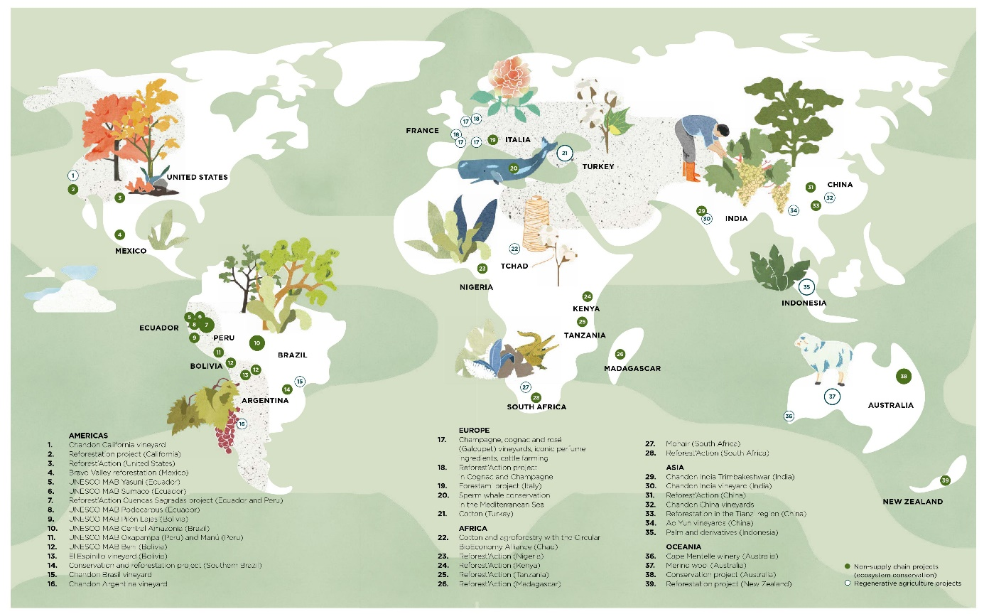
Source: LVMH 2022 Social and Environmental Sustainability Report
This partnership exemplifies their dedication to combating deforestation, promoting reforestation, and creating sustainable employment opportunities in the fragile Amazon basin, where biodiversity is threatened by significant threats. The financial commitment of Louis Vuitton demonstrates their commitment to achieving these conservation objectives. Participation in the IUCN World Conservation Congress functions as a reaffirmation of their commitment to the preservation of global biodiversity. Their joint pavilion with UNESCO at the congress is a tangible demonstration of these goals, conveying the potent message that luxury can coexist in harmony with nature and actively contribute to the conservation of global biodiversity.

4.2 Yves Saint Laurent

4.2.1 Sustainable Initiatives
An important pillar of YSL's sustainability strategy is its emphasis on employee education and awareness. The brand recognises that sustainable practises can only be implemented effectively when employees are informed, engaged, and aligned with its sustainability objectives. In response, YSL encourages its employees to complete a three-part course on sustainability. In addition, the Saint Laurent Couture Institute offers a six-month course on sustainability for advanced fashion students and YSL employees in partnership with the Institut Français de la Mode. This emphasis on education ensures that sustainability principles become inherent to the brand's identity and are woven into the organization's very fabric.
As a member of the Kering Group, YSL actively adheres to Kering's rigorous regulations and standards, which have been developed over the course of 25 years. These standards cover a vast multitude of crucial topics, including human rights, biodiversity, the sourcing of raw materials, and internal operations. Importantly, these standards are not static; they evolve through ongoing consultation with subject-matter experts in order to conform to the most recent industry best practises. YSL's unwavering adherence to these open-source guidelines demonstrates its dedication to upholding the most stringent ethical and environmental standards in the luxury fashion industry. The following table illustrates some of these standards:
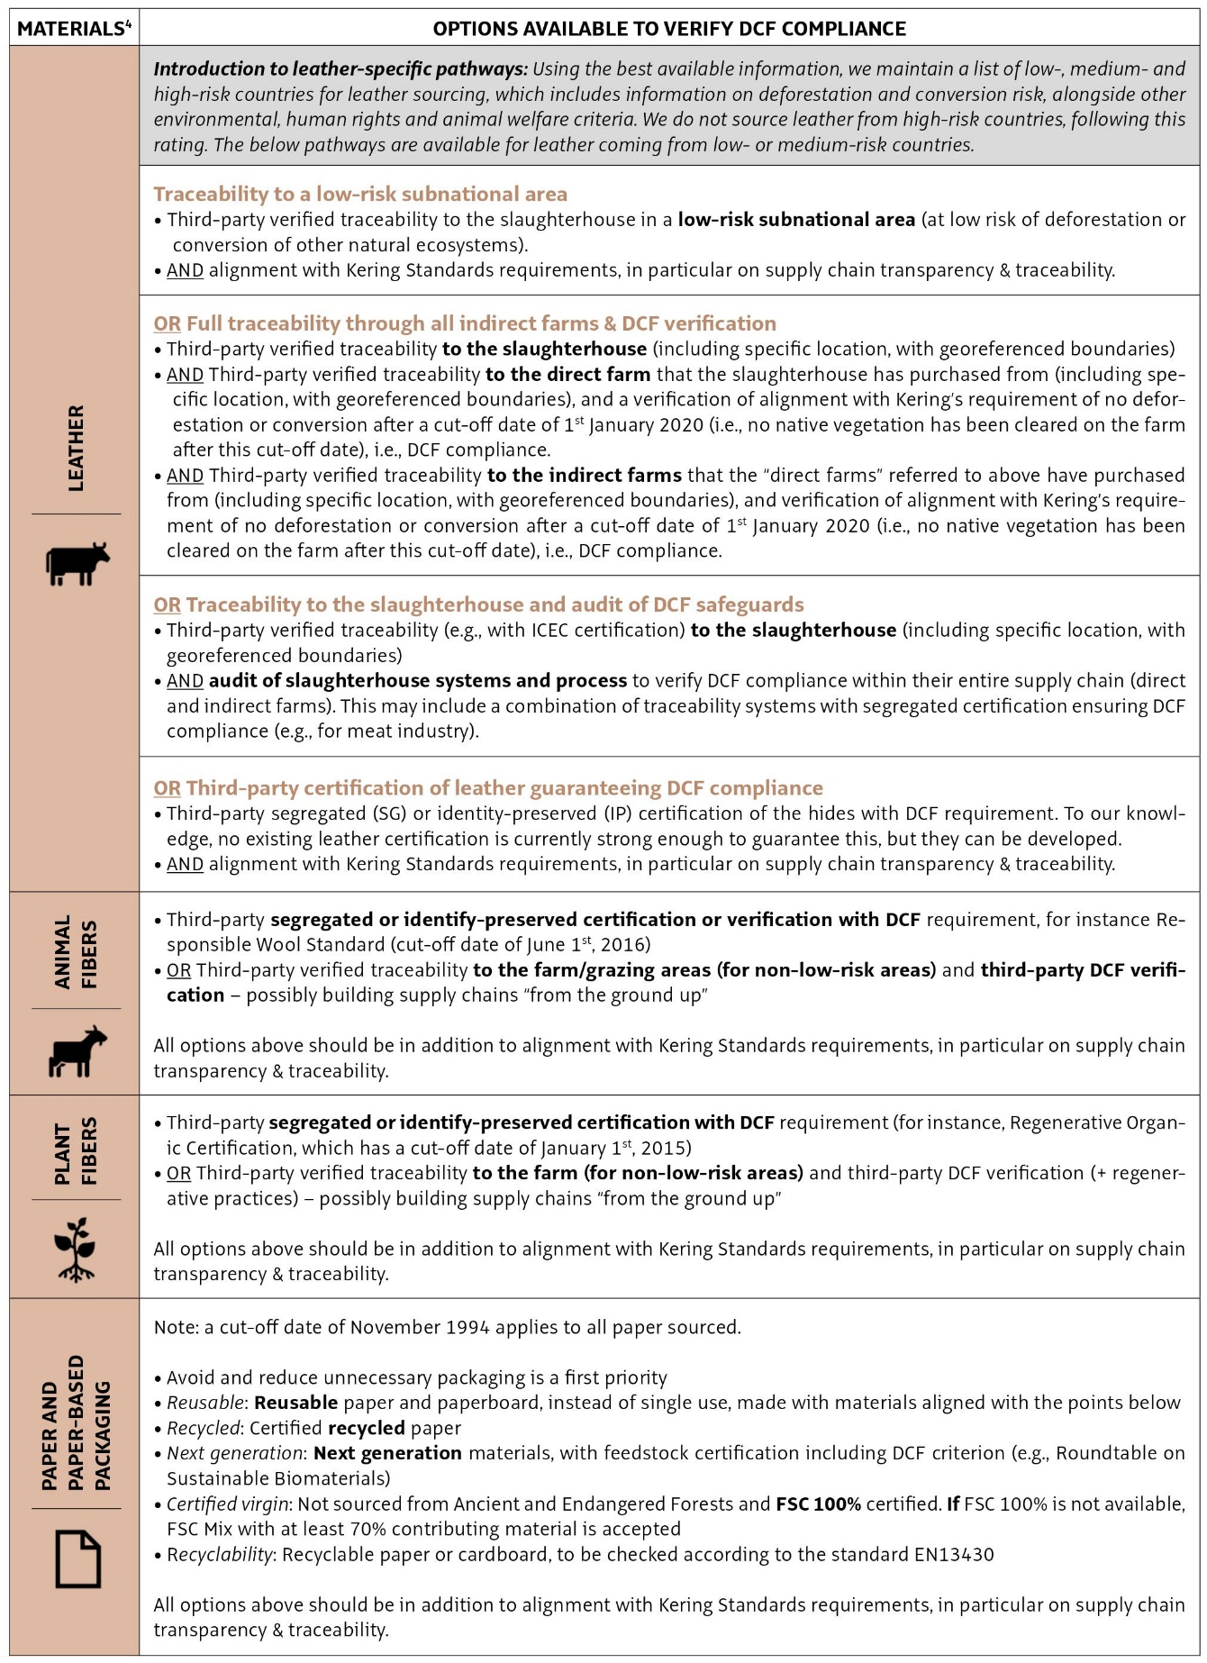
Source: Kering Group Sustainability Progress Report 2020-2023
YSL utilises Kering's Environmental Profit & Loss (EP&L) account to comprehensively evaluate and comprehend its environmental impacts. Since 2012, the brand has been able to measure various environmental factors, including carbon emissions, water consumption, air and water pollution, land use, and refuse production, across its entire supply chain using this instrument. These impacts are then quantified in monetary terms, providing YSL with valuable insights that inform its strategic decisions, process enhancements, and technology selections.
Approximately 70% of YSL's environmental impact is concentrated in the domain of raw material production and processing, according to its EP&L analysis. This understanding has influenced the brand's development of sustainability initiatives designed to resolve this essential aspect of its supply chain. These initiatives are comprehensive, spanning the entire value chain, with a particular emphasis on maximising resource efficiency, instituting circularity strategies, and adopting sustainable sourcing practises, especially in regards to fibres and leather.
YSL has not only established ambitious sustainability objectives, but also demonstrated the ability to surpass them. By achieving a 50% reduction in EP&L intensity (relative to revenue) in 2022, exceeding its objective of a 40% reduction by 2025 (using 2015 as a baseline), the brand has demonstrated its unwavering dedication to driving significant progress. In addition, YSL is actively working to reduce greenhouse gas (GHG) emissions across all scopes, with a goal of reaching net-zero emissions by 2050. Notably, the company annually offsets any remaining greenhouse gas emissions by investing in forest conservation and restoration projects, reiterating its commitment to combating climate change while simultaneously supporting biodiversity and local communities.
Sustainability is not limited to YSL's operations; it is ingrained in the brand's daily operations. In 2022, the brand's ateliers, offices, and stores will obtain all of their electricity from renewable sources, marking a significant achievement. Notable is YSL's emphasis on alternative energy solutions, such as the biomass heating system installed in the ready-to-wear atelier in Angers. These measures demonstrate the company's dedication to operating sustainably in every aspect of its business.
Additionally, YSL has made significant progress in obtaining environmental certifications for its facilities. Twenty-nine of the brand's locations, including 26 stores, have earned LEED Platinum status, the highest recognition for sustainable building design. Additionally, the brand's headquarters on Rue de Bellechasse possesses "excellent" and "exceptional" certifications from BREEAM and HQE, respectively. To bolster these certifications, YSL adheres stringently to environmental guidelines for new sites, resulting in nearly 100 percent energy-efficient LED illumination across its global store network.
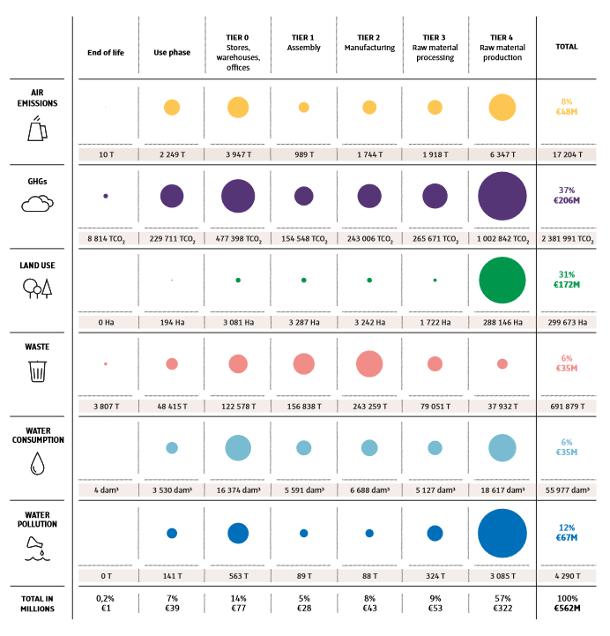
Source: Kering Group Sustainability Progress Report 2020-2023
The brand's dedication to eco-friendly packaging demonstrates a comprehensive approach. In the vast majority of its packaging, YSL employs eco-friendly, certified materials. For example, certified by the Forest Stewardship Council (FSC), paper used in purchasing bags contains at least 40% recycled content. Moreover, YSL's plans to transition all black boxes to 100 percent recycled content by 2023 demonstrate its commitment to sustainable packaging practises over the long term.
Notable is YSL's commitment to reducing single-use plastics. The brand actively eliminates single-use plastics across its operations, providing employees and event participants with reusable cups and water vessels. Beginning with the Spring 22 collections, YSL has embraced reusable garment transport covers. In addition, the company is on track to replace plastic product protective elements with sustainable alternatives by 2023, such as sustainable paper and cellulose-based fibres.

4.2.2 Sustainability Goals
The sustainability objectives of YSL are distinguished by their specificity, ambition, and alignment with broader industry and global objectives. Notably, the brand seeks to reduce Environmental Profit & Loss (EP&L) intensity relative to revenue by 40% by 2025, using 2015 as a baseline. This accomplishment in 2022 demonstrates YSL's ability to exceed its sustainability objectives. Such measurable outcomes demonstrate the brand's commitment to measurable environmental improvements.
YSL is committed to attaining net-zero greenhouse gas (GHG) emissions by 2050, taking Scopes 1, 2, and 3 of the GHG Protocol into account. This goal aligns with global efforts to mitigate climate change and demonstrates YSL's awareness of the significance of its carbon footprint throughout the value chain. In addition, YSL's annual offsetting of remaining greenhouse gas emissions through investments in forest conservation and restoration initiatives exemplifies a multifaceted approach to carbon neutrality, emphasising environmental responsibility beyond reduction alone.
In addition, YSL is unwavering in its pursuit of sustainable raw materials, with a 2025 goal of achieving 100 percent traceability of critical raw materials and 100 percent compliance with Kering's standards for raw materials and manufacturing processes. This objective demonstrates YSL's dedication to ensuring that the procurement of its materials adheres to strict ethical and environmental guidelines, thereby addressing the core of the fashion industry's sustainability concerns.
YSL has made significant strides in the sphere of sustainable textiles by adopting the Textile Genesis traceability platform. This platform employs digital tokens (FiberCoinsTM) to provide transparent monitoring of textile products from their origin to retail, allowing consumers to make sustainable purchasing decisions. By 2022, YSL had accomplished a remarkable 85 percent GOTS-certified cotton procurement. In addition, 50% of the silk and 57% of the wool sourced by YSL were certified sustainable by GOTS or RWS. In addition, 68% of the viscose utilised was derived from sustainably managed forests, as certified by the Forest Stewardship Council (FSC). YSL's proactive procurement of sustainable textile fibres exemplifies its commitment to eco-friendly materials.
In the category of leather and skins, YSL uses a specialised system to track hides from their country of origin, assuring transparency and accountability throughout the supply chain. Importantly, the brand prioritises hides tanned without metals, thereby reducing water and energy consumption and preventing tannery-level water contamination. Moreover, since the Autumn 22 collections, YSL has ceased using animal fur in accordance with evolving consumer preferences for ethical and sustainable fashion practises.
YSL is also committed to fostering regenerative agricultural practises and sustainable livestock production techniques. Through the procurement of regenerative wool, cashmere, and leather, the brand actively supports farmers practising regenerative agriculture. This initiative includes financial support for biodiversity monitoring and the transformation of agricultural territories in South Africa and Argentina into spaces for regenerative agriculture. By investing in these initiatives, YSL not only promotes sustainable material procurement, but also enhances ecosystems and rural livelihoods.
Aspect | Yves Saint Laurent (YSL)
Environmental Impact Reduction | - Reduce Environmental Profit & Loss (EP&L) intensity by 40% by 2025 (achieved in 2022, using 2015 as a baseline). - Commit to achieving net-zero greenhouse gas (GHG) emissions by 2050 (Scopes 1, 2, and 3 of GHG Protocol). - Offset remaining GHG emissions through investments in forest conservation and restoration initiatives.
Raw Material Procurement | - Aim to achieve 100% traceability of critical raw materials by 2025. - Commit to 100% compliance with Kering's standards for raw materials and manufacturing processes. - Procurement of sustainable textile fibers: 85% GOTS-certified cotton by 2022; 50% of silk and 57% of wool certified sustainable by GOTS or RWS; 68% of viscose sourced from sustainably managed forests (FSC-certified). - Use of Textile Genesis traceability platform and FiberCoinsTM for transparency.
Leather and Skins | - Specialized tracking system for leather and skins from country of origin. - Prioritization of hides tanned without metals to reduce water and energy consumption and prevent water contamination. - Discontinued use of animal fur in collections to align with ethical and sustainable fashion practices (since Autumn 22 collections).
Support for Regenerative Agriculture | - Procurement of regenerative wool, cashmere, and leather. - Support for farmers practicing regenerative agriculture. - Financial support for biodiversity monitoring and the transformation of agricultural territories into spaces for regenerative agriculture in South Africa and Argentina.

4.3 Comparative Analysis

4.3.1 Nature of Sustainability Practices
The sustainability practises of Louis Vuitton are characterised by a broad and holistic approach. They have expanded their efforts beyond the realm of luxury fashion into the realm of healthcare, focusing primarily on the struggle against sickle cell anaemia. Their collaboration with the Robert Debré Hospital in Paris demonstrates their dedication to combating pervasive genetic disorders and enhancing global health. This initiative demonstrates Louis Vuitton's capacity to leverage its influence and partnerships for societal impact. Moreover, their EllesVMH initiative for gender equity and diversity in the workplace establishes specific goals, highlighting their holistic approach to diversity. Between 2007 and 2022, the percentage of women in critical positions increased from 23% to 45%, demonstrating their tangible progress. Louis Vuitton's LVMH Climate Week and support for eco-friendly innovations such as Desserto's vegan leather are indicative of their commitment to environmental sustainability. Their partnership with UNESCO's Man and Biosphere programme demonstrates their dedication to global biodiversity conservation. As a whole, Louis Vuitton's sustainability practises transcend the traditional boundaries of the fashion industry, demonstrating a multifaceted approach.
In contrast, YSL places a heavy emphasis on education and awareness within its sustainability efforts. They acknowledge that a well-informed and engaged workforce is essential for the effective implementation of sustainable practises. The company actively encourages its employees to enrol in sustainability courses, ensuring that the principles of sustainability are profoundly ingrained in its organisational culture. YSL's alignment with the Kering Group's stringent sustainability standards demonstrates a commitment to adhering to established industry standards. Their data-driven approach to sustainability is demonstrated by their use of the Environmental Profit & Loss (EP&L) account to measure and quantify environmental impacts across the supply chain. YSL's targeted sustainability programmes are informed by its analysis demonstrating that approximately 70% of its environmental impact is associated with raw material production. Notably, their sustainability objectives are specific and ambitious, with a focus on reducing EP&L intensity, attaining net-zero greenhouse gas emissions by 2050, and ensuring raw material traceability and compliance. YSL's commitment to renewable energy, sustainable building design, and sustainable packaging practises bolsters their holistic approach to sustainability in the fashion industry.

4.3.2 Sustainability Goals
The sustainability objectives of Louis Vuitton represent a broad and holistic approach that transcends traditional boundaries. Their dedication to global healthcare, specifically the struggle against sickle cell anaemia, exemplifies the brand's desire to have a global impact. Through their partnership with Robert Debré Hospital, Louis Vuitton actively directs its resources and influence towards the treatment of genetic disorders, demonstrating a profound commitment to societal welfare. The annual "Dîner des Maisons Engagées" functions as a key event that mobilises resources and raises awareness, highlighting their unwavering commitment to global healthcare.
Moreover, Louis Vuitton's dedication to gender equality and diversity, as exemplified by the EllesVMH initiative, transcends mere lip service. This initiative focuses on obtaining a 50 percent representation of women in leadership positions by 2025. Between 2007 and 2022, the percentage of women in critical positions increased from 23% to an impressive 45%, demonstrating their tangible progress. It demonstrates their multifaceted approach to diversity in the fashion industry.
In the realm of climate action, the sustainability objectives of Louis Vuitton emphasise measurable outcomes. The LVMH Climate Week and their support for environmentally responsible innovations such as Desserto's vegan leather demonstrate their dedication to environmental sustainability. These initiatives represent a brand that actively pursues innovative solutions and quantifiable results in its voyage towards sustainability.
In addition, Louis Vuitton's commitment to biodiversity preservation is demonstrated by its partnership with the Man and Biosphere programme of UNESCO. The brand devotes significant resources to combating deforestation, promoting reforestation, and establishing sustainable employment opportunities, especially in vulnerable regions such as the Amazon basin. Their participation in the IUCN World Conservation Congress demonstrates their commitment to the preservation of global biodiversity.
In contrast, Yves Saint Laurent (YSL) takes a methodical and focused approach to its sustainability objectives. The brand's commitment to reduce Environmental Profit & Loss (EP&L) intensity relative to revenue by 40% by 2025, a goal already met in 2022, demonstrates YSL's ability to exceed ambitious goals. This demonstrates their commitment to tangible environmental improvements and measurable progress.
Considering Scopes 1, 2, and 3 of the GHG Protocol, YSL's goal to achieve net-zero greenhouse gas (GHG) emissions by 2050 aligns the brand with global efforts to combat climate change. This objective highlights YSL's recognition of the significance of its entire value chain carbon footprint. Their annual offsetting of remaining greenhouse gas emissions through investments in forest conservation and restoration initiatives exemplifies a multifaceted approach to carbon neutrality, emphasising environmental responsibility in addition to reduction.
YSL's sustainability objectives extend to the procurement of basic materials. By 2025, they hope to attain 100 percent traceability of key raw materials and 100 percent compliance with Kering's standards for raw materials and production processes. This commitment ensures that the procurement of materials adheres to strict ethical and environmental guidelines, thereby addressing critical sustainability issues within the fashion industry.
When comparing the sustainability goals of Louis Vuitton and Yves Saint Laurent, it becomes evident that Louis Vuitton's goals are characterised by a broad, multifaceted approach that extends into healthcare, diversity, climate action, and biodiversity preservation. YSL, on the other hand, employs a more targeted and data-driven strategy, emphasising concrete achievements in reducing environmental impact, achieving net-zero emissions, and ensuring responsible raw material sourcing. Both brands are committed to sustainability, but their objectives reflect different strategies and areas of focus within the context of responsible luxury fashion practises.

4.3.3 Metrics and Impact Assessment
Louis Vuitton takes a multifaceted approach to sustainability, prioritising partnerships and measurable results. Their dedication to addressing sickle cell anaemia, a genetic disorder with a worldwide prevalence, is exemplary. Through a partnership with Robert Debré Hospital in Paris, a renowned centre for sickle cell anaemia research, Louis Vuitton contributes to innovative research and enhanced patient care. Although specific metrics regarding the impact on sickle cell anaemia research and patient outcomes are not provided, the annual "Dinner des Maisons Engagées" functions as an indicator of resource mobilisation and public awareness.
In the realm of gender equity and diversity, the EllesVMH initiative of Louis Vuitton concentrates on achieving 50 percent female representation in key positions by 2025. Between 2007 and 2022, the percentage of women in essential positions increased from 23% to an impressive 45%, as demonstrated by the data. Moreover, an astounding 65 percent of administrators and managers are women, and 18 women hold the position of CEO. These metrics demonstrate Louis Vuitton's dedication to promoting a diverse and inclusive workplace, translating diversity goals into measurable outcomes.
The climate action initiatives of Louis Vuitton emphasise practical outcomes. The LVMH Climate Week, in which all 150,000 employees participate, demonstrates the company's dedication to environmental sustainability. Although specific environmental metrics are not disclosed, the LIFE 360 program's emphasis on circularity and transparency suggests a focus on measurable outcomes and impact assessment. In addition, their support for innovative solutions, such as Desserto's vegan leather, correlates with their commitment to eco-friendly materials, despite the absence of quantifiable data on environmental impact reduction.
In biodiversity preservation, Louis Vuitton partners with UNESCO's Man and Biosphere programme, allocating substantial resources to combat deforestation, promote reforestation, and create sustainable employment. Although specific metrics regarding the reduction of deforestation or the positive impact on local populations are not provided, their participation in the IUCN World Conservation Congress and joint pavilion with UNESCO represent a commitment to raising awareness and showcasing collaborative work in the field of biodiversity conservation.
Yves Saint Laurent (YSL), on the other hand, employs a rigorous and data-driven approach to sustainability metrics and impact assessment. The brand's use of the Environmental Profit & Loss (EP&L) account is a defining characteristic. This instrument measures and quantifies numerous environmental factors throughout its supply chain, such as carbon emissions, water consumption, pollution, land use, and waste production. By quantifying these effects in monetary terms, YSL obtains valuable insights that inform strategic decisions and process improvements.
Approximately 70 percent of YSL's environmental impact is attributable to the production and refining of raw materials, as revealed by its EP&L analysis. This data-driven evaluation informs the development of sustainability programmes aimed at this crucial aspect of the company's supply chain. The achievement of a 50% reduction in EP&L intensity relative to revenue in 2022, exceeding their objective of a 40% reduction by 2025 (using 2015 as a baseline), demonstrates the brand's tangible progress and its ability to surpass ambitious goals.
In order to achieve net-zero greenhouse gas (GHG) emissions by 2050, YSL employs a multifaceted strategy that includes investing in forest conservation and restoration initiatives to offset any remaining GHG emissions. This demonstrates their dedication to reducing climate change while sustaining biodiversity and local communities.
YSL's dedication to raw material traceability and compliance with Kering's standards includes data-driven evaluations of their procurement practises. While specific metrics are not provided, the objective of achieving 100 percent traceability and compliance by 2025 demonstrates the company's commitment to ethical and environmentally responsible sourcing.
The following table summarises the comparison:
Aspect | Louis Vuitton | Yves Saint Laurent (YSL)
Nature of Sustainability Practices | Broad, holistic approach; Expands beyond luxury fashion; Focus on healthcare (sickle cell anaemia), gender equity (EllesVMH), climate action, and biodiversity preservation; Collaborative partnerships. | Emphasis on education and awareness; Alignment with Kering Group's sustainability standards; Data-driven approach; Focus on raw material impact (70% of environmental impact), carbon neutrality, and responsible sourcing.
Sustainability Goals | Global healthcare impact (sickle cell anaemia); Gender equality and diversity (50% women in key positions by 2025); Climate action (LVMH Climate Week, eco-friendly innovations); Biodiversity conservation (UNESCO partnership). | Tangible environmental improvements (40% reduction in EP&L intensity achieved by 2022); Net-zero greenhouse gas emissions by 2050; Raw material traceability and compliance with Kering's standards (100% by 2025).
Metrics and Impact Assessment | Partnership with Robert Debré Hospital; Specific metrics not provided; EllesVMH initiative results (23% to 45% women in key positions); LVMH Climate Week; Support for eco-friendly innovations; UNESCO partnership. | Use of Environmental Profit & Loss (EP&L) account; 70% of impact from raw materials; 50% reduction in EP&L intensity achieved by 2022; Net-zero GHG emissions strategy; Investment in forest conservation; Raw material traceability and compliance (100% by 2025).

Chapter 5: Discussion of Findings

5.1 Factors Influencing Consumer Perceptions and Behaviours
The healthcare initiatives that both Louis Vuitton and Yves Saint Laurent proactively implement have a significant impact on consumer attitudes and behaviour. Their active involvement in healthcare, specifically in the treatment of inherited disorders such as sickle cell anaemia, strongly appeals to consumers who prioritise social responsibility. Through strategic collaborations with esteemed medical establishments and the coordination of fundraising banquets, these brands establish themselves as allies in the struggle for global health, surpassing the limitations of conventional luxury fashion. These types of initiatives inspire consumers to feel compassion and responsibility, which in turn strengthens the brands' reputation and cultivates brand allegiance.
The advocacy for diversity and gender equality exhibited by these high-end brands has the capacity to profoundly influence the attitudes and actions of consumers. By virtue of its impeccable track record in advancing the presence of women in leadership roles, Yves Saint Laurent demonstrates an unwavering commitment to advancing gender diversity. In light of the fashion industry's concerns regarding gender disparity, certain brands, including YSL, demonstrate an innovative stance by targeting consumers who prioritise inclusiveness and equitable opportunities. There is a growing trend among consumers to align themselves with brands that actively promote diversity, which significantly impacts their buying choices.
Consistently evolving consumer behaviours and perceptions are influenced by the manner in which brands tackle climate change and demonstrate innovation in sustainability. Climate Week by Louis Vuitton and extensive environmental measurements by YSL serve as symbols of brands that endeavour to implement practises that are transparent, quantifiable, and environmentally conscientious. As demonstrated through its sponsorship of Desserto, the incorporation of eco-friendly materials by Louis Vuitton appeals to environmentally conscious consumers in search of fashion items that reflect their personal values. These initiatives resonate with the environmentally conscious portion of high-end consumers, thereby enhancing the favourable perception of these brands and encouraging them to make purchases.
The support for regenerative agriculture and the conservation of biodiversity, which has been endorsed by both Louis Vuitton and Yves Saint Laurent, contributes an additional facet that impacts consumer attitudes and actions. The company's collaborations with UNESCO and other organisations, its commitment to addressing deforestation, and its endorsement of sustainable material procurement all appeal to consumers who place a high value on ecological sustainability. These endeavours represent an all-encompassing strategy towards ecological accountability, catering to consumers in search of high-end brands that authentically contribute to the safeguarding of our planet.
As a result of their collective commitment to sustainable initiatives and goals, these luxury fashion houses transcend the boundaries of mundane commerce. These initiatives not only foster a sense of accountability but also enhance their attractiveness to an expanding demographic of environmentally and socially conscious consumers. In light of the growing demand from consumers for products that reflect their personal values and convictions, luxury brands such as Louis Vuitton and Yves Saint Laurent, renowned for their all-encompassing sustainability approaches, are strategically positioned to meet the demands of these evolving consumers. The luxury fashion sector is currently undergoing a paradigm shift in which sustainability is no longer a discretionary consideration but rather a critical determinant impacting consumer attitudes and actions

5.2 Impact on Branding and Positioning
As the analysis results for LV and YSL demonstrate, sustainability initiatives make a substantial contribution to brand differentiation. Within an industry characterised by intense rivalry and an abundance of high-end brands, sustainability functions as a potent instrument for distinguishing oneself. LV and YSL have both effectively utilised sustainability as a differentiating factor in their respective industries. Consumers are becoming more appreciative of brands that implement sustainable practises and communicate their values via their products, according to the analysis. By prioritising ethical sourcing and production and integrating eco-friendly materials, these brands distinguish themselves from competitors that may not place the same emphasis on sustainability. The findings emphasise that distinguishing oneself through sustainability practises not only strengthens brand awareness but also establishes a unique position in the perception of customers.
An additional noteworthy determinant that impacts branding and positioning within the realm of sustainability is societal alignment. The findings of the data analysis suggest that the sustainability efforts of LV and YSL are consistent with prevailing societal values and issues. These brands effectively connect with consumers who prioritise common values by actively endorsing social and environmental initiatives. Consumers are inclined to select brands that demonstrate a commitment to altruistic endeavours and share their societal concerns, according to the findings of the analysis. The association of LV and YSL with societal concerns establishes these labels as conscientious and socially responsible entities, thereby impacting how consumers perceive their positioning and image. Their strong position as responsible and pertinent entities in the luxury fashion industry is reinforced by this alignment, which positively impacts their overall brand reputation.

5.3 Insights into Consumer Behaviour
The significance of authenticity in influencing consumer behaviour is substantiated by the data analysis. Both LV and YSL have demonstrated an authentic dedication to sustainability, a commitment that is openly disclosed through their respective sustainability reports and initiatives. Consumer behaviour is significantly influenced by the trustworthiness and genuineness that these brands project through their initiatives to mitigate environmental harm and advocate for social issues. These findings emphasise the importance of authenticity in the decision-making process of contemporary consumers. Amidst a climate of growing doubt, consumers place a premium on brands that authentically exhibit their dedication to sustainability; thus, authenticity emerges as a critical determinant shaping consumer inclinations and decision-making processes.
An additional significant factor that arises from the data analysis of the sustainability initiatives of LV and YSL is innovation. Both brands have made investments in cutting-edge technologies and materials in order to further their sustainability goals. Desserto, a product that has been shortlisted for the LVMH Innovation Award 2020, serves as a tangible manifestation of LV's dedication to eco-friendly materials. The innovative approach of YSL is demonstrated through their utilisation of sustainable textiles and the Textile Genesis traceability platform. Consumers are becoming more attracted to brands that provide innovative, eco-friendly alternatives, according to the data analysis. This indicates that consumers have a greater preference for environmentally conscious and progressive brands. In the realm of sustainability, innovation not only amplifies the environmental initiatives of a brand but also exerts a substantial impact on consumer conduct. With the increasing environmental awareness of consumers, brands that proactively seek out sustainable and innovative solutions are able to capture their attention.
Furthermore, the results of the analysis emphasise the critical significance of economic factors in shaping consumer behaviour. The pricing of LV and YSL products may be influenced by their frequent investments in environmentally favourable materials and processes as part of their sustainability initiatives. Nevertheless, the analysis further demonstrates that consumers are driven by factors other than sustainability alone; they also prioritise value for their money. Consumers tend to be more attracted to brands that successfully reconcile sustainability with perceived value. This particular aspect is crucial for comprehending consumer behaviour, underscoring the substantial influence that economic factors exert on their deliberations. Brands that are capable of providing sustainable products while simultaneously ensuring that consumers perceive them as valuable have a stronger ability to impact purchasing decisions.
In a similar vein, the findings from the data analysis validate that consumer behaviour remains significantly impacted by the notions of scarcity and exclusivity, even when considering sustainability endeavours. Sustainability has been skillfully utilised by both LV and YSL to produce limited-edition and exclusive collections that are frequently associated with environmental or social causes. By intensifying the perception of scarcity and exclusivity, this approach successfully influences consumer behaviour. The analysis findings emphasise that consumers are not exclusively driven by considerations of sustainability; rather, they are also enticed by the opportunity to possess something distinctive and exclusive. The sustained allure of luxury fashion labels resides in their capacity to captivate clientele who are inclined towards exclusivity and sustainability. In addition to price, exclusivity and rarity of the product are also components of luxury; brands that can achieve this equilibrium effectively sway consumer preferences.
The data analysis demonstrates that social media is an additional crucial element that significantly impacts consumer behaviour. Social media platforms facilitate the active dissemination and amplification of sustainability initiatives. The effective utilisation of social media platforms by LV and YSL to promote their sustainability initiatives is readily apparent. Unquestionably, social media has a significant impact on consumer behaviour. The findings of the analysis underscore the growing impact that social influence from sustainability-aware peers, influencers, and the content they come across on these platforms has on consumer behaviour. The analysis of the data highlights the substantial influence that social media has on consumer behaviour through the dissemination of information and the promotion of participation in sustainability initiatives. Brands that possess expertise in leveraging social media influence can successfully redirect consumer inclinations towards sustainability in the contemporary digital era.

Chapter 6: Recommendations
In this section, we move from analysis to action by proposing a series of data-driven recommendations to further enhance the sustainability efforts of Louis Vuitton and Yves Saint Laurent. These recommendations are based on the findings of the extensive data analysis and provide a practicable road map for these luxury brands to enhance their environmental and social responsibility.
- Data-Driven Sustainability Targeting: The incorporation of data-driven sustainability targeting into Louis Vuitton and Yves Saint Laurent's strategies can be a game-changer. To do so effectively, these luxury brands must rely not only on conventional metrics, but also on advanced analytics and machine learning. By doing so, they can obtain a deeper understanding of their environmental impact and establish extremely precise sustainability goals. For instance, they can employ predictive modelling to simulate the impact of various initiatives, helping them identify which actions will generate the most significant reductions in carbon emissions, water usage, or waste generation. This strategy will allow both brands to maximise their resource allocation and environmental impact.
- Comprehensive Gender Diversity Metrics: To enhance their gender diversity initiatives, Louis Vuitton and Yves Saint Laurent should expand their gender diversity metrics beyond simple representation figures. Implementing diversity scorecards that assess various dimensions of diversity and inclusion could be part of a comprehensive strategy. In addition to gender, these scorecards can include metrics on ethnic diversity, age diversity, and LGBTQ+ representation in the workforce. In addition, these luxury firms should utilise sentiment analysis and employee feedback mechanisms to assess the inclusiveness and fairness of their workplace culture. Such exhaustive metrics will provide a 360-degree perspective of diversity efforts and serve as the basis for devising targeted strategies to create even more inclusive workplaces.
- Targeted Supply Chain Impact Assessment: To gain a deeper understanding of the environmental impact of their supply chains, both firms should employ advanced analytics and Geographic Information System (GIS) technology. By integrating EP&L data with geographic data, they can perform spatial analysis to identify supply chain regions or facilities with the greatest environmental impact. This analysis could, for instance, disclose regions with high concentrations of suppliers that contribute to deforestation or regions with water scarcity issues. Armed with this knowledge, Louis Vuitton and Yves Saint Laurent can take targeted action, such as collaborating with local suppliers on sustainability initiatives or investing in water-saving technologies in high-risk regions. This targeted approach to supply chain impact assessment will result in more effective and efficient sustainability initiatives.
- Consumer Engagement Metrics: Enhancing consumer engagement in sustainability initiatives necessitates a data-driven strategy that transcends simple metrics such as website views and social media likes. Both brands can implement sophisticated consumer analytics to fully comprehend consumer behaviour and preferences. This includes sentiment analysis of social media conversations about sustainability, A/B testing of various sustainability messaging strategies to determine what resonates most with consumers, and even the development of predictive models to forecast consumer demand for sustainable products. Armed with these insights, Louis Vuitton and Yves Saint Laurent can effectively adapt their marketing and product development strategies to satisfy the evolving demands of consumers who are environmentally conscious.
- Strategic Investment in Sustainable Innovation: Taking sustainable innovation to the next level requires a sophisticated, data-driven method for calculating the return on investment (ROI) for these initiatives. Both firms should develop key performance indicators (KPIs) that measure not only the environmental impact, but also the financial and operational benefits of sustainability innovations. For instance, they can calculate the cost savings associated with decreased energy consumption and the additional revenue generated by introducing eco-friendly product lines. In addition, using life cycle assessments (LCAs) can provide a comprehensive view of the environmental impact of products from conception to grave, enabling luxury brands to make informed decisions regarding materials and processes that offer the greatest sustainability benefits. By making data-driven decisions regarding which innovations to leverage and invest in, Louis Vuitton and Yves Saint Laurent can align their sustainability efforts with their environmental and financial goals.

Chapter 7: Scope for Future Research
A deeper investigation of transparency initiatives in the luxury fashion industry is a potential avenue for future investigation. This involves evaluating the effectiveness of disclosing sustainability metrics, practises, and supply chain data. Researchers may investigate whether increased transparency impacts consumer behaviour and brand perception. Valuable insights could be gained by examining whether consumers are more likely to trust and remain loyal to luxury brands that are transparent about their sustainability efforts. Understanding the extent to which transparency influences purchase decisions and whether this varies across demographic groups could also contribute to the development of customised sustainability strategies.
Expansion of cross-industry comparisons is an additional fertile area for future research. While this study concentrated on Louis Vuitton and Yves Saint Laurent, conducting comprehensive assessments of sustainability efforts across a broader array of luxury brands can yield valuable insights. This research could involve analysing various approaches to sustainability, evaluating their relative success, and identifying the most effective strategies. By comparing and contrasting how various luxury brands resolve sustainability challenges, academics can provide a more comprehensive perspective on the industry's collective efforts, allowing benchmarking and the dissemination of successful strategies.
Analysis of the behaviour of consumers of luxury fashion in regards to sustainability is an intriguing area for future research. In the context of luxury sustainability, researchers can investigate the psychology and motivations that influence consumer choices. This may involve investigating the factors that motivate consumers to prioritise sustainability in their purchasing decisions, as well as how these motivations may vary across demographics and regions. In addition, examining the obstacles and challenges consumers face when attempting to align their luxury fashion choices with sustainability values can cast light on methods for overcoming these obstacles. By comprehending the complexities of consumer behaviour, luxury brands can more effectively tailor their sustainability marketing efforts, ultimately influencing consumer preferences in favour of eco-friendly products.
Future research can also investigate the impact of sustainable innovations implemented by luxury brands in the actual world. Investigating whether product lines and innovations with a focus on sustainability actually result in reduced environmental impact and positive financial outcomes can yield crucial insights. This study could include life cycle assessments (LCAs) to evaluate the environmental effects of products from conception to disposal. By quantifying the tangible benefits of sustainable innovations, luxury brands such as Louis Vuitton and Yves Saint Laurent can make more informed decisions concerning resource allocation and product development, thereby aligning sustainability efforts with both environmental and financial objectives.
As luxury brands expand their global reach, future research can delve into the challenges and opportunities associated with scaling sustainability initiatives across diverse geographic regions. Analysis of how Louis Vuitton and Yves Saint Laurent, among other luxury brands, adapt their sustainability strategies to address region-specific environmental and social concerns can provide insightful information. Such research can investigate the cultural nuances and regulatory frameworks that influence sustainability practises, underscoring the need for localised strategies that appeal to diverse consumer bases.

Chapter 8: Conclusion
In conclusion, this study has delved into the domain of sustainability within the luxury fashion industry, with a particular emphasis on two prominent brands: Louis Vuitton and Yves Saint Laurent. This study has cast light on the multifaceted landscape of environmental and social responsibility in the luxury sector through extensive data analysis and a comprehensive review of sustainability initiatives.
The significance of data-driven strategies in bolstering sustainability efforts is one of the primary findings of this study. The proposed recommendations highlight the importance of data analytics, machine learning, and predictive modelling in improving environmental performance. By utilising advanced analytics, luxury brands can gain a deeper comprehension of their environmental footprint, allowing them to establish more precise sustainability goals and allocate resources more efficiently. This data-driven strategy not only correlates with their sustainability objectives, but also bolsters their commitment to responsible business practises in general.
In addition, the study highlights the significance of comprehensive metrics for evaluating gender diversity, supply chain impact, and consumer engagement. It encourages brands to evaluate various dimensions of diversity, spatially analyse supply chain data, and gain a thorough understanding of consumer behaviour through sentiment analysis and predictive modelling. These exhaustive metrics provide a nuanced perspective that serves as the basis for targeted and effective strategies.

Final Remarks
In closing, the luxury fashion industry, represented by Louis Vuitton and Yves Saint Laurent, stands at a critical juncture in its sustainability voyage. The recommendations presented in this research serve as a guide for these brands to improve their environmental and social responsibility efforts. While the path to sustainability is unquestionably complicated, it is also replete with opportunities for innovation, development, and positive change.
Sustainability is not a one-size-fits-all endeavour, and this must be acknowledged. Each prestige brand must adapt these recommendations to its specific circumstances and align them with its values and goals. In addition, it is a journey that necessitates ongoing commitment and adaptation in response to evolving global challenges and consumer demands.
Ultimately, the research aspires to inspire not only Louis Vuitton and Yves Saint Laurent but also the broader luxury fashion industry to embrace sustainability as an inherent part of their identity and purpose. In doing so, these brands have the potential to reduce their environmental footprint, positively influence industry practises, contribute to global sustainability objectives, and establish a standard for responsible luxury fashion. This research suggests that the future of luxury fashion is one in which elegance and ethics coexist harmoniously and where style is synonymous with sustainability

References
Amatulli, C. et al. (2017) Sustainable luxury brands: Evidence from Research and Implications for Managers. Springer.
Athwal, N. et al. (2019) 'Sustainable Luxury Marketing: A synthesis and research agenda,' International Journal of Management Reviews, 21(4), pp. 405–426. https://doi.org/10.1111/ijmr.12195.
Atkinson, S.D. and Kang, J. (2021) 'New luxury: defining and evaluating emerging luxury trends through the lenses of consumption and personal values,' Journal of Product & Brand Management, 31(3), pp. 377–393. https://doi.org/10.1108/jpbm-09-2020-3121.
Black, I. and Veloutsou, C. (2017) 'Working consumers: Co-creation of brand identity, consumer identity and brand community identity,' Journal of Business Research, 70, pp. 416–429. https://doi.org/10.1016/j.jbusres.2016.07.012.
Castleberry, A.N. and Nolen, A. (2018) 'Thematic analysis of qualitative research data: Is it as easy as it sounds?' Currents in Pharmacy Teaching and Learning, 10(6), pp. 807–815. https://doi.org/10.1016/j.cptl.2018.03.019.
Choo, H.J. et al. (2012) 'Luxury customer value,' Journal of Fashion Marketing and Management, 16(1), pp. 81–101. https://doi.org/10.1108/13612021211203041.
Church, R.M. (2002) 'The effective use of secondary data,' Learning and Motivation, 33(1), pp. 32–45. https://doi.org/10.1006/lmot.2001.1098.
Colombi, C. and D’Itria, E. (2023) 'Fashion Digital Transformation: Innovating Business Models toward Circular Economy and Sustainability,' Sustainability, 15(6), p. 4942. https://doi.org/10.3390/su15064942.
De Kerviler, G. (2021) Research: How to position a luxury brand as sustainable. https://hbr.org/2021/09/research-how-to-position-a-luxury-brand-as-sustainable.
Elo, S. and Kyngäs, H. (2008) 'The qualitative content analysis process,' Journal of Advanced Nursing, 62(1), pp. 107–115. https://doi.org/10.1111/j.1365-2648.2007.04569.x.
Faraoni, M. (2021) 'Building a sustainable brand image in luxury fashion companies,' in Springer eBooks, pp. 273–296. https://doi.org/10.1007/978-3-030-70324-0_12.
Freire, N.A. and Loussaïef, L. (2018) 'When advertising highlights the binomial identity values of luxury and CSR principles: the examples of Louis Vuitton and Hermès,' Corporate Social Responsibility and Environmental Management, 25(4), pp. 565–582. https://doi.org/10.1002/csr.1479.
Gilal, F.G. et al. (2019) 'Towards a new model for green consumer behaviour: A self‐determination theory perspective,' Sustainable Development, 28(4), pp. 711–722. https://doi.org/10.1002/sd.2021.
Ginsberg, J.M. and Bloom, P.N. (2004) 'Choosing the right green marketing strategy,' MIT Sloan Management Review, 46(1), pp. 79–84. https://dialnet.unirioja.es/servlet/articulo?codigo=2194524.
Grassi, A. (2020) 'Art to enhance consumer engagement in the luxury fashion domain,' Journal of Fashion Marketing and Management, 24(3), pp. 327–341. https://doi.org/10.1108/jfmm-09-2019-0194.
Gurzki, H., Schlatter, N. and Woisetschläger, D.M. (2019) 'Crafting extraordinary stories: decoding luxury brand communications,' Journal of Advertising, 48(4), pp. 401–414. https://doi.org/10.1080/00913367.2019.1641858.
Gwilt, A. and Rissanen, T. (2012) Shaping sustainable fashion: Changing the Way We Make and Use Clothes. Routledge.
Hameed, I. and Waris, I. (2018) 'Eco labels and eco conscious Consumer behavior: the mediating effect of green trust and environmental concern,' Journal of Management Sciences, 5(2), pp. 86–105. https://doi.org/10.20547/jms.2014.1805205.
Hammarberg, K., Kirkman, M. and De Lacey, S. (2016) 'Qualitative research methods: when to use them and how to judge them,' Human Reproduction, 31(3), pp. 498–501. https://doi.org/10.1093/humrep/dev334.
Harding, T. and Whitehead, D., 2013. Analysing data in qualitative research. Nursing & midwifery research: Methods and appraisal for evidence-based practice, 5, pp.141-160.
Hennigs, N. et al. (2013) 'Sustainability as Part of the Luxury Essence: Delivering Value through Social and Environmental Excellence,' The Journal of Corporate Citizenship, 2013(52), pp. 25–35. https://doi.org/10.9774/gleaf.4700.2013.de.00005.
Henninger, C.E., Alevizou, P.J. and Oates, C. (2016) 'What is sustainable fashion?' Journal of Fashion Marketing and Management, 20(4), pp. 400–416. https://doi.org/10.1108/jfmm-07-2015-0052.
Hollenbeck, C.R. and Kaikati, A.M. (2012) 'Consumers’ use of brands to reflect their actual and ideal selves on Facebook,' International Journal of Research in Marketing, 29(4), pp. 395–405. https://doi.org/10.1016/j.ijresmar.2012.06.002.
Hur, W., Moon, T. and Kim, H. (2020) 'When does customer CSR perception lead to customer extra-role behaviors? The roles of customer spirituality and emotional brand attachment,' Journal of Brand Management, 27(4), pp. 421–437. https://doi.org/10.1057/s41262-020-00190-x.
Joshi, R. and Garg, P. (2020) 'Role of brand experience in shaping brand love,' International Journal of Consumer Studies, 45(2), pp. 259–272. https://doi.org/10.1111/ijcs.12618.
Jung, J., Kim, S.J. and Kim, K.H. (2020) 'Sustainable marketing activities of traditional fashion market and brand loyalty,' Journal of Business Research, 120, pp. 294–301. https://doi.org/10.1016/j.jbusres.2020.04.019.
Karaosman, H., Morales-Alonso, G. and Brun, A. (2017) 'Strike a pose: Luxury for Sustainability,' in Environmental footprints and eco-design of products and processes, pp. 145–161. https://doi.org/10.1007/978-981-10-2917-2_7.
Kelleci, A. (2022) 'Key Determinants of Luxury Marketing Accordant with Sustainability-Oriented Value Perspectives,' Sustainability, 14(10), p. 5916. https://doi.org/10.3390/su14105916.
Kering Group (2023) Sustainability Progress Report 2020-2023 - KERING. https://www.youtube.com/watch?v=Y82uQpMUCCc.
Kim, H. and Hall, M.L. (2015) 'Green brand strategies in the fashion industry: leveraging connections of the consumer, brand, and environmental sustainability,' in Springer eBooks, pp. 31–45. https://doi.org/10.1007/978-3-319-12703-3_2.
Kong, H.M., Witmaier, A. and Ko, E. (2021) 'Sustainability and social media communication: How consumers respond to marketing efforts of luxury and non-luxury fashion brands,' Journal of Business Research, 131, pp. 640–651. https://doi.org/10.1016/j.jbusres.2020.08.021.
Kumar, B. and Dholakia, N. (2020) 'Firms enabling responsible consumption: a netnographic approach,' Marketing Intelligence & Planning, 40(3), pp. 289–309. https://doi.org/10.1108/mip-09-2018-0387.
Lundblad, L. and Davies, I. (2015) 'The values and motivations behind sustainable fashion consumption,' Journal of Consumer Behaviour, 15(2), pp. 149–162. https://doi.org/10.1002/cb.1559.
LVMH (2023) 2022 Social and Environmental Sustainability Report. https://www.lvmh.com/news-documents/documentation/.
MacInnis, D.J. and Folkes, V.S. (2017) 'Humanizing brands: When brands seem to be like me, part of me, and in a relationship with me,' Journal of Consumer Psychology, 27(3), pp. 355–374. https://doi.org/10.1016/j.jcps.2016.12.003.
Maranesi, C. and De Giovanni, P. (2020) 'Modern circular Economy: corporate strategy, supply chain, and industrial symbiosis,' Sustainability, 12(22), p. 9383. https://doi.org/10.3390/su12229383.
McNeill, L.S. and Moore, R. (2015) 'Sustainable fashion consumption and the fast fashion conundrum: fashionable consumers and attitudes to sustainability in clothing choice,' International Journal of Consumer Studies, 39(3), pp. 212–222. https://doi.org/10.1111/ijcs.12169.
Parris, D.L. et al. (2016) 'Exploring transparency: a new framework for responsible business management,' Management Decision, 54(1), pp. 222–247. https://doi.org/10.1108/md-07-2015-0279.
Peattie, K.J. (2010) 'Green Consumption: Behavior and norms,' Annual Review of Environment and Resources, 35(1), pp. 195–228. https://doi.org/10.1146/annurev-environ-032609-094328.
Ryan, R.M. and Deci, E.L. (2000) 'Self-determination theory and the facilitation of intrinsic motivation, social development, and well-being.,' American Psychologist, 55(1), pp. 68–78. https://doi.org/10.1037/0003-066x.55.1.68.
Safeer, A.A. and Liu, H. (2022) 'Role of corporate social responsibility authenticity in developing perceived brand loyalty: a consumer perceptions paradigm,' Journal of Product & Brand Management, 32(2), pp. 330–342. https://doi.org/10.1108/jpbm-01-2022-3807.
Salazar, H.A., Oerlemans, L.A.G. and Van Stroe-Biezen, S. (2012) 'Social influence on sustainable consumption: evidence from a behavioural experiment,' International Journal of Consumer Studies, 37(2), pp. 172–180. https://doi.org/10.1111/j.1470-6431.2012.01110.x.
Shen, B. (2014) 'Sustainable Fashion Supply Chain: Lessons from H&M,' Sustainability, 6(9), pp. 6236–6249. https://doi.org/10.3390/su6096236.
So, J.T., Parsons, A.J. and Yap, S.F. (2013) 'Corporate branding, emotional attachment and brand loyalty: the case of luxury fashion branding,' Journal of Fashion Marketing and Management, 17(4), pp. 403–423. https://doi.org/10.1108/jfmm-03-2013-0032.
Steenkamp, J.E.M. (2001) 'The role of national culture in international marketing research,' International Marketing Review, 18(1), pp. 30–44. https://doi.org/10.1108/02651330110381970.
Szmigin, I., Carrigan, M. and McEachern, M.G. (2009) 'The conscious consumer: taking a flexible approach to ethical behaviour,' International Journal of Consumer Studies, 33(2), pp. 224–231. https://doi.org/10.1111/j.1470-6431.2009.00750.x.
Todeschini, B.V. et al. (2017) 'Innovative and sustainable business models in the fashion industry: Entrepreneurial drivers, opportunities, and challenges,' Business Horizons, 60(6), pp. 759–770. https://doi.org/10.1016/j.bushor.2017.07.003.
Vázquez, B.L., Rangel, C. and Fernández, M. (2023) 'Sustainable strategies in the luxury business to increase efficiency in reducing carbon footprint,' Journal of Business Research, 157, p. 113607. https://doi.org/10.1016/j.jbusres.2022.113607.
Widyastuti, S. et al. (2019) 'Customer Trust through Green Corporate Image, Green Marketing Strategy, and Social Responsibility: A Case Study,' European Research Studies Journal, XXII(Issue 2), pp. 83–99. https://doi.org/10.35808/ersj/1427.
Zadek, S. (2007) 'The path to corporate responsibility,' in Springer eBooks, pp. 159–172. https://doi.org/10.1007/978-3-540-70818-6_13.

Appendix

Ethics Form


