Romanian Culture Portfolio

Student name: Iuliana G Vasile

Student number: 2022387

Lecture: Natalie Brailsford

Module: Foreign languages and Cultural Awareness (BMIH5009)

Table of Contents
Element One: Reflective Essay 2
Bibliography 5
Element 2: Critical Analysis of Culture and Communication in Improving Hotel Guest Service? 5
Bibliography 8
Element 3 9
Element 5: Presentation 13
Element 6: Reflective Essay on Culture, Communication, and Diversity 16

Element One: Reflective Essay

The cultural origins have been shaped through different factors which have contributed such as the geographical factor. An example of this is the Danube River, which runs through Romania for “1075 km” (Doplhin Camping team, 2024) Through this river, Romania is able to readily link with the rest of Europe, and it also facilitates the interchange of cultural ideas. The Carphatians, these are mountains that go through the heart of Romania and have acted as a barrier which is natural protecting Romanian people from invaders. These mountains are also incredibly significant in Romanian culture and tradition, and they are a symbol of both physical and spiritual security across the country. Due to its location on the Black Sea and its proximity to the Balkans, Romania has been shaped by a variety of civilisations, including that of the Greeks, the Ottomans, and the Slavic people.

As for historical influences that have been, one of the biggest ones was the communist time from “1947-1989”. (friend, 2024) Romanian culture changed a lot when Nicolae Ceaușescu controlled the arts, supported nationalism policies, and shut down other cultures. When communism fell in Romania, plenty of changes happened in business and in everyday life. This was the time when things were becoming more modern and open to people from Western Europe. Culture in Romania, especially in Transylvania, has also been changed a lot by Hungarian and Austro-Hungarian beliefs. It was a part of the Kingdom of Hungary and then the Austro-Hungarian Empire at one point. It has an effect on the way Romanians build, follow the rules, and even some of their food. People who reside in Romania have also had a significant role in shaping the country's society. The Orthodox Church is responsible for a great deal of the transformations that have occurred in history and society. Everyday life is filled with acts, rituals, and practices that are associated with one's religious beliefs. Among the Romanian population, holidays such as Christmas, Easter, and St. Andrew's Day are very important to their customs and sense of who they are. The church did more than just help with school. It also looked after cultural items.
Family customs are many because our families are very close, and we enjoy family every day of the year with little things that mean a lot. As “1.5 million” (Communication, 2024) of individuals come from large families. In traditional settings, families are usually set up so that each person has a clear and strong role to play. These occupations are influenced by both historical events and the cultural standards. In Romania, the gender roles of the society has typically resulted in fathers (or grandfathers) being responsible for their families. Although gender roles have evolved in recent decades, a significant number of elderly individuals and rural residents continue to maintain the belief that males should be responsible for the family. Men are usually seen as defenders and workers, while women have traditionally raised children, done housework, and kept family rituals alive. Respect and admiration for older generations are some of the things that make Romanian families unique. When it comes to Romanian homes, grandparents are very important. They are seen not only as wise, but also as mental supports and sometimes as people who take care of children. When discussing the role of family and community in shaping our culture, The family is the main source of mental and financial support. They trust their family to help them when things go wrong, whether it's with child care, job search help, or emotional support. Even when they are in their late 20s or early 30s, adult children often stay with their parents until they can support themselves. There is still a strong feeling of collectivism among families in Romania, no matter the fact that Romania is becoming more and more integrated into the worldwide societies of the World. In comparison with cultures that are more individualistic, where the goal of personal success is often stressed above the interests of the collective, this is a contradiction. There is a high focus placed on the family in Romanian culture, which is a reflection of the historical roots, religious beliefs, and social institutions that have been in existence in Romania. The intimate relationships that exist between members of a family may be quite powerful; nevertheless, as the times change, these bonds can also become a cause of stress. It is possible for it to provide you with a great deal of emotional and financial support; yet, it is also possible for it to establish norms that make it difficult for you to be independent or to produce conflicts across generations. It is possible that the family institution may change as Romania keeps becoming more modern.
In Romanian culture, trust is highly valued, particularly in family matters. My experience has taught me to value strong connections and to work hard to aid those who are important to me. I have prioritised finding other individuals, whether by providing them with emotional support or practical assistance. For example, I may be prepared to assist a friend who is in danger because I feel loyalty is more than simply a choice; it is also a cultural obligation. As I kept developing relationships—with my family, friends, or my workplace—my strong conventional values of family and community as well as my own aspirations for independence and uniqueness came under notice. I came to the realisation that it was essential for me to accomplish this balance. In a society that is becoming more globalised and focused on the individual, it is possible for me to establish interactions with other people that are more rewarding and healthy if I acknowledge both the power of Romanian cultural standards and the need of being adaptable.

Bibliography
Communication, 2024. Family in Romania: Realities and Perspectives. [Online]
Available at: https://www.elfac.org/family-in-romania-realities-and-perspectives/
[Accessed 02 12 2024].
Doplhin Camping team, 2024. Danube River: general information and curiosities. [Online]
Available at: https://www.dolphincamping.ro/en/danube-river-general-information-and-curiosities/
[Accessed 01 12 2024].
friend, M. f. R., 2024. The Communist Regime in Romania: History, Attractions & Tours. [Online]
Available at: https://www.romanianfriend.com/blog/communist-attractions-tours-romania
[Accessed 01 12 2024].

Element 2: Critical Analysis of Culture and Communication in Improving Hotel Guest Service?

Introduction
In the hotel business, making sure customers are happy is very important, and knowing about different cultures is a big part of that. Hotels accommodate a diverse array of guests, each with distinct cultural norms. The research examines the influence of culture and communication on hotel customer service, including guest expectations, communication modalities, staff training, and practical examples. (Roque, 2019)

According to their cultural heritage, what kinds of things might folks anticipate?
The cultural background of visitors significantly influences their preferences, attitudes, and perspectives about the quality of service received. Individuals' expectations are significantly influenced by Hofstede's theory of cultural dimensions, which asserts that some cultures prioritise freedom above community and power distance. (Wale, n.d.) For instance,

Various types of lifestyles: Visitors from the United States or Australia who are affable may prioritise personalised service, autonomy, and the ability to make independent choices.(Murniati, 2020)

Peoples from Asia and the Middle East were given the option to choose specific positions within the common culture. In addition, they are engaging in activities that involve groups of people and developing relationships with other people.

National traditions not only influence how people interact with one another, but they also influence the foods that people consume and the way that they organise their living spaces. While it is important to be culturally conscious, it is also important to ensure that visitors who are Muslim adhere to the regulations for halal food and that Chinese tourists adhere to the laws about the arrangement of their rooms for Feng Shui. If hotels are aware of these standards, they will be able to better accommodate a larger variety of visitors and ensure their satisfaction. (Khan, 2017)

How people talk to each other and interact with guests
To improve the guest experience, you need to be able to communicate clearly. Managing cultural differences in how people talk and act in conversations in the wrong way can cause problems.
Talking: When Americans and Germans talk to each other directly, they expect words to be short and easy to understand.
In Japan and India, for example, the way people talk depends on the tone, the situation, and how sensitive they are.
To make sure that people from other countries understand, hotel staff have to change how they talk, write, and give information. In traditional places like Japan, greeting people with their titles and last names shows that you are polite and value them. (rcademy, n.d.)

Some examples of nonverbal speech are
Hand signs and body language are used in very different ways by people from different countries. In some societies, a thumbs-up might mean "yes," while in others, it might mean "no."
Eye Contact: Making eye contact is a sign of trust in the West, but it could be seen as an invasion of privacy in Asia.(Zucchet, 2023)

In order to avoid errors, take the time to listen attentively, observe the body language of your peers, and respond to any inquiries with respect.
Acquisition of cultural proficiency and its enhancement through training and development
To equip hotel personnel with the necessary abilities to interact with individuals from diverse origins, they require training programs that are both culturally competent and effective.
Positive aspects of a physical plan include:
Regional awareness workshops: These teach workers basic etiquette, regional cultures, and ordinary human conduct throughout the globe.

Role-playing games: This way, staff can practice how to deal with cultural differences without risk by acting out real-life scenarios.
Having educational opportunities in languages assists individuals in overcoming barriers to speaking, so facilitating communication with international acquaintances.
Cultural competency training offers many benefits:
Improves the quality of life on Earth.
Customers share greater satisfaction and loyalty when services are designed to their specific needs.
Provides employees with increased confidence in their capacity to accommodate a diverse array of visitors.
For example, when hiring people, Marriott International stresses how important it is to understand regional differences and be flexible when dealing with guests.

Real-life examples and situations
There are a few places that show how to successfully use methods for mixing cultures:
The Ritz-Carlton is known for its "Gold Standards" service attitude, which stresses being aware of how other countries live. Workers learn a lot about accepting and understanding cultural differences. For example, Ritz-Carlton hotels in Asia adapt the kind of cuisine they offer to reflect local dining traditions.
Hilton Hotels' "Team Members and Diversity" initiative, for example, seeks to make the workplace more inclusive. Due to their education, they can understand and address regional disparities. Hilton hotels ensure that men and women are assigned separate accommodations according to cultural norms in Saudi Arabia. . (Editor, 2023)

In the middle distance are establishments owned by Shangri-La: The term Shangri-La effectively merges traditional Asian hospitality with contemporary aspirations. By learning about Confucian ideas in training, staff can serve Chinese guests with ease while still being friendly to foreigners.
These examples show how vague the benefits are of hotels putting cultural understanding at the top of their list of priorities.
Conclusion
To make customer service better in the hotel business, a lot of work needs to be done on attitude and communication. Hotels can give great service by understanding how different cultures affect what guests want, communicating in a variety of ways, and choosing staff who have been trained in cultural competence. Looking at what has worked in the past, it's clear that a plan that takes into account different cultures makes relationships with people better, makes customers happier, and strengthens loyalty to the company. We should look into new ways to combine cultures and how technology can help hotels be more culturally aware.

Bibliography

- Editor, H. D., 2023. HILTON PLANS TO MORE THAN QUADRUPLE ITS PRESENCE IN SAUDI ARABIA. 21 August .
- Khan, M., 2017. The Role of National Cultures in Shaping the Corporate Management Cultures: A Four Countries Theoretical Analysis. April.
- Murniati, M., 2020. Hotel Marketing Strategies in the Digital Age. December .p. ResearchGate .
- rcademy, n.d. RCADEMY. [Online]
Available at: https://rcademy.com/effective-communication-in-cross-cultural-and-diverse-environments/
- Roque, H., 2019. The importance of cultural training in the hospitality sector. European Journal of Tourism Hospitality and Recreation, December .
- Wale, H., n.d. Hofstede’s Cultural Dimensions Theory. Management & Leadership, p. CFI.
- Zucchet, E., 2023. Body language in different cultures around the world: A top guide. August .

Element 3

Guideline for hotel staff to show respect
Hotel staff needs to learn about the cultural diversity and they should always remember to respect another culture also.
Keep up with users and visitors: Learn about the common culture rules and tastes of the main groups of visitors.
Friendly Language: Always try to use welcoming and accepting language, and don't guess about guests' likes or dislikes or how they will act.
Effective Methods of Communicating with Others
1. Communicating verbally: (1)
Strive to overcome obstacles related to language by expressing yourself in a straightforward and plain manner.
Nonverbal ways of communication include the following types of communication:
Maintain an approachable and friendly approach when giving hospitality to others with the use of smiles and gestures that are considered appropriate behaviour.
Develop a conscious understanding of the variations that are linked with the various cultures:
In the context of interacting with Western visitors, it is essential to demonstrate respect for personal space by adhering to particular norms, such as avoiding being too close to a person.
Service to Guests Guidance that is Useful
Greetings in the language of the local people: Visitors should be greeted with essential greetings in their original language, such as "Bonjour" (in French), "Namaste" (in Hindi), or "Konnichiwa" (in Japanese).
Meal Requirements-
Everyone needs to eat sometimes. Because everybody has their own choices. So try to learns about any limits, such as halal, kosher, or vegan.
Accessibility and the sign: When providing information about hotel services, possible room configurations, and instructions, it is important to use signs that are available in several languages.
Delivery of Instruction on Cultural Sensitivity:
Develop employees who are familiar with cultural practices, such as the practice of providing tea to Asian visitors as a show of welcome.
It is necessary to provide prayer coverings and change prayer times in order to accommodate visitors who are Muslim.
Element 4:
A misunderstanding of cultural norms
An employee at the front desk of a hotel in the United States extended a warm welcome to a Japanese tourist who was staying there. While conversing with the visitor, the employee maintained direct eye contact. Despite the staff's efforts to create a welcoming atmosphere, the client maintained a cautious demeanor, avoided eye contact, and only rendered a minor bow in lieu of reciprocating the obeisance. The visitor politely declined offers to convey their preferences for room service or amenities for the remainder of their stay.
The staff was bewildered by this, as they mistook the guest's initial refusal for disinterest and failed to follow up promptly. The delay in satisfying the guest's demands left them upset, causing a complaint about inadequate service.
Nonverbal Communication: Bowing is a common practice in Japanese culture. Because they express their respect and esteem by following the bow. However, handshakes and direct eye contact may seem harsh or arrogant.
Communication Through Indirect Means: In Japan, people talk to each other in a roundabout way so as not to be offensive or pushy. Although a polite refusal doesn't always mean "no," the staff thought that it meant that they weren't interested.
Cultural Awareness Gap: The hotel personnel was unable to anticipate the requirements of guests due to their lack of knowledge regarding Japanese cultural norms and discourse.
The Impact of the Misunderstanding on the Guest Experience:
The consumer was dissatisfied with the service due to their sense of confusion and undervaluation.
Staff Morale: The staff was aggravated by the complaint, as they were under the impression that they had adhered to standard hospitality protocols.
Reputation Risk: The incident exposed a deficiency in the hotel's capacity to accommodate a wide range of cultural preferences, which could potentially affect its reputation among international guests.
Resolution of the Misunderstanding
The hotel manager continuously apologized to the passenger and assured them that their concerns would be addressed upon receiving the complaint to resolve the matter:
So, the manager gave the guests personalized attention, enquired about their preferences in writing, and respected their indirect communication style.
The staff tried to make sure that the remainder of the visitors' stay was stress-free and comfortable by responding to the guests' requests.
Finally the hotel delivered a message of apology. For example, complimentary services, in an effort to re-establish a positive romantic connection.
Comprehension of cultural norms: It is essential to have a comprehension of the meaning of cultural norms in order to provide your visitors with experiences that are both courteous and distinctive.
Employers in the hospitality industry need to be able to identify and accommodate a variety of communication styles in order to be successful in their jobs.
So get a deeper understanding of their requirements by actively engaging them and offering them with a range of communication methods. This is one approach to prevent problems like this from happening.
Diverse recruitment methods include hiring people who can speak many languages or cultural ambassadors to help people communicate with one another.
Element 5: Presentation
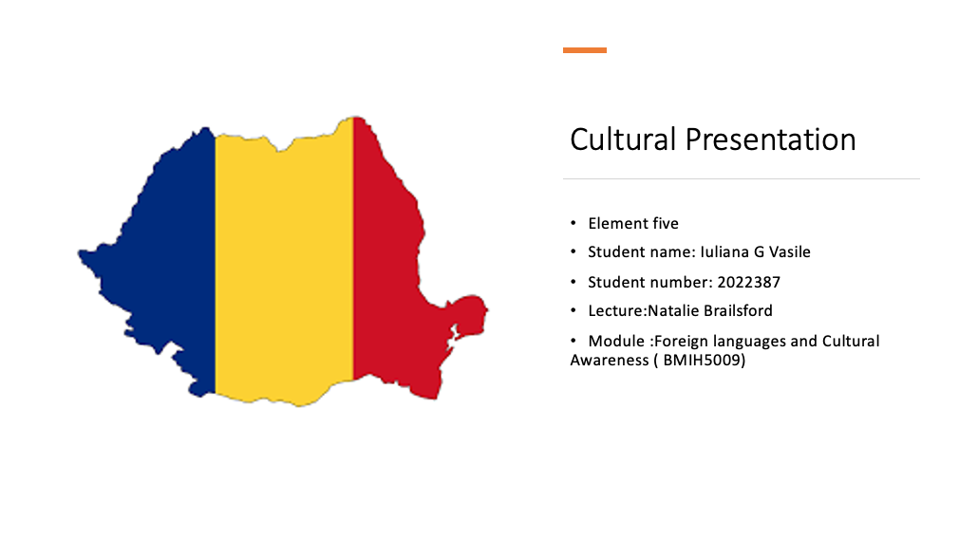
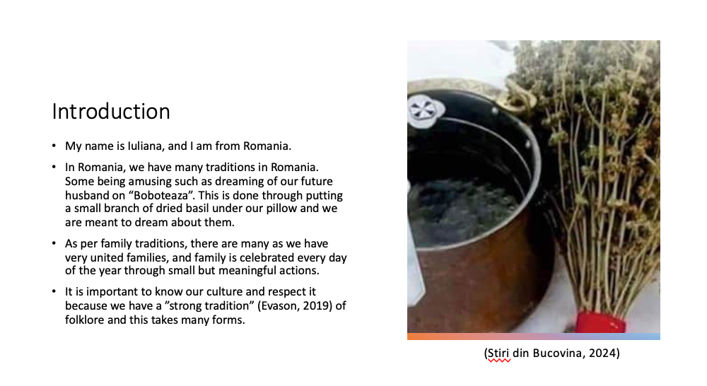

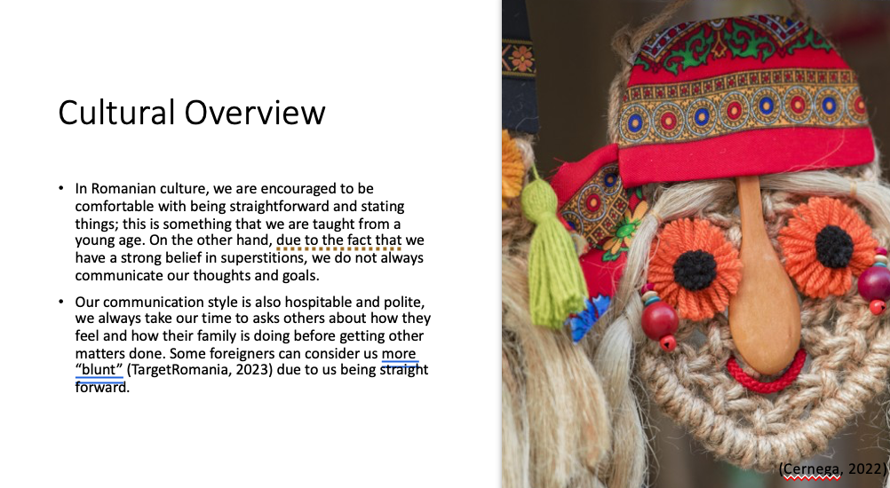
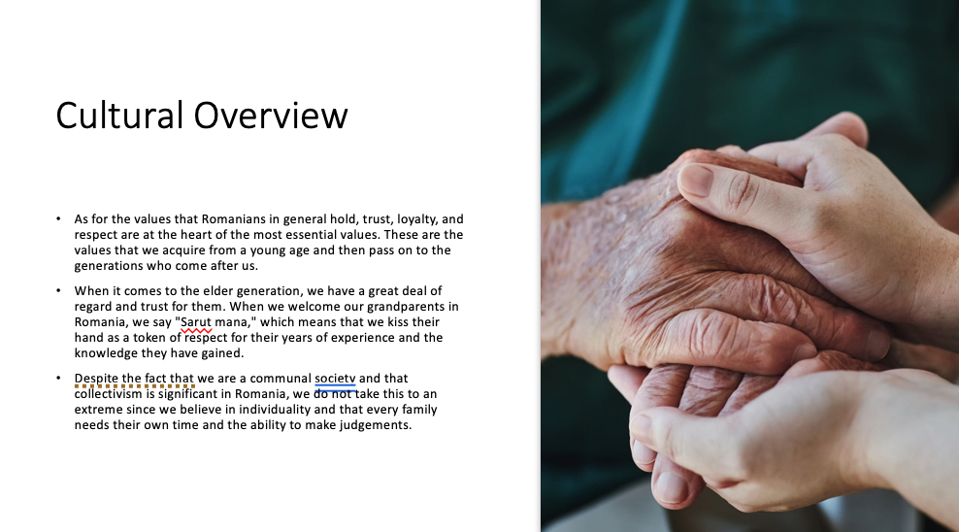

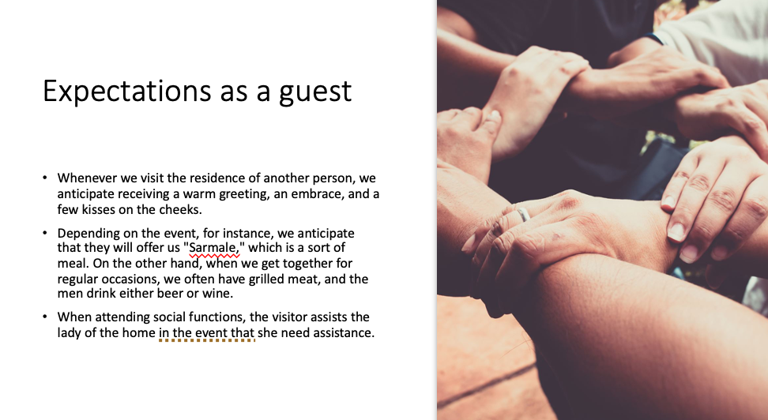
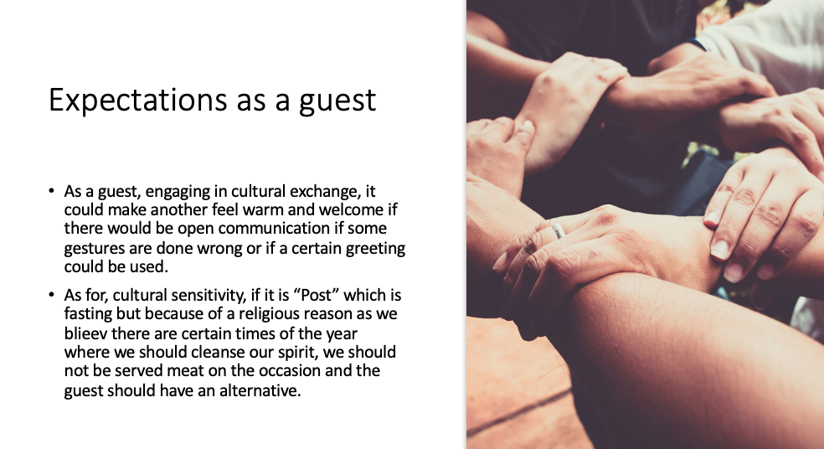

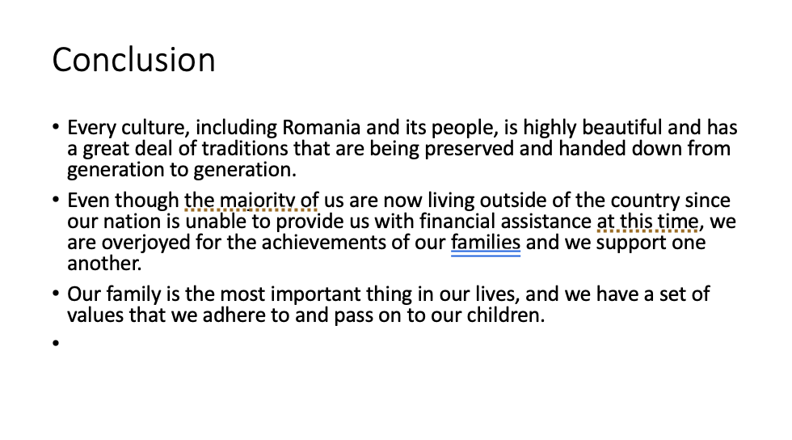
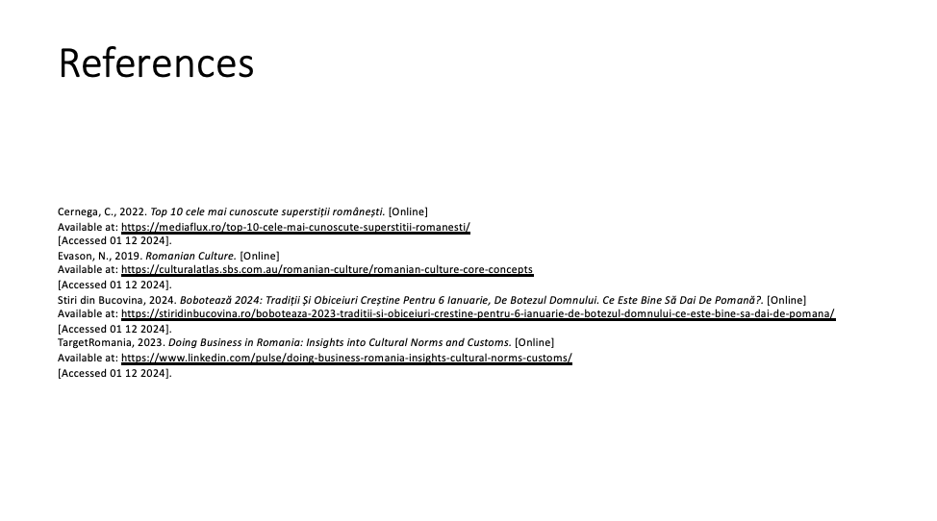
Element 6: Reflective Essay on Culture, Communication, and Diversity
Introduction
When people engage professionally and globally, culture, conversation, and diversity become inextricably linked. This portfolio project has given me a deep understanding of the importance of cultural awareness and good communication in creating inclusion, building connections, and achieving professional success. I will explore how these principles affected my viewpoint, the particular talents that I obtained, and how I expect to employ these insights in my professional activities as I reflect on my educational path. I will also address how I aim to use these capabilities.
I am going to talk about my viewpoint and how it has changed throughout the course of your life.
Before I started working with this portfolio, the majority of my understanding of culture and diversity was theoretical. This was due to the fact that I had minimal experience to international contacts in the actual world. I knew that there were cultural gaps, but I didn't realise how much they affected how people talked to each other, how the workplace worked, and what people expected from customer service. By doing this thoughtful process, I've become more aware of the complex ways that society affects people's habits, hobbies, and beliefs.
During the course of my case study on cultural misunderstandings in the hospitality industry, I saw that misunderstandings might arise from the incorrect perception of non-verbal signals. These signs include eye contact, gestures, and body language. According to the findings of studies that investigated the significance of cultural competency in the provision of services, it was necessary to modify methods in order to cater to the requirements of a large percentage of consumers.
Finally, the focus that has been put on diversity has caused my preconceived beliefs about inclusivity to be called into question on several occasions.. When I first started thinking about diversity, I thought of it as being synonymous with demographic distinctions like colour, ethnicity, or gender. On the other hand, the activities in the portfolio highlighted the fact that diversity also includes a variety of approaches to problem-solving, communication styles, and worldviews. My dedication to accepting various ideas in private and professional contexts has been strengthened as a result of this more comprehensive knowledge.
One of the most valuable skills that I have learned as a result of growing my cultural awareness is the ability to see and appreciate the distinctions that exist across cultures without casting judgment on them. I learned about high-context and low-context countries, direct vs. indirect communication, and how cultural rules shape behaviour through study and tasks that made me think about what I had done. Because I'm aware of the informal way of communicating that is common in Asian cultures, I have learned to listen more carefully and pick up on small cues, like not depending only on spoken responses.
Proficiencies in Interpersonal Communication
By enrolling in activities centered on communication strategies, I developed my verbal and non-verbal communication skills. I have just understood the need to adjust my words to suit many cultural contexts. Language barriers may be overcome by using straightforward, jargon-free language and ensuring understanding is achieved. Furthermore, I have cultivated an enhanced understanding of non-verbal cues, like body language, gestures, and vocal tone, which are crucial for fostering connection and confidence.
The Resolution of Conflicts in Contexts That Strain Multiple Cultures
Reiterating the need of empathy and adaptation in the process of conflict resolution was the case study that focused on cultural misconceptions. My past experiences gave me with the ability to approach disagreements with tolerance, to seek explanations rather than making assumptions, and to find solutions that take into account the many cultural differences that exist. This finding is particularly relevant in circumstances when there is a broad prevalence of misunderstandings.
Adaptability and a willingness to be open-minded
Getting the opportunity to attend in a variety of situations has helped me become more confident and open to new ideas. In the hotel business, for instance, doing research on real-world instances of cultural integration taught me how to use new ways, such as providing materials in many languages or training programs, in order to enhance the level of pleasure experienced by guests. This adaptability will be very necessary in order to successfully navigate surroundings that are culturally varied.
Continuing Education for Professionals in the Field of Diversity Management
In my work life, I have made diversity management a priority because of the focus placed on cultural competency as a professional ability. My personal experiences have helped me to decide that maintaining an inclusive culture is both a moral imperative and a strategic benefit for organizations aiming to innovate and succeed in global marketplaces.
Promoting Customer Service Quality in the Hospitality Sector Through Professional Insights to Achieve Objectives
Cultural competency is a vital need in the hospitality sector because to the evident correlation between client happiness and the ability to understand and meet diverse requirements. I can approach arguments with tolerance, to seek answers rather than making assumptions. Moreover, I try to develop solutions that take into consideration the many cultural differences that exist as a result of the experiences that I have had in the past. When individuals are working in professions that require them to engage with clients. Moreover, when they are working in teams that are comprised of people from different cultural backgrounds.
I would like to push for training programs that teach staff members about cultural diversity and unintended prejudice, and I want to do this by using the material that I have previously collected. In addition to this, I will make it a priority to provide a secure environment in which members of the team are made to feel appreciated and are given the authority to voice their own opinions.
Improving Communication among Multicultural Teams
Effective communication is the basis of any successful collaboration. Some of the aforementioned strategies that I want to apply include active listening, paraphrasing to verify information, and paying attention to nonverbal signs. I want to reduce the number of misunderstandings that occur, and I also want to enhance the dynamics of the team by encouraging communication that is not just accurate but also considerate. Both of these goals are important to me.
A Leadership Role in a World
My long-term professional goal is to develop into a leader who is culturally aware and able to motivate and direct teams comprised of members from a variety of backgrounds.
It is essential to fully understand cultural differences and use them as advantages to accomplish this. In corporating abroad range of perspectives in the decision-making process may result in more efficient and inventive solutions.
Concerning the Avoidance and Resolution of Conflicts
Misunderstandings of different cultures are often the underlying cause of problems in the workplace. I am able to proactively handle any problems before they become more serious by using my talents in cultural sensitivity and empathy. For instance, I would want to use communication methods that take culture norms and tastes into account to make sure that the results are fair and appropriate.
When the results are put to use, there are problems to solve and chances to take.
Even if these insights are very significant, it will be necessary to continue studying and practicing them in order to use them in situations that are based on the actual world. Among the challenges I must overcome is my biases that are which may affect my interactions with people and the viewpoints I maintain. I will focus receiving input from my colleagues and mentors to identify areas where I lack essential knowledge and to implement required modifications to address this issue.
The ability to negotiate situations in which cultural values are in conflict with one another is another challenge that may be particularly challenging. One example is that it might be hard to find a balance between the need for quick input in Western settings and the tendency for people in Eastern countries to talk to each other in a more indirect way. Adaptation and methods that work in that place will be very important in these kinds of situations.
At the same time, the growing globalisation of sectors gives a huge chance to put these abilities to practical application. The ability to recruit top personnel, grow into new areas, and develop long-lasting connections with consumers is a lot easier for businesses that place a priority on diversity and cultural competency. I will be able to make an important impact to the development of workplaces that are both inclusive and high-performing if I integrate my professional goals with these changes and coordinate them closely.
Conclusion
As part of reflecting on my progress during the learning process, I have come to the realisation that I have grown a stronger knowledge of culture, communication, and diversity, as well as their crucial relevance in both of my personal and professional growth. Because of the information and skills that I have acquired, I will be able to establish a strong foundation for my professional life. These skills and knowledge cover a broad variety of subjects, including cultural awareness, effective communication, conflict resolution, and how to include others.

