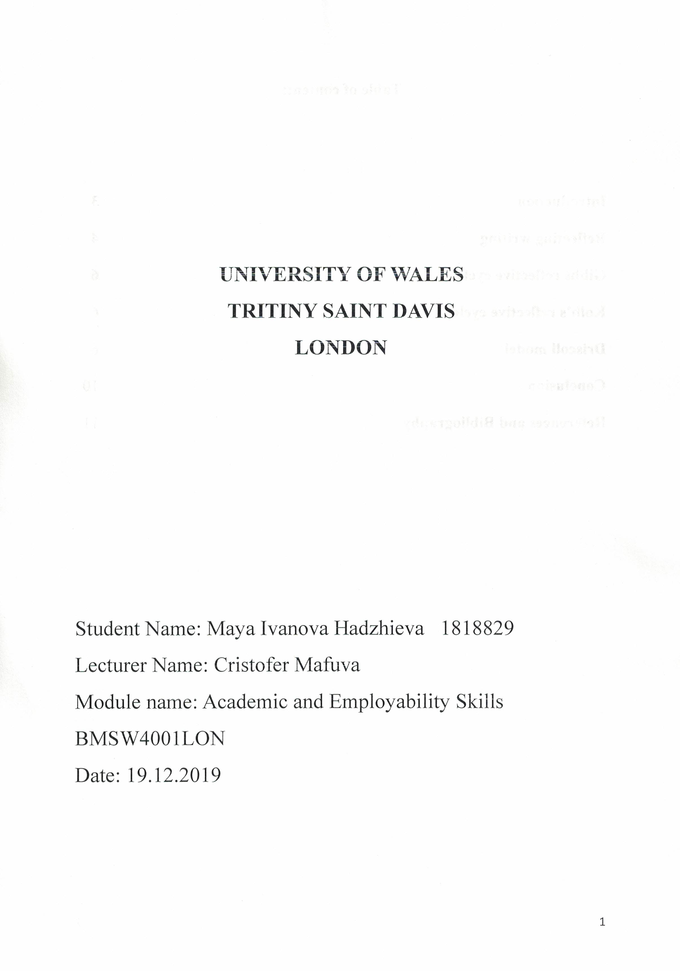

Table of content:

Introduction 3
Reflecting writing 4
Gibbs and Kolb’s reflective cycles 6
Driscoll model 6
Conclusion 10
References and Bibliography 12
Appendix 13

Introduction

Reflective writing is an analytical rehearsal and writer makes description of events, thoughts, feelings, memories, emotions, real or imagine stage of the life. It is focused on writing with the reflection on meaning and examinations with detailed emotions, to reveal the requirement of continuous learning throughout the whole life. Reflective writing is analysing of depth-orientated ideas and thinking, references are required (Jasper, 2005). It has recognised as a significant factor of the reflective practice and has taken sources from experience. Reflective writing has full capacities for development of the critical thinking combined with analytical skills of the writer and the total contribution for the creativeness with strong links between desired data and the new viewpoints on the matters (Jasper, 2005). All these lookouts are part of skilled and knowledgeable research work.
The landscape of reflective writing and its usage within the qualitative research as a technique with own source and inside the analytical procedures. Reflecting on experiences is supportive connection between practices and theories and between the writer’s present and past knowledge. Learning step by step from the module, has supported me to develop both employability and academic skills. I used the feedback from all in-class actions that helped me to fill the gaps with knowledge and new learning (Hickson, 2011).

Reflective writing is providing deep learning for the excellent experience usage, for advancement of the university scholarships, improvement of the performances with future exercises by use of the outcomes and strong and long-lasting professional progress after university graduation (Jasper, 2005).
Reflective report is a section of writing that summarises the topic critical reflection of the scholar. It counts on strongly on first-person statements, while traditional academic writing discourages them (Robinson, 2000). Reflective reports are regularly used as fragment of the assessment of practical plans.
Reflective writing delivers a prospect for future advantages of the whole activity through profounder of the work. It offers multiple perspectives for professional development, design of teaching systems and multi-dimensionality for progress of the interpretative and critical thinking skills (Begg, 2011). It reflects to promote capability with the new dimension of the effectiveness of the new reflective heights that make contribution to students for deeper understanding. There are future perspectives to raise the quality of the scholars reflective writing (Evers, 1998).
Reflecting the universal concern about students’ writing performance and defining teacher education and accreditation systems. Reflecting has a huge impact on the writing thoughts about value and quality (Begg, 2011). These skills are important for the employees and for the employer. This makes me employable with interpersonal and communication skills, problem-solving, self-motivation, to work under pressure and to finish work before the deadline, team-working, numeracy, negotiating skills, learning and adaption abilities. For the employer the most important and valuable personal attributes are: loyalty, motivation, honesty, reliability, self-esteem, and ability to work under pressure (Robinson, 2000).
The straightforward knowledge is essential for receiving, developing and performance work as a professional. These learning assistances can be considered as the transfer aptitudes essential by an individual to be employee. Combined with great particular empathetic and topic data, managers often diagram a lot of capabilities that they require from the workers. The abilities are what they admit to formulate the representative to finish their job properly (Warren, 2007).
Effective communication and interpersonal skills are required by employers and the employees must speak and write clearly, accurately and to be active listening. Teamwork – most of workplaces are real teamwork (Robinson, 2000). People must be self-confident and enjoy occupied with other with association, management prospects, trustworthiness and professional. Critical thinking refers to one’s ability to recognise, study, and interpret information and to have analytical skills, creativity, and problems-solving (Robinson, 2000). Ethics means to trail the business-organisation instructions, to be truthful, honest and to act professional, responsible, integrity, empathy, compliance.
I use academic works for my reliable and credible reports. I use libraries’ sources for my research skills. For health and social care, the most important are problem-solving skills. They include situations and analyses with the suitable solutions. The major skills are: identification of the existing problem and the definition, capabilities to apply theory to practice, analyses and evaluation from various sources (Jasper, 2005).
One of the most famous models is Gibbs Reflective Cycle (1988) and offers that reflection takes place after experiences. It delivers structure that usually viewpoints the procedure of reflecting. This reflective cycle is unusual like the others because is highlights reflecting on the feelings of all involved in the experiences and accomplishes with a special action plan (Davies, 2012).
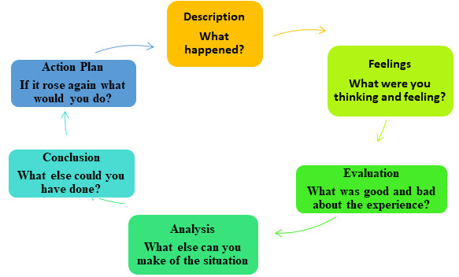
Figure 1: Gibbs Reflective Cycle
(Source: toolshero, 2019)
Kolb’s Reflective Cycle is meaningful an individual's learning style empowers knowledge to be situated according to the preferred method (Vince, 1998). The individual responses to and requirements the stimulus of all types of learning styles. There are different viewpoints and ideas in generation time, brainstorming and private feedbacks. The most important is the cycle within the development and mainstream management education to acknowledge additional learning (Vince, 1998).

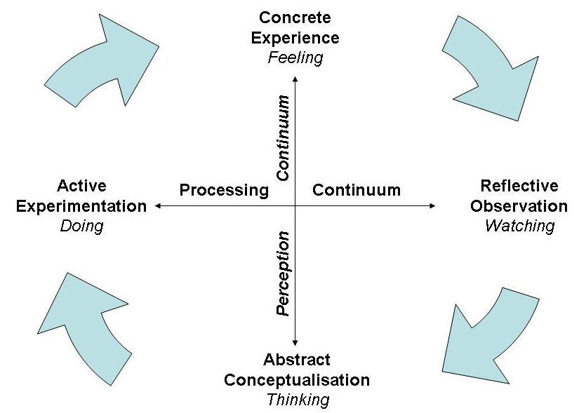
Figure 2: Kolb's Reflective Cycle
(Source: nwlink, 2019)

Driscoll model (2007) has three questions to the scenes and the cycle is accomplished. The reflective exercise is a method to learning through experience. This method is a reflection to maintain professional development and to enhance the learning outcomes (Driscoll, 2014).
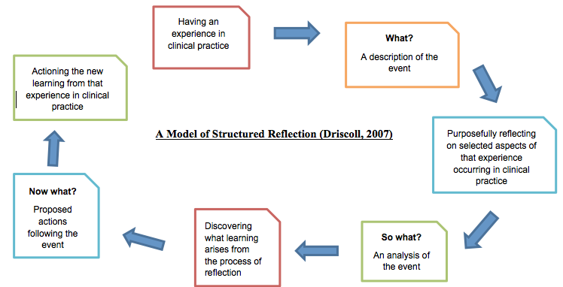
Figure 3: Driscoll Reflective Cycle
(Source: pinterest, 2019)
For me, the most significant event for the year of 2019 was my beginning at the university. At the time, I felt that I must improve my writing and speaking English language skills with the high-level course. Later, I noticed that I become confident to use my English language skills and I was ready for surprises that lead to improve my arguments and discussion at a new scene. Alternatively, this could be difficult because of the academic English is complex and hard learning is required. I started my way with summarising and paraphrasing like essay which demonstrates many lacks in my piece of work.
This is similar to focus to topics, to improve my performances because there is space for new learning and teaching. Subsequently, I noticed that I was so exciting to tests my new skills with the new creative thinking and fresh new ideas for my career development.
Having analysed the clear purpose to improve my English language skills I now feel that I can find my dream job and to be worthy person within the new realities in completely new academic dimension. Additionally, I have learned that to understand core essential skills is vital for effective learning.
I have significantly developed my skills in references, research and writing skills, memories and critical analysis. This means that the beginning of the development of my academic skills together with transferable and adaptive skills are connected with the important job-related skills (Hickson, 2011). This knowledge is essential to me as a learner because I started to prepare and use my personal development plan. Because I am not yet confident about how to enhance my crucial range of educational and advancement activities, I will now need to accomplish my purpose by attractive performance in my present character, challengers and objectives required for the future role.
As a next step, I need to achieve my goals, especially the long-period of time after the university and to include critical thinking ability, creativeness, enterprising and international thinking. This means that time management supports me for time activities and reviews of time usage, to set the SMART goals, daily tasks for my future career development. This skill could be useful to me as a practitioner because the academic writing includes huge improvement of my language and grammar skills, and the correct use of sentences, paragraphs and vocabulary.
Presentation skills are essential for my development, to speak confidently in the public and to engage individuals’ attention. For me the most important things are my knowledge and my experiences. They are crucial part of giving my ideas to the public with proper tone voice and body language. The listeners must absorb every word with proper speed and intonation. I have prepared notes to remind the most important points of my speaking. Having experienced with the presentation now, I know that the most important thing is to build up my confidence for the future. I have spoken on my presentation about the useful academic vocabulary. For me the most useful learning resulted from the academic vocabulary.
Initially, I have realised that this vocabulary is used by university lecturers, it is used to write scientific papers and textbooks and it’s used in educational institutions as knowledge and advantage. Alternatively, this is probably related to the matter of finding that the academic words are for the academic works at the universities and Academic Vocabulary is the brilliant education support for anybody who uses English language for their academic labour. Perfect for scholars of any subject, from engineers or communal experts to commercial scholars or solicitors, it includes all significant vocabularies that will be featured in academic workbooks, apprenticeships, speeches and etc (Warren, 2007).
Having experienced with a good range of vocabulary I now know that it’s important for effective higher education. Furthermore, I have learned that academic vocabulary, academic dictionaries, vocabulary exercises are the best platform to learn the thematic areas including the health and social care.
I have significantly developed my employability skills with general awareness, communication skills, interpersonal skills, personal skills, body language and public speaking skills. Most importantly, I have learned that my presentation will be like job hunting in the real life. I have significantly improved my ability to the work-based issues such CV writing, cover letter, analytical and critical thinking. This makes me feel boring in the beginning of the term but now I am feeling wonderful and well-prepared for the life outside the university.
At the beginning at the term I thought that the topics are challenging and difficult but now I am feeling that they are useful for my future career development and to accomplish my goals and objectives. Other things I know how useful are lectures at the university and their advantages for knowledge for the effective and successful learning.
Furthermore, I have clarified my personal aspirations. My short-period of time aspirations and goals are to earn a professional certificate, to have new job and to improve my communication skills. I have significantly developed my soft skills such cultural awareness, personal development and teamwork. My long-period of time aspirations and goals are to get a promotion, to change career, to start my own business, to become part of the management and to build my own personal brand. This makes me feel happy because I feel valued and have satisfaction at work, effective performance, my productivity is professional, leadership skills, developing conflict management and to implement the self-motivation.
For me the most useful issues were to use the knowledge, skills, attributes and other things to prepare personal statement. At first, I realised that my education and qualifications, work experience, relevant skills, my duties and responsibilities as a healthcare assistant are just steps forward to accomplish my goal for professional career development.
Having discussed my work-based evidence, I now feel that I have solid ground to move forward with my communication skills, numeracy, leadership skills, teamwork, administration, innovation and IT literacy. Additionally, I have learned that I must focus on the benefits and advantages that I can offer for the company. This means that my cover letter must be my road to success. This means to prepare short business style cover letter to introduce myself to the prospective employers and to summaries that I am suitable for the job.
I have significantly developed my ability to reach my targets and purposes with power point presentation, writing CV and job application. This makes me feel stronger and with analytical thinking I can move forward. Having learned analytical thinking skills, I now wonder I have developed problem solving skills method to analyse, tackle and sort new information, ideas, problems and solutions. There is invaluable asset to have which is easily transfer and apply across many spectrums of our lives and creates better effectiveness.
The benefits of the analytical thinking are extremely important for the improvement of the critical thinking abilities and include tangible and the most concrete advantages. As a next step I need to get the dream job, to acquire these skills to score the position, because better problem-solving means to empower success for tomorrow and to encourage the critical thinking. This knowledge is essential to me learner because offers me organisation skills, creative skills, effective problem-solving skills, budgeting, reporting, effective research, metrics and diagnostics. This makes me feel to improve the communication skills, creativeness, learning to negotiate.
Having experienced, I now think I am more future-orientated about to achieve the goals and objectives. My development plan is to move forward with the achievement and my hobbies and interests. I have significantly developed my understanding of other modules because there are very strong connections with them. This helps me to move even forward to achievement of the academic theories. The usefulness and the advantages of all new academic and employability skills are significant for the new important knowledge for the professional career development (Davies, 2012).
For me the better model for my practice is Kolb’s reflective model because is the best for the situations with several viewpoints (Johnson, 1990). It allows the individuals to perform better in situations that required ideas in the generation like brainstorming and it is developed from the learning from the experiences.
For my dream job I’ll have communication skills with body language, effective listening, collaboration with the others to achieve goals, to receive feedback, identification of others opportunities and openness for new ideas.

Conclusion

Reflecting writing offers new developments and strategic changes to deliver problem-solving writing strategies. It promotes new theoretical understanding, new research-based view of the academic, professional and personal writing. Reflective writing offers solutions with analyses, evaluations, plans, building theses. All three models are reflective decision makers, to encourage the motivation, to set goals, to monitor activities, to evaluate the outcomes ant to reflect on the professional thinking.

References

Begg, A., (2011). Reflecting on writing autobiography. Policy futures in education, Vol. 9, No. 3,
pp. 145-150.
Davies, S., (2012). Embracing reflective practice. Education for primary care, Vol. 23, No.1, pp. 9-12.
Driscoll, D. a. Alla. E., (2014). The three-fold benefit of reflective writing: Improving program assessment, student learning, and faculty professional developmen. Assessing Writing, Vol. 21, No. 3, pp. 37-55.
Evers, F. Rush. J. and Berdrow I., (1998). The Bases of Competence. Skills for Lifelong Learning and Employability. San Francisco: Jossey-Bass Publishers.
Hickson, H., (2011). Critical Reflection: Reflecting on learning to be reflective. Reflective practice, Vol. No. 6, pp. 829-839.
Jasper, M., (2005). 'Using reflective writing within research'. Journal of research in nursing, Vol.10, No. 3, pp. 247-260.
Johnson, D., (1990). Social Skills for Successful Group Work. [Online]
Available at: https://pdfs.semanticscholar.org/4198/b0e20d2cac6566c0e51fac842b52733ab384.pdf
[Accessed 03 December 2019].
Robinson, J., (2000). What are Employability Skills. The Workplace , Vol.1, No. 3, pp. 1-3
Vince, R., (1998). Behind and beyond Kolb's learning cycle. Journal of Management Education, Vol. 22, No. 3, pp. 304-319.
Warren, S., (2007). A missing link to creating optimally effective communication interventions. Mental Retardation and Developmental Disabilities Research, Vol. 13, No. 1, p. 215.



