Part 1

Outline a brief history of surveying, describing different measurement and surveying techniques from antiquity to the modern era.
Historians say that surveying dates back to ancient times, there's records of the ancient Egyptians in 1400 BC using very basic forms of surveying. The Egyptians first used surveying to divide up sections of land into plots for taxation, to plot the land they would use measuring ropes as guides, they would do this by stretching out a long piece of rope that had been treated with different materials such as bees wax to keep it stiff so that it would stay the same size, the Egyptians would measure distance tying knots were necessary, to form margins. The Egyptians even used a form of plum bob because they knew that that would give a true vertical line.
“Though nothing is known of the long-distance levelling devices, two different short-distance types were used to build the pyramids. The first was a water level. The bedrock was networked with narrow trenches, then filled with water. The waterline was marked on all the trench walls, the protrusions cut down, and the trenches re-filled with stone to create a level base. The second type of level was an A-frame with a plumb bob suspended from the apex. Since the Egyptians understood the isosceles triangle, stones could be cut “and chiselled square, and mortared into place using this instrument.” – surveyinghistory.org

some other methods of surveying that have been used over the years were footsteps where one man would walk the length of what needed to be measured out trying to take as accurate steps as possible and classing one step as a measurement. There was also, during different periods in time, when throwing a stone was a measurement, this dates back to the very early times of surveying and it was known as the stones throw, this form of surveying was very primitive and seems very inaccurate as there is no way of consistently throwing the stone the same distance regardless of who's throwing it, as times change and humans have become more intelligent, lots of new more precise ways are been invented.

The next big discovery in early surveying is the creation of the diopter, this was believed to be created by the Greeks in a round 120 BC. This invention was one the first pieces of surveying equipment ever invented. It was portable, it featured a cogwheel, screw and water level. It worked by measuring terrestrial and atmospheric elements on a property. This led the Greeks to develop the first set of guidelines and standards for surveying methods.

Some of the early tools for surveying were very basic, a Gunters chain developed in 1620s, was a chain consisting of 100 links that could reach up to 65 feet, it was very similar to the Egyptian rope except it's more easily transportable and gave a more accurate reading as it was made of metal. The Gunters chain was used very heavily by the British colonies of Australia and New Zealand along with several other techniques and approximation where they thought necessary.

“Over time, Gunter’s chain was replaced by steel bands and invar tapes, and later by Electromagnetic Distance Measurement (EDM) equipment, and subsequently Global Positioning System (GPS) devices, each in turn capable of improved efficiency and greater accuracies of measurement than the preceding forms. Likewise, compasses were replaced by transits, later theodolites and then Total Stations, which combined angular and distance measurement in a single survey instrument.”- Icsm.gove
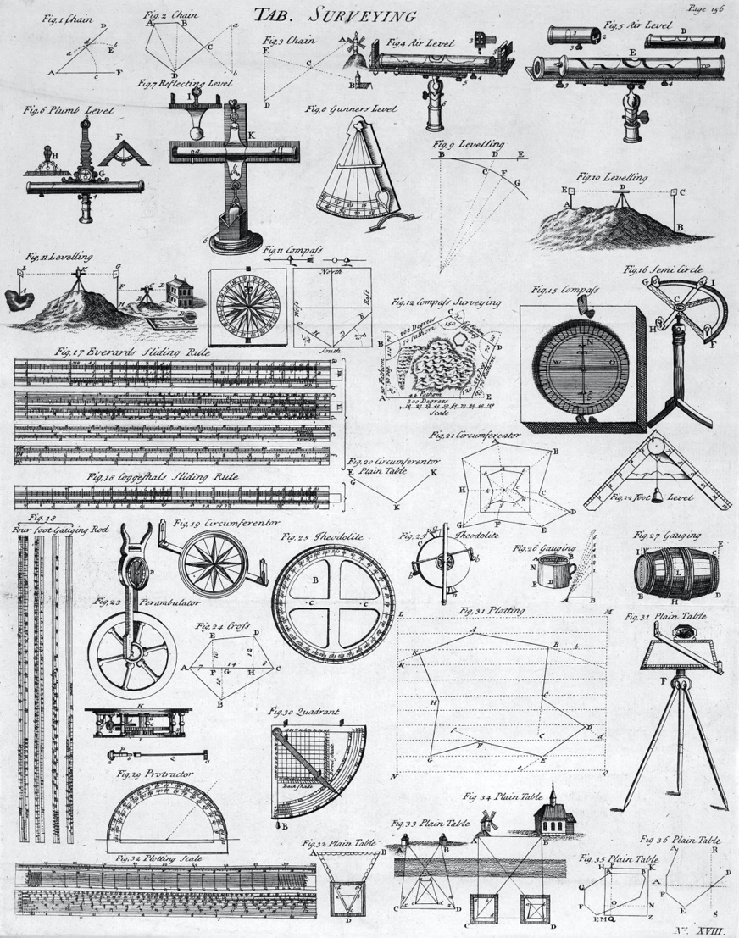

Around 1571 Joshua Harbermel invented a new land surveying tool. This tool was called a Theodolite, this is the first reasonably precise surveying tool and it used a tripod and a compass, in 1725 it was modified by Jonathan Sission who added a scope to the top of the instrument this making it a lot more accurate. This invention was highly impactful as theodolites are still used in modern day surveying, although they are used in modern day surveying their advancement from tripod with compass and scope has gone to a fully digital tripod system, that will give you readings with a click of a button. Theodolites these days are extremely helpful and very advanced.

With the introduction of technology modern day surveying is becoming more and more technical, this is due to the advancement in technology with the introduction of GPS and 3D images, this over the last two decades has become more and more prominent in the construction industry. As GPS has been introduced into the surveying world this has made setting out a lot easier and a lot quicker this is due to satellite pinpoint accuracy allowing survivors to only use a staff that can give exact points to set out buildings etc.
As surveying has moved into the 21st century it has become more advanced than ever this, is due to some of the new tools such as the use of drones. Drones marking a new era of surveying as it means it can survey a plot of land a lot quicker and a lot more accurately than a human, this is due to the speed at which a drone works and the technology behind it. The technology behind it is BIM this uses a massive circuit board of computers that can run programmes to survey correctly and can 3D model a full site.
“As the 21st century evolves, 3D laser scanning and use of lidar allows for every physical point within visible distance to be recorded, both on the surface of the land and vertically, such as trees, buildings, and utility lines. Additionally, mobile mapping allows for survey data to be recorded while in transit, for use in mapping landfill surveys and transportation surveys. The use of drones and drone surveying, which use photogrammetry to perform surveys, is also used as that technology becomes widely available. This allows surveyors to record vast expanses and terrain that is not easy to traverse.” – windowservice.com

Part 2

Briefly describe the application of digital surveying technologies in surveying listed buildings giving examples of appropriate tools to be used and the information to be collected from the survey.

The essay can incorporate the use of diagrams and figures to illustrate the text.

A list of references is required, and all referencing is to be clearly indicated throughout the essay.

A listed building survey is different from your standard building survey, this is due to the building being protected for one of three reasons, it was built before 1700, it was built in between 1700 and 1840 and is in very good condition or it can just be listed due to the significant importance of the building. Although listed buildings are usually 30 years or older, a special type of surveyor has to be brought in as not all surveyors can survey listed buildings, this is due to them having undertaken specialist training.

“To be able to survey a listed building, you also need to understand the building. This means knowing your bricks, timber types, mortars, and roofing materials. Years of study will give you an insight as to how buildings have evolved over time, and how construction methods change.” – heritage-house.org

To undertake a survey on a listed building specialist equipment is needed. Some of the specialist equipment needed is 3D laser scanners these take a 3D model of the building and put them into a BIM model. This then allows you to see any flaws or any problems with the building. Using this technique, it gives you accurate pinpoint drawings with external floor plans, sections and elevations. This is quick and efficient, and all the data gathered can be presented into both 2D and 3D views. 3D scanners work by driving the laser probe above the surface of the object two cameras continuously record the changing distance and shape of the laser line in three dimensions on an XYZ access.

Drones are another crucial piece of equipment for undertaking listed building surveys this is because drones are able to fly around various parts of the building that otherwise are very tricky to access. Drones cut out a lot of manual work as they can survey roofs and chimneys without any men having to get up to these Heights. Drones can also be used to carry out detailed, thorough and safe inspections very efficiently.

Pieces of equipment that are used for listed building surveying is radar scanning technology and x-ray scanners, these can be used to identify buried and covered features and defects as well as cubbyholes, false walls and hidden corridors in listed buildings. They are used on all old estate homes and larger Manor houses as well as small individual listed buildings. These can be very useful as they can see if walls have been built on top of walls, or if there is any structural damage to the property that the 3D scanner can’t pick up.

Whilst doing a survey on a listed building there are a number of aspects to take into consideration and to check for damage, there's a condition categories chart which goes from good to not visible. Whilst doing a survey the surveyor will go around the house checking if it's structurally sound, weathertight, if any significant repairs are needed. He will also look if there's any rot or fire damage, if there's any leaking from the roof or anywhere else, if there is he will check for water damage. After he's checked all of these areas, he will rate the house from one of the five categories as shown below. Below that is a list of what gets checked and also what they check about each point.

York.ac.uk

Good | Structurally sound; weathertight; no significant repairs needed
Fair | Structurally sound; in need of minor repair; showing signs of a lack of general maintenance.
Poor | Deteriorating masonry; leaking roof; defective rainwater goods, usually accompanied by rot outbreaks; general deterioration of most elements of the building fabric, including external joinery; or where there has been a fire or other disaster which has affected part of the building.
Very bad | Structural failure or clear signs of structural instability; loss of significant areas of the roof covering, leading to major deterioration of the interior; or where there has been a major fire or other disaster affecting most of the building.
Not visible | Building element not visible

Roofs: Slipped or missing slates/tiles; deteriorated thatch; slate or tile debris around the perimeter of the building; cracked or missing leadwork; general failure of flashings. Internally look for rot outbreaks, water staining and blistered paintwork on walls.
Rainwater goods: Plant growth in gutters and hopper heads; downpipes that are disconnected or detached; water discharging into the walls; blocked drains with plant growth in them. Internally look for rot outbreaks, water staining and blistered paintwork on walls.
Wall structure: Eroded masonry, cracked or missing pointing, spalling brickwork, failure of render, fallen pieces of brick or stone, saturated masonry, vegetation growth.
Structural stability: Significant cracks, bulges or other structural defects in walls, where these appear likely to threaten the stability of the whole or a large part of the structure of the building.
Doors and windows: Problems with glasswork; decayed window frames, signs of vandalism such as broken or boarded-up windows.
Architectural details: Loss of detail through erosion or decay, pollution likely to result in acidic decay.
Interior: Evidence of leaking/water ingress such as staining or bubbling paintwork; damage to interior fixtures and fittings.
Walls, gates and railings: Flaking or missing paintwork, rusting, decaying wood, eroded/spalling brick or stonework.

