DATABASES AND APPLICATION DEVELOPMENT
AdventureWorks Cycles: Database Solution
  - Shaun Davies (1104018)

University of Wales Trinity Saint David
Computing: Software Engineering

Contents
1. Introduction 2
2. Entity Relationship Diagram (ERD) 3
3. Screenshots of Work Completed 3
3.1 Database Schema Creation 3
3.2 Data Insertion 5
3.3 Constraints Testing 6
3.4 Transaction Rollback and Commit Operations 8
3.5 Performance Tuning Enhancement 10
4. Transactional Scenarios 11
4.1 Inserting Multiple New Products 11
4.2 Processing an Invalid Customer Order 12
5. Performance Tuning Enhancement 12
6. Conclusion 14
7. References 15
8. Appendix 15

Introduction
AdventureWorks Cycles is a fictional company specializing in the manufacturing and sales of bicycles and related accessories. As part of its efforts to enhance operational efficiency and customer service, the company has commissioned the development of a relational database to manage its business processes effectively. This report provides a detailed overview of the database development process, including the design, implementation, and optimization stages, all aimed at addressing the specific needs of AdventureWorks Cycles.
The project begins with the creation of an Entity Relationship Diagram (ERD) to represent the database schema. The schema design ensures that all tables adhere to the 3rd Normal Form (3NF), reducing redundancy and improving data integrity. Each table includes clearly defined primary keys, and relationships are established through foreign keys to maintain a logical structure. [1]
The implementation phase involves crafting SQL statements to create the database schema, incorporating referential integrity constraints and check constraints to uphold data consistency and validity. [2] Realistic sample data is added to test the schema, ensuring its functionality meets the intended requirements.
Additionally, the database supports transactional operations. A transactional scenario is developed to demonstrate the use of rollback and commit operations, ensuring that the system can handle errors gracefully while maintaining data consistency. Performance optimization is achieved by analysing frequent queries and introducing secondary indexes to improve execution speed. [3]
This report is structured to include an ERD diagram, documented implementation details, performance tuning strategies, and evidence of testing through SQL scripts. Screenshots and references to tools and sources are also provided to support the findings and methodologies used throughout the project.

Entity Relationship Diagram (ERD)
The ERD below illustrates the logical structure of the AdventureWorks Cycles database. It includes:
- Primary Keys (PK): Uniquely identify records in each table.
- Foreign Keys (FK): Establish relationship between tables.
- Non-Key Attributes: Represent additional information stored in each table. [1]

ERD
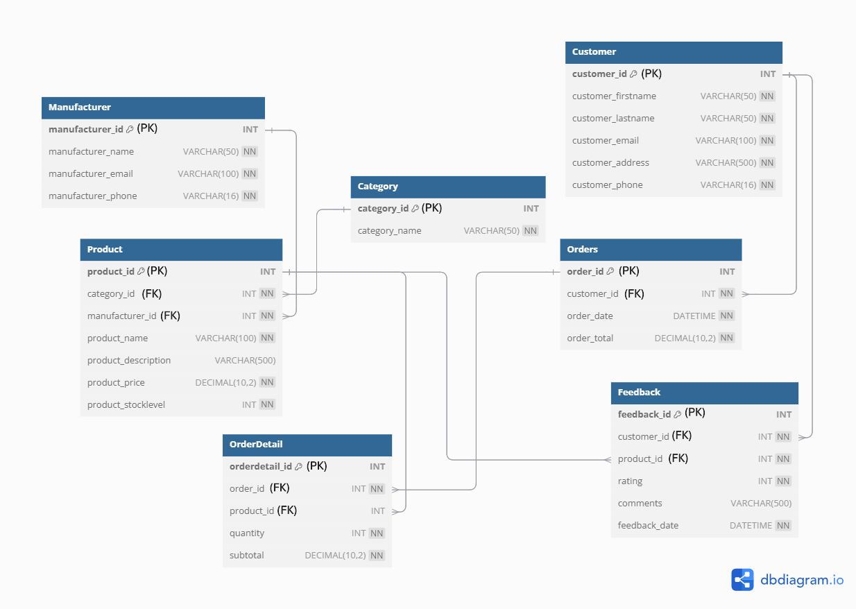
  - Key Features of the ERD
- Customer table stores individual customer details
- Manufacturer table stores information about bicycle manufacturers
- Category table categorizes products into types
- Product table includes details about the items for sale
- Orders and OrderDetail tables record customer purchases and the items within each order
- Feedback table collects customer feedback on products.

Screenshots of Work Completed

3.1 Database Schema Creation
Screenshots of the SQL commands executed to create the database and its tables.
  - CREATE and USE AdventureWorksCycles Database

  - Customer Table with constraints
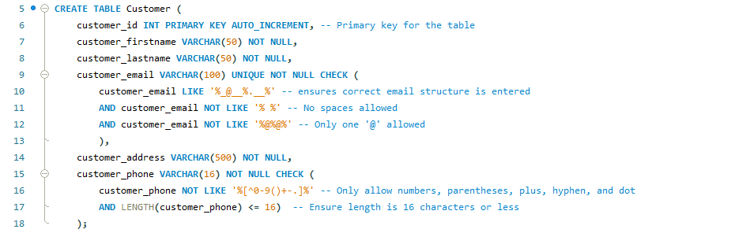

  - Manufacturer Table with constraints
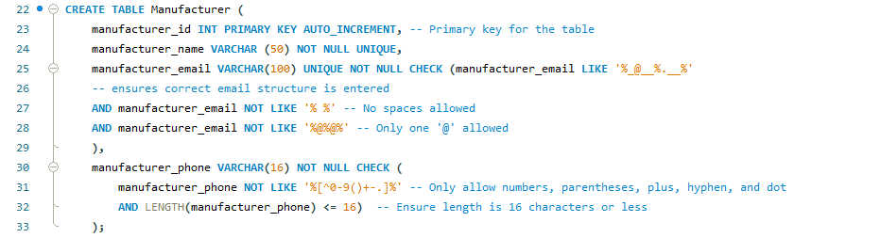

  - Category Table with constraints

  - Product Table with constraints
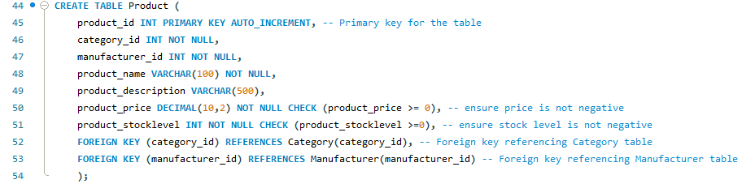

  - Orders Table with constraints
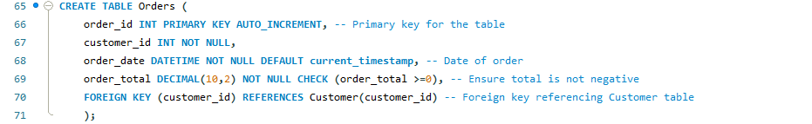

  - OrderDetail Table with constraints
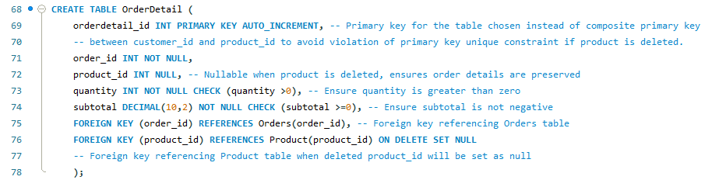

  - Feedback Table with constraints
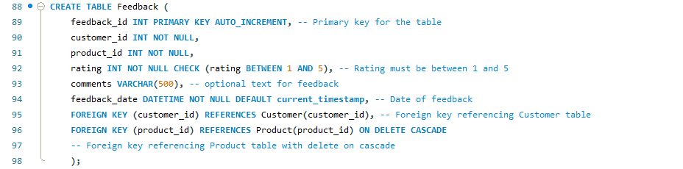

3.2 Data Insertion
Screenshots of the SQL commands executed to populate the tables with data.
  - Category Table
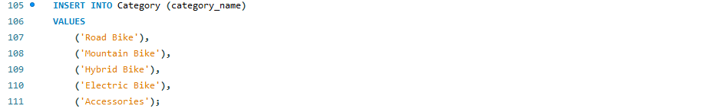
  - Customer Table
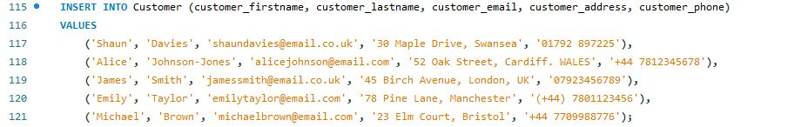
  - Manufacturer Table

  - Orders Table

  - OrderDetail Table
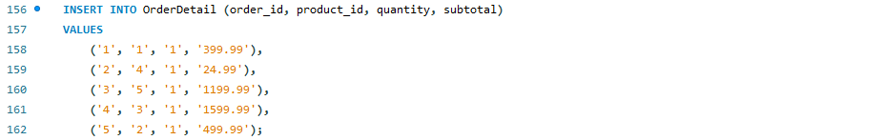
  - Feedback Table
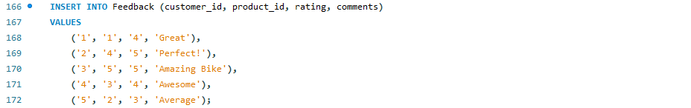

3.3 Constraints Testing
Screenshots of the SQL commands executed to test the constraints
  - Customer Table
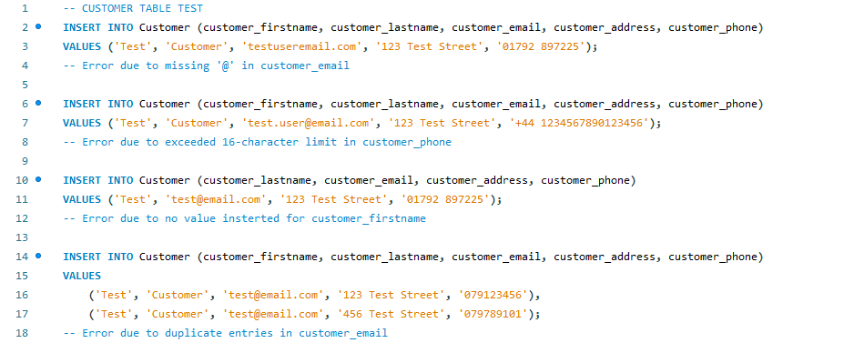

- Email Validation: An attempt to insert ‘testuseremail.com’ resulted in an error due to the missing ‘@’ symbol in the email address

- Phone Number Length: A phone number exceeding the 16-character limit caused an error.
- Mandatory Fields: An error was caused when customer_firstname was omitted from the INSERT statement.
- Unique Email Constraint: Duplicate entries in customer_email triggered a unique constraint violation.
  - Manufacturer Table
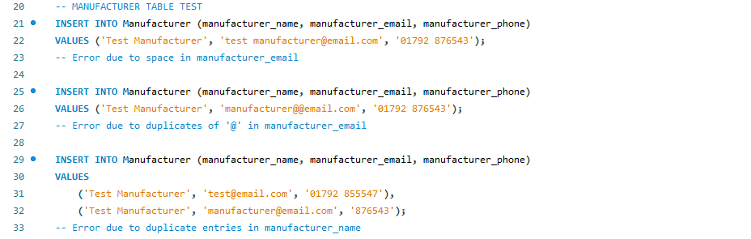
- Email Validation: Invalid email formats, such as a space in test manufacturer@email.com or duplicate "@" in manufacturer@@email.com, caused errors.
- Unique Name Constraint: Duplicate entries in manufacturer_name resulted in a constraint violation.

  - Category Table
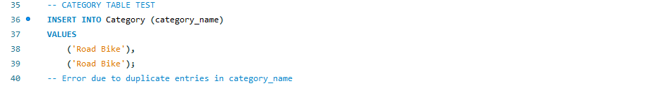
- Unique Category Name: An attempt to insert duplicate category_name values, such as 'Road Bike', triggered an error.

  - Product Table
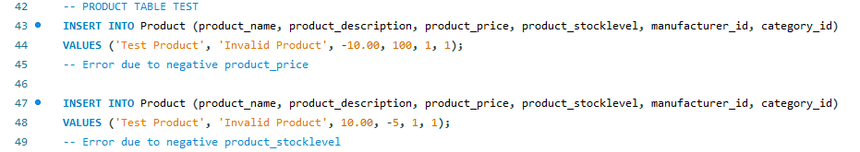
- Negative Values: Constraints prevented the insertion of a negative product_price or product_stocklevel.
  - Orders Table
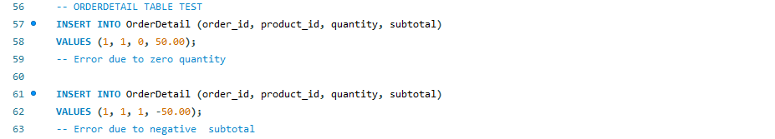
- Order Total Validation: A negative order_total caused a constraint violation.
  - OrderDetail Table
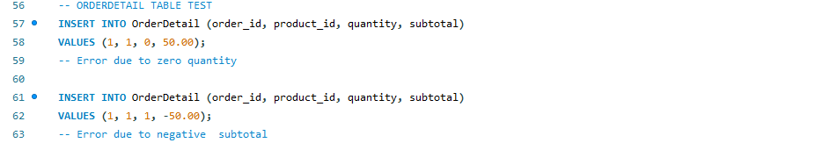
- Quantity Validation: Inserting a zero quantity was prohibited by constraints.
- Subtotal Validation: Negative subtotal values were rejected.
  - Feedback Table
- Rating Validation: Ratings outside the range of 1 to 5, such as 6, were prevented from being inserted.

3.4 Transaction Rollback and Commit Operations
Screenshots of the SQL commands used in Transaction Rollback and Commit Operations.
  - Autocommit
- Check and disable autocommit before running transactions.

  - Commit
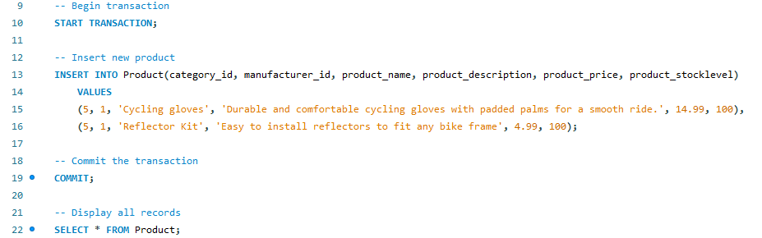
- Start Transaction
- Insert two new products into the Product Table
- Commit and display all records to verify the changes.

  - Rollback
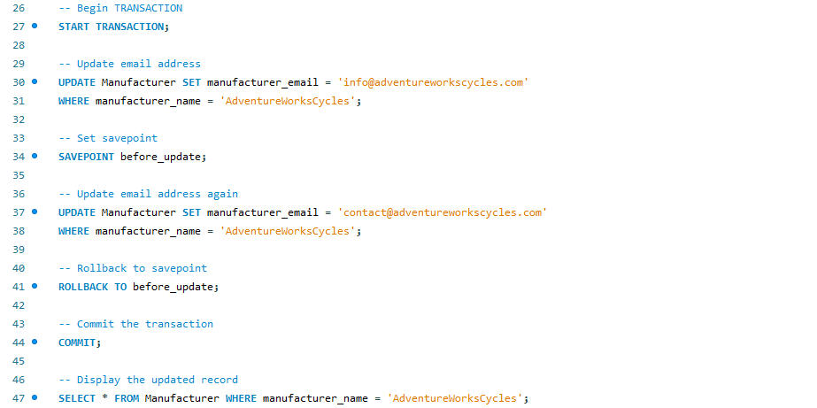
- Start Transaction and Update manufacturer_email in Manufacturer Table
- Set Savepoint
- Update the email again and rollback to the Savepoint
- Display the updated email address.

  - Rollback with error handling
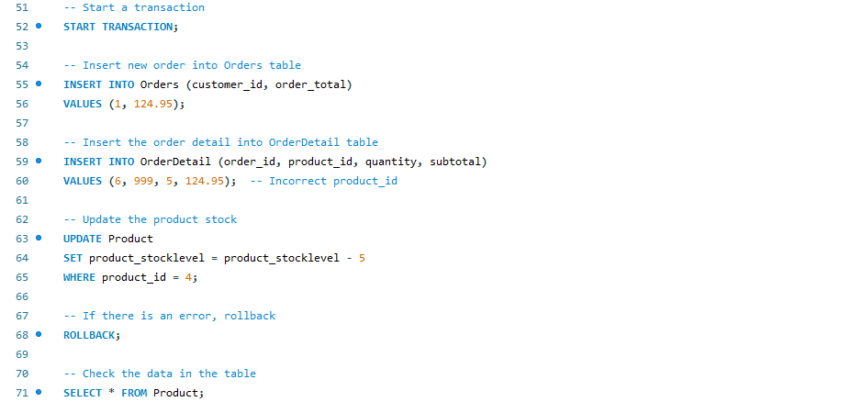
- Start transaction and insert new order into Orders Table
- Insert new OrderDetail
- Update stock of product
- Rollback due to intentional error
- Display all products to ensure no changes have been made.

3.5 Performance Tuning Enhancement
Screenshots of the SQL queries and indexes used for performance tuning enhancement.
  - Queries
SQL commands created to test queries on the database.
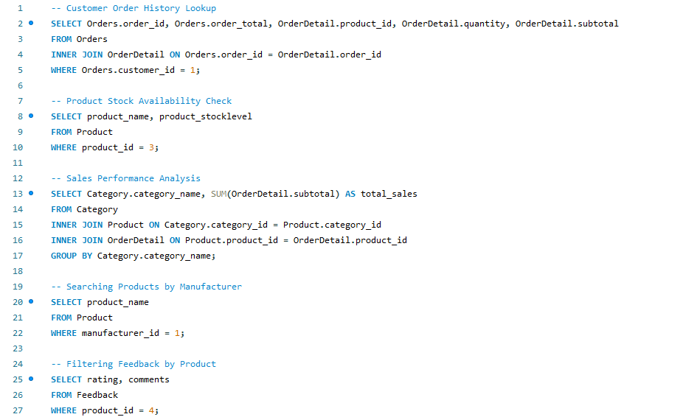
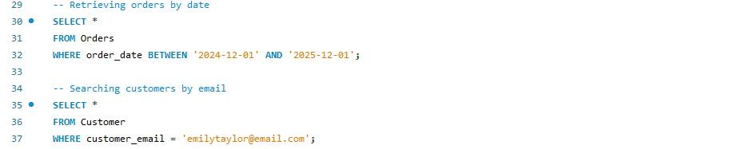
  - Secondary Indexes
SQL commands used to create indexes to improve performance when querying the database.
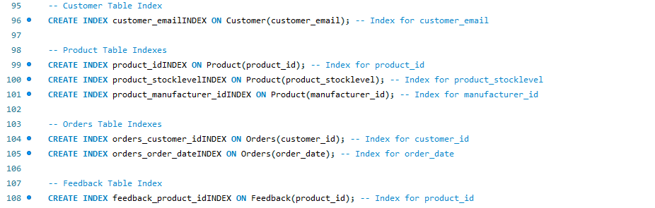

4. Transactional Scenarios
The purpose of this section is to demonstrate the implementation of transactional operations using START TRANSACTION, COMMIT, ROLLBACK, and SAVEPOINT. These operations ensure data integrity, enforce business logic, and allow error recovery during complex database interactions. [3] [4] [5]

4.1 Inserting Multiple New Products
  - SQL Implementation:
This transaction demonstrates the use of COMMIT to ensure that either both product entries are successfully added or neither is added, preserving the database’s consistent state thus ensuring atomicity. When adding products in bulk this ensures that partial data which could lead to operational discrepancies is not committed if constraints such as invalid category_id or manufacturer_id are triggered. [3]

4.2 Processing an Invalid Customer Order
  - SQL Implementation:
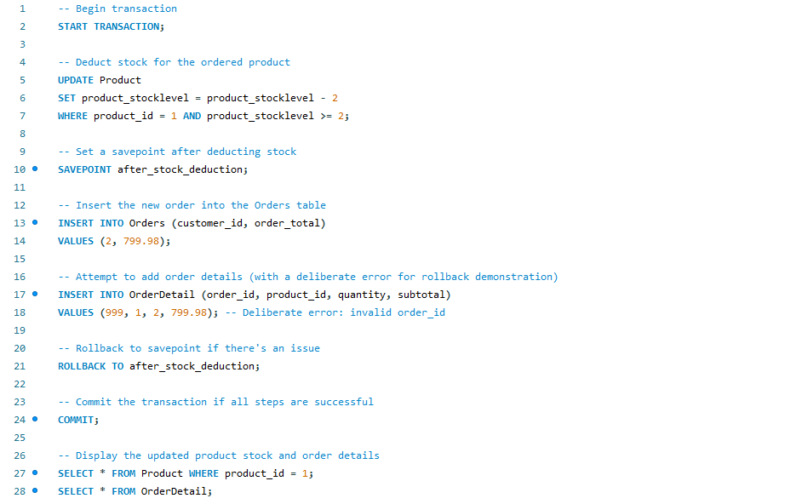
This transactional scenario handles a customer order by deducting stock, adding the order, and inserting order details. A deliberate error in the order_id field demonstrates the use of SAVEPOINT and ROLLBACK to manage errors effectively.
The savepoint is set after stock is deducted, ensuring that the stock deduction is preserved even if an error occurs during the subsequent order processing steps. By doing so, the database maintains consistency in its inventory, reflecting the fact that stock has been allocated to the customer even if the order is temporarily incomplete.
If an error occurs, such as a failure in inserting the order or order details (e.g., an invalid order_id), the rollback undoes only the operations that follow the savepoint—specifically, the order and order details insertion. However, the stock deduction remains intact, effectively reserving the items for the customer while preventing others from purchasing the same product. This is especially useful in cases of low stock, where maintaining accuracy in inventory levels is essential to prevent overselling or customer dissatisfaction
This approach also highlights the importance of atomicity in transactions, where all steps must succeed together or fail as a unit. By using a savepoint strategically, the transaction ensures that partial success (such as stock deduction) is not entirely lost during an error, while incomplete or invalid steps (such as invalid order details) can be safely discarded without affecting the reserved stock. This allows the system to reflect real-time changes to inventory, avoid stock conflicts, and ensure a seamless recovery path for failed order processes.

5. Performance Tuning Enhancement
In an e-commerce database like AdventureWorks Cycles, data queries are central to business operations, enabling tasks such as order management, inventory checks, and customer interaction. To ensure these operations run smoothly and efficiently, data queries must be optimized. Data queries retrieve, update, or manipulate data from tables, often requiring the combination of multiple tables through joins, which help correlate related data. Joins, particularly inner joins, enhance performance by returning rows where there is a match across multiple tables, streamlining data retrieval [1][7].
In order to optimize query performance and minimize delays in retrieving important information, various secondary indexes were created for frequently queried columns. These indexes are designed to improve retrieval speed by allowing the database to locate and access data more efficiently, rather than performing a full scan of a table [8].
The following secondary indexes were created to improve the performance of data queries:

  - Customer Queries
An index was created on the customer_email column in the Customer table. This index ensures fast retrieval of customer records based on their email address, a critical operation in e-commerce systems. Email addresses are commonly used for account identification and customer lookups, and having an index on this field allows for quicker searches, thus improving user experience during customer service interactions and account management.
  - Product Information
Several indexes were introduced in the Product table to optimize frequently executed queries related to products:
- product_id index: This allows for fast access to individual product records. For example, when checking stock availability or retrieving product details, the database can locate the product quickly, which is particularly important for inventory management.
- manufacturer_id index: This index facilitates the retrieval of products by manufacturer, making it easier to filter and display products based on brand or supplier in search results.
- product_stocklevel index: This index speeds up queries that check the stock levels of products, helping to ensure that inventory levels are efficiently monitored and updated in real time, critical for preventing overselling or stockouts.
  - Order Management
To improve the efficiency of order management, two indexes were created in the Orders table:
- customer_id index: This allows for quick retrieval of all orders associated with a particular customer, which is essential for looking up order history or performing customer-specific analysis.
- order_date index: This index supports efficient range queries based on order dates, enabling quick retrieval of orders within a specific time frame. This is particularly useful for reporting and analyzing sales trends or fulfilling time-sensitive order requests.
  - Feedback
An index on the product_id column in the Feedback table ensures that customer feedback related to specific products can be accessed quickly. This is essential for monitoring product performance, collecting insights on customer satisfaction, and making timely improvements to products based on customer input.

6. Conclusion
In conclusion, the development of the AdventureWorks Cycles database serves as a comprehensive solution to manage and optimize the company’s key business processes, such as customer orders, inventory management, and product performance analysis. The database schema has been meticulously designed to ensure data integrity, consistency, and efficiency, adhering to third normal form (3NF) to reduce redundancy and ensure smooth relational connections through foreign keys.
By implementing transactional operations, including the use of rollback, commit, and savepoint features, the database is able to maintain data consistency and integrity even in the face of errors, thus providing a robust framework for handling real-world business scenarios. Performance tuning has been a critical focus, and the creation of secondary indexes has significantly enhanced the speed and efficiency of common data queries, ensuring that the system remains responsive even as the volume of data grows.
Through the careful optimization of both database design and query performance, this report demonstrates how an effective relational database can improve operational efficiency, ensure accurate data management, and ultimately support the business goals of AdventureWorks Cycles. With a focus on scalable performance and reliable transactional support, the database is well-equipped to meet the evolving needs of the company.

7. References
[1] T. Connolly, C. Begg, Database Systems: A Practical Approach to Design, Implementation, and Management, 6th ed., Pearson, 2015.
[2] S. Link, U. Leck, and Z. Wei, "Entity Integrity, Referential Integrity, and Query Optimization with Embedded Uniqueness Constraints," 2019 IEEE 35th International Conference on Data Engineering
[3] A. Šijan, L. Ilić, I. Šušter, et al., "Database Replication: Ensuring MySQL Data Integrity," Quaestus (Timio̦ara), 2024.
[4] J. Wei, Y. Hu, Y. Zheng, et al., "Understanding Transaction Bugs in Database Systems," 2024 IEEE/ACM 46th International Conference on Software Engineering (ICSE), 2024.
[5] J. Wei, W. Wang, Z. Cui, et al., "Differentially Testing Database Transactions for Fun and Profit," Proc. 37th IEEE/ACM International Conference on Automated Software Engineering, 2022.
[6] F. Mithani, S. Machchhar, F. Jasdanwala, "A novel approach for SQL query optimization," 2016 IEEE International Conference on Computational Intelligence and Computing Research (ICCIC), 2016.
[7] F. Y. Alnawajha, "The Performance of Inner Join Types in SQL," International Journal of Advanced Studies in Computers, Science and Engineering, 2016.

8. Appendix
  - Prompt used in Generative AI
- Generate randomised data similar to: 'Shaun', 'Davies', 'shaundavies@email.co.uk', '30 Maple Drive, Swansea', '01792 897225'
- Generate randomised data similar to: 'AdventureWorksCycles', 'contact@adventureworkscycles.com', '0800 234567'
- Generate randomised data similar to: 'Mountain Bike', 'Durable mountain bike for off-road cycling', 399.99, 100, 4, 2

