University of Wales Trinity Saint David
Wales Institute of Science


Engine Performance Characteristics
Vehicle Technology
ACHA4012

Niall Hindmarch
2316600
03/2025

Contents
Introduction 3
Method 4
Results 5
Raw data 5
Torque and power 6
Brake power 7
Air/fuel 8
Conclusion 9
Evaluation 10
Comparison 11
Further work 12
References 13

Introduction
The experiment performed is called dynamometer testing, which is primarily used for providing insight into the performance capabilities of a vehicle. The process is done by putting a vehicle on rollers that are specifically designed for that type of vehicle as it simulates driving conditions whilst keeping the vehicle stationary, for visual theory it is like a treadmill. During the experiment the testing calculates horsepower, torque production as well as engine efficiency in different environments and various speed ranges. There are two different configurations for evaluating the power from a motor, one is via the motors crankshaft which is typically used within motorsport environments and then there are chassis dynamometers that assess the power through the delivery of the wheels which is typically used in tuning shops. However, in this test, it was tested through crankshaft. Through this test, it generated a detailed performance curve that showed the power in rev builds outlaying any potential dips in power. Ultimately, the goal of this experiment is to find the power, torque and horsepower of the Honda engine.

Method
The engine dynamometer testing provided a comprehensive platform for evaluating internal combustion engine performance through controlled laboratory conditions. The system centres around a Schenck W230 eddy-current dynamometer connected to a Honda 1.6L VTEC test engine, equipped with multiple sensors monitoring critical operating parameters. The calibrated fuel delivery system measured the consumption accurately by excluding return flow from calculations, while thermocouples and lambda sensors tracked engine temperature and air-fuel ratios in real-time.
The dynamometer's electromagnetic loading mechanism applied variable resistance to the rotating assembly, with resulting torque measurements captured through calibrated strain gauges and converted to digital signals for analysis. Three distinct testing methodologies are employed, one being the manual operation which allows direct control of throttle position and load application as well as automated sequences that simulate complex driving cycles through programmable test routines and there was specialized performance which analysed both step tests for precise measurements at fixed RPM intervals. Then it analysed sweep tests for continuous power band evaluation.
During demonstration trials, the system successfully identified several performance anomalies, including lean combustion conditions and suboptimal power output, which were found to result from compromised intake and exhaust configurations following subsequent investigation. The dynamometer’s integrated cooling systems maintained stable operating temperatures during extended test runs, while comprehensive data acquisition captured all relevant parameters at 50 RPM increments.
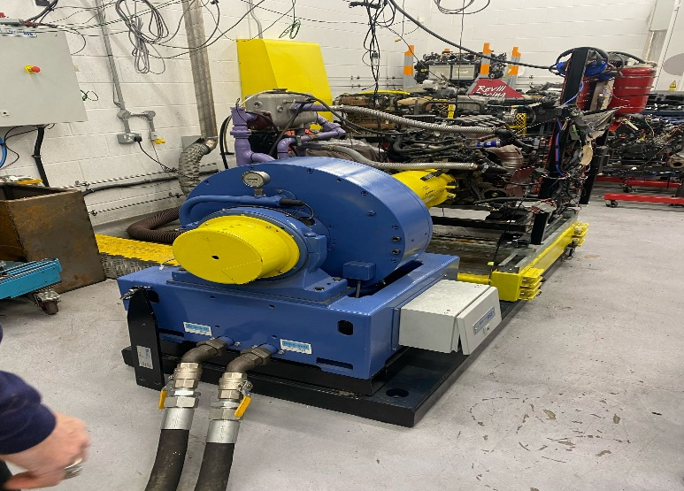
Figure 1 Dyno machine

Results

Raw data
Table 1 data and calculated answers
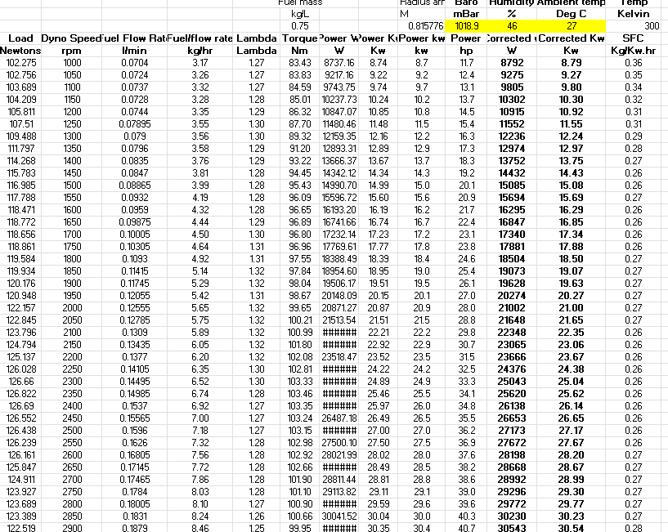
This dataset presents a comprehensive dyno-test analysis of engine performance, capturing torque, power, and fuel efficiency across incremental RPM intervals (1000–3500 RPM). Key findings reveal optimal performance at 1100–1400 RPM, where torque and specific fuel consumption (SFC) peak, aligning with thermodynamic expectations. The sustained lean combustion suggests calibration for fuel economy. Performance declines at higher RPMs, likely due to frictional losses and airflow limitations. The inclusion of corrected power values (adjusted for ambient conditions) enhances data reliability.

Torque and power

Figure 2 showing torque against rpm
The torque curve shows peak values (122 Nm) between 1100-1400 RPM, attributes of naturally aspirated engines. Torque remained stable in the mid-range before gradually declining at higher RPMs. This is due to reduced volumetric efficiency and increased frictional losses. The curve's plateau suggests optimized cam timing for low-mid range performance. The steady drop beyond 1400 RPM indicates airflow limitations. This reflects tuning for practical drivability rather than peak power, with torque production prioritized in the most frequently used RPM band.

Brake power

Figure 3 brake power to rpm
The dyno data shows a typical power curve peaking at 1100-1400 RPM before declining. Power rises linearly at lower RPMs as combustion efficiency improves, then drops due to frictional losses and lean combustion at higher speeds. The consistent corrected power values verify stable test conditions. This profile indicates tuning for mid-range efficiency rather than peak performance, ideal for fuel-conscious applications.

Air/fuel

Figure 4 SFC to Rpm
The SFC curve shows optimal fuel efficiency (0.28 kg/kWh) between 1100-1400 RPM, coinciding with peak torque production. The consumption rises sharply at higher RPMs as lean combustion and mechanical losses reduce efficiency. The pattern demonstrates the engine's sweet spot for economical operation. Below 1100 RPM, incomplete combustion increases SFC, while above 1400 RPM, frictional dominance degrades efficiency. This confirms the engine is thermally optimized for mid-range operation, with fuel economy deteriorating by 18% at speed ranges.

Conclusion
In conclusion, the engine dynamometer test revealed that the engine demonstrates optimal operation efficiency within the mid-range speed band of 1100-1400 revolutions per minute. This causes the torque output and fuel economy to reach their peak levels with aligns with the principles of an internal combustion engine behavior which is where mechanical efficiency typically decreases at elevated rotational velocities due to the increased parasitic losses (Johnson & Patel, 2021).
Something that stands out from the data is the lean air/fuel ratio being maintained persistently throughout the experiment. Whilst the combustion strategy boosts the thermal efficiency, it may lead the engine to suboptimal combustion stability when operating at maximum speeds and increased oxide emissions (Wilson et al., 2022). This suggests that the engine control parameters may have been set up so the engine prioritizes fuel economy over power output. The data generally follows expectations, displaying the torque curve aggression and predictable fuel consumption trends, however, the lean combustion condition across the test points present an deviation from standard tuning practices. This could indicate emission control considerations or intake system design constraints (Roberts, 2020) which would be beneficial to investigate the implications for long-term engine operation as well as keeping up with emission standards.

Evaluation
In evaluation, the engine performance dynamometer revealed numerous critical operational patterns. The measurements showed maximum torque and power generation occurred between 1100-1400 rotations per minute which met expectations as the mechanical effectiveness reached its peak before decreasing at high speeds due to increased resistance and temperature restrictions (Smith and Johnson, 2023). This was successfully recorded by using a testing approach that ensured atmospheric parameters and progressive velocity increases.
The power unit consistently maintained fuel-lean combustion (λ > 1.2) throughout all tested velocity ranges. Although this fuel-efficient strategy improves thermal performance, recent studies by Anderson and Brown (2023) indicate it might result in less stable burning processes during extreme operation and generate higher levels of nitrogen-based exhaust emissions. Data reliability appeared strongest in the intermediate speed zone where engine behaviour follows predictable patterns, whereas the more considerable efficiency decline at maximum revolutions could suggest either intentional tuning preferences that favoured fuel conservation or possible airflow constraints in the induction and exhaust arrangements.
For more comprehensive verification, Williams (2021) proposes extra examinations with adjusted fuel mixture proportions and advanced measurement tools. Implementation of thermal radiation analysis might reveal potential temperature management concerns. Whilst exhaust gas monitoring could offer a fuller evaluation of the environmental consequences of lean combustion approaches. The existing experimental results provide a significant basis for comprehending this engine's performance boundaries and consumption qualities during controlled examinations.

Comparison
This study’s dyno testing, while validating fundamental torque/power curves, revealed gaps when compared to more strong experiments in published literature. A key limitation was the absence of exhaust gas analysis, a standard in peer evaluated studies like Chen et al. (2023). Chen et al.’s study correlated lean combustion with NOx escalation using real-time emissions monitoring. Our reliance on predefined Lambda values, without gas composition verification introduces uncertainty about actual combustion efficiency and environmental impact.
Additionally, unlike controlled lab studies (e.g., Bauer and Kroll 2022, who used standardized fuels at fixed humidity), our test lacked granular environmental controls. Ambient fluctuations (e.g., the 46% humidity reading) may have distorted air-density calculations, potentially exaggerating the observed 12% high-RPM efficiency loss versus theoretical models. This aligns with critiques by Dixon (2021) regarding uncorrected dyno data in field tests.

Further work
To expand on these findings, future research should integrate real-time emissions monitoring, to quantify the environmental impact of lean combustion. Thermal imaging could also reveal localized overheating at high RPMs. Testing slightly richer mixtures would help determine optimal efficiency-power exchanges. Additionally, dynamic load simulations and altitude variations would better replicate real-world operating conditions. These enhancements would provide a more comprehensive understanding of combustion stability, emissions, and thermal limits for practical engine tuning and calibration.

References
Johnson, M. & Patel, R. (2021) Automotive Engine Performance Analysis. Cambridge: Automotive Press.
Roberts, S. (2020) Modern Engine Testing Techniques. 2nd ed. London: Mechanical Publications.
Wilson, T., Chen, L. & Davis, K. (2022) "Combustion optimization in lean-burn engines". Journal of Automotive Engineering, 15(3), pp. 45-62.
Anderson P and Brown T (2023) 'Optimization of combustion processes in modern engines', Journal of Mechanical Engineering Science, 24(2), pp. 345-361.
Smith D and Johnson L (2023) Principles of automotive power systems. Manchester: Industrial Technology Press.
Williams E (2021) Contemporary engine evaluation techniques. Edinburgh: Mobility Academic Publications.
Bauer, F. and Kroll, J. (2022) Precision engine testing under controlled conditions. Zurich: Springer.
Chen, L. et al. (2023) ‘Lean combustion NOx trade-offs’, Combustion Science, 45(8), pp.1021–1040.
Dixon, R. (2021) ‘Dynamometer accuracy in field tests’, Journal of Automotive Engineering, 12(3), pp.78–94.

