UNIVERSITY OF WALES TRINITY SAINT DAVID (LONDON CAMPUS)

Diabetes Presentation
iNTRODUCTION TO PHYSIOLOGY
bmhp5003_lon
bsc (hons) health and social care level 5
Student NAME: Charmaine Roach
sTUDENT NUMBER: 1913890
Name of lecturer: eleni koutsogeorgou
Date:29/07/2021

Contents
Poster 4
Speaker Notes 5
Introduction 5
The Definition of diabetes 5
What is the Cause of Diabetes? 5
The Risk of Diabetes 5
Physiology for type 2 diabetes 6
Intervention/Management Options for patients 6
Case Study of Lifestyle Questionnaire 6
Conclusion 7
Appendices 7
8
9
Referencing 10

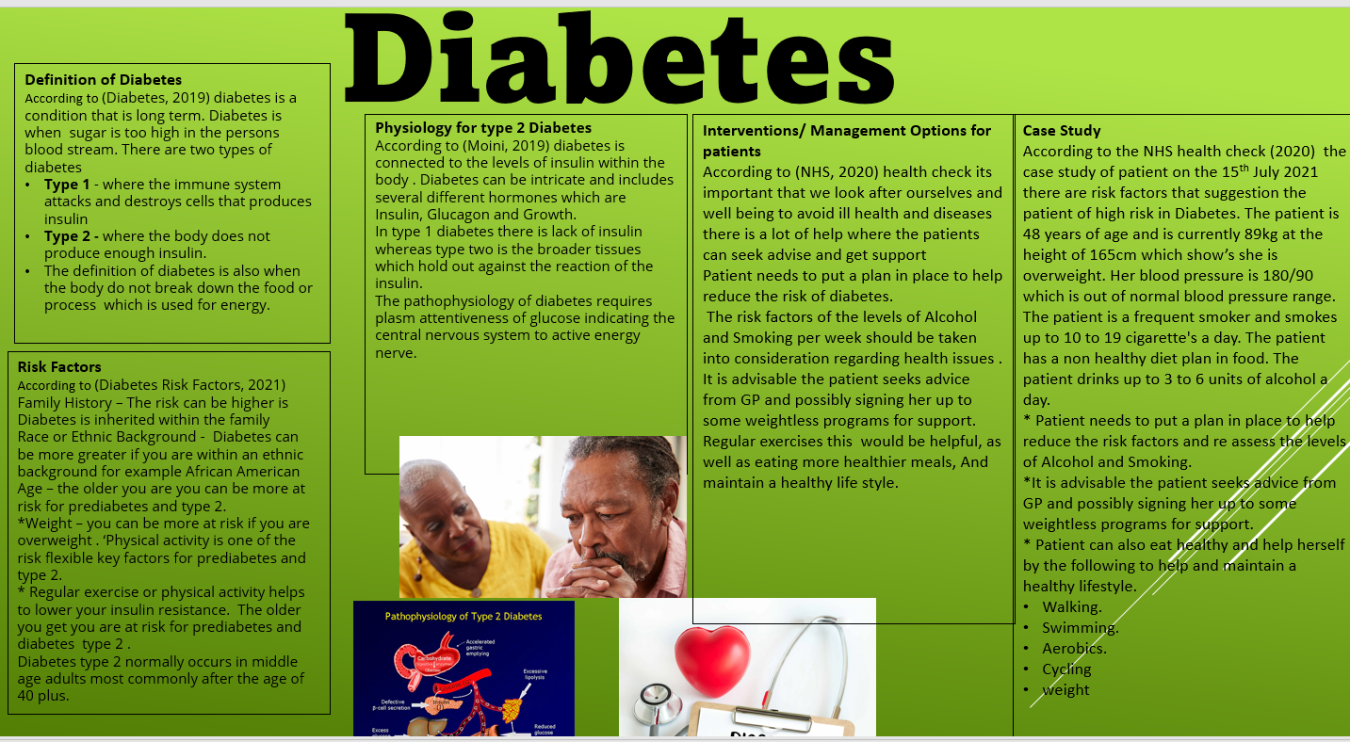
Poster

Speaker Notes

Introduction
My speaker notes are based on Diabetes Type 2, in my speaker notes I will talk about the bullet points (e.g.) Definition of Diabetes, The Risk factors, Physiology for Type 2 Diabetes, what is the Cause of Diabetes, Intervention/Management option for patients, and the case study of the lifestyle Questionnaire.

The Definition of diabetes
Diabetes is where the body does not deal with food properly the food then turns into glucose or sugar for the body to use for energy. There are two types of diabetes, there is diabetes type 1 and diabetes type 2.

What is the Cause of Diabetes?
Diabetes type two according to the (Your NHS Health Check results and action plan, 2020)) stated ‘The diabetes is a popular condition which causes sugar level in the blood to escalate.’ It continues to state ‘Some of the symptoms it may cause is extreme thirst, wanting to pee, and a lot of tiredness’. This can become very dangerous to your health, and cause a load of problems, including your eye, heart, nerves, and other function of your body.
According to (Diabetes, 2019) ‘If you have diabetes in your body, it is powerless to crack down this is because the insulin is not enough to move the glucose or the insulin that is produced do not work properly. Diabetes can be control through healthy lifestyle for (e.g.) regular exercise healthy eating and attaining a healthy body by losing the weight.

The Risk of Diabetes
The Risk of having diabetes can be very high if not controlled. According to the (Diabetes, 2019) ‘Type two diabetes is very common than type 1 in the United Kingdom and there are 90% of adult with type 2 diabetes’.
According to (Diabetes Risk Factor 2021) “Family history contribute to some risk factor of diabetes this could be hereditary from our parents or biological family member’ for (e.g.) if your mother or father has diabetes the chances are that you are at largely at risk for developing the disease”.
“Diabetes can result into a serious health problem which can cause complications such as heart diseases, blindness, kidney failure and amputation”.
“Diabetes within ethnic backgrounds is very high’ for example Afro Caribbean people are 1.7 times is very likely to developed diabetes as white”.
According to (Tinna Hicklin, 2018) “Stated they have found that the biological risk factors including weight and fat around the abdomen are mostly to blame for higher rates of diabetes for black Americans to compare to white Americans. It is also study that by having positive changes in the known risk factors for example losing weight can reduce the racial health disparity for improving diabetes”.

Physiology for type 2 diabetes
“Type 2 diabetes is one of the most popular metabolic disorder which is cause by a mixture of two primary factors according to (Unai Galicia-Garia, 2020)”
“Defective insulin secretion by pancreatic B – cell and the inability of insulin-sensitive tissues to react properly to insulin”.
According to (Jahangir Moini MD, 2019) “normally, the pancreatic beta cells distribute insulin due to increased blood glucose awareness. The Brain for normal functions to occur constantly requires glucose hypoglycaemia or low plasma glucose level, is generally caused by drugs used in the medication of diabetes, including insulin and oral antihyperglycemics”.

Intervention/Management Options for patients
There are so many helps within the (Your NHS Health Check results and action plan, 2020)) which will help and support with diabetes, The national health has as a health check action plan, and therefore the patient in question within the questionnaire can always get advice from them including their GP.
The health check is broken down into your body mass. This includes high blood pressure, cholesterol, alcohol use score, physical activities, and diabetes.
At the National Health (NHS 2020) “they will sometimes check your heart using the heart age tool which tells them your age of your heart and compared it with your real age ‘for (e.g.) your heart can be higher than your age’ your BMI will be check where this will help them to understand your weight (e.g.) are you overweight or underweight. Blood pressure score will be measured which will indicate how high or low your pressure is. Cholesterol result will be check where they will inform you how high or low your cholesterol is or whether your cholesterol is good or bad. Your alcohol score will be based on the question they ask these scores ‘are from 0-4’. Then there is also your physical activity score this will be measured which is calculated using a worldwide validated tool.”

Case Study of Lifestyle Questionnaire
Looking into Patient A questionnaire, Patient A is at hight risk to diabetes 2. There is highly a risk factor which can become dangerous to her health. According to the lifestyle questionnaire which the patient was interviewed on the (15/07/2020) Patient A was ask some health question which has cause some concerns. Smoking 10-19 cigarettes/day, suffers from high blood pressure 180/90, father had a heart attack above the age of 60, sister has trouble with high cholesterol, not form of physical activities, do not have a healthy diet, alcohol intake 3-6 units a day weight is 86.kg height is 165cm. According to the (Your NHS Health Check results and action plan, 2020) ‘normal blood pressure should be 90/60 or 140/90, if your BMI is overweight then you are at a risk to health problems’. ‘In adults a healthy cholesterol should have a total of 5mmol/L or less, adults between the age of 91-64 should have regular activities’.
For Patient A to maintain a healthy lifestyle she needs to have a plan put in place, she also needs to get professional help to assist her with her health plan to reduce the risk factors, which also include the level of alcohol intake. Patient A can also sign up to weightless programme for support including exercises classes, walking, cycling, water aerobics and yoga or even speak to her GP for more support who can point her in the right directions.

Conclusion

Looking into the overall picture of Diabetes Type 2, its very important that we stay physically healthy. There are loads of activities one can get involved into, for example, walking, swimming, and other exercises. Having a healthy diet and reducing alcohol intake, keep a track on our cholesterol level avoid smoking, which will eventually leads to a healthy lifestyle. By doing so this will reduce the risk of having diabetes high blood pressure and any other complication health problem that will occurs including dementia. Diabetes can be cured when we tackle the problems that will leads us to have diabetes, so therefore its important that we do regular exercises, watch our food intake, and stop smoking.

Appendices

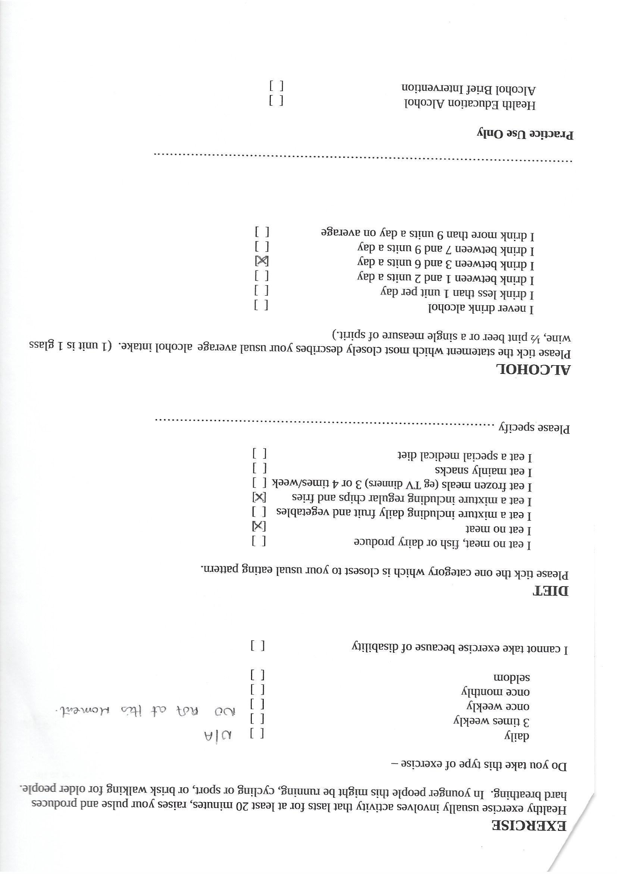

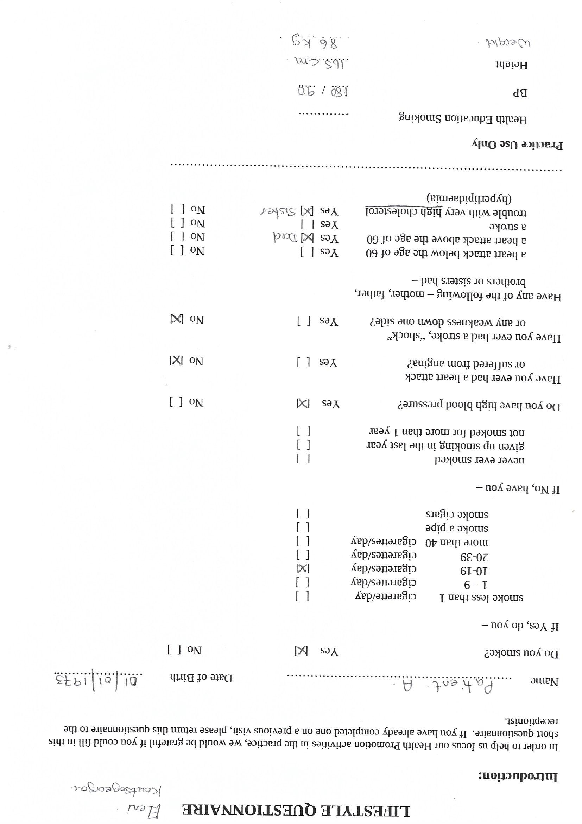

Referencing

nhs.uk. 2019. Diabetes. [online] Available at: <https://www.nhs.uk/conditions/diabetes/> [Accessed 20 July 2021].

www.heart.org. 2021. Diabetes Risk Factors. [online] Available at: <https://www.heart.org/en/health-topics/diabetes/understand-your-risk-for-diabetes#:~:text=The%20changes%20can%20also%20improve%20your%20overall%20quality,risk%20factors%20for%20prediabetes%20and%20Type%202%20diabetes.> [Accessed 20 July 2021].

Moini, J., 2019. Pathophysiology of Diabetes - an overview | ScienceDirect Topics. [online] Sciencedirect.com. Available at: <https://www.sciencedirect.com/topics/medicine-and-dentistry/pathophysiology-of-diabetes#:~:text=The%20pathophysiology%20of%20diabetes%20is%20related%20to%20the,the%20peripheral%20tissues%20resist%20the%20effects%20of%20insulin.> [Accessed 20 July 2021].
Topics, H., 2021. How to Prevent Diabetes: MedlinePlus. [online] Medlineplus.gov. Available at: <https://medlineplus.gov/howtopreventdiabetes.html> [Accessed 26 July 2021].

u.osu.edu, n.d. Diabetes Mellitus Type 2: Pathophysiology. [image] Available at: <https://u.osu.edu/diabetestype2/diagnosis/> [Accessed 20 July 2021].

www.diabetes.co.uk, 2019. Brittle Diabetes (Labile Diabetes). [image] Available at: <https://www.diabetes.co.uk/brittle-diabetes.html> [Accessed 20 July 2021].
nhs.uk. 2020. Your NHS Health Check results and action plan. [online] Available at: <https://www.nhs.uk/conditions/nhs-health-check/your-nhs-health-check-results-and-action-plan/> [Accessed 26 July 2021].

galicia-Garcia, u., 2020. [Online]
Available at: www.ncbi.nlm.gov
Jane Kelly, M., n.d. [Online]
Available at: www.cdc.gov
M.D, J. K., n.d. CDC national center for chronic disease. [Online]
Available at: http://www.cdc.gov/diabetes
Ph.D, T. H., 2018. [Online]
Available at: www.nih.gov
Ph.D, T. h., 2018. nih.gov/news-events. [Online]
Available at: www.nih.gov
Tinna Hicklin, P., 2018. nih.gov. [Online]
Available at: www.nih.gov
Unai Galicia-Garia, A. B.-V. C. M., 2020. [Online]
Available at: www.ncbi.nlm.nih.gov

