Top of Form
SOFTWARE DEVELOPMENT TEST April 2022 (30%)

NOTE: The test uses a question bank on Moodle. Students are served a random sample from each group of questions below.

Q1-3 – Variable types (3 questions from the below - 1 mark each)

Variables 1
What type would Python infer for a variable holding the following value?
John
- Answer

Variables 10
What type would Python infer for a variable holding the following value?
24
- Answer

Variables 11
What type would Python infer for a variable holding the following value?
63000
- Answer

Variables 12
What type would Python infer for a variable holding the following value?
g
- Answer

Variables 13
What type would Python infer for a variable holding the following value?
-26.1
- Answer

Variables 14
What type would Python infer for a variable holding the following value?
0.004
- Answer

Variables 15
What type would Python infer for a variable holding the following value?
Christopher
- Answer

Variables 16
What type would Python infer for a variable holding the following value?
56
- Answer

Variables 2
What type would Python infer for a variable holding the following value?
4.192
- Answer

Variables 3
What type would Python infer for a variable holding the following value?
64995
- Answer

Variables 4
What type would Python infer for a variable holding the following value?
2
- Answer

Variables 5
What type would Python infer for a variable holding the following value?
b
- Answer

Variables 6
What type would Python infer for a variable holding the following value?
-6.23
- Answer

Variables 7
What type would Python infer for a variable holding the following value?
-1.23
- Answer

Variables 8
What type would Python infer for a variable holding the following value?
bert
- Answer

Variables 9
What type would Python infer for a variable holding the following value?
67.456
- Answer

Q4-6 – Variables – which of the following variables are valid? (3 questions from the below - 1 mark each)

Variables 1b (1)
Is the below a valid Python variable name? If not, why not?
finally = 1
- Answer

Variables 1b (2)
Is the below a valid Python variable name? If not, why not?
except = 23
- Answer

Variables 1b (3)
Is the below a valid Python variable name? If not, why not?
return = 25
- Answer

Variables 1b (4)
Is the below a valid Python variable name? If not, why not?
My_Number = 24
- Answer

Variables 1b (5)
Is the below a valid Python variable name? (Yes/No) If not, why not?
_my_price = 3
- Answer

Variables 1b (6)
Is the below a valid Python variable name? (Yes/No) If not, why not?
end.value = 8
- Answer

Variables 1b (7)
Is the below a valid Python variable name? (Yes/No) If not, why not?
try3 = 8
- Answer

Variables 1b (8)
Is the below a valid Python variable name? (Yes/No) If not, why not?
myPrice = 4.567
- Answer

Q7 – Random selection of 1 of the below questions (5 marks)

Q2 - function calculation
What errors are present in the following code listing to do a calculation with two numbers and print the result on the screen? Write your answers in the box below. Line numbers are included for easy reference
1 def calculate():
2 total = v1 + v2;
3 print("The total was ")
4
5
6 print("Welcome to my program)
7
8 myValue1 = input()
9 myValue2 = input()
10
11 calculate(myValue1, myValue2)

Q2 - triangle
What errors are present in the following code listing to calculate the area of a triangle and print it on the screen? Write your answers in the box below. Line numbers are included for easy reference
1 print('Enter base: ')
2 base = input()
3
4 print "Enter height: "
5 height = input()
6
7 total = base * base / 2
8
9 print("The area of the triangle is", total);

Q2 - welcome
What errors are present in the following code welcoming a user to a program? Write your answers in the box below. Line numbers are included for easy reference
1 print(Welcome to my program")
2
3 print("Please enter your name: ")
4 myName = int(input())
5
6 print("Welcome, " myName)
7
8 print("I shall say hello to you 10 times: ")
9
10 for counter in range(0, 11)
11 print("Hello")

Q8-9 – 2 random questions from the below (2 marks each)

I1
How many iterations does the following loop have?
for i in range(0, 8, 1):
print("Hello")
- Answer

I2
How many iterations does the following loop have?
for counter in range(2, 8):
print("Hello")
- Answer

I3
How many iterations does the following loop have?
for i in range(1, 6):
print("Hello")
- Answer

I4
How many iterations does the following loop have?
for i in range(1, 9):
print("Hello")
- Answer

I5
How many iterations does the following loop have?
for i in range(4, 8, 1):
print("Hello")
- Answer

I6
How many iterations does the following loop have?
for i in range(0, 8, 2):
print("Hello")
- Answer

I7
How many iterations does the following loop have?
for i in range(10, 5, -1):
print("Hello")
- Answer

I8
How many iterations does the following loop have?
for i in range(8, 4, -1):
print("Hello")
- Answer

Q10 – 1 random question from the below (3 marks)

T1
What is the value of variable total after the following code is executed?

total=1
for x in range (0,9):
total=total + x
if x == 5:
total = 0
- Answer

T2
What is the value of the variable total after the following code is executed?
total = 1
for x in range(0, 8, 1):
total = total + x
if x == 5:
total = 0

- Answer

T3
What is the value of the variable total after the following code is executed?
total = 1
for x in range(0, 10, 1):
total = total + x
if x == 5:
total = 0
- Answer

Questions 11-14 – 4 questions randomly selected from the below (0.5 marks each)

T/F 01
Given the following values x=5, y=3, z=12 is the statement below true or false?
x==y
- True
- False

T/F 02
Given the following values x=5, y=3, z=12 is the statement below true or false?
x > z/y
- True
- False

T/F 03
Given the following values x=5, y=3, z=12 is the statement below true or false?
z != y*4
- True
- False

T/F 04
Given the following values x=5, y=3, z=12 is the statement below true or false?
z = y+8
- True
- False

T/F 05
Given the following values x=5, y=3, z=12 is the statement below true or false?
z < y*x
- True
- False

T/F 06
Given the following values x=5, y=3, z=12 is the statement below true or false?
z = y*4
- True
- False

T/F 07
Given the following values x=5, y=3, z=12 is the statement below true or false?
x = z-7
- True
- False

T/F 08
Given the following values x=5, y=3, z=12 is the statement below true or false?
z > y*y
- True
- False

T/F 09
Given the following values x=5, y=3, z=12 is the statement below true or false?
x < z/y
- True
- False

T/F 10
Given the following values x=5, y=3, z=12 is the statement below true or false?
x*z > x*y
- True
- False

Q15 – One question from the below (10 marks)

Programming 1 of 3 - Calculating the surface area of a sphere
The surface area of a sphere is calculated using the formula:
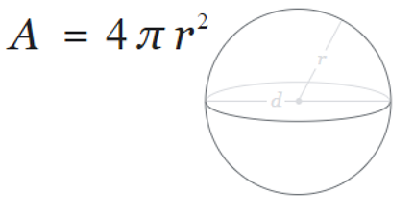
Task:
Write a program to calculate the area using the above formula.
Allow the user to enter the measurement for r. r should be a positive number. You can set pi to 3.142.
Print the area on the screen to 2 decimal places

Write your program using Python/PyCharm (or any other Python editor you may favour)
Copy and paste your code into the box below for submission.

Programming 1 of 3 - Calculating the volume of a sphere
The volume of a sphere is calculated using the formula:
Task:
Write a program to calculate the volume using the above formula.
Allow the user to enter the measurement for r. r should not be negative. You may set PI as 3.142
Print the volume on the screen to 2 decimal places
Write your program using Python/PyCharm (or any other Python editor you may favour)
Copy and paste your code into the box below for submission.

Programming 1 of 3 - Calculating the volume of a square-based pyramid
The volume of a square-based pyramid is calculated using the formula:
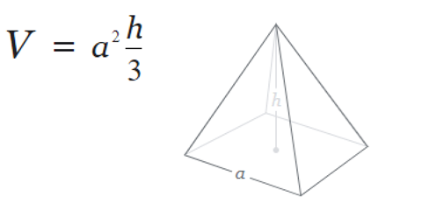
Task:
Write a program to calculate the volume using the above formula.
Allow the user to enter the measurements for a and h. Both a and h should be positive numbers.
Print the volume on the screen to 2 decimal places

Write your program using Python/PyCharm (or any other Python editor you may favour)
Copy and paste your code into the box below for submission.

Programming 1 of 3 - Calculating the volume of a square-based pyramid (copy)
The volume of a cone is calculated using the formula:
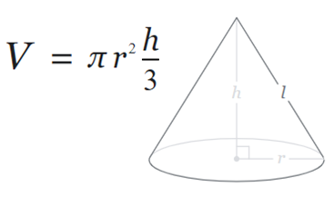
Task:
Write a program to calculate the volume using the above formula.
Allow the user to enter the measurements for r and h. Both r and h should be positive numbers. You can set pi to 3.142
Print the volume on the screen to 2 decimal places

Write your program using Python/PyCharm (or any other Python editor you may favour)
Copy and paste your code into the box below for submission.

Q16 – One question from the below (15 marks)

Programming 2 of 3 - Using lists (ages)
Write a program designed to calculate the average age of some people in a room. There are 6 people in the room. Start by declaring an empty list eg
ages = []
1. Prompt the user to enter the six ages.
2. After the ages have been entered, print each of them on the screen.
3. Calculate the average age of the people in the room (to 2 decimal places) and print it on the screen.
Use loops where appropriate
Sample output:
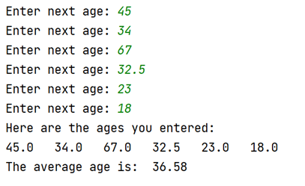
Write your program using Python/PyCharm (or any other Python editor you may favour)
Copy and paste your code into the box below for submission.

Programming 2 of 3 - Using lists (mileage)
A salesman wants to calculate the number of miles he has covered in the last working week (Monday to Friday), and also the new total mileage for his car which was 8600 miles at the beginning of the week.
Start by declaring an empty list eg
miles = []
1. Prompt the user to enter the five mileage figures for the week.
2. Print each of the mileage figures on the screen.
3. Calculate the total mileage for the week.
4. Calculate the new mileage for the car (it was 8600 at the start of the week)
Use loops where appropriate
Sample output:
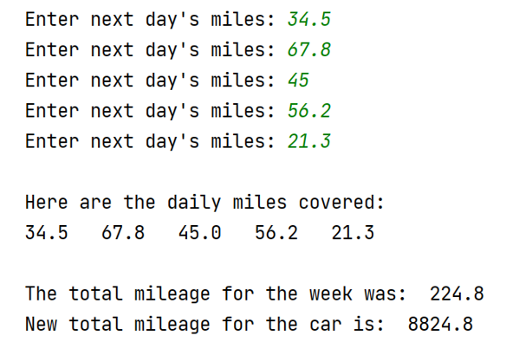
Write your program using Python/PyCharm (or any other Python editor you may favour)
Copy and paste your code into the box below for submission.

Programming 2 of 3 - Using lists (rainfall)
Task:
Declare an empty list in your program to hold some measurements, for example:
measures = []
1. Prompt the user to enter five rainfall measurements into a list (in millimetres). (eg 3.3, 5.0, 2.6 etc)
2. Print each of the entered values on the screen using a loop.
3. Calculate the total rainfall (ie add all five measurements)
Print the total on the screen.
Sample output:
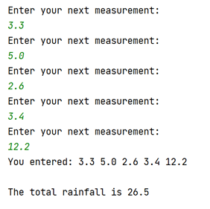
Write your program using Python/PyCharm (or any other Python editor you may favour)
Copy and paste your code into the box below for submission.

Q17 – One question from the below (15 marks)

Programming 3 of 3 - Using Functions (delegates)
Task: Write a function called entername() to allow the user to enter the names of three conferences delegates in turn. The function should be called 3 times, once for each of the conference delegates, and the name entered returned to the main program.
Print the names entered from the main program, then calculate the total bill for attending the conference (£65 per person) and print it on the screen
Sample output:
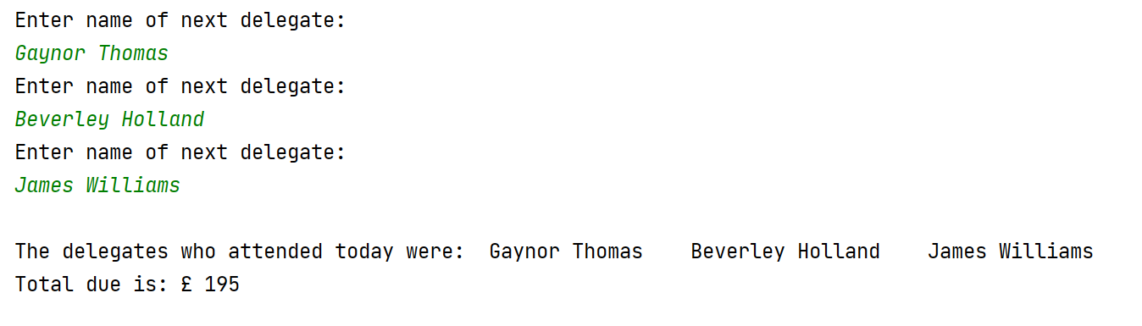
Write your program using Python/PyCharm (or any other Python editor you may favour)
Copy and paste your code into the box below for submission.

Programming 3 of 3 - Using Functions (mobile numbers)
Task: Write a function called enterphone() to allow the user to enter some UK mobile phone numbers. The function should be called 3 times, once for each of the numbers, and the numbers entered returned to the main program.
Print the numbers entered from the main program, then print the total cost of the call plans (£12.99 per number)
Sample output:
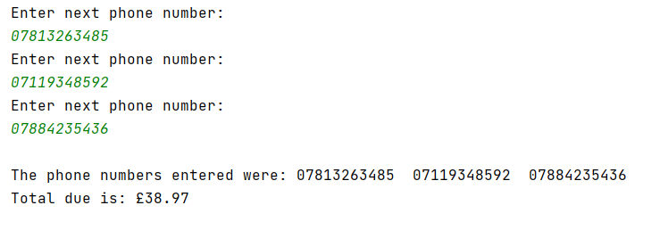
Write your program using Python/PyCharm (or any other Python editor you may favour)
Copy and paste your code into the box below for submission.

Programming 3 of 3 - Using Functions (parcel)
Task: Write a function called entermeasurement() to allow the user to enter a measurement for a parcel - length, width and height in turn. The function should be called 3 times, once for each of the measurements, and the value entered returned to the main program.
Print the measurements entered from the main program, then print the volume of the parcel (length * width * height)
Sample output:
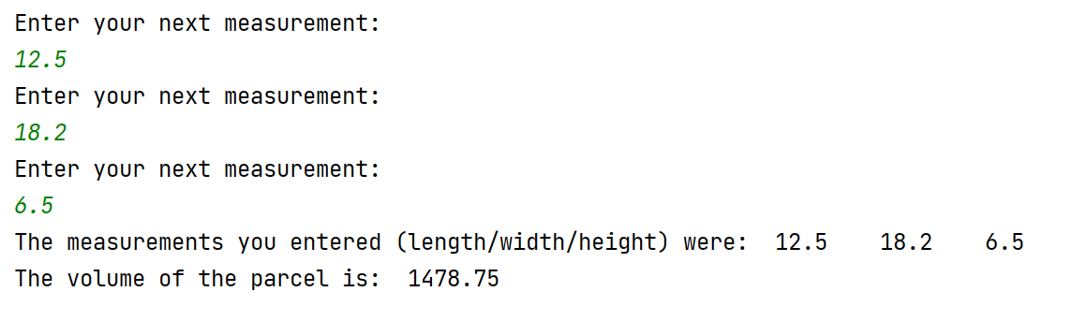
Write your program using Python/PyCharm (or any other Python editor you may favour)
Copy and paste your code into the box below for submission.
[60 marks total]
Bottom of Form

