THE GLOBAL BUSINESS ENVIRONMENT
LCBB4005

New Business Opportunities
and
Product Life Cycle

Lecturer Dr. Syed Jaffery

Student: Ligia Neacsu 1905215

Table of Contents
Introduction: 3
LO1 - Recognition of the major forces that contribute to the global business environment and accomplishment of an understanding of the changing global business environment: 4
LO2 - Application of business models within the context of an analysis of European electronic vehicle industry: 8
LO3 - Identification, and evaluation of the reasons for which organizations engage in international trade: 11
LO4 - Assessment of the markets in action, understanding the microeconomics and macroeconomics foundation of those actions, different market structure and their influence on organizational strategy, long-run and short-run changes, and major features of the international economy: 12
Conclusion: 14
References: 15

Introduction:
The world economy depends mainly on the production of raw materials. But that doesn't mean that the contribution different organizations are doing to the global economy by transforming the raw materials in usable goods is not significant. These two different types of production are two different sides of a coin in which both are important to create and maintain the value. In the current situation of the Global Business Environment, the world economy is opening new doors for corporations to engage themselves in international business and to contribute to the world economy. And in this situation, the success of this organization and the success of the global economy depend on the global Business Environment. The automobile industry in Europe is a large contributor to the global economy and a lot of the world's largest corporations are involved in this industry. Due to technological advancement and social awareness to save the environment recently this industry is going through a large potential change that is OK to change the whole structure of this industry. This report contains a discussion about that significant change in which the automotive industry of Europe is transforming its products from conventional IEC engine operated vehicles to Electronic vehicles. This is surely a bold move which will, in the long run, bring fruitful outcome for all the stakeholders of this industry.

LO1 - Recognition of the major forces that contribute to the global business environment and accomplishment of an understanding of the changing global business environment:
Global Business Environment refers to the environment for business around the world that consists of several factors that have a direct or indirect impact on the operations of the business organization, their relationship with their customers, and their success. The automotive industry is one of the top contributing industries in the global economy (Dyker, 2010). It contributes to a wide range of other upstream and downstream business segments also. Moreover, other industries that are related to the automotive industry contribute to the lion share of the global economy (Evaluation- Electronic vehicles in Europe: gearing up for a new phase?, 2014). The business environment of the automotive industry of Europe is influenced by a lot of forces which can be better identified by PESTLE analysis of the electrified car industry in Europe.

PESTLE ANALYSIS of the electric car industry in Europe-
Political factors: Political factors in PESTLE analysis refers to the influence or impact of the political structure of a country in its business environment. In European countries, governments play a very active role in monitoring or supervising any kind of industry. The automotive industry is one of the largest industries contributing to a huge scale to the economy of those countries (Schulz, 2009). Show the political structure of the Government of European countries is very much active in the case of the electrified car industry. And the political influence in this industry is very much positive because governments of European countries are very much concerned about the environment and that's why they are promoting the production of electrified automobiles in European countries. The primary objective of the governments of European countries to promote electrified cars is to reduce the carbon footprint which is generated from the ICE engine. Electrified vehicles can prevent the emission of carbon dioxide and NOx (Electric Vehicles | ACEA - European Automobile Manufacturers' Association, 2020). To promote production and uses of electronic vehicles by maintaining demand and supply government is providing subsidies and rebates to the producers and users. Moreover, governments are establishing rules, regulations, and targets for organizations producing automobiles.
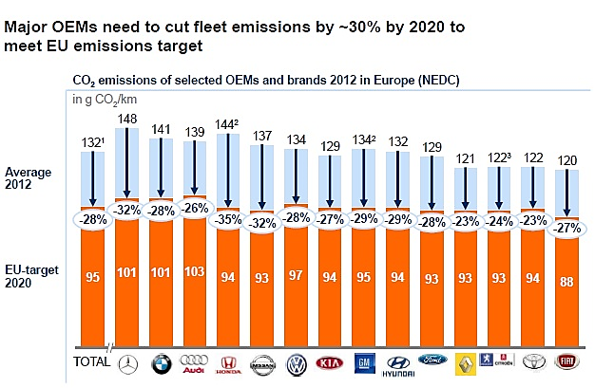
Figure 1 Governments’ target to cut fleet emission (Evaluation- Electronic vehicles in Europe: gearing up for a new phase?, 2014)

Economic factors: Economic factors refer to the influencing factors that are part of the economy of European countries. The main economic factors that influence the electronic vehicle industries in Europe are the production cost, marketing of, different custom duties and various taxes that are associated (Schulz, 2009). Evaluation of the market of the electronic vehicle in Europe depend on economic factors. Because this factor determines the cost of establishing the infrastructure and cost of production. As a result, the factors influence the price of the product (electronic vehicles). In European countries, economic factors influence the electronic automotive industry is positive. Because to support the production and promotion of the electronic vehicle industry the government is providing subsidies and various kinds of exemptions (Examination of current and future excess capacity in the European automobile industry, 1997). This activity influences the organizations of the industry to focus on the production of electronic vehicles and motivates the customers to purchase an electronic vehicle.
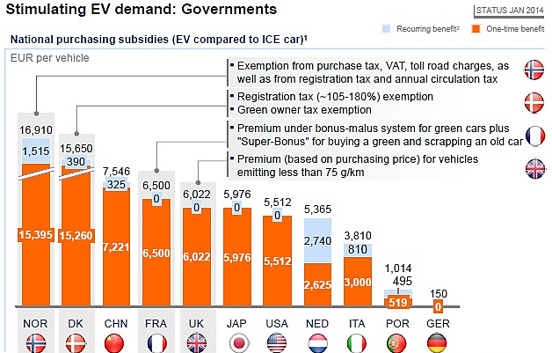
Figure 2 Governments contribution in stimulating EV demand (Evaluation- Electronic vehicles in Europe: gearing up for a new phase?, 2014)
This figure represents the contribution of the governments of European countries through economic factors to stimulate the production and demand of electronic vehicles in Europe.

Social factors: Social factor refers to the trend or culture of the society that influences the demand, acceptance, and value. Citizens in European countries are comparatively more aware of the environment than the other part of the world. As a result, they are very much concerned about the negative aspects of ICE engines producing carbon dioxide and NOx (Electric Vehicles | ACEA - European Automobile Manufacturers' Association, 2020). So they are more interested in using electronic vehicles 2 to reduce the emission of carbon dioxide and other toxic gases. This is a positive social factor of the electric automatic industry in Europe.

Technological factors: Technological factor refers to the technological advancement that can support the electronic vehicle industries in Europe. The automotive industry in Europe is technically advanced on every higher level but as the concept of the electronic vehicle is a recent Innovation and it has yet not gained a properly developed structure, there is a lack of technological advancement (Schulz, 2009). Increase of technological factors European countries are lagging in the case of production and sale of electronic cars. ICE engine operated vehicles are been used for a very long time and the introduction of electronic vehicles as yet not been adopted by a large population. Moreover due to lack of technological advancement customers sometimes have to face technological difficulties, which in result demotivates the probable customer.

Legal factors: Legal factors refer to the regulations that are related to the production, distribution, and utilization of electronic vehicles in European countries. In the case of the operations of the automotive industry, legislations are very much important because their production strategy and distribution strategy depends on legislations (Safdar, Raza, Khan and Ali, 2017). As the governments of European countries are concerned about the protection of the environment, legislations are supported to the production and distribution of electronic vehicles because they are concerned about reducing carbon dioxide and other gases that emit from ICE engines of conventional vehicles. Both the Producers and Consumers are getting legal benefits in case of production, distribution, and utilization of electronic vehicles.

Environmental factors: Environmental factors influence the electronic vehicle industry because the automotive industry is directly associated with the environment because its production and utilization has a large impact on the environment (Examination of current and future excess capacity in the European automobile industry, 1997). As we have learned the government and people of European countries are very much eager to reduce the emission of carbon dioxide and other toxic gases from conventional ICE engine vehicles, environmental factors are positively influencing the electronic vehicle industry in Europe. Because the promotion and use of electronic vehicles are helping the government and people to reduce the amount of carbon dioxide and other gases emission by reducing the use of conventional ICE engine vehicles.

LO2 - Application of business models within the context of an analysis of European electronic vehicle industry:
Business organizations are profit-motivated and operations are conducted to maximize. A business model refers to a business plan that enables an organization to earn a profit. There is a wide range of business models that are well established and has a reputation for successful implication in different business structures (Safdar, Raza, Khan and Ali, 2017). Hair is a discussion about some Business models that can be successfully implicated in electronic vehicle industry of Europe-
Porter's Diamond model: It is a very popular and established business model developed by Michael Porter. This model analysis nation wise competitiveness of a particular industry. The organizations in the electronic vehicle industry of European countries can use this business model to analyze the competitive environment in this industry.
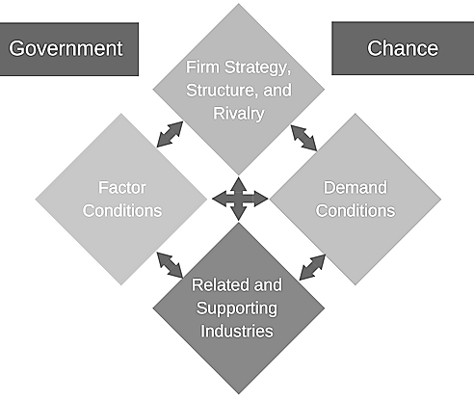
Figure 3 Porter's Diamond Model (Niestadt and Bjørnåvold, 2019)
According to this model, there are four determinants of the function of organizations in the electronic vehicle industry of Europe. Those are-
Factor conditions: Factor condition contains a discussion about different kinds of resources available to this industry. The factor conditions that make the electronic automotive industry Europe competitive are technological advancement, legal benefits, government-provided subsidies and exemptions, people's awareness and many more (Muller, 2016).
Demand conditions: Demand conditions are influenced by the increasing demand for electronic vehicles in the market of Europe. Government and people being concerned about the emission of carbon dioxide and other toxic gases by conventional ICE engines, the demand for electronic vehicles is increasing day by day because this vehicles do not emit any kind of toxic gas. Moreover, the government is providing subsidies and many other than benefits that are contributing to the increase of demand of the electronic automotive industry (Green propulsion in transport - Mobility and Transport - European Commission, 2009).
Related and supporting industries: The performance and success of the electronic vehicle industry of Europe are is relying on the support it gets from some other industries that are directly or indirectly associated with the production and distribution of electronic vehicles in Europe (Niestadt and Bjørnåvold, 2019). Such as the suppliers who provide support for developing the structure of electronic vehicles, the suppliers who provide technical support to establish electric functions, suppliers provide batteries, and many more.
Firm Strategy, Structure, and Rivalry: The comparativeness for the organizations in the electric automotive industry of Europe is determined by the organizations themselves when they set their organizational strategy and structure. Almost all large automotive industry organization have their operation and market in European countries. So it cannot be denied that there is rivalry among some of them. But in most of the cases, the electronic vehicles offered by the organizations are distinctive and have a separate customer base (Green propulsion in transport - Mobility and Transport - European Commission, 2009).
Government: The development of the electronic vehicle industry in Europe would not have been possible without the contribution of the governments of European countries. Because to save the environment they have minimized legislations, provided subsidies and exemptions, and many more. Without this role of the governments, the production cost and selling price would rise and which would have resulted in a fall in demand (Muller, 2016).
Chance conditions: Chance conditions are the opportunities of the market. The electronic bicycle industry of Europe is getting many benefits from the chance condition because due to social awareness and government initiatives there is a demand in the market for this industry.

Porter's Five Forces Model:
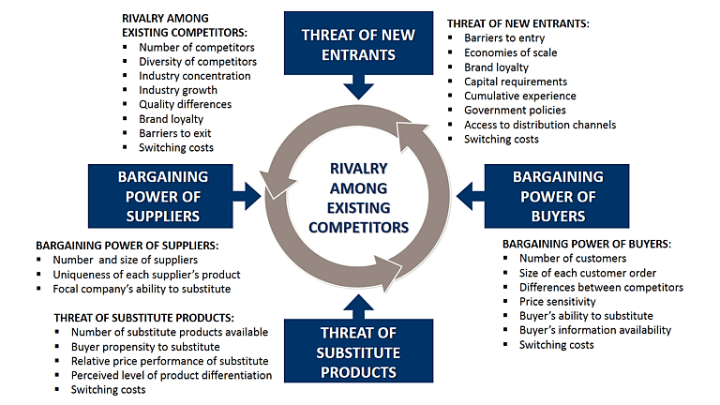
Figure 4 Porter's Five Forces Model (Norbye, 2006)
This figure contains all the pros and cons of the five forces model developed by Michael Porter. This model analyze the most influencing five forces of the business environment. By integrating these models organizations in the electronic vehicle industry of Europe can achieve a better plan for the operations of the organization.

LO3 - Identification, and evaluation of the reasons for which organizations engage in international trade:
In this era of globalization, the world is a very small place and it would not be a wise decision for a large organization to leave a large potential customer segment just because they are located outside a specific territory, instead of having the capacity to serve them (Belloc, 1967). Most of the automotive industries that are involved in the production of electronic vehicles are very large in capital and operation and they can serve a large population that is not limited to a nation for a specific area. So these organizations are motivated to engage in the international market of the production of electric vehicles (IEEE standard for environmental conditions for transit rail car electronic equipment, 2001). Moreover, as these organizations are profit motivated, engaging in international trade is the best option for maximization of their profit outcome.
The main reasons that operations involved in the production of electronic vehicles are getting involved in international trade in European countries and other countries out of it are the followings-
To expand sales: These organizations have the capacity and using that capacity they can expand their sales by addressing a bigger customer segment in the international market.
To acquire resources: Engagement in the international market of European countries and other countries enables those organizations to acquire resources for their production and distribution from those countries (Dyker, 2010).
To diversify sources of sales and supplies: Diversification is widely used and a very effective strategy in any type of business. Diversification of the sources of supplies and self enables an organization to minimize its risk (Norbye, 2006).
To minimize competitive risk: Engagement in international trade opens the door of addressing a large population which as a result reduces the risk of competitiveness.

LO4 - Assessment of the markets in action, understanding the microeconomics and macroeconomics foundation of those actions, different market structure and their influence on organizational strategy, long-run and short-run changes, and major features of the international economy:
The electronic automobile industry of the European countries is operating in a perfectly competitive market. Large number of reputed manufacturers are contacted their business in this market. They are operating their business with a distinguished customer base and targeting sophisticated customer segments (Dyker, 2010). Market structure can be of different types. And different types of the market have different types of influences on the operational strategy adopted by the organizations operating in that market.
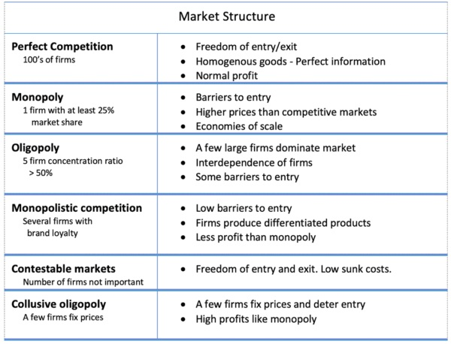
Figure 5 Different market structures (Andō, 2005)
This figure there is a property prostration of different structures of the market and their features. This is structures influence the organization to adopt the organizational strategy in different ways (Norbye, 2006).
In the short run consideration electronic automobile industry may not seem to be very much spectacular which can gain a lot of market share or a lot of revenue from the market. It is because there are some technological lacks that our yet to be addressed. And the use of electronic vehicle might prevent the users from some facilities they got from conventional vehicles. But in the long run, electronic automobile industry is a potential factor that is sure to achieve greater success (Andō, 2005). Because due to the tendency of people around the world to reduce the use of non-renewable energy like oil to safeguard the environment from carbon dioxide and other toxic elements generated from those energy sources will result in a reduction in the use of conventional ICE engine in the automotive industry. And it will result in an expansion of the business and production of electronic vehicles.

Conclusion:
The discussion conducted here in this report represents a significant overview of the radical change going on in the automotive industry of Europe. Proper utilization of this content will facilitate and user to understand what is the change that caused the increase in the production of electronic vehicles and a decrease in the production of conventional IEC engine operated vehicles. They will get a proper concept about which are the factors that are influencing the business environment of the automotive industry in Europe.

References:
1997. Examination Of Current And Future Excess Capacity In The European Automobile Industry. Luxembourg: Office for Official Publications of the European Communities.
2001. IEEE Standard For Environmental Conditions For Transit Rail Car Electronic Equipment. New York: Institute of Electrical and Electronics Engineers.
Acea.be. 2020. Electric Vehicles | ACEA - European Automobile Manufacturers' Association. [online] Available at: <https://www.acea.be/industry-topics/tag/category/electric-vehicles> [Accessed 8 May 2020].
Andō, K., 2005. Japanese Multinationals In Europe. Cheltenham [etc.]: Edward Elgar.
Belloc, H., 1967. On. Freeport, N.Y.: Books for Libraries Press.
Dyker, D., 2010. Network Dynamics In Emerging Regions Of Europe. London: Imperial College Press.
Mckinsey.com. 2014. Evaluation- Electronic Vehicles In Europe: Gearing Up For A New Phase?. [online] Available at: <https://www.mckinsey.com/~/media/mckinsey/locations/europe%20and%20middle%20east/netherlands/our%20insights/electric%20vehicles%20in%20europe%20gearing%20up%20for%20a%20new%20phase/electric%20vehicles%20in%20europe%20gearing%20up%20for%20a%20new%20phase.ashx> [Accessed 8 May 2020].
Mobility and Transport - European Commission. 2009. Green Propulsion In Transport - Mobility And Transport - European Commission. [online] Available at: <https://ec.europa.eu/transport/themes/urban/vehicles/road_en> [Accessed 8 May 2020].
Muller, H., 2016. Large Scale Electric Car Sharing Stimulates EV Adoption and EVSE Infrastructure Deployment. World Electric Vehicle Journal, 8(3), pp.609-610.
Niestadt, M. and Bjørnåvold, A., 2019. Electric Road Vehicles In The European Union Trends, Impacts And Policies. [online] Europarl.europa.eu. Available at: <https://www.europarl.europa.eu/RegData/etudes/BRIE/2019/637895/EPRS_BRI(2019)637895_EN.pdf> [Accessed 8 May 2020].
Norbye, J., 2006. An Historical Whos Who Of The Automotive Industry In Europe. North Caroline: McFarland.
Safdar, I., Raza, A., Khan, A. and Ali, E., 2017. Feasibility, emission and fuel requirement analysis of hybrid car versus solar electric car: a comparative study. International Journal of Environmental Science and Technology, 14(8), pp.1807-1818.
Schulz, I., 2009. The change in the automotive industry: a comparison between Europe, USA, Japan. Production, 7(1), pp.57-67.

