Student Name: Adriana Balica  Student ID: 2232252  Module Title: Foreign Languages & Cultural Awareness  Module Code:5003  Lecturer: Lisa Bassler  Date: 8.02.2024 | 
ASSIGNMENT 1: PORTFOLIO
(4 Components)

Component 1: Professional Reflection (500 words +/- 10%)

Weighting: 25%
As the sun dipped below the London skyline, casting a warm glow over Hilton Paddington's upscale dining area, I found myself navigating a delicate cultural encounter during dinner service with a distinguished Japanese guest. A reservation for a solo diner, Mr. Yamamoto, a Japanese businessman, added an air of sophistication to the evening. Seated at a corner table, he inspects the menu with meticulous attention, his choice reflecting a blend of traditional and contemporary Japanese cuisine. Intrigued by the challenge of providing an exceptional dining experience, I approach Mr. Yamamoto with genuine warmth and respect. His order included a selection of sushi and a miso soup, showcasing his desire for a well-rounded Japanese meal. The potential for a cultural misunderstanding arose when the miso soup arrived at the table accompanied by a spoon. Unbeknownst to me, in Japanese dining etiquette, miso soup is traditionally consumed by lifting the bowl to the lips and sipping directly, without the use of a spoon. The subtle deviation from this practice caused a moment of hesitation for Mr. Yamamoto. Sensing the unspoken discomfort, I decided to address the situation delicately. With a polite smile, I engaged Mr. Yamamoto in conversation, expressing a genuine interest in ensuring his dining experience met his expectations. Utilising a translation app, I inquired about his preferences for enjoying miso soup and whether there were specific cultural nuances I should be aware of. Mr. Yamamoto, appreciative of my attentiveness, explained the traditional method of sipping miso soup directly from the bowl. He emphasised that the use of a spoon, while acceptable in some settings, differed from the customary practice in Japan. Quick to rectify the situation, I discreetly arranged for a replacement bowl of miso soup, sans spoon, adhering to the traditional Japanese presentation. As the revised dish arrived, Mr. Yamamoto's expression softened, and a subtle nod conveyed his approval. The evening continued with a renewed sense of harmony, and Mr. Yamamoto engaged in conversation, sharing insights into Japanese dining customs, and expressing gratitude for my openness to cultural nuances. The initial moment of misunderstanding transformed into an opportunity for cultural exchange, enriching both my experience and Mr. Yamamoto's dining journey. As the dinner concluded, Mr. Yamamoto departed with a gracious bow, appreciating the sincerity and adaptability displayed during the evening. Reflecting on the encounter, I recognised the significance of cultural awareness, even in seemingly small details like the presentation of a bowl of miso soup. This scenario underscored the importance of embracing diverse customs during dinner service, demonstrating Hilton Paddington's commitment to providing a truly inclusive and authentic experience for guests from around the world. The lesson learned resonated beyond that evening, leaving a permanent mark on my approach to catering to the nuanced preferences of international guests. Reflecting on this encounter, I realised that such experiences not only enrich the guest’s journey but also contributes to my own cultural awareness.
References:
- Bellah, R. N. (2005). Imagining Japan: The Japanese Tradition and Its Modern Interpretation. Sociology of Religion, 66(1), 85. https://doi.org/10.2307/4153118
- Shively, D. H. (2015). Tradition and modernization in Japanese culture. Princeton University Press.
- Tussyadiah, I. (2006). A Gourmet Trip: One direction of domestic tourism in Japan. Tourism Review International, 9(3), 281–291. https://doi.org/10.3727/154427206776886250

Component 2: Training Plan (500 words +/- 10%)

Weighting: 25%

Identified cultural misunderstanding (in a few words):
In the vibrant industry of hospitality, acknowledging and respecting diverse cultural backgrounds is paramount. Our recent experience with Mr. Yamamoto has illuminated the need for a comprehensive training plan to foster cultural sensitivity among Hilton Paddington's food and beverage employees. This plan aims to create an environment where every guest feels understood, appreciated, and accommodated regardless of their cultural preferences.
Training plan (Why/What//Who/Where/When):
Cultural Sensitivity Workshop
I propose the implementation of a Cultural Sensitivity Workshop, equipping our team with the knowledge and understanding necessary to navigate diverse cultural preferences. Through interactive sessions, we will explore different cuisines, dietary restrictions, and the significance of ingredients in various cultures.
Employees will actively participate in workshops led by cultural experts, providing insights into customs, traditions, and culinary expectations from different regions. These sessions will encourage open dialogue, fostering a deeper appreciation for the richness of cultural diversity.
Guest Preference Inquiry Protocol
Recognising the importance of personalisation, I suggest incorporating a discreet inquiry about guests' cultural preferences during the reservation process. This information will be recorded in our booking system, allowing us to tailor our service to individual tastes.
To enhance guest satisfaction, staff members will be trained to delicately ask about dietary preferences, allergies, and cultural considerations during reservation interactions. This personalised approach ensures that each guest's unique needs are anticipated and met.
Menu Transparency and Symbolic Representation
I recommend updating our menu to include symbols or brief descriptions indicating spice levels, unusual ingredients, or any cultural influences. This will empower guests to make informed choices aligned with their preferences.
The menu will undergo a revision to incorporate visual cues, making it easier for both guests and staff to navigate. Clear indications of potential spice levels and cultural influences will be included, promoting transparency in our offerings.
Feedback Mechanism and Continuous Improvement
To foster a culture of learning and adaptation, I propose the establishment of a feedback mechanism. Guests will have the opportunity to share their experiences, including any cultural considerations they find lacking.
Regular team meetings will be scheduled to discuss guest feedback, creating a dynamic feedback loop. This process ensures that we continuously refine our services based on real-time insights, demonstrating our commitment to improvement.
Cultural Resource Library
I suggest creating a Cultural Resource Library within the hotel, offering quick references on various cultural practices, customs, and dining etiquette. This resource will empower employees to better understand and anticipate the needs of guests from diverse backgrounds.
A centralised library will be established, providing staff with valuable insights into the cultural intricacies of our global clientele. This resource will serve as a tool for ongoing education, fostering a more culturally aware and competent team.
By embracing these initiatives, we not only rectify past misunderstandings but also fortify Hilton Paddington's reputation as a hospitality haven that celebrates and respects the diversity of its guests. Through continuous learning and adaptation, we strive to create an inclusive environment where every guest feels at home, regardless of their cultural background.
References:
- Harris, P. R., & Moran, R. T. (1987). Managing cultural differences. Butterworth-Heinemann.
- Hutnik, N., & Gregory, J. (2008). Cultural sensitivity training: Description and evaluation of a workshop. Nurse Education Today, 28(2), 171–178. https://doi.org/10.1016/j.nedt.2007.03.012
- Kowalski, S. (2023). Cultural sensitivity training: Developing the Basis for Effective Intercultural Communication.

Component 3: Student Self-Reflection (500 words +/- 10%)

Weighting: 25%
Embarking on a journey as a food and beverage employee at Hilton Paddington has been a dynamic experience, marked by encounters that underscore the paramount importance of cultural awareness within the hospitality industry. The scenario with Mr. Yamamoto, a distinguished Japanese guest, serves as a poignant reflection point on my evolving, understanding of this crucial aspect of guest service. Initially, my perception of cultural awareness centred around acknowledging and respecting diverse backgrounds. However, the encounter with Mr. Yamamoto highlighted the need for a deeper understanding, extending beyond mere recognition. The pivotal question that arose was: How does one navigate the intricacies of cultural nuances to provide an authentic and seamless guest experience? Over time, I realised that cultural awareness is not a static concept but an ongoing process of learning and adaptation. The scenario with Mr. Yamamoto illuminated the dynamic nature of this understanding. I questioned my assumptions and recognised the importance of actively seeking insights into the specific preferences and customs of each guest, especially during dinner service where cultural nuances are more pronounced. The experience with Mr. Yamamoto was a catalyst for self-reflection, prompting me to question the assumptions embedded in my approach to service. Why did I assume that a spoon was the appropriate utensil for enjoying miso soup? How could I have proactively anticipated and addressed potential cultural differences before they became apparent? I learned that proactive communication is key in navigating cultural diversity. Instead of waiting for a guest to express discomfort, I could incorporate culturally sensitive questions during the ordering process. For instance, asking about preferred dining customs or any specific cultural considerations would not only demonstrate attentiveness but also prevent potential misunderstandings. The importance of this experience extends beyond individual interactions—it shapes the overarching reputation of Hilton Paddington as a culturally attuned establishment. A single cultural misunderstanding, if not addressed effectively, can impact a guest's perception of the entire dining experience. The question emerged: How does my role contribute to the broader reputation of the hotel, and how can I ensure that each guest feels understood and valued? This experience underscored the significance of adaptability within the hospitality industry. While maintaining the core of the hotel's offerings, the ability to adapt to the unique preferences of diverse guests ensures a truly inclusive and memorable experience. How can I balance maintaining the authenticity of the dining experience with the need to adapt to various cultural expectations? In conclusion, the scenario with Mr. Yamamoto propelled me to critically reflect on the evolving nature of my understanding of cultural awareness within the hospitality industry. It prompted a shift from passive acknowledgment to proactive engagement, from assumptions to inquiry. The importance of this experience lies in its transformative impact on my approach to service, emphasising the continuous learning required to navigate the rich tapestry of cultural diversity. Each interaction serves as an opportunity to enhance my cultural awareness, contributing not only to individual guest satisfaction but also to the broader reputation of Hilton Paddington as a paragon of inclusive hospitality.

References:
- Hunwicks, M. (1994). Cultural awareness: Hospitality Perspective.
- Hall, E. T., & Hall, M. R. (2004). Understanding cultural differences. In SAGE Publications, Inc. eBooks (pp. 41–73). https://doi.org/10.4135/9781452229706.n2
- Fong, E. H., Catagnus, R. M., Brodhead, M. T., Quigley, S. P., & Field, S. (2016). Developing the cultural awareness skills of behavior analysts. Behavior Analysis in Practice, 9(1), 84–94. https://doi.org/10.1007/s40617-016-0111-6

Component 4: Training Presentation (6 Slides)

Weighting: 25%
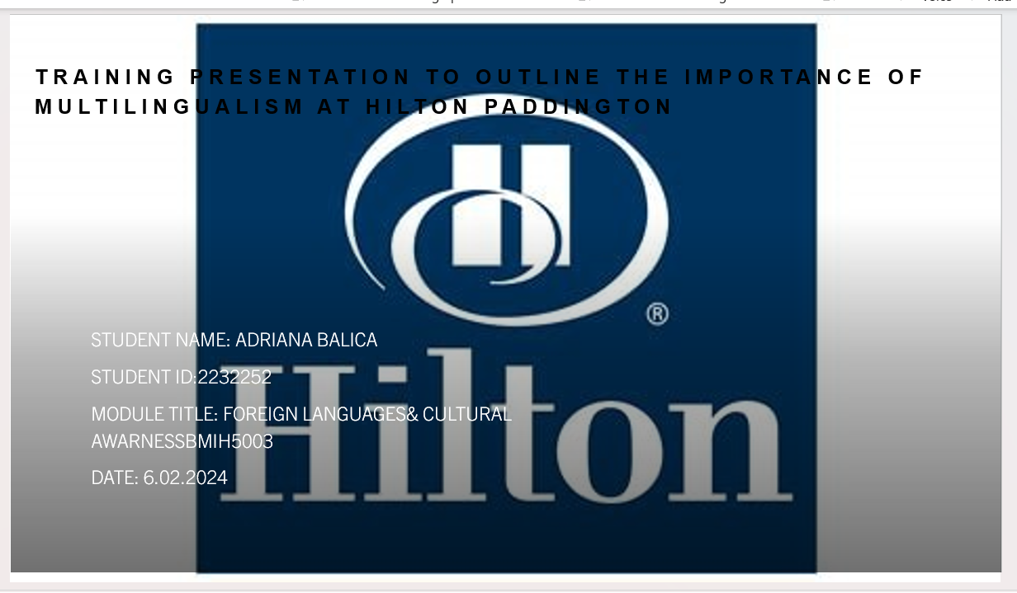
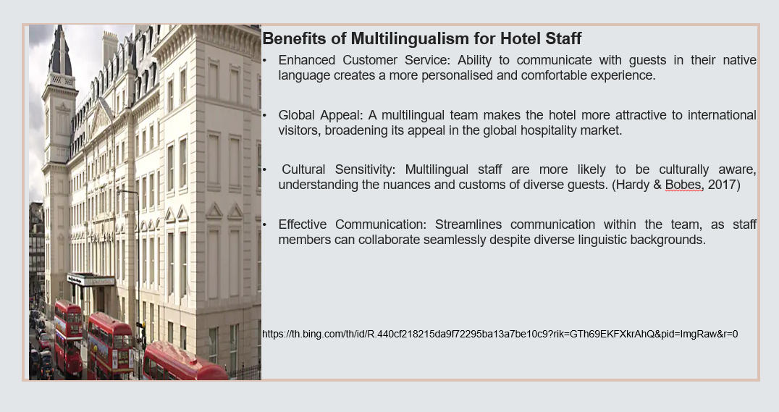

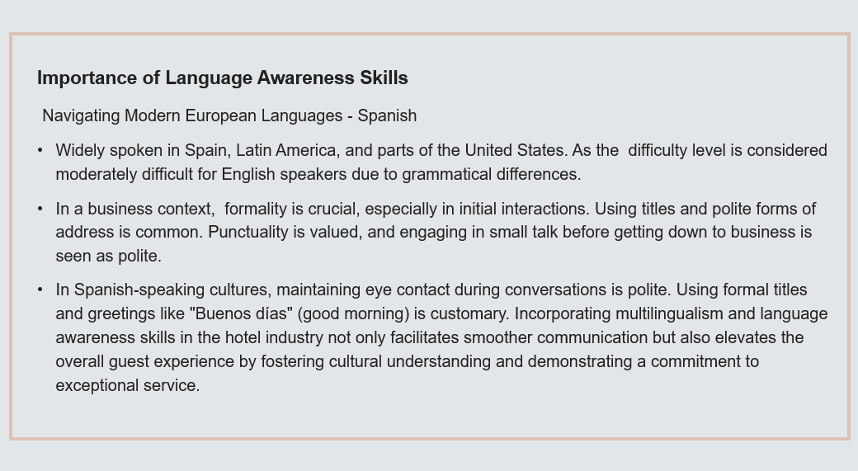

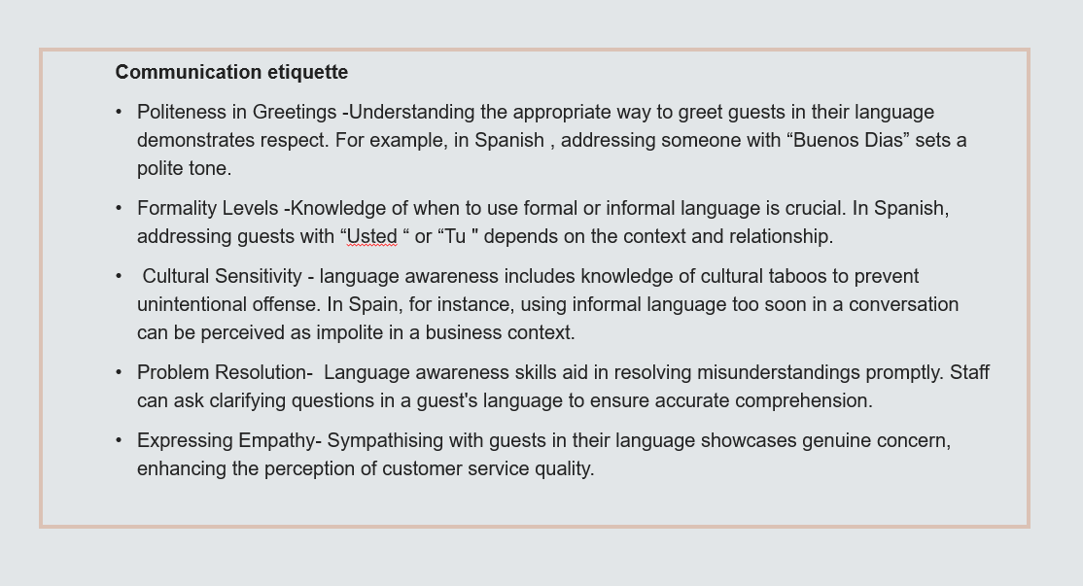

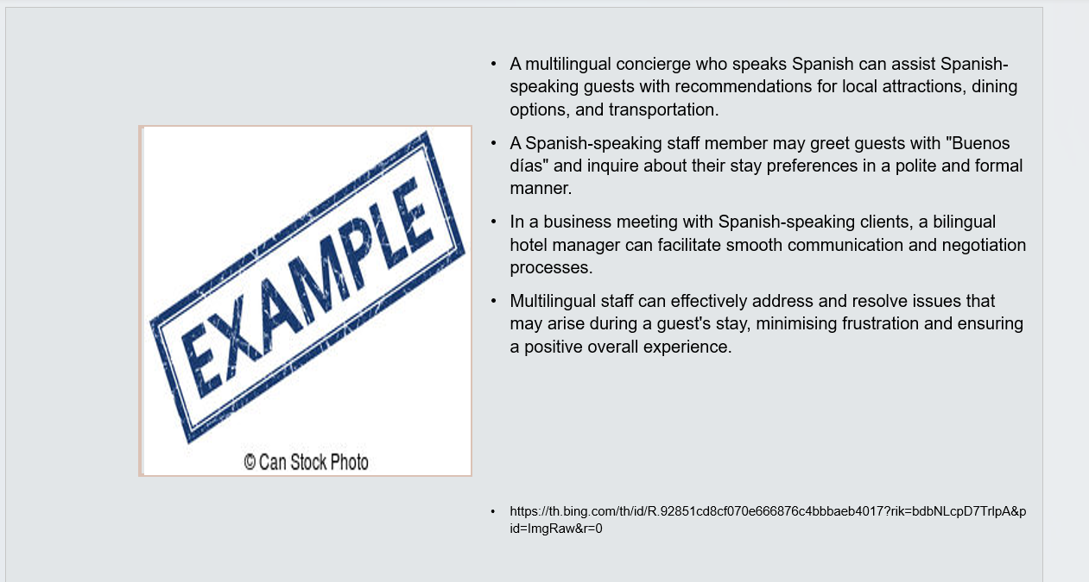
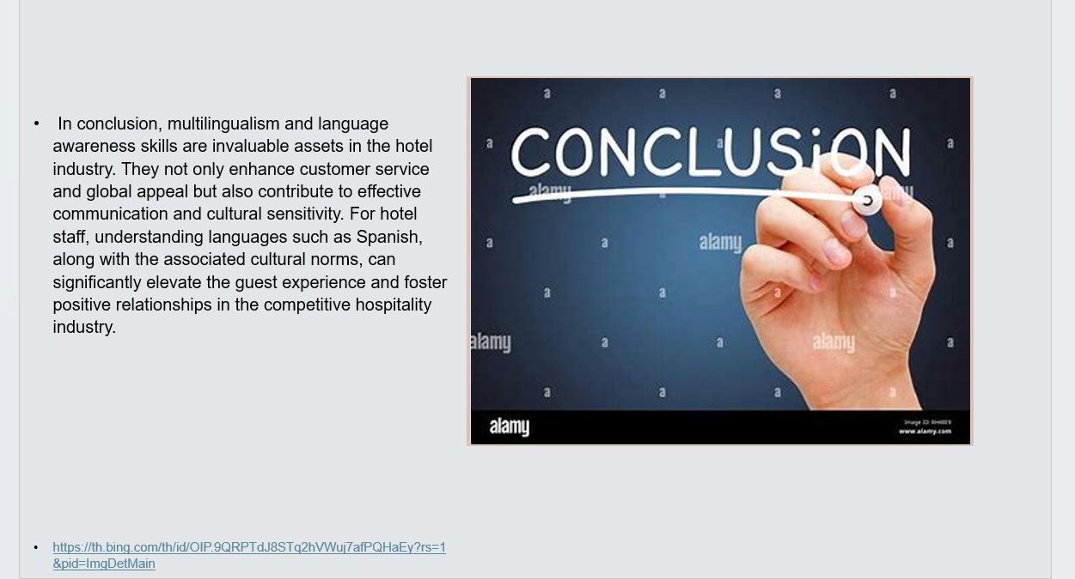

References (no screenshots):
- Burton, S. L. (2007). Quality customer service rekindling the art of service to customers. Lulu.com.
- Hardy, K. V., & Bobes, T. (2017). Promoting cultural sensitivity in supervision: A Manual for Practitioners. Routledge.
- Solomon, M. (2016). The heart of hospitality: Great Hotel and Restaurant Leaders Share Their Secrets. SelectBooks, Inc.
- Fong, E. H., Catagnus, R. M., Brodhead, M. T., Quigley, S. P., & Field, S. (2016). Developing the cultural awareness skills of behavior analysts. Behavior Analysis in Practice, 9(1), 84–94. https://doi.org/10.1007/s40617-016-0111-6
- Brulotte, R. L., & Di Giovine, M. A. (2016). Edible Identities: Food as Cultural Heritage. https://doi.org/10.4324/9781315578781

