

BMHP5014 Changemakers: Creativity and Value Creation

Component 2: Assignment (Report)
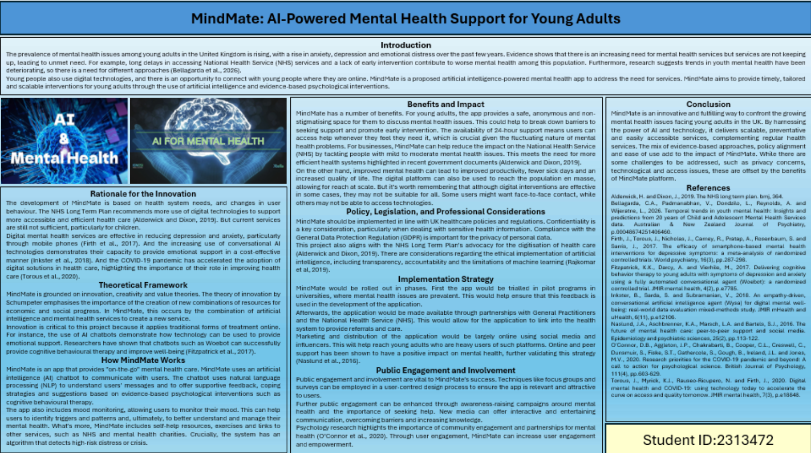
MindMate: AI-Powered Mental Health Support for Young Adults
Introduction
The prevalence of mental health issues among young adults in the United Kingdom is rising, with a rise in anxiety, depression and emotional distress over the past few years. Evidence shows that there is an increasing need for mental health services but services are not keeping up, leading to unmet need. For example, long delays in accessing National Health Service (NHS) services and a lack of early intervention contribute to worse mental health among this population. Furthermore, research suggests trends in youth mental health have been deteriorating, so there is a need for different approaches (Bellagarda et al., 2026).
Young people also use digital technologies, and there is an opportunity to connect with young people where they are online. MindMate is a proposed artificial intelligence-powered mental health app to address the need for services. MindMate aims to provide timely, tailored and scalable interventions for young adults through the use of artificial intelligence and evidence-based psychological interventions.
Rationale for the Innovation
The development of MindMate is based on health system needs, and changes in user behaviour. The NHS Long Term Plan recommends more use of digital technologies to support more accessible and efficient health care (Alderwick and Dixon, 2019). But current services are still not sufficient, particularly for children.
Digital mental health services are effective in reducing depression and anxiety, particularly through mobile phones (Firth et al., 2017). And the increasing use of conversational AI technologies demonstrates their capacity to provide emotional support in a cost-effective manner (Inkster et al., 2018). And the COVID-19 pandemic has accelerated the adoption of digital solutions in health care, highlighting the importance of their role in improving health care (Torous et al., 2020).
Theoretical Framework
MindMate is grounded on innovation, creativity and value theories. The theory of innovation by Schumpeter emphasises the importance of the creation of new combinations of resources for economic and social progress. In MindMate, this occurs by the combination of artificial intelligence and mental health services to create a new service.
Innovation is critical to this project because it applies traditional forms of treatment online. For instance, the use of AI chatbots demonstrate how technology can be used to provide emotional support. Researchers have shown that chatbots such as Woebot can successfully provide cognitive behavioural therapy and improve well-being (Fitzpatrick et al., 2017).
How MindMate Works
MindMate is an app that provides "on-the-go" mental health care. MindMate uses an artificial intelligence (AI) chatbot to communicate with users. The chatbot uses natural language processing (NLP) to understand users' messages and to offer supportive feedback, coping strategies and suggestions based on evidence-based psychological interventions such as cognitive behavioural therapy.
The app also includes mood monitoring, allowing users to monitor their mood. This can help users to identify triggers and patterns and, ultimately, to better understand and manage their mental health. What's more, MindMate includes self-help resources, exercises and links to other services, such as NHS and mental health charities. Crucially, the system has an algorithm that detects high-risk distress or crisis.
Benefits and Impact
MindMate has a number of benefits. For young adults, the app provides a safe, anonymous and non-stigmatising space for them to discuss mental health issues. This could help to break down barriers to seeking support and promote early intervention. The availability of 24-hour support means users can access help whenever they feel they need it, which is crucial given the fluctuating nature of mental health problems. For businesses, MindMate can help reduce the impact on the National Health Service (NHS) by tackling people with mild to moderate mental health issues. This meets the need for more efficient health systems highlighted in recent government documents (Alderwick and Dixon, 2019).
On the other hand, improved mental health can lead to improved productivity, fewer sick days and an increased quality of life. The digital platform can also be used to reach the population en masse, allowing for reach at scale. But it's worth remembering that although digital interventions are effective in some cases, they may not be suitable for all. Some users might want face-to-face contact, while others may not be able to access technologies.
Policy, Legislation, and Professional Considerations
MindMate should be implemented in line with UK healthcare policies and regulations. Confidentiality is a key consideration, particularly when dealing with sensitive health information. Compliance with the General Data Protection Regulation (GDPR) is important for the privacy of personal data.
This project also aligns with the NHS Long Term Plan's advocacy for the digitisation of health care (Alderwick and Dixon, 2019). There are considerations regarding the ethical implementation of artificial intelligence, including transparency, accountability and the limitations of machine learning (Rajkomar et al, 2019).
Implementation Strategy
MindMate would be rolled out in phases. First the app would be trialled in pilot programs in universities, where mental health issues are prevalent. This would help ensure that this feedback is used in the development of the application.
Afterwards, the application would be made available through partnerships with General Practitioners and the National Health Service (NHS). This would allow for the application to link into the health system to provide referrals and care.
Marketing and distribution of the application would be largely online using social media and influencers. This will help reach young adults who are heavy users of such platforms. Online and peer support has been shown to have a positive impact on mental health, further validating this strategy (Naslund et al., 2016).
Public Engagement and Involvement
Public engagement and involvement are vital to MindMate's success. Techniques like focus groups and surveys can be employed in a user-centred design process to ensure the app is relevant and attractive to users.
Further public engagement can be enhanced through awareness-raising campaigns around mental health and the importance of seeking help. New media can offer interactive and entertaining communication, overcoming barriers and increasing knowledge.
Psychology research highlights the importance of community engagement and partnerships for mental health (O’Connor et al., 2020). Through user engagement, MindMate can increase user engagement and empowerment.
Conclusion
MindMate is an innovative and fulfilling way to confront the growing mental health issues facing young adults in the UK. By harnessing the power of AI and technology, it delivers scalable, preventative and easily accessible services, complementing regular health services. The mix of evidence-based approaches, policy alignment and ease of use add to the impact of MindMate. While there are some challenges to be addressed, such as privacy concerns, technological and access issues, these are offset by the benefits of MindMate platform.

References
Alderwick, H. and Dixon, J., 2019. The NHS long term plan. bmj, 364.
Bellagarda, C.A., Padmanabhan, V., Dondzilo, L., Reynolds, A. and Wijeratne, L., 2026. Temporal trends in youth mental health: Insights and predictions from 20 years of Child and Adolescent Mental Health Services data. Australian & New Zealand Journal of Psychiatry, p.00048674251406460.
Firth, J., Torous, J., Nicholas, J., Carney, R., Pratap, A., Rosenbaum, S. and Sarris, J., 2017. The efficacy of smartphone‐based mental health interventions for depressive symptoms: a meta‐analysis of randomized controlled trials. World psychiatry, 16(3), pp.287-298.
Fitzpatrick, K.K., Darcy, A. and Vierhile, M., 2017. Delivering cognitive behavior therapy to young adults with symptoms of depression and anxiety using a fully automated conversational agent (Woebot): a randomized controlled trial. JMIR mental health, 4(2), p.e7785.
Inkster, B., Sarda, S. and Subramanian, V., 2018. An empathy-driven, conversational artificial intelligence agent (Wysa) for digital mental well-being: real-world data evaluation mixed-methods study. JMIR mHealth and uHealth, 6(11), p.e12106.
Naslund, J.A., Aschbrenner, K.A., Marsch, L.A. and Bartels, S.J., 2016. The future of mental health care: peer-to-peer support and social media. Epidemiology and psychiatric sciences, 25(2), pp.113-122.
O'Connor, D.B., Aggleton, J.P., Chakrabarti, B., Cooper, C.L., Creswell, C., Dunsmuir, S., Fiske, S.T., Gathercole, S., Gough, B., Ireland, J.L. and Jones, M.V., 2020. Research priorities for the COVID‐19 pandemic and beyond: A call to action for psychological science. British Journal of Psychology, 111(4), pp.603-629.
Torous, J., Myrick, K.J., Rauseo-Ricupero, N. and Firth, J., 2020. Digital mental health and COVID-19: using technology today to accelerate the curve on access and quality tomorrow. JMIR mental health, 7(3), p.e18848.

