The Zero Trust Architecture: A Critical Review of its Concepts, Implementation Issues and Performance versus traditional security designs, and the Architecture of a Zero-Trust-Consistent Security Programme of MediTrust Analytics Ltd.
Module: Data Security and Compliance
Module:- ACCA-5034
Student Name: Corenelia Ioana Dobre
Student ID : [2333752]
Submission Date: [31.03.2026]

Introduction
In the current digital age, organisations are quickly transitioning to cloud computing, artificial intelligence and remote working. As much as the technologies enhance efficiency and innovativeness, they also raise cybersecurity risks. Sensitive data can now be accessed at diverse locations, devices, and by numerous users, which makes the traditional security approaches ineffective. Simultaneously, organisations are obliged to adhere to stringent regulations like GDPR, DORA, and NIS2, which stipulate the high quality of data protection and the stability of its work. Accordingly, the current businesses require dynamic and robust security designs that are able to prevent, identify, and act against the threats in real-time. The Zero Trust model is one of such approaches, and it is grounded in the principle of never trust, always check.
This report critically assesses the concept of Zero Trust architecture before using it to determine a regulatory-conformant security programme of MediTrust Analytics Ltd.

TASK 1 — RESEARCH IN DATA SECURITY

Introduction
Previously, most organisations employed perimeter-based security to secure their systems. In this strategy, emphasis was laid on the establishment of strong defences around the network as well as firewalls and believed that everything inside was secure. Nevertheless, this model is out of date. Offices have ceased to be the only place one works. Employees do not come to the office, use their own devices and access systems from another place. Meanwhile, cloud platforms are crucial to the operations of organisations as they save and process data. These developments have brought about the threat of cyberattacks, particularly insider threats and hacked accounts.
These challenges have made a new strategy, known as Zero Trust, significant. Zero Trust does not presuppose that any user or device is safe. It rather verifies each access request. The purpose of this section is to critically discuss the principles of Zero Trust and its comparison with traditional security models in order to get familiar with its efficiency [1].

Evolution of Security Models
The conventional models of security rested on the concept of a castle-and-moat. Under this strategy, the network of the organisation was considered as a castle and good defences, such as firewalls, served as the moat. After a user had gotten into the network, he or she was trusted and would be free to move about [2]. This model was good when the employees were located within offices and systems were not interconnected with the internet in complicated ways.
This method is, however, limited in a number of ways. Firstly, it presupposes the fact that everyone within the network is trustworthy, which is not always the case. Security can be easily bypassed using insider threats and stolen credentials. Second, it lacks management of remote access, because now the employees operate in various locations and on various devices. Third, an attacker will be able to traverse the network without numerous limitations, but with many limitations once they gain access, which will enhance damage [3].
The concept of implicit trust was effectively overcome by zero trust, which requires every access request to be verifiable.

Core Principles of Zero Trust
Zero Trust is developed on several major notions that assist organisations in securing their systems and data to a greater extent. These ideals are aimed at verifying all access requests and decreasing trust on the net.

Identity-Centric Access Control
Identity is the most significant consideration in Zero Trust. All users have to identify themselves before access is granted. This is normally done through strong procedures such as multi-factor authentication. Identity is used to access a certain location, not a geographical location[5].

Least Privilege Enforcement
Users are only given the access they need to do their job. They cannot access extra data or systems. This reduces the risk of misuse or accidental data exposure.

Continuous Authentication and Authorisation
Access is not verified only once. The system continues to check users as they are in session. In case of anything that seems to be abnormal, this can be halted instantly.

Micro-Segmentation
The network is separated into smaller subdivisions. Only certain areas are accessible to the users and not the entire system. This assists in preventing the movement of attackers on the network.

Device and Context Awareness
The system checks the situation and the device being used as well. To give a sample, it verifies whether the device is a secure one or whether the place of log-in is suspicious [4].

Continuous Monitoring
Everything is monitored and analysed on the fly. This assists in identifying threats at an early stage and performing expeditiously.

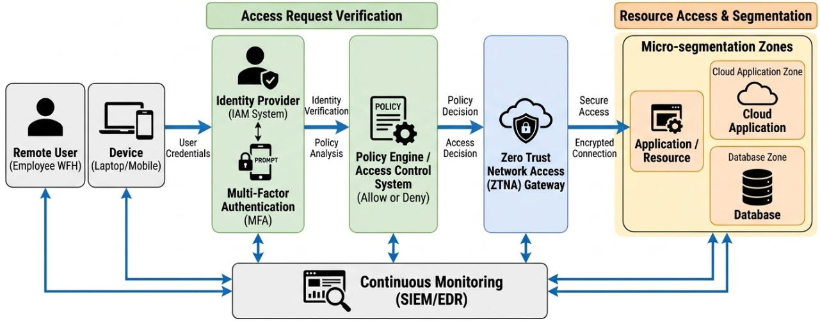
Figure 1 Zero Trust Architecture
Zero Trust architecture, as shown in Figure 1, consists of restricting access through identity checking, checking of devices, and implementation of policies. None of the resources should be given access without the user and device being verified. This will eliminate the implicit trust, and only the authorised personnel will be able to access sensitive systems. It also facilitates secure access in the cloud and hybrid environment and minimises the possibilities of unauthorised access and data breach [6].

Table 1 Core Principles of Zero Trust
Principle | Function | Security Value
Identity-Centric Access Control | Verifies user identity before access | Prevents unauthorised access
Least Privilege | Limits user access rights | Reduces data exposure risk
Continuous Authentication | Checks access continuously | Detects suspicious behaviour early
Micro-Segmentation | Divides the network into smaller zones | Stops lateral movement
Device & Context Awareness | Evaluates device and login conditions | Improves access control accuracy
Continuous Monitoring | Tracks system activity in real time | Enables fast threat detection

Benefits of Zero Trust (Critical Analysis)
Zero Trust enhances the management of access to systems and data within organisations. It authenticates every user and device prior to access, and this ensures that attackers have difficulty accessing the system. This method is quite convenient in the contemporary setting where employees are situated elsewhere. It contributes to the hybrid work by enabling access in a secure manner from any place without depending on a permanent network perimeter. It is also compatible with cloud systems where the information and applications are not stored at a single location [8].
The second advantage is that Zero Trust restricts the movement laterally. Once an attacker gets in, he/she will not be able to freely travel within the network as a new check is made on each request. This will minimise the overall effects of a security breach [7].
These benefits, however, rely on robust identity and access management (IAM). Zero Trust cannot operate well in the case of weak identity systems. This implies that before organisations can use this model, they need to invest in trusted identity solutions. One of the main shortcomings is that Zero Trust may be complicated to install, particularly in organisations that have older systems. It may need modifications to the current infrastructure and processes.
Besides this, large organisations may find the cost of implementation to be high. It might be required to install new tools, training, and system upgrades. Nevertheless, these obstacles do not eliminate the fact that Zero Trust is beneficial to contemporary organisations in terms of minimising risks and enhancing security on a long-term basis [38].
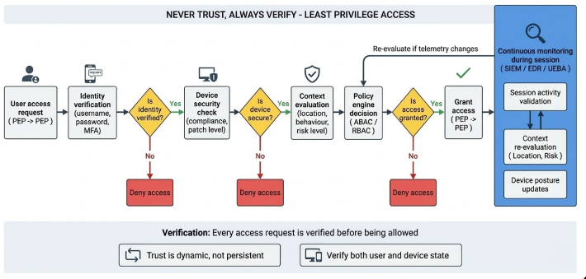
Figure 2 Zero Trust Logical Flow / Access Decision Model
The Zero Trust access decision process in Figure 2 shows that the access request is stepwise evaluated. Before access is granted, the system verifies the identity, device security and contextual aspects. The result of this constant verification is that suspicious behaviour is detected early enough. It also restricts the freedom of attackers to roam inside the system, a factor that enhances the overall security and minimises the amount of damage that could have occurred [34].

Implementation Challenges
Even though the application of Zero Trust has great security advantages, it can present a challenge to most organisations. The existence of legacy systems is one of the major daunting issues. The old systems were not built to conform to the modern security models and might not be able to rely on identity-based access and ongoing verification. Consequently, the implementation of Zero Trust in relation to these systems may not be easy and quick [9].
The other significant challenge is the price and resource demand. Some of the new technologies that organisations should invest in include identity management systems, monitoring tools and secure access solutions. Moreover, to operate these systems, there must be qualified personnel to maintain them. This puts a strain on both the operational and financial pressures, particularly on big organisations.
The problem of cultural resistance is also important. Traditional security models may be employed by employees and the management unit, and these models might be limited to Zero Trust. Users may resist adopting frequent authentication and tight access controls due to their effect on user experience [11].
There is another level of complexity with identity management. Zero Trust relies a lot on proper verification of identities, where good user, role and user access management systems are needed. When identity information is not complete and not well managed, the effectiveness of Zero Trust is diminished.
Performance concerns are also present. Constant verification and monitoring may delay the processes of the system unless well instituted. This can have an impact on productivity and user satisfaction [10].
Lastly, there is a lack of competent professionals with knowledge of Zero Trust architecture. This complicates the implementation process and causes more risk of misconfiguration. Technology alone cannot achieve success as often as organisational preparation.

Comparison with Traditional Security
The classical security models emphasise securing the network boundary. They apply firewalls and other measures to exclude threats within the system. After a user is introduced into the network, they are most likely to be trusted. Conversely, Zero Trust does not trust anybody or anything, including those that are within the network. Each access request is verified on identity, device and context [12].
Table 2 Traditional Security vs Zero Trust
Area | Traditional Model | Zero Trust Model
Trust Approach | Trusts internal users | No implicit trust
Access Control | Based on network location | Based on identity and context
Security Focus | Perimeter-based | Data and identity-focused
Threat Detection | Reactive | Continuous monitoring
Remote Access | Limited and less secure | Designed for hybrid work
Lateral Movement Control | Weak | Strong due to segmentation

Zero Trust should be regarded as an extension of conventional security and not as an alternative. Many organisations continue to apply perimeter controls and Zero Trust principles. This implies the possibility of hybrid security models in which these approaches are integrated to enhance overall protection [13].
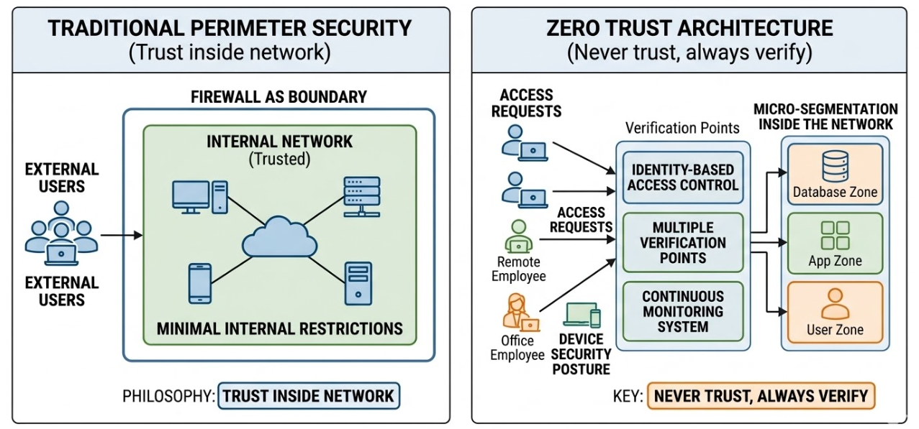
Figure 3 TRADITIONAL VS ZERO TRUST
The comparison between the traditional perimeter-focused security and the Zero Trust model is provided in Figure 3. In the conventional model, network users are not doubted, and this heightens the risk of insider attacks. Zero Trust, in its turn, eliminates this assumption and authenticates all access requests. Herein lies the reason why Zero Trust would be more aligned with the present-day setting, where remote work and cloud-based systems are highly prevalent [11].

Relevance in Modern Context
Zero Trust is quite applicable in the contemporary digital world, particularly in such fields as healthcare. Organisations like MediTrust deal with sensitive patient information, and such information should be secured at all costs. Zero Trust aids in making sure that such data is accessible only to authorised users and that data breaches are decreased.
It is also significant in safeguarding AI systems. AI models are based on a significant volume of training data, which may be sensitive or valuable. Zero trust guarantees the control and monitoring of access to this data. This decreases the chances of data leaks or manipulation of models.
Moreover, cloud and SaaS applications allow modern organisations to store and process data. Such systems can be accessed in other locations and devices, thereby enhancing security risks. Zero Trust helps to provide secure access to such environments by constantly authenticating users and devices.
The third-party risk is another important problem. Organisations usually collaborate with their partners, vendors, and developers. In case all these third parties are not safe, they may be attacked. This risk is reduced to zero through Zero Trust, which manages and regulates access by third parties.
Strong data protection and operational resiliency are also needed by regulations like GDPR and DORA. Zero Trust, in turn, facilitates adherence to strict rules of access control, ongoing monitoring, and timely reaction to security breaches. This renders it an appropriate method for organisations that will be operating in highly regulated systems [14].

Recommendations
Zero trust should be implemented in stages by organisations rather than being implemented at once. This assists in minimising disruption and makes the improvement of systems in a step-by-step manner. The primary emphasis must be made on an identity-first approach because identity management is the core of Zero Trust. Also, malicious activity detection and response should be enhanced by the use of automation tools like SIEM and SOAR. It is also necessary to constantly monitor the activity of users so that dangers could be detected in real time. The mixture of these strategies will enable organisations to implement Zero Trust in a more efficient manner and improve their security posture.

Task 1 Conclusion
The lack of implicit trust and strengthening of access controls makes Zero Trust an effective security strategy to the modern organisations. It assists in mitigating the risk of breach of data and facilitates access security in cloud and hybrid contexts. The success of it, however, lies in good Identity systems, implementation and organisational preparedness [19]. It may be intricate and expensive, particularly in the case of legacy systems of organisations. Irrespective of these constraints, Zero Trust is necessary in the contemporary world because the old-fashioned security models are unable to deal with contemporary threats. It offers a more dynamic and trustworthy system of guarding delicate information and frameworks amid a shifting electronic landscape.

TASK 2 — CASE SCENARIO

Scenario Overview
MediTrust Analytics Ltd is a technology firm in the healthcare industry that operates based on artificial intelligence and cloud-computing methodology to enable the delivery of clinical solutions. It handles very sensitive customer information, such as medical records and real-time health information. The company has a hybrid workforce, which involves employees being based in different areas and utilising different devices. It is also relying on third-party partners and cloud service providers to provide its services. These aspects pose a number of security threats, including unauthorised access to sensitive information, inadequate control over remote users, and external systems vulnerability. Thus, its operations need a powerful and contemporary security strategy [15].

Security Objectives
MediTrust is primarily aimed at ensuring that sensitive patient data is not accessed and abused by unauthorised information users. This is necessary to provide patient safety and privacy. The organisation also needs to adhere to laws, including GDPR, DORA, and NIS2, and those demand excellent data security and operational stability. Besides this, MediTrust will have to protect its AI systems, such as training data and algorithms, to avoid leaking or manipulating data.
The other important goal is to achieve resilience, such that even in the case of a cyberattack or system outage, the services will be available. This involves the presence of excellent surveillance, response, and recovery mechanisms. It is also important not to lose trust. The patients, hospitals, and partners should be assured that their information is safe. In fulfilling these goals, MediTrust will be able to facilitate safe operations, regulation, and sustainable business development [17].

Zero Trust Security Strategy
MediTrust is to use a Zero Trust security strategy in defending its systems and data. This practice is founded on the philosophy of never believing. It implies that by default, no user or device is trusted, regardless of whether it is within the network or not. Each access request should be verified before being granted.
It should be an identity-first strategy. This implies that it can be accessed depending on the user rather than their location. Powerful identity checking procedures like multi-factor authentication must be employed to authenticate the users before gaining access. This plays a crucial role in a hybrid workforce in which workers operate in various locations and devices [18].
Another important element of this strategy is segmentation. The network and cloud systems are supposed to be segmented into smaller units so that the users do not get more than what they require. This will minimise the effect of any security breach. All the activities and the detection of threats must be tracked in real time by using continuous monitoring.
The principles align with the results of Task 1, which revealed that Zero Trust enhanced access control and minimised the risk of security breaches in the current environment.
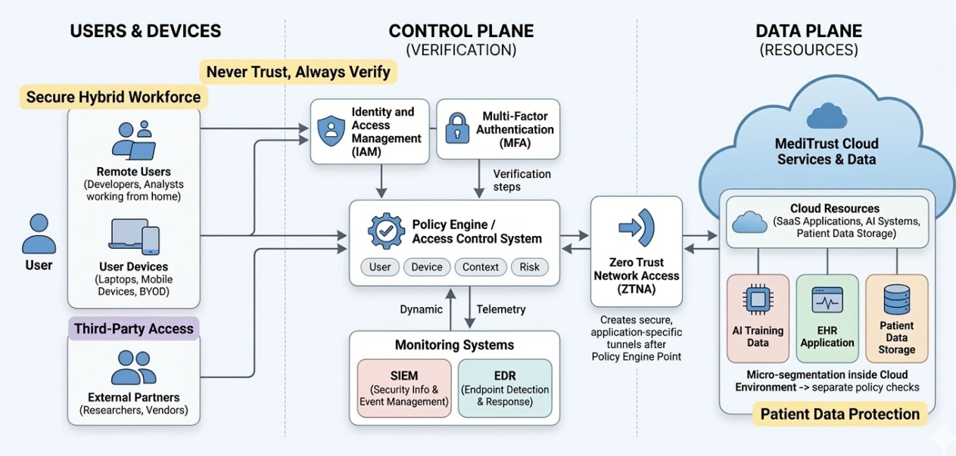
Figure 4 ZERO TRUST ARCHITECTURE FOR MEDITRUST
Figure 4 demonstrates the Zero Trust architecture of MediTrust, according to which access to cloud systems, AI platforms, and patient data is managed with the help of identity verification and policy-based access decisions. The model facilitates the secure access of hybrid users and third-party partners. Constant tracking and grouping of data will mitigate the probability of data breaches, while also providing security to sensitive healthcare information at all times [16].

Organisation Structure
MediTrust requires a well-defined organisational structure with clear roles and responsibilities to facilitate this security strategy. On the highest level, the Chief Information Security Officer (CISO) is in charge of the overall security strategy, governance, and compliance. The CISO makes sure that security practices are in accordance with the business objectives and regulatory standards [18].
The Cloud Security Architect, under the CISO, will design secure cloud systems and deal with the risks associated with cloud and multi-cloud environments. The DevSecOps Lead will also make sure that security is incorporated into the software development process and minimise vulnerabilities in applications and code [20]. The SOC (Security Operations Centre) Lead is in charge of security observation, threat detection and response to incidents.
Data Protection Officer (DPO) is concerned with the adherence to data protection regulations, including GDPR and also makes sure that the treatment of personal data is performed in the right way. The AI Security Specialist will be in place to protect AI models and training data, to ensure that the latter is not abused or misused.
These roles are all under the CISO, and this forms a chain of responsibility. This framework enhances accountability, promotes compliance and proper application of the Zero Trust strategy.

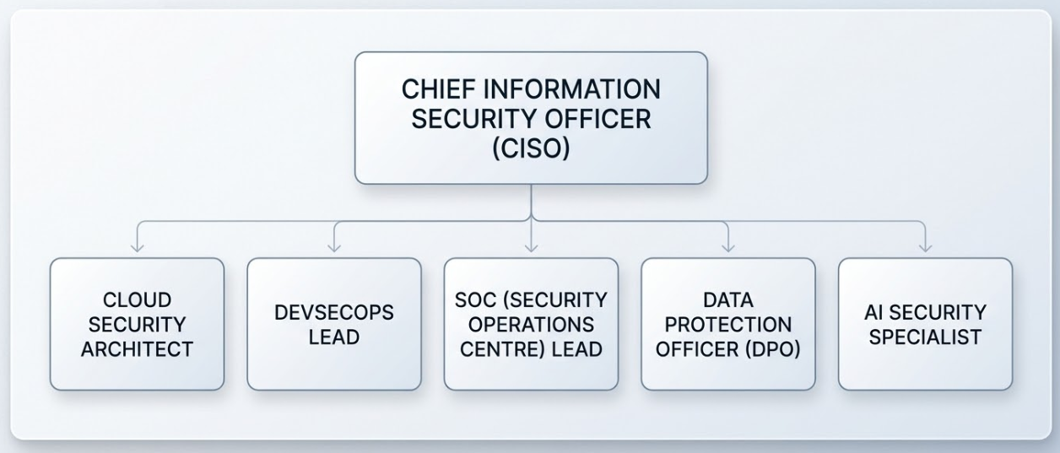
Figure 5 ORGANISATIONAL STRUCTURE
Figure 5 demonstrates the suggested organisational structure of MediTrust, where there is a clear reporting line and duties. Every position will cover a certain field of security, e.g. cloud protection, incident response and data privacy. Such an arrangement enhances accountability and makes security duties more defined, which facilitates effective governance and adherence to the regulations [21].

Governance Model (NIST CSF 2.0)
The NIST Cybersecurity Framework (CSF) 2.0 is to be applied to MediTrust to ensure its security governance. This framework offers a clear framework to deal with cybersecurity risks and integrate security with business objectives. It assists the organisation to establish a robust and consistent security strategy, particularly when it goes international to the EU market and is expected to comply with stringent rules, like GDPR, DORA, and NIS2 [37].
Table 3 NIST CSF 2.0 Application for MediTrust
Function | MediTrust Application | Business Value
Govern | Define security policies, roles, and responsibilities | Ensures accountability and supports compliance
Identify | Maintain asset inventory and classify sensitive data | Improves visibility of risks and critical systems
Protect | Apply access control, encryption, and Zero Trust controls | Reduces risk of data breaches
Detect | Use monitoring tools like SIEM and EDR | Enables early threat detection
Respond | Implement incident response plans and automation | Minimises the impact of security incidents
Recover | Establish backup and disaster recovery systems | Ensures business continuity and resilience

Through this framework, MediTrust will be able to minimise risks, enhance decision-making and also have a systematic approach to security. It also contributes to adherence to the EU regulations and assists in establishing trust with the patients, partners, and regulators in the course of its growth [22].

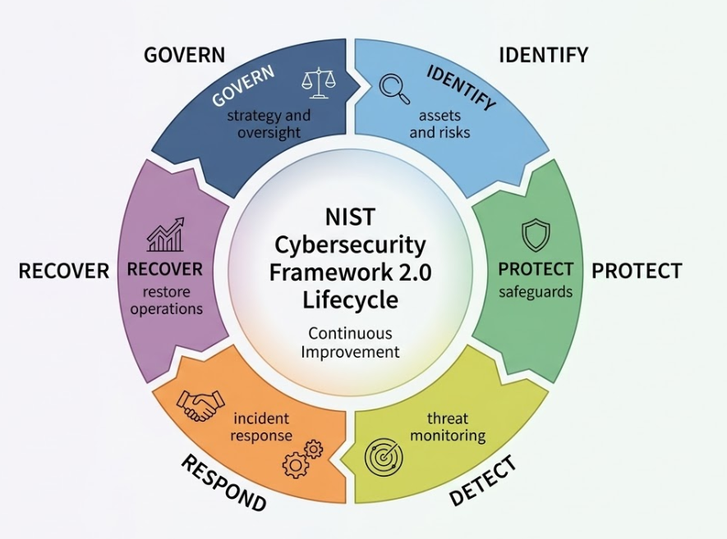
Figure 6 NIST CSF 2.0 GOVERNANCE MODEL

Figure 6 shows the NIST CSF 2.0 framework that offers a systematic way of addressing cybersecurity risks. The cycle of govern, identify, protect, detect, respond and recover is consistent and ensures that security is taken care of at each level. The model assists MediTrust in risk management, compliance, and in its growth of business in the EU market [23].

Policies & Procedures
MediTrust needs to create a structured policy, which is to be used in the management of systems and data to support its security measures.

AI Usage Policy
The AI Usage Policy must make sure that all information used in AI systems is safeguarded and used cautiously. Without authorisation and security measures, sensitive patient data should not be accessed. The use of all AI models should be tested and validated to make sure that they are accurate and reliable. The policy must also facilitate ethical application of AI through discouraging misuse, favouritism, or harmful decisions. It should have human control to scrutinise significant outputs and choices of AI systems [24].

Secure SaaS Policy
The policy of Secure SaaS must regulate access and management of cloud-based applications. All users should be made to undergo multi-factor authentication to enhance security[27]. The principle of least privilege should be applied, i.e. users should receive the minimum possible access. The logging and monitoring of all activities in SaaS applications should be done to identify abnormal behaviour. Reviews are to be performed periodically to make sure that settings are safe.

BYOD Policy
Bring Your Own Device (BYOD) Policy must provide that personal devices that are used in work are secure. All the devices should be enrolled on a Mobile Device Management (MDM) system. Encryption of devices used to store information should be turned on. Remote wipe should also be provided in the event of loss or theft to wipe out sensitive information. This policy can prevent the theft of organisational data, and at the same time, flexibility in working can be enabled [7].

Compliance Alignment (DORA + NIS2)
To stay safe in the EU market, MediTrust will have to comply with such regulations as DORA and NIS2. These policies are aimed at enhancing cybersecurity, risk control, and operational resilience. MediTrust must comply with these requirements in its security programme to ensure that it is not punished and maintains trust [25].

Table 4 Compliance Alignment
Regulation | Requirement | Implementation
DORA | Incident reporting | Establish clear incident response plans and reporting timelines
DORA | Operational resilience | Use backup systems, disaster recovery plans, and regular testing
DORA | Third-party risk management | Assess and monitor vendors and cloud providers regularly
NIS2 | Incident reporting obligations | Create structured reporting procedures for cyber incidents
NIS2 | Risk management measures | Apply security controls such as Zero Trust and monitoring tools
NIS2 | Supply chain security | Evaluate and secure third-party software and services

With these requirements, MediTrust will be able to enhance its security posture and guarantee compliance. This ensures continuity in business as well as enables the organisation to work peacefully in a highly controlled environment.

Risk Assessment
The application of AI systems, cloud environments, and third-party services has a number of critical risks to MediTrust. These risks can be identified by a sophisticated risk assessment, and appropriate controls can be put in place to mitigate the effects of the risks [26].

Table 5 Risk Assessment
Risk | Likelihood | Impact | Control
AI model poisoning | Medium | High | Validate training data and restrict data sources
Cloud misconfiguration | High | High | Use CSPM tools and regular security audits
Supply chain risk | Medium | High | Monitor third-party vendors and use secure dependencies
Ransomware attack | Medium | Very High | Use backups, EDR tools, and incident response plans

Clinical decisions can be influenced by AI model poisoning and their accuracy and reliability. Misconfigurations of the clouds are typical and may reveal sensitive data. Third-party risks occur when the external vendors fail to observe the right security measures. Ransomware attacks may disrupt the activities and result in loss of data.
Through detection and implementation of suitable controls, MediTrust will be able to decrease vulnerabilities and enhance its overall security and resilience [28].

Protection Mechanisms
MediTrust should also utilize modern security controls in order to reduce risks and protect its systems. Zero Trust Network Access (ZTNA) is an approach that grants access to the systems to the users upon successful validation. This is useful in curbing unauthorised access, particularly in a hybrid work set-up. Multi-Factor Authentication (MFA) is an additional protection mechanism to ensure account compromise is not achieved by asking individuals to follow more than one validation tool [36].
Security Information and Event Management (SIEM) is the process of gathering and analysing data from a system to identify any unusual activity. This assists in recognising the threats prematurely. SOAR collaborates with SIEM to automate responses so that it requires less time to respond to incidents. Endpoint Protection and Response (EDR) is a device protection that identifies and prevents threats like malware and ransomware.
Cloud Security Posture Management (CSPM) is useful in uncovering misconfigurations within cloud systems, and this prevents the risk of exposing data. Data Loss Prevention (DLP) is what guarantees sensitive data leakage or abuse.
All these controls will mitigate the particular risks that include unauthorised access, cloud misconfiguration, data leakage, and ransomware attacks, and assist MediTrust in a robust and secure environment [30].

Disaster Recovery Plan
MediTrust ought to be able to have an effective disaster recovery plan in the event of ransomware and other significant incidents. The first is detection, in which the monitoring systems detect an abnormal activity or an attack indicator. After detection, the containment phase follows, whereby the affected systems are isolated to curb further propagation of the attack.
The next step is recovery. Secure backups should be utilised by MediTrust in order to recover data, including AI training data, as well as source code. The backup must be stored in a secure location and checked on a regular basis to prevent the possibility of failure when required. This will enable the organisation to recuperate in time without ransom.
Once the recovery is done, validation has to be done to ensure that systems are functioning normally and that there are no threats left. This involves confirming data integrity as well as system security before going back to normal operations [31].
Such a formal provision assists MediTrust in minimising downtime, securing very important data, and supporting service availability. It also promotes adherence to laws like DORA, which mandate high operational resilience and recovery planning.

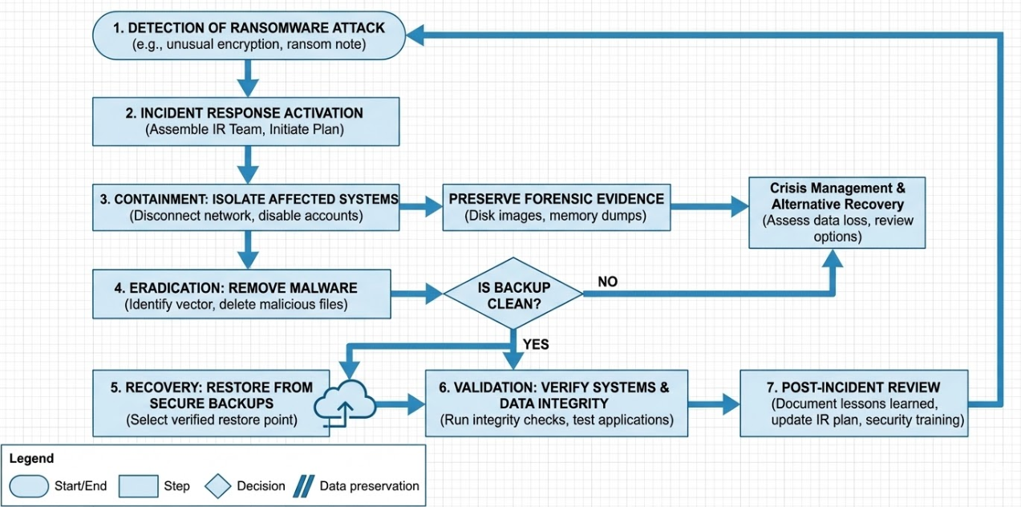
Figure 7 RANSOMWARE DISASTER RECOVERY FLOW
The response and disaster recovery process of the ransomware incident are demonstrated in Figure 7. It defines the process of detection, recovery, and validation. Such a systematic strategy makes sure that attacks can be restricted in a short period and systems can be reinstated with safe backups. It also assists in operational resilience, as well as enabling MediTrust to comply with regulatory standards like DORA.

Implementation Roadmap
MediTrust is advised to roll out its security programme in distinct stages to allow a seamless adoption. During the first stage, assessment, the organisation is to evaluate the existing systems, determine the risks, and learn about the security gaps. This assists in the establishment of priorities. The second stage is deployment, in which the necessary tools and controls, like Zero trust, MFA, monitoring systems, etc., must be implemented gradually. The employees should also be trained to adhere to new security practices.
The last stage is optimisation. During this step, they need to constantly monitor the systems and optimise them depending on their performance and emerging threats. To ensure that security is effective, reviews and updates should be conducted regularly. This incremental strategy minimises the interference and guarantees overall success in the long run [38].

Task 2 Conclusion
The suggested Zero Trust security programme offers a solid and viable solution to MediTrust. It enhances access control, secures sensitive patient data, and minimises security risks in both cloud and hybrid environments. The design also allows adhering to the regulations (GDPR, DORA, NIS2) because the design has adequate governance, monitoring, and response mechanisms.
Moreover, the programme increases the resilience of the organisation, whereby the organisation is in a position to identify, respond appropriately, and recover from cyber incidents. This serves to sustain the continuity of services and create trust among the partners and the patients. In general, the solution is viable, future-proof, and applicable to the expansion of MediTrust into the EU market [32].

REFERENCES
- Ademola, A., George, C. and Mapp, G., 2024. Addressing the interoperability of electronic health records: the technical and semantic interoperability, preserving a privacy and security framework. Applied System Innovation, 7(6), p.116.
- ADENIYAN, T., 2025. Cyber Risk Assessment Frameworks for Protecting US Critical Infrastructure Against Emerging Threats.
- Ahmadi, S., 2024. Zero trust architecture in cloud networks: Application, challenges and future opportunities. Ahmadi, S.(2024). Zero Trust Architecture in Cloud Networks: Application, Challenges and Future Opportunities. Journal of Engineering Research and Reports, 26(2), pp.215-228.
- Akinsola, A. and Akinde, A., 2024. Enhancing software supply chain resilience: Strategy for mitigating software supply chain security risks and ensuring security continuity in the development lifecycle. arXiv preprint arXiv:2407.13785.
- Al-Khassawneh, Y.A., 2023. A review of artificial intelligence in security and privacy: Research advances, applications, opportunities, and challenges. Indonesian Journal of Science and Technology, 8(1), pp.79-96.
- Allagulyyev, B., 2025. RANSOMWARE ATTACKS: PREVENTION, DETECTION, AND RECOVERY STRATEGIES. ОБРАЗОВАНИЕ И НАУКА В XXI ВЕКЕ, (62-3 (том 1)).
- Anasuri, S. and Rusum, G.P., 2024. Software supply chain security: Policy, tooling, and real-world incidents. International Journal of Emerging Trends in Computer Science and Information Technology, 5(3), pp.79-89.
- Ashfaq, S., Patil, S.A., Borde, S., Chandre, P., Shafi, P.M. and Jadhav, A., 2023. Zero Trust Security Paradigm: A Comprehensive Survey and Research Analysis. Journal of Electrical Systems, 19(2).
- Bajpai, P. and Enbody, R., 2023. Know thy ransomware response: a detailed framework for devising effective ransomware response strategies. Digital Threats: Research and Practice, 4(4), pp.1-19.
- Boamah, K.G., 2025. Cloud Security Posture Management: A Comprehensive Analysis of Automated Risk Identification and Mitigation in Multi-Cloud Environments. International Journal of Research and Innovation in Social Science (IJRISS), 9(11).
- Boban, M., 2024. Cybersecurity in the digital age: regulatory framework based on the implementation of the NIS2 directive. Economic and Social Development: Book of Proceedings, pp.570-582.
- Chinamanagonda, S., 2022. Zero-trust security models in cloud infrastructure: adoption of zero-trust principles for enhanced security. Academia Nexus Journal, 1(2).
- Choi, Y.B., 2025. A Certainty-Based Approach to Implementing Zero Trust Architecture Using NIST SP 800-207 and NIST SP 1800-35. KAUPA Letters, 13(1), p.11.
- Cinà, A.E., Grosse, K., Demontis, A., Vascon, S., Zellinger, W., Moser, B.A., Oprea, A., Biggio, B., Pelillo, M. and Roli, F., 2023. Wild patterns reloaded: A survey of machine learning security against training data poisoning. ACM Computing Surveys, 55(13s), pp.1-39.
- Dhiman, P., Saini, N., Gulzar, Y., Turaev, S., Kaur, A., Nisa, K.U. and Hamid, Y., 2024. A review and comparative analysis of relevant approaches to the zero-trust network model. Sensors, 24(4), p.1328.
- Gokkaya, B., Aniello, L. and Halak, B., 2023. Software supply chain: review of attacks, risk assessment strategies and security controls. arXiv preprint arXiv:2305.14157.
- Jančiūtė, L., 2025. Cybersecurity in the financial sector and the quantum-safe cryptography transition: in search of a precautionary approach in the EU Digital Operational Resilience Act framework. International Cybersecurity Law Review, 6(2), pp.145-154.
- Jayabalan, K., Keshava, R., Venumuddala, S.K., Keshap, P., Rowtu, H. and Maruthi, R., 2025, November. Implementing Zero Trust Architecture For Enhanced Security in Cloud-based Systems. In 2025, the 9th International Conference on Electronics, Communication and Aerospace Technology (ICECA) (pp. 1589-1594). IEEE.
- Karakasilioti, G.M., 2024. Supporting the digital operational resilience of the financial sector: The EU’s DORA Digital Operational Resilience Act (Master's thesis, Πανεπιστήμιο Πειραιώς).
- Kure, H.I., Sarkar, P., Ndanusa, A.B. and Nwajana, A.O., 2025, May. Detecting and preventing data poisoning attacks on AI models. In 2025 Photonics & Electromagnetics Research Symposium-Spring (PIERS-Spring) (pp. 01-12). IEEE.
- Lata, M. and Kumar, V., 2025. Cyber security techniques in cloud environment: comparative analysis of public, private and hybrid cloud. EDPACS, 70(3), pp.1-21.
- Macrae, C., 2025. Managing risk and resilience in autonomous and intelligent systems: Exploring safety in the development, deployment, and use of artificial intelligence in healthcare. Risk Analysis, 45(4), pp.910-927.
- Mensah, F., 2024. Zero trust architecture: A comprehensive review of principles, implementation strategies, and future directions in enterprise cybersecurity. International Journal of Academic and Industrial Research Innovations (IJAIRI), 10, pp.339-346.
- Mushtaq, S., Mohsin, M. and Mushtaq, M.M., 2025. A systematic literature review on the implementation and challenges of zero-trust architecture across domains. Sensors, 25(19), p.6118.
- Oh, K.B., Hoang, G., Sturdy, J. and Guo, S.S., 2025. Enterprise Risk Management and Cybersecurity Governance. In Cybersecurity Governance: An Enterprise Risk Management Strategy for Cyber Risk Control (pp. 65-88). Singapore: Springer Nature Singapore.
- Ologunde, E., 2025. Identity-Centric Zero Trust Architecture: A Comprehensive Framework for Modern Enterprise Security Governance. Available at SSRN 5656350.
- Oyerinde, A.T., Okunlola, O.A. and Alao, B.S., Identity-Centric Security Architectures for Large-Scale Distributed Cloud Systems.
- Pascoe, C.E., 2023. Public draft: The NIST cybersecurity framework 2.0. National Institute of Standards and Technology.
- Rose, S., 2022. Planning for a zero trust architecture: a planning guide for federal administrators. National Institute of Standards and Technology White Paper, 20.
- Sarkar, S., Choudhary, G., Shandilya, S.K., Hussain, A. and Kim, H., 2022. Security of zero-trust networks in cloud computing: A comparative review. Sustainability, 14(18), p.11213.
- Schmitz-Berndt, S., 2023. Defining the reporting threshold for a cybersecurity incident under the NIS Directive and the NIS 2 Directive. Journal of Cybersecurity, 9(1), p.tyad009.
- Selvaprasanth, P., 2025. Adoption of Secure Access Service Edge (SASE) in Distributed Enterprises for Ensuring Cloud Application Protection and Network Optimisation through Unified Security Frameworks.
- Shepherd, C., 2022. Zero trust architecture: Framework and case study.
- Tertulino, R., Ivaki, N. and Morais, H., 2024. Design a software reference architecture to enhance privacy and security in electronic health records. IEEE Access, 12, pp.112157-112179.
- Triplett, W.J., 2024. Cybersecurity vulnerabilities in healthcare: a threat to patient security. Cybersecurity and Innovative Technology Journal, 2(1), pp.15-25.
- Ugochukwu, O.M., Rosa, R.L., Adenike, O.O. and Rodriguez, D.Z., 2024. Advancing cybersecurity use of sensitive data in electronic healthcare systems: A review of privacy and regulations. INFOCOMP Journal of Computer Science, 23(2).
- Vaka, P.R., 2023. CLOUD SECURITY AND THE HYBRID WORK MODEL. International Journal of Computer Engineering and Technology, 14(3), pp.207-219.
- Yiliyaer, S. and Kim, Y., 2022, January. Secure Access Service Edge: A zero-trust-based framework for accessing data securely. In 2022 IEEE 12th Annual Computing and Communication Workshop and Conference (CCWC) (pp. 0586-0591). IEEE.

