Module Code: LCCB4005
Module Title: The Global Business Environment - Assessment 2

Student ID: 2019150
Student name: Adriana Cornelia Brian

Contents
Introduction 1
Task 01 Changes made in the Business Model by Next Plc to self-regulate and adapt the concerns 2
1.1 Porter’s Value Chain 2
1.1.1. Primary Activities 2
1.1.2 Secondary Activities 4
1.2 Pestle Analysis 5
1.2.1 Political, Economic, and Social 5
1.2.2 Technological, Legal, and Environmental 6
Task 02 Impact of the Changes on the Company’s Competitive Position 7
2.1 Porter’s Five Forces 7
2.2 Recommendation 8
Conclusion 10
References: 11

List of Figures:
Figure 1: Market share of Next plc 2
Figure 2: Implementing the concept of circular economy 3
Figure 3: Interest rate in the UK 5
Figure 4: Porter’s five forces model 7

Introduction
Business environment refers to all the factors and events that have a major or minor influence on the operations, decisions, and strategies (both short-term and long-term) of the company. The companies in the retail fashion industry have made several changes in their operations to self-regulate and adapt and in this report, the changes that Next Plc made have been focused on. Firstly, porter’s value chain model has been deployed to highlight the changes that the company brought in its business model to self-regulate itself and adapt to external factors. Besides, the Pestle analysis has also been carried out to show how the company adapted to the external factors by making some important changes. In the second section of this report, the impact of the changes on the competitive position has been shown, that is, how the changes have either enhanced or undermined the competitive position of the company. Porter’s five forces model has been used for depicting the impact on the competitive position. Lastly, some recommendations have been added, which the company can consider in order to ameliorate its response to some factors and drive its business forward.

Task 01 Changes made in the Business Model by Next Plc to self-regulate and adapt the concerns
Next Plc is one of the leading fashion retailers in the UK, and one of the major factors underpinning its success is its adaptability to the changing scenario that has increased its market share in the last decade (Sheen, 2021). However, following the covid-19, environmental degradation, etc., the stakeholders of the company have communicated some of their concerns, which propelled the firm to bring some changes to self-regulate and adapt. The porter’s value chain model and Pestle analysis have been used to shed light on the changes.
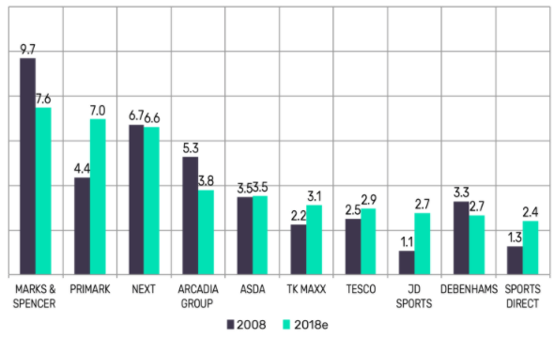
Figure 1: Market share of Next plc
Source: (Sheen, 2021)

Porter’s Value Chain

1.1.1. Primary Activities
One of the concerns of the stakeholders relates to the sourcing of the raw materials and the violation of the modern slavery regulations and the company responded by devising the “Responsible Sourcing” strategy, where it provides a guideline that must be used while manufacturing the garments (Varnavskii, 2021). Next plc also audits the supplier’s operations and ensures that their suppliers are providing a safe environment so that incidents like “Rana Plaza Collapse” do not repeat. Apart from the inbound logistics, the company has also brought changes in the production facilities, that is, the company communicated its CSR goals and placed adequate facilities to reduce the carbon emission and the use of water in the production. The company has also emphasized recycling in its operations to embrace the idea of a circular economy as stakeholders are raising concerns over the bad impacts of fast fashion (Mishra, Jain, and Malhotra, 2020).
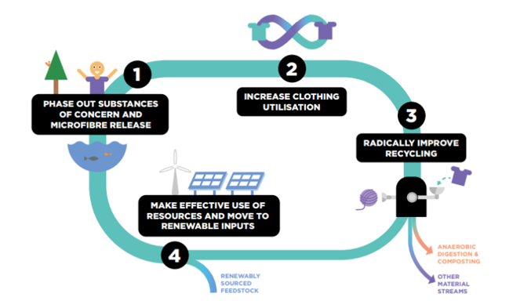
Figure 2: Implementing the concept of circular economy
Source: (Jacometti, 2021)
The company has also adopted the RFID technology to avoid excess inventory and make sure that the distributors do not run out of products, which can lead to consumer dissatisfaction. The company is also encouraging the customers to develop a swap society, where the consumers will swap their clothes for money and anything of value with each other (Nachum, 2021). The changes in the after-sales services are that the company now uses a different type of customer service to serve the customers (Varnavskii, 2021). For example, to solve the standard problems of the individual customers, the company uses a chatbot and if the problem is unique or cannot be resolved by the chatbots, they redirect the customer call to the call centre representatives.

1.1.2 Secondary Activities
Next plc has also made changes in its HR activities, that is, it has provided work from home facilities in the face of Coronavirus and also made some changes in the workplaces so that employees can maintain a safe distance from each other (Tarim, 2020). Besides, the managers have received training on managing the remote teams. In terms of technological development, the firm has invested in AI computing technology that has enhanced self-regulation (Nachum, 2021). Besides, the company adapted to the concerns of shareholders by developing a suite of 75 enterprise apps that revolutionised Next’s approach to stock management and cut stock inventory times from hours to seconds and supported the RFID technology.
The company has strengthened its internal control system to enhance the internal audit system and prevent any kind of fraudulent activities, which has been reflected in the performance of the company. In the infrastructure segment, the company has purchased a planning software, that has improved the sales, production, inventory, and human resource planning for the company (Carmody, 2020). Lastly, the real-time inventory management with the help of a suite of 75 enterprise apps and RFID technology has ameliorated the procurement operations of the company.

1.2 Pestle Analysis

1.2.1 Political, Economic, and Social
Next plc has partnered with Zoom to facilitate the employees to work from home after the govt. of the UK imposed a country-wide lockdown, which helped the firm to continue to serve the consumers (Litka and Blodgett, 2020). After lifting the lockdowns, the company has complied with the regulations of the local authority and WTO to ensure that social distancing is maintained in the stores and corporate offices of the firm.
In terms of economic factors, which caused the company to bring changes, the company has terminated jobs from both the head office and the stores as the demand falls sharply and the company suffered huge financial losses (Kelly and Ashwin, 2020). Next plc has recently changed its capital structure to replace some of the old debts with new ones to take advantage of the lower interest rates.
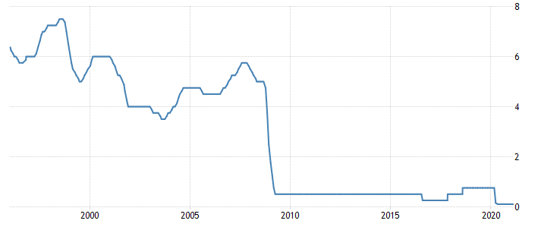
Figure 3: Interest rate in the UK
Source: (Tradingeconomics.com, 2021)
As per the social factors, the concept of a minimalistic lifestyle is gradually becoming popular, especially among the youth, which is also causing the customer to raise their voice against fast fashion. The company has responded to this concern by attempting to implement the concept of the circular economy (Mishra, Jain, and Malhotra, 2020). The company has also brought changes in its product portfolio by introducing more varieties of products for elderly customers because, in the UK, the elderly population will account for a larger portion in the future.

1.2.2 Technological, Legal, and Environmental
The company has augmented its mobile app and boosted its online presence as online sales were reaching new heights in the fashion industry. The company is considering using AR in its app to enrich the consumer experience further. The deployment of other technology like AI computing, RFID technology, etc. are the big changes that the company brought to adopt the new lifestyle of the consumers surrounded by technology (Meiners, Ringleb and Edwards, 2021). The company is also using big data analytics to enhance its consumer research.
The data security issue has become such an important matter that dragged companies like Google and Facebook to the courts. Hence, the company has reinforced its data security to comply with the data protection act 2018 (Kelly and Ashwin, 2020). Next plc has also ensured that its recruitment and other HR policies encourage diversity and inclusion by thwarting discrimination to abide by the equality act 2010. The company also changed its operations in an attempt to comply with the health and safety act 1974, consumer rights act 2015, etc.
The environmental concerns have also caused the company to make some big calls. The company had to change its production processes to achieve the CSR and environmental goals that the company determined (Jacometti, 2021). Besides, the company has also redesigned its transportation routes to reduce carbon emissions.

Task 02 Impact of the Changes on the Company’s Competitive Position
The changes that the company made have implications on its competitive position, which is analysed below.

2.1 Porter’s Five Forces
Porter’s five forces model is a strategic management tool that helps to assess the market competition and other factors relating to the market attractiveness.
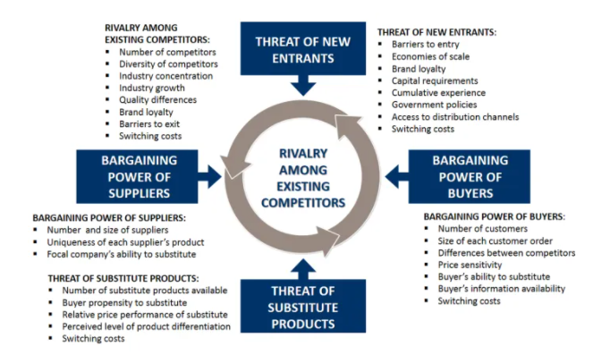
Figure 4: Porter’s five forces model
Source: (Smith, 2018)
The several changes that the company brought have affected its competitive position, which has been detected using porter’s five forces model. The consumer’s bargaining power has decreased because the company has addressed several concerns of their over sustainable sourcing, fast fashion, etc. and the study showed the customers are eager to pay more for the products of an environmentally friendly company (Carmody, 2020). Besides, the company’s improved customer services have increased brand loyalty and subsequently switching costs, which reduced their bargaining power.
The implementation of the circular economy, swap society, and improvement in the recycling process has given the company a competitive edge over competitors (Jacometti, 2021). The company’s position in the overall competitive rivalry has enhanced because it developed new products for an underserved segment of the market (elderly customers). In addition, the company has deployed many technologies including RFID technology, which drove down the inventory-related costs and other costs because of the efficiency it brought in the operations.
The threat of new entrants has been pushed down because the company enjoys economies of scale and scope because of the mass customisation process that the company supported with its state-of-the-art technology (Varnavskii, 2021). The threat of substitution has been reduced as the company provided a price-performance ratio, which is very difficult for alternative products to maintain.
The supplier’s power to push prices has been reduced because the company poses a credible threat of backward integration (Smith, 2018). Besides, as the company has improved its communication technology, it can easily find suitable suppliers, who will provide similar products, thus undermining the supplier’s bargaining power.
Besides, the other factors like providing facilities like working from home enabled the company to continue to drive its workforce towards beating the competitors, which enhanced its competitive position in the market (Meiners, Ringleb and Edwards, 2021). The capital restructuring reduced its finance costs, which has helped the company to keep the prices the same though the inflation went up and will go further higher. The internal control has allowed the company to prevent its internal problems and enrich the work environment, which has helped the firm to develop an extraordinary strategy to outperform its competitor.

2.2 Recommendation
Though it may seem that the company has perfectly made the changes to self-regulate and adapt, it also failed to respond to some factors in an effective manner. Like other fashion retailers, the company has also terminated many jobs and failed to provide a safe working environment. Next plc could have chosen not to cut jobs and used that as part of their branding, which would have differentiated the brand and provided a competitive edge over the company (Litka and Blodgett, 2020). Even though the company had to terminate some employees, it could plan the whole process to maintain the ambiance at the workplace. Now, the company should assure the rest of the employees that no employee will lose their jobs further so that they can get job security and focus on their work rather than pondering over the possibility of losing their jobs, which has affected their productivity and motivation level. Besides, the company should conduct Lewin’s change management model if the company needs to cut jobs in the future.
Next plc only trades in 16 countries and most of them are European countries and hence, the company should contemplate expanding its reach in the Asian, African countries and some American countries to diversify its sales (Nachum, 2021). The company should continue with its strategy of operating through wholly-owned subsidiaries to expand internationally. However, as the financial constraints will not allow it to expand to many countries quickly, it should reinforce its online shipping services, through which it will serve customers all over the globe.

Conclusion
The analysis of the changes brought by the company has divulged some key insights into how the companies transform and drive their business towards sustainable growth. Several changes brought by the company including the implementation of the concept of circular economy and swap society, sustainable sourcing and fighting modern slavery, deployment of technologies like RFID, AI computing, augmented apps, etc. have strengthened the competitive position of the company. The adaptability of the company made sure that the company responds to external factors in a way that would give it a competitive edge in the market. The company can consider implementing the recommendations for driving its business forward. Lastly, though the company has made many important changes, it should regularly update its knowledge of the factors that will affect its business so that it can continue to adapt.

References:
Carmody, P., 2020. Meta-trends in global value chains and development: Interacting impacts with COVID-19. Transnational Corporations, 27(2), pp.143-155.
Jacometti, V., 2021. Circular Economy and Waste in the Fashion Industry. Laws, 8(4), p.27.
Kelly, P. and Ashwin, A., 2020. The business environment. Andover: Cengage Learning.
Litka, M. and Blodgett, M., 2020. International dimensions of the legal environment of business. Cincinnati, Ohio: South-Western College Pub.
Meiners, R., Ringleb, A. and Edwards, F., 2021. Legal environment of business. Boston, MA, USA: Cengage Learning.
Mishra, S., Jain, S. and Malhotra, G., 2020. The anatomy of circular economy transition in the fashion industry. Social Responsibility Journal, ahead-of-print(ahead-of-print).
Nachum, L., 2021. Global Pandemics and the Economics of Global Value Chains. SSRN Electronic Journal,.
Sheen, C., 2021. M&S to lose its decades long status as the number one clothing retailer to Primark - GlobalData. [online] GlobalData. Available at: <https://www.globaldata.com/ms-lose-decades-long-status-number-one-clothing-retailer-primark/> [Accessed 16 March 2021].
Smith, J., 2018. Business strategy. Cambridge (Mass.): Basil Blackwell.
Tarim, T., 2020. Managing modern workforce: managing remote teams. IEEE Engineering Management Review, 41(2), pp.3-4.
Tradingeconomics.com, 2021. United Kingdom Interest Rate | 1971-2021 Data | 2022-2023 Forecast | Calendar. [online] Tradingeconomics.com. Available at: <https://tradingeconomics.com/united-kingdom/interest-rate#:~:text=Looking%20forward%2C%20we%20estimate%20Interest,according%20to%20our%20econometric%20models.> [Accessed 16 March 2021].
Varnavskii, V., 2021. Global Value Chains (GVCS) and COVID-19 Pandemic. World Economy and International Relations, 65(1), pp.14-23.

