Introduction to the Organisation
The School-Based Youth Work Team (SBYWT) in Pembrokeshire employs 8 youth workers, whose main role is to offer informal learning opportunities for young people across nearly all of the secondary schools in the county. This work mostly involves running an alternative education curriculum called the Princes’ Trust Achieve Programme and Agored Cymru Programme, where young people can attain qualifications that are the equivalent to a GCSE to enhance their personal developmental skills; a main focus of youth work practice (NOS, 2019, ref. YW05). The SBYWT is expected to provide at least one accredited qualification, where the schools request at least a level one or two accreditation to account to their performance targets. Yet unlike formal teaching, school-based youth work is catered towards the young people, as support is provided through a mixture of mediums to meet the needs of the young person. The SBYWT therefore works with young people on 1-2-1 interventions surrounding emotional health and well-being, which young people can be supported through group projects and individual work as well as alternative curriculums.
However, school-based youth work is being reshaped, namely by schools, to reduce exclusions and absenteeism of the students. This is reflection of the high numbers of young people missing education since Covid-19 (NYA, 2024: 1). This means much of the original work school-based youth workers offer is being culminated into the overall aim of encouraging young people to remain in school, restricting the scope of opportunity again for youth work. Although young people interpret youth workers as being distinct from school due to its informalised approach, school-based youth work is being recognised by practitioners and policy-makers on how it can play a significant role in addressing young people’s needs not only in a community context, but also formal learning environments (Ibid: 4). This is something that I observed whilst on placement with the SBYWT in Pembrokeshire, where I was placed at Ysgol Bro Gwaun Secondary School in Fishguard, whom have one full-time youth worker present. This portfolio will document this process, namely the experiences and opportunities afforded on placement which advanced my professional development as a youth worker.

Roles and Responsibilities of a Trainee School-Based Youth Worker
The roles and responsibilities of a trainee school-based youth worker do not differ from that of a community based youth worker, for example, yet during my time on placement it was noted how there are some distinctions present in their practice. The main difference in roles was how there is less of a voluntary aspect within school-based youth work in comparison to youth community work. This is in spite of guidance which states how the practice should be based on the voluntary participation of young people (CWVYS, 2018: 4), leaving school-based youth work in an obscure position with engagement. This was expanded during Reflection 2 (see Appendix 1), where in order for young people to attain a level one or level two alternative qualification, they have to dedicate their time to pieces of work that can be used as evidence of their participation. For example, each student has module handbooks they need to work through in their own time with a school-based youth worker, which is collected and marked by the examining board of the respective qualification programme. Thus, although the SBYWT ensures that their approach to each young person is moulded to their needs, interests and abilities, this impacts on the voluntariness of their practice in comparison to a community youth worker.
This is not to say that the young people are expected to begin or complete an alternative qualification, however. This area of work has been recognised as providing avenues for young people to progress in their education and provide them with essential life skills (Prince’s Trust, 2022: 5). Yet from my own experience supporting these sessions, prioritising this can lead to challenges in empowering young people through a youth work lens. The responsibility of providing alternative curriculum programmes such as the Prince’s Trust can obscure the informal learning approach of youth work practice for school-based youth workers. Related to this is also the joined-up working role school-based youth workers have with school staff. Working collaboratively with other professionals is not something distinct to school-based youth work; as it is an expectation for all youth workers to develop relationships with other practitioners (NOS, 2019, ref. YW04). Yet, certain aspects of working alongside teachers differentiate school-based youth work from community youth work. To illustrate, it was expressed by the youth worker in Ysgol Bro Gwaun how some teachers could ‘resist’ insights and interventions from a youth work lens, as it does not adhere to formal education approaches to young people. This can be supported by previous studies on school-based youth work (Bradford and Byrne, 2010).
With this joined-up working approach with teachers also comes varying expectations within the responsibilities of a school-based youth worker from the school and youth service. Youth workers are expected to abide by certain roles as part of their work, namely the key purpose being to ‘…enable young people to develop holistically, working with them to facilitate their personal, social and educational development…’ (CWVYS, 2018: 2). Specific standards also inform school-based youth workers’ practice, such as the Youth Work Strategy for Wales (2019) and the Curriculum Statement for Wales (2017). Those who are a part of the SBYWT in Pembrokeshire are expected to offer 1-2-1 interventions on the basis of these standards with young people. Yet, there are expectations held by the schools themselves. Whilst on placement I learnt that it was expected for the youth worker to provide at least a level one or level two Princes’ Trust qualification to young people, otherwise it would not ‘fit’ the purpose of the programme (Reflection 2). This was because these qualifications would contribute to the school’s position on national league tables. Thus, school-based youth workers may feel like they are “fitting” young people into a qualification category that may not be best suited to them, which undermines the practice of youth work being holistic and supportive in nature (CWVYS, 2018).
A final responsibility of a trainee school-based youth worker would be working towards a rigid schedule due to the nature of the school day. In Ysgol Bro Gwaun, the school day is a six hour day that is separated into five lessons. The school-based youth worker in the school has to schedule sessions during the students’ lessons, yet these sessions cannot override ‘core’ subjects, such as English and Maths. This can be related to the contested professionalism of youth work within schools, where a prioritisation of formal education can impact the way youth workers conduct their practice (Bradford and Byrne, 2010). It was my responsibility to schedule in my own sessions with young people and determine which lessons I could or could not take them out of. In order to minimise any issues, I ensured to provide session slips to the young people in advance and confirm they were happy with the timetabled session. On occasion I did run into some issues, such as the teacher requesting the young person stay in the lesson or the young person preferring another lesson to come out of. This differs to a community youth worker, for example, where universal access invites more flexibility. This can also impact on the amount of time spent with young people, therefore further moulding the work school-based youth workers can do.

Leading Upon An Area of Youth Work Practice
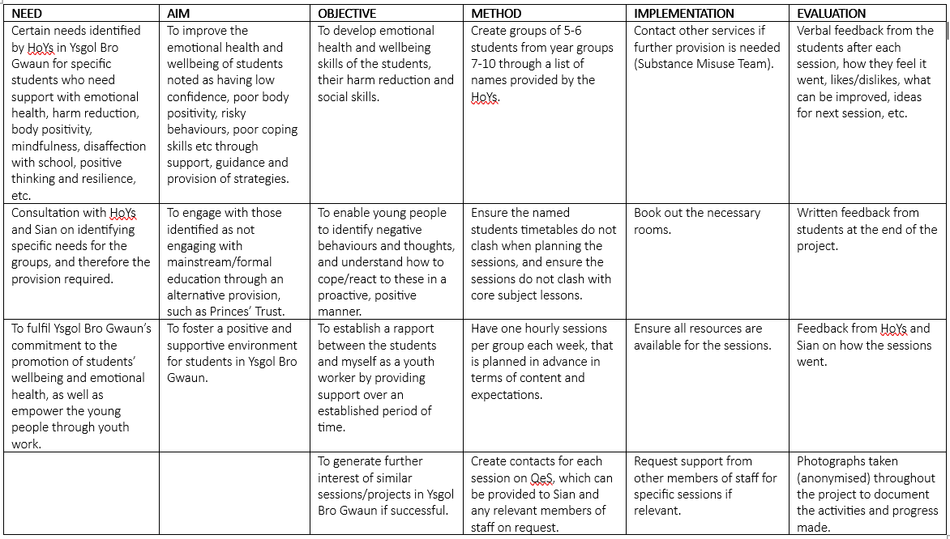
I was provided the opportunity to lead upon group work with young people from years seven to ten at Ysgol Bro Gwaun. This was from information provided by the Senior Leadership Team (SLT) and youth worker at the school, Sian, where certain young people were identified as requiring extra support for their emotional health and wellbeing. I was provided a list of names and the suggested focus from each Head of Year, such as one group having issues with feeling anxious and another requiring support with harm reduction. From this information I created a NAOIME needs assessment for the project, which can be found below.
Figure 1: NAOMIE for emotional health and wellbeing project.
Using the NAOMIE model to plan this project was beneficial in identifying each stage that was needed to successfully support the young people (Whelan, 2010). I arranged timetabled sessions for each group and informed them of the session’s day and time in advance. For the first session, I aimed to go into it with an open mind and no specific plan, as it was important for me to go into the sessions with no pre-conceived assumptions of the young people and what they wanted. This is because youth work practice stems from a non-judgemental stance, where youth workers should understand all young people regarding their backgrounds and personal circumstances (CWVYS, 2018: 7). I therefore used the first session to get to know each group of young people, for them to be introduced to me and understand my role in the school, and to brainstorm together on the potential activities and areas of interest we could focus upon. Below are examples of brainstorming maps that some of the groups created from this session. This was inspired by Hart’s ‘ladder of participation’ (1992), where the young people felt empowered in curating the programmes they would engage in as part of the project, rather than feel as if this had been decided beforehand.

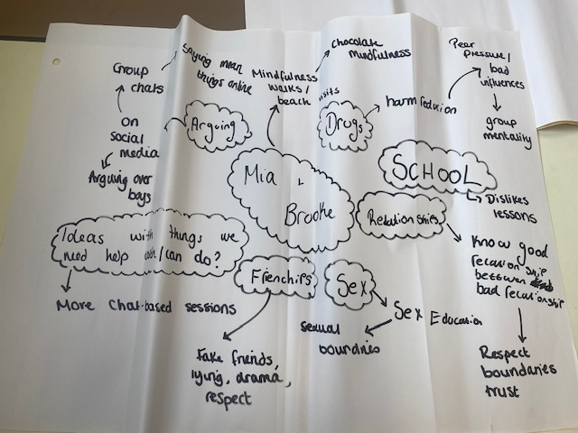

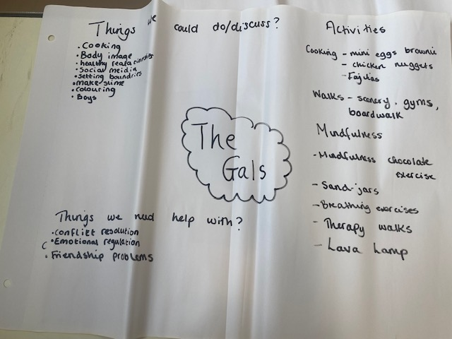
Figure 2: Year 10 group mind map.

Figure 3: Year 9 group mind map.
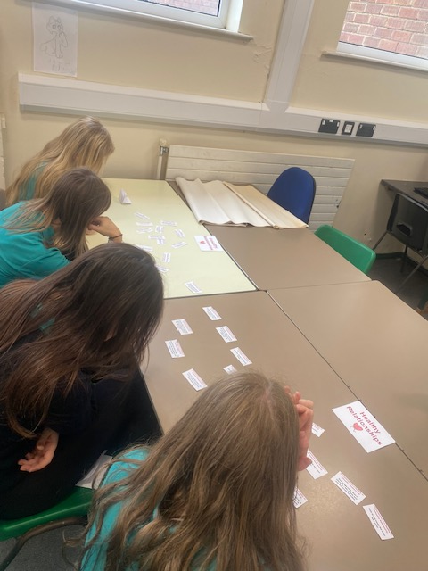
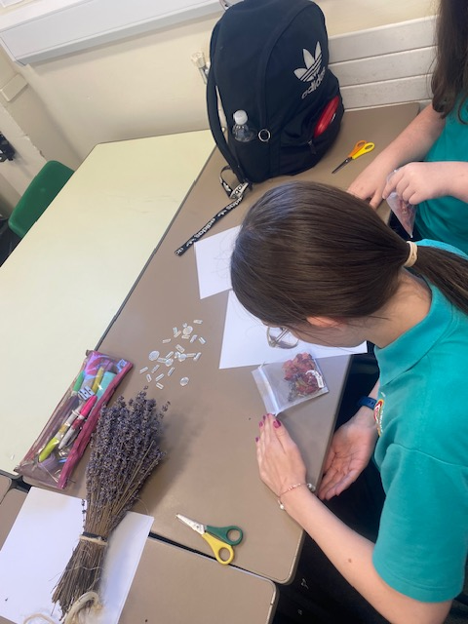
Weekly sessions were held over a six week period, with topics like body positivity, disaffection with school, anxiety, sexual health, harm reduction advice, confidence and resilience were touched upon through practical, visual and written activities, such as making sensory bags for those who feel anxious and creating a pyramid of intimacy during sexual health advice. Photographs taken throughout the project (with the young people’s permission) can be found below to document this process. I feel this particular project - where I explored a breadth of topics with young people - significantly enhanced my professional learning as a trainee youth worker. Although there were areas of improvement identified - such as those in Reflection 3 (see Appendix 1) - from discussions with staff and the young people, this project was successful in enhancing the young people’s emotional health and wellbeing. For example, one young person explained how they had really enjoyed the sessions and felt more able to express their worries to a trusted adult. In comparison to my previous placement, this project was also planned and ran entirely by myself, which allowed me to develop myself into an effective practitioner without direction from colleagues (NOS, 2019, ref. YW25). This area of youth work practice will be discussed more thoroughly in the summary of own learning and development section of this portfolio.
Figure 4: Creation of anxiety bags. Figure 5: Healthy vs unhealthy relationships.

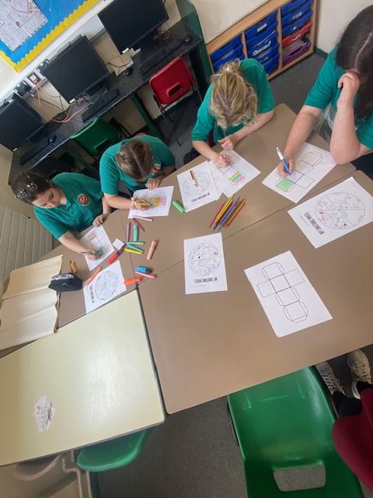

Figure 6: Emotional regulation wheels.

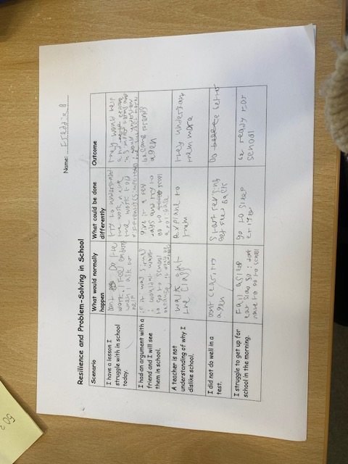

Figure 7: Resilience and problem-solving at school activity.

Community Profile
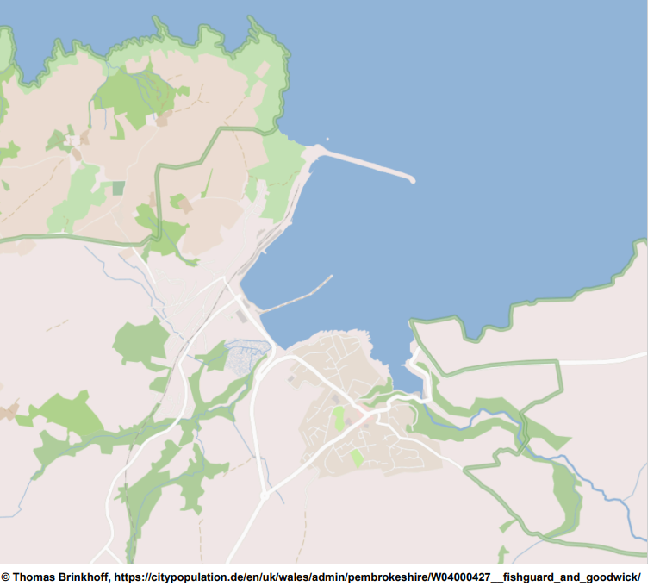

Figure 8: Map of Fishguard and Goodwick.
To contextualise the area around Ysgol Bro Gwaun, a community profile was created of Fishguard and Goodwick. A community profile covers the needs, issues and resources that are available to a specific community, and what is important to the profile is how the community is included within this (Hawtin and Percy-Smith, 2007: 4). In my previous placement, the community profile centred around a ‘community of need’ due to the nature of the work being undertaken with young people. This community profile will focus on the geographical location of the community, and will take into account the social, economic and personal aspects of the area (Christakopoulou et al., 2001). It will also consider the opinions and perceptions of young people who live in Fishguard and Goodwick and who attend Ysgol Bro Gwaun, to understand what resources are available to the younger generation and what may be needed to improve the community. This was done by arranging a session with students in the school purely to discuss the profile, where mind maps were created to identify specific discrepancies in Fishguard and Goodwick and what is needed to improve the lives of the young people (Williams, 2005). In order to understand Fishguard and Goodwick, a discussion of demographic data on the area is first required.
The towns of Fishguard and Goodwick refer to two communities, where historically it was as a large market town with agriculture being the main source of trade. Main features of the towns include a local railway station and a harbour that provides connections to Ireland through a ferry service. Today, the general population density equates to 5,443 people, where just over half of the residents are female (51.2%) and the rest male (48.8%). The general age was found to be 18-64 year olds, accounting for 52.7% of the population, with those 0-17 years old making up the least (18.2%) (City Population, 2024). The ethnicity of 97.6% of the residents are white, leaving a tiny percentage of the rest of the population deriving from minority ethnic backgrounds (Ibid). In relation to employment levels, a quarter of the population are employed in the service industry, followed by health and social services (15%), construction (12%) and education (12%) (WRO, 2013: 56). Ysgol Bro Gwaun covers the catchment area of Fishguard and Goodwick, with 500 students and 50 members of teaching staff. This area of North Pembrokeshire is also ‘rural’, as areas with a population density of fewer than 150 people per square kilometre are classified as such (Ibid).
The area being rural in nature, as well as the age demographic and employment rates, have an impact on the young people who reside in the area, particularly how they are viewed by others and their future prospects. Therefore, this community profile will consider how these statistics can relate to the voices of young people. An important aspect of youth work is ensuring that young people are involved in its practice, especially on topics that shape their lives (NOS, 2019, ref. YW02). I asked a large group of students from different year groups to come to a session purely dedicated to the profile, where the young people were asked to discuss their thoughts on the community. A spider diagram was created, where the positives and negatives of living in Fishguard and Goodwick were debated, as well as any recommendations on how the area could be enhanced for young people (Figure 9). This session was a mixture of both discussion and practical-based activities regarding the community profile. Each section of this diagram will be discussed in detail to understand the young people’s viewpoints, which will then be used to consider how Fishguard and Goodwick could be improved with young people at the core of this focus.
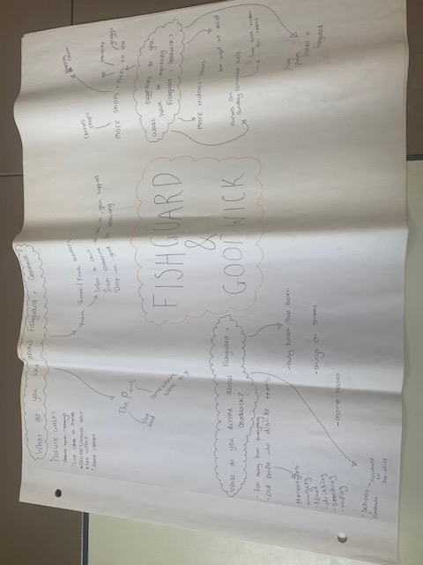
Figure 9: Spider diagram of young people’s views on Fishguard and Goodwick.

What do young people like about Fishguard and Goodwick?
The young people expressed how the youth provision in the area was a positive for them. The Point Youth Centre in Fishguard has been operating since 2001, where they offer young people the chance to acquire new skills and gain support. The young people noted how the Centre provides free meals to young people throughout the week, which invites young people to the Centre to engage in youth work. They spoke of how it is “somewhere warm to go to” to socialise and gain support. This has also been identified in previous studies, which acknowledged the significance of youth-focused work within the area (WRO, 2013: 45). However, the Centre has recently been hit with budget cuts, which means its free counselling service and mentoring project had to be discontinued (Western Telegraph, July 2023). This is at the expense of young people, who do not have another open-access, community youth work provision locally. Moreover, the young people liked the area’s natural environment, where locations such as Goodwick Beach offering space to engage in physical activity and meeting with friends. This relates to previous findings which uncovered how rural Wales provides opportunities for outdoor recreation and socialisation for young people (Woods and Utz, 2022: 13). From this discussion, it was clear the main positives for young people in Fishguard and Goodwick was the youth provision and the natural environment of the area.

What do young people dislike about Fishguard and Goodwick?
The main negative identified by the young people was the remoteness of the location from other areas of Pembrokeshire. They expressed how it was “far away from everything” regarding leisure and retail, transport and employment opportunities (Figure 9). Fishguard and Goodwick are lacking in shops and services due to a decline in the local economy, which means the young people and their families have to travel to neighbouring towns to purchase clothes and larger food shops. This restriction brought by the rurality of the community has been found in other areas of Wales, where social isolation was noted as a barrier for young people(Woods and Utz, 2022: 18). The young people also expressed how they disliked the perceptions of young people in the community, namely the older generation of Fishguard and Goodwick. When asked to expand upon this, the young people spoke of the different stereotypes they face, such as being “naughty, loud, drinking, smoking, and vaping” (Figure 9). As the Welsh Rural Observatory (2013: 47) found in their research on rural Wales, this illustrates how isolated communities’ perceptions of young people can leave them feeling overlooked and undervalued. Therefore, it was clear that the rurality of the area negatively affected the young people.

What suggestions do young people have to improve Fishguard and Goodwick?
The young people noted how a lack of adequate transport was a barrier for young people accessing further education and employment opportunities, where bus services - which have limited availability on the weekends and evenings - impacted young people locating and maintaining employment. This has been found in previous studies on how rurality can affect young people’s career prospects, where 60% of young people considered moving to a place that had better employment rates (Storer Jones, 2020). The young people suggested that there be a scheme created to combat this, such as a bus service operating purely for those from rural communities to go to and from education or work. Lastly, the young people referred to a past event that was held for the community called ‘GwaunFest’, which they argued brought the community together and provided young people the opportunity to socialise in a safe environment. They suggested that holding community events would help bridge the gap between the younger and older generation in the area. This aligns with a standard held in youth work, where it is important to engage with communities to promote the voices and needs of young people (NOS, 2019, ref. F2). It is clear that making better connections within and outside of Fishguard and Goodwick would reduce the social isolation and exclusion young people feel, thus improving their community experiences.

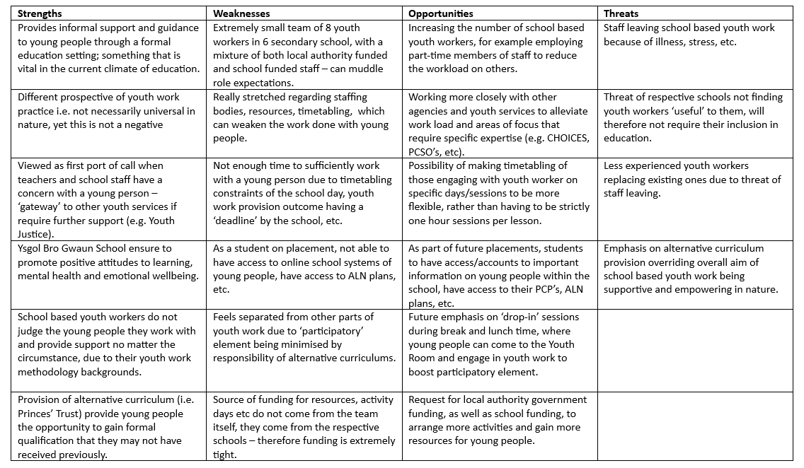
SWOT Analysis
Figure 10: SWOT Analysis of Pembrokeshire SBYWT.

Funding Issues for School-Based Youth Work
One of the main weaknesses found within the SBYWT was funding derivation and allocation. In other youth teams, such as Youth Justice, their funding streams come from local authority government, where they are provided an annual sum to be allocated to different activities and resources, with the opportunity to apply for more funding if required. This is different for the SBYWT, where its funding comes from differing sources, such as the Families First Grant (FFG), the Youth Support Grant (YSG) and the Poverty Grant from schools. Yet significant budget constraints has meant spending has dropped from £947 million to £371 million between 2011 to 2022 (House of Commons, 2024: 3). Money has become extremely tight for school-based youth workers, who are having to be strategic with funding allocation – often at the expense of young people. Funding situations are different for each school, where one school may be more generous with their grants than another, making it difficult to have a cohesive approach to funding. A colleague expressed how because their youth work is ‘hidden’ within a formal education context, youth work funding tends to be concentrated on more visible types of youth work, such as outreach. To combat this, it would be beneficial for local authority government funding to be evenly distributed across all youth workers within the team, and for each school to have its own money purely for the youth worker employed there, to reduce irregular approaches to funding amongst the schools.

Participatory Issue of School-Based Youth Work
A threat to the SBYWT is an over-emphasis on alternative curriculum projects from the schools, rather than focusing on youth work principles and purposes. This was a common issue for all youth workers within the team, who spoke of how it was difficult to engage in ‘real youth work’ because of the nature of their roles within formal education. The identity of youth workers has become more complex because of more emphasis being placed on specialised programmes - such as the Princes’ Trust - rather than open-access provision (Borden et al., 2011: 2). This has put a strain on the work school-based youth workers can engage in, where opportunities for recreation and informal support are rare. This issue is further exacerbated by the amount of time school -based youth workers can spend with young people. For example, for the emotional health and wellbeing project, the sessions could only be held once weekly and last an hour to coincide with the students’ formal lessons. This impacts on the voluntary relationship that is important within good youth work (CWVYS, 2018: 8). An opportunity to rectify this would be creating space for more participatory, open-access youth work to balance out both expectations. Opening up the Youth Room during break and lunch times for ‘drop-ins’ would allow young people to socialise and relax, therefore bringing back the voluntary nature of the practice.

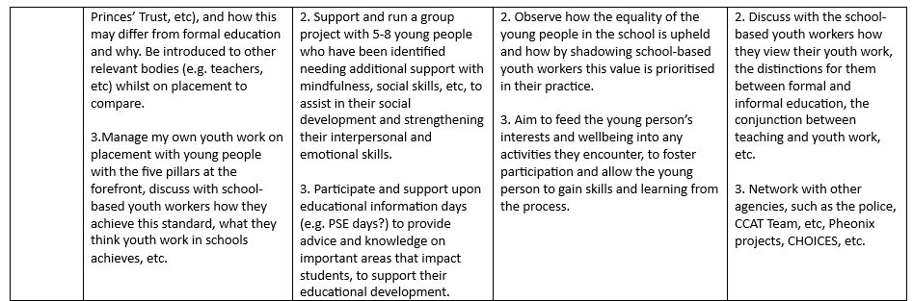
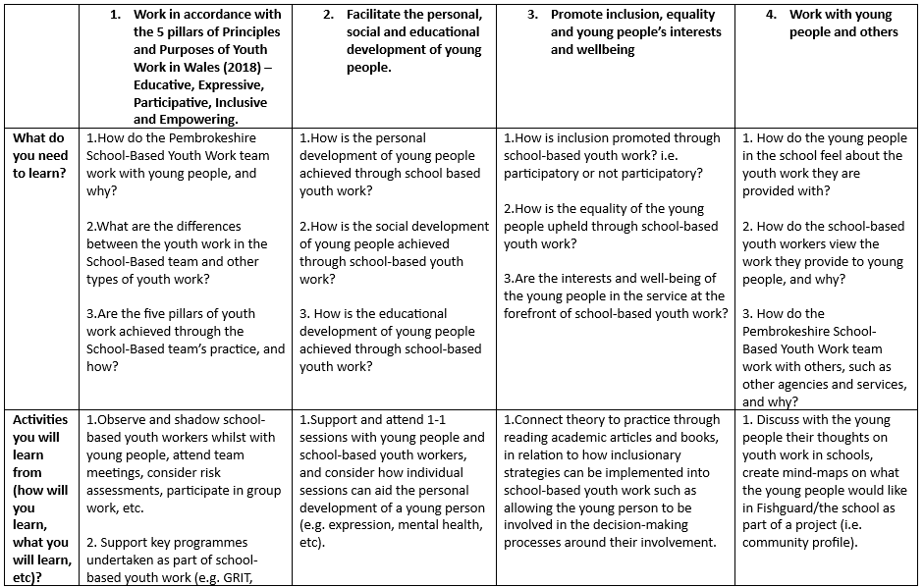
Summary of Own Learning and Development
Figure 11: Professional development plan.
As part of my youth work journey, reflecting upon my own practice and development is an important aspect. Youth workers must make an effort to continually develop their practice (EWC, 2023), to which I have done throughout my placement. The National Occupational Standards for Youth Work (NOS, 2019) will be applied to summarise my own learning and development, which will enable me to contextualise the goals set at the beginning of my placement and how these have been fulfilled with the Pembrokeshire SBYWT.

The Five Pillars and School-Based Youth Work
As discussed in Reflection 2, it is debatable how school-based youth work attends to the five pillars of youth work – this being participatory, expressive, educative, empowering and inclusive (Welsh Government, 2019: 5). However, I aimed to enhance the participatory element by creating interventions which allowed young people to opt in or out of the wellbeing project. This was proven to be successful, as all of the young people agreed to stay throughout the sessions. Young people were also able to express themselves regularly throughout placement, as it is vital for young people to communicate their needs, understanding and opinions (NOS, 2019, ref. YW14, YW15). For example, at the first session the young people were asked what they would like from the project, to prioritise their interests and mould the support around them. I also regularly sought feedback from the young people on how they felt the sessions were progressing, any positives or negatives to report upon and how well my support was for them. Their opinions were helpful in ascertaining how successful the project was becoming, as well as allowing the young people built upon their personal development. As Harrison and Wise (2007: 2) note, this collaboration between youth worker and young people allowed the development of not just the project, but of all involved.
Youth work should also has an educational purpose (Jeffs and Smith, 2010), which was arguably the main goal of the wellbeing project. The educative pillar was therefore satisfied by ensuring each activity enabled the young people to learn. For example, the groups covered topics such as sexual health and intimacy, signs of unhealthy relationships, and substance harm reduction advice, which all had the aim of informally educating the young people on important topics (WAG, 2007: 3). This leads on to the empowering pillar of youth work, where I strove to prioritise what the young people wanted and how this support would be offered. For instance, as this work was being undertaken within a formal education setting, it was important to provide a space that the young people could call their own. The Youth Room provided this, where the young people could exercise their rights and viewpoints in a safe environment (CWVYS, 2018: 6). This was important for certain students who were disengaged from mainstream education, with some expressing how it was disempowering rather than empowering for them. This work was therefore vital for the young people to express their emotions, viewpoints and interests freely, which aids their social development with handling similar situations in the future.
The inclusivity of my practice was developed by shaping the work to the young people’s needs and abilities. As highlighted in Reflection 3, this was not immediate, as there was some difficulty in knowing and then moulding the sessions to the young people’s needs. As I was not aware of a students’ dyslexia, I planned an activity that involved writing, making it difficult for them to engage. This was because I did not have access to the students’ Person Centred Plans (PCP) or Additional Learning Needs (ALN) plans, as this was only accessible to school staff. If this had been made available to me, I would have been able to plan the sessions more sufficiently with the young persons’ additional needs in mind. Moving forward, I will make every effort to obtain such documents, to better plan the sessions around the young people and their capabilities (NOS, 2019, ref. YW11). There were also moments during my time on placement where I had to challenge certain assumptions or comments made by young people, which enhanced the diversity in my practice. For instance, during a body image session with young people, one young person began to make hurtful remarks to another student about their body. I challenged the young person on their inappropriateness, making them aware this behaviour would not be tolerated, in order to create a space of inclusion (NOS, 2019, ref. YW19). My placement as a trainee school-based youth worker allowed my professional learning to flourish through such experiences, as well as the personal, social and educational development of the young people.

Professionalism and Working with Others
A part of my development was also re-asserting my professionalism. This relates to Reflection 4, which details age-related problems I encountered on placement. As I am close in age to young people, other professionals assumed I was less professional or experienced than them. For example, some teachers would mistake me for a young person, which would impact the way they approached and viewed me. Interestingly, when I reaffirmed my identity as a trainee youth worker, their attitude towards me shifted. Relating back to the community profile, the young people felt the older generation held stereotypical views on them purely for being young people (Figure 9), which was also felt in my case as a ‘new’ youth worker. Although youth workers are expected to be non-judgement towards young people, this too should be extended to that of your colleagues and other professionals (CWVYS, 2018: 7). Yet it was expressed during placement how the teaching staff viewed youth work as less valuable than formal education, based off of combative expectations and prioritisation of core subjects (Bradford et al., 2010). As such, this could have impacted the way the teaching staff also viewed myself as a trainee school-based youth worker. It was therefore paramount to uphold my identity and sense of belonging, not only to boost my professionalism but to recognise the important of youth work practice.
Despite this challenge, I was able to demonstrate to colleagues a commitment to my practice, particularly by working collaboratively with others. A widely held standard in youth work is to work with other services to contribute to young people’s development (Code of Occupational Ethics, 2012: 3), where on placement I liaised with both SLT, teachers, counsellors and child protection officers to safeguard and support young people. For instance, Reflection 5 discusses a safeguarding concern of a young person I worked with during placement, where it was my responsibility to take this issue further to the relevant authorities (EWC, 2023: 3). This was possible through working with both the safeguarding officer, youth worker and Child Care Assessment Team (CCAT) to reach a conclusion on the next steps. Doing so allowed myself to have a well-rounded, thoughtful approach to the outcome, ensuring that the young person was safe and aware at every stage. Not only did this enhance my learning in safeguarding procedures, but also multi-agency working approaches for the welfare of young people. Working with other professionals did not stop here, however. Due to a lack of resources available for the team, it was necessary to become creative with the situation. Hence, I used working connections in the youth sector to source resources for creative activities, such as the materials for the anxiety bags made with young people. Working in tandem with other professionals, as well as strengthening connections already established in the youth service, therefore lessened the divide felt by the team and other practitioners.

Conclusion
My professional learning and development has progressed greatly during my time at the SBYWT. In comparison to my previous placement, my confidence has grew through managing my own project, without the assistance of colleagues (NOS, 2019, ref. YW25). What was different was how I was able to reflect ‘in-action’, rather than after (Schön, 1987), where if a session was losing focus, I would adapt the session to the young people whilst still delivering the core plan. Having access to important data, such as PCP and ALN plans, would have developed my learning further, as I would be able to sufficiently plan for all situations regarding the young people’s abilities. What I have also learnt is how school-based youth work can be shaped by the bureaucracy of formal education, where teachers challenge school-based youth workers by pushing for certain outcomes with the work (Morgan et al., 2008). Nevertheless, working as a trainee school-based youth worker enhanced my professionalism, particularly when working with others, and allowed me to gain insight into a contested area of practice (Bradford and Byrne, 2010). It was clear how school-based youth workers in Pembrokeshire strove to incorporate informality and participation in their practice despite some challenges, in order to support the young people they engaged with. This is something I attended to on placement, and what I will take with me throughout my youth work career.

Appendices

Appendix 1: Reflections

Reflection 1
Professional Boundaries and Integrity on Placement
25/3/2024
This reflection will discuss boundaries, professionalism and tensions in youth work practice whilst on placement. Unfortunately, it will also discuss my original placement at the Milford Haven Youth Centre falling through and why this occurred. It is important through writing accounts of your experience on placement to reflect on not just the positives but also the negatives of youth work practice. As Claxton (1990: 18) says, ‘…[reflection] is getting better at knowing when, how and what to do when you don’t know what to do’. I was able to do so at this placement, and acknowledge aspects of the work that would have undermined my practice. For example, it is important for youth workers to respect, support and work well with colleagues and others to achieve the best outcome for young people (EWC, 2023: 4). Yet this was not felt during my original placement. There were clear tensions and apprehensions from my learning mentor, which caused issues in me feeling comfortable nor able to seek enough opportunities during placement.
For example, I was prevented from developing within the first few weeks of this placement through my learning mentor restructuring the sessions I could run, being dismissive of sessions plans rather than suggesting other alternatives, and insinuating a poor grade at the end of placement. In hindsight, I could have communicated more effectively on these issues to minimise further problems, as this is an expected part of youth work practice (EWC, 2023: 5). However, as a learning mentor, it was their responsibility to mentor students and facilitate their professional development - which is something that each learning mentor agrees to upon signing a contract at the start of placement. Therefore, as a student I recognised the problems within my placement and sought advice from the university. After careful consideration and discussion with the placement coordinator, it was agreed by the university, myself and my original placement to withdraw and find a new placement. By being transparent and recognising these issues with my placement, I critically reflected on my own practice and experience insofar and what I would like to gain from this as a result (NOS, 2019, ref, YW25).
Fortunately, I have acquired a new placement, which I hope will provide me with the opportunity to gain more experience and understanding in how to holistically support young people through my practice (LLUK, 2008). This experience has demonstrated how youth work generally, and placement itself, can be difficult to navigate, where not only may you have issues with the work achieved with young people, but also the professional relationships and boundaries you have with colleagues. To the best of my ability I remained professional throughout this experience, despite the tensions identified, where I followed the necessary procedures suggested by the university when a problem occurs. This has been discussed with the placement coordinator, multiple lecturers, other colleagues and my supervisor, where I have built productive working relationships to achieve best practice for myself and the young people I work with (NOS, 2019, ref. YW04). I look forward to the new placement at a local secondary school, Ysgol Bro Gwaun, within the school-based youth work team of Pembrokeshire.

Reflection 2
Comparison of School-Based Youth Work to Others
20/05/2024
This reflection will consider the distinctions between school-based youth work and other practices of youth work, namely youth justice and youth community work. I have experienced many comparisons during my previous placement with a Pembrokeshire Youth Justice Team, my part-time work as a youth club assistant and currently my placement at the Pembrokeshire school-based youth work team. For example, it is clear that the ‘participatory’ element in youth justice and school-based youth work is blurred in contrast to community youth work. Jeffs and Smith (2010) argue that the relation between young people and youth workers relies on being voluntary, where the work has to be centred around the young person’s needs. However, the nature of school-based youth work leaves most of the practice being statutory. To illustrate, school-based youth workers in Pembrokeshire provide the Princes’ Trust (2022) qualification programme, which offers alternative qualifications for those who may not be able to attain mainstream education. This means specific students are referred to the programme, irrespective if they would like to engage in the first place. This is different to community youth work, which functions off an open-access basis for young people.
School-based youth work also operates on the same working days as teachers. After having conversations with school-based youth workers, they explained how having to timetable their sessions with students restricted the amount of time spent with young people and the work they were able to do. This hinders the standard of planning, preparing and facilitating learning activities with young people in a school environment (NOS, 2019, ref. YW11), as school-based youth workers do not the liberty of time and resources in comparison to youth justice workers, for instance. School-based youth workers are able to only plan sessions with young people during lessons that are not considered to be ‘core’ subjects, such as Maths and English, which limits the flexibility of their practice. In comparison to my previous placement at the Pembrokeshire Youth Justice Team, youth justice workers were able to more freely see their young people during times that suited them and the young person. Therefore, school-based youth workers have to be more strategic in their planning of sessions and what they wish to focus on with the young person, where prioritising the main task could lead to the risk of not building rapport with young people.
Due to the work school-based youth workers have to achieve, such as alternative qualification programmes, this means their respective schools also have a say in the decision-making around what type of programmes these are and what levels of qualification the young people work towards. During placement, it was noticed that the school asked for at least level one or level two Princes’ Trust qualifications, as this impacted their standing on the educational league tables. There has been much discussion on how league tables provide inaccurate and unfair pictures of student’s progress during school (The Guardian, January 26th 2019), which not only impacts that of the school itself, but also the youth work that is practiced there. Although one of the five pillars of youth work is being educative in nature, this is not its main concern. It also strives to be inclusive, empowering, expressive and participative (CWVYS, 2018). This means that because school-based youth workers are expected to focus on attaining specific qualification levels for students, other valuable aspects of the practice can fall short. This is in contrast to community youth work, which can focus more heavily on features that include, empower and allow young people to express themselves through universal activity opportunities.

Reflection 3
Consideration of Literacy Skills During Group Work
27/05/2024
This reflection will consider the background of young people’s abilities and skills during group youth work sessions whilst on placement. As part of my placement, I was tasked with leading upon emotional health and wellbeing sessions with groups from years 7-10, with young people who were identified as requiring additional support in specific areas, such as anxiety, harm reduction, self-esteem issues, and so on. For the year 7 group, these sessions focused on mostly their disaffection with school and anxiety, where one session in particular looked into problem-solving and resilience in school. The activity involved the group writing down scenarios about school that make them anxious, where they were then asked as a group to discuss strategies to manage this anxiety proactively and positively. This was built upon previous work by Taylor (2000), which encourages practitioners to reach disaffected young people through respect and individuality, in order to understand the reasoning behind their disaffection. However, it became clear during the session how one young person was struggling with the activity.
To not single out the young person, I collectively reminded the group that they can gain my support to help them with the activity. After the session was complete, I asked the young person to stay behind to discuss any potential issues privately. This was important, as I wanted to create an atmosphere of inclusion for young people through my practice (NOS, 2019, ref. YW19). The young person explained how they were dyslexic, and found it difficult to read and write during the session. I was completely surprised by this, and also felt as a youth worker that I had let them down in supporting them with their dyslexia – despite not being informed beforehand. One of the main tenants of youth work is to encourage avenues for young people to reach their full potential (CWYVS, 2018: 7), and I felt I had not lived up to this expectation during this experience. Nevertheless, I discussed with the young person how we could make the activities more enjoyable and understandable for them. For example in future sessions, all activities that are paper-based will be printed on tinted paper that will alleviate visual stress.
This experience has also enhanced my professional development, in the sense that I will ensure any additional learning needs or capabilities are made aware to me and understood before working with the young person. Although some could argue this may lead to predispositions in how you work with young people, as youth work practice is built upon a non-judgemental approach (Youth Work Strategy for Wales, 2019), it is important that young people can engage with the practice fully and to the best of their ability. After this session, the use of tinted paper as well as more practical-based activities were utilised, where the young person in question expressed how they were finding the sessions more enjoyable and thus more helpful. I will take this experience with me and apply it to other contexts of youth work, and mould my practice more consciously in the effort of best supporting the young people I interact with.

Reflection 4
Age-Related Issues as a Trainee Youth Worker
05/06/2024
This reflection will discuss the age-related issues I have encountered during my time on placement, as well as more generally as a youth worker. It has been noticed by myself and others how my age has led to presumptions being made on my practice or professionalism, by other youth workers or practitioners, due to the fact that I am younger than others in the service. It has been found in previous studies how younger employees are often seen as unreliable and less organised purely because of their age (Finkelstein et al., 2013), which can result in fewer training opportunities or job promotions (Duncan and Loretto, 2004). From my own experiences, I feel that older colleagues presume I am less of a professional than they are as I am closer in age to the young people we support. For example, there is more of an emphasis placed on me by others to remain professional with young people, as they may feel more inclined to transgress them because of the age similarity. This is something I have considered and understood, which has been translated into my practice, yet this is not the sole reason as to why I have done so.
This is because youth workers must acknowledge in all situations their professional responsibility of being role models to young people (EWC, 2023), where respect and communication are needed to maintain these professional relationships. Further, during my experiences as a youth worker it has been implied that being more relatable to the young people because of the age similarity is a negative aspect, yet I disagree. I feel able to understand young people’s situations more clearly as I have gone through similar experiences as a young person myself. For instance, it is no surprise that the cost of living crisis, is impacting young people’s lives severely (UK Youth, May 2023). This is something that has also impacted me in relation to living costs, where I can therefore relate to young people on this matter in comparison to the older generation. As such, being closer in age to the young people we support as youth workers is not a negative, rather it can be reflected into a positive in terms of relatability, although it is always healthy to be aware of potential issues throughout.
Lastly, this reflection will consider how youth work and youth workers in general are expected to take a non-judgemental stance, yet regarding my age I feel this has not been the case entirely. Youth work in Wales should aim to enhance access and understanding for all young people irrespective of their gender, race, background, disability and personal circumstances (CWVYS, 2018: 7). Yet this, in some respects, does not always apply to colleagues in youth work practice. For instance, when I began my placement in Ysgol Bro Gwaun, a lot of the teachers presumed I was a school student because of my age, where it was then necessary to reaffirm my professionalism as a youth worker. This impacted my initial identity during induction to the school, but over time my status as a practitioner became known to others, therefore impacting on how I was viewed in the school. Nevertheless, I do not take this experience as a negative one; rather it has provided me the opportunity to reflect on my own position as a youth worker, what that means for me, and how my practice informs my identity for the young people and others I work with.

Reflection 5
Safeguarding Procedures with Young People
13/06/2024
This reflection will discuss the safeguarding procedures in which I had to make regarding a young person during my placement with the school-based youth work team. As part of my placement, I had the opportunity to support 1-2-1 interventions at Ysgol Bro Gwaun, such as sessions with a young person who struggled with substance misuse and mental health problems. During a session, the young person shared how on the weekend they had partied with their friends by taking illicit substances and drinking alcohol. This information is not new for myself or the school-based youth worker, Sian. Due to a rapport previously built with this young person, we were aware of their substance use already (NOS, 2019, ref: YW01). However, what was of alarm to myself and Sian was how the young person explained they could “get drugs off of anybody” and “for free”. As part of our youth work training, disclosures such as these can be identified as signs of child criminal exploitation, specifically ‘debt bondage’ (Thompson, 2019), where drug dealers use tactics such as drug gifting to entrap young people into county lines activity.
What was of even more concern for us was the level of vulnerability this person had, and therefore it was appropriate for further action to be taken on the basis of this information. After this conversation, I consulted with Sian on the next steps regarding safeguarding. As a youth worker, it is expected practice to support young people in keeping themselves safe (CWYVS, 2018: 7), where it is our legal responsibility to take any matters which may endanger a young person to the relevant authorities, such as police or social services. This was the first instance in which I had to follow these procedures during placement; such as identifying the concern, discussing the action with colleagues, submitting a Multi-Agency Referral Report (MARF) and following up after a decision has been made. Due to recognising this concern first, it was my responsibility to do undertake these steps as swiftly as possible. Firstly, I reviewed the school and youth services’ safeguarding policies and procedures documents to ensure each action was taken proportionately and appropriately (NOS, 2019, ref: YW17).
From this I was able to liaise with both the school safeguarding team and Sian in submitting the MARF to the Child Care Assessment Team (CCAT) at the local authority. Nevertheless, what was also of importance was engaging with the young person and helping them with their own safeguarding techniques. This is where specific 1-2-1 sessions were created that focused on county lines drug dealing, criminal exploitation and harm reduction advice, which the young person at the end of the session expressed was useful for them. After the safeguarding procedure and intervention, it was then my responsibility to follow-up with the team to enquire whether a decision had been reached. A decision had been made in contacting the parents of the young person and those in whom they were with on the weekend, as well as speaking individually with the young person about the concern. I then made the young person aware of this outcome, as due to the professional relationship that had been developed, I did not want to leave them blindsided that our conversation had been taken further (NOS, 2019, ref: YW01). They understood the responsibility I had to take as a youth worker, and this did not impact our work together. However, I had combative feelings to this experience, as a part of me felt like I was ‘betraying’ the trust of the young person who had confided in me, yet the legal responsibility in taking this further overrode this feeling. Thus, this experience of following safeguarding procedures has allowed me to learn the steps needed for similar incidents, which has enhanced my professional knowledge in youth work and safeguarding practices overall (EWC, 2023).

Reflection 6
Ending Youth Work Relationships When Necessary
26/06/2024
It is anticipated in good youth work practice that youth workers should build a professional rapport with the young people they work with, in order to understand their needs and facilitate their personal, social and educational development (NOS, 2019, ref. YW05). Despite the challenges of having a limited amount of time with young people, as well as being restricted on the type of work I engaged in, I was able to build professional relationships with young people well. For example, there were two young people in particular that I supported through the emotional health and wellbeing sessions that really benefitted from this. After the first few sessions in the year 8 group - which focused on general anxiety, worries with school and emotional regulation - one young person expressed how they really enjoyed the sessions and the support provided by me specifically. They revealed to me how they were having family issues that were impacting their mental health, which was not known previously known to the school or youth worker. This demonstrated how the young person felt comfortable enough to disclose such information to me based on the trust that was built (CWVYS, 2018: 7).
Furthermore, the young person expressed how they wanted to solely work with me on this issue, rather than anybody else in the school - such as the school counsellor. This felt like a big responsibility to undertake, but one that I was ready for to support this young person’s emotional health and wellbeing. 1-2-1 sessions, as well as the group work they were previously involved in, began, where a form of informalised talking therapies and mindfulness was used to assist the young person with the problems they were having with their mood and family. Previous research has detailed the significance youth workers can have on young people’s mental health (Elsen and Ord, 2023), and how youth work practice should be implemented more widely into mental health interventions for adolescents. This work spanned over the course of a month, and proved to be very helpful for the young person regarding their emotional regulation, where strategies to use during family disagreements and identifying negative behaviours in relationships was learnt. Nevertheless, it is also important to understand how each working relationship with young people reaches a natural end, particularly when it is clear your support is no longer required. Not recognising such could lead to issues of creating dependency for young people, particularly those with emotional health problems (Elsen and Ord, 2023: 1437).
The sessions with this young person were coming to a natural end, as it was clear from our work that their emotional regulation had improved, yet it was also being drawn to a close due to my placement ending. Therefore, it was important for me to make the young person aware of this so they did not feel blindsided, as well as it being vital for them to be a part of how the sessions progressed (NOS, 2019, ref. YW02). I slowly introduced the other youth worker in the school - Sian - to the sessions, to familiarise both Sian and the young person, as Sian would be taking over with the support when my placement finished. Doing so would ensure a seamless transition for the young person, and enable Sian as the school-based youth worker to undertake any work that may be needed in the future. Collaborative working with colleagues is an expected element of good youth work, where youth workers must support and work with colleagues to achieve the best outcome for young people (EWC, 2023). For the last session, I asked Sian to lead the intervention so the young person could begin to build a relationship with me present. I then asked the young person how they felt about this; to which they expressed their contentment. This experience has therefore allowed me to understand how although youth work is significant, the professional relationships and interventions do and should come to a end when required, but done so in a way that does not impact the young person’s progress.

Appendix 2: Placement Timesheet
Student Name: Taylor Trueman | Level: 7 |  | NB: Highlighted sections account for non in-person hours.
Learning Mentor: Tristy McDermott and Sian Phillips | Placement Provider:  Ysgol Bro Gwaun Secondary School
Date | Hours Completed | Learning Mentor Signature | Brief Outline of Session
17/04/2024 | 9:00am – 1:00pm  4hrs | T McDermott | Induction to YBG, tour of the school, introduction to key members of staff, students, etc.
17/04/2024 | 2:00pm – 4:00pm  5:00pm – 6:00pm  4 hrs | T McDermott | School based team meeting, IF verification checks, etc.  Contract form signing, provision of QeS log in, key fob for YBG, WIFI installed, policies and procedures overlooked, etc.
18/04/2024 | 10:00 pm – 12:30 pm  2.30hrs | T McDermott | - Princes Trust qualification  session with JJ  Anger management session with B
25/04/2024 | 8:30 am – 3:30 pm  7hrs | T McDermott | Full first day in YBG  Y9 Harbwr students session  Princes trust session with JJ and AT
25/04/2024 | 4:30 pm – 6:30 pm  2hrs | T McDermott | GRIT Project planning, emailing HOYs, first session plan completed.
26/04/2024 | 8:30 am – 3:30pm  7hrs | T McDermott | Attended school assembly  Session with ME, AI and SV,  1-1 Princes Trust qualification and Chess playing with CW  Break and lunchtime drop-in provision
26/04/2024 | 6:30pm – 8:30pm  2hrs | T McDermott | Creation of project on QeS of GRIT/EH Project  Creation of NAOMIE model for project.  Reflection on first week of placement created.
02/05/2024 | 8:30am – 3:30pm  7hrs | T McDermott | Princes’ Trust qualification session with ME.  - intervention with JP about respectful relationships  Drop-in session with ME and BG  MARF Safeguarding issue with ME and substance misuse, vulnerability, etc.
02/05/2024 | 4:30pm – 5:30pm  1 hr | T McDermott | Timetabling planning for GRIT project  Create resources for GRIT project  Overview of placement this week
03/05/2024 | 8:30am – 3:30pm  7hrs | T McDermott | Princes’ Trust qualification session with year 11 ALN Harbwr students  Included project on planning own holiday  Break and Lunchtime drop-in sessions, created first session and young person on QeS  Delivered appointment notes to GRIT groups
9/05/2024 | 8:30am – 3.30pm  7 hrs | T McDermott | Year 9 ALN Harbwr students completed their Princes’ Trust qualification activity  Held first GRIT Session with year 8 group, introductions and session planning were made  Break and lunchtime drop-in provision
10/05/2024 | 8.30am – 3.30pm  7 hrs | T McDermott | Held first GRIT Sessions with year 7, year 9 and year 10 groups, where introductions and session plans were made  Provided appointment slips to GRIT groups
11/05/2024 | 12:30pm-2:30pm  2 hrs | T McDermott | Planning second GRIT sessions for all year groups, honing in on wellbeing and mental health (as it is mental health awareness week), mindfulness activities, emotions wheel, etc  Write up contact for this week of placement hours
16/05/2024 | 8.30am – 3.30pm  7 hrs | T McDermott | Held second GRIT session with the year 9 group, which involved topics on emotional wellbeing and community profiling. This will be used for the placement portfolio.  Planned further sessions with the year 9 group, and completed planner for other GRIT groups.
17/05/2024 | 8.30 am – 3.30pm  7 hrs | T McDermott | Held the remainder of the GRIT sessions (year 8, 7 and 10), where topics on disaffection with school, emotional wellbeing and harm reduction were included.  Overall really positive and engaging sessions, where all groups agreed to continue with participation.
18/05/2024 | 10.30-11.30am  1 hr | T McDermott | Submitted GRIT session details into QeS with evaluation and session planning.
24/05/2024 | 8.30 am – 3.30pm  7 hrs | T McDermott | Included GRIT sessions with year 8, 9 and 10 (could not do year 7 due to illness day before).  Year 8 group involved activities around words of affirmation, positivity cubes, etc. Will finish these off next session and move onto anxiety.  Year 9 and 10 groups involved activities around healthy vs. unhealthy relationships. Used an activity where group had to group behaviours/perceptions in relationships to healthy or unhealthy and discuss. Really positive and engaging session.  Sian and I did some ‘outreach’ work in the school by engaging with students at lunchtime.  Put details into QeS.
06/06/2024 | 8.30 am – 3.30 pm  7 hrs | T McDermott | GRIT sessions with year 9 and 10 groups.  Year 9 girls session looked at harm reduction, due to concerns with previous substance use. Included the risks of taking certain substances, how to keep themselves safe before, during and after taking substances, etc. Also discussed risks of county lines, drug dealing etc and keeping themselves safe from exploitation as young girls who take substances.  Year 10 group focused on intimacy and sexual health, looking at how to tell if someone is wanting to be intimate with you and vice versa, consent, staying safe from HIV/STDs, etc.  Opened up for lunchtime drop-in provision, where a group of 5-6 year 10 students came to spend lunch.
06/06/2024 | 5.30 pm – 9.00 pm | T McDermott | GRIT evaluation and project planning on QeS.  Began Portfolio planning for assessment in July.  Emails.
07/06/2024 | 8.30 am – 3.30 pm  7 hrs  Total so far of in person hours = 76.3 | T McDermott | GRIT sessions with year 8 and 7 groups.  Year 8 group focused more heavily on anxiety, where we began anxiety booklets for them to take away and keep safe. Started the booklet by identifying what triggers their anxiety, ways they could minimise this (e.g. doing something they enjoy, breathing exercises, talking to a friend), and one way they combatted their anxiety before. Really positive and engaging session.  Year 7 group looked at disaffection with school, through an activity that focused on scenario examples of why they may dislike/not want to go to school (e.g. struggling with a certain subject, falling out with friends, etc), and how this would usually be handled (e.g. not coming into school, skipping lessons), and how it could be handled differently for a more beneficial outcome.  Did have a disclosure made during this project about suicidal ideation, which was dealt with by discussing with SLT and school safeguarding officer.
07/06/2024 | 6.00 pm – 9.00 pm | T McDermott | GRIT evaluation and project planning on QeS.  Portfolio work.
11/06/2024 | 8.30 – 3.30 pm  7 hrs | T McDermott | Extra day in YBG, included 1-2-1 intervention work with Sian, drop in sessions at lunch and break time, and project planning with students for the future.  Also supported a young person who was upset in hall way between lessons. Provided advice and informed teacher of upset, and let the student know about youth work provision in school for further support.
13/06/2024 | 8.30 – 3.30 pm  7hrs | T McDermott | GRIT Year 9 and 10 groups.  Year 9 groups looked at safe sex and intimacy, where they were asked important questions to discuss whether they understood safe sex or not (i.e. consent, managing pressure, indicators someone is ready to have sex or not, etc).  Year 10 group focused on staying safe and making wise decisions online, focusing on sexting, deep fakes, online bullying, online drug dealing, etc. Overall both were really positive and engaging sessions, where the young people benefitted from the topics covered due to area of need.
14/06/2024 | 8.30 – 3.30pm  7 hrs | T McDermott | 1-2-1 interventions with Sian, including anger management and emotional regulation work.  GRIT Year 8 and 7 groups, where we created anxiety bags with different scents and feels.
15/06/2024 | 4.30 – 7.30 pm  3 hrs | T McDermott | QeS evaluation of recent week  Continue work on portfolio.
27/06/2024 | 8.30 – 3.30 pm  7 hrs | T McDermott | Year 10 GRIT group, where we had a catch-up (off for a week due to illness), and also briefly spoke about a topic they wanted to discuss – trans rights, gender conformity, etc. Provided insights into different types of genders, transgender awareness, etc which was positive and insightful for the young people.  1-2-1 Princes’ Trust work with young person, included planning own holiday activity to equate with budgeting skills etc.
27/06/2024 | 5.30 – 6.30 pm  1 hr | T McDermott | QeS evaluation of recent week  Continue work on portfolio

Appendix 3: Risk Assessment
Area of Concern | Person(s) at risk | Existing Controls | Risk Score | Additional Actions/Protective Measures | Actions by Whom | Actions by When | Updated Risk Score
Lone Working | Youth workers working alone in the Youth Room  Susceptible to violence and/or aggression from students. | Phone/walkie talkie system in place to communicate when there is an issue.  Mobile phones should be provided to all staff, charged and reachable at all times in the Youth Room | Medium | All staff should undertake Lone Working Personal Information form in line with Lone Working Policy.  Ensure that the local database flagging system (Potentially Hazardous Contact Register) is checked prior to working alone with a young person.  Work with the Behaviour Officer Jerome to combat any issues of behaviour prior, during or after a session. | Staff | ASAP | Low
Behaviour of young people | Youth workers and the young people themselves.  May be challenging of peers, school and teaching staff. Due to the nature of the young people we support, some may engage in risky behaviour during sessions. | All staff trained in youth work methodology where engagement and management techniques are required.  When a staff member does not feel safe, they should make a reasonable excuse to leave in the Youth Room in safe manner and contact nearest member of staff.  All planned activities should be suitable to the young person, their abilities, relevant needs and appropriately risk assessed. | Low | If behaviour continues, young person will no longer be able to attend the sessions.  Where necessary, consent should be given by parents/carers that their child is engaging with the youth worker, and they should be kept updated of any changes/plans/issues.  Potential use of ‘code word’ system for telephone contact if staff feel unsafe, where all aware of this system. | Staff | ASAP | Low
Fire safety/Alarm in School | All staff and students.  Burns, asphyxiation, injury or death caused by smoke inhalation. | School Fire Evacuation Plan to be in operation, where staff are provided with individual roles to carry out.  Staff to be briefed on emergency/evacuation plans.  Nearest fire exit must be used in the event of an emergency.  Fire alarm checks to be carried out regularly.  All staff and pupils be given induction (e.g. tour of exits and assembly points).  Trained first aid staff and first aid kit available at all times.  Fully charged mobile phones to be carried at all times by staff to contact emergency services.  Emergency contact details of the young people provided to staff in order to contact parents/carers. | Low | All pupils and staff be made aware of the Fire Evacuation Plan and will be present at a Fire Alarm Drill. | Staff | ASAP | Low
Child Protection | Young people at the school | Standard procedures to be observed including consideration of older age groups.  Appropriate site security arrangements in place. | Low | Usual safeguarding policies to always be enforced, and the arrangement for the Designated Child Protection Person will be shared with staff.  In the absence of SLT, relevant safeguarding information will be shared with all staff through briefing documents. | Staff | ASAP | Low
Property and building maintenance of school | All staff and students.  Legionella  Fire alarms  Property security  Emergency lighting and general building faults, which may cause burns/electrical shocks, etc. | All routine inspections and tests must be maintained (e.g. Legionella water monitoring and hand wash water temperature).  Statutory inspections and servicing.  Defects to be reported for remedial action.  All keep locked shut doors to be such, including chemical/cleaning storage, electrical distribution cupboards and high risk areas.  Good housekeeping to be upkept.  All outdoor building maintenance must be co-ordinated with the headteacher to ensure students and staff are aware (e.g. grass cutting).  All contractors to report to reception before starting any work. | Medium | All building maintenance to be maintained.  Testing of Legionella/fire alarm/emergency lighting/property security to be recorded as required, and the Buildings Manager to be updated.  PAT Testing to be regularly updated.  Toilet facilities being made available to contractors in the reception area of the school.  The school following the ‘PCC Policy of Disposal of Contaminated Waste’, where caretakers are advised of this and any amendments made. | Staff  Caretakers | ASAP | Low

Appendix 4: Supervision Contract
Practicalities | Teams  Fridays 5-6pm  - 23rd February  - 15th March  - 12th April  - 3rd May  - TBC  - TBC  Communicate if interruptions need to happen.  Let each other know 24 hours in advance if we cannot attend.  Send teams link to both of Alex’s emails and put in the diary ASAP.
For example - timing, frequency, place, what are reasonable interruptions.
Boundaries | Discuss anything.  Free to ask each other any questions.  Understand confidentiality.  Remain professional.
What can be discussed, what cannot, confidentiality, how will gossip be dealt with.
Working together | Send reflective notes and/or community profile draft to Alex at least 24 hours before sessions.  Supervisor vs. supervisee relationship.  Hopes  - Complete placement/s.  - Gain learning, practical experience.  - Practice linked to theory.  Fears  - Worried about not achieving placement hours – speak during supervisions about this fear.  - Feeling uncomfortable with difficult conversations, conflict, etc.
Sharing expectations, what the focus of the relationship will be, hopes and fears, the ethos of the supervision.
Session Format | Open sessions, but focusing on a piece of work and/or situation.  Sessions will vary depending on what is occurring during placement.  Bring recorded accounts to session.
What will each session be like? Will all the time be spent on one incident; are supervisees expected to bring written recordings or verbatim accounts?
Organisational & Professional context | Remain professional.  Understand each other’s roles as supervisor and supervisee.  Supervisor  - Provide feedback on supervisee’s experiences, reflections, etc.  - Help bring theory into practice.  - Provide opportunities to develop.  Supervisee  - Engage in sessions.  - Make the most of the sessions.  - Complete ‘homework’.  Communicate if something happens in placement, personal life, university, etc.  Be PC at all times and both to be appropriate, and if ethical boundaries are overstepped to discuss with relevant person (e.g. Angharad).
Expectations, fitness to practise, responsibilities on supervisor and supervisee, professional and ethical boundary discussions.

Signed (supervisee) T.L Trueman Date: 23/02/2024

Signed (supervisor) AH ATKINS Date: 23/02/2024

Appendix 5: Supervision Meetings

Supervision 1
SUPERVISION RECORDING
DATE: 15/03/2024
TIME: 5:00pm
PEOPLE PRESENT: Taylor Trueman, Alex Atkins
DURATION OF THE MEETING: 1 hour
AGENDA/ DISCUSSION POINTS
1. Introductions and informal catch-up with one another.
2. Creation of supervision contract.
3. Forward planning for other supervision sessions.
4. Expectations on placement, supervisor, supervisee, any questions being raised, etc.
5. Concerns mediated.
NOTES/ ACTION OF EACH ITEM
1. Building rapport and getting to know our roles as supervisor and supervisor.
2. Creation and agreement of the supervision contract.
3. Future supervisions planned to coincide with ending of placement.
4. Expectations made of one another and any outstanding questions answered.
5. Concerns resolved.
PROBLEMS ENCOUNTERED
N/A

REFLECTION ANALYSIS AND LEARNING Links between theory and practice can be made here and referenced in the usual way. Also reflection on effectiveness of supervision.
Overall, the first supervision was successful. Myself and Alex knew each other previously, as Alex was my supervisor for my last placement. Therefore we re-introduced ourselves and caught up. Like last time, we agreed for the supervisions to be supportive and educative, rather than administrative or bureaucratic to relate better to my placement journey (Kadushin, 1992). We then focused the majority of the session in creating the supervision contract using Hawkin and Smith’s (2006) CLEAR model of supervision. Ground rules, expectations and a reaffirmation of roles were also included. The session ended by booking in future sessions in advance.

QUESTIONS ARISING
N/A

DATE OF NEXT MEETING: 12/04/2024
SIGNED:
STUDENT T L Trueman
SUPERVISOR A H ATKINS

Supervision 2
SUPERVISION RECORDING
DATE: 12/04/2024
TIME: 5:00pm
PEOPLE PRESENT: Taylor Trueman, Alex Atkins
DURATION OF THE MEETING: 1 hour
AGENDA/ DISCUSSION POINTS
1. Updates on placement, how each other has been, etc.
2. Overview on what has happened so far during placement for Taylor, any concerns being discussed, etc.
3. Support with issue of placement overall.
4. Any questions being answered for both supervisor and supervisee.
NOTES/ ACTION OF EACH ITEM
2. Referring to placement conduct and procedures, discussing how this placement may not be suitable for Taylor, further discussion needed with placement coordinator.
3. Support provided to Taylor with this problem on placement, reflection provided discussed.
4. Questions answered and next session planned.

PROBLEMS ENCOUNTERED
N/A

REFLECTION ANALYSIS AND LEARNING Links between theory and practice can be made here and referenced in the usual way. Also reflection on effectiveness of supervision.
This session focused on problems I was having with the first few weeks of placement. My learning mentor and I were not gelling well, with issues of professionalism from the learning mentor affecting my development. Therefore, Alex suggested further discussion with Fran (placement coordinator) to make a decision on outcome of placement and possibility of moving. This experience was stressful for me, but Alex was able to relieve this stress through providing important advice and support (White et al., 2020). I felt able to resolve this issue with the help of Alex and Fran. The session ended and the next session was then confirmed.

QUESTIONS ARISING
N/A

DATE OF NEXT MEETING: 03/05/2024
SIGNED:
STUDENT T L Trueman
SUPERVISOR A H ATKINS

Supervision 3
SUPERVISION RECORDING
DATE: 03/04/2023
TIME: 5:00pm
PEOPLE PRESENT: Taylor Trueman, Alex Atkins
DURATION OF THE MEETING: 1 hour
AGENDA/ DISCUSSION POINTS
1. Catch-up between Alex and Taylor, how each other has been, etc.
2. Supporting Taylor with outcome of placement change, why this had to occur, and looking forward to future development.
3. Reflection on comparison of school-based youth work and other types of youth work.
4. Any questions raised for both supervisor and supervisee.

NOTES/ ACTION OF EACH ITEM
2. Support provided to Taylor regarding placement change.
3. Working on reflection notes and aimed to connect this better to theory, guidelines, etc.
4. Questions answered and next session booked.

PROBLEMS ENCOUNTERED
A couple technical difficulties but resolved.

REFLECTION ANALYSIS AND LEARNING Links between theory and practice can be made here and referenced in the usual way. Also reflection on effectiveness of supervision.
The third session involved discussing the outcome I took of moving placements from a community youth work placement to a school-based youth work placement, due to difficulties with my previous placement. Alex assured me this was the most appropriate and professional decision to make, guided by herself and Fran, and this was a good experience to reflect upon (Schon, 1987). Alex used her own experiences in youth work to make comaprisons between our practices, which helped to contextualise this issue I encountered (Woods, 2001). We then looked at another reflection on the difference between school-based youth work and community youth work, which was helpful for the portfolio. Questions answered and next session confirmed.
QUESTIONS ARISING
N/A

DATE OF NEXT MEETING: 07/06/2024
SIGNED:
STUDENT T L Trueman
SUPERVISOR A H ATKINS

Supervision 4
SUPERVISION RECORDING
DATE: 07/06/2024
TIME: 5:00pm
PEOPLE PRESENT: Taylor Trueman, Alex Atkins
DURATION OF THE MEETING: 1 hour
AGENDA/ DISCUSSION POINTS
1. Initial greetings between Taylor and Alex, with update on how new placement is progressing.
2. Support with issue of not attending to young person’s ALN on placement and how to rectify this next time.
3. SWOT analysis and needs assessment for project supported.
4. Any concerns raised.

NOTES/ ACTION OF EACH ITEM
2. Reflection created on this incident discussed, where what to do next time was spoken of.
3. Referring to professional development plan to create SWOT and needs assessment for emotional health and well-being project.
4. Concerns met with and next session booked.
PROBLEMS ENCOUNTERED
N/A

REFLECTION ANALYSIS AND LEARNING Links between theory and practice can be made here and referenced in the usual way. Also reflection on effectiveness of supervision.
This session focused upon an issue of not knowing a young person had dyslexia prior to a session involving a written task. Following the NOS (2019), Alex recommended having access to their ALN and PCP documents prior to future projects and sessions. Reminded myself to put theory into practice, and referred back to the needs assessment of the young people to update this. SWOT analysis was also produced, where the session closed with any final questions being answered.

QUESTIONS ARISING
N/A

DATE OF NEXT MEETING:
SIGNED:
STUDENT T L Trueman
SUPERVISOR A H ATKINS

Supervision 5
SUPERVISION RECORDING
DATE: 21/06/2024
TIME: 5:00pm
PEOPLE PRESENT: Taylor Trueman, Alex Atkins
DURATION OF THE MEETING: 1 hour
AGENDA/ DISCUSSION POINTS
1. Greetings between Taylor and Alex.
2. Queries in relation to portfolio, beginning the summary of own learning and development section, etc.
3. Looked upon final reflection notes to include in the portfolio.
4. Any questions asked.
NOTES/ ACTION OF EACH ITEM
2. Relating to the summary of own learning and development in connection with the five pillars and NOS (2019).
3. Strengthened reflection notes by relating to theory.
4. Questioned answered.
PROBLEMS ENCOUNTERED
N/A

REFLECTION ANALYSIS AND LEARNING Links between theory and practice can be made here and referenced in the usual way. Also reflection on effectiveness of supervision.
The fifth supervision looked into support with the portfolio and finishing up the reflections to add into the final submission. We reflected on my overall learning and development up to date, and how I have progressed since the beginning of placement (Harrison and Wise, 2005). Alex reminded me to relate my reflections more to theory, to which I will do. Lastly, any remaining questions were answered and the session was closed by booking in the last supervision.

QUESTIONS ARISING
N/A

DATE OF NEXT MEETING: 01/07/2024
SIGNED:
STUDENT T L Trueman
SUPERVISOR A H ATKINS

Supervision 6
SUPERVISION RECORDING
DATE: 01/07/2024
TIME: 5:00pm
PEOPLE PRESENT: Taylor Trueman, Alex Atkins
DURATION OF THE MEETING: 1 hour
AGENDA/ DISCUSSION POINTS
1. Initial catch-up between Taylor and Alex.
2. Submission of portfolio.
3. Submission of supervisor report.
4. Official closing of supervision sessions.
5. Final goodbyes before closing session!
NOTES/ ACTION OF EACH ITEM
2. Any remaining edits made, last advice from Alex, etc.
3. Supervisor report given by Alex in this meeting.
4. Officially closed supervision with goodbyes and thanks.

PROBLEMS ENCOUNTERED
N/A

REFLECTION ANALYSIS AND LEARNING Links between theory and practice can be made here and referenced in the usual way. Also reflection on effectiveness of supervision.
The final supervision involved closing the supervisory relationship, which is important in the overall process of supervision in order for myself to develop further (Sapin, 2013). We had a final look at my portfolio, where further suggested edits were made. The supervisor report was also provided during this meeting and emailed to both myself, Darren and Angharad. After this, we ended the relationship by giving thanks to each other and saying our goodbyes. It was a real pleasure to have Alex as my supervisor, where I would not be able to develop the way I have been without her support. Thank you Alex!

QUESTIONS ARISING
N/A
DATE OF NEXT MEETING: N/A
SIGNED:
STUDENT T L Trueman
SUPERVISOR A H ATKINS

Bibliography
Borden, L.M., Schlomer, G.L. and Bracamonte Wiggs, C. (2011). ‘The Evolving Role of Youth Workers’, Journal of Youth Development, 6(3), 110603FA008.
Bradford, S. and Byrne, S. (2010). ‘Beyond the boundaries: resistances to school-based youth work in Northern Ireland’, Pastoral Care in Education, 28(1), pp. 19-31.
Christakopoulou, S., Dawson, J. and Gari, A. (2001). ‘The community well-being questionnaire: Theoretical context and initial assessment of its reliability and validity’, Social Indicators Research, 56, pp. 321-51.
City Population (2014). Fishguard and Goodwick Statistics. Available at: https://citypopulation.de/en/uk/wales/admin/pembrokeshire/W04000427__fishguard_and_goodwick/ (Accessed 25/04/2024).
Claxton G. (1990). Teaching to Learn. Cassell.
Code of Occupational Ethics for the Youth Service in Wales (2012). Cardiff: ETS Wales & YMCA Wales Community College.
Code of Occupational Ethics for the Youth Service in Wales (2012). Cardiff: ETS Wales & YMCA Wales Community College.
CWVYS (2014). Planning and Evaluation Methodology Handbook: Planning, Evaluating and Reviewing Youth Work Engagement. Available at: https://www.cwvys.org.uk/wp-content/uploads/2014/06/HB-Planning-Evaluation.pdf (Accessed 21/03/2024).
CWVYS (2018). Youth Work in Wales: Principles and Purposes. Available at: https://www.cwvys.org.uk/wp-content/uploads/2018/11/YOUTH-WORK-IN-WALES-PRINCIPLES-AND-PURPOSES.pdf (Accessed 28/01/202).
Duncan, C. and Loretto, W. (2003). ‘Never the Right Age? Gender and Age-Based Discrimination in Employment’, Gender, Work and Organisation, 11(1), pp. 95-115.
Elsen, F. and Ord, J. (2023). “‘You Don’t Get Ditched” – Young People’s Mental health and Youth Work: Challenging Dominant Perspectives’, Youth, 3, pp. 1429-1440.
EWC (2023). Code of Professional Conduct and Practice: For registrants with the Education Workforce Council (EWC). Available at: https://www.ewc.wales/site/index.php/en/documents-eng/fitness-to-practise/code-of-professional-conduct-and-practice/37-j16540-ewc-code-of-professional-conduct-e-web-1-1/file (Accessed 12/11/2023).
EWC (2023). Code of Professional Conduct and Practice: For registrants with the Education Workforce Council (EWC). Available at: https://www.ewc.wales/site/index.php/en/documents-eng/fitness-to-practise/code-of-professional-conduct-and-practice/37-j16540-ewc-code-of-professional-conduct-e-web-1-1/file (Accessed 12/11/2023).
Finkelstein, L.M., Ryan, K.M. and King, E.B. (2012). ‘What do the young (old) people think of me? Content and accuracy of age-based metastereotypes’, European Journal of Work and Organisational Psychology, 22(6), pp. 633-657.
Harrison, R. and Wise, C. (2005). Working with Young People. London: Sage Publications Ltd.
Hart, R.A. (1992) Children’s Participation: From Tokenism to Citizenship. Florence, Italy: United Nations Children’s Fund International Child Development Centre.
Hawkins, P. and Smith, N. (2006). Coaching, Mentoring and Organisational Consultancy: Supervision and Development. Open University Press.
Hawtin, M. and Percy-Smith, J. (2007). Community Profiling: A Practical Guide, 2nd ed. Maidenhead: Open University Press.
House of Commons (2024). Trends in funding levels for youth services. Available at: https://researchbriefings.files.parliament.uk/documents/CDP-2024-0040/CDP-2024-0040.pdf (Accessed 04/04/2024).
Jeffs, T. and Smith, M.K. (2010). ‘Introducing Youth Work’, in Jeffs, T. and Smith, M.K. (eds), Youth Work Practice. London: Palgrave Macmillan.
Kadushin, A. (1992). Supervision in Social Work, 3rd ed. New York: Columbia University Press.
Kadushin, A. (1992). Supervision in Social Work, 3rd ed. New York: Columbia University Press.
LLUK (2008) National Occupational Standards for Youth Work. Available at: http://www.youthworkwales.co.uk/Data/whole_suite_of_Professional_and_National_Oc (Accessed 12/11/2023).
Morgan, T., Morgan, P. and O’Kelly, B. (2008). Youth Work in Schools: An Investigation of Youth Work, as a Process of Informal Learning, in Formal Settings. Northern Ireland: Department of Education. Available at: https://dera.ioe.ac.uk/id/eprint/7821/7/no_48-3_Redacted.pdf.
NYA (2024). Better Together: Youth Work with Schools: Complementing formal education to change young lives. Available at: https://nya.org.uk/wp-content/uploads/2024/02/NYA_Publications-2023_Youth-Work-With-Schools_pdf_for_upload_REV-1-1.pdf (Accessed 03/04/2024).
Princes’ Trust (2022) Employment, Team and Community Skills. Available at: https://documents.princes-trust.org.uk/Document_Qualifications_ETC-Specification-Ver-2-2022.pdf (Accessed 01/03/2024).
Sapin, K. (2013). Essential Skills for Youth Work Practice, 2nd ed. London: Sage.
Schön, D.A. (1987). Educating the reflective practitioner: Toward a new design for teaching and learning in the professions. Jossey-Bass.
Storer Jones, F. (2020). Wales Rural Youth Research Report. Available at: https://issuu.com/ruralyouthproject/docs/wales_rural_youth_research_report (Accessed 15/04/2024).
Taylor, S. (2000). Back on Track: Successful Learning Provision for Disaffected Young People, Learning and Skills Development Agency. Available at: https://dera.ioe.ac.uk/id/eprint/11310/1/002133.pdf (Accessed 05/03/2024).
The Guardian. (2019, 26th January). ‘Ban school league tables: They’re not just misleading, they’re harmful’. Available at: https://www.theguardian.com/commentisfree/2019/jan/26/school-league-tables-research-grammar (Accessed 01/07/2024).
Thompson, N. (2019). ‘“It’s a No-Win Scenario, either the Police or the Gang will Get You”: Young People and Organised Crime – Vulnerable or Criminal?’, Youth Justice, 19(2), pp. 102-119.
UK Youth (May 2023). ‘How the cost of living crisis is affecting the youth sector’. Available at: https://www.ukyouth.org/2023/05/how-the-cost-of-living-crisis-is-affecting-the-youth-sector/ (Accessed 23/12/2023).
Wales Rural Observatory (WRO) (2013). The Experiences and Aspirations of Young People in Rural Wales. Available at: https://www.walesruralobservatory.org.uk/sites/default/files/WRO%20Young%20People%27s%20Report%202013.pdf (Accessed 05/06/2024).
Welsh Assembly Government (2007). Young People, Youth Work, Youth Service: National Youth Service Strategy for Wales, Cardiff: Welsh Assembly Government.
Welsh Assembly Government (2007). Young People, Youth Work, Youth Service: National Youth Service Strategy for Wales, Cardiff: Welsh Assembly Government.
Welsh Government (2019). Youth Work Strategy for Wales. Available at: https://www.gov.wales/sites/default/files/publications/2019-06/youth-work-strategy-for-wales.pdf (Accessed 06/04/2024).
Western Telegraph (2023, 17th July). ‘Funding problems mean Fishguard’s POINT will have to cut services’. Available at: https://www.westerntelegraph.co.uk/news/23660061.funding-problems-mean-fishguards-point-will-cut-services/ (Accessed 02/06/2024).
Whelan, M. (2010). ‘Detached Youth Work’, in Batsleer, J. and Davies, B. (eds), What is Youth Work? Exeter: Learning Matters.
White, A.M., DeMand, A., McGovern, G. and Akiva, T. (2020). ‘Understanding Youth Worker Job Stress’, Journal of Youth Development, 15(1), pp. 47-69.
Williams, D. (2002). A Community Profile: A group of young people living in a small South Wales Valley Village. Available at: https://www.youthworkwales.org.uk/wp-content/uploads/2017/11/A-Community-Profile.pdf (Accessed 29/10/2023).
Woods, J. (2001). ‘Using Supervision for Professional Development’, in Richardson, L.D. and Wolfe, M. (eds), Principles and Practice of Informal Education. London: Routledge Falmer.
Woods, M. and Utz, P. (2022). Young People in Rural Wales: Survey Report. Available at: https://pure.aber.ac.uk/ws/portalfiles/portal/62171190/Rural_Wales_Youth_Survey_Report.pdf (Accessed 01/01/2024).
Youth Work Curriculum Statement for Wales (2017). Available at: https://www.youthworkwales.org.uk/wp-content/uploads/2017/11/curriculum_statement1992eng.pdf (Accessed 15/04/2024).
Youth Work NOS (2019). Youth Work NOS: Functional Map. CLD Standards Council Scotland. Available at:https://cldstandardscouncil.org.uk/wp-content/uploads/YouthWorkNOSFunctionalMap.pdf (Accessed 27/10/2023).
Youth Work NOS (2019). Youth Work NOS: Functional Map. CLD Standards Council Scotland. Available at:https://cldstandardscouncil.org.uk/wp-content/uploads/YouthWorkNOSFunctionalMap.pdf (Accessed 27/10/2023).

