
Certificate of Higher Education Skills for Workplace (Health and Social Care)
Academic and Employability skills
LCHS4001

Student Name: Sabina Gabcova
Student ID: 2540799

TASK1
SLIDE 1:
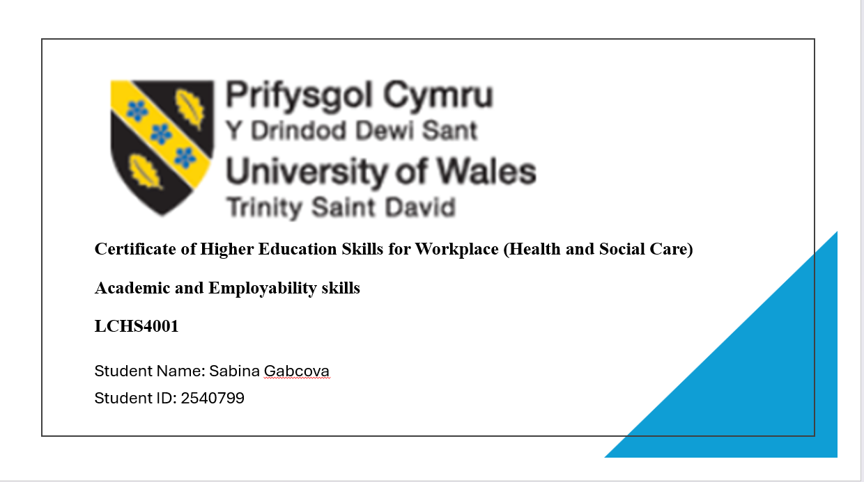
SLIDE 2:
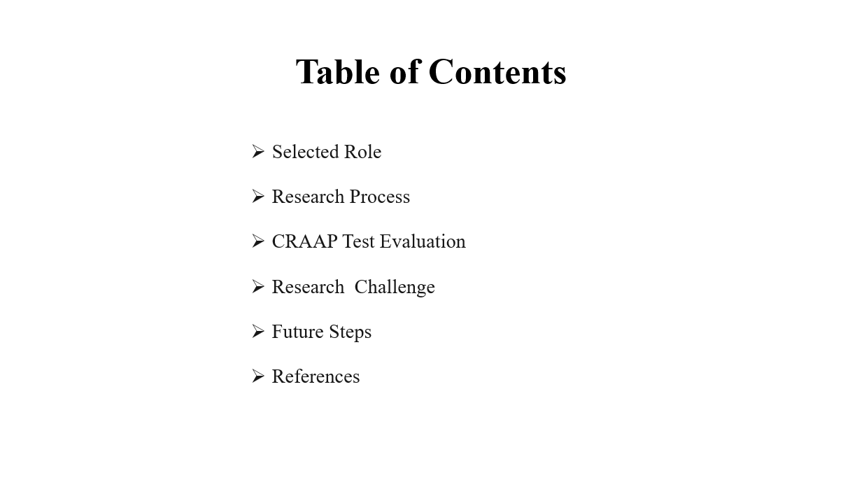

SLIDE 3:
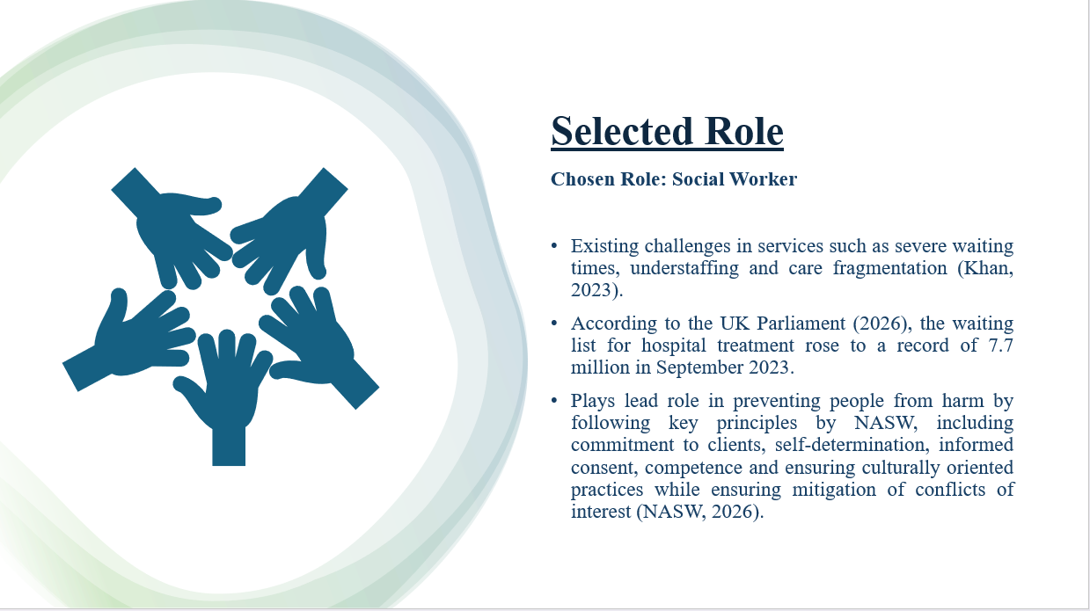
Speaker notes:
I picked being a Social Worker because a job that helps people who need protection and promotes healthy living. Social workers assist people dealing with problems like abuse, neglect, poverty, mental health issues and family issues. This role is especially important because social workers often make decisions that affect people’s safety, independence and quality of life. As the need for social care grows social workers need skills and good judgment.

SLIDE 4:
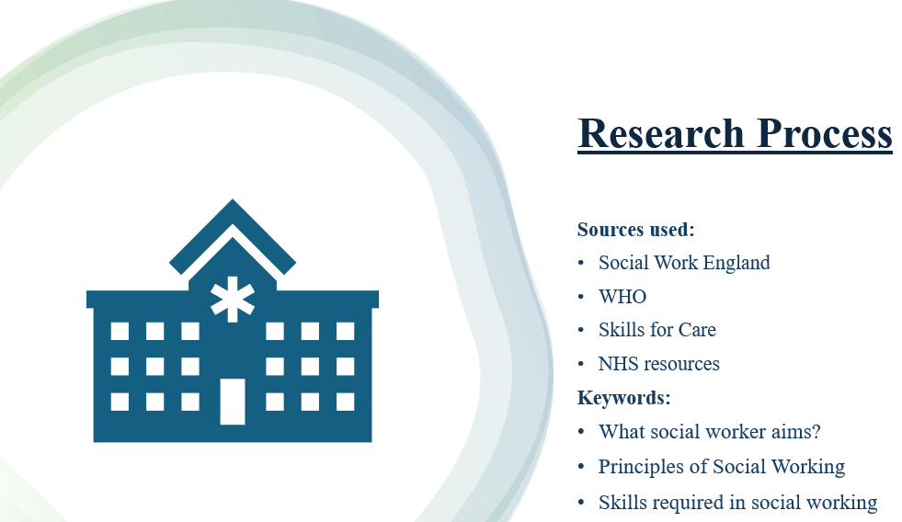
Speaker notes:
I started my research with official sources because they are usually more trustworthy. I used keywords related to what social workers do and the skills they need. The research kept showing that communication, empathy and time management are skills. These skills were often linked to safeguarding, good assessments and positive outcomes for people who use social services.

SLIDE 5:
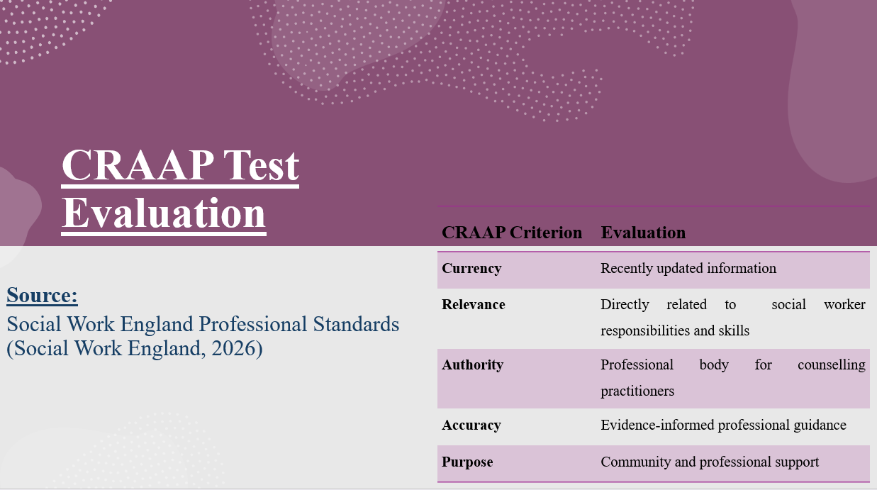
Speaker notes:
I evaluated the source using the CRAAP test. The information is up-to-date. Moreover it is directly relevant because it outlines what social workers in England are what they supposed to do . The source is trustworthy because Social Work England is in charge of workers in England (Social Work England, 2026). The information is based on evidence. Aims to support professional practice, not commercial interests. This makes it highly credible.

Slide 6:
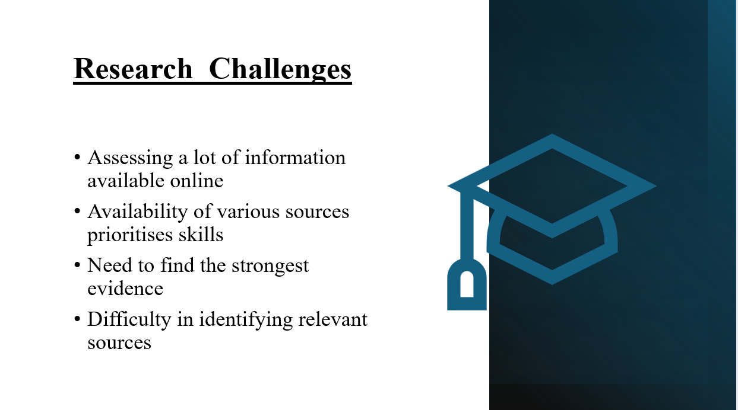
Speaker notes:
One challenge was dealing with the huge amount of information on social work. Another issue was that different organizations highlighted skills. So I had to compare evidence from sources and determine which skills were consistently regarded as essential for effective social work practice.

SLIDE 7:
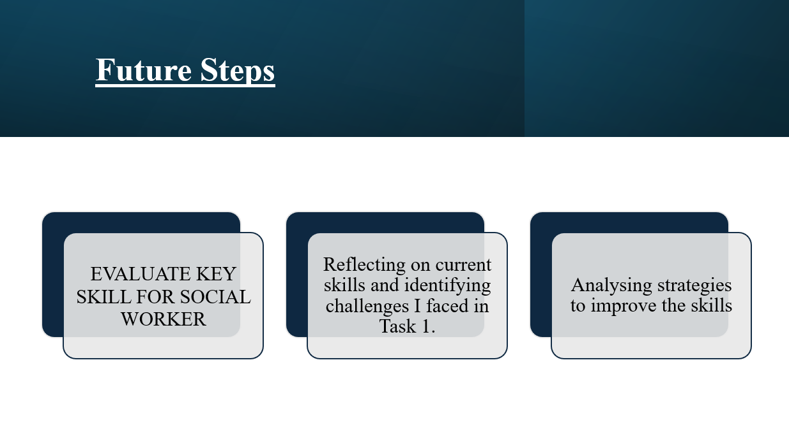
Speaker notes:
The next step is to critically assess communication, empathy and time management, in social work practice. I will review sources to strengthen the evidence base. After that I will develop the report structure making sure all arguments are backed with references and linked to real social work practices.

SLIDE 8:
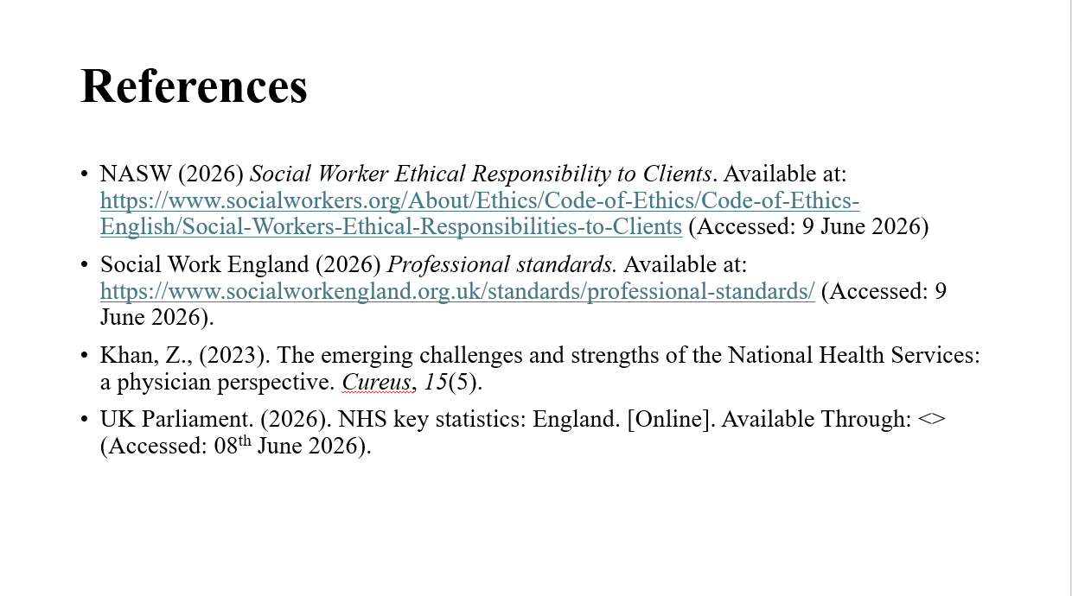

Table of Contents
Task 2: Reflecting Using Gibbs Reflective Cycle 3
Task 3: Report 5
Introduction 5
Overview of the background and the role of a social worker 5
Evaluation of skills needed for social worker 6
Strategies to improve the skills for social work 7
Conclusion 9
References 10

Task 2: Reflecting Using Gibbs Reflective Cycle
This section will discuss the reflection on the experience and challenges which I faced during Task 1.
Section | Your Response
1. Research | The key aim of the task was to research the role and importance of social workers in health and social care. Further, at the beginning, it is identified that the role of a social worker involves the end-to-end process of providing services. The presentation discussed the research process and source evaluation by using the CRAAP framework and completing the final report. The evaluated resource is Social Work England Professional Standards, which shows relevance to the ethics of the role of a social worker (Social Work England, 2026).
2. Presenting | At the start of the research process, I was confused about some uncertainty regarding the selection of reliable sources and the identification of the most important skills necessary for the social worker role. In this context, there was some concern about presenting information clearly within a limited time frame.
3. Challenges you faced with your presentation | In the context of evaluation, the positive aspect was identified as the successful use of professional and governmental sources, including Social Work England and Skills for Care. These sources provided reliable and relevant information related to the role I selected, which is a social worker. Also, improved confidence in the quality of research. Moreover, the application of the CRAAP framework was also helpful in examining the relevance of the source and identifying the credibility of the resource (Muis et al., 2022). However, some aspects of the presentation could have included more critical discussion on the social worker's role. In the analysis of data sources, the role was helpful for me in developing critical thinking skills, and to become a successful social worker, critical thinking skills are mandatory to enhance problem-solving skills. Therefore, the understanding of why specific skills are important is valuable rather than descriptively understanding them. Furthermore, the activity also demonstrated the importance of communication skills, as the effectiveness of a presentation is based on the importance of communication skills.
4. Actions to improve | In conclusion, working on task 1 activity was insightful in understanding the role of a social worker and evaluating the role of a social worker. Overall, the presentation activity improved understanding of both the social worker's role and the research process. It also highlighted the strengths for evaluating the source while identifying the opportunities to improve the critical analysis and delivering a quality presentation.
5. Further steps needed to Prepare for Task 3 | In future, I will try to more critically evaluate the source’s credibility and relevancy. Further, the future presentation will be critically discussed while improving the confidence level and deep understanding of practising social work. In this line, Task 3 will be focused on embedding and discussing evidence, theoretical application and ensuring accurate credibility throughout the report.

Task 3: Report

Introduction
The social worker plays a leading role in health and social care by helping and supporting individuals in under-resourced communities, minorities and vulnerable people. Furthermore, they are supposed to encourage people to take part in the community-based services, promoting well-being and protecting people from harm. Moreover, their responsibilities move beyond providing direct support to manage interventions while ensuring safeguarding (Kaushik, and Walsh, 2019). Although the key aim of this report is to critically discuss the role of social workers, 3 essential skills and the importance of these skills in the profession. Additionally, it will also discuss the effective strategies to improve these skills. The description of skills will be discussed by pointing out relevant examples of when and where these strategies will be applied to provide better services as a social worker.

Overview of the background and the role of a social worker
Social workers play a dominant role in the health and social care industry. As professionals, they are dedicated to advocating for vulnerable individuals and communities by addressing key challenges like poverty, discrimination and inequality. Further, by connecting people to critical resources and providing counselling, they empower people to overcome hardship and navigate complex societal systems. Their role as social workers includes identifying the key needs of individuals, managing risks and coordinating interventions to promote safety, well-being and independence. The key responsibility includes safeguarding vulnerable adults and children from abuse and preventing harm. In this line, another one is to critically evaluate and assess care plans, advocate for individuals and work collaboratively with healthcare professionals. Additionally, the application of system theory seems to social workers as a perspective of community service which operates services within the interconnected social system where individuals' challenges are mainly affected due to family, community and societal factors. Consequently, empathy and time management are also equally important as they significantly influence the assessment quality, ethical decision making and relationship building with the consumer.

Evaluation of skills needed for social worker
In the context of the required skills, the key skills required of a social worker are effective communication skills, which are helpful in assessing the key needs of individuals. Effective communication skills also include active listening. Active listening is related to the ability to truly understand and assess verbal and non-verbal cues without any judgment. Additionally, the social workers should develop the ability to assess the clinical needs of individuals and note the key demands of the individuals. Further, exceptional communication is helpful in building loyalty with individuals. It will also ensure that social workers collect accurate information to build an effective support plan (Reith-Hall, and Montgomery, 2023). Conversely, the poor communication may contribute to misunderstanding, incomplete information and inappropriate intervention. It could be understood that during a child protection assessment, ineffective questioning may prevent a social worker from identifying safeguarding concerns, potentially increasing risks to the child.
Next, empathy is also a skill which should be owned by the social worker. Empathy is related to the capacity of intellectualising and emotionally identifying with another person’s living experience. So it could be evaluated that empathy is considered the cornerstone of the profession (Moudatsou et al., 2020). It also validates that consumers may struggle to express their feelings. In this line, the empathy is effective in empowering them to actively engage in finding. Similarly, the next skill is critical thinking and problem solving, which is related to assessing complex, dynamic situations and weighing conflicting, developing evidence-based solutions. Critical thinking enables professionals to identify the root cause of the problem rather than treating immediate symptoms and ensuring long-term positive outcomes. Therefore, effective social work requires a balance between empathy and professional boundaries. This could be understood as when the individuals face any inequality, then the social worker must showcase some understanding while managing the objective judgment in the context of risk and safeguarding requirements. In this line of work, time management is an equally important skill because the social worker often manages complex cases of vulnerability and inequality. Conversely, poor time management is related to a delayed intervention approach and poor health outcomes. For instance, delayed intervention or diagnosis could extend the exposure to harmful effects, not only for vulnerable individuals. Consequently, managing time effectively is also necessary to promote the safety and well-being of individuals through social work.

Strategies to improve the skills for social work
This section discusses key strategies to manage empathy, communication and time management as a social worker. The first one includes improving communication skills through participation in professional communication training programs. These programs and workshops will enhance the efficiency of quality service delivery, interacting with more individuals, which will have a direct positive impact on the communication. Attending workshops and training programs, including managing interviews and utilising role play exercises while gathering structured feedback from peers, will be helpful in improving questioning techniques (Banks et al., 2020). Moreover, on-going reinforcement through professional experience is mandatory. Further, the second strategy includes improving reflective practices, which could be understood through the theory of Schon, which suggests that professionals should improve performance by critically examining their experience and decision-making (Ziebart, and MacDermid, 2019). Additionally, the reflection allows social workers to assess their own potential areas of improvement. This is also helpful in identifying strengths and weaknesses in communication, empathy and decision making. For instance, reflecting upon safeguarding cases may help identify the alternative approaches that could help improve future practice. Nevertheless, the reflection is most effective when supported by constructive feedback from experienced professionals. Likewise, professional supervision is also a critical necessity for a social worker. The professional supervision represented a third strategy for skill development. Through the regular supervision session, the social worker could critically discuss the case and receive feedback. In this line, Kolb's experimental learning suggests that progressive development occurs when an individual reflects upon experience and applies new knowledge to future situations. Moreover, the supervision facilitates this process by connecting practical experience with professional learning. In addition, professional supervision supports emotional resilience and is helpful in identifying the key needs of individuals. Although supervision requires organisational resources, its contribution to professional competence and service quality makes it a highly valuable development strategy.

Conclusion
In conclusion, the key social worker plays a multifaceted role in the health and social care industry. The workers aim to perform a lead role by ensuring the safeguarding of vulnerable individuals and promoting positive outcomes. Furthermore, becoming a successful social worker and delivering effective practice depends heavily upon communication, empathy and time management because these skills influence assessment quality. This report has discussed three critical skills that social workers should possess, including communication, active listening, maintaining professional practice, and managing empathy. These skills help analyse the needs of individuals and provide effective intervention to promote their well-being. Additionally, some strategies, like attending workshops and training programs to get peer-reviewed feedback and assessment, were discussed, which will be helpful in knowing about the strengths and weaknesses of individuals. Ultimately, integrating social work into the industrial sector transforms organisations by prioritising the human element in business. by utilising counselling, advocacy and strategic planning. This focus on holistic well-being not only empowers the workforce but also gives companies a sustainable and competitive advantage through higher morale, increased productivity and responsible corporate operation.

References
Banks, S., Cai, T., De Jonge, E., Shears, J., Shum, M., Sobočan, A.M., Strom, K., Truell, R., Úriz, M.J. and Weinberg, M. (2020) ‘Practising ethically during COVID-19: Social work challenges and responses’ International social work, 63(5), pp.569-583. https://journals.sagepub.com/doi/pdf/10.1177/0020872820949614
Kaushik, V. and Walsh, C.A. (2019) ‘Pragmatism as a research paradigm and its implications for social work research’ Social sciences, 8(9), p.255. https://www.mdpi.com/2076-0760/8/9/255
Moudatsou, M., Stavropoulou, A., Philalithis, A. and Koukouli, S. (2020) January. ‘The role of empathy in health and social care professionals’ In Healthcare (Vol. 8, No. 1, p. 26). MDPI. https://www.mdpi.com/2227-9032/8/1/26
Muis, K.R., Denton, C. and Dubé, A. (2022) ‘Identifying CRAAP on the internet: A source evaluation intervention’ Advances in Social Sciences Research Journal, 9(7), pp.239-265. https://www.researchgate.net/profile/Adam-Dube/publication/362327098_Identifying_CRAAP_on_the_Internet_A_Source_Evaluation_Intervention/links/62fea0dfceb9764f7206d5a7/Identifying-CRAAP-on-the-Internet-A-Source-Evaluation-Intervention.pdf
Reith-Hall, E. and Montgomery, P. (2023) ‘Communication skills training for improving the communicative abilities of student social workers: A systematic review’ Campbell systematic reviews, 19(1), pp.cl2-1309. https://journals.sagepub.com/doi/pdf/10.1002/cl2.1309
Social Work England. (2026) Professional standard. Available at: https://www.socialworkengland.org.uk/standards/professional-standards/?__cf_chl_tk=Fi.KDlbwc_bDKctQWf7x4f7Zw5mgWsz4wmN26HISmd8-1780981652-1.0.1.1-4MIw2za7dJETlQPCq3a8zOfbjbFX02PAiS8BzdCtY60. (Accessed: 9 June 2026)
Ziebart, C. and MacDermid, J.C. (2019) ‘Reflective practice in physical therapy: A scoping review’ Physical therapy, 99(8), pp.1056-1068. https://pmc.ncbi.nlm.nih.gov/articles/PMC6665949/

