Assignment Title: Major Health Issue (Depression)

Submitted by:

Student ID:

Module Title: Introduction to Public Health

Module Code:

Submitted to:
Introduction:
There are numerous illnesses that quietly kill victims without any prior symptoms or warnings. The most common mental illness in the world is depression. It describes a mental condition that causes a profound and persistent sense of sadness. For more than 2000 years, depression has been acknowledged as an unique and dangerous disorder.( Holtzheimer, P. E., & Mayberg, H. S.,2011).In English, the word "depressed" refers to a momentary unhappiness that everyone encounters. It can ruin a person's life, social interactions, and perception of their physical wellbeing. It is not a disease exclusive to a certain race, sex, or age. It has an impact on everyone in the world, especially since technology has advanced. People are more isolated than ever because to the advancement of technology, especially the younger generation between the ages of 15 and 30.
An imbalance of specific brain chemicals known as "neurotransmitters," which carry signals in the brain that the body uses to regulate mood, is thought to be the root cause of depression. Depression may be inherited, brought on by traumatic experiences in the past, postpartum depression (mostly affecting women after giving birth), or it may result from any number of other illnesses. Since the symptoms are very common in society, the majority of people do not get the disease. When depression strikes,
-a person may experience loneliness,
-a loss of interest in once-enjoyable activities,
-a sense of worthlessness or excessive guilt,
-exhaustion or a loss of vitality,
-excessive or insufficient sleep,
-loss of appetite, restlessness, and
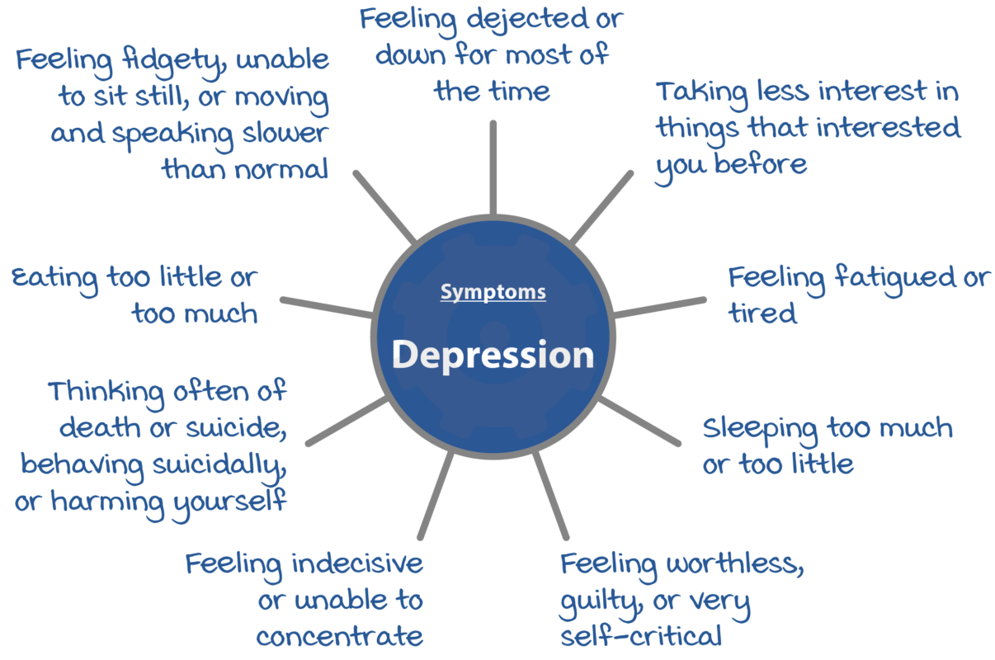
-an easy irritability.

This assignment will provide a clear understanding of depression, its public health measurement system, risk factors for the disease, the disease's short- and long-term effects on health and social services, and finally, a conclusion regarding general prevention and what steps can be taken to prevent this disease in the future.

Main body:
In the UK, instances of depression are on the rise. One in six persons in the UK are affected by depression, one of the most common mental health illnesses. It also has links to other mental health problems like stress, anxiety, and loneliness. Due to this epidemic, which began in 2019 when people began isolating themselves to avoid COVID-19, the occurrence of depression has greatly increased. Depression rates in the UK are still much higher than they were before the outbreak. In the summer of 2021, 17% of adults in the UK reported having some type of depression, up from just 10% the year before.

Types of depression:
Depression comes in a variety of forms depending on the causes, risk factors, and symptoms. The following are a few prevalent types of depression: :

- Major depression: The most typical form of depression is major depression. A person with serious depression has recurring episodes and is depressed all the time.:
- Persistent depressive disorder (also called Dysthymia):A gloomy mood that lasts for at least two years is referred to as persistent depressive disorder (also known as dysthymia). Both severe and moderate depression episodes can occur in a person.:
- Bipolar disorder (also called Manic Depressive Disorder): Manic and depressed episodes are both a part of bipolar disorder, often known as manic-depressive disorder.
- Psychotic depression: Hallucinations or delusions are evident in psychotic depression; the person is catatonic or stays in bed.
- Postpartum depression: Depression after childbirth or pregnancy is called postpartum depression. affects the mother's emotions, which may cause her to feel cut off from her child.
- Seasonal affective disorder: Major depressive disorder with seasonal pattern is the current name for seasonal affective disorder. A disruption in the body's Atypical depression: typical circadian cycle causes it to occur.
- Atypical depression is a form of depression that possesses unusual characteristics. Overreacting, relationship issues, impatience, and excessive sleep are all brought on by it.
- Situational depression: is brought on by traumatic or life-altering experiences.

For many people, anxiety and depression are the same condition. Although the physical symptoms of each of these illnesses may be similar, depression is one ailment whose symptoms can differ depending on the individual. In reality, anxiety can have several different meanings. A group of mental conditions can be referred to in medical terminology. An individual can experience both depression and anxiety simultaneously. The most prevalent mental disorder in Britain is mixed anxiety and depression, with 7.8% of the population fitting the diagnostic criteria. (NICE 2011)

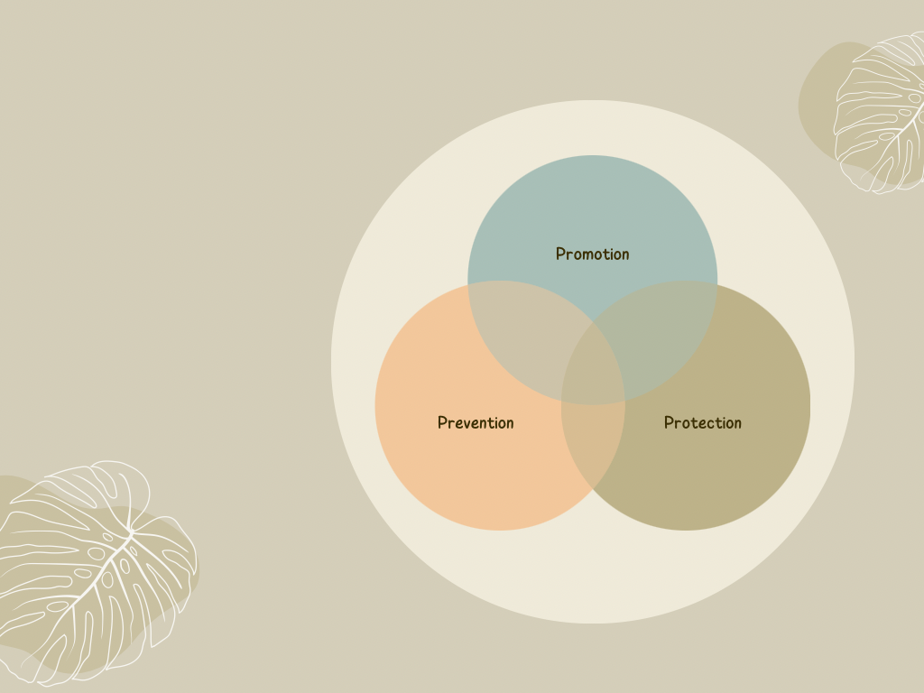
Finding evidence-based solutions is aided in the interdisciplinary field of public health by

interactive collaboration between many disciplines. Public health's primary goals are disease
prevention and community health and well-being enhancement, not patient cure. The three P's—promotion, prevention, and protection—are important to public health.
- Promotion: To promote is to make contact with the general public. Even among the younger generations, there are still individuals in society who refuse to acknowledge that depression is a mental illness that can be treated. Even inside the family, if someone's behaviour changes, family members continue to blame and criticise rather than showing concern and compassion. Therefore, it's important to raise awareness of the signs of depression as well as how supporting mental health might improve literacy.
- Prevention: Avoiding stress, exercising, eating well, getting enough sleep, abstaining from drugs and alcohol, and, in some situations, taking medication can all help prevent depression. New opportunities to lessen the illness burden of depressive disorders may be provided by prevention. According to an Institute of Medicine report, preventive refers to any action taken to stop the development of new cases of mental diseases in people who do not yet match the necessary criteria for them. (National Academy Press,1994).
- Protection: There are several techniques to protect against depression. In order to treat an illness and prevent repeat occurrences, it is important to identify symptoms early on and conduct promotional campaigns.

Risk factors of depression:
Depression is a widespread and severe mood disease that has a profound impact on a person's lifespan. The detrimental effects can occasionally result in suicidal attempts. When someone is under stress or depressed, this is typical. With more than 322 million sufferers globally, depression has become a widespread illness. The World Health Organisation and Global Burden of Disease estimate that about 800,000 individuals die by suicide each year. Suicide accounted for 1.4% of fatalities worldwide. Depression is also to blame for the rise in suicide instances because those who have been depressed for a long time have a 70% risk of doing so at any time.
One of the most prevalent mental disorders is depression, which can be brought on by a variety of genetic, environmental, biochemical, physical, and psychological causes. Major depressive disorder risk factors include:
- Generic traits
- Alterations in the levels of brain neurotransmitters
- Specific medical conditions and medications
- Stress, trauma, and significant life changes
- Unsound nutrition
- Light style.
According to specialists, factors that have contributed to the rise in depression include social instability, gender inequity, broken social peace, and dread of natural disaster.
Suicide is a symptom of depression solely, according to specialists, but it can cause it. Risk factors for suicide-related long-term effects include:
- Depression
- abusing drugs
- use of alcohol
- Schizophrenia
- financial situation
- Disorder of the mood and personality
- Other disease history (anxiety, post-traumatic stress)
- hormone alterations.

Short term impact of depression:
As was already established, depression doesn't just impact certain age groups; it may also affect children, teenagers, and adults. Teenagers suffer from long-term effects mostly because they do not comprehend what is happening, and even their parents sometimes fail to pay attention to their symptoms because they believe that behavioural changes are common at this age. Teens may experience symptoms like sadness, irritability, feeling down and unworthy, anger, poor grades or poor attendance at school, feeling extremely sensitive and misunderstood, using alcohol or drugs recreationally, eating excessively, sleeping excessively, self-harming, losing interest in regular activities, and more, whereas young children might manifest as melancholy, impatience, clinginess, concern, aches and pains, refusal to attend school, or underweight.
Adults typically disregard their mental health because they still believe that psychologists are just for those who are insane. According to society, this is the biggest drawback for the majority of individuals. Adults may experience exhaustion, memory issues, physical pain, appetite loss, sleep issues, a loss of interest in sex, a preference for staying home over going out and socialising, etc.

Long-term impact of depression:
If a person with depression does not see a doctor or psychologist, the long-term effects can be very significant. Serious exhaustion, a loss of energy, memory loss, and the most serious of them is suicidal thoughts.The precise aetiology of depression is unknown. According to Doreen Marshall, PhD, VP of Mission Engagement at the American Foundation for Suicide Prevention (ASFP), a number of things, including physical brain shape, brain chemistry, hormones, or heredity, might contribute to suicidal thoughts. Suicidal behaviour can be identified by the following signs:
- expressing a desire to end one's life while expressing feelings of worthlessness, helplessness, and hopelessness.
- leaving behind family, friends, and social interactions
- Writing about death,
- giving away personal possessions,
- Having drugs or alcohol excessively,
- acting violently, or accumulating and saving medicines
- Mood swings.

Cures for depression:
Everybody has different mental health problems, thus no two people will respond to the same treatments. Research shows that women are twice as likely as men to experience depression. However, in UK 15% of women receive treatment for depression, compared to only 9% of men as men tend to smoke more, exercise less, adhere less to treatment and drink more alcohol.(Allgulander, C.,1994) The following actions can be performed to manage these situations:
- Maintaining healthy nutrition, sound sleep, and regular exercise are all critical aspects of self-care.
- Have faith in someone with whom you can have honest discussions about anything, whether they be a friend, relative, cousin, or even a parent.
- Parents today must be aware of such everyday occurrences in order to properly guide their children.
- Abstain from alcohol and narcotics.
- Discover your passion.
- Seek medical advice, join a group, or use virtual therapists.
- Proper medication.
In UK, there are around 7.5 million people who have been diagnosed with a mental illness, albeit in most cases they are completely unaware that they are suffering. According to estimates, 50% of borrowers in the UK also struggle with mental health issues. In Great Britain, 2.6 million adults report feeling alone most of the time and 75% of illnesses begin before the age of 18. For this reason, the National Health Service (NHS) has a helpline and a support group that provides mental health patients with voluntary support. Additionally, the NHS provides antidepressants, cognitive behavioural therapy (CBT) who tries to understand one's ideas and behaviour and how they affect as well as psychodynamic psychotherapy, and counselling. With the added benefit of lower rates of long-term relapse, cognitive behaviour therapy is just as effective in treating depression as pharmaceutical therapy.(King, M., Davidson, O., Taylor, F., Haines, A., Sharp, D. & Turner, R.,2002).

Conclusion:
Without taking any action, depression cannot be lessened. To get through this kind of scenario, either medication or support groups are really necessary. If any of the above mentioned symptoms are present, the patient should contact their GP for assistance. Not only the patient, but family members, friends, and even members of the community should be asked to speak with anyone who seems off and request a doctor's appointment if the problem cannot be resolved. To avoid this kind of undesirable circumstance, parents must act more amiably and learn about their children's mindsets. If a medicine is administered that is relatively typical for a patient with schizophrenia, it must be taken as directed after contacting a doctor. The NHS UK website offers a great deal more information on how to use self-help CBT approaches to assess one's own level of depression. The National Institute for Health and Care Excellence (NICE) suggests vortioxetine (Brintellix or Lundbeck) for treating adults experiencing their first or subsequent severe depressive episode if the current episode has not responded to two prior antidepressants. Vortioxetine frequently causes strange dreams, constipation, diarrhoea, dizziness, itching, nausea, and vomiting as adverse effects.

References

NICE (2011). Common mental health disorders | Guidance and guidelines | NICE. [online] Available at: http://www.nice.org.uk/guidance/cg123 [Accessed 25 Aug 2015].

Institute of Medicine, Committee on Prevention of Mental Disorders, Division of Biobehavorial Science and Mental Disorders . Reducing Risks for Mental Disorders: Frontiers for Preventive Intervention Research. National Academy Press; Washington, DC: 1994

https://publichealthupdate.com/depression-and-suicide-the-hidden-crisis/ [Accessed on 18 Nov, 2022]

Allgulander, C. (1994) Suicide and mortality patterns in anxiety neurosis and depressive neurosis. Archives of Generai Psychiatry, 51, 708–712.

https://www.nhs.uk/mental-health/conditions/clinical-depression/treatment/ [Accessed on 18 Nov, 2022]

King, M., Davidson, O., Taylor, F., Haines, A., Sharp, D. & Turner, R. (2002). Effectiveness of teaching general practitioners skills in brief cognitive behaviour therapy to treat patients with depresson: randomised controlled trial. British Medical Journal 324, 947–950.

Holtzheimer, P. E., & Mayberg, H. S. (2011). Stuck in a rut: Rethinking depression and its treatment. Trends in Neurosciences, 34

https://championhealth.co.uk/insights/depression-statistics/ [Accessed on 18 Nov, 2022]

