A New Approach to Performance Management M6X00873
Grazia Martone (1703121)

Contemporary Human Resource in Practice
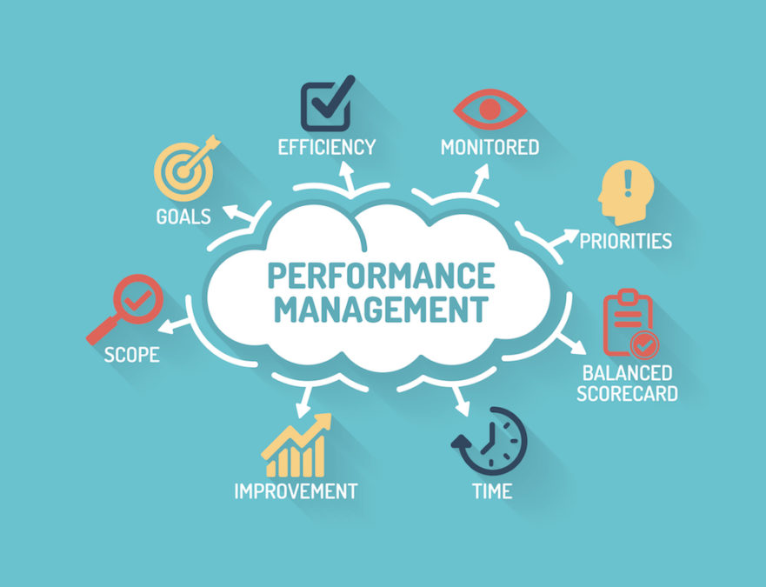

Introduction
Organisations have goals and in order to accomplish these goals, organisations like to take different approaches to do so, by hiring employees to perform to the standard required in order to achieve future visions. (Successfactors.com, 2019) states that performance is crucial to obtain organisational goals, by having processes to analyse performance and organisations should use specific processes to keep record which is known as a performance appraisal. Organisations try their best to recruit and retain good employees, appraisals are seen to increase employee’s morale and performance with results like better productivity and morale.
"Performance appraisal is a structured formal system that measures and evaluates an employee’s job, their behaviour and outcomes to find out how and why an employee is currently performing on the job and how the employee can perform more effectively for the foreseeable future so that the employee, organisation, and society can all benefit." (Sharma, 2014).
Background
(Capelli and Conyon, 2017) say Organisations will use appraisals for many reasons the main reasoning is to measure individual’s performance, it enables to identify if employees are working to a standard that is required, to measure which employees are performing to the best of abilities and who is eligible for any incentives and to address any issues where is necessary. Below shows a diagram of the average cycle of performance management, this traditional approach can be used by many organisations as a basic guide
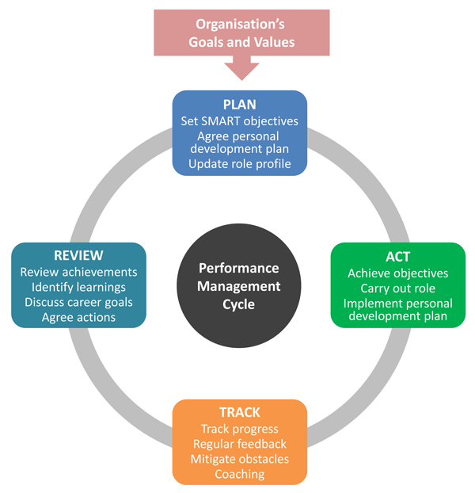
figure 1: performance management cycle (Clear Review, 2020).
Armstrong’s performance management tool shown above is used to plan the phase for the forth coming period and planning initially should involve agreeing to any SMART objectives, a personal development plan, actions to be taken in the coming months and a review of any employee’s job requirements while updating any roles where and when necessary.
For many of years organisations have used the planning stage once a year, but today organisations and the business environment are becoming more fast-moving and agile, organisations are shifting towards processes that will set a more near-term objective system taking place more frequently for example every three months. Organisations values and goals should feed into any performance planning while ensuring that employees’ performance will align with the organisation’s overall strategy. Being more specific every SMART objective should aim to contribute towards achieving one or even more of any goals set from the organisation.
By having a performance management system will enable goals to be set from an organisation while helping employees to conduct a plan and to aim to achieve the objectives in a purposeful way. Through the employees’ appraisal, the implementation of the performance management system has been put into performance traditionally. Nevertheless, by the huge use of technology the traditional approach towards the performance management system has now become more significant for organisations and most importantly the employees.
Engagement is an important aspect which is seen to heightened with the development of a within the workplace, this including all employees from management level down should be encouraged to always give the best performance, it has shown that when the engagement levels are high it will give organisations opportunities to succeed and grow swiftly in time. Although, findings shown by Ginac, (2019) only 15% of employees are willing to engage in their work and give their most while 85% are being looked at being disengaged and lacking motivation over time, this is either consciously or unconsciously. 12% of companies have stated that they are content with their level of engagement and organisations that have higher employee engagement will gain 16% more profits also with a lower level of absences which is around 37% less in regard to other organisations. Productivity is increased by around 18% giving a higher revenue by up to 2.5 times more. Additionally, organisations that do have more levels of engagement will have an average of 65% reduction in staff turnovers. The figures above are showing a good demonstration of a strong employee’s engagement, and henceforth the increase in the demands for a more stronger work environment with more motivation and communication between all employees within.
Dalal, (2012) says there are key drivers are recognized for engagement which are
- The impression of how employees contribute to the greater organisations
- The understanding of how employees work at an individual level
- The understanding complexion of the corporate goals
- The opportunities for personal and professional development
Every employee will give different weights of engagement to organisations due to different capabilities and experiences. But as an employer acknowledgment of different levels of engagement should be recognized and the importance of each employee when it comes to the practical life.
Some may say that the current system of employee appraisal’s is when a job is completed every employee should show a evaluation of their performance, which involves an employee filling out a form while rating the employee’s section. Which is based on different factors relating to the job’s features. The employee is expected to evaluate all factors. Management will then rate the employee against any criteria’s, while both discussing the reasonings for any differences in scores or opinions. This process would be repeated for different departments and each employee. The system will contain six different categories which are needed to be evaluated which include meeting deadlines, commitment, technical and product knowledge, working in teams, determination, energy, work rate, enhancing capability and flexibility (Sameeksha, 2014).
This is seen as the traditional five level rating scale for every category listed, Iqbal, (2016) suggests that employees after having conversations with their management, they are still unaware about how what the figures or score mean to them, also how simple scores can affect an individual’s impact on any bonuses or promotions. It has come to thought that employees have felt after the procedure it was a waste of their time, this is seen as a common repetition for a lot of organisations also with management having to go through the same process, this appraisal process will push management to give an evaluation on their employees other than amending any problems. By doing it this way there will be no chance to have a discussion about what area of employment is going well and where it is not going so well. This can lack in the processes of suitable recommendations and implementing these for an impact on results for the next procedure.
For organisations to stay up to date from traditional approaches will mean staying up to date with external environmental factors and VUCA is a popular term which covers several dimensions of the external environment it stands for Volatility, Uncertainty, Complexity and Ambiguity. It will make you look at things in a new perspective and forcing individuals to react to changes that may occur every day. VUCA is used for challenging any conditions in an uncontainable environment and in order to succeed in these challenging conditions people should adapt to changes that will arise by strategic plans and learning new skills. For organisations this is crucial especially today in the competitive industries (Bennett & Lemoine, 2014).
Adaptive performance within a working environment will refer to a better understanding and altering of new change in a working environment by changing behaviours to this will enable individuals to meet new demands that are changing quickly (Potsangbam, 2017).
for the future of work it is being seen by unexpected changes in technology and globalisation. People that are employed are mostly millennials that are wanting a new management process and would prefer to be coached instead of a boss, this is because they will see them as their work friend and will feel more comfortable with them. Employees are wanting more accountability, a purpose, clear expectations and ongoing feedback. By taking this approach will benefit the organisation and employees will work better and making the environment more successful (Harter, 2017).
Buckingham and Goodall took a took a survey showing that more than half of their employees in Deloitte said that their current performance management approach did not increase employees engagement and did not increase a higher performance (Buckingham & Goodall, 2015).
for other organisations it is seen the traditional approach is not working for them an example being the leading global professional services called Accenture demolished their annual performance reviews. Which for a large company of 330,000 employees is a big change for their employees and this goes to show that the traditional strategies are not working like they once did before for these big companies to take drastic changes (Cunningham, 2015)
A HR consultancy in 2017 goes by the name of Mercer found that 80% of their employers have employee performance ratings linking to the employees pay. Throughout the study it found that 95% of managers were dissatisfied with the organisations system for performance management. 48% said that for their performance system needed more work on it for it to become more effective. Furthermore, it was seen that 15% of the organisations said they would stop performance ratings and for a new process which included written descriptions or checklists. (Sammer, 2017).
it is said that performance ratings can influence organisations ratings, and they cannot help employees improve performance. And this is because when an employee is given a high rating they work harder and for other employees who does not reach high ratings there may be conflict causing jealousy and this can demotivate them to work harder and this can lead to the working environment being negative (Latham, 2016).
also the traditional approach is done over a 12 month period which is a long time, but the way the working environment is today it is more efficient to be done on a monthly basis this enables employees to change and adapt if it is a requirement needed right away leading to quicker success. (Schaufenbuel, 2016).
Cloudreach is a technology consultancy who implemented the weekly performance reviews this resulted in management and employees felt they could communicate about opportunities, concerns or risks in order to get answers for crucial information and advice they can also keep management up to date with any information on their work. The overall outcome worked well for them and the consultancy said how they would highly recommend to others the weekly performance reviews as it gives everyone to feel closer and on top of things and this just shows how the method is working better than the traditional approach (Hackland & Brunton, 2018).
Brian Jensen in 2002 said to his HR directors that the company Colorcon was putting a stop to doing annual reviews and their reaction was they were not happy, as this was in 2002 this would be a shock to them and as it being 18 years ago it is a vital change needed for other organisations to change to feedback instantly and weekly bonuses in order to keep up to date. In America one third of companies have changed their performance management processes with replacing it with annual reviews with more regular informal chats with management and employees (Cappelli & Tavis, 2016).
By making the objective concise will stop disengagement and misalignment and there is a need to change to make more changes, and while summarising goals which should be both influential and vital. With having more of a focus towards momentum and equal productivity and involving the employees (Choon, 2016).
Being more flexible is needed today, focusing on individual’s needs, time and experiences this should be reviewed occasionally so it becomes practical for the employees benefit and the organisation. It should be giving an overview of the works atmosphere and involving all the employee’s values (HR, 2019).
another effective way for performance of the employees to be increased would be to look at the use of ORK’s which is linking their contribution to the highest prioritised goals for the organisation. The ORK’s will help with putting objectives of an employee at an individual level with the outcome and goals that the organisation wishes to achieve, while making sure employee’s efforts are supported. And through this employee can identify their performance and efforts are helping to aim their own targets in the organisations (OKR, 2019).
Conclusion
It has concluded that through the report that change is happening surely and very quickly, organisations are nearly being forced to adapt to these changes to stay up to date with trends. And some may say that the traditional performance management approach is not working to it abilities as it did before. This meaning that the there is a need for it to change. And this can be hard for some as they may not like change especially when people feel secure. But it is seen throughout change leads to success. And that the change for a new process is valuable for the organisation and if they are not willing to change processes could lead to loss off success and profit.
Recommendations
By recommending the organisation improvements to benefit them would be management to look into the differences of the old and new way of performance management processes, and another recommendation being that employees within the organisation to give their honest opinions and feedback when relevant, this will give employees the chance to see if they are happy with the current processes and if there is any changes needed. This is useful and could improve any current processes. By enabling employees to have their say will help them to feel included and valued. And by employees feeling they matter and ensuring harder working environments benefitting the company as well. By organisations shifting with change and evolving which is a major skill to have and can benefit for the foreseeable future and being able to identify which change management process works best for them and the models that can be used is Kotter’s 8 step model, Crail 2007 etc will be a huge benefit if these are implemented.
Referemces
Bennett, N. & Lemoine, G. J., 2014. What VUCA Really Means for You. Harvard Business Review, p. 1.
Buckingham, M. & Goodall, A., 2015. Reinventing Performance Management. Harvard Business Review.
Capelli, P. and Conyon, M. (2017). What Do Performance Appraisals Do? - Peter Cappelli, Martin J. Conyon, 2018. [online] SAGE Journals. Available at: https://journals.sagepub.com/doi/full/10.1177/0019793917698649 [Accessed 8 Jan. 2020].
Cappelli, P. & Tavis, A., 2016. The Performance Management Revolution. Harvard Business Review, 1 October.pp. 58-67.
Choon, T., 2016. The Impact of Goal Setting on Employee Effectiveness to Improve Organisation Effectiveness: Empricial Study of a Hig-Tech Company in Singapore. Journal of Business and Economic Policy, 3(1).
Clear Review. (2020). What is an Effective Performance Management System? | Clear Review. [online] Available at: https://www.clearreview.com/resources/guides/what-is-effective-performance-management/ [Accessed 8 Jan. 2020].
Cunningham, L., 2015. In big move, Accenture will get rid of annual performance reviews and rankings. [Online]
Available at: https://www.washingtonpost.com/news/on-leadership/wp/2015/07/21/in-big-move-accenture-will-get-rid-of-annual-performance-reviews-and-rankings/?arc404=true
[Accessed 10 January 2020].
Hackland, J. & Brunton, N., 2018. Tried and tested: Weekly performance reviews. [Online]
Available at: https://www.managers.org.uk/insights/news/2018/january/tried-and-tested-weekly-performance-reviews
[Accessed 10 January 2020].
Harter, J., 2017. Failed Performance Management: The Fix. [Online]
Available at: https://www.gallup.com/workplace/236396/failed-performance-management-fix.aspx
[Accessed 10 January 2020].
Latham, A., 2016. Why Your Employee Performance Ratings Are Hurting Your Organization. [Online]
Available at: https://www.forbes.com/sites/annlatham/2016/02/07/why-your-employee-performance-ratings-are-hurting-your-organization/#79e749565410
[Accessed 10 January 2020].
OKR, 2019. An Introduction to Objectives and Key Results (OKRs). [Online]
Available at: http://www.agilenotanarchy.com/2017/03/an-introduction-to-objectives-and-key.html
HR, 2019. 5 Ways to Improve Your Performance Management System. [Online]
Available at: https://www.hrtechnologist.com/articles/performance-management-hcm/5-ways-to-improve-your-performance-management-system/
[Accessed 10 01 2020].
Potsangbam, C., 2017. Abstract. Adaptive Performance in VUCA era: Where is research going?, 8(6), p. 9.
Sammer, J., 2017. Rethinking Stale Performance Management Practices. [Online]
Available at: https://www.shrm.org/resourcesandtools/hr-topics/compensation/pages/rethink-stale-performance-management.aspx
[Accessed 10 January 2020].
Schaufenbuel, K., 2016. Change Board. [Online]
Available at: https://www.changeboard.com/article-details/14539/time-to-transform-the-traditional-performance-review-process/
[Accessed 10 January 2020].
Sharma, R. (2014). Essentials of an Effective Appraisal System. [online] Indusedu.org. Available at: http://www.indusedu.org/pdfs/IJRIME/IJRIME_1397_49882.pdf [Accessed 8 Jan. 2020].
Successfactors.com. (2019). Importance of Performance Management Process & Best Practices To Optimize Monitoring Performance Work Reviews/Feedback and Goal Management. [online] Available at: https://www.successfactors.com/resources/knowledge-hub/educational-articles/optimize-monitoring-performance-and-goal-management.html [Accessed 8 Jan. 2020].

